Template for Defeating the Enemy
The Word of God Series is a collection of 20 booklets that present Scripture verses in an easy-to-read format, with each booklet focused on a different topic.
Titles include Healthy Relationships, A Joy-Filled Life, Freedom from Depression, and many others.
The booklets are available in both paperback and digital formats at www.TheWordOfGodSeries.com or Amazon.com.
Why This Template?
Because I believe in the power of God’s Word to transform people’s lives, I have dedicated several years of my life to
bring this series to fruition.
I am passionate about using these booklets to reach
a dark and dying world with the love of Christ and
the hope of the Gospel.
Initially, I had expected this series would be a small business. But one day, when I asked God what my next steps should be,
He spoke to me through His Word and told me to:
“…complete the ministry God has given you.”
~ 2 Timothy 4:5 (NLT, 1996 version)
So, I shifted the focus from a business to a ministry.
My vision, also, has evolved over time and I have come to believe that it is possible for millions of these booklets to be distributed (in both print and digital formats) around the world (see the document entitled The Vision at www.TheWordOfGodSeries.com for more info.)
In order to make this a far-reaching ministry, accessing populations that I couldn’t on my own, I decided to invite others to partner with me in producing and distributing these booklets to their own personal networks. To help get it started, I have made templates of each booklet freely available to anyone who would like them.
This way you (whether you are a church, Christian organization or an individual) can easily re-create the booklets in your own ministry’s name, and distribute them to the people you minister to.
I hope that this template will save you:
- Time – so you can benefit from the thousands of hours
of development time that has been invested so far
- Money – eliminate layers of profit margin, and save on shipping costs (especially for large quantities)

Whether you simply replicate and reproduce what has already been done, build on it, or take this idea in a different direction, you won’t have to waste time starting with a blank page.
I hope you can easily get these finalized and printed, so you can begin sharing them with the people in your sphere of influence.
On the following pages you will find document formatting and printing tips.
Photo editing tips are also presented, as well as the preview images of each photo (with the Photo ID#), so you to easily find it on either bigstockphoto.com or shutterstock.com.

Photo Editing Tips
At the end of this document you will find the copyright and descriptive info for each photo in the booklet, as well as editing suggestions for a few of them.
Many photos will need to be slightly stretched or cropped to fit the page.
Most of the editing suggestions below (especially brightening or increasing color saturation) should be very slight adjustments.
Editing photos within this document
Wrapping text around the photo: Doubleclick the photo, click
on Wrap Text and select Square. Then, drag the image by the corner until it is the right size to wrap the text around it.
Rotate: Doubleclick the photo, click on the Rotate Object icon.

Editing photos in the Pictures editing app in MS Word
Navigate to your Pictures folder, doubleclick the photo, and click on the blue Edit button on left
Most of the editing can be done by using one of these 3 options:


Crop: Click on the Crop icon and drag edges to desired spot
Brighten a photo: Adjustment icon / Light / Brightness
Increase color saturation: Adjustment icon / Color / Saturation or Warmth
Remove distracting elements from a photo: Click on the Generative Erase icon, select a brush size and click on the part of the photo you want removed.

Photo Searching Tips
Occasionally photographers pull their photos from the sites,
so there may be some in this booklet that are no longer available.
You can try using the same key words to search for the photo
on other sites (scroll to the end of this document for more descriptive information about each photo.)
Or, you can search for another photo on Bigstock. Under
All Images select Photos and search by key word. At the next screen, make sure that Safe Search is on. In the Category field, select either Landscapes, Nature or Animals.

Booklet Formatting Tips
If you make any changes to this document that results in changing the number of lines on a page, then the page will need to be re-formatted for everything to fit.
Often changing the spacing between the characters or between the lines in one verse is enough to re-format it.
Changing the spacing between the characters
Home / Font / Advanced / Character Spacing
Choose Expanded or Condensed, and select a numeric value (best from .1 to .3)


Changing the spacing between the lines
Highlight all the text in the passage or page and click on:
Layout / Paragraph / Line Spacing / Multiple
Select a numeric value (best from .98 to 1.02)


Saving the document as a PDF
Adobe Acrobat Pro subscriptions are available at www.adobe.com/creativecloud/plans.html. You could also
ask your library tech center if they carry Adobe products.
When the Word doc is final: File / Save as Adobe PDF

Viewing the PDF as a booklet
Remove the first blank page of the doc: Edit / Trash icon.
Enter pages 1 to 1 to delete. Then exit from the Edit mode.
To view the document as a booklet, click on the page icon
(on right side of page, below the rotate button) and select
Two-page view and Show cover page.


Adding page numbers to the PDF
Edit / Header & Footer / Add / Add New
Under Font Name choose your font (this document uses the Georgia font) and under Size enter 8 pt.
Under Margins, in the Bottom box, enter .4
Click in box under Center Footer Text and click on the Insert Page Number button.
Click on Page Range Options. The Pages From _ to _
will depend on which page in your document you want read as Page 1 in the PDF.
In these booklets, the verses begin on Page 5 (after the forward page, copyright page, and Table of Contents).
If you plan to develop several booklets, select Save Settings.


Printing the Booklets
You can print these as regular paperbacks with a binding, (which look a bit nicer) or, you can print them with a staple binding. The staple binding does require a certain type of machine that can print them in a way that they open fully to any page (not just the center page) and lay flat. Your local printer may or may not have that capability, so discuss options with them.
A glossy cover is recommended, as it has a better feel than a matte finish. You may want to request the booklets be printed on Cougar® paper, which has a very smooth finish.

Stuck on a Step Above and Need Help?
If you want to do this project on your own, but are having tech issues with one of the steps above, feel free to contact me at Susan@TheWordOfGodSeries.com. I may be able to assist you, since I’ve gone through this whole process myself!

Need Help with the Whole Project?
If you want these booklets set up in your own in your own ministry’s name, but don’t have the resources to do the whole project yourself,
I may be able to manage that process for you for a one-time project fee.
This would include the following services:
- Set up an account with Bigstock and Shutterstock in your ministry’s name and purchase the rights for you to use each of the photos
- Download and name the photos
- Edit photos as needed
- Create a cover with your church or ministry logo
- Request the rights to use the various Bible translations from each of the publishers (if applicable)
Feel free to contact me at Susan@TheWordOfGodSeries.com to discuss pricing options.
I hope that this information will help you finalize this document with ease so you can begin distributing it to the people in your realm of influence.
Thank you for partnering with me in this effort. I wish you the best as you make God’s Word known and share His love with others!
Warmly in Christ,
Susan

Soli Deo gloria



Feel free to edit this forward page to align to your own ministry’s vision and goals.

The Bible is the best-selling and most transformative book in history. Written over 2,000 years ago, it is still living and powerful today.
Throughout the pages of Scripture you will find inspiration and joy, comfort and peace, healing and hope.
Most importantly, you will learn of God’s abundant love for you, and His plan to give you a glorious, eternal inheritance.
The Word of God Series is a collection of booklets which presents Scripture by topic, so you can focus on verses that are relevant to you at different stages and circumstances throughout your life.
All of the booklets in this series feature Scripture exclusively—
just the powerful, undiluted Word of God.
Let God’s Word permeate your mind and transform your life.
Here are a few suggestions to help you fully benefit from Scripture:
Meditate
Pause and reflect on the verses as you read, and even meditate on them throughout the day.
Memorize
A great memorization technique is to repeat the verse several times, each time emphasizing a different word.
The Lord will rescue me from every evil attack…
The Lord will rescue me from every evil attack…
The Lord will rescue me from every evil attack…
~ 2 Timothy 4:18a (NIV)

Pray
Pray God’s Word back to Him. For example,
Dear Lord, thank you for assuring me in Your Word
that You will rescue me from every evil attack.

Do What It Says
Do not merely listen to the word, and so deceive yourselves.
Do what it says.
~ James 1:22 (NIV)

My prayer for you, as you read this booklet, is that when you face spiritual attack, you will use the weapon of God’s Word to demolish demonic strongholds and know that God will rescue and deliver you.
Let the word of Christ dwell in you richly…
~ Colossians 3:16a (ESV)

A few comments about this series:

- The booklets in this series provide you with a sample of what the Bible offers, but it is important that you also read the Bible itself, preferably with a book-by-book focus.

- Passages in quotation marks are the actual words of God, either through His prophets in the Old Testament, or the words of Christ
in the New Testament.

- Every booklet includes a section that details God’s plan of salvation (commonly referred to as “The Gospel.”) The booklet entitled God’s Gift of Eternal Life
is devoted to the Gospel message.

This series presents verses in the following translations:

NIV: New International Version
Scripture quotations marked NIV are taken from the Holy Bible, New International Version®, NIV®. Copyright © 1973, 1978, 1984, 2011 by Biblica, Inc.™ Used by permission of Zondervan. All rights reserved worldwide. www.zondervan.com. The "NIV" and "New International Version" are trademarks registered in the United States Patent and Trademark Office by Biblica, Inc.™

NLT: New Living Translation
Scripture quotations marked NLT are taken from the Holy Bible, New Living Translation, Copyright© 1996, 2004, 2015 by Tyndale House Foundation. Used by permission of Tyndale House Publishers, Inc., Carol Stream, Illinois 60188. All rights reserved.

ESV: English Standard Version
Scripture quotations marked ESV are taken from the ESV Bible® (The Holy Bible, English Standard Version®), copyright © 2001 by Crossway Bibles, a publishing ministry of Good News Publishers. Used by permission. All rights reserved.

KJV: King James Version
Public Domain

NKJV: New King James Version
Scripture quotations marked NKJV are taken from the New King James Version®. Copyright © 1982 by Thomas Nelson, Inc. Used by permission.

Since this is a template booklet featuring preview photos, it is not copyrighted, so you are free to purchase licenses to use the photos and develop your own booklets for print. Be sure to determine whether or not you need to request permission (and in some cases pay) for the rights to use the various Bible translations. Scripture verses were sourced from www.BibleGateway.com.
If it would be easier for you to simply purchase this booklet, the copyrighted version is available at www.TheWordOfGodSeries.com or www.amazon.com.
ISBN info for the copyrighted booklets is as follows:
The ISBN is 978-1-964538-26-6 and the Amazon ISBN is 9798360248958.
Defeating The Enemy

Contents

Recognize Your Enemy 1
The Character of Satan
The World’s Response to Satan
Warnings About Sorcery
Warnings About False Prophets
The History and Future of Satan
The Dragon and the Beast
The Man of Lawlessness

The Wrath of God Against the Wickedness 9
of People

The Reality of Hell 11

Endure Hardship 13

Avoid and Reject Evil 14

Guard Yourself (Your Heart, Mind, Mouth) 16

Live in the Light 20

The Armor of God 23

The Weapons God Gives Us for Victory 24

The Word of God The Name of Jesus

Doing Good The Blood of Jesus

Fasting Obedience to God

Prayer Living in Righteousness

Forgiveness Praise

The Holy Spirit Faith

Jesus Saves 39

Jesus Offers Eternal Life 40

Jesus Has Authority 44

Trust God for Victory 48

Recognize Your Enemy

The Character of Satan


Your enemy the devil
prowls around like a
roaring lion looking
for someone to devour.
~ 1 Peter 5:8b (NIV)

“He was a murderer
from the beginning.”
~ John 8:44b (ESV)

“…he is a liar and the
father of lies.”
~ John 8:44b (ESV)

Satan himself masquerades as an angel of light.
~ 2 Corinthians 11:14b (NIV)

The great dragon was hurled down—that ancient serpent called the devil, or Satan, who leads the whole world astray.
~ Revelation 12:9a (NIV)

…the deceiver of the whole world…
~ Revelation 12:9b (ESV)

The World’s Response to Satan

We know that we are children of God and that the world around us is under the control of the evil one.
~ 1 John 5:19 (NLT)

…the whole world lies under the sway of the wicked one.
~ 1 John 5:19b (NKJV)

Satan, who is the god of this world, has blinded the minds of those who don’t believe.
They are unable to see the glorious light of the Good News.
~ 2 Corinthians 4:4a (NLT)
The wicked prowl on every side, when vileness is exalted among the sons of men.
~ Psalm 12:8 (NKJV)

But when people keep on sinning, it shows that they belong to the devil, who has been sinning since the beginning.
~ 1 John 3:8a (NLT)

You used to live in sin, just like the rest of the world, obeying the devil—the commander of the powers in
the unseen world. He is the spirit at work in the hearts
of those who refuse to obey God.
~ Ephesians 2:2 (NLT)

Warnings About Sorcery

“Then I will draw near to you for judgment.
“I will be a swift witness against the sorcerers…”
says the Lord of hosts.
~ Malachi 3:5 (ESV)

“I will set my face against anyone who turns to mediums and spiritists to prostitute themselves by following them…
“Consecrate yourselves and be holy, because I am the
Lord your God.”
~ Leviticus 20:6-7 (NIV)

The people of Israel had also secretly done many
things that were not pleasing to the Lord their God.
They built pagan shrines for themselves…They offered sacrifices on all the hilltops…
Again and again the Lord had sent his prophets and seers to warn both Israel and Judah: “Turn from all
your evil ways. Obey my commands and decrees…”
But the Israelites would not listen…They worshiped worthless idols, so they became worthless themselves…
They even sacrificed their own sons and daughters in
the fire.
They consulted fortune-tellers and practiced sorcery and sold themselves to evil, arousing the Lord’s anger.
~ 2 Kings 17:9-17 (NLT)
Let no one be found among you who sacrifices their son
or daughter in the fire, who practices divination or sorcery, interprets omens, engages in witchcraft, or casts spells, or who is a medium or spiritist or who consults the dead.
Anyone who does these things is detestable to the Lord…
~ Deuteronomy 18:10-12a (NIV)

Warnings About False Prophets

…Satan disguises himself as an angel of light. So it is
no surprise if his servants, also, disguise themselves as servants of righteousness.
~ 2 Corinthians 11:14b-15a (ESV)

“Beware of false prophets, who come to you in sheep’s clothing but inwardly are ravenous wolves.
“You will recognize them by their fruits…
“A healthy tree cannot bear bad fruit, nor can a diseased tree bear good fruit...
“Thus you will recognize them by their fruits.”
~ Matthew 7:15-20 (ESV)

…many deceivers, who do not acknowledge Jesus Christ as coming in the flesh, have gone out into the world.
Any such person is the deceiver and the antichrist.
~ 2 John 1:7b (NIV)

Dear friends, do not believe every spirit, but test the spirits to see whether they are from God, because many false prophets have gone out into the world.
This is how you can recognize the Spirit of God:
Every spirit that acknowledges that Jesus Christ has come in the flesh is from God, but every spirit that does not acknowledge Jesus is not from God. This is the spirit of the antichrist...
~ 1 John 4:1-3a (NIV)

…no one who is speaking by the Spirit of God says,
“Jesus be cursed,” and no one can say, “Jesus is Lord,” except by the Holy Spirit.
~ 1 Corinthians 12:3b (NIV)
The History and Future of Satan

How you are fallen from heaven,
O Lucifer, son of the morning!
How you are cut down to the ground,
You who weakened the nations!
For you have said in your heart:
“I will ascend into heaven,
“I will exalt my throne above the stars of God;
“I will also sit on the mount of the congregation…
“I will ascend above the heights of the clouds,
“I will be like the Most High.”
Yet you shall be brought down to Sheol, to the lowest depths of the Pit.
~ Isaiah 14:12-15 (NKJV)

This is what the Sovereign Lord says:
“You were the seal of perfection,
full of wisdom and perfect in beauty.
You were in Eden, the garden of God;
every precious stone adorned you…
Your settings and mountings were made of gold;
on the day you were created they were prepared.
You were anointed as a guardian cherub,
for so I ordained you.
You were on the holy mount of God;
you walked among the fiery stones.
You were blameless in your ways
from the day you were created
till wickedness was found in you.
“Through your widespread trade
you were filled with violence, and you sinned.
So I drove you in disgrace from the mount of God,
and I expelled you, guardian cherub,
from among the fiery stones.
Your heart became proud
on account of your beauty,
and you corrupted your wisdom
because of your splendor.
“So I threw you to the earth;
I made a spectacle of you before kings…
So I made a fire come out from you,
and it consumed you,
and I reduced you to ashes on the ground
in the sight of all who were watching.
All the nations who knew you
are appalled at you;
you have come to a horrible end
and will be no more.”
~ Ezekiel 28:12b-19 (NIV)

Then there was war in heaven. Michael and his angels fought against the dragon and his angels. And the
dragon lost the battle, and he and his angels were
forced out of heaven.
This great dragon—the ancient serpent called the devil,
or Satan, the one deceiving the whole world—was thrown down to the earth with all his angels.
~ Revelation 12:7-11 (NLT)

But woe to you, O earth and sea, for the devil has come down to you in great wrath, because he knows that his time is short!
~ Revelation 12:12b (ESV)

Now the serpent was more crafty than any of the wild animals the Lord God had made. He said to the woman, “Did God really say, ‘You must not eat from any tree in the garden’?”
The woman said to the serpent, “We may eat fruit from the trees in the garden, but God did say, ‘You must not eat fruit from the tree that is in the middle of the garden, and you must not touch it, or you will die.’”
“You will not certainly die,” the serpent said to the woman.
“For God knows that when you eat from it your eyes will be opened, and you will be like God, knowing good and evil.”
When the woman saw that the fruit of the tree was good for food and pleasing to the eye, and also desirable for gaining wisdom, she took some and ate it.
~ Genesis 3:1-6a (NIV)
The Dragon and the Beast

The dragon stood on the shore of the sea.
And I saw a beast coming out of the sea. It had ten horns and seven heads, with ten crowns on its horns, and on each head a blasphemous name...
The dragon gave the beast his power and his throne and great authority. One of the heads of the beast seemed to have had a fatal wound, but the fatal wound had been healed.
The whole world was filled with wonder and followed the beast. People worshiped the dragon because he had given authority to the beast, and they also worshiped the beast and asked, “Who is like the beast? Who can wage war against it?”
The beast was given a mouth to utter proud words and blasphemies and to exercise its authority for forty-two months. It opened its mouth to blaspheme God, and to slander his name and his dwelling place and those who live in heaven.
It was given power to wage war against God’s holy people and to conquer them. And it was given authority over every tribe, people, language and nation. All inhabitants of the earth will worship the beast—all whose names have not been written in the Lamb’s book of life, the Lamb who was slain from the creation of the world…
Then I saw a second beast, coming out of the earth...
It exercised all the authority of the first beast on its behalf, and made the earth and its inhabitants worship the first beast, whose fatal wound had been healed. And it performed great signs, even causing fire to come down from heaven to the earth in full view of the people.
Because of the signs it was given power to perform on behalf of the first beast, it deceived the inhabitants of the earth. It ordered them to set up an image in honor of the beast who was wounded by the sword and yet lived.
The second beast was given power to give breath to the image of the first beast, so that the image could speak and cause all who refused to worship the image to be killed.
It also forced all people, great and small, rich and poor, free and slave, to receive a mark on their right hands or
on their foreheads, so that they could not buy or sell unless they had the mark, which is the name of the beast or the number of its name.
This calls for wisdom. Let the person who has insight calculate the number of the beast, for it is the number of
a man. That number is 666.
~ Excerpts from Revelation 13 (NIV)

As I watched, this horn was waging war against the holy people and defeating them, until the Ancient of Days came and pronounced judgment in favor of the holy people of the Most High, and the time came when they possessed the kingdom.
~ Daniel 7:21-22 (NIV)

Then a third angel followed them, saying with a loud voice,
“If anyone worships the beast and his image, and receives his mark on his forehead or on his hand, he himself shall also drink of the wine of the wrath of God, which is poured out full strength into the cup of His indignation.
“He shall be tormented with fire and brimstone in the presence of the holy angels and in the presence of the Lamb.
“And the smoke of their torment ascends forever and ever; and they have no rest day or night, who worship the beast and his image, and whoever receives the mark of his name.”
~ Revelation 14:9-11 (NKJV)

The ten horns which you saw are ten kings…and they will give their power and authority to the beast.
These will make war with the Lamb, and the Lamb will overcome them, for He is Lord of lords and King of kings...
~ Revelation 17:12-14a (NKJV)

But the beast was captured, and with it the false prophet who had performed the signs on its behalf. With these signs he had deluded those who had received the mark of the beast and worshiped its image.
The two of them were thrown alive into the fiery lake of burning sulfur…
And the devil, who deceived them, was thrown into the lake of burning sulfur, where the beast and the false prophet had been thrown.
They will be tormented day and night for ever and ever.
~ Revelation 19:20, 20:10 (NIV)

The Man of Lawlessness

Concerning the coming of our Lord Jesus Christ and
our being gathered to him…
Don’t let anyone deceive you in any way, for that day
will not come until the rebellion occurs and the man of lawlessness is revealed, the man doomed to destruction.
He will oppose and will exalt himself over everything that is called God or is worshiped, so that he sets himself up in God’s temple, proclaiming himself to be God…
For the secret power of lawlessness is already at work;
but the one who now holds it back will continue to do so till he is taken out of the way.
And then the lawless one will be revealed, whom the
Lord Jesus will overthrow with the breath of his mouth and destroy by the splendor of his coming.
The coming of the lawless one will be in accordance with how Satan works.
He will use all sorts of displays of power through signs and wonders that serve the lie, and all the ways that wickedness deceives those who are perishing.
They perish because they refused to love the truth and
so be saved.
For this reason God sends them a powerful delusion
so that they will believe the lie and so that all will be condemned who have not believed the truth but have delighted in wickedness.
~ 2 Thessalonians 2:1-12 (NIV)

The Wrath of God

Against

The Wickedness of People

The wrath of God is being revealed from heaven against all the godlessness and wickedness of people, who suppress the truth by their wickedness, since what may
be known about God is plain to them, because God has made it plain to them.
For since the creation of the world God’s invisible qualities—his eternal power and divine nature—have been clearly seen, being understood from what has been made, so that people are without excuse.
For although they knew God, they neither glorified him
as God nor gave thanks to him, but their thinking became futile and their foolish hearts were darkened…
Furthermore, just as they did not think it worthwhile to retain the knowledge of God, so God gave them over to
a depraved mind...
They have become filled with every kind of wickedness, evil, greed and depravity. They are full of envy, murder, strife, deceit and malice.
They are gossips, slanderers, God-haters, insolent, arrogant and boastful; they invent ways of doing evil; they disobey their parents; they have no understanding, no fidelity,
no love, no mercy.

~ Romans 1:18-31 (NIV)

For, as I have often told you before and now tell you again even with tears, many live as enemies of the cross of Christ.
Their destiny is destruction, their god is their stomach, and their glory is in their shame. Their mind is set on earthly things.
~ Philippians 3:18-19 (NIV)
“Whom have you so dreaded and feared
that you have not been true to me…
“Is it not because I have long been silent
that you do not fear me?”
~ Isaiah 57:11 (NIV)

“I am about to pour out my wrath on you and spend
my anger against you. I will judge you according to your conduct and repay you for all your detestable practices.”
~ Ezekiel 7:8 (NIV)

“Then I will draw near to you for judgment.
“I will be a swift witness
against the sorcerers,
against the adulterers,
against those who swear falsely,
against those who oppress the hired worker in his wages, the widow and the fatherless,
against those who thrust aside the sojourner,
“and do not fear me,” says the Lord of hosts.

~ Malachi 3:5 (ESV)

“I will punish the world for its evil,
the wicked for their sins.
“I will put an end to the arrogance of the haughty
and will humble the pride of the ruthless.”
~ Isaiah 13:11 (NIV)

“See, the day of the Lord is coming—a cruel day, with wrath and fierce anger—to make the land desolate and destroy the sinners within it.”
~ Isaiah 13:9 (NIV)

“It will be a day when the Lord’s anger is poured out—
a day of terrible distress and anguish, a day of ruin and desolation, a day of darkness and gloom...”
~ Zephaniah 1:15a (NLT)

“Don’t let that day catch you unaware, like a trap. For
that day will come upon everyone living on the earth.
Keep alert at all times.
“And pray that you might be strong enough to escape these coming horrors and stand before the Son of Man.”
~ Luke 21:34b-36 (NLT)

The Reality of Hell

“The Son of Man will send out his angels, and they will weed out of his kingdom everything that causes sin and all who do evil. They will throw them into the blazing furnace, where there will be weeping and gnashing of teeth.”
~ Matthew 13:41-42 (NIV)

The wicked shall be turned into hell…
~ Psalm 9:17a (NKJV)

“Not everyone who says to Me, ‘Lord, Lord,’ shall enter the kingdom of heaven, but he who does the will of
My Father in heaven.
“Many will say to Me in that day, ‘Lord, Lord, have we not prophesied in Your name, cast out demons in Your name, and done many wonders in Your name?’ And then
I will declare to them, ‘I never knew you; depart from Me…’”
~ Matthew 7:21-23a (NKJV)

“Woe to the world for temptations to sin!
“For it is necessary that temptations come, but woe to the one by whom the temptation comes!”
~ Matthew 18:7 (ESV)

“…do not be afraid of those who kill the body, and after that have no more that they can do.
“But I will show you whom you should fear: Fear Him who, after He has killed, has power to cast into hell; yes, I say
to you, fear Him!”
~ Luke 12:4b-5 (NKJV)

“When the master of the house has locked the door, it will be too late.”
~ Luke 13:25a (NLT)

“I tell you, many will come from east and west and recline at table with Abraham, Isaac, and Jacob in the kingdom of heaven, while the sons of the kingdom will be thrown into the outer darkness.”
~ Matthew 8:11-12 (ESV)
He will guard the feet of his faithful servants, but the wicked will be silenced in the place of darkness.
~ 1 Samuel 2:9a (NIV)

They will be punished with everlasting destruction and shut out from the presence of the Lord and from the
glory of his might…
~ 2 Thessalonians 1:9 (NIV)

“Outside are the dogs, those who practice magic arts,
the sexually immoral, the murderers, the idolaters and everyone who loves and practices falsehood.”
~ Revelation 22:15 (NIV)

But the cowardly, the unbelieving, the vile, the murderers, the sexually immoral, those who practice magic arts, the idolaters and all liars—they will be consigned to the fiery lake of burning sulfur. This is the second death.
~ Revelation 21:8 (NIV)

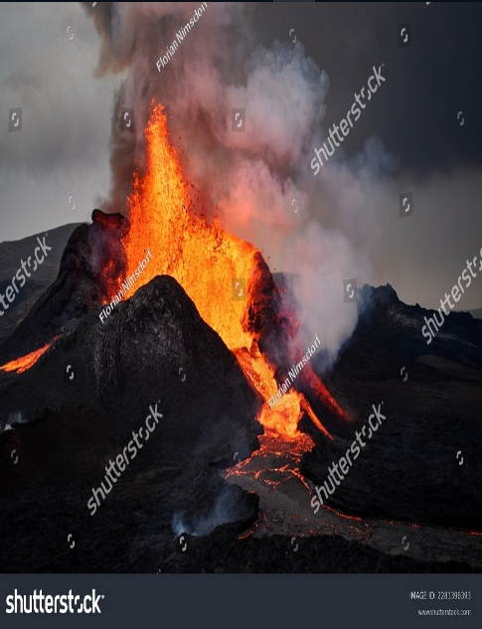
And don’t forget Sodom
and Gomorrah and their neighboring towns,
which were filled with immorality and every kind of sexual perversion.
Those cities were destroyed by fire and serve as a warning of the eternal fire of God’s judgment.
~ Jude 1:7 (NLT)

And anyone whose name
was not found recorded in the Book of Life was thrown into the lake of fire.
~ Revelation 20:15 (NLT)
Shutterstock Photo ID: 2281396393

…all sinners will be destroyed; there will be no future
for the wicked.
~ Psalm 37:38 (NIV)

For you are not a God who delights in wickedness;
evil may not dwell with you.
~ Psalm 5:4 (ESV)

Endure Hardship

You therefore must endure hardship as a good soldier of Jesus Christ. No one engaged in warfare entangles himself with the affairs of this life…
~ 2 Timothy 2:3-4a (NKJV)

If we endure hardship, we will reign with him.
~ 2 Timothy 2:12a (NLT)

“Because of the increase of wickedness, the love of most will grow cold, but the one who stands firm to the end
will be saved.”
~ Matthew 24:12-13 (NIV)

“And because lawlessness will abound, the love of many will grow cold. But he who endures to the end shall be saved.”
~ Matthew 24:12-13 (NKJV)

For if we are faithful to the end, trusting God just as firmly as when we first believed, we will share in all that belongs to Christ.
~ Hebrews 3:14 (NLT)

So do not throw away this confident trust in the Lord. Remember the great reward it brings you!
Patient endurance is what you need now, so that you will continue to do God’s will. Then you will receive all that
he has promised.
~ Hebrews 10:35-36 (NLT)

I pray that out of his glorious riches he may strengthen you with power through his Spirit in your inner being…
~ Ephesians 3:16 (NIV)

We also pray that you will be strengthened with all his glorious power so you will have all the endurance and patience you need.
~ Colossians 1:11a (NLT)

He will keep you strong to the end so that you will be free from all blame on the day when our Lord Jesus Christ returns.
~ 1 Corinthians 1:8 (NLT)

Avoid and Reject Evil

All who belong to the Lord must turn away from evil.
~ 2 Timothy 2:19b (NLT)

Let everyone who names the name of Christ depart
from iniquity.
~ 2 Timothy 2:19b (NKJV)

Have nothing to do with the fruitless deeds of darkness, but rather expose them.
~ Ephesians 5:11 (NIV)

…fear the Lord and shun evil.
~ Proverbs 3:7b (NIV)

…reject every kind of evil.
~ 1 Thessalonians 5:22 (NIV)

Abstain from all appearance of evil.
~ 1 Thessalonians 5:22 (KJV)

Abhor what is evil; hold fast to what is good.
~ Romans 12:9b (ESV)

Like a muddied spring or a polluted well are the righteous who give way to the wicked.
~ Proverbs 25:26 (NIV)

…I want you to be wise as to what is good and innocent
as to what is evil.
~ Romans 16:19b (ESV)

I will not look with approval on anything that is vile…
I will have nothing to do with what is evil.
~ Psalm 101:3-4 (NIV)

You adulterers! Don’t you realize that friendship with
the world makes you an enemy of God?
I say it again: If you want to be a friend of the world,
you make yourself an enemy of God.
~ James 4:4 (NLT)
The night is nearly over; the day is almost here. So let us put aside the deeds of darkness and put on the armor of light.
~ Romans 13:12 (NIV)

Those who have been born into God’s family do not make a practice of sinning, because God’s life is in them. So they can’t keep on sinning, because they are children of God.
~ 1 John 3:9 (NLT)

Do not let sin control the way you live; do not give in to sinful desires.
Do not let any part of your body become an instrument
of evil to serve sin.
Instead, give yourselves completely to God…
~ Romans 6:12-13a (NLT)

…those who desire to be rich fall into temptation and a snare, and into many foolish and harmful lusts which drown men in destruction and perdition.
For the love of money is a root of all kinds of evil, for which some have strayed from the faith in their greediness, and pierced themselves through with many sorrows.

~ 1 Timothy 6:9-10 (NKJV)

Therefore, my beloved, flee from idolatry.
~ 1 Corinthians 10:14 (ESV)

Flee also youthful lusts…
~ 2 Timothy 2:22a (NKJV)

Flee from sexual immorality. All other sins a person commits are outside the body, but whoever sins sexually, sins against their own body.
Do you not know that your bodies are temples of the Holy Spirit, who is in you, whom you have received from God?
You are not your own; you were bought at a price.
Therefore honor God with your bodies.
~ 1 Corinthians 6:18-20 (NIV)

But you, O man of God, flee these things and pursue righteousness, godliness, faith, love, patience, gentleness.
~ 1 Timothy 6:11 (NKJV)

Guard Yourself

Guard Your Heart

Guard your heart above all else, for it determines the course of your life.
~ Proverbs 4:23 (NLT)

…for everything you do flows from it.
~ Proverbs 4:23b (NIV)

“For it is from within, out of a person’s heart, that
evil thoughts come—sexual immorality, theft, murder, adultery, greed, malice, deceit, lewdness, envy, slander, arrogance and folly.”
~ Mark 7:21-22 (NIV)

“The human heart is the most deceitful of all things, and desperately wicked. Who really knows how bad it is? But
I, the Lord, search all hearts and examine secret motives.”
~ Jeremiah 17:9-10a (NLT)

But if you harbor bitter envy and selfish ambition in
your hearts, do not boast about it or deny the truth.
Such “wisdom” does not come down from heaven but
is earthly, unspiritual, demonic.
For where you have envy and selfish ambition, there
you find disorder and every evil practice.
~ James 3:14-16 (NIV)

…wash your heart from evil, that you may be saved. How long shall your wicked thoughts lodge within you?
~ Jeremiah 4:14b (ESV)

I know, my God, that you test the heart and are pleased with integrity.
~ 1 Chronicles 29:17a (NIV)

Search me, O God, and know my heart;
test me and know my anxious thoughts.
Point out anything in me that offends you,
and lead me along the path of everlasting life.
~ Psalm 139:23-24 (NLT
Guard Your Mind

Be alert and of sober mind. Your enemy the devil prowls around like a roaring lion looking for someone to devour.
~ 1 Peter 5:8 (NIV)

So humble yourselves before God. Resist the devil, and
he will flee from you.
~ James 4:7 (NLT)

Do not conform to the pattern of this world, but be transformed by the renewing of your mind.
~ Romans 12:2a (NIV)

…be renewed in the spirit of your mind…
~ Ephesians 4:23 (NKJV)

Now the Spirit expressly says that in latter times some will depart from the faith, giving heed to deceiving spirits and doctrines of demons…
~ 1 Timothy 4:1 (NKJV)

But I am afraid that as the serpent deceived Eve by his cunning, your thoughts will be led astray from a sincere and pure devotion to Christ.
~ 2 Corinthians 11:3 (ESV)

See to it that no one takes you captive through hollow and deceptive philosophy, which depends on human tradition and the elemental spiritual forces of this world rather than on Christ.
~ Colossians 2:8 (NIV)

We demolish arguments and every pretension that sets itself up against the knowledge of God, and we take captive every thought to make it obedient to Christ.
~ 2 Corinthians 10:5 (NIV)

We destroy every proud obstacle that keeps people from knowing God.
~ 2 Corinthians 10:5a (NLT)

…casting down arguments and every high thing that exalts itself against the knowledge of God…
~ 2 Corinthians 10:5a (NKJV)
The Lord detests the thoughts of the wicked...
~ Proverbs 15:26a (NIV)

How long will you harbor your evil thoughts?
~ Jeremiah 4:14b (NLT)

Woe to those
who call evil good and good evil,
who put darkness for light and light for darkness,
who put bitter for sweet and sweet for bitter!
~ Isaiah 5:20 (ESV)

Those who are dominated by the sinful nature think
about sinful things, but those who are controlled by
the Holy Spirit think about things that please the Spirit.
So letting your sinful nature control your mind leads to death. But letting the Spirit control your mind leads to
life and peace.
~ Romans 8:5-6 (NLT)

…acknowledge the God of your father, and serve him
with wholehearted devotion and with a willing mind,
for the Lord searches every heart and understands
every desire and every thought.
~ 1 Chronicles 28:9b (NIV)

Think about the things of heaven, not the things of earth.
~ Colossians 3:2 (NLT)

Finally, brothers and sisters,
whatever is true,
whatever is noble,
whatever is right,
whatever is pure,
whatever is lovely,
whatever is admirable,
if anything is excellent or praiseworthy,
think about such things.

~ Philippians 4:8 (NIV)

And the peace of God, which transcends all understanding, will guard your hearts and your minds in Christ Jesus.
~ Philippians 4:7 (NIV)
Guard Your Mouth

May the words of my mouth and the meditation of my heart
be pleasing to you, O Lord,
my rock and my redeemer.
~ Psalm 19:14 (NLT)

Those who consider themselves religious and yet do not keep a tight rein on their tongues deceive themselves,
and their religion is worthless.
~ James 1:26 (NIV)

Death and life are in the power of the tongue...
~ Proverbs 18:21a (ESV)

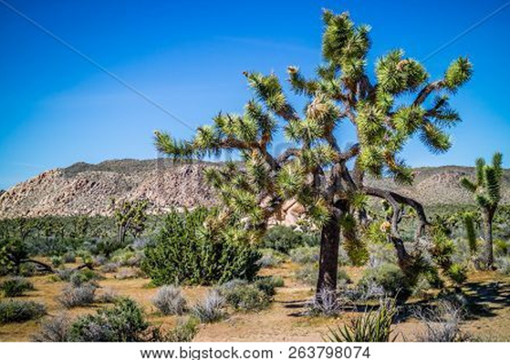

“A good man brings good things out of the good stored up in him, and an evil man brings evil things out of the evil stored up in him.”
~ Matthew 12:35 (NIV)

“For the mouth speaks what the heart is full of.”
~ Matthew 12:34b (NIV)

“For whatever is in your heart determines what you say.”
~ Matthew 12:34b (NLT)

“For out of the abundance of the heart the mouth speaks.”
~ Matthew 12:34b (ESV)

Live in the Light

…God is light and in Him is no darkness at all.

~ 1 John 1:5b (NKJV)

I pray that your hearts will be flooded with light so that you can understand the confident hope he has given to those he called…
~ Ephesians 1:18a (NLT)


The light shines in the darkness, and the darkness can never extinguish it.
~ John 1:5 (NLT)

You are all children of the light and children of the day. We do not belong to the night or to the darkness.
~ 1 Thessalonians 5:5 (NIV)

For you were once darkness, but now you are light in the Lord. Live as children of light…
~ Ephesians 5:8 (NIV)

If you are walking in darkness, without a ray of light,
trust in the Lord and rely on your God.
~ Isaiah 50:10b (NLT)

…the darkness is passing away and the true light is
already shining.
~ 1 John 2:8b (ESV)

The way of the righteous is like the first gleam of dawn, which shines ever brighter until the full light of day.
~ Proverbs 4:18 (NLT)
“Arise, shine, for your light has come, and the glory of
the Lord rises upon you.
“See, darkness covers the earth and thick darkness is
over the peoples, but the Lord rises upon you and his glory appears over you.”
~ Isaiah 60:1-2 (NIV)

“Feed the hungry, and help those in trouble.
“Then your light will shine out from the darkness, and
the darkness around you will be as bright as noon.”
~ Isaiah 58:10 (NLT)

The people walking in darkness
have seen a great light;
on those living in the land of deep darkness
a light has dawned.
~ Isaiah 9:2 (NIV)

Whoever says he is in the light and hates his brother is still in darkness.
~ 1 John 2:9 (ESV)

The night is nearly over; the day is almost here. So let us put aside the deeds of darkness and put on the armor of light.
~ Romans 13:12 (NIV)

…the day of the Lord will come like a thief in the night. While people are saying, “Peace and safety,” destruction will come on them suddenly, as labor pains on a pregnant woman, and they will not escape.
But you, brothers and sisters, are not in darkness so that this day should surprise you like a thief.
You are all children of the light and children of the day. We do not belong to the night or to the darkness.
So then, let us not be like others, who are asleep, but let us be awake and sober. For those who sleep, sleep at night, and those who get drunk, get drunk at night.
But since we belong to the day, let us be sober, putting on faith and love as a breastplate, and the hope of salvation as a helmet.
~ 1 Thessalonians 5:2b-8 (NIV)
Again Jesus spoke to them, saying,
“I am the light of the world. Whoever follows me will
not walk in darkness, but will have the light of life.”
~ John 8:12 (ESV)

“I have come as a light to shine in this dark world, so that all who put their trust in me will no longer remain in the dark.”
~ John 12:46 (NLT)

“You are the light of the world.
“A town built on a hill cannot be hidden.
“Neither do people light a lamp and put it under a bowl.
“Instead they put it on its stand, and it gives light to everyone in the house.
“In the same way, let your light shine before others,
that they may see your good deeds and glorify your
Father in heaven.”
~ Matthew 5:14-16 (NIV)



“Yes, I am sending you to the Gentiles to open their eyes, so they may turn from darkness to light and from the power of Satan to God.”
~ Acts 26:17b-18a (NLT)

The Armor of God

Finally, be strong in the Lord and in his mighty power.
Put on the full armor of God so that you can take your stand against the devil’s schemes.
For our struggle is not against flesh and blood, but
against the rulers,
against the authorities,
against the powers of this dark world and
against the spiritual forces of evil in the heavenly realms.
Therefore put on the full armor of God, so that when the day of evil comes, you may be able to stand your ground, and after you have done everything, to stand.
Stand firm then,
with the belt of truth buckled around your waist,
with the breastplate of righteousness in place, and
with your feet fitted with the readiness that comes from the gospel of peace.
In addition to all this,
take up the shield of faith, with which you can extinguish all the flaming arrows of the evil one.
Take the helmet of salvation
and the sword of the Spirit, which is the word of God.
And pray in the Spirit on all occasions with all kinds of prayers and requests.
With this in mind, be alert and always keep on praying
for all the Lord’s people.
Pray also for me, that whenever I speak, words may be given me so that I will fearlessly make known the mystery of the gospel, for which I am an ambassador in chains.
Pray that I may declare it fearlessly, as I should.

~ Ephesians 6:10-20 (NIV)

The Weapons God Gives Us for Victory

The weapons we fight with…have divine power to demolish strongholds.
~ 2 Corinthians 10:4 (NIV)

For though we live in the world, we do not wage war
as the world does. The weapons we fight with are not
the weapons of the world.
On the contrary, they have divine power to demolish strongholds.
~ 2 Corinthians 10:3-4 (NIV)

The Word of God

Take the helmet of salvation and the sword of the Spirit, which is the word of God.
~ Ephesians 6:17 (NIV)

For the word of God is living and powerful, and sharper than any two-edged sword, piercing even to the division
of soul and spirit, and of joints and marrow, and is a discerner of the thoughts and intents of the heart.
~ Hebrews 4:12 (NKJV)

God’s word lives in your hearts, and you have won your battle with the evil one.
~ 1 John 2:14b (NLT)

…the word of God abides in you, and you have overcome the evil one.
~ 1 John 2:14b (ESV)

Blessed is the one who does not walk in step with the wicked…but whose delight is in the law of the Lord,
and who meditates on his law day and night.
That person is like a tree planted by streams of water, which yields its fruit in season and whose leaf does
not wither—whatever they do prospers.
~ Psalm 1:1-3 (NIV)
Guide my steps by your word,
so I will not be overcome by evil.
~ Psalm 119:133 (NLT)

Order my steps in thy word:
and let not any iniquity have dominion over me.
~ Psalm 119:133 (KJV)

Direct my footsteps according to your word;
let no sin rule over me.
~ Psalm 119:133 (NIV)


Shutterstock Photo ID: 2521591241
Then Jesus was led by the Spirit into the wilderness to be tempted by the devil. After fasting forty days and forty nights, he was hungry. The tempter came to him and said, “If you are the Son of God, tell these stones to become bread.”
Jesus answered,
“It is written: ‘Man shall not live on bread alone, but on every word that comes from the mouth of God.’”
Then the devil took him to the holy city and had him stand on the highest point of the temple. “If you are the Son of God,” he said, “throw yourself down. For it is written:
‘He will command his angels concerning you, and they will lift you up in their hands, so that you will not strike your foot against a stone.’”
Jesus answered him,
“It is also written: ‘Do not put the Lord your God
to the test.’”
Again, the devil took him to a very high mountain and showed him all the kingdoms of the world and their splendor. “All this I will give you,” he said, “if you will
bow down and worship me.”
Jesus said to him,
“Away from me, Satan! For it is written:
‘Worship the Lord your God, and serve him only.’”
Then the devil left him, and angels came and attended him.
~ Matthew 4:1-11 (NIV)

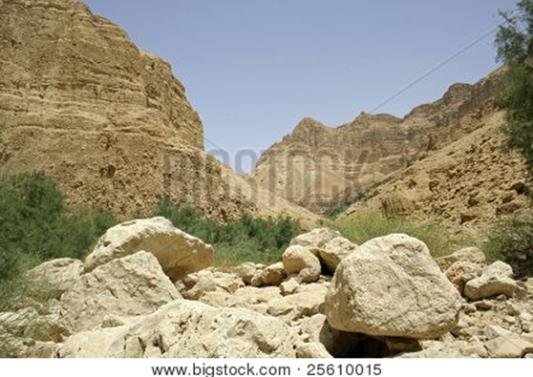

Desert landscape in Israel
Doing Good

Do not be overcome by evil, but overcome evil with good.
~ Romans 12:21 (ESV)

Turn from evil and do good;
then you will dwell in the land forever…
Wrongdoers will be completely destroyed;
the offspring of the wicked will perish.
The righteous will inherit the land
and dwell in it forever.
~ Psalm 37:27-29 (NIV)

And you know that God anointed Jesus of Nazareth with the Holy Spirit and with power. Then Jesus went around doing good and healing all who were oppressed by the devil, for God was with him.
~ Acts 10:38 (NLT)

“Feed the hungry, and help those in trouble. Then your light will shine out from the darkness, and the darkness around you will be as bright as noon.”
~ Isaiah 58:10 (NLT)

Let us not become weary in doing good, for at the proper time we will reap a harvest if we do not give up.
~ Galatians 6:9 (NIV)

Fasting

“Is not this the kind of fasting I have chosen:
to loose the chains of injustice
and untie the cords of the yoke,
to set the oppressed free
and break every yoke?
“Is it not to share your food with the hungry
and to provide the poor wanderer with shelter—
when you see the naked, to clothe them,
and not to turn away from your own flesh and blood?
“Then your light will break forth like the dawn,
and your healing will quickly appear;
then your righteousness will go before you,
and the glory of the Lord wil l be your rear guard.”
~ Isaiah 58:6-8 (NIV)
Prayer

The prayer of a righteous person is powerful and effective.
~ James 5:16b (NIV)

The Lord is far from the wicked, but he hears the prayer of the righteous.
~ Proverbs 15:29 (ESV)

Afterward, when Jesus was alone in the house with his disciples, they asked him, “Why couldn’t we cast out that evil spirit?”
Jesus replied, “This kind can be cast out only by prayer.”
~ Mark 9:28-29 (NLT)

“Simon, Simon, Satan has asked to sift all of you as wheat. But I have prayed for you, Simon…”
~ Luke 22:31-32a (NIV)

“My prayer is not for the world, but for those you have given me…keep them safe from the evil one.”
~ John 17:9a, 15b (NLT)

“And lead us not into temptation, but deliver us from evil: For thine is the kingdom, and the power, and the glory, for ever. Amen.”
~ Matthew 6:13 (KJV)

Forgiveness

…I have forgiven in the sight of Christ for your sake,
in order that Satan might not outwit us. For we are
not unaware of his schemes.
~ 2 Corinthians 2:10b-11 (NIV)

…I have forgiven that one for your sakes in the presence of Christ, lest Satan should take advantage of us; for we are
not ignorant of his devices.

~ 2 Corinthians 2:10b-11 (NKJV)

Do not let the sun go down while you are still angry,
and do not give the devil a foothold.
~ Ephesians 4:26b-27 (NIV)

…give no opportunity to the devil.
~ Ephesians 4:27 (ESV)
The Holy Spirit

But you belong to God, my dear children.
You have already won a victory over those people, because the Spirit who lives in you is greater than the spirit who lives in the world.
~ 1 John 4:4 (NLT)

…greater is he that is in you, than he that is in the world.
~ 1 John 4:4b (KJV)


The Name of Jesus

…God has highly exalted him and bestowed on him the name that is above every name…
~ Philippians 2:9 (ESV)

…God exalted him to the highest place
and gave him the name that is above every name,
that at the name of Jesus every knee should bow,
in heaven and on earth and under the earth,
and every tongue acknowledge that Jesus Christ is Lord…
~ Philippians 2:9-11a (NIV)

The seventy-two [disciples] returned with joy and said,
“Lord, even the demons submit to us in your name.”
~ Luke 10:17 (NIV)

John said to him, “Teacher, we saw someone casting out demons in your name, and we tried to stop him...”
But Jesus said, “Do not stop him, for no one who does a mighty work in my name will be able soon afterward to speak evil of me.”
~ Mark 9:38-39 (ESV)

“And these signs will accompany those who believe:
“In my name they will drive out demons; they will speak in new tongues; they will pick up snakes with their hands; and when they drink deadly poison, it will not hurt them at all; they will place their hands on sick people, and they will get well.”
~ Mark 16:17-18 (NIV)

Paul, having become greatly annoyed, turned and said to the spirit,
“I command you in the name of Jesus Christ to come out of her.”
And it came out that very hour.
~ Acts 16:18b (ESV)

Let me clearly state to all of you…that he was healed
by the powerful name of Jesus Christ the Nazarene…
Praise God for the privilege of being called by his name!

~ 1 Peter 4:16b (NLT)

Lord, there is no one like you!
For you are great, and your name is full of power.
~ Jeremiah 10:6 (NLT)

O Lord, our Lord, how majestic is your name in all the earth! You have set your glory above the heavens.

~ Psalm 8:1 (ESV)

…you have exalted above all things
your name and
your word.
~ Psalm 138:2b (ESV)

Let them praise your great and awesome name.
Your name is holy!
~ Psalm 99:3 (NLT)

Let them praise the name of the Lord,
For His name alone is exalted;
His glory is above the earth and heaven.
~ Psalm 148:13 (NKJV)

From the west, people will fear the name of the Lord,
and from the rising of the sun, they will revere his glory.
~ Isaiah 59:19a (NIV)

From the rising of the sun to its setting, the name of the Lord is to be praised!
~ Psalm 113:3 (ESV)


Bigstock Photo ID: 150309773
The Blood of Jesus

…and the blood of Jesus Christ His Son cleanses us
from all sin.
~ 1 John 1:7b (NKJV)

Then he took a cup, and when he had given thanks, he gave it to them, saying,
“Drink from it, all of you. This is my blood of the covenant, which is poured out for many for the forgiveness of sins.”
~ Matthew 26:27-28 (NIV)

The great dragon was hurled down—that ancient serpent called the devil, or Satan, who leads the whole world astray. He was hurled to the earth, and his angels with him.
Then I heard a loud voice in heaven say: “Now have come the salvation and the power and the kingdom of our God, and the authority of his Messiah. For the accuser of our brothers and sisters, who accuses them before our God day and night, has been hurled down.
“They triumphed over him by the blood of the Lamb and by the word of their testimony; they did not love their lives so much as to shrink from death.”
~ Revelation 12:9-11 (NIV)

And having disarmed the powers and authorities, he
made a public spectacle of them, triumphing over them by the cross.
~ Colossians 2:15 (NIV)


Obedience to God

Submit yourselves, then, to God. Resist the devil, and he will flee from you.
~ James 4:7 (NIV)

Even though Jesus was God’s Son, he learned obedience from the things he suffered.
~ Hebrews 5:8 (NLT)

During the days of Jesus’ life on earth, he offered up prayers and petitions…and he was heard because of
his reverent submission.
~ Hebrews 5:7 (NIV)

Jesus said to him, “Away from me, Satan! For it is written: ‘Worship the Lord your God, and serve him only.’”
~ Matthew 4:10 (NIV)

Then Jesus went with them to the olive grove called Gethsemane…and bowed with his face to the ground, praying,
“My Father! If it is possible, let this cup of suffering be taken away from me. Yet I want your will to be done,
not mine.”
~ Matthew 26:36-39 (NLT)

Then those who feared the Lord talked with each other, and the Lord listened and heard. A scroll of remembrance was written in his presence concerning those who feared the Lord and honored his name.
“On the day when I act,” says the Lord Almighty, “they will be my treasured possession. I will spare them, just as a father has compassion and spares his son who serves him.
“And you will again see the distinction between the righteous and the wicked, between those who serve God and those who do not.”
~ Malachi 3:16-18 (NIV)

I know that you are pleased with me,
for my enemy does not triumph over me.
Because of my integrity you uphold me
and set me in your presence forever.
~ Psalm 41:11-12 (NIV)
Living in Righteousness

Stand firm then, with the…breastplate of righteousness
in place…
~ Ephesians 6:14 (NIV)

We use the weapons of righteousness in the right hand
for attack and the left hand for defense.
~ 2 Corinthians 6:7b (NLT)

We know that God’s children do not make a practice of sinning, for God’s Son holds them securely, and the
evil one cannot touch them.
~ 1 John 5:18 (NLT)

So now we can tell who are children of God and who are children of the devil. Anyone who does not live righteously and does not love other believers does not belong to God.
~ 1 John 3:10 (NLT)

The eyes of the Lord are on the righteous,
and his ears are attentive to their cry;
but the face of the Lord is against those who do evil,
to blot out their name from the earth.
~ Psalm 34:15-16 (NIV)

Surely, Lord, you bless the righteous; you surround them with your favor as with a shield.
~ Psalm 5:12 (NIV)


Praise

May the praise of God be in their mouths and a double-edged sword in their hands…
~ Psalm 149:6 (NIV)

Through the praise of children and infants you have established a stronghold against your enemies…
~ Psalm 8:2a (NIV)

...thanks be to God, who gives us the victory through our Lord Jesus Christ.
~ 1 Corinthians 15:57 (ESV)

Through Jesus, therefore, let us continually offer to God
a sacrifice of praise—the fruit of lips that openly profess his name.
~ Hebrews 13:15 (NIV)

After consulting the people, Jehoshaphat appointed men
to sing to the Lord and to praise him for the splendor of
his holiness as they went out at the head of the army, saying:
“Give thanks to the Lord, for his love endures forever.”
As they began to sing and praise, the Lord set ambushes against the men…who were invading Judah, and they were defeated.
~ 2 Chronicles 20:21-22 (NIV)

Around midnight Paul and Silas were praying and singing hymns to God, and the other prisoners were listening.
Suddenly, there was a massive earthquake, and the prison was shaken to its foundations.
All the doors immediately flew open, and the chains of every prisoner fell off!
~ Acts 16:25-26 (NLT)

“For my own name’s sake I delay my wrath;
for the sake of my praise I hold it back from you,
so as not to destroy you completely.”
~ Isaiah 48:9 (NIV)
Be exalted, O God, above the heavens, and Your glory above all the earth…
~ Psalm 108:5 (NKJV)

How great you are, O Sovereign Lord!
There is no one like you.
~ 2 Samuel 7:22a (NLT)

O Lord my God, you are very great!
You are clothed with splendor and majesty…

~ Psalm 104:1b (ESV)

Before the mountains were born
or you brought forth the whole world,
from everlasting to everlasting you are God.

~ Psalm 90:2 (NIV)



...you are holy, enthroned on the praises of Israel.

~ Psalm 22:3 (ESV)
Yours, O Lord, is the greatness, the power, the glory,
the victory, and the majesty.
Everything in the heavens and on earth is yours, O Lord, and this is your kingdom.
We adore you as the one who is over all things.
~ 1 Chronicles 29:11 (NLT)

You alone are the Lord.
You made the heavens, even the highest heavens, and all their starry host, the earth and all that is on it, the seas and all that is in them.
You give life to everything, and the multitudes of heaven worship you.

~ Nehemiah 9:6 (NIV)

O Lord…you alone are the God who is in heaven.
You are ruler of all the kingdoms of the earth.
You are powerful and mighty; no one can stand against you!
~ 2 Chronicles 20:6b (NLT)

Wealth and honor come from you alone, for you rule over everything.
Power and might are in your hand, and at your discretion people are made great and given strength.

~ 1 Chronicles 29:12 (NLT)

Who is like you—majestic in holiness, awesome in glory, working wonders?

~ Exodus 15:11b (NIV)

All your works praise you, Lord;
your faithful people extol you.
They tell of the glory of your kingdom
and speak of your might,
so that all people may know of your mighty acts
and the glorious splendor of your kingdom.
Your kingdom is an everlasting kingdom,
and your dominion endures through all generations.
~ Psalm 145:10-13a (NIV)
Faith

…take up the shield of faith, with which you can extinguish all the flaming arrows of the evil one.
~ Ephesians 6:16b (NIV)

For every child of God defeats this evil world, and
we achieve this victory through our faith.
~ 1 John 5:4 (NLT)

Who is it that overcomes the world?
Only the one who believes that Jesus is the Son of God.
~ 1 John 5:5 (NIV)

…a man came to Him, kneeling down to Him and saying, “Lord, have mercy on my son, for he is an epileptic and suffers severely…So I brought him to Your disciples, but they could not cure him.”
Then Jesus answered and said, “O faithless and perverse generation, how long shall I be with you? How long shall
I bear with you? Bring him here to Me.”
And Jesus rebuked the demon, and it came out of him; and the child was cured from that very hour.
Then the disciples came to Jesus privately and said,
“Why could we not cast it out?”
So Jesus said to them, “Because of your unbelief; for assuredly, I say to you, if you have faith as a mustard seed, you will say to this mountain, ‘Move from here to there,’ and it will move; and nothing will be impossible for you.”
~ Matthew 17:14b-20 (NKJV)

I have fought the good fight,
I have finished the race,
I have kept the faith.
Now there is in store for me the crown of righteousness, which the Lord, the righteous Judge, will award to me
on that day—and not only to me, but also to all who have longed for his appearing.
~ 2 Timothy 4:7-8 (NIV)

Jesus Saves

…the Son of God came to destroy the works of the devil.
~ 1 John 3:8b (NLT)

And then the lawless one will be revealed, whom the Lord Jesus will overthrow with the breath of his mouth and destroy by the splendor of his coming.

~ 2 Thessalonians 2:8 (NIV)

“The thief comes only to steal and kill and destroy.
“I came that they may have life and have it abundantly.”
~ John 10:10 (ESV)


“I will build
my church,
and all the powers of hell will not conquer it.”
~ Matthew 16:18b (NLT)

“I will build
my church,
and the gates
of hell shall
not prevail against it.”
~ Matthew 16:18b (ESV)

Who will free me from this life that is dominated by sin and death? Thank God! The answer is in Jesus Christ our Lord.

~ Romans 7:24b-25a (NLT)

This includes you who were once far away from God.
You were his enemies, separated from him by your evil thoughts and actions. Yet now he has reconciled you to himself through the death of Christ in his physical body.

~ Colossians 1:21-22a (NLT)

Jesus Offers Eternal Life

God loves you abundantly, and has made a way for you to live forever in His glorious kingdom. However, first He had to pay an enormous price for you to be forgiven of your sin, in order to receive this eternal glory. This section explains His plan to forgive and save you. In summary:
God loves you, but your sin separates you from Him, and because of it, God’s wrath will come. However, Jesus died as a sacrifice to save you from your sins, from God’s wrath, and from death itself. When you confess your sins, repent and accept the salvation that Christ offers, God will forgive you. By trusting in Christ you become God’s child, and as His child, you will inherit eternal life and heaven will be your home.

God Loves You

…God loves you and has chosen you to be his own people.
~ 1 Thessalonians 1:4b (NLT)

Even before he made the world, God loved us and chose us in Christ to be holy and without fault in his eyes.
~ Ephesians 1:4 (NLT)

But Your Sin Separates You from God

But your iniquities have separated you from your God;

And your sins have hidden His face from you,

So that He will not hear.
~ Isaiah 59:2 (NKJV)

The Day of God’s Wrath Will Come

“For a fire will be kindled by my wrath,
one that burns down to the realm of the dead below.
It will devour the earth and its harvests
and set afire the foundations of the mountains.”
~ Deuteronomy 32:22 (NIV)

Confess Your Sin and Repent

The Lord is…not willing that any should perish but that all should come to repentance.
~ 2 Peter 3:9 (NKJV)
Jesus Died to Save You…

…From Your Sin

Jesus gave his life for our sins, just as God our Father planned, in order to rescue us from this evil world in which we live.
~ Galatians 1:4 (NLT)

…that He might deliver us from this present evil age…
~ Galatians 1:4b (NKJV)

…From God’s Wrath

Jesus, whom God raised from the dead…is the one who has rescued us from the terrors of the coming judgment.
~ 1 Thessalonians 1:10b (NLT)

…From Death

For the wages of sin is death, but the free gift of God is eternal life in Christ Jesus our Lord.
~ Romans 6:23 (ESV)

Because God’s children are human beings—made of flesh and blood—the Son also became flesh and blood. For only as a human being could he die, and only by dying could he break the power of the devil, who had the power of death.
~ Hebrews 2:14 (NLT)

God Bought You at a Price

You are not your own; you were bought at a price.
~ 1 Corinthians 6:19b-20a (NIV)

“I don’t have much more time to talk to you, because the ruler of this world approaches. He has no power over me, but I will do what the Father requires of me...”
~ John 14:30-31a (NLT)

He went on a little farther and bowed…praying,
“My Father! If it is possible, let this cup of suffering be taken away from me.
“Yet I want your will to be done, not mine.”
~ Matthew 26:39 (NLT)
In Christ You Are Forgiven

Then God made you alive with Christ, for he forgave
all our sins. He canceled the record of the charges against us and took it away by nailing it to the cross.
~ Colossians 2:13b-14 (NLT)

…because Jesus lives forever…he is able, once and forever, to save those who come to God through him. He lives forever to intercede with God on their behalf.
~ Hebrews 7:24-25 (NLT)

God Demonstrates His Love Through Christ

“For God so loved the world that He gave His only begotten Son, that whoever believes in Him should
not perish but have everlasting life.”
~ John 3:16 (NKJV)

Salvation is Through Christ Alone

Salvation is found in no one else, for there is no other name under heaven given to mankind by which we must be saved.
~ Acts 4:12 (NIV)

Jesus said to him, “I am the way, the truth, and the life. No one comes to the Father except through Me.”
~ John 14:6 (NKJV)

Salvation is a Gift: Free and Undeserved

For it is by grace you have been saved, through faith—
and this not from yourselves, it is the gift of God—
not by works, so that no one can boast.
~ Ephesians 2:8-9 (NIV)

Accept This Gift of Salvation

If you declare with your mouth, “Jesus is Lord,” and believe in your heart that God raised him from the dead, you will be saved.
~ Romans 10:9 (NIV)
You Belong to God Through Faith in Christ
and Have Become His Child

See what great love the Father has lavished on us, that we should be called children of God!
~ 1 John 3:1a (NIV)

Eternal Life is Yours Through Christ

Jesus answered him,
“Truly I tell you, today you will be with me in paradise.”
~ Luke 23:43 (NIV)

“…whoever comes to me I will never drive away.”
~ John 6:37b (NIV)

Heaven is Your Home

Because of God’s tender mercy, the morning light from heaven is about to break upon us, to give light to those who sit in darkness and in the shadow of death, and to guide us to the path of peace.

~ Luke 1:78-79 (NLT)

Point out anything in me that offends you, and lead me along the path of everlasting life.

~ Psalm 139:24 (NLT)

You make known to me the path of life;
you will fill me with joy in your presence,
with eternal pleasures at your right hand.

~ Psalm 16:11 (NIV)



Jesus Has Authority

The Lord will rescue me from every evil attack and
will bring me safely to his heavenly kingdom.
~ 2 Timothy 4:18a (NIV)

Jesus Has Authority Over Demonic Spirits

When Jesus climbed out of the boat, a man possessed
by an evil spirit came out from the tombs to meet him.
This man lived in the burial caves and could no longer
be restrained, even with a chain…
Day and night he wandered among the burial caves and in the hills, howling and cutting himself with sharp stones.
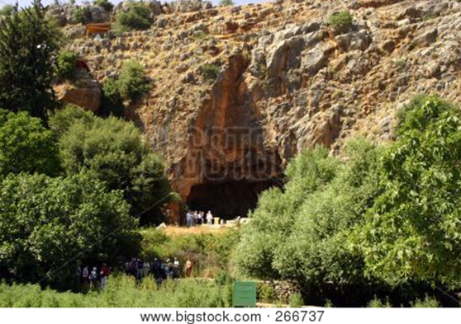

Cave in Israeli desert

When Jesus was still some distance away, the man saw him, ran to meet him, and bowed low before him. With a shriek, he screamed, “Why are you interfering with me, Jesus, Son of the Most High God?”...
Then Jesus demanded, “What is your name?” And he replied, “My name is Legion, because there are many of
us inside this man.” Then the evil spirits begged him again and again not to send them to some distant place.
There happened to be a large herd of pigs feeding on the hillside nearby. “Send us into those pigs,” the spirits begged. “Let us enter them.”
So Jesus gave them permission. The evil spirits came out of the man and entered the pigs, and the entire herd of about 2,000 pigs plunged down the steep hillside into the lake and drowned in the water.
The herdsmen fled to the nearby town and the surrounding countryside, spreading the news as they ran. People rushed out to see what had happened.
A crowd soon gathered around Jesus, and they saw the man who had been possessed by the legion of demons.
He was sitting there fully clothed and perfectly sane, and they were all afraid.
Then those who had seen what happened told the others about the demon-possessed man and the pigs. And the crowd began pleading with Jesus to go away and leave them alone.
As Jesus was getting into the boat, the man who had been demon possessed begged to go with him. But Jesus said, “No, go home to your family, and tell them everything the Lord has done for you and how merciful he has been.”
~ Mark 5:2-19 (NLT)

Then Jesus went to Capernaum, a town in Galilee, and taught there in the synagogue every Sabbath day. There, too, the people were amazed at his teaching, for he spoke with authority.
Once when he was in the synagogue, a man possessed by a demon—an evil spirit—began shouting at Jesus, “Go away! Why are you interfering with us, Jesus of Nazareth?
Have you come to destroy us? I know who you are—the Holy One sent from God!” Jesus cut him short. “Be quiet! Come out of the man,” he ordered. At that, the demon threw the man to the floor as the crowd watched; then
it came out of him without hurting him further.
Amazed, the people exclaimed, “What authority and power this man’s words possess! Even evil spirits obey him, and they flee at his command!” The news about Jesus spread through every village in the entire region.
~ Luke 4:31-37 (NLT)
And demons also came out of many, crying, “You are the Son of God!” But he rebuked them and would not allow them to speak, because they knew that he was the Christ.
~ Luke 4:41 (ESV)

Jesus Gives His Followers Authority

“…I have given you authority over all the power of the enemy…”
~ Luke 10:19a (NLT)

One day Jesus called together his twelve disciples and gave them power and authority to cast out all demons
and to heal all diseases.
Then he sent them out to tell everyone about the
Kingdom of God and to heal the sick.
~ Luke 9:1-2 (NLT)

Jesus called his twelve disciples to him and gave them authority to drive out impure spirits and to heal every disease and sickness…
These twelve Jesus sent out with the following instructions:
“…proclaim this message: ‘The kingdom of heaven has come near.’
“Heal the sick, raise the dead, cleanse those who have leprosy, drive out demons.
“Freely you have received; freely give…
“I am sending you out like sheep among wolves. Therefore be as shrewd as snakes and as innocent as doves.”
~ Matthew 10:1-16 (NIV)

After this the Lord appointed seventy-two others and
sent them two by two ahead of him to every town and place where he was about to go.
He told them, “The harvest is plentiful, but the workers are few. Ask the Lord of the harvest, therefore, to send out workers into his harvest field.
“Go! I am sending you out like lambs among wolves…”
The seventy-two returned with joy and said,
“Lord, even the demons submit to us in your name.”
He replied, “I saw Satan fall like lightning from heaven.
“I have given you authority to trample on snakes and scorpions and to overcome all the power of the enemy; nothing will harm you.
“However, do not rejoice that the spirits submit to you, but rejoice that your names are written in heaven.”
~ Luke 10:1-20 (NIV)

Later Jesus appeared to the Eleven…He said to them,
“Go into all the world and preach the gospel to all creation.”
~ Mark 16:14-15 (NIV)

Then Jesus came to them and said,
“All authority in heaven and on earth has been given to me.
“Therefore go
and make disciples of
all nations, baptizing them in the name of the Father and of the Son and of the Holy Spirit, and teaching
them to obey everything
I have commanded you.
“And surely I am with you always, to the very end of the age.”
~ Matthew 28:18-20 (NIV)

Trust God for Victory

The God of peace will soon crush Satan under your feet.
~ Romans 16:20a (ESV)

For he has rescued us from the dominion of darkness
and brought us into the kingdom of the Son he loves…
~ Colossians 1:13 (NIV)

“…no weapon turned against you will succeed.
“You will silence every voice raised up to accuse you.
“These benefits are enjoyed by the servants of the Lord; their vindication will come from me.
“I, the Lord, have spoken!”
~ Isaiah 54:17b (NLT)

Your right hand, Lord,
was majestic in power.
Your right hand, Lord,
shattered the enemy.
~ Exodus 15:6 (NIV)

…we are more than conquerors
through Him who loved us.
~ Romans 8:37b (NKJV)

The Lord shall preserve thee from all evil:
he shall preserve thy soul.
~ Psalm 121:7 (KJV)

Do not fret because of those who are evil
or be envious of those who do wrong;
for like the grass they will soon wither,
like green plants they will soon die away…
Be still before the Lord
and wait patiently for him…
Refrain from anger and turn from wrath;
do not fret—it leads only to evil.
For those who are evil will be destroyed,
but those who hope in the Lord will inherit the land.
~ Psalm 37:1-9 (NIV)
…the Lord is faithful, and he will strengthen you and protect you from the evil one.
~ 2 Thessalonians 3:3 (NIV)

For the eyes of the Lord run to and fro throughout the whole earth, to show Himself strong on behalf of those whose heart is loyal to Him.
~ 2 Chronicles 16:9a (NKJV)


If you make the Lord your refuge, if you make the
Most High your shelter, no evil will conquer you…
~ Psalm 91:9-10a (NLT)

The Lord will rescue me from every evil attack and
will bring me safely to his heavenly kingdom.
To him be glory for ever and ever. Amen.
~ 2 Timothy 4:18 (NIV)



Booklet Titles in the Series



www.TheWordOfGodSeries.com

Booklet Titles in the Series



www.TheWordOfGodSeries.com

Booklet Titles in the Series

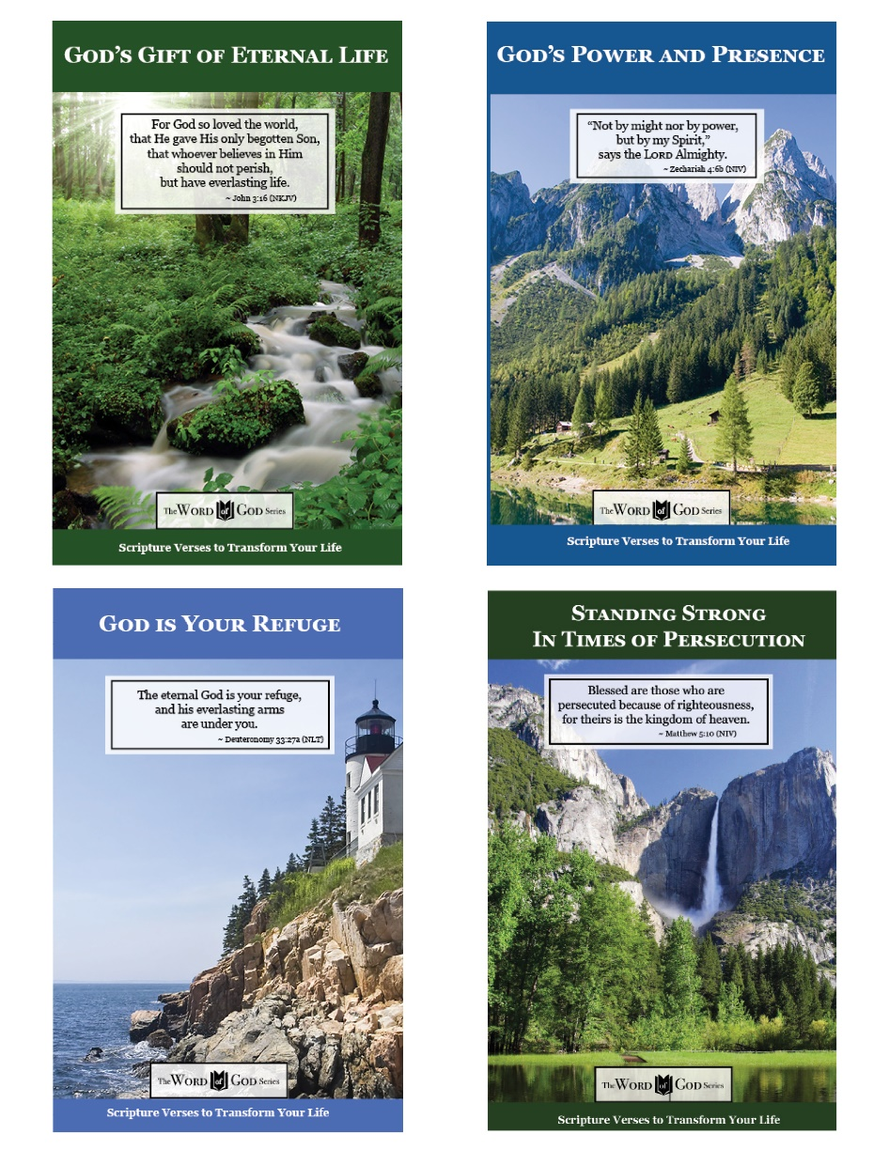

www.TheWordOfGodSeries.com

Booklet Titles in the Series

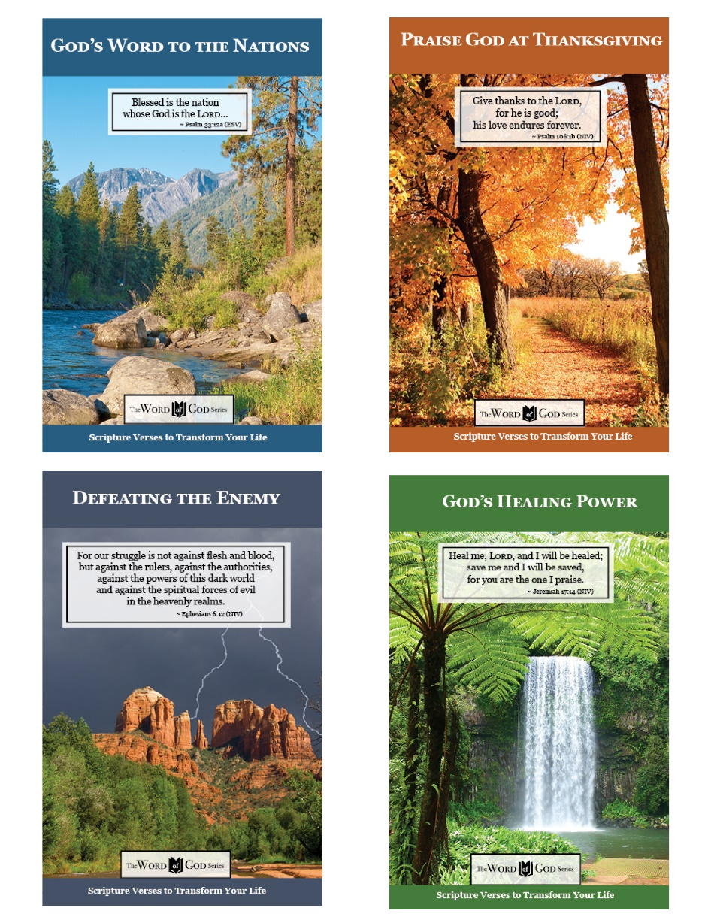

www.TheWordOfGodSeries.com

Booklet Titles in the Series

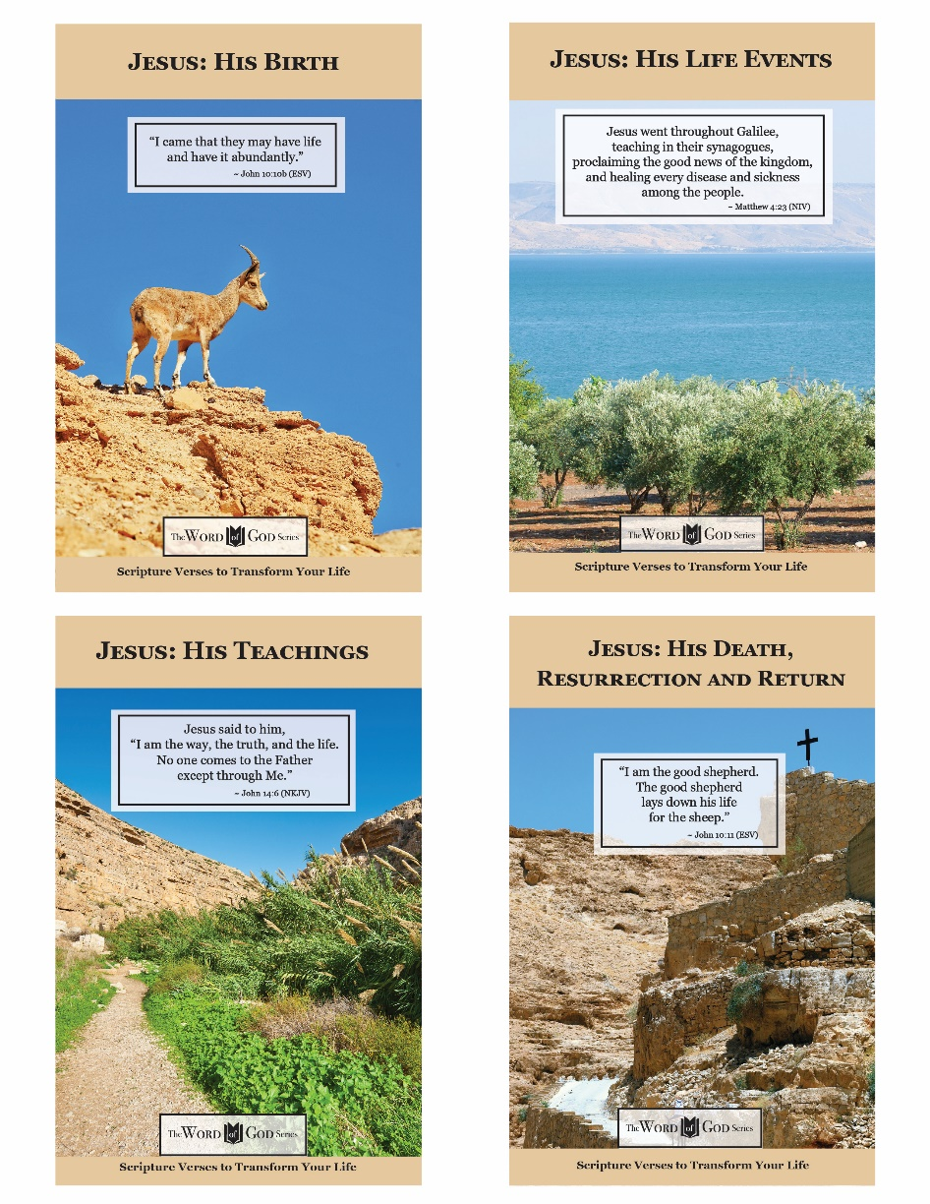

www.TheWordOfGodSeries.com

Photo Copyright Info

Note: when purchasing the rights to use the photos,
you may want to purchase an Extended License
for the cover image.


Bigstock Photo ID: 31299659
Lion King
Direct frontal shot of a Lion roaring.
Stock Photo ID: 31299659
Copyright: Andrew Blue
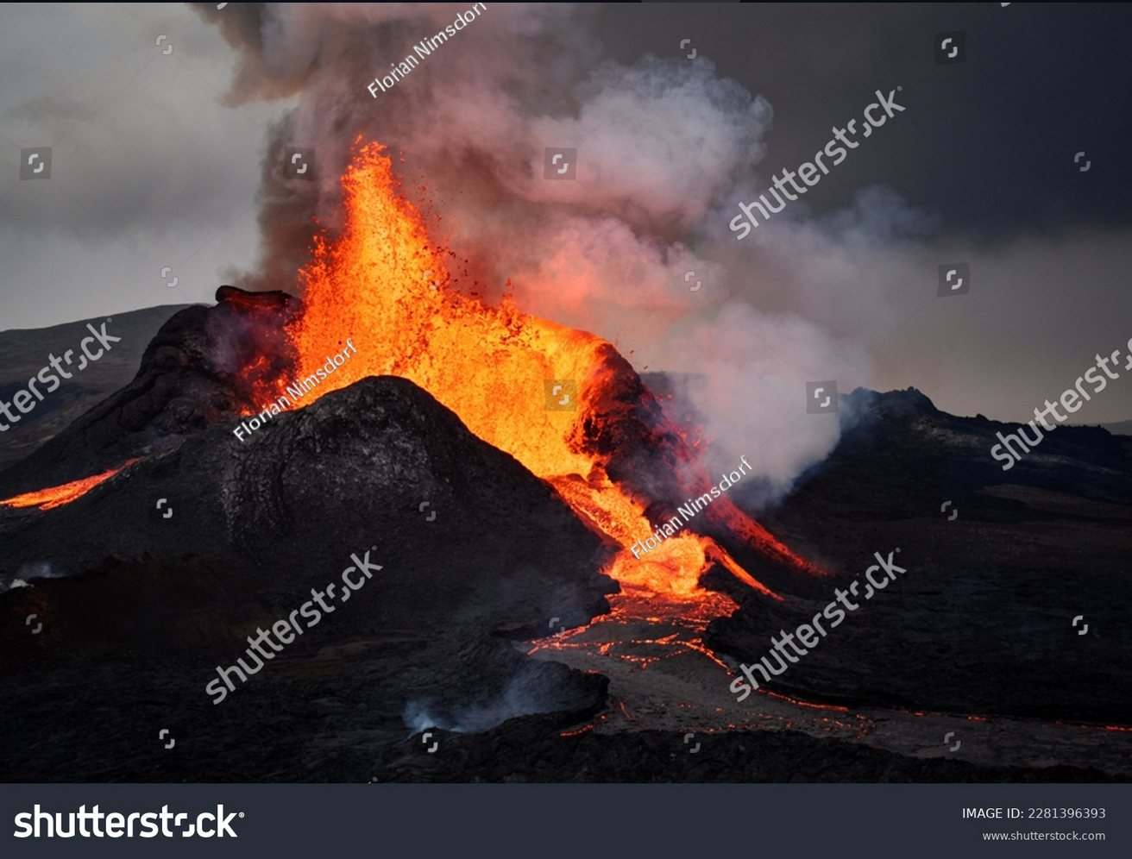
Shutterstock Photo ID: 2281396393
Fagradalsfjall volcano eruption on Reykjanes peninsula, Iceland.
Florian Nimsdorf
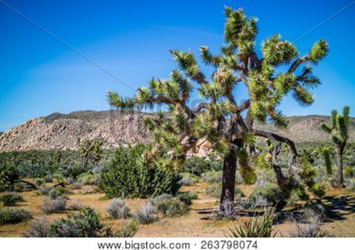
Bigstock Photo ID: 263798074
Joshua Trees in Joshua Tree National Park, California
Stock Photo ID: 263798074
Copyright: CheriAlguire

Bigstock Photo ID: 6062263
bright rays of sun in deep summer forest
Stock Photo ID: 6062263
Copyright: jordano2000


Bigstock Photo ID: 1841054
Scenic Night View Of Colorful Village
Scenic night view of colorful village Manarola in Cinque Terre Italy ** Note: Slight graininess, best at smaller sizes
Stock Photo ID: 51841054
Copyright: MartinM303

Shutterstock Photo ID: 2521591241
Steps of rock in a pretty park setting with lush greenery and a blue sky
Susan's Nature Photos

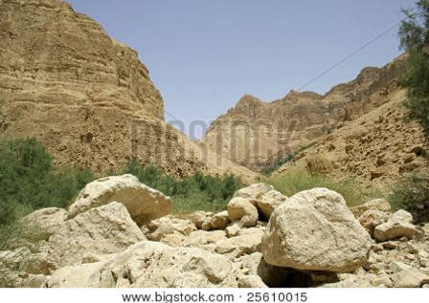
Bigstock Photo ID: 25610015
Desert landscape in the dead sea region
Stock Photo ID: 25610015
Copyright: paul prescott

Bigstock Photo ID: 91680221
View of exotic paradise bay on Phi Phi Island, Phuket, Thailand
Stock Photo ID: 91680221
Copyright: ankamonika


Bigstock Photo ID: 150309773
Editing suggestion: Crop out half of sky, and slightly crop bottom of photo
Silhouette of mount Athos at sunrise or sunset with light rays and sea panorama in Greece
Stock Photo ID: 150309773
Copyright: Kisa_Markiza


Bigstock Photo ID: 6510989
Editing suggestion: Crop out some of the darker portions of the bottom of cross photo

Llanddwyn Island a beautiful place with lighthouses crosses and ruins
Stock Photo ID: 6510989
Copyright: GailJohnson


Bigstock Photo ID: 26001467
Editing suggestion: Crop out the distracting leaf on left side
St. Marija monastery on litle island in national park Mljet, Croatia
by Aleksandar Todorovic, Stock Photo 26001467


Bigstock Photo ID: 3100261
Editing suggestion: Crop out a third of the sky and slightly crop bottom of river photo
Mountain Top Lake
View of a lake in the cascade mountains taken while backpacking.
by alwashbu, Stock Photo 3100261

Bigstock Photo ID: 51468880
Small stone church in forest Elenite Bulgaria
Stock Photo ID: 51468880
Copyright: Martina_L


Bigstock Photo ID: 434209493
Path through a spring forest in bright sunshine. Shallow depth of field. Wide photo.
Stock Photo ID: 434209493
Copyright: AlinaMD

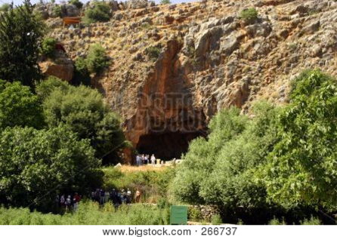
Bigstock Photo ID: 266737
Editing suggestion: Use cloning tool to remove people from photo
israelian desert
Stock Photo ID: 266737
Copyright: nanolsonka

Bigstock Photo ID: 21161411
traveling in europe. lovely alpine landscape.
Stock Photo ID: 21161411
Copyright: nagib


Bigstock Photo ID: 2412915
Storm Over Cathedral Rock
Beautiful view of Cathedral Rock lit by the sun with stormy skies and lightning in the background
Stock Photo ID: 2412915
Copyright: alexeys


Bigstock Photo ID: 8331170
Colourful sunrise with morning dew at a lake
Stock Photo ID: 8331170
Copyright: Peter Wollinga

