Template for Freedom from Addictions
The Word of God Series is a collection of 20 booklets that present Scripture verses in an easy-to-read format, with each booklet focused on a different topic.
Titles include Healthy Relationships, A Joy-Filled Life, Freedom from Depression, and many others.
The booklets are available in both paperback and digital formats at www.TheWordOfGodSeries.com or Amazon.com.
Why This Template?
Because I believe in the power of God’s Word to transform people’s lives, I have dedicated several years of my life to
bring this series to fruition.
I am passionate about using these booklets to reach
a dark and dying world with the love of Christ and
the hope of the Gospel.
Initially, I had expected this series would be a small business. But one day, when I asked God what my next steps should be,
He spoke to me through His Word and told me to:
“…complete the ministry God has given you.”
~ 2 Timothy 4:5 (NLT, 1996 version)
So, I shifted the focus from a business to a ministry.
My vision, also, has evolved over time and I have come to believe that it is possible for millions of these booklets to be distributed (in both print and digital formats) around the world (see the document entitled The Vision at www.TheWordOfGodSeries.com for more info.)
In order to make this a far-reaching ministry, accessing populations that I couldn’t on my own, I decided to invite others to partner with me in producing and distributing these booklets to their own personal networks. To help get it started, I have made templates of each booklet freely available to anyone who would like them.
This way you (whether you are a church, Christian organization or an individual) can easily re-create the booklets in your own ministry’s name, and distribute them to the people you minister to.
I hope that this template will save you:
- Time – so you can benefit from the thousands of hours
of development time that has been invested so far
- Money – eliminate layers of profit margin, and save on shipping costs (especially for large quantities)

Whether you simply replicate and reproduce what has already been done, build on it, or take this idea in a different direction, you won’t have to waste time starting with a blank page.
I hope you can easily get these finalized and printed, so you can begin sharing them with the people in your sphere of influence.
On the following pages you will find document formatting and printing tips.
Photo editing tips are also presented, as well as the preview images of each photo (with the Photo ID#), so you to easily find it on either bigstockphoto.com or shutterstock.com.

Photo Editing Tips
At the end of this document you will find the copyright and descriptive info for each photo in the booklet, as well as editing suggestions for a few of them.
Many photos will need to be slightly stretched or cropped to fit the page.
Most of the editing suggestions below (especially brightening or increasing color saturation) should be very slight adjustments.
Editing photos within this document
Wrapping text around the photo: Doubleclick the photo, click
on Wrap Text and select Square. Then, drag the image by the corner until it is the right size to wrap the text around it.
Rotate: Doubleclick the photo, click on the Rotate Object icon.

Editing photos in the Pictures editing app in MS Word
Navigate to your Pictures folder, doubleclick the photo, and click on the blue Edit button on left
Most of the editing can be done by using one of these 3 options:


Crop: Click on the Crop icon and drag edges to desired spot
Brighten a photo: Adjustment icon / Light / Brightness
Increase color saturation: Adjustment icon / Color / Saturation or Warmth
Remove distracting elements from a photo: Click on the Generative Erase icon, select a brush size and click on the part of the photo you want removed.

Photo Searching Tips
Occasionally photographers pull their photos from the sites,
so there may be some in this booklet that are no longer available.
You can try using the same key words to search for the photo
on other sites (scroll to the end of this document for more descriptive information about each photo.)
Or, you can search for another photo on Bigstock. Under
All Images select Photos and search by key word. At the next screen, make sure that Safe Search is on. In the Category field, select either Landscapes, Nature or Animals.

Booklet Formatting Tips
If you make any changes to this document that results in changing the number of lines on a page, then the page will need to be re-formatted for everything to fit.
Often changing the spacing between the characters or between the lines in one verse is enough to re-format it.
Changing the spacing between the characters
Home / Font / Advanced / Character Spacing
Choose Expanded or Condensed, and select a numeric value (best from .1 to .3)


Changing the spacing between the lines
Highlight all the text in the passage or page and click on:
Layout / Paragraph / Line Spacing / Multiple
Select a numeric value (best from .98 to 1.02)


Saving the document as a PDF
Adobe Acrobat Pro subscriptions are available at www.adobe.com/creativecloud/plans.html. You could also
ask your library tech center if they carry Adobe products.
When the Word doc is final: File / Save as Adobe PDF

Viewing the PDF as a booklet
Remove the first blank page of the doc: Edit / Trash icon.
Enter pages 1 to 1 to delete. Then exit from the Edit mode.
To view the document as a booklet, click on the page icon
(on right side of page, below the rotate button) and select
Two-page view and Show cover page.


Adding page numbers to the PDF
Edit / Header & Footer / Add / Add New
Under Font Name choose your font (this document uses the Georgia font) and under Size enter 8 pt.
Under Margins, in the Bottom box, enter .4
Click in box under Center Footer Text and click on the Insert Page Number button.
Click on Page Range Options. The Pages From _ to _
will depend on which page in your document you want read as Page 1 in the PDF.
In these booklets, the verses begin on Page 5 (after the forward page, copyright page, and Table of Contents).
If you plan to develop several booklets, select Save Settings.


Printing the Booklets
You can print these as regular paperbacks with a binding, (which look a bit nicer) or, you can print them with a staple binding. The staple binding does require a certain type of machine that can print them in a way that they open fully to any page (not just the center page) and lay flat. Your local printer may or may not have that capability, so discuss options with them.
A glossy cover is recommended, as it has a better feel than a matte finish. You may want to request the booklets be printed on Cougar® paper, which has a very smooth finish.

Stuck on a Step Above and Need Help?
If you want to do this project on your own, but are having tech issues with one of the steps above, feel free to contact me at Susan@TheWordOfGodSeries.com. I may be able to assist you, since I’ve gone through this whole process myself!

Need Help with the Whole Project?
If you want these booklets set up in your own in your own ministry’s name, but don’t have the resources to do the whole project yourself,
I may be able to manage that process for you for a one-time project fee.
This would include the following services:
- Set up an account with Bigstock and Shutterstock in your ministry’s name and purchase the rights for you to use each of the photos
- Download and name the photos
- Edit photos as needed
- Create a cover with your church or ministry logo
- Request the rights to use the various Bible translations from each of the publishers (if applicable)
Feel free to contact me at Susan@TheWordOfGodSeries.com to discuss pricing options.
I hope that this information will help you finalize this document with ease so you can begin distributing it to the people in your realm of influence.
Thank you for partnering with me in this effort. I wish you the best as you make God’s Word known and share His love with others!
Warmly in Christ,
Susan

Soli Deo gloria



Feel free to edit this forward page to align to your own ministry’s vision and goals.

The Bible is the best-selling and most transformative book in history. Written over 2,000 years ago, it is still living and powerful today.
Throughout the pages of Scripture you will find inspiration and joy, comfort and peace, healing and hope.
Most importantly, you will learn of God’s abundant love for you, and His plan to give you a glorious, eternal inheritance.
The Word of God Series is a collection of booklets which presents Scripture by topic, so you can focus on verses that are relevant to you at different stages and circumstances throughout your life.
All of the booklets in this series feature Scripture exclusively—
just the powerful, undiluted Word of God.
Let God’s Word permeate your mind and transform your life.
Here are a few suggestions to help you fully benefit from Scripture:
Meditate
Pause and reflect on the verses as you read, and even meditate on them throughout the day.
Memorize
A great memorization technique is to repeat the verse several times, each time emphasizing a different word.
I can do all things through Christ who strengthens me.
I can do all things through Christ who strengthens me.
I can do all things through Christ who strengthens me.
~ Philippians 4:13 (NKJV)
Pray
Pray God’s Word back to Him. For example,
Lord Jesus, I believe that Your word is true, and that
I can do all things through You who strengthens me.

Do What It Says
Do not merely listen to the word, and so deceive yourselves.
Do what it says.
~ James 1:22 (NIV)

My prayer for you, as you read this booklet, is that you will find deliverance from addiction through the power of God’s Word
and that you will live in freedom. Because Christ has set you free.
Let the word of Christ dwell in you richly…
~ Colossians 3:16a (ESV)

A few comments about this series:

- The booklets in this series provide you with a sample of what the Bible offers, but it is important that you also read the Bible itself, preferably with a book-by-book focus.

- Passages in quotation marks are the actual words of God, either through His prophets in the Old Testament, or the words of Christ
in the New Testament.

- Every booklet includes a section that details God’s plan of salvation (commonly referred to as “The Gospel.”) The booklet entitled God’s Gift of Eternal Life
is devoted to the Gospel message.

This series presents verses in the following translations:

NIV: New International Version
Scripture quotations marked NIV are taken from the Holy Bible, New International Version®, NIV®. Copyright © 1973, 1978, 1984, 2011 by Biblica, Inc.™ Used by permission of Zondervan. All rights reserved worldwide. www.zondervan.com. The "NIV" and "New International Version" are trademarks registered in the United States Patent and Trademark Office by Biblica, Inc.™

NLT: New Living Translation
Scripture quotations marked NLT are taken from the Holy Bible, New Living Translation, Copyright© 1996, 2004, 2015 by Tyndale House Foundation. Used by permission of Tyndale House Publishers, Inc., Carol Stream, Illinois 60188. All rights reserved.

ESV: English Standard Version
Scripture quotations marked ESV are taken from the ESV Bible® (The Holy Bible, English Standard Version®), copyright © 2001 by Crossway Bibles, a publishing ministry of Good News Publishers. Used by permission. All rights reserved.

KJV: King James Version
Public Domain

NKJV: New King James Version
Scripture quotations marked NKJV are taken from the New King James Version®. Copyright © 1982 by Thomas Nelson, Inc. Used by permission.

Since this is a template booklet featuring preview photos, it is not copyrighted, so you are free to purchase licenses to use the photos and develop your own booklets for print. Be sure to determine whether or not you need to request permission (and in some cases pay) for the rights to use the various Bible translations. Scripture verses were sourced from www.BibleGateway.com.
If it would be easier for you to simply purchase this booklet, the copyrighted version is available at www.TheWordOfGodSeries.com or www.amazon.com.
ISBN info for the copyrighted booklets is as follows:
The ISBN is 978-1-964538-14-3 and the Amazon ISBN is 9798359837613.
Freedom From Addictions

Contents

Build Your Recovery on a Solid Foundation 1

Know that God Loves You

Meditate on God’s Word

Pray

Forget What is Behind

Do Not Let Sin Control You 7

Stay Away from Darkness and Debauchery

Do Not Love the World or Anything in the World

Resist Evil

Do Not Let Sin Control the Way You Live
Confess Your Sin

Accept God’s Gift of Eternal Life 18

Praise God 27
Praise God for His Gift of Eternal Life
Praise God’s Great and Awesome Name
Praise Him for His Greatness
Praise Him for His Goodness
Meditate on Psalms of Praise 30

Experience God’s Deliverance 32

Call Upon the Name of the Lord

Claim Victory Over Temptation

Enjoy Freedom in Christ
Stay on the Path of Recovery
Encourage Others in Their Recovery

Be Strengthened with All His Glorious Power

Build Your Recovery

on a Solid Foundation

Know that God Loves You

“I have loved you with an everlasting love;
“I have drawn you with unfailing kindness.”
~ Jeremiah 31:3b (NIV)

“See, I have inscribed you on the palms of My hands…”
~ Isaiah 49:16a (NKJV)

“And even the very hairs of your head are all numbered.”
~ Matthew 10:30 (NIV)

“I have called you by your name; you are Mine.”
~ Isaiah 43:1b (NKJV)



“So do not fear, for I am with you;
do not be dismayed, for I am your God.
I will strengthen you and help you;
I will uphold you with my righteous right hand.”
~ Isaiah 41:10 (NIV)
Meditate on God’s Word

Guide my steps by your word,
so I will not be overcome by evil.
~ Psalm 119:133 (NLT)

Order my steps in thy word:
and let not any iniquity have dominion over me.
~ Psalm 119:133 (KJV)

Direct my footsteps according to your word;
let no sin rule over me.
~ Psalm 119:133 (NIV)

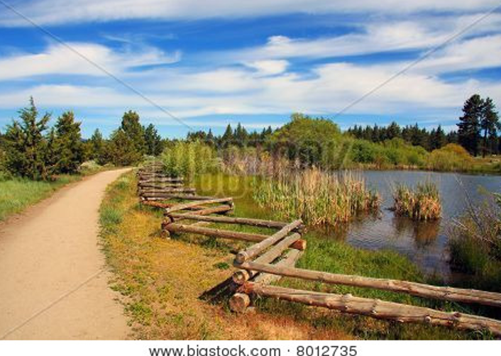

So Jesus said…
“If you abide in my word, you are truly my disciples,
and you will know the truth, and the truth will set you free.”
~ John 8:31-32 (ESV)

…the word of God abides in you, and you have overcome the evil one.
~ 1 John 2:14b (ESV)

Take the helmet of salvation and the sword of the Spirit, which is the word of God.
~ Ephesians 6:17 (NIV)

Keep this Book of the Law always on your lips;
meditate on it day and night,
so that you may be careful to do everything written in it.
Then you will be prosperous and successful.
~ Joshua 1:8 (NIV)
Pray

Beloved, if our heart does not condemn us, we have confidence before God;
and whatever we ask we receive from him, because we keep his commandments and do what pleases him.
~ 1 John 3:21-22 (ESV)

If I had cherished sin in my heart, the Lord would not have listened…
~ Psalm 66:18 (NIV)

The Lord is far from the wicked, but he hears the prayer
of the righteous.
~ Proverbs 15:29 (ESV)

Therefore, let all the godly pray to you while there is still time…
~ Psalm 32:6a (NLT)

The prayer of a righteous person is powerful and effective.
~ James 5:16b (NIV)

Is anyone among you in trouble? Let them pray.
Is anyone happy? Let them sing songs of praise.
Is anyone among you sick? Let them call the elders of the church to pray over them and anoint them with oil in the name of the Lord.
And the prayer offered in faith will make the sick person well; the Lord will raise them up. If they have sinned, they will be forgiven.
Therefore confess your sins to each other and pray for each other so that you may be healed.
The prayer of a righteous person is powerful and effective.
~ James 5:13-16 (NIV)

Do not be anxious about anything, but in every situation, by prayer and petition, with thanksgiving, present your requests to God.
And the peace of God, which transcends all understanding, will guard your hearts and your minds in Christ Jesus.
~ Philippians 4:6-7 (NIV)
Be joyful in hope, patient in affliction, faithful in prayer.
~ Romans 12:12 (NIV)

Devote yourselves to prayer with an alert mind and
a thankful heart.
~ Colossians 4:2 (NLT)

…be alert and of sober mind so that you may pray.
~ 1 Peter 4:7b (NIV)

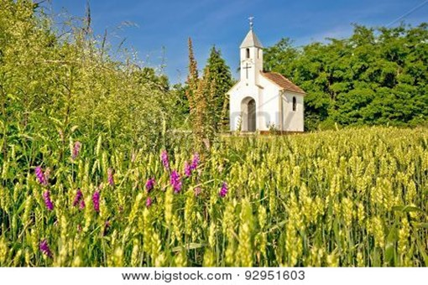

Then Jesus told this story to some who had great confidence in their own righteousness and scorned everyone else:
“Two men went to the Temple to pray. One was a Pharisee, and the other was a despised tax collector.
“The Pharisee stood by himself and prayed this prayer:
‘I thank you, God, that I am not a sinner like everyone else...’
“But the tax collector stood at a distance and dared not even lift his eyes to heaven as he prayed. Instead, he beat his chest in sorrow, saying, ‘O God, be merciful to me,
for I am a sinner.’
“I tell you, this sinner, not the Pharisee, returned home justified before God.
“For those who exalt themselves will be humbled,
and those who humble themselves will be exalted.”
~ Luke 18:9-14 (NLT)
“Ask and it will be given to you; seek and you will find; knock and the door will be opened to you.
“For everyone who asks receives; the one who seeks finds; and to the one who knocks, the door will be opened.
“Which of you, if your son asks for bread, will give him a stone? Or if he asks for a fish, will give him a snake?
“If you, then, though you are evil, know how to give good gifts to your children, how much more will your Father in heaven give good gifts to those who ask him!”
~ Matthew 7:7-11 (NIV)

“Therefore I tell you, whatever you ask in prayer, believe that you have received it, and it will be yours.”
~ Mark 11:24 (ESV)

“…when you pray, go into your room, close the door and pray to your Father, who is unseen. Then your Father,
who sees what is done in secret, will reward you.”
~ Matthew 6:6 (NIV)

“…whenever you stand praying, if you have anything against anyone, forgive him, that your Father in heaven may also forgive you your trespasses.”
~ Mark 11:25 (NKJV)

“…when you pray, do not heap up empty phrases…”
~ Matthew 6:7a (ESV)

“This, then, is how you should pray:”
~ Matthew 6:9a (NIV)

“Our Father which art in heaven,
Hallowed be thy name.
Thy kingdom come,
Thy will be done in earth, as it is in heaven.
Give us this day our daily bread.
And forgive us our debts, as we forgive our debtors.
And lead us not into temptation, but deliver us from evil:
“For thine is the kingdom, and the power, and the glory, for ever. Amen.”
~ Matthew 6:9b-13 (KJV)
Forget What Is Behind

This is what the Lord says—
he who made a way through the sea,
a path through the mighty waters…
“Forget the former things;
do not dwell on the past.
“See, I am doing a new thing!
Now it springs up; do you not perceive it?
“I am making a way in the wilderness
and streams in the wasteland.”
~ Isaiah 43:16-19 (NIV)

“See, I will create
new heavens and a new earth.
The former things will not be remembered,
nor will they come to mind.”
~ Isaiah 65:17 (NIV)

Forgetting what is behind and straining toward what
is ahead, I press on toward the goal to win the prize
for which God has called me heavenward in Christ Jesus.
~ Philippians 3:13b-14 (NIV)

Let your eyes look straight ahead;
fix your gaze directly before you.
~ Proverbs 4:25 (NIV)

You were taught, with regard to your former way of life,
to put off your old self, which is being corrupted by its deceitful desires;
to be made new in the attitude of your minds; and to
put on the new self, created to be like God in true righteousness and holiness.
~ Ephesians 4:22-24 (NIV)

Therefore, if anyone is in Christ, he is a new creation.
The old has passed away; behold, the new has come.
~ 2 Corinthians 5:17 (ESV)

There is therefore now no condemnation for those
who are in Christ Jesus.
~ Romans 8:1 (ESV)

Do Not Let Sin Control You

Stay Away from Darkness and Debauchery

The night is nearly over; the day is almost here.
So let us put aside the deeds of darkness and put on the
armor of light.
Let us behave decently, as in the daytime, not in carousing and drunkenness, not in sexual immorality and debauchery, not in dissension and jealousy.
~ Romans 13:12-13 (NIV)

Have nothing to do with the fruitless deeds of darkness,
but rather expose them.
~ Ephesians 5:11 (NIV)



So letting your sinful nature control your mind leads to death. But letting the Spirit control your mind leads to life and peace. For the sinful nature is always hostile to God. It never did obey God’s laws, and it never will. That’s why those who are still under the control of their sinful nature can never please God.
But you are not controlled by your sinful nature.
You are controlled by the Spirit if you have the Spirit of God living in you.
~ Romans 8:6-9a (NLT)
The wrath of God is being revealed from heaven against
all the godlessness and wickedness of people, who
suppress the truth by their wickedness…
For although they knew God, they neither glorified him
as God nor gave thanks to him, but their thinking became futile and their foolish hearts were darkened...
Furthermore, just as they did not think it worthwhile to retain the knowledge of God, so God gave them over to a depraved mind, so that they do what ought not to be done.
They have become filled with every kind of wickedness, evil, greed and depravity.
~ Romans 1:18-29a (NIV)

The acts of the flesh are obvious: sexual immorality, impurity and debauchery; idolatry and witchcraft;
hatred, discord, jealousy, fits of rage, selfish ambition, dissensions, factions and envy; drunkenness, orgies,
and the like.
I warn you, as I did before, that those who live like this
will not inherit the kingdom of God.
~ Galatians 5:19-21 (NIV)

For of this you can be sure: No immoral, impure or greedy person—such a person is an idolater—has any inheritance in the kingdom of Christ and of God.
~ Ephesians 5:5 (NIV)

Marriage should be honored by all, and the marriage bed kept pure, for God will judge the adulterer and all the sexually immoral.
~ Hebrews 13:4 (NIV)

“…anyone who looks at a woman lustfully has already committed adultery with her in his heart.”
~ Matthew 5:28b (NIV)

I will not look with approval on anything that is vile.
~ Psalm 101:3a (NIV)

I will set no wicked thing before mine eyes…
~ Psalm 101:3a (KJV)
“Watch out! Don’t let your hearts be dulled by carousing and drunkenness, and by the worries of this life.”
~ Luke 21:34a (NLT)

For, as I have often told you before and now tell you again even with tears, many live as enemies of the cross of Christ.
Their destiny is destruction, their god is their stomach,
and their glory is in their shame. Their mind is set on earthly things.
~ Philippians 3:18-19 (NIV)

Their minds are full of darkness; they wander far from
the life God gives because they have closed their minds
and hardened their hearts against him.
They have no sense of shame. They live for lustful pleasure and eagerly practice every kind of impurity.
~ Ephesians 4:18-19 (NLT)

Do not get drunk on wine, which leads to debauchery. Instead, be filled with the Spirit…
~ Ephesians 5:18 (NIV)

Do not carouse with drunkards or feast with gluttons,
for they are on their way to poverty…
~ Proverbs 23:20-21a (NLT)

It is not for kings, O Lemuel, to guzzle wine.
Rulers should not crave alcohol…
Alcohol is for the dying,
and wine for those in bitter distress.
~ Proverbs 31:4-6 (NLT)


Do Not Love the World or Anything in the World

Do not conform to the pattern of this world, but
be transformed by the renewing of your mind.
Then you will be able to test and approve what
God’s will is—his good, pleasing and perfect will.
~ Romans 12:2 (NIV)

Do not love the world or anything in the world.
If anyone loves the world, love for the Father is not in them.
For everything in the world—the lust of the flesh, the lust of the eyes, and the pride of life—comes not from the Father but from the world.
The world and its desires pass away, but whoever does the will of God lives forever.
~ 1 John 2:15-17 (NIV)

Dear friends, I warn you as “temporary residents and foreigners” to keep away from worldly desires that wage war against your very souls.
~ 1 Peter 2:11 (NLT)


Bigstock Photo ID 165434144

You adulterers! Don’t you realize that friendship with the world makes you an enemy of God? I say it again: If you want to be a friend of the world, you make yourself an enemy of God.
~ James 4:4 (NLT)
Dear children, keep away from anything that might
take God’s place in your hearts.
~ 1 John 5:21 (NLT)

We know that we are children of God, and that the
whole world is under the control of the evil one.
~ 1 John 5:19 (NIV)

…the whole world lies under the sway of the wicked one.
~ 1 John 5:19b (NKJV)

Jesus gave his life for our sins, just as God our Father planned, in order to rescue us from this evil world in
which we live.
~ Galatians 1:4 (NLT)

Jesus answered,
“My kingdom is not of this world.”
~ John 18:36a (ESV)

“…take heart; I have overcome the world.”
~ John 16:33b (ESV)

Resist Evil

Be alert and of sober mind. Your enemy the devil prowls around like a roaring lion looking for someone to devour.
~ 1 Peter 5:8 (NIV)

Be sober, be vigilant…
~ 1 Peter 5:8a (KJV)

Fear the Lord and depart from evil.
~ Proverbs 3:7b (NKJV)

All who belong to the Lord must turn away from evil.
~ 2 Timothy 2:19b (NLT)

Submit yourselves, then, to God.
Resist the devil, and he will flee from you.
~ James 4:7 (NIV)

So get rid of all the filth and evil in your lives, and humbly accept the word God has planted in your hearts, for it has the power to save your souls.
~ James 1:21 (NLT)
Finally, be strong in the Lord and in his mighty power.
Put on the full armor of God so that you can take your stand against the devil’s schemes.
For our struggle is not against flesh and blood, but against the rulers, against the authorities, against the powers of this dark world and against the spiritual forces of evil in
the heavenly realms.
Therefore put on the full armor of God, so that when the day of evil comes, you may be able to stand your ground, and after you have done everything, to stand.
Stand firm then, with the belt of truth buckled around your waist, with the breastplate of righteousness in place, and with your feet fitted with the readiness that comes from the gospel of peace.
In addition to all this, take up the shield of faith, with which you can extinguish all the flaming arrows of the evil one. Take the helmet of salvation and the sword of the Spirit, which is the word of God.
~ Ephesians 6:10-17 (NIV)



The weapons we fight with…have divine power to demolish strongholds.
~ 2 Corinthians 10:4 (NIV)
Do Not Let Sin Control the Way You Live

For you are a slave to whatever controls you.
~ 2 Peter 2:19b (NLT)

Do not let sin control the way you live; do not give in to sinful desires.
Do not let any part of your body become an instrument
of evil to serve sin.
Instead, give yourselves completely to God, for you were dead, but now you have new life.
So use your whole body as an instrument to do what is right for the glory of God.
Sin is no longer your master…
~ Romans 6:12-14a (NLT)

Don’t you realize that you become the slave of whatever
you choose to obey?
You can be a slave to sin, which leads to death, or you can choose to obey God, which leads to righteous living.
~ Romans 6:16 (NLT)

My son, if sinful men entice you, do not give in to them.
~ Proverbs 1:10 (NIV)

Do not enter the path of the wicked,
and do not walk in the way of the evil.
Avoid it; do not go on it;
turn away from it and pass on.
~ Proverbs 4:14-15 (ESV)

But if you refuse to do what is right, then watch out!
Sin is crouching at the door, eager to control you.
But you must subdue it and be its master.
~ Genesis 4:7b (NLT)

If I had cherished sin in my heart, the Lord would
not have listened…
~ Psalm 66:18 (NIV)

…wash your heart from evil, that you may be saved.
~ Jeremiah 4:14b (ESV)
Don’t slip back into your old ways of living to satisfy your own desires…
But now you must be holy in everything you do, just as God who chose you is holy.
For the Scriptures say, “You must be holy because I am holy.”
~ 1 Peter 1:14b-16 (NLT)

Do not be deceived: God cannot be mocked.
A man reaps what he sows.
Whoever sows to please their flesh, from the flesh will reap destruction;
whoever sows to please the Spirit, from the Spirit will reap eternal life.
~ Galatians 6:7-8 (NIV)

I pray that out of his glorious riches he may strengthen you with power through his Spirit in your inner being…
~ Ephesians 3:16 (NIV)

You are controlled by the Spirit if you have the Spirit of God living in you.
~ Romans 8:9b (NLT)

Then [Jesus] breathed on them and said,
“Receive the Holy Spirit.”
~ John 20:22 (NLT)

Jesus answered him, “If anyone loves me, he will
keep my word, and my Father will love him, and
we will come to him and make our home with him.”
~ John 14:23 (ESV)

Do you not know that you are God’s temple and that
God’s Spirit dwells in you?
~ 1 Corinthians 3:16 (ESV)

Do you not know that your bodies are temples of the
Holy Spirit, who is in you, whom you have received
from God?
You are not your own; you were bought at a price.
Therefore honor God with your bodies.
~ 1 Corinthians 6:19-20 (NIV)
Jesus replied, “Very truly I tell you, everyone who sins
is a slave to sin.”
~ John 8:34 (NIV)

“Whoever desires to come after Me, let him deny himself, and take up his cross, and follow Me.”
~ Mark 8:34b (NKJV)



We know that our old sinful selves were crucified with Christ so that sin might lose its power in our lives.
We are no longer slaves to sin.
~ Romans 6:6 (NLT)

But you were cleansed; you were made holy; you were made right with God by calling on the name of the Lord Jesus Christ and by the Spirit of our God.
~ 1 Corinthians 6:11b (NLT)

This includes you who were once far away from God.
You were his enemies, separated from him by your
evil thoughts and actions. Yet now he has reconciled you
to himself through the death of Christ in his physical body.
As a result, he has brought you into his own presence,
and you are holy and blameless as you stand before him without a single fault.
~ Colossians 1:21-22 (NLT)
Confess Your Sin

“Only acknowledge your guilt.
Admit that you rebelled against the Lord your God…
Confess that you refused to listen to my voice.
I, the Lord, have spoken!”
~ Jeremiah 3:13 (NLT)

Have mercy on me, O God,
according to your unfailing love;
according to your great compassion
blot out my transgressions.
Wash away all my iniquity
and cleanse me from my sin.
~ Psalm 51:1-2 (NIV)

For my iniquities have gone over my head;
like a heavy burden, they are too heavy for me.
~ Psalm 38:4 (ESV)

Heal my soul, for I have sinned against You.
~ Psalm 41:4b (NKJV)

If you, Lord, kept a record of sins, Lord, who could stand?
~ Psalm 130:3 (NIV)

Listen to my cry,
for I am in desperate need…
Set me free from my prison,
that I may praise your name.
~ Psalm 142:6-7a (NIV)

Search me, O God, and know my heart;
test me and know my anxious thoughts.
Point out anything in me that offends you,
and lead me along the path of everlasting life.
~ Psalm 139:23-24 (NLT)

Create in me a pure heart, O God,
and renew a steadfast spirit within me.
Do not cast me from your presence
or take your Holy Spirit from me.
Restore to me the joy of your salvation
and grant me a willing spirit, to sustain me.
~ Psalm 51:10-12 (NIV)
Seek the Lord while He may be found,
Call upon Him while He is near.
Let the wicked forsake his way,
And the unrighteous man his thoughts;
Let him return to the Lord,
And He will have mercy on him;
And to our God,
For He will abundantly pardon.
~ Isaiah 55:6-7 (NKJV)

For with the Lord there is mercy, and with Him is abundant redemption.
~ Psalm 130:7b (NKJV)

Repent, then, and turn to God, so that your sins may be
wiped out, that times of refreshing may come from the Lord…
~ Acts 3:19 (NIV)



Therefore, if anyone is in Christ, he is a new creation.
The old has passed away; behold, the new has come.
~ 2 Corinthians 5:17 (ESV)

Accept God’s Gift
of Eternal Life

God loves you abundantly, and has made a way for you to live forever in His glorious kingdom. However, first He had to pay an enormous price for you to be forgiven of your sin, in order to receive this eternal glory. This section explains His plan to forgive and save you. In summary:
God loves you, but your sin separates you from Him, and because of it, God’s wrath will come. However, Jesus died as a sacrifice to save you from your sins, from God’s wrath, and from death itself. When you confess your sins, repent and accept the salvation that Christ offers, God will forgive you. By trusting in Christ you become God’s child, and as His child, you will inherit eternal life and heaven will be your home.

God Loves You

Know that the Lord is God. It is he who made us, and
we are his; we are his people, the sheep of his pasture.
~ Psalm 100:3 (NIV)

The Lord is my shepherd;
I shall not want.
He makes me to lie down in green pastures;
He leads me beside the still waters.
He restores my soul;
He leads me in the paths of righteousness
For His name’s sake.
Yea, though I walk through the valley of the shadow of death,
I will fear no evil;
For You are with me;
Your rod and Your staff, they comfort me.
You prepare a table before me in the presence of my enemies;
You anoint my head with oil;
My cup runs over.
Surely goodness and mercy shall follow me
All the days of my life;
And I will dwell in the house of the Lord
Forever.
~ Psalm 23 (NKJV)
Then Jesus told them this parable: “Suppose one of you has a hundred sheep and loses one of them.
“Doesn’t he leave the ninety-nine in the open country and go after the lost sheep until he finds it?
“And when he finds it, he joyfully puts it on his shoulders and goes home…
“I tell you that in the same way there will be more rejoicing in heaven over one sinner who repents than over ninety-nine righteous persons who do not need to repent.”
~ Luke 15:3-7 (NIV)

“I am the good shepherd.”
~ John 10:14a (NIV)

“For the Son of Man came to seek and to save the lost.”
~ Luke 19:10 (ESV)

“For this is what the Sovereign Lord says: I myself will search for my sheep and look after them.”
~ Ezekiel 34:11 (NIV)

“My sheep listen to my voice; I know them, and they follow me. I give them eternal life…”
~ John 10:27-28a (NIV)



So Jesus again said to them...
“The thief comes only to steal and kill and destroy.
“I came that they may have life and have it abundantly.”
~ John 10:7-10 (NIV)
But Your Sin Separates You from God

But your iniquities have separated you from your God;
And your sins have hidden His face from you,
So that He will not hear.
~ Isaiah 59:2 (NKJV)

Don’t you realize that those who do wrong will not inherit the Kingdom of God?
~ 1 Corinthians 6:9a (NLT)

Once you were dead because of your disobedience and your many sins.
You used to live in sin, just like the rest of the world, obeying the devil—the commander of the powers in the unseen world…
By our very nature we were subject to God’s anger…
~ Ephesians 2:1-3a (NLT)

The Day of God’s Wrath Will Come

“I am about to pour out my wrath on you and spend
my anger against you; I will judge you according to your conduct and repay you for all your detestable practices.”
~ Ezekiel 7:8 (NIV)

“The angels will come and separate the wicked from
the righteous…”
~ Matthew 13:49b (NIV)

They will be punished with everlasting destruction and shut out from the presence of the Lord and from the
glory of his might…
~ 2 Thessalonians 1:9 (NIV)

Confess Your Sin and Repent

That is why the Lord says,
“Turn to me now, while there is time.
Give me your hearts.
Come with fasting, weeping, and mourning.”
~ Joel 2:12 (NLT)
The Lord is…not willing that any should perish but that all should come to repentance.
~ 2 Peter 3:9 (NKJV)

Jesus Died to Save You…

…From Your Sin

He gave his life to free us from every kind of sin, to cleanse us, and to make us his very own people...
~ Titus 2:14a (NLT)

...the blood of Christ will purify our consciences from sinful deeds so that we can worship the living God.
For by the power of the eternal Spirit, Christ offered himself to God as a perfect sacrifice for our sins.
~ Hebrews 9:14b (NLT)

…From God’s Wrath

Who then will condemn us? No one—for Christ Jesus died for us and was raised to life for us, and he is sitting in the place of honor at God’s right hand, pleading for us.
~ Romans 8:34 (NLT)

…we have an advocate who pleads our case before the Father. He is Jesus Christ, the one who is truly righteous.
~ 1 John 2:1b (NLT)

…he is able to save completely those who come to God through him, because he always lives to intercede for them.
~ Hebrews 7:25 (NIV)

…From Death

For the wages of sin is death, but the free gift of God
is eternal life in Christ Jesus our Lord.
~ Romans 6:23 (ESV)

…we know that since Christ was raised from the dead…
death no longer has mastery over him...In the same way, count yourselves dead to sin but alive to God in Christ Jesus.
~ Romans 6:9-11 (NIV)
God Bought You at a Price

…God paid a ransom to save you from the empty life you inherited from your ancestors. And it was not paid with mere gold or silver...
It was the precious blood of Christ, the sinless, spotless Lamb of God.
~ 1 Peter 1:18-19 (NLT)

In Christ You Are Forgiven

Therefore, my friends, I want you to know that through Jesus the forgiveness of sins is proclaimed to you.
~ Acts 13:38 (NIV)

Praise the Lord, my soul,
and forget not all his benefits—
who forgives all your sins
and heals all your diseases,
who redeems your life from the pit
and crowns you with love and compassion…
as far as the east is from the west,
so far has he removed our transgressions from us.
~ Psalm 103:2-4, 12 (NIV)

In your love you kept me
from the pit of destruction;
you have put all my sins
behind your back.
~ Isaiah 38:17b (NIV)

God Demonstrates His Love Through Christ

“For God so loved the world that He gave His only begotten Son, that whoever believes in Him should
not perish but have everlasting life.”
~ John 3:16 (NKJV)

…God demonstrates his own love for us in this:
While we were still sinners, Christ died for us.
~ Romans 5:8 (NIV)

And the life I now live in the flesh I live by faith in the
Son of God, who loved me and gave himself for me.
~ Galatians 2:20b (ESV)
Salvation is Through Christ Alone

Jesus said to him, “I am the way, the truth, and the life. No one comes to the Father except through Me.”
~ John 14:6 (NKJV)

“…whoever comes to me I will never drive away.”
~ John 6:37b (NIV)

“Enter through the narrow gate.
“For wide is the gate and broad is the road that leads to destruction, and many enter through it.
“But small is the gate and narrow the road that leads to life, and only a few find it.”
~ Matthew 7:13-14 (NIV)

“I am the gate; whoever enters through me will be saved.”
~ John 10:9a (NIV)


Salvation is a Gift: Free and Undeserved

…because of his great love for us, God, who is rich in mercy, made us alive with Christ even when we were dead in transgressions—it is by grace you have been saved.
~ Ephesians 2:4-5 (NIV)

Accept This Gift of Salvation

If you declare with your mouth, “Jesus is Lord,” and believe in your heart that God raised him from the dead, you will be saved.
~ Romans 10:9 (NIV)

Dear friends, if we deliberately continue sinning
after we have received knowledge of the truth, there is
no longer any sacrifice that will cover these sins.
~ Hebrews 10:26 (NLT)

But we are not like those who turn away from God
to their own destruction. We are the faithful ones,
whose souls will be saved.
~ Hebrews 10:39 (NLT)

You Belong to God Through Faith in Christ
and Have Become His Child

See what great love the Father has lavished on us, that
Xwe should be called children of God!
~ 1 John 3:1a (NIV)

For you are all children of God through faith in Christ Jesus.
~ Galatians 3:26 (NLT)

Now if we are children, then we are heirs—heirs of God and co-heirs with Christ, if indeed we share in his sufferings in order that we may also share in his glory.
~ Romans 8:17 (NIV)

“If you belonged to the world, it would love you as its own.
“As it is, you do not belong to the world, but I have chosen you out of the world.”
~ John 15:19a (NIV)
Eternal Life is Yours Through Christ

…God gave us eternal life, and this life is in his Son.
~ 1 John 5:11b (ESV)

Since he did not spare even his own Son but gave him up for us all, won’t he also give us everything else?
~ Romans 8:32 (NLT)

…you have been born again, but not to a life that will quickly end. Your new life will last forever because it comes from the eternal, living word of God.
~ 1 Peter 1:23 (NLT)

For our light and momentary troubles are achieving for us an eternal glory that far outweighs them all.
So we fix our eyes not on what is seen, but on what is unseen, since what is seen is temporary, but what is unseen is eternal.
~ 2 Corinthians 4:17-18 (NIV)

Point out anything in me that offends you, and lead me along the path of everlasting life.
~ Psalm 139:24 (NLT)



“All who are victorious will be clothed in white.
“I will never erase their names from the Book of Life,
but I will announce before my Father and his angels that
they are mine.”
~ Revelation 3:5 (NLT)
Heaven is Your Home

Jesus answered him,
“Truly I tell you, today you will be with me in paradise.”
~ Luke 23:43 (NIV)

“…rejoice because your names are written in heaven.”
~ Luke 10:20b (NKJV)

“And be sure of this:
“I am with you always, even to the end of the age.”
~ Matthew 28:20b (NLT)

“So don’t be afraid, little flock. For it gives your Father great happiness to give you the Kingdom.”
~ Luke 12:32 (NLT)

He will wipe away every tear from their eyes, and death shall be no more, neither shall there be mourning, nor crying, nor pain anymore, for the former things have passed away.
~ Revelation 21:4 (ESV)

Because of God’s tender mercy, the morning light from heaven is about to break upon us, to give light to those who sit in darkness and in the shadow of death, and to guide us to the path of peace.
~ Luke 1:78-79 (NLT)



Praise God

Praise God for His Gift of Eternal Life

Thanks be to God for His indescribable gift!
~ 2 Corinthians 9:15 (NKJV)

Thank God for this gift too wonderful for words!
~ 2 Corinthians 9:15 (NLT)

May you be filled with joy, always thanking the Father.
He has enabled you to share in the inheritance that belongs to his people, who live in the light.
~ Colossians 1:11b-12 (NLT)

Praise God’s Great and Awesome Name

Praise God for the privilege of being called by his name!
~ 1 Peter 4:16b (NLT)

…at the name of Jesus every knee should bow, in heaven and on earth and under the earth, and every tongue acknowledge that Jesus Christ is Lord…
~ Philippians 2:10-11a (NIV)

Let me clearly state to all of you…that he was healed
by the powerful name of Jesus Christ…
~ Acts 4:10a (NLT)

Let them praise the name of the Lord,
For His name alone is exalted;
His glory is above the earth and heaven.
~ Psalm 148:13 (NKJV)

Let them praise your great and awesome name.
Your name is holy!
~ Psalm 99:3a (NLT)

Lord, there is no one like you!
For you are great, and your name is full of power.
~ Jeremiah 10:6 (NLT)
Praise Him for His Greatness

Praise him for his mighty works;
praise his unequaled greatness!
~ Psalm 150:2 (NLT)

Splendor and majesty are before him;
strength and joy are in his dwelling place.
~ 1 Chronicles 16:27 (NIV)

O Lord my God, you are very great!
You are clothed with splendor and majesty…
~ Psalm 104:1b (ESV)

Yours, O Lord, is the greatness, the power, the glory,
the victory, and the majesty.
Everything in the heavens and on earth is yours, O Lord, and this is your kingdom.
We adore you as the one who is over all things.
~ 1 Chronicles 29:11 (NLT)

Before the mountains were born or you brought forth the whole world, from everlasting to everlasting you are God.
~ Psalm 90:2 (NIV)

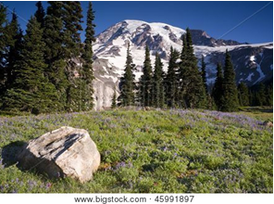
Praise Him for His Goodness

The Lord is good to those whose hope is in him, to the one who seeks him…
~ Lamentations 3:25 (NIV)

The Lord is gracious and compassionate,
slow to anger and rich in love.
The Lord is good to all;
he has compassion on all he has made.
~ Psalm 145:8-9 (NIV)

The Lord is my strength and shield.
I trust him with all my heart.
He helps me, and my heart is filled with joy.
I burst out in songs of thanksgiving.
~ Psalm 28:7 (NLT)

What is man, that you make so much of him, and that you set your heart on him…
~ Job 7:17 (ESV)

For you, O Lord, are good and forgiving, abounding in steadfast love to all who call upon you.
~ Psalm 86:5 (ESV)

For you created my inmost being;
you knit me together in my mother’s womb…
Your eyes saw my unformed body;
all the days ordained for me were written in your book
before one of them came to be.
~ Psalm 139:13-16 (NIV)

Each morning I will sing with joy about your unfailing love.
~ Psalm 59:16b (NLT)

I will praise you forever, O God, for what you have done.
I will trust in your good name…
~ Psalm 52:9a (NLT)

I will praise you, Lord my God, with all my heart;
I will glorify your name forever.
~ Psalm 86:12 (NIV)

Meditate on Psalms

of Praise

How great is the goodness
you have stored up for those who fear you.
You lavish it on those who come to you for protection,
blessing them before the watching world.
~ Psalm 31:19 (NLT)

I will exalt you, my God the King;
I will praise your name for ever and ever.
Every day I will praise you
and extol your name for ever and ever.
Great is the Lord and most worthy of praise;
his greatness no one can fathom…
The Lord is gracious and compassionate,
slow to anger and rich in love.
The Lord is good to all;
he has compassion on all he has made.
All your works praise you, Lord;
your faithful people extol you.
They tell of the glory of your kingdom
and speak of your might,
so that all people may know of your mighty acts
and the glorious splendor of your kingdom.
Your kingdom is an everlasting kingdom,
and your dominion endures through all generations.
The Lord is trustworthy in all he promises
and faithful in all he does.
The Lord upholds all who fall
and lifts up all who are bowed down…
He fulfills the desires of those who fear him;
he hears their cry and saves them…
My mouth will speak in praise of the Lord.
Let every creature praise his holy name
for ever and ever.
~ Excerpts from Psalm 145 (NIV)
Praise the Lord, my soul;
all my inmost being, praise his holy name.
Praise the Lord, my soul,
and forget not all his benefits—
who forgives all your sins
and heals all your diseases,
who redeems your life from the pit
and crowns you with love and compassion,
who satisfies your desires with good things
so that your youth is renewed like the eagle’s…
The Lord is compassionate and gracious,
slow to anger, abounding in love.
He will not always accuse,
nor will he harbor his anger forever;
he does not treat us as our sins deserve
or repay us according to our in iquities.
For as high as the heavens are above the earth,
so great is his love for those who fear him;
as far as the east is from the west,
so far has he removed our transgressions from us.
As a father has compassion on his children,
so the Lord has compassion on those who fear him…
Praise the Lord, all his works
everywhere in his dominion…
~ Excerpts from Psalm 103 (NIV)

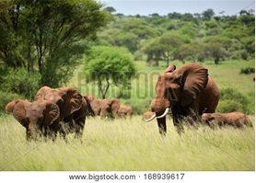

Experience God’s Deliverance

Call Upon the Name of the Lord

“Call upon Me in the day of trouble; I will deliver you,
and you shall glorify Me.”
~ Psalm 50:15 (NKJV)

Then they cried out to the Lord in their trouble,
And He saved them out of their distresses.
He sent His word and healed them,
And delivered them from their destructions.
~ Psalm 107:19-20 (NKJV)

Let your unfailing love surround us, Lord, for our hope
is in you alone.
~ Psalm 33:22 (NLT)

…the eyes of the Lord are on those who fear him,
on those whose hope is in his unfailing love…
~ Psalm 33:18 (NIV)

For the eyes of the Lord run to and fro throughout the whole earth, to show Himself strong on behalf of those whose heart is loyal to Him.
~ 2 Chronicles 16:9a (NKJV)

If you make the Lord your refuge, if you make the
Most High your shelter, no evil will conquer you…
~ Psalm 91:9-10a (NLT)

The Lord your God in your midst, The Mighty One, will save;
He will rejoice over you with gladness,
He will quiet you with His love,
He will rejoice over you with singing.
~ Zephaniah 3:17 (NKJV)

The Lord shall preserve thee from all evil…
~ Psalm 121:7a (KJV)

Help us, God our Savior, for the glory of your name;
deliver us and forgive our sins for your name’s sake.
~ Psalm 79:9 (NIV)
He lifted me out of the slimy pit,
out of the mud and mire;
he set my feet on a rock
and gave me a firm place to stand.
~ Psalm 40:2 (NIV)

I will exalt you, Lord, for you lifted me out of the depths...

Lord my God,
I called to you
for help,
and you healed me.
You, Lord, brought me up from the realm of the dead; you spared me from going down to the pit.
~ Psalm 30:1-3 (NIV)

For great is your love toward me; you have delivered me from the depths, from the realm of the dead.
~ Psalm 86:13 (NIV)

…out of the goodness of your love, deliver me.
~ Psalm 109:21b (NIV)

The Lord will rescue me from every evil attack and
will bring me safely to his heavenly kingdom.
~ 2 Timothy 4:18a (NIV)

I trust in the steadfast love of God forever and ever.
~ Psalm 52:8b (ESV)
Claim Victory Over Temptation

Then Jesus, being filled with the Holy Spirit, returned from the Jordan and was led by the Spirit into the wilderness, being tempted for forty days by the devil.
~ Luke 4:1-2a (NKJV)

After fasting forty days and forty nights, he was hungry.
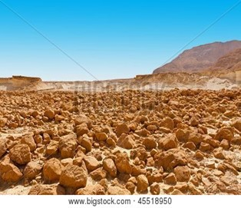
The tempter came to him and said, “If you are the Son of God, tell these stones to become bread.”
Jesus answered,
“It is written:
‘Man shall not live on bread alone,
but on every word that comes from the mouth of God.’”
Then the devil took him to the holy city and had him stand on the highest point of the temple. “If you are the Son of God,” he said, “throw yourself down. For it is written:
‘He will command his angels concerning you, and they will lift you up in their hands, so that you will not strike your foot against a stone.’”
Jesus answered him, “It is also written: ‘Do not put the Lord your God to the test.’”
Again, the devil took him to a very high mountain and showed him all the kingdoms of the world and their splendor. “All this I will give you,” he said, “if you will
bow down and worship me.”
Jesus said to him, “Away from me, Satan! For it is written: ‘Worship the Lord your God, and serve him only.’”
Then the devil left him, and angels came and attended him.
~ Matthew 4:2-11 (NIV)
Therefore, since we have a great high priest who has ascended into heaven, Jesus the Son of God, let us hold firmly to the faith we profess.
For we do not have a high priest who is unable to empathize with our weaknesses, but we have one who has been tempted in every way, just as we are—yet he did not sin.
Let us then approach God’s throne of grace with confidence, so that we may receive mercy and find grace to help us in our time of need.
~ Hebrews 4:14-16 (NIV)

When tempted, no one should say, “God is tempting me.” For God cannot be tempted by evil, nor does he tempt anyone; but each person is tempted when they are dragged away by their own evil desire and enticed.
Then, after desire has conceived, it gives birth to sin;
and sin, when it is full-grown, gives birth to death.
~ James 1:13-15 (NIV)

Put to death, therefore, whatever belongs to your earthly nature: sexual immorality, impurity, lust, evil desires and greed, which is idolatry.
~ Colossians 3:5 (NIV)

I say then: Walk in the Spirit, and you shall not fulfill the lust of the flesh.
~ Galatians 5:16 (NKJV)

“Watch and pray that you may not enter into temptation. The spirit indeed is willing, but the flesh is weak.”
~ Matthew 26:41 (ESV)

“And lead us not into temptation, but deliver us from evil…”
~ Matthew 6:13a (KJV)

No temptation has overtaken you except what is common to mankind.
And God is faithful; he will not let you be tempted beyond what you can bear.
But when you are tempted, he will also provide a way out so that you can endure it.
~ 1 Corinthians 10:13 (NIV)
Enjoy Freedom in Christ

It is for freedom that Christ has set us free.
Stand firm, then, and do not let yourselves be burdened again by a yoke of slavery.
~ Galatians 5:1 (NIV)

Now the Lord is the Spirit, and where the Spirit of the Lord is, there is freedom.
~ 2 Corinthians 3:17 (ESV)

Who will free me from this life that is dominated by sin
and death?
Thank God! The answer is in Jesus Christ our Lord.
~ Romans 7:24b-25a (NLT)

Jesus gave his life for our sins, just as God our Father planned, in order to rescue us from this evil world in which we live.
~ Galatians 1:4 (NLT)

…that he might deliver us from this present evil world…
~ Galatians 1:4b (KJV)

…the Son of God came to destroy the works of the devil.
~ 1 John 3:8b (NLT)

Jesus replied, “Very truly I tell you, everyone who sins is
a slave to sin. Now a slave has no permanent place in the family, but a son belongs to it forever.
“So if the Son sets you free, you will be free indeed.”
~ John 8:34-36 (NIV)

“The thief comes only to steal and kill and destroy.
“I came that they may have life and have it abundantly.”
~ John 10:10 (ESV)

Now you are free from your slavery to sin…
~ Romans 6:18a (NLT)

So now there is no condemnation for those who belong
to Christ Jesus. And because you belong to him, the power
of the life-giving Spirit has freed you from the power of
sin that leads to death.
~ Romans 8:1-2 (NLT)
Stay on the Path of Recovery

Watch out that you do not lose what we have worked so hard to achieve. Be diligent so that you receive your full reward.
~ 2 John 1:8 (NLT)

So put to death the sinful, earthly things lurking within you. Have nothing to do with sexual immorality, impurity, lust, and evil desires….
You used to do these things when your life was still part of this world…
Put on your new nature, and be renewed as you learn to know your Creator and become like him.
~ Colossians 3:5-10 (NLT)

…let us throw off everything that hinders and the sin that so easily entangles.
And let us run with perseverance the race marked out for us, fixing our eyes on Jesus…
~ Hebrews 12:1b-2a (NIV)

Let your eyes look straight ahead; fix your gaze directly before you.
Give careful thought to the paths for your feet and be steadfast in all your ways.
~ Proverbs 4:25-26 (NIV)


Fight the good fight of the faith. Take hold of the eternal life to which you were called…
~ 1 Timothy 6:12a (NIV)

Consider it pure joy, my brothers and sisters, whenever you face trials of many kinds, because you know that the testing of your faith produces perseverance.
Let perseverance finish its work so that you may be mature and complete, not lacking anything.
~ James 1:2-4 (NIV)

So be truly glad. There is wonderful joy ahead, even though you must endure many trials for a little while. These trials will show that your faith is genuine…
So when your faith remains strong through many trials,
it will bring you much praise and glory and honor on the day when Jesus Christ is revealed to the whole world.
~ 1 Peter 1:6-7 (NLT)

…the grace of God has appeared that offers salvation
to all people.
It teaches us to say “No” to ungodliness and worldly passions, and to live self-controlled, upright and godly lives in this present age, while we wait for the blessed hope—the appearing of the glory of our great God and Savior, Jesus Christ,
who gave himself for us to redeem us from all wickedness and to purify for himself a people that are his very own, eager to do what is good.
~ Titus 2:11-14 (NIV)

So do not throw away this confident trust in the Lord. Remember the great reward it brings you!
Patient endurance is what you need now, so that you will continue to do God’s will. Then you will receive all that
he has promised.
~ Hebrews 10:35-36 (NLT)

And the God of all grace, who called you to his eternal glory in Christ, after you have suffered a little while, will himself restore you and make you strong, firm and steadfast.
~ 1 Peter 5:10 (NIV)
Encourage Others in Their Recovery

Let each of you look not only to his own interests, but also to the interests of others.
~ Philippians 2:4 (ESV)

Dear brothers and sisters, if another believer is overcome by some sin, you who are godly should gently and humbly help that person back onto the right path.
And be careful not to fall into the same temptation yourself.
Share each other’s burdens, and in this way obey the law
of Christ.
~ Galatians 6:1-2 (NLT)

But you should keep a clear mind in every situation.
Don’t be afraid of suffering for the Lord.
Work at telling others the Good News, and fully carry out the ministry God has given you.
~ 2 Timothy 4:5 (NLT)


Be Strengthened with All His Glorious Power

I pray that out of his glorious riches he may strengthen
you with power through his Spirit in your inner being...
~ Ephesians 3:16 (NIV)

We also pray that you will be strengthened with all his glorious power so you will have all the endurance and patience you need.
~ Colossians 1:11a (NLT)

…God is working in you, giving you the desire and the power to do what pleases him.
~ Philippians 2:13 (NLT)

For the eyes of the Lord run to and fro throughout the whole earth, to show Himself strong on behalf of those whose heart is loyal to Him.
~ 2 Chronicles 16:9a (NKJV)

He gives strength to the weary and increases the power
of the weak.
~ Isaiah 40:29 (NIV)

…thanks be to God, who gives us the victory through our Lord Jesus Christ.
~ 1 Corinthians 15:57 (ESV)

Because of Christ and our faith in him, we can now come boldly and confidently into God’s presence.
~ Ephesians 3:12 (NLT)

…we are more than conquerors through Him who loved us.
~ Romans 8:37b (NKJV)

It is not that we think we are qualified to do anything
on our own.
~ 2 Corinthians 3:5a (NLT)

Our qualification comes from God.
~ 2 Corinthians 3:5b (NLT)

…our competence comes from God.
~ 2 Corinthians 3:5b (NIV)

…our sufficiency is from God…
~ 2 Corinthians 3:5b (ESV)
The Lord is my rock, my fortress, and my savior;
my God is my rock, in whom I find protection.
He is my shield, the power that saves me,
and my place of safety.
~ Psalm 18:2 (NLT)

He is my loving ally and my fortress, my tower of safety,
my rescuer.
~ Psalm 144:2a (NLT)

…he said to me,
“My grace is sufficient for you, for my power
is made perfect in weakness.”
Therefore I will boast all the more gladly of my weaknesses, so that the power of Christ may rest upon me.
~ 2 Corinthians 12:9 (ESV)

…so that the power of Christ can work through me.
~ 2 Corinthians 12:9b (NLT)

I can do all things through Christ who strengthens me.
~ Philippians 4:13 (NKJV)


Be on guard. Stand firm in the faith. Be courageous. Be strong.
~ 1 Corinthians 16:13 (NLT)

I write to you, young men,
because you are strong,
and the word of God abides in you,
and you have overcome the evil one.
~ 1 John 2:14b (ESV)

Therefore, my dear brothers and sisters, stand firm.
Let nothing move you.
~ 1 Corinthians 15:58a (NIV)

Finally, my brethren, be strong in the Lord, and in the power of his might.
~ Ephesians 6:10 (KJV)

Trust in the Lord forever, for the Lord, the Lord himself,
is the Rock eternal.
~ Isaiah 26:4 (NIV)



He will keep you strong to the end so that you will be
free from all blame on the day when our Lord Jesus
Christ returns.
~ 1 Corinthians 1:8 (NLT)

Booklet Titles in the Series

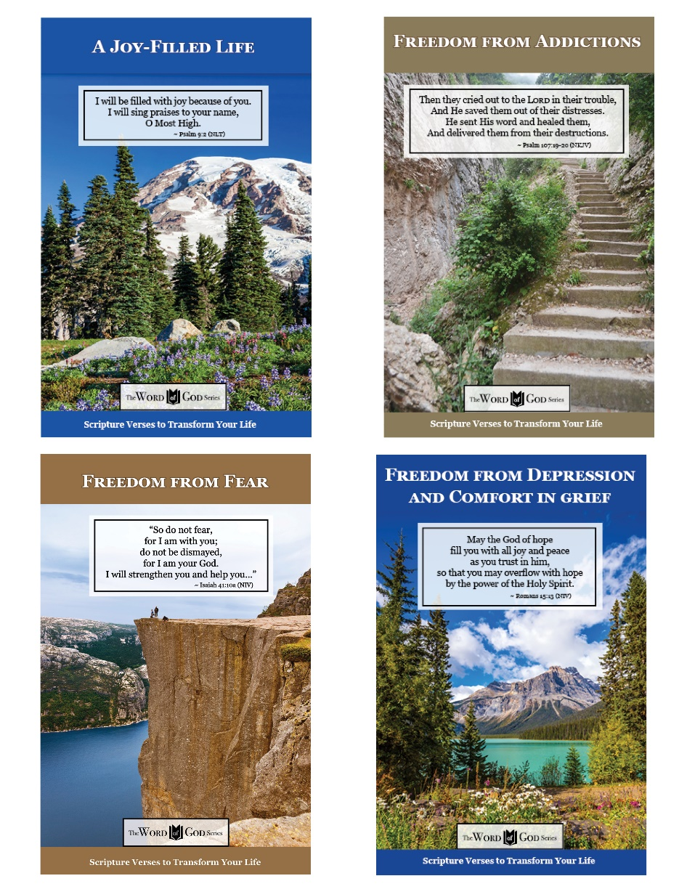

www.TheWordOfGodSeries.com

Booklet Titles in the Series

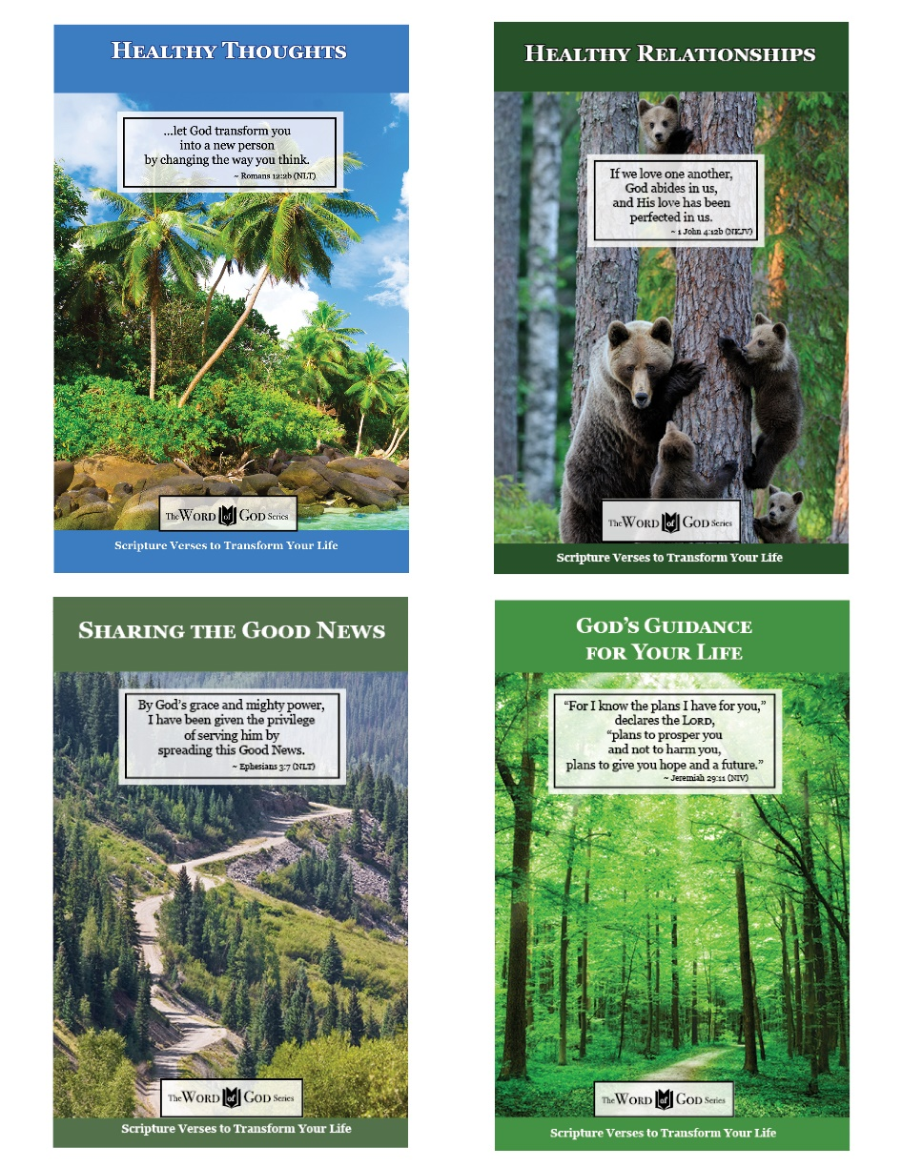

www.TheWordOfGodSeries.com

Booklet Titles in the Series

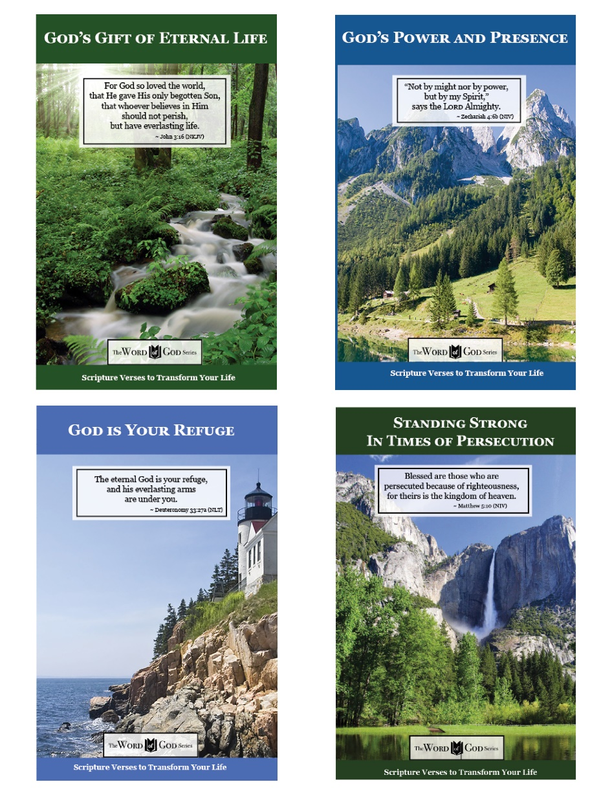

www.TheWordOfGodSeries.com

Booklet Titles in the Series

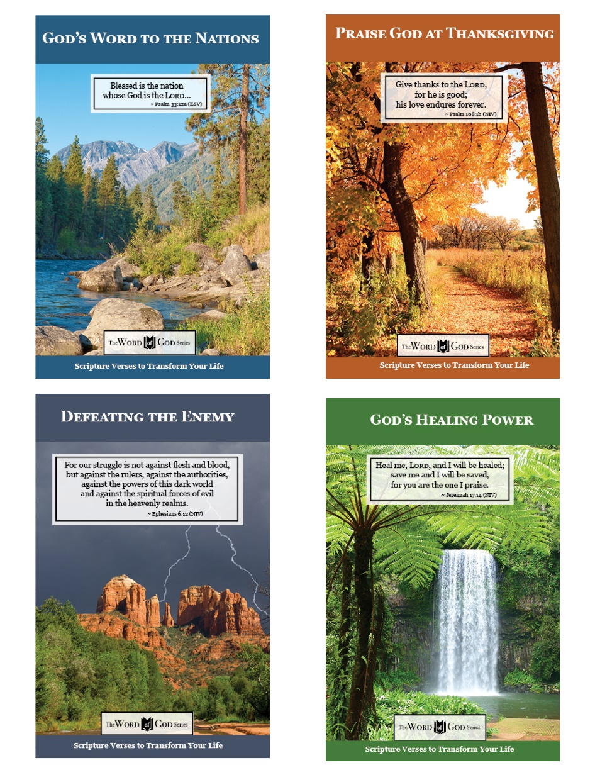

www.TheWordOfGodSeries.com

Booklet Titles in the Series

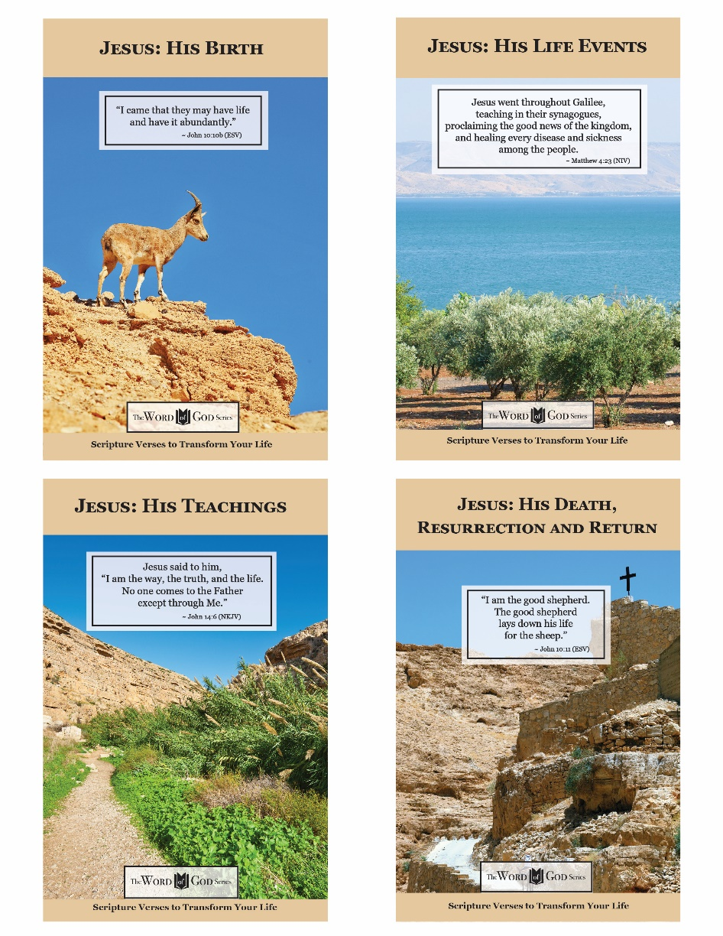

www.TheWordOfGodSeries.com

Photo Copyright Info

Note: when purchasing the rights to use the photos,
you may want to purchase an Extended License
for the cover image.


Bigstock Photo ID: 93497375
Strbske Pleso in the Tatra Mountains Slovakia Europe. Štrbské Pleso Summer Scenery.
Stock Photo ID: 93497375
Copyright: duallogic

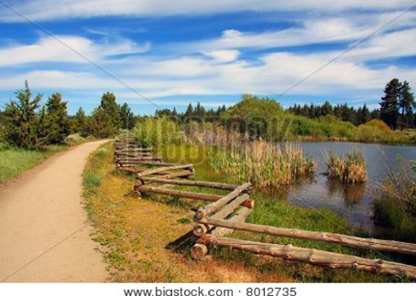
Bigstock Photo ID: 8012735
Beautiful dirt pathway next to a pond in a mountain meadow.
Stock Photo ID: 8012735
Copyright: judwick

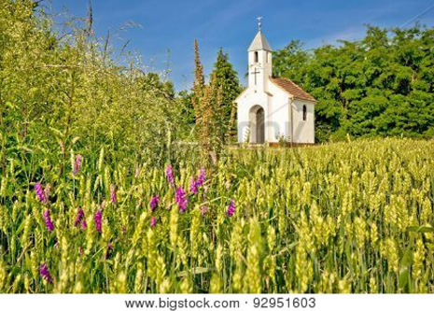
Bigstock Photo ID: 92951603
Catholic chapel in rural agricultural landscape hay field in Cepidlak village of Croatia ** Note: Visible grain at 100%, best at smaller sizes
Stock Photo ID: 92951603
Copyright: xbrchx


Bigstock Photo ID: 464998331
Green tree in green forest near sunset river
Stock Photo ID: 464998331
Copyright: Pavlo Vakhrushev


Bigstock Photo ID: 38284651
Sand dunes over sunrise sky in Death Valley California
Stock Photo ID: 38284651
Copyright: javarman


Bigstock Photo ID: 165434144
Cactus landscape near Salta in the North of Argentina
Stock Photo ID: 165434144
Copyright: Jorisvo


Bigstock Photo ID: 37688674
Editing suggestion: Crop bottom of photo to reduce the amount of black
Rising Sun shinning through an Acacia tree in Africa. Beautiful scenery of sunrise / sunset in Serengeti National Park
Stock Photo ID: 37688674
Copyright: tr3gi

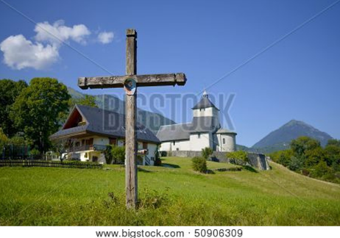
Bigstock Photo ID: 50906309

Cross and church in the frnch aples
Stock Photo ID: 50906309
Copyright: philipimage


Bigstock Photo ID: 3261443
Editing suggestion: Brighten photo, crop out dark portion on the right
Havasu Falls
Havasu Falls and its lime green water in Arizona
Stock Photo 3261443
Copyright: SKPhoton

Bigstock Photo ID: 153318587

Small sheeps grazing on pasture in District Lake England
Stock Photo ID: 153318587
Copyright: Shaiith


Bigstock Photo ID: 434544401
Editing suggestion: Brighten and warm photo
The wooden gate in a stone wall on a monastery. Retro countryside wooden gate with with stone wall in vintage style. Peaceful nature. Conceptual image.
Stock Photo ID: 434544401
Copyright: Dzmitry Dzemidovich

Bigstock Photo ID: 52948120
Editing suggestion: Crop bottom and left edges to remove the black shadows
way to beach in jungle, Phi-Phi island, Thailand
Stock Photo ID: 52948120
Copyright: Iakov Kalinin


Bigstock Photo ID: 60682427
Editing suggestion: Rotate photo so trees border the left side of the page
beach on Mahe island, Seychelles
Stock Photo ID: 60682427
Copyright: Iakov Kalinin


Bigstock Photo ID: 45991897
Mt. Rainier Boulder and Wildflowers in Bloom
Stock Photo ID: 45991897
Copyright: Christopher Boswell

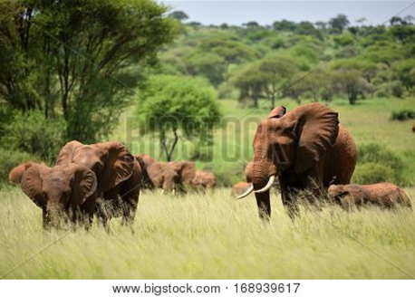
Bigstock Photo ID: 168939617
Herd of Elephants , Serengeti natural park, Tanzania
Stock Photo ID: 168939617
Copyright: mirceab
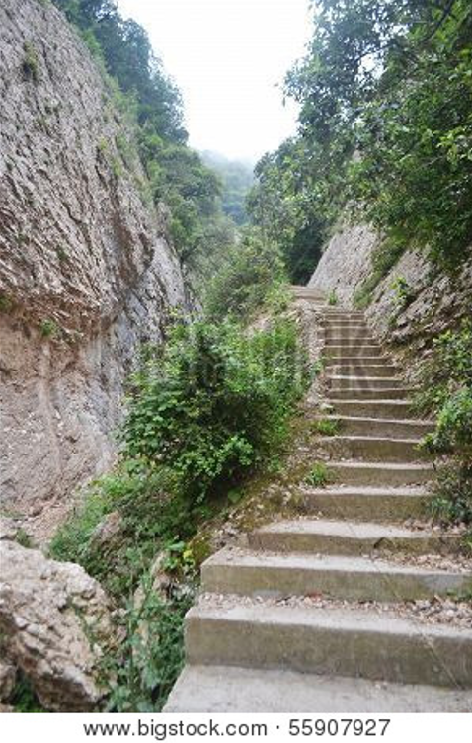
Bigstock Photo ID: 55907927
Stone mountain path in Montserrat Mountain Catalonia Spain.
Stock Photo ID: 55907927
Copyright: konstan

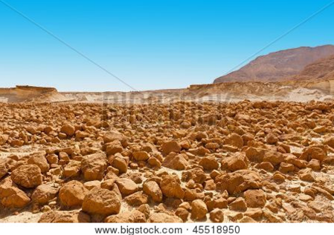
Bigstock Photo ID: 45518950
Stones In The Desert
Stones in the Judean Desert on the West Bank of the Jordan River
Stock Photo ID: 45518950
Copyright: gkuna


Bigstock Photo ID: 54265772
Wide country road in Kyrgyzstan
Wide country road in Tien Shan mountains, Kyrgyzstan
Stock Photo ID: 54265772
Copyright: Evgeny_D


Bigstock Photo ID: -35312726
Tegenungan Waterfall is a beautiful waterfall located in plateau area and it is one of places of interest of Bali
Stock Photo ID: 35312726
Copyright: Lenor


Bigstock Photo ID: 32896154
Peyto Lake Of Canada
Bright blue glacial waters of Peyto Lake of Banff National Park in Canada.
Stock Photo 32896154
by Wirepec


Bigstock Photo ID: 64263751
Spitzkoppe with sandstone boulders in the foreground Namibia
Stock Photo ID: 64263751
Copyright: Grobler du Preez

