Template for God’s Guidance for Your Life
The Word of God Series is a collection of 20 booklets that present Scripture verses in an easy-to-read format, with each booklet focused on a different topic.
Titles include Healthy Relationships, A Joy-Filled Life, Freedom from Depression, and many others.
The booklets are available in both paperback and digital formats at www.TheWordOfGodSeries.com or Amazon.com.
Why This Template?
Because I believe in the power of God’s Word to transform people’s lives, I have dedicated several years of my life to
bring this series to fruition.
I am passionate about using these booklets to reach
a dark and dying world with the love of Christ and
the hope of the Gospel.
Initially, I had expected this series would be a small business. But one day, when I asked God what my next steps should be,
He spoke to me through His Word and told me to:
“…complete the ministry God has given you.”
~ 2 Timothy 4:5 (NLT, 1996 version)
So, I shifted the focus from a business to a ministry.
My vision, also, has evolved over time and I have come to believe that it is possible for millions of these booklets to be distributed (in both print and digital formats) around the world (see the document entitled The Vision at www.TheWordOfGodSeries.com for more info.)
In order to make this a far-reaching ministry, accessing populations that I couldn’t on my own, I decided to invite others to partner with me in producing and distributing these booklets to their own personal networks. To help get it started, I have made templates of each booklet freely available to anyone who would like them.
This way you (whether you are a church, Christian organization or an individual) can easily re-create the booklets in your own ministry’s name, and distribute them to the people you minister to.
I hope that this template will save you:
- Time – so you can benefit from the thousands of hours
of development time that has been invested so far
- Money – eliminate layers of profit margin, and save on shipping costs (especially for large quantities)

Whether you simply replicate and reproduce what has already been done, build on it, or take this idea in a different direction, you won’t have to waste time starting with a blank page.
I hope you can easily get these finalized and printed, so you can begin sharing them with the people in your sphere of influence.
On the following pages you will find document formatting and printing tips.
Photo editing tips are also presented, as well as the preview images of each photo (with the Photo ID#), so you to easily find it on either bigstockphoto.com or shutterstock.com.

Photo Editing Tips
At the end of this document you will find the copyright and descriptive info for each photo in the booklet, as well as editing suggestions for a few of them.
Many photos will need to be slightly stretched or cropped to fit the page.
Most of the editing suggestions below (especially brightening or increasing color saturation) should be very slight adjustments.
Editing photos within this document
Wrapping text around the photo: Doubleclick the photo, click
on Wrap Text and select Square. Then, drag the image by the corner until it is the right size to wrap the text around it.
Rotate: Doubleclick the photo, click on the Rotate Object icon.

Editing photos in the Pictures editing app in MS Word
Navigate to your Pictures folder, doubleclick the photo, and click on the blue Edit button on left
Most of the editing can be done by using one of these 3 options:


Crop: Click on the Crop icon and drag edges to desired spot
Brighten a photo: Adjustment icon / Light / Brightness
Increase color saturation: Adjustment icon / Color / Saturation or Warmth
Remove distracting elements from a photo: Click on the Generative Erase icon, select a brush size and click on the part of the photo you want removed.

Photo Searching Tips
Occasionally photographers pull their photos from the sites,
so there may be some in this booklet that are no longer available.
You can try using the same key words to search for the photo
on other sites (scroll to the end of this document for more descriptive information about each photo.)
Or, you can search for another photo on Bigstock. Under
All Images select Photos and search by key word. At the next screen, make sure that Safe Search is on. In the Category field, select either Landscapes, Nature or Animals.

Booklet Formatting Tips
If you make any changes to this document that results in changing the number of lines on a page, then the page will need to be re-formatted for everything to fit.
Often changing the spacing between the characters or between the lines in one verse is enough to re-format it.
Changing the spacing between the characters
Home / Font / Advanced / Character Spacing
Choose Expanded or Condensed, and select a numeric value (best from .1 to .3)


Changing the spacing between the lines
Highlight all the text in the passage or page and click on:
Layout / Paragraph / Line Spacing / Multiple
Select a numeric value (best from .98 to 1.02)


Saving the document as a PDF
Adobe Acrobat Pro subscriptions are available at www.adobe.com/creativecloud/plans.html. You could also
ask your library tech center if they carry Adobe products.
When the Word doc is final: File / Save as Adobe PDF

Viewing the PDF as a booklet
Remove the first blank page of the doc: Edit / Trash icon.
Enter pages 1 to 1 to delete. Then exit from the Edit mode.
To view the document as a booklet, click on the page icon
(on right side of page, below the rotate button) and select
Two-page view and Show cover page.


Adding page numbers to the PDF
Edit / Header & Footer / Add / Add New
Under Font Name choose your font (this document uses the Georgia font) and under Size enter 8 pt.
Under Margins, in the Bottom box, enter .4
Click in box under Center Footer Text and click on the Insert Page Number button.
Click on Page Range Options. The Pages From _ to _
will depend on which page in your document you want read as Page 1 in the PDF.
In these booklets, the verses begin on Page 5 (after the forward page, copyright page, and Table of Contents).
If you plan to develop several booklets, select Save Settings.


Printing the Booklets
You can print these as regular paperbacks with a binding, (which look a bit nicer) or, you can print them with a staple binding. The staple binding does require a certain type of machine that can print them in a way that they open fully to any page (not just the center page) and lay flat. Your local printer may or may not have that capability, so discuss options with them.
A glossy cover is recommended, as it has a better feel than a matte finish. You may want to request the booklets be printed on Cougar® paper, which has a very smooth finish.

Stuck on a Step Above and Need Help?
If you want to do this project on your own, but are having tech issues with one of the steps above, feel free to contact me at Susan@TheWordOfGodSeries.com. I may be able to assist you, since I’ve gone through this whole process myself!

Need Help with the Whole Project?
If you want these booklets set up in your own in your own ministry’s name, but don’t have the resources to do the whole project yourself,
I may be able to manage that process for you for a one-time project fee.
This would include the following services:
- Set up an account with Bigstock and Shutterstock in your ministry’s name and purchase the rights for you to use each of the photos
- Download and name the photos
- Edit photos as needed
- Create a cover with your church or ministry logo
- Request the rights to use the various Bible translations from each of the publishers (if applicable)
Feel free to contact me at Susan@TheWordOfGodSeries.com to discuss pricing options.
I hope that this information will help you finalize this document with ease so you can begin distributing it to the people in your realm of influence.
Thank you for partnering with me in this effort. I wish you the best as you make God’s Word known and share His love with others!
Warmly in Christ,
Susan

Soli Deo gloria



Feel free to edit this forward page to align to your own ministry’s vision and goals.

The Bible is the best-selling and most transformative book in history. Written over 2,000 years ago, it is still living and powerful today.
Throughout the pages of Scripture you will find inspiration and joy, comfort and peace, healing and hope.
Most importantly, you will learn of God’s abundant love for you, and His plan to give you a glorious, eternal inheritance.
The Word of God Series is a collection of booklets which presents Scripture by topic, so you can focus on verses that are relevant to you at different stages and circumstances throughout your life.
All of the booklets in this series feature Scripture exclusively—
just the powerful, undiluted Word of God.
Let God’s Word permeate your mind and transform your life.
Here are a few suggestions to help you fully benefit from Scripture:
Meditate
Pause and reflect on the verses as you read, and even meditate on them throughout the day.
Memorize
A great memorization technique is to repeat the verse several times, each time emphasizing a different word.
The Lord will fulfill his purpose for me...
The Lord will fulfill his purpose for me...
The Lord will fulfill his purpose for me...
~ Psalm 138:8a (ESV)
Pray
Pray God’s Word back to Him. For example,
Dear Lord, thank you for your promise that You are going to fulfill Your purpose for me.

Do What It Says
Do not merely listen to the word, and so deceive yourselves.
Do what it says.

~ James 1:22 (NIV)

My prayer for you, as you read this booklet, is that you will seek God’s guidance, fulfill His purpose for you, and be confident that He will carry on to completion the good work He has begun in you.
Let the word of Christ dwell in you richly…
~ Colossians 3:16a (ESV)

A few comments about this series:

- The booklets in this series provide you with a sample of what the Bible offers, but it is important that you also read the Bible itself, preferably with a book-by-book focus.

- Passages in quotation marks are the actual words of God, either through His prophets in the Old Testament, or the words of Christ
in the New Testament.

- Every booklet includes a section that details God’s plan of salvation (commonly referred to as “The Gospel.”) The booklet entitled God’s Gift of Eternal Life
is devoted to the Gospel message.

This series presents verses in the following translations:

NIV: New International Version
Scripture quotations marked NIV are taken from the Holy Bible, New International Version®, NIV®. Copyright © 1973, 1978, 1984, 2011 by Biblica, Inc.™ Used by permission of Zondervan. All rights reserved worldwide. www.zondervan.com. The "NIV" and "New International Version" are trademarks registered in the United States Patent and Trademark Office by Biblica, Inc.™

NLT: New Living Translation
Scripture quotations marked NLT are taken from the Holy Bible, New Living Translation, Copyright© 1996, 2004, 2015 by Tyndale House Foundation. Used by permission of Tyndale House Publishers, Inc., Carol Stream, Illinois 60188. All rights reserved.

ESV: English Standard Version
Scripture quotations marked ESV are taken from the ESV Bible® (The Holy Bible, English Standard Version®), copyright © 2001 by Crossway Bibles, a publishing ministry of Good News Publishers. Used by permission. All rights reserved.

KJV: King James Version
Public Domain

NKJV: New King James Version
Scripture quotations marked NKJV are taken from the New King James Version®. Copyright © 1982 by Thomas Nelson, Inc. Used by permission.

Since this is a template booklet featuring preview photos, it is not copyrighted, so you are free to purchase licenses to use the photos and develop your own booklets for print. Be sure to determine whether or not you need to request permission (and in some cases pay) for the rights to use the various Bible translations. Scripture verses were sourced from www.BibleGateway.com.
If it would be easier for you to simply purchase this booklet, the copyrighted version is available at www.TheWordOfGodSeries.com or www.amazon.com.
ISBN info for the copyrighted booklets is as follows:
The ISBN is 978-1-964538-34-1 and the Amazon ISBN is 9798322916390.
God’s Guidance
For Your Life

Contents

God Will Guide You Along the Right Path 1
Ask God for Wisdom 6
Be Guided by God’s Word 9
Be Guided by the Holy Spirit 12
Be Guided in Righteousness 14
God’s Purpose for You 17
Accept His Gift of Eternal Life
Share the Good News with Others
Live a Life of Love
Praise and Glorify Him
Work Enthusiastically for the Lord 40
Give Yourself Fully to the Work of the Lord
Commit Your Work to the Lord
Finish the Work
God Will Fulfill His Purpose for Your Life 46
The Lord’s Purpose Will Prevail
May God Give You the Desire
and the Power to Do What Pleases Him

God Will Guide You

Along the Right Path

The Lord says,
“I will guide you along the best pathway for your life.
“I will advise you and watch over you.”

~ Psalm 32:8 (NLT)

“I will instruct you and teach you in the way you should go;
“I will guide you with My eye.”

~ Psalm 32:8 (NKJV)

This is what the Lord says:
“Stand at the crossroads and look;
ask for the ancient paths,
ask where the good way is,
and walk in it,
and you will find rest for your souls.”

~ Jeremiah 6:16a (NIV)



Your ears shall hear a word behind you, saying,
“This is the way, walk in it…”

~ Isaiah 30:21a (NKJV)
“I will lead the blind by ways they have not known,
along unfamiliar paths I will guide them;
“I will turn the darkness into light before them
and make the rough places smooth.
“These are the things I will do;
I will not forsake them.”

~ Isaiah 42:16 (NIV)



“See, I am sending an angel before you to protect you
on your journey and lead you safely to the place I have prepared for you.”

~ Exodus 23:20 (NLT)
Thus says the Lord, your Redeemer, the Holy One
of Israel:
“I am the Lord your God,
who teaches you to profit,
who leads you in the way you should go.”

~ Isaiah 48:17 (ESV)

“Forget the former things;
do not dwell on the past.
See, I am doing a new thing!
Now it springs up; do you not perceive it?
I am making a way in the wilderness
and streams in the wasteland.”

~ Isaiah 43:18-19 (NIV)

“So do not worry, saying, ‘What shall we eat?’ or ‘What shall we drink?’ or ‘What shall we wear?’ For the pagans run after all these things, and your heavenly Father knows that you need them.”

~ Matthew 6:31-32 (NIV)

“But seek first the kingdom of God and His righteousness, and all these things shall be added to you.”

~ Matthew 6:33 (NKJV)

Lord, I know that people’s lives are not their own;
it is not for them to direct their steps.

~ Jeremiah 10:23 (NIV)

The heart of man plans his way, but the Lord establishes his steps.

~ Proverbs 16:9 (ESV)

A man’s steps are of the Lord; how then can a man understand his own way?
~ Proverbs 20:24 (NKJV)

Do not enter the path of the wicked, and do not walk in the way of the evil.

~ Proverbs 4:14 (ESV)

Put your hope in the Lord. Travel steadily along his path.
He will honor you by giving you the land.

~ Psalm 37:34a (NLT)
Lead me in the right path, O Lord…Make your way plain for me to follow.

~ Psalm 5:8 (NLT)

Show me Your ways, O Lord; teach me Your paths.
Lead me in Your truth and teach me...

~ Psalm 25:4-5a (NKJV)

Show me the way I should go, for to you I entrust my life.

~ Psalm 143:8b (NIV)



Teach me thy way, O Lord, and lead me in a plain path…

~ Psalm 27:11a (KJV)

…lead me in a straight path…

~ Psalm 27:11b (NIV)

…lead me on a level path…

~ Psalm 27:11b (ESV)

If I rise on the wings of the dawn, if I settle on the far side of the sea, even there your hand will guide me, your right hand will hold me fast.

~ Psalm 139:9-10 (NIV)
Trust in the Lord with all your heart,
And lean not on your own understanding;
In all your ways acknowledge Him,
And He shall direct your paths.

~ Proverbs 3:5-6 (NKJV)

Trust in the Lord and do good;
dwell in the land and enjoy safe pasture.
Take delight in the Lord,
and he will give you the desires of your heart.

~ Psalm 37:3-4 (NIV)

Trust in the Lord forever, for the Lord, the Lord himself, is the Rock eternal.
~ Isaiah 26:4 (NIV)

For thou art my rock and my fortress; therefore for thy name’s sake lead me, and guide me.

~ Psalm 31:3 (KJV)

We ask God to give you complete knowledge of his will and to give you spiritual wisdom and understanding.
Then the way you live will always honor and please the Lord, and your lives will produce every kind of good fruit.

~ Colossians 1:9b-10a (NLT)

Who are those who fear the Lord? He will show them the path they should choose.

~ Psalm 25:12 (NLT)

Let your eyes look straight ahead;
fix your gaze directly before you.
Give careful thought to the paths for your feet
and be steadfast in all your ways.

~ Proverbs 4:25-26 (NIV)

The Lord himself goes before you and will be with you;
he will never leave you nor forsake you.

~ Deuteronomy 31:8a (NIV)

For this God is our God forever and ever: he will be our guide even unto death.

~ Psalm 48:14 (KJV)

Ask God for Wisdom

If any of you lacks wisdom, you should ask God,
who gives generously to all without finding fault,
and it will be given to you.
But when you ask, you must believe and not doubt, because the one who doubts is like a wave of the sea, blown and tossed by the wind. That person should
not expect to receive anything from the Lord.

~ James 1:5-7 (NIV)

For the Lord gives wisdom;
from his mouth come knowledge and understanding.
He holds success in store for the upright,
he is a shield to those whose walk is blameless,
for he guards the course of the just
and protects the way of his faithful ones.
Then you will understand what is right and just
and fair—every good path.

~ Proverbs 2:6-9 (NIV)

He grants a treasure of common sense to the honest.

~ Proverbs 2:7a (NLT)

He stores up sound wisdom for the upright…

~ Proverbs 2:7a (NKJV)

Whoever is wise, let him understand these things;
whoever is discerning, let him know them;
for the ways of the Lord are right,
and the upright walk in them…

~ Hosea 14:9a (ESV)

The fear of the Lord is the beginning of knowledge:
but fools despise wisdom and instruction.

~ Proverbs 1:7 (KJV)

…do not let wisdom and understanding out of your sight, preserve sound judgment and discretion…

~ Proverbs 3:21b (NIV)
…the wisdom that comes from heaven is first of all pure; then peace-loving, considerate, submissive, full of mercy and good fruit, impartial and sincere.

~ James 3:17 (NIV)

The Lord will guide you continually,
giving you water when you are dry
and restoring your strength.
You will be like a well-watered garden,
like an ever-flowing spring.

~ Isaiah 58:11 (NLT)


Listen to advice and accept instruction, that you may
gain wisdom in the future.

~ Proverbs 19:20 (ESV)

Listen, my son, to your father’s instruction and
do not forsake your mother’s teaching.

~ Proverbs 1:8 (NIV)

Plans are established by seeking advice…

~ Proverbs 20:18a (NIV)

Without counsel plans fail, but with many advisers
they succeed.

~ Proverbs 15:22 (ESV)

…those who take advice are wise.

~ Proverbs 13:10b (NLT)

The plans of the diligent lead surely to abundance,
but everyone who is hasty comes only to poverty.

~ Proverbs 21:5 (ESV)

Whoever heeds instruction is on the path to life,
but he who rejects reproof leads others astray.

~ Proverbs 10:17 (ESV)

The one who gets wisdom loves life; the one who cherishes understanding will soon prosper.

~ Proverbs 19:8 (NIV)

…true wisdom and power are found in God; counsel and understanding are his.

~ Job 12:13 (NLT)

My son, if you accept my words
and store up my commands within you,
turning your ear to wisdom
and applying your heart to understanding…
then you will understand the fear of the Lord
and find the knowledge of God.

~ Proverbs 2:1-5 (NIV)

Further Reading

The book of Proverbs – try reading all 31 chapters for a month, beginning with the chapter that corresponds to the day of the month (i.e. if it’s the 3rd day of the month, begin with chapter 3.)

Be Guided By God’s Word

Let the word of Christ dwell in you richly…

~ Colossians 3:16a (ESV)

“If you abide in my word, you are truly my disciples,
and you will know the truth, and the truth will set you free.”

~ John 8:31b-32 (ESV)

“If you remain in me and my words remain in you,
ask whatever you wish, and it will be done for you.”

~ John 15:7 (NIV)


Guide my steps by your word,
so I will not be overcome by evil.

~ Psalm 119:133 (NLT)

Order my steps in thy word:
and let not any iniquity have dominion over me.

~ Psalm 119:133 (KJV)

Direct my footsteps according to your word;
let no sin rule over me.

~ Psalm 119:133 (NIV)


All Scripture is God-breathed and is useful for teaching, rebuking, correcting and training in righteousness, so that the servant of God may be thoroughly equipped for every good work.

~ 2 Timothy 3:16-17 (NIV)

Blessed is the one…whose delight is in the law of the Lord, and who meditates on his law day and night.
That person is like a tree planted by streams of water, which yields its fruit in season and whose leaf does
not wither—whatever they do prospers.

~ Psalm 1:1-3 (NIV)

Keep this Book of the Law always on your lips;
meditate on it day and night,
so that you may be careful to do everything written in it.
Then you will be prosperous and successful.

~ Joshua 1:8 (NIV)

Do not merely listen to the word, and so deceive yourselves. Do what it says.

~ James 1:22 (NIV)

Hold firmly to the word of life…

~ Philippians 2:16a (NLT)

Thy word is a lamp unto my feet, and a light unto my path.

~ Psalm 119:105 (KJV)

Make me walk along the path of your commands, for that is where my happiness is found.

~ Psalm 119:35 (NLT)

I have kept my feet from every evil path so that I might obey your word.

~ Psalm 119:101 (NIV)

So get rid of all the filth and evil in your lives, and humbly accept the word God has planted in your hearts, for it has the power to save your souls.

~ James 1:21 (NLT)

Further Reading
Deuteronomy 28:1-8, Psalm 119, James 1:18-25

Be Guided by the Holy Spirit

“But when he, the Spirit of truth, comes, he will guide you into all the truth.
“He will not speak on his own; he will speak only what
he hears, and he will tell you what is yet to come.”

~ John 16:13 (NIV)

“He will tell you about the future.”

~ John 16:13b (NLT)



Teach me to do your will, for you are my God!
Let your good Spirit lead me on level ground!

~ Psalm 143:10 (ESV)

And the Holy Spirit helps us in our weakness.
For example, we don’t know what God wants us to pray for.
But the Holy Spirit prays for us with groanings that cannot be expressed in words.

~ Romans 8:26 (NLT)
“…I will ask the Father, and he will give you another Advocate, who will never leave you.
“He is the Holy Spirit, who leads into all truth.”

~ John 14:16-17a (NLT)

“..the Helper, the Holy Spirit, whom the Father will send in My name, He will teach you all things, and bring to your remembrance all things that I said to you.”

~ John 14:26 (NKJV)

…let the Holy Spirit guide your lives.

~ Galatians 5:16a (NLT)

…the disciples were filled with joy and with the Holy Spirit.

~ Acts 13:52 (NKJV)

…we have received God’s Spirit (not the world’s spirit),
so we can know the wonderful things God has freely
given us.

~ 1 Corinthians 2:12 (NLT)

“Do not turn to mediums or seek out spiritists, for you
will be defiled by them. I am the Lord your God.”

~ Leviticus 19:31 (NIV)

There is a way that seems right to a man, but its end is
the way to death.

~ Proverbs 14:12 (ESV)

So Saul died because he was unfaithful to the Lord.
He failed to obey the Lord’s command, and he even consulted a medium instead of asking the Lord for guidance.

~ 1 Chronicles 10:13-14a (NLT)

Repent and be baptized, every one of you, in the name
of Jesus Christ for the forgiveness of your sins.
And you will receive the gift of the Holy Spirit.

~ Acts 2:38 (NIV)

May the God of hope fill you with all joy and peace
as you trust in him, so that you may overflow with hope
by the power of the Holy Spirit.

~ Romans 15:13 (NIV)

Be Guided In Righteousness

…the godly will flourish like palm trees…
For they are transplanted to the Lord’s own house.
They flourish in the courts of our God.
Even in old age they will still produce fruit;
they will remain vital and green.

~ Psalm 92:12-14 (NLT)



Blessed are all who fear the Lord, who walk in obedience to him.
You will eat the fruit of your labor; blessings and prosperity will be yours.

~ Psalm 128:1-2 (NIV)
You can be sure of this:
The Lord set apart the godly for himself.

~ Psalm 4:3a (NLT)

The Lord directs the steps of the godly.
He delights in every detail of their lives.

~ Psalm 37:23 (NLT)

…for those who are righteous, the way is not steep
and rough.
You are a God who does what is right, and you smooth
out the path ahead of them.

~ Isaiah 26:7 (NLT)

The righteousness of the blameless keeps his way straight…

~ Proverbs 11:5a (ESV)

…he leadeth me in the paths of righteousness...

~ Psalm 23:3b (KJV)

So be careful to do what the Lord your God has commanded you; do not turn aside to the right or to the left.

~ Deuteronomy 5:32 (NIV)

Walk in obedience to all that the Lord your God has commanded you, so that you may live and prosper…

~ Deuteronomy 5:33a (NIV)

He leads the humble in what is right…

~ Psalm 25:9a (ESV)

The integrity of the upright will guide them…

~ Proverbs 11:3a (NKJV)

Joyful are people of integrity, who follow the instructions of the Lord…They do not compromise with evil, and they walk only in his paths.

~ Psalm 119:1-3 (NLT)

Do not enter the path of the wicked, and do not walk in the way of the evil.

~ Proverbs 4:14 (ESV)

…walk in the way of the good and keep to the paths of
the righteous.

~ Proverbs 2:20b (ESV)
Point out anything in me that offends you, and lead me along the path of everlasting life.

~ Psalm 139:24 (NLT)

Lord, who may dwell in your sacred tent?
Who may live on your holy mountain?
The one whose walk is blameless,
who does what is righteous,
who speaks the truth from their heart;
whose tongue utters no slander,
who does no wrong to a neighbor,
and casts no slur on others;
who despises a vile person
but honors those who fear the Lord;
who keeps an oath even when it hurts,
and does not change their mind;
who lends money to the poor without interest;
who does not accept a bribe against the innocent.
Whoever does these things will never be shaken.

~ Psalm 15 (NIV)

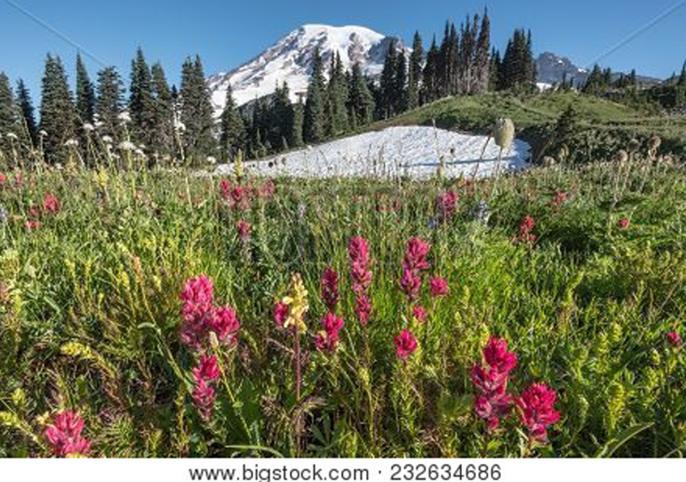

Because of my integrity you uphold me and set me in
your presence forever.

~ Psalm 41:12 (NIV)

God’s Purpose for You:

Accept His Gift of Eternal Life

God loves you abundantly, and has made a way for you to live forever in His glorious kingdom. However, first He had to pay an enormous price for you to be forgiven of your sin, in order to receive this eternal glory. This section explains His plan to forgive and save you. In summary:
God loves you, but your sin separates you from Him, and because of it, God’s wrath will come. However, Jesus died as a sacrifice to save you from your sins, from God’s wrath, and from death itself. When you confess your sins, repent and accept the salvation that Christ offers, God will forgive you. By trusting in Christ you become God’s child, and as His child, you will inherit eternal life and heaven will be your home..

God Loves You

Even before he made the world, God loved us and chose us…

~ Ephesians 1:4a (NLT)

We know how much God loves us, and we have put our trust in his love. God is love…

~ 1 John 4:16a (NLT)

Every good and perfect gift is from above, coming down from the Father of the heavenly lights…

~ James 1:17a (NIV)

The earth is full of the goodness of the Lord.

~ Psalm 33:5b (NKJV)

“Before I formed you in the womb I knew you, before you were born I set you apart…”

~ Jeremiah 1:5a (NIV)

“I have called you by your name; You are Mine.”

~ Isaiah 43:1b (NKJV)

“…the very hairs of your head are all numbered.”

~ Matthew 10:30b (NIV)

“…I lavish unfailing love for a thousand generations on those who love me and obey my commands.”

~ Deuteronomy 5:10b (NLT)
But Your Sin Separates You from God

We are all infected and impure with sin. When we display our righteous deeds, they are nothing but filthy rags.

~ Isaiah 64:6a (NLT)

Don’t you realize that those who do wrong will not inherit the Kingdom of God? Don’t fool yourselves.

~ 1 Corinthians 6:9a (NLT)

The acts of the flesh are obvious: sexual immorality, impurity and debauchery; idolatry and witchcraft; hatred, discord, jealousy, fits of rage, selfish ambition, dissensions, factions and envy; drunkenness, orgies,
and the like.
I warn you, as I did before, that those who live like this will not inherit the kingdom of God.

~ Galatians 5:19-21 (NIV)

For of this you can be sure:
No immoral, impure or greedy person—such a person
is an idolater—has any inheritance in the kingdom of Christ and of God.
Let no one deceive you with empty words, for because of such things God’s wrath comes on those who are disobedient.

~ Ephesians 5:5-6 (NIV)

Wealth is worthless in the day of wrath…

~ Proverbs 11:4a (NIV)

The Day of God’s Wrath Will Come

The wrath of God is being revealed from heaven against all the godlessness and wickedness of people, who suppress the truth by their wickedness, since what may
be known about God is plain to them, because God has made it plain to them.
For since the creation of the world God’s invisible qualities—his eternal power and divine nature—have been clearly seen, being understood from what has been made…
For although they knew God, they neither glorified him
as God nor gave thanks to him, but their thinking became futile and their foolish hearts were darkened. Although they claimed to be wise, they became fools…
Furthermore, just as they did not think it worthwhile to retain the knowledge of God, so God gave them over to
a depraved mind...

~ Romans 1:18-28a (NIV)

Even now the ax of God’s judgment is poised, ready to sever the roots of the trees. Yes, every tree that does not produce good fruit will be chopped down and thrown into the fire.

~ Matthew 3:10 (NLT)

“The angels will come and separate the wicked people from the righteous, throwing the wicked into the fiery furnace, where there will be weeping and gnashing of teeth.”

~ Matthew 13:49b-50 (NIV)

And anyone whose name was not found recorded in the Book of Life was thrown into the lake of fire.

~ Revelation 20:15 (NLT)

They will be punished with everlasting destruction and shut out from the presence of the Lord and from the
glory of his might…

~ 2 Thessalonians 1:9 (NIV)

Confess Your Sin and Repent

So put to death the sinful, earthly things lurking within you.
Have nothing to do with sexual immorality, impurity, lust, and evil desires. Don’t be greedy, for a greedy person is an idolater, worshiping the things of this world. Because of these sins, the anger of God is coming.

~ Colossians 3:5-6 (NLT)

The Lord is…not willing that any should perish but that all should come to repentance.

~ 2 Peter 3:9 (NKJV)

Repent, then, and turn to God, so that your sins may be wiped out, that times of refreshing may come from the Lord…

~ Acts 3:19 (NIV)
Jesus Died to Save You…

…From Your Sin

Jesus gave his life for our sins, just as God our Father planned, in order to rescue us from this evil world in which we live.

~ Galatians 1:4 (NLT)

For God presented Jesus as the sacrifice for sin. People are made right with God when they believe that Jesus sacrificed his life, shedding his blood.

~ Romans 3:25a (NLT)

…From God’s Wrath

Jesus, whom God raised from the dead…is the one who has rescued us from the terrors of the coming judgment.

~ 1 Thessalonians 1:10b (NLT)

For God did not appoint us to suffer wrath but to receive salvation through our Lord Jesus Christ.

~ 1 Thessalonians 5:9 (NIV)

Since we have now been justified by his blood, how much more shall we be saved from God’s wrath through him!

~ Romans 5:9 (NIV)

…everyone who calls on the name of the Lord will be saved.

~ Acts 2:21 (NLT)

…From Death

Because God’s children are human beings—made of flesh and blood—the Son also became flesh and blood.
For only as a human being could he die, and only by dying could he break the power of the devil, who had the power of death.

~ Hebrews 2:14 (NLT)

He broke the power of death and illuminated the way to life and immortality through the Good News.

~ 2 Timothy 1:10b (NLT)

We know that God, who raised the Lord Jesus, will also raise us with Jesus…

~ 2 Corinthians 4:14a (NLT)
God Demonstrates His Love Through Christ

“For God so loved the world that He gave His only begotten Son, that whoever believes in Him should
not perish but have everlasting life.”

~ John 3:16 (NKJV)

Who shall separate us from the love of Christ?
Shall trouble or hardship
or persecution or famine
or nakedness or danger
or sword?...
No, in all these things we are
more than conquerors through him who loved us.
For I am convinced that neither death nor life, neither angels nor demons, neither the present nor the future, nor any powers, neither height nor depth, nor anything else in all creation, will be able to separate us from the love of God that is in Christ Jesus our Lord.

~ Romans 8:35-39 (NIV)
God Bought You at a Price

You are not your own; you were bought at a price.

~ 1 Corinthians 6:19b-20a (NIV)

God paid a high price for you, so don’t be enslaved
by the world.

~ 1 Corinthians 7:23 (NLT)

But he was pierced for our transgressions,
he was crushed for our iniquities;
the punishment that brought us peace was on him,
and by his wounds we are healed.

~ Isaiah 53:5 (NIV)

Now, brothers and sisters, I want to remind you of the gospel I preached to you…By this gospel you are saved, if you hold firmly to the word I preached to you…that Christ died for our sins according to the Scriptures, that he was buried, that he was raised on the third day according to the Scriptures…

~ 1 Corinthians 15:1-4 (NIV)

But even if we, or an angel from heaven, preach any other gospel to you than what we have preached to you, let him be accursed.

~ Galatians 1:8 (NKJV)

For the time will come when people will not put up with sound doctrine. Instead, to suit their own desires, they will gather around them a great number of teachers to
say what their itching ears want to hear.

~ 2 Timothy 4:3 (NIV)

In Christ You Are Forgiven

…he has rescued us from the dominion of darkness
and brought us into the kingdom of the Son he loves,
in whom we have redemption, the forgiveness of sins.

~ Colossians 1:13-14 (NIV)

For with the Lord there is mercy, and with Him is abundant redemption.

~ Psalm 130:7b (NKJV)

Be kind and compassionate to one another, forgiving
each other, just as in Christ God forgave you.

~ Ephesians 4:32 (NIV)
Salvation is Through Christ Alone

Salvation is found in no one else, for there is no other name under heaven given to mankind by which we must be saved.

~ Acts 4:12 (NIV)

Jesus said to him, “I am the way, the truth, and the life. No one comes to the Father except through Me.”

~ John 14:6 (NKJV)

“I have come as a light to shine in this dark world, so that all who put their trust in me will no longer remain in the dark.”

~ John 12:46 (NLT)

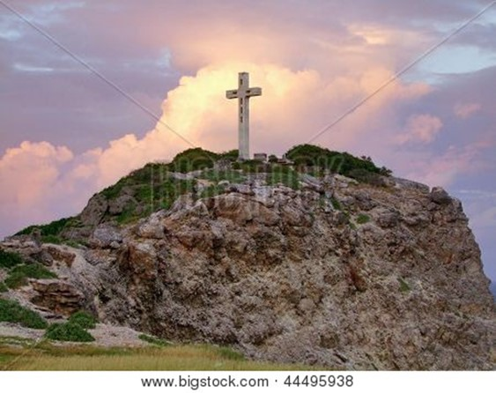

“…whoever comes to me I will never drive away.”

~ John 6:37b (NIV)

“Enter through the narrow gate.
“For wide is the gate and broad is the road that leads to destruction, and many enter through it.
“But small is the gate and narrow the road that leads to life, and only a few find it.”

~ Matthew 7:13-14 (NIV)
Salvation is a Gift: Free and Undeserved

Salvation is not a reward for the good things we have done, so none of us can boast about it.

~ Ephesians 2:9 (NLT)

For it is by grace you have been saved, through faith—
and this not from yourselves, it is the gift of God—
not by works, so that no one can boast.

~ Ephesians 2:8-9 (NIV)

…he saved us, not because of the righteous things we had done, but because of his mercy…Because of his grace he declared us righteous and gave us confidence that we will inherit eternal life.

~ Titus 3:5-7 (NLT)

He did this, not because we deserved it, but because that was his plan from before the beginning of time…

~ 2 Timothy 1:9b (NLT)

Accept This Gift of Salvation

Whoever believes in the Son has eternal life, but whoever rejects the Son will not see life…

~ John 3:36a (NIV)

If you declare with your mouth, “Jesus is Lord,” and believe in your heart that God raised him from the dead, you will be saved.

~ Romans 10:9 (NIV)

But you must continue to believe this truth and stand firmly in it. Don’t drift away from the assurance you received when you heard the Good News.

~ Colossians 1:23a (NLT)

God’s promise of entering his rest still stands, so we
ought to tremble with fear that some of you might fail
to experience it.

~ Hebrews 4:1 (NLT)

…how shall we escape if we ignore so great a salvation?

~ Hebrews 2:3a (NIV)
You Belong to God Through Faith in Christ
and Have Become His Child

But you belong to God, my dear children.

~ 1 John 4:4a (NLT)

Even before he made the world, God loved us and chose us in Christ to be holy and without fault in his eyes.
God decided in advance to adopt us into his own family
by bringing us to himself through Jesus Christ.

~ Ephesians 1:4-5a (NLT)

Everyone who believes that Jesus is the Christ has become a child of God.

~ 1 John 5:1a (NLT)

And since you are his child, God has made you his heir.

~ Galatians 4:7b (NLT)



We know that we are children of God and that the world around us is under the control of the evil one.

~ 1 John 5:19 (NLT)

“If you belonged to the world, it would love you as its own. As it is, you do not belong to the world, but I have chosen you out of the world.”

~ John 15:19a (NIV)
Eternal Life is Yours Through Christ

No eye has seen, no ear has heard, and no mind has imagined what God has prepared for those who love him.

~ 1 Corinthians 2:9b (NLT)

His dominion is an everlasting dominion that will not pass away, and his kingdom is one that will never be destroyed.

~ Daniel 7:14b (NIV)

Since we are receiving a Kingdom that is unshakable,
let us be thankful and please God by worshiping him
with holy fear and awe.

~ Hebrews 12:28 (NLT)

Now we live with great expectation, and we have a priceless inheritance—an inheritance that is kept in heaven for you, pure and undefiled, beyond the reach of change and decay.

~ 1 Peter 1:3b-4 (NLT)

You make known to me the path of life;
you will fill me with joy in your presence,
with eternal pleasures at your right hand.

~ Psalm 16:11 (NIV)



Yet I still belong to you; you hold my right hand.
You guide me with your counsel,
leading me to a glorious destiny.

~ Psalm 73:23-24 (NLT)
Heaven is Your Home

Jesus answered him,
“Truly I tell you, today you will be with me in paradise.”

~ Luke 23:43 (NIV)

Jesus answered,
“My kingdom is not of this world.”

~ John 18:36a (ESV)

“The kingdom of heaven is like treasure hidden in a field.
“When a man found it, he hid it again, and then in his joy went and sold all he had and bought that field.”

~ Matthew 13:44 (NIV)

“The kingdom of heaven is like a mustard seed, which a man took and planted in his field.
“Though it is the smallest of all seeds, yet when it grows,
it is the largest of garden plants…”

~ Matthew 13:31b-32a (NIV)

“And people will come from all over the world…to take their places in the Kingdom of God.
“And note this: Some who seem least important now will be the greatest then, and some who are the greatest now will be least important then.”

~ Luke 13:29-30 (NLT)

“Blessed are those who are persecuted because of righteousness, for theirs is the kingdom of heaven…
“Rejoice and be glad, because great is your reward in heaven…”

~ Matthew 5:10-12a (NIV)

“All who are victorious will be clothed in white.
“I will never erase their names from the Book of Life...”

~ Revelation 3:5a (NLT)

“And be sure of this:
“I am with you always, even to the end of the age.”

~ Matthew 28:20b (NLT)
God’s Purpose for You:

Share the Good News

with Others

And [Jesus] said to them, “Go into all the world and proclaim the gospel to the whole creation.”

~ Mark 16:15 (ESV)

Then Jesus came to them and said,
“All authority in heaven and on earth has been given to me.
“Therefore go and make disciples of all nations, baptizing them in the name of the Father and of the Son and of the Holy Spirit, and teaching them to obey everything I have commanded you.
“And surely I am with you always, to the very end of the age.”

~ Matthew 28:18-20 (NIV)

We are therefore Christ’s ambassadors, as though
God were making his appeal through us.
We implore you on Christ’s behalf: Be reconciled to God.

~ 2 Corinthians 5:20 (NIV)

I thank Christ Jesus our Lord, who has given me
strength to do his work. He considered me trustworthy and appointed me to serve him…

~ 1 Timothy 1:12 (NLT)

…my life is worth nothing to me unless I use it for finishing the work assigned me by the Lord Jesus—the work of telling others the Good News about the wonderful grace of God.

~ Acts 20:24 (NLT)

So I am willing to endure anything if it will bring salvation and eternal glory in Christ Jesus to those God has chosen.

~ 2 Timothy 2:10 (NLT)

I don’t just do what is best for me; I do what is best for others so that many may be saved.

~ 1 Corinthians 10:33b (NLT)
“Everyone who calls on the name of the Lord will be saved.”
But how can they call on him to save them
unless they believe in him?
And how can they believe in him
if they have never heard about him?
And how can they hear about him
unless someone tells them?

~ Romans 10:13b-14 (NLT)

By God’s grace and mighty power, I have been given the privilege of serving him by spreading this Good News.

~ Ephesians 3:7 (NLT)

…thanks be to God, who in Christ always leads us in triumphal procession, and through us spreads the fragrance of the knowledge of him everywhere.

~ 2 Corinthians 2:14 (ESV)


Always be prepared to give an answer to everyone who asks you to give the reason for the hope that you have.
But do this with gentleness and respect, keeping a
clear conscience, so that those who speak maliciously against your good behavior in Christ may be ashamed
of their slander.

~ 1 Peter 3:15b-16 (NIV)

But you should keep a clear mind in every situation. Don’t be afraid of suffering for the Lord.
Work at telling others the Good News, and fully carry out the ministry God has given you.

~ 2 Timothy 4:5 (NLT)

Do your best to present yourself to God as one approved,
a worker who has no need to be ashamed, rightly handling the word of truth.

~ 2 Timothy 2:15 (ESV)

Do all things without complaining and disputing, that
you may become blameless and harmless, children of God without fault in the midst of a crooked and perverse generation, among whom you shine as lights in the world…

~ Philippians 2:14-15 (NKJV)

When they saw the courage of Peter and John and realized that they were unschooled, ordinary men, they were astonished and they took note that these men had been with Jesus.

~ Acts 4:13 (NIV)

…let us throw off everything that hinders and the sin that so easily entangles.
And let us run with perseverance the race marked out for us, fixing our eyes on Jesus…

~ Hebrews 12:1b-2a (NIV)

But on the judgment day, fire will reveal what kind of work each builder has done. The fire will show if a person’s work has any value.
If the work survives, that builder will receive a reward.

~ 1 Corinthians 3:13-14 (NLT)
But the Lord said to me, “Do not say, ‘I am too young.’ You must go to everyone I send you to and say whatever
I command you.”

~ Jeremiah 1:7 (NIV)

“You must influence them; do not let them influence you!”

~ Jeremiah 15:19b (NLT)

“Do not be afraid of them, for I am with you and will rescue you,” declares the Lord.

~ Jeremiah 1:8 (NIV)

“You are the light of the world.
“A town built on a hill cannot be hidden.
“Neither do people light a lamp and put it under a bowl.
“Instead they put it on its stand, and it gives light to everyone in the house.
“In the same way, let your light shine before others,
that they may see your good deeds and glorify your
Father in heaven.”

~ Matthew 5:14-16 (NIV)



Further Reading
The book of Acts.
See also the Sharing the Good News booklet in this series.

God’s Purpose for You:

Live a Life of Love

Above all, love each other deeply, because love covers over a multitude of sins.
~ 1 Peter 4:8 (NIV)

Live a life filled with love, following the example of Christ.
~ Ephesians 5:2a (NLT)

And walk in love…
~ Ephesians 5:2a (ESV)

Love is patient, love is kind.
It does not envy, it does not boast, it is not proud.
It does not dishonor others, it is not self-seeking,
it is not easily angered, it keeps no record of wrongs.
~ 1 Corinthians 13:4-5 (NIV)

Love bears all things, believes all things, hopes all things, endures all things.
~ 1 Corinthians 13:7 (ESV)

And now these three remain: faith, hope and love.
But the greatest of these is love.
~ 1 Corinthians 13:13 (NIV)


Shutterstock Photo ID: 114859960

God is love, and all who live in love live in God, and
God lives in them.

~ 1 John 4:16b (NLT)

If we love one another, God abides in us, and His love
has been perfected in us.
~ 1 John 4:12b (NKJV)

…as God’s chosen people, holy and dearly loved,
clothe yourselves with compassion, kindness, humility, gentleness and patience.
~ Colossians 3:12 (NIV)

…the fruit of the Spirit is
love, joy, peace,
patience, kindness, goodness,
faithfulness, gentleness, self-control…
~ Galatians 5:22-23a (ESV)

Do everything in love.

~ 1 Corinthians 16:14 (NIV)

Do nothing out of selfish ambition or vain conceit. Rather, in humility value others above yourselves, not looking to your own interests but each of you to the interests of the others.

~ Philippians 2:3-4 (NIV)

No one should seek their own good, but the good of others.

~ 1 Corinthians 10:24 (NIV)

Be devoted to one another in love. Honor one another above yourselves.

~ Romans 12:10 (NIV)

…make every effort to add to your faith goodness; and
to goodness, knowledge; and to knowledge, self-control;
and to self-control, perseverance; and to perseverance, godliness; and to godliness, mutual affection; and to mutual affection, love…
For if you do these things, you will never stumble, and
you will receive a rich welcome into the eternal kingdom of our Lord and Savior Jesus Christ.
~ 2 Peter 1:5-11 (NIV)
And what does the Lord require of you?
To act justly and
to love mercy and
to walk humbly with your God.

~ Micah 6:8b (NIV)

“For I desire mercy, not sacrifice and acknowledgment of God rather than burnt offerings.”

~ Hosea 6:6 (NIV)

“This is my command: Love each other.”

~ John 15:17 (NLT)

One of the teachers of the law came and…asked him,
“Of all the commandments, which is the most important?”
“The most important one,” answered Jesus, “is this:
‘Hear, O Israel: The Lord our God, the Lord is one. Love the Lord your God with all your heart and with
all your soul and with all your mind and with all
your strength.’
“The second is this:
‘Love your neighbor as yourself.’
“There is no commandment greater than these.”

~ Mark 12:28-31 (NIV)

“A new command I give you: Love one another.
“As I have loved you, so you must love one another.
By this everyone will know that you are my disciples,
if you love one another.”
~ John 13:34-35 (NIV)

“But I say, love your enemies! Pray for those who persecute you! In that way, you will be acting as true children of your Father in heaven.”

~ Matthew 5:44-45a (NLT)

“If you love those who love you, what credit is that to you? Even sinners love those who love them...
“But love your enemies, do good to them, and lend to them without expecting to get anything back.
“Then your reward will be great...”

~ Luke 6:32-35 (NIV)
Let us think of ways to motivate one another to acts of love and good works.

~ Hebrews 10:24 (NLT)

Let each of us please his neighbor for his good, to build him up.

~ Romans 15:2 (ESV)

If anyone has material possessions and sees his brother
in need but has no pity on him, how can the love of God
be in him?
Dear children, let us not love with words or tongue but with actions and in truth.
~ 1 John 3:17-18 (NIV)

Dear brothers and sisters, I close my letter with these
last words:
Be joyful. Grow to maturity. Encourage each other.
Live in harmony and peace.
Then the God of love and peace will be with you.

~ 2 Corinthians 13:11 (NLT)



Further Reading

The book of 1 John.
See also the Healthy Relationships booklet in this series.

God’s Purpose for You:

Praise and Glorify Him

Praise the Lord. Give thanks to the Lord, for he is good; his love endures forever.

~ Psalm 106:1b (NIV)

Praise him for his acts of power;
praise him for his surpassing greatness.

~ Psalm 150:2 (NIV)

For great is his steadfast love toward us…

~ Psalm 117:2a (ESV)

Shout for joy to the Lord,
all the earth.
Worship the Lord with gladness;
come before him with joyful songs.
Know that the Lord is God.
It is he who made us, and we are his
we are his people, the sheep of his pasture.
Enter his gates with thanksgiving and his courts with praise;
give thanks to him and praise his name.
For the Lord is good and his love endures forever;
his faithfulness continues through all generations.

~ Psalm 100 (NIV)

He alone is your God, the only one who is worthy of
your praise…

~ Deuteronomy 10:21a (NLT)

Rejoice always, pray continually, give thanks in
all circumstances; for this is God’s will for you in
Christ Jesus.

~ 1 Thessalonians 5:16-18 (NIV)

Let the message of Christ dwell among you richly…
singing to God with gratitude in your hearts.

~ Colossians 3:16 (NIV)

Lift up your hands in the sanctuary and praise the Lord.

~ Psalm 134:2 (NIV)
May you be filled with joy, always thanking the Father.
He has enabled you to share in the inheritance that belongs to his people, who live in the light.

~ Colossians 1:11b-12 (NLT)

…you are a chosen generation,
a royal priesthood,
a holy nation,
His own special people,
that you may proclaim the praises of Him who called you out of darkness into His marvelous light…

~ 1 Peter 2:9 (NKJV)



…he has purchased us to be his own people.
He did this so we would praise and glorify him.

~ Ephesians 1:14b (NLT)

So we praise God for the glorious grace he has poured out on us who belong to his dear Son.

~ Ephesians 1:6 (NLT)

…giving thanks always for all things to God the Father in the name of our Lord Jesus Christ…

~ Ephesians 5:20 (ESV)
Lord, there is no one like you!
For you are great, and your name is full of power.

~ Jeremiah 10:6 (NLT)

Let them praise your great and awesome name.
Your name is holy!

~ Psalm 99:3 (NLT)

I will glorify your name forever.

~ Psalm 86:12b (NIV)

Yours, O Lord, is the greatness, the power, the glory,
the victory, and the majesty.
Everything in the heavens and on earth is yours, O Lord, and this is your kingdom.
We adore you as the one who is over all things.

~ 1 Chronicles 29:11 (NLT)

Wealth and honor come from you alone, for you rule over everything.
Power and might are in your hand, and at your discretion people are made great and given strength.

~ 1 Chronicles 29:12 (NLT)

O Lord my God, you are very great!
You are clothed with splendor and majesty…

~ Psalm 104:1b (ESV)

Be exalted, O God, above the heavens, and Your glory above all the earth…

~ Psalm 108:5 (NKJV)

What is man, that you make so much of him, and that
you set your heart on him…

~ Job 7:17 (ESV)

Your eyes are open to the ways of all mankind;
you reward each person according to their conduct
and as their deeds deserve.

~ Jeremiah 32:19b (NIV)

Before the mountains were born or you brought forth the whole world, from everlasting to everlasting you are God.

~ Psalm 90:2 (NIV)
I will exalt you, my God the King;
I will praise your name for ever and ever.

~ Psalm 145:1 (NIV)

I will give thanks to you, Lord, with all my heart;
I will tell of all your wonderful deeds.

~ Psalm 9:1 (NIV)

I will be filled with joy because of you.
I will sing praises to your name, O Most High.

~ Psalm 9:2 (NLT)

I will meditate on your majestic, glorious splendor
and your wonderful miracles.

~ Psalm 145:5 (NLT)

I will praise you as long as I live, lifting up my hands
to you in prayer.

~ Psalm 63:4 (NLT)

I will perpetuate your memory through all generations; therefore the nations will praise you for ever and ever.

~ Psalm 45:17 (NIV)



I give thanks to you, O Lord my God, with my whole heart, and I will glorify your name forever.

~ Psalm 86:12 (ESV)

Work Enthusiastically

for the Lord

Give Yourself Fully to the Work of the Lord

Whatever you do, work at it with all your heart,
as working for the Lord, not for human masters,
since you know that you will receive an inheritance
from the Lord as a reward.
It is the Lord Christ you are serving.

~ Colossians 3:23-24 (NIV)

And whatsoever ye do, do it heartily, as to the Lord...

~ Colossians 3:23a (KJV)

Throw yourself into your tasks…
~ 1 Timothy 4:15b (NLT)

And whatever you do or say, do it as a representative
of the Lord Jesus…

~ Colossians 3:17a (NLT)

So whether you eat or drink, or whatever you do, do it
all for the glory of God.

~ 1 Corinthians 10:31 (NLT)

Never be lacking in zeal, but keep your spiritual fervor, serving the Lord.

~ Romans 12:11 (NIV)

“You did not choose me, but I chose you and appointed you so that you might go and bear fruit—fruit that will last—and so that whatever you ask in my name the
Father will give you.”

~ John 15:16 (NIV)

“Wash yourselves and be clean!
“Get your sins out of my sight. Give up your evil ways.
“Learn to do good. Seek justice. Help the oppressed.
“Defend the cause of orphans. Fight for the rights of widows.”

~ Isaiah 1:16-17 (NLT)
Therefore, my dear brothers and sisters, stand firm.
Let nothing move you.
Always give yourselves fully to the work of the Lord, because you know that your labor in the Lord is not in vain.

~ 1 Corinthians 15:58 (NIV)

So, my dear brothers and sisters, be strong and immovable.
Always work enthusiastically for the Lord, for you know that nothing you do for the Lord is ever useless.

~ 1 Corinthians 15:58 (NLT)



If you keep yourself pure, you will be a special utensil
for honorable use. Your life will be clean, and you will
be ready for the Master to use you for every good work.

~ 2 Timothy 2:21 (NLT)

Do not conform to the pattern of this world, but be transformed by the renewing of your mind.
Then you will be able to test and approve what God’s will is—his good, pleasing and perfect will.

~ Romans 12:2 (NIV)

Don’t copy the behavior and customs of this world, but let God transform you into a new person by changing
the way you think.

~ Romans 12:2a (NLT)
Imitate God, therefore, in everything you do, because
you are his dear children.
Live a life filled with love, following the example of Christ.
~ Ephesians 5:1-2a (NLT)

…being confident of this, that he who began a good work in you will carry it on to completion until the day of
Christ Jesus.
~ Philippians 1:6 (NIV)

God is not unjust; he will not forget your work and the love you have shown him as you have helped his people and continue to help them.

~ Hebrews 6:10 (NIV)

Let us not become weary in doing good, for at the proper time we will reap a harvest if we do not give up.

~ Galatians 6:9 (NIV)



Don’t let anyone think less of you because you are young.
Be an example to all believers in what you say, in the way you live, in your love, your faith, and your purity.
~ 1 Timothy 4:12 (NLT)
Carefully determine what pleases the Lord…
So be careful how you live…
Make the most of every opportunity in these evil days.
Don’t act thoughtlessly, but understand what the Lord wants you to do…
And give thanks for everything to God the Father in the name of our Lord Jesus Christ.
~ Ephesians 5:10-20 (NLT)

…make it your ambition to lead a quiet life:
You should mind your own business and work with your hands, just as we told you, so that your daily life may win the respect of outsiders and so that you will not be dependent on anybody.
~ 1 Thessalonians 4:11-12 (NIV)

The one who is unwilling to work shall not eat.

~ 2 Thessalonians 3:10b (NIV)

Sow your seed in the morning, and at evening let your hands not be idle, for you do not know which will succeed…
~ Ecclesiastes 11:6a (NIV)

And you shall remember the Lord your God, for it is He who gives you power to get wealth…

~ Deuteronomy 8:18a (NKJV)

Remember now your Creator in the days of your youth,
Before the difficult days come,
And the years draw near when you say,
“I have no pleasure in them…”

~ Ecclesiastes 12:1 (NKJV)

There is nothing better for a person than that he should eat and drink and find enjoyment in his toil.

~ Ecclesiastes 2:24a (ESV)

Moreover, when God gives someone wealth and possessions, and the ability to enjoy them, to accept their lot and be happy in their toil—this is a gift of God.

~ Ecclesiastes 5:19 (NIV)
Commit Your Work to the Lord

Commit your work to the Lord, and your plans will
be established.

~ Proverbs 16:3 (ESV)

Commit everything you do to the Lord.
Trust him, and he will help you.
He will make your innocence radiate like the dawn, and the justice of your cause will shine like the noonday sun.

~ Psalm 37:5-6 (NLT)

Do not despise these small beginnings, for the Lord rejoices to see the work begin…
~ Zechariah 4:10a (NLT)

For we are God’s handiwork, created in Christ Jesus to do good works, which God prepared in advance for us to do.

~ Ephesians 2:10 (NIV)

…we are God’s masterpiece.

~ Ephesians 2:10a (NLT)

…we are His workmanship…

~ Ephesians 2:10a (NKJV)

Our purpose is to please God, not people. He alone examines the motives of our hearts.

~ 1 Thessalonians 2:4b (NLT)

Work hard to show the results of your salvation, obeying God with deep reverence and fear.
~ Philippians 2:12b (NLT)

Feed the hungry and help those in trouble.
Then your light will shine out from the darkness, and the darkness around you will be as bright as noon.

~ Isaiah 58:10 (NLT)

Delight yourself in the Lord, and he will give you the desires of your heart.

~ Psalm 37:4 (ESV)

May he give you the desire of your heart and make
all your plans succeed.

~ Psalm 20:4 (NIV)
Finish the Work

See to it that you complete the ministry you have received in the Lord.
~ Colossians 4:17b (NIV)

…fully carry out the ministry God has given you.
~ 2 Timothy 4:5b (NLT)

“We must quickly carry out the tasks assigned us by the one who sent us. The night is coming, and then no one can work.”

~ John 9:4 (NLT)

“This is what the Lord of Heaven’s Armies says:
“Be strong and finish the task!”
~ Zechariah 8:9a (NLT)

“I [Jesus] have brought you [the Father] glory on earth
by finishing the work you gave me to do.”
~ John 17:4 (NIV)

I have fought the good fight,
I have finished the race,
I have kept the faith.
~ 2 Timothy 4:7 (NIV)



God Will Fulfill His Purpose for Your Life

The Lord’s Purpose Will Prevail

“For I know the plans I have for you,” declares the Lord,
“plans to prosper you and not to harm you,
“plans to give you hope and a future.”

~ Jeremiah 29:11 (NIV)

“I am God, and there is no other;
I am God, and there is none like me.
“I make known the end from the beginning,
from ancient times, what is still to come.
“I say, ‘My purpose will stand,
and I will do all that I please.’”

~ Isaiah 46:9b-10 (NIV)



The Lord of hosts has sworn: “As I have planned, so shall it be, and as I have purposed, so shall it stand…”

~ Isaiah 14:24 (ESV)
The Lord called me before my birth; from within the womb he called me by name…
He said to me, “You are my servant, Israel, and you will bring me glory.”
I replied, “But my work seems so useless! I have spent my strength for nothing and to no purpose. Yet I leave it all in the Lord’s hand; I will trust God for my reward.”
~ Isaiah 49:1b-4 (NLT)

And the Lord answered me:
“Write the vision;
make it plain on tablets,
so he may run who reads it.”

~ Habakkuk 2:2 (ESV)

“For still the vision awaits its appointed time;
it hastens to the end—it will not lie.
“If it seems slow, wait for it;
it will surely come; it will not delay.”

~ Habakkuk 2:3 (ESV)

…no purpose of yours can be thwarted.

~ Job 42:2b (ESV)

But I am trusting you, O Lord, saying, “You are my God!” My future is in your hands.

~ Psalm 31:14-15a (NLT)

For you created my inmost being;
you knit me together in my mother’s womb…
Your eyes saw my unformed body;
all the days ordained for me were written in your book
before one of them came to be.

~ Psalm 139:13-16 (NIV)

Show me, Lord, my life’s end
and the number of my days;
let me know how fleeting my life is.

~ Psalm 39:4 (NIV)

Teach us to realize the brevity of life, so that we may
grow in wisdom.

~ Psalm 90:12 (NLT)
And we know that for those who love God all things
work together for good, for those who are called
according to his purpose.

~ Romans 8:28 (ESV)

…he chose us in advance, and he makes everything
work out according to his plan.

~ Ephesians 1:11b (NLT)

I cry out to God Most High, to God who fulfills his
purpose for me.

~ Psalm 57:2 (ESV)

Many are the plans in a person’s heart, but it is the
Lord’s purpose that prevails.

~ Proverbs 19:21 (NIV)



But the Lord’s plans stand firm forever; his intentions can never be shaken.

~ Psalm 33:11 (NLT)
May God Give You the Desire and the Power
to Do What Pleases Him

For God is working in you, giving you the desire and the power to do what pleases him.

~ Philippians 2:13 (NLT)

May he give you the power to accomplish all the good things your faith prompts you to do.

~ 2 Thessalonians 1:11b (NLT)

…we constantly pray for you, that our God may make you worthy of his calling, and that by his power he may bring to fruition your every desire for goodness and your every deed prompted by faith.

~ 2 Thessalonians 1:11b (NIV)

In all my prayers for all of you, I always pray with joy because of your partnership in the gospel from the first day until now, being confident of this, that he who began
a good work in you will carry it on to completion until the day of Christ Jesus.
~ Philippians 1:4-6 (NIV)

So we have not stopped praying for you since we first heard about you.
We ask God to give you complete knowledge of his will and to give you spiritual wisdom and understanding.
Then the way you live will always honor and please the Lord, and your lives will produce every kind of good fruit.

~ Colossians 1:9-10a (NLT)

May our Lord Jesus Christ himself and God our Father, who loved us and by his grace gave us eternal encouragement and good hope, encourage your hearts and strengthen you in every good deed and word.

~ 2 Thessalonians 2:16-17 (NIV)

Now may the God of peace…equip you with all you need
for doing his will.
May he produce in you, through the power of Jesus Christ, every good thing that is pleasing to him.

~ Hebrews 13:20-21a (NLT)
The Lord will fulfill his purpose for me…

~ Psalm 138:8a (ESV)



Now to him who is able to do immeasurably more
than all we ask or imagine, according to his power that
is at work within us, to him be glory in the church and in
Christ Jesus throughout all generations, forever and ever!

~ Ephesians 3:20-21 (NIV)

Now all glory to God, who is able to keep you from
falling away and will bring you with great joy into his glorious presence without a single fault.
All glory to him who alone is God, our Savior through
Jesus Christ our Lord.
All glory, majesty, power, and authority are his before
all time, and in the present, and beyond all time! Amen.
~ Jude 1:24-25 (NLT)

Booklet Titles in the Series

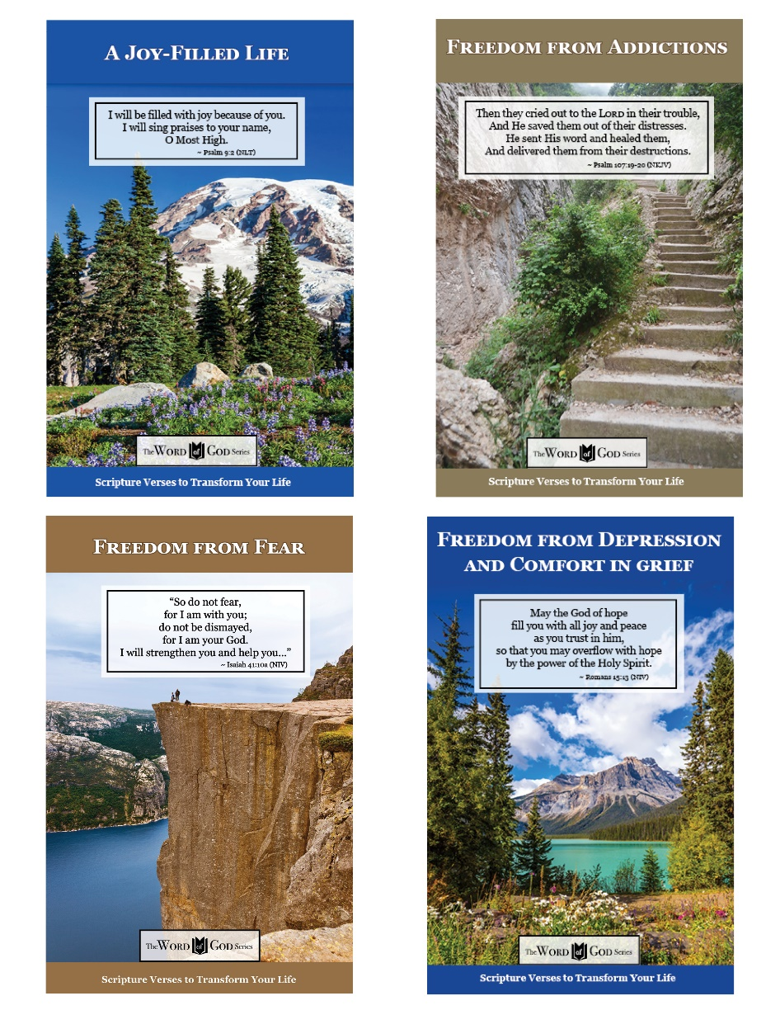

www.TheWordOfGodSeries.com

Booklet Titles in the Series

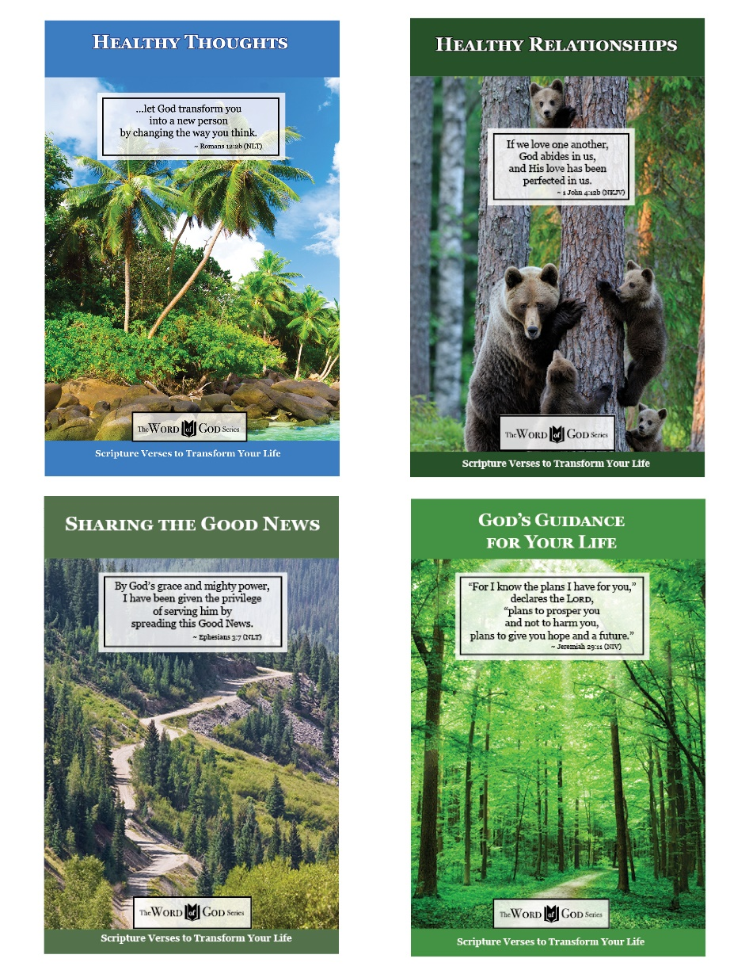

www.TheWordOfGodSeries.com

Booklet Titles in the Series

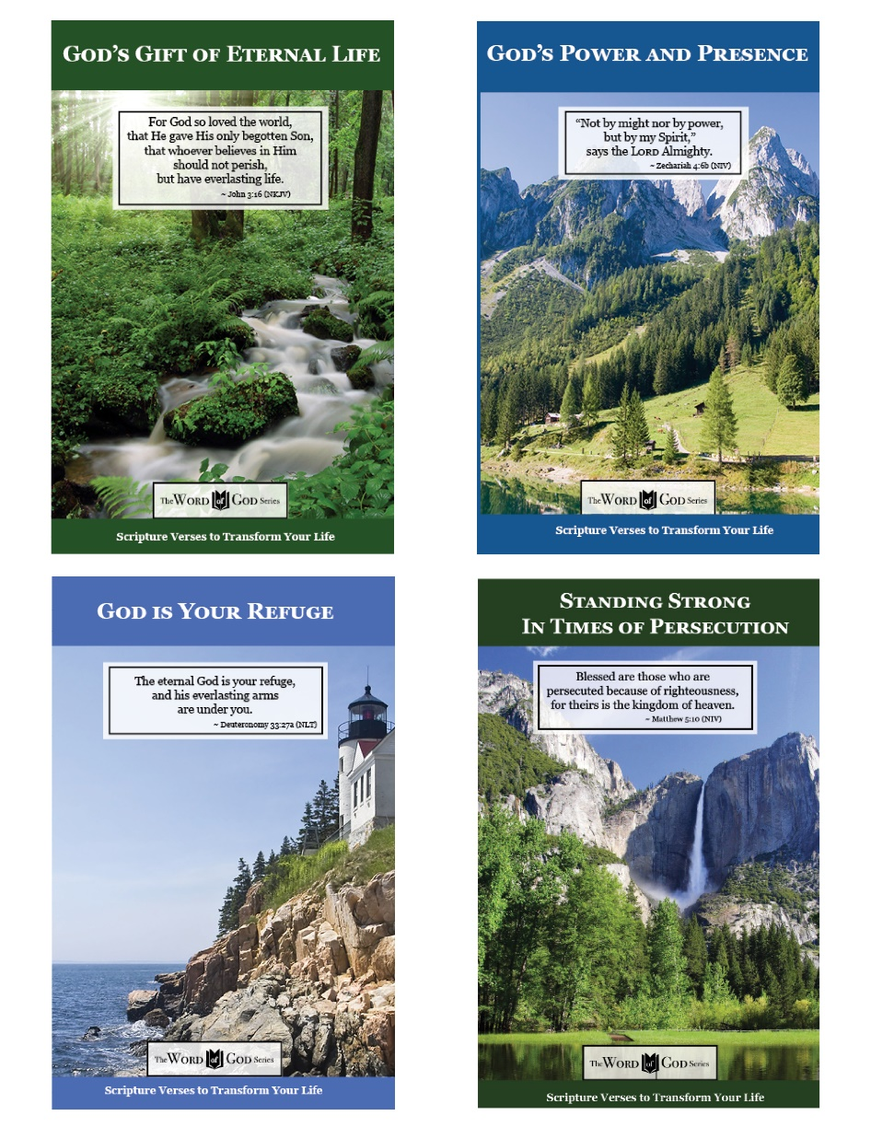

www.TheWordOfGodSeries.com

Booklet Titles in the Series

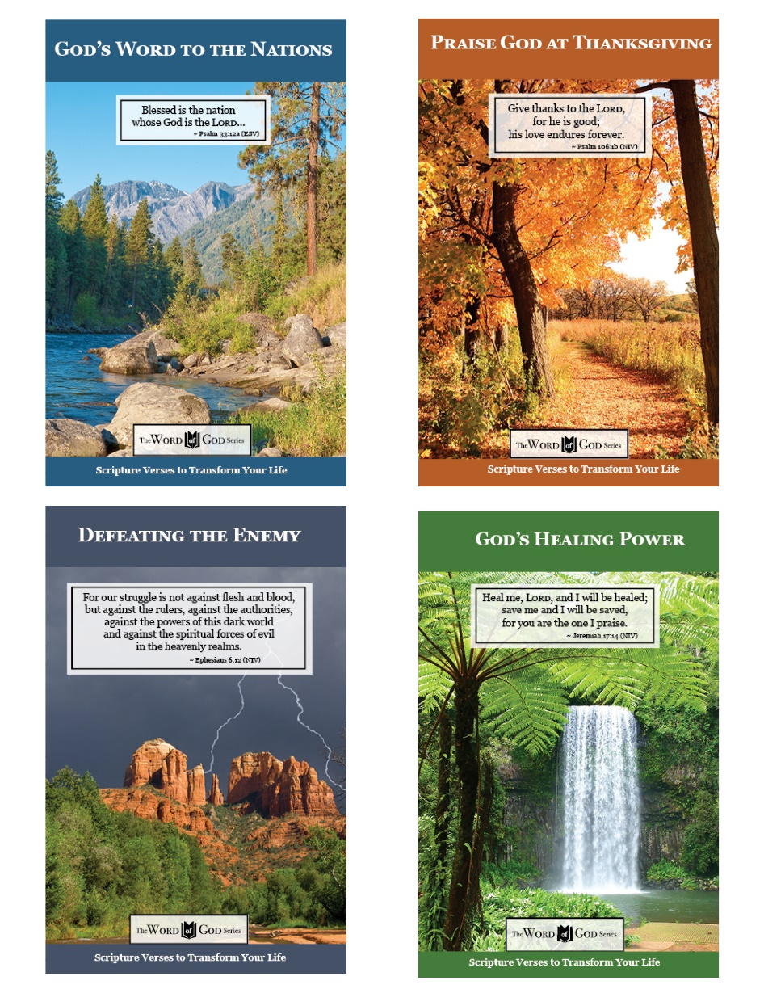

www.TheWordOfGodSeries.com

Booklet Titles in the Series

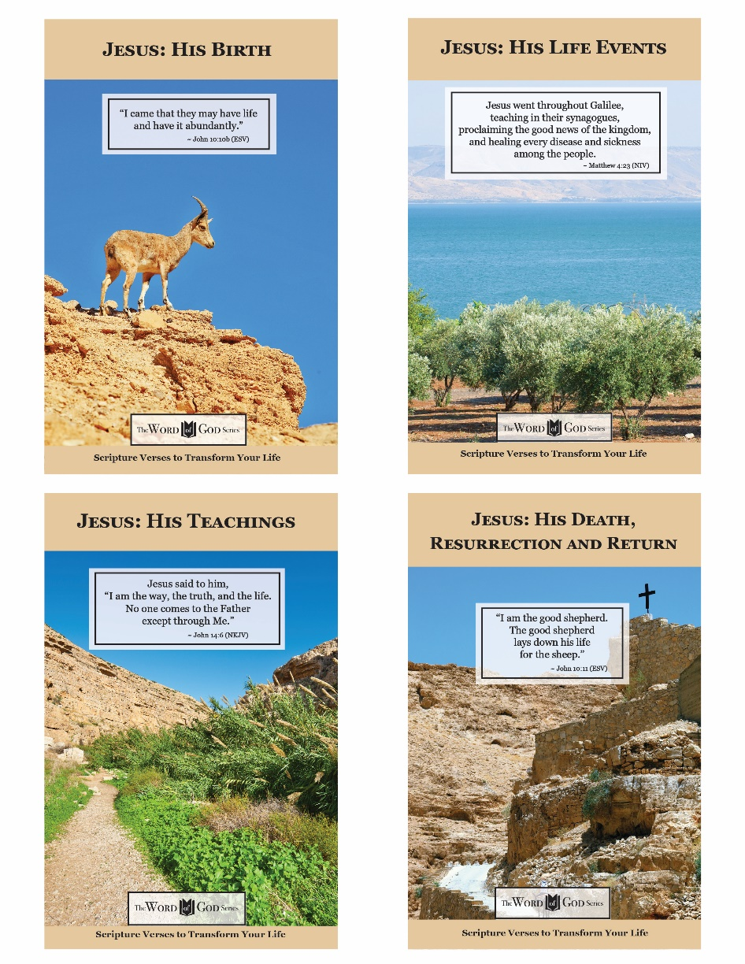

www.TheWordOfGodSeries.com

Photo Copyright Info

Note: when purchasing the rights to use the photos,
you may want to purchase an Extended License
for the cover image.


Bigstock Photo ID: 30668177
Editing suggestion: Crop bottom of photo
Scenic path across Azores rain forest at S. Miguel Island
Stock Photo ID: 30668177
Copyright: rjmiguel


Bigstock Photo ID: 5487811
Path In Mountains Forest
Path in green mountains forest with sunshine
Stock Photo 5487811
Copyright: pavel_klimenko

Bigstock Photo ID: 407305160
Small wooden bridge. Mount Cook and Mount Tasman. On the way to Lake Matheson. Magnificent journey to distant lands. New Zealand, South Island
Stock Photo ID: 407305160
Copyright: kavram


Bigstock Photo ID: 7908088
Spruce Flats Falls
Beautiful Spruce Flat Falls in Great Smoky Mountains Natonal Park, after the spring rains. On the border of North Carolina and Tennessee.
Stock Photo 7908088
Copyright: Tim Mainiero


Bigstock Photo ID: 4677250
Nature. Path In Forest With Sunshine
nature. Path in the forest with sunlight
Stock Photo 4677250
Copyright: Alex Kalina


Bigstock Photo ID: 231501232
Picturesque Pathway in Lush Green Setting with Stone Steps
Stock Photo ID: 231501232
Copyright: SusansPhotos


God Bigstock Photo ID: 1070502
Editing suggestion: Brighten photo
Path In The Forest
peaceful path in the forest. mostly cedar trees.
Stock Photo ID: 1070502
Copyright: Ms. Candy


Bigstock Photo ID: 23424164
Empty hammock between palm trees on tropical beach
Stock Photo ID: 23424164
Copyright: Martin Valigursky

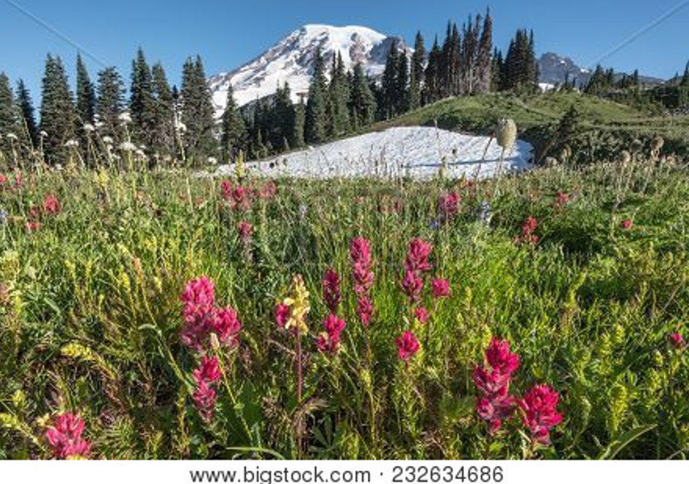
Bigstock Photo ID: 232634686
Sunny Shot of Scarlet Paintbrush with Mount Rainier Looming in Background
Stock Photo ID: 232634686
Copyright: kvd design
Bigstock Photo ID: 220467064
Aerial view of Navagio (Shipwreck) Beach in Zakynthos island, Greece. Navagio Beach is a popular attraction among tourists visiting the island of Zakynthos
Stock Photo ID: 220467064
Copyright: vverve

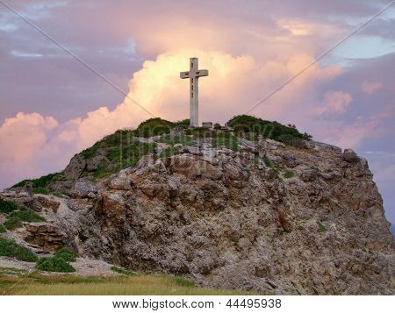
Bigstock Photo ID: 44495938
Cross On Mountain Top
colorful sundown scenery on a caribbean island named Guadeloupe including a summit cross on mountain top
Stock Photo 44495938
Copyright: prill

Bigstock Photo ID: 56118122
Parent and child love

Experience the relentless bond love between a parent and a child
Stock Photo ID: 56118122
Copyright: SharmaPK

Bigstock Photo ID: 92305691
Path through the tropical plants garden in Palmitos Park in Gran Canaria, Canary Islands, Spain ** Note: Visible grain at 100%, best at smaller sizes
Stock Photo ID: 92305691
Copyright: Pav-Pro-Photography Ltd.


Bigstock Photo ID: 601391
Editing suggestion: slightly brighten and warm photo
A Path To Where?
A path leading down along the Swaledale in North Yorkshire. A beautiful sunny day, A ruined field house in the distance. The path is lined with dry stone walls. The view is stunning and the path leading away makes you want to walk down it to find out wher
Stock Photo ID: 601391
Copyright: Ljay


Bigstock Photo ID: 41246971
Manarola Village, Rocks And Sea At Sunset. Cinque Terre, Italy
Manarola village on cliff rocks and sea at sunset. Seascape in Five lands Cinque Terre National Park Liguria Italy Europe. Long Exposure Photography.
Stock Photo ID: 41246971
Copyright: stevanzz


Shutterstock Photo ID: 114859960
Brown bear with cubs in the forest
Photo Contributor
Erik Mandre


Bigstock Photo ID: 74163391
Tropical beach Source D'Argent at Seychelles - vacation background
Stock Photo ID: 74163391
Copyright: Nik_Sorokin


Bigstock Photo ID: 445422350
A red burning sunset over the sea with rocky volcanic cliff. Abstract nature summer or spring ocean sea background. Small waves on golden warm water surface with bokeh lights from sun.
Stock Photo ID: 445422350
Copyright: panophotograph

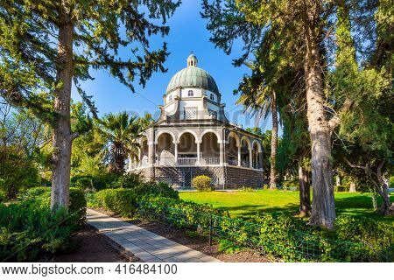
Bigstock Photo ID: 416484100
The Sea of Galilee. The Catholic Church of the Beatitudes of the Italian Franciscan monastery on Mount Bliss. Israel. Blooming huge park around the monastery. The concept of religious pilgrimage
Stock Photo ID: 416484100
Copyright: kavram


Bigstock Photo ID: 23228978
african landscapes,Namibia
Stock Photo ID: 23228978
Copyright: Andrushko Galyna


Bigstock Photo ID: 18702125
Napa Valley vineyard in California at sunset
Stock Photo ID: 18702125
Copyright: Andy777


Bigstock Photo ID: 45051043
Editing suggestion: crop out distracting leaf from top center of photo
Halong Bay,Vietnam
Stock Photo ID: 45051043
Copyright: Andrushko Galyna


Bigstock Photo ID: 59141861
Unusual Rhino Horn shaped peaks on a Corsican Mountain.
Stock Photo ID: 59141861
Copyright: perszing1982


Bigstock Photo ID: 118981112
Mount Kilimanjaro in Kenya Amboseli National Park
Stock Photo ID: 118981112
Copyright: Kyslynskyy


Bigstock Photo ID: 458903669
Waterfall cascade in the forest called Kroshuna waterfalls in Bulgaria.
Stock Photo ID: 458903669
Copyright: Diliana Nikolova

