Template for Healthy Relationships
The Word of God Series is a collection of 20 booklets that present Scripture verses in an easy-to-read format, with each booklet focused on a different topic.
Titles include Healthy Relationships, A Joy-Filled Life, Freedom from Depression, and many others.
The booklets are available in both paperback and digital formats at www.TheWordOfGodSeries.com or Amazon.com.
Why This Template?
Because I believe in the power of God’s Word to transform people’s lives, I have dedicated several years of my life to
bring this series to fruition.
I am passionate about using these booklets to reach
a dark and dying world with the love of Christ and
the hope of the Gospel.
Initially, I had expected this series would be a small business. But one day, when I asked God what my next steps should be,
He spoke to me through His Word and told me to:
“…complete the ministry God has given you.”
~ 2 Timothy 4:5 (NLT, 1996 version)
So, I shifted the focus from a business to a ministry.
My vision, also, has evolved over time and I have come to believe that it is possible for millions of these booklets to be distributed (in both print and digital formats) around the world (see the document entitled The Vision at www.TheWordOfGodSeries.com for more info.)
In order to make this a far-reaching ministry, accessing populations that I couldn’t on my own, I decided to invite others to partner with me in producing and distributing these booklets to their own personal networks. To help get it started, I have made templates of each booklet freely available to anyone who would like them.
This way you (whether you are a church, Christian organization or an individual) can easily re-create the booklets in your own ministry’s name, and distribute them to the people you minister to.
I hope that this template will save you:
- Time – so you can benefit from the thousands of hours
of development time that has been invested so far
- Money – eliminate layers of profit margin, and save on shipping costs (especially for large quantities)

Whether you simply replicate and reproduce what has already been done, build on it, or take this idea in a different direction, you won’t have to waste time starting with a blank page.
I hope you can easily get these finalized and printed, so you can begin sharing them with the people in your sphere of influence.
On the following pages you will find document formatting and printing tips.
Photo editing tips are also presented, as well as the preview images of each photo (with the Photo ID#), so you to easily find it on either bigstockphoto.com or shutterstock.com.

Photo Editing Tips
At the end of this document you will find the copyright and descriptive info for each photo in the booklet, as well as editing suggestions for a few of them.
Many photos will need to be slightly stretched or cropped to fit the page.
Most of the editing suggestions below (especially brightening or increasing color saturation) should be very slight adjustments.
Editing photos within this document
Wrapping text around the photo: Doubleclick the photo, click
on Wrap Text and select Square. Then, drag the image by the corner until it is the right size to wrap the text around it.
Rotate: Doubleclick the photo, click on the Rotate Object icon.

Editing photos in the Pictures editing app in MS Word
Navigate to your Pictures folder, doubleclick the photo, and click on the blue Edit button on left
Most of the editing can be done by using one of these 3 options:


Crop: Click on the Crop icon and drag edges to desired spot
Brighten a photo: Adjustment icon / Light / Brightness
Increase color saturation: Adjustment icon / Color / Saturation or Warmth
Remove distracting elements from a photo: Click on the Generative Erase icon, select a brush size and click on the part of the photo you want removed.

Photo Searching Tips
Occasionally photographers pull their photos from the sites,
so there may be some in this booklet that are no longer available.
You can try using the same key words to search for the photo
on other sites (scroll to the end of this document for more descriptive information about each photo.)
Or, you can search for another photo on Bigstock. Under
All Images select Photos and search by key word. At the next screen, make sure that Safe Search is on. In the Category field, select either Landscapes, Nature or Animals.

Booklet Formatting Tips
If you make any changes to this document that results in changing the number of lines on a page, then the page will need to be re-formatted for everything to fit.
Often changing the spacing between the characters or between the lines in one verse is enough to re-format it.
Changing the spacing between the characters
Home / Font / Advanced / Character Spacing
Choose Expanded or Condensed, and select a numeric value (best from .1 to .3)


Changing the spacing between the lines
Highlight all the text in the passage or page and click on:
Layout / Paragraph / Line Spacing / Multiple
Select a numeric value (best from .98 to 1.02)


Saving the document as a PDF
Adobe Acrobat Pro subscriptions are available at www.adobe.com/creativecloud/plans.html. You could also
ask your library tech center if they carry Adobe products.
When the Word doc is final: File / Save as Adobe PDF

Viewing the PDF as a booklet
Remove the first blank page of the doc: Edit / Trash icon.
Enter pages 1 to 1 to delete. Then exit from the Edit mode.
To view the document as a booklet, click on the page icon
(on right side of page, below the rotate button) and select
Two-page view and Show cover page.


Adding page numbers to the PDF
Edit / Header & Footer / Add / Add New
Under Font Name choose your font (this document uses the Georgia font) and under Size enter 8 pt.
Under Margins, in the Bottom box, enter .4
Click in box under Center Footer Text and click on the Insert Page Number button.
Click on Page Range Options. The Pages From _ to _
will depend on which page in your document you want read as Page 1 in the PDF.
In these booklets, the verses begin on Page 5 (after the forward page, copyright page, and Table of Contents).
If you plan to develop several booklets, select Save Settings.


Printing the Booklets
You can print these as regular paperbacks with a binding, (which look a bit nicer) or, you can print them with a staple binding. The staple binding does require a certain type of machine that can print them in a way that they open fully to any page (not just the center page) and lay flat. Your local printer may or may not have that capability, so discuss options with them.
A glossy cover is recommended, as it has a better feel than a matte finish. You may want to request the booklets be printed on Cougar® paper, which has a very smooth finish.

Stuck on a Step Above and Need Help?
If you want to do this project on your own, but are having tech issues with one of the steps above, feel free to contact me at Susan@TheWordOfGodSeries.com. I may be able to assist you, since I’ve gone through this whole process myself!

Need Help with the Whole Project?
If you want these booklets set up in your own in your own ministry’s name, but don’t have the resources to do the whole project yourself,
I may be able to manage that process for you for a one-time project fee.
This would include the following services:
- Set up an account with Bigstock and Shutterstock in your ministry’s name and purchase the rights for you to use each of the photos
- Download and name the photos
- Edit photos as needed
- Create a cover with your church or ministry logo
- Request the rights to use the various Bible translations from each of the publishers (if applicable)
Feel free to contact me at Susan@TheWordOfGodSeries.com to discuss pricing options.
I hope that this information will help you finalize this document with ease so you can begin distributing it to the people in your realm of influence.
Thank you for partnering with me in this effort. I wish you the best as you make God’s Word known and share His love with others!
Warmly in Christ,
Susan

Soli Deo gloria



Feel free to edit this forward page to align to your own ministry’s vision and goals.

The Bible is the best-selling and most transformative book in history. Written over 2,000 years ago, it is still living and powerful today.
Throughout the pages of Scripture you will find inspiration and joy, comfort and peace, healing and hope.
Most importantly, you will learn of God’s abundant love for you, and His plan to give you a glorious, eternal inheritance.
The Word of God Series is a collection of booklets which presents Scripture by topic, so you can focus on verses that are relevant to you at different stages and circumstances throughout your life.
All of the booklets in this series feature Scripture exclusively—
just the powerful, undiluted Word of God.
Let God’s Word permeate your mind and transform your life.
Here are a few suggestions to help you fully benefit from Scripture:
Meditate
Pause and reflect on the verses as you read, and even meditate on them throughout the day.
Memorize
A great memorization technique is to repeat the verse several times, each time emphasizing a different word.
Above all, love each other deeply…
Above all, love each other deeply…
Above all, love each other deeply…
~ 1 Peter 4:8a (NIV)
Pray
Pray God’s Word back to Him. For example,
Dear Lord, please give me the power to love others deeply,
because I know that is what pleases You.
Do What It Says
Do not merely listen to the word, and so deceive yourselves.
Do what it says.
~ James 1:22 (NIV)

My prayer for you, as you read this booklet, is that God’s Word will equip you to love others deeply, develop healthy relationships, and experience much joy as you bring joy to others.
Let the word of Christ dwell in you richly…
~ Colossians 3:16a (ESV)

A few comments about this series:

- The booklets in this series provide you with a sample of what the Bible offers, but it is important that you also read the Bible itself, preferably with a book-by-book focus.

- Passages in quotation marks are the actual words of God, either through His prophets in the Old Testament, or the words of Christ
in the New Testament.

- Every booklet includes a section that details God’s plan of salvation (commonly referred to as “The Gospel.”) The booklet entitled God’s Gift of Eternal Life
is devoted to the Gospel message.

This series presents verses in the following translations:

NIV: New International Version
Scripture quotations marked NIV are taken from the Holy Bible, New International Version®, NIV®. Copyright © 1973, 1978, 1984, 2011 by Biblica, Inc.™ Used by permission of Zondervan. All rights reserved worldwide. www.zondervan.com. The "NIV" and "New International Version" are trademarks registered in the United States Patent and Trademark Office by Biblica, Inc.™

NLT: New Living Translation
Scripture quotations marked NLT are taken from the Holy Bible, New Living Translation, Copyright© 1996, 2004, 2015 by Tyndale House Foundation. Used by permission of Tyndale House Publishers, Inc., Carol Stream, Illinois 60188. All rights reserved.

ESV: English Standard Version
Scripture quotations marked ESV are taken from the ESV Bible® (The Holy Bible, English Standard Version®), copyright © 2001 by Crossway Bibles, a publishing ministry of Good News Publishers. Used by permission. All rights reserved.

KJV: King James Version
Public Domain

NKJV: New King James Version
Scripture quotations marked NKJV are taken from the New King James Version®. Copyright © 1982 by Thomas Nelson, Inc. Used by permission.

Since this is a template booklet featuring preview photos, it is not copyrighted, so you are free to purchase licenses to use the photos and develop your own booklets for print. Be sure to determine whether or not you need to request permission (and in some cases pay) for the rights to use the various Bible translations. Scripture verses were sourced from www.BibleGateway.com.
If it would be easier for you to simply purchase this booklet, the copyrighted version is available at www.TheWordOfGodSeries.com or www.amazon.com.
ISBN info for the copyrighted booklets is as follows:
The ISBN is 978-1-964538-10-5 and the Amazon ISBN is 9798323027712.
Healthy Relationships

Contents

Love Each Other Deeply 1

Guard Your Tongue 7

Forgive 11

In Your Anger Do Not Sin 14

Show Mercy 15

Seek Peace and Pursue It 16

Your Relationship with God 18

Your Relationships with Friends 33

Your Relationships with Enemies 34

Dating Relationships 36

Guard Your Heart

Flee from Sexual Immorality

Seek Wisdom and Advice

Marital Relationships 39

Roles Within Marriage

Warnings Against Adultery

Warnings Against Divorce

Family Relationships 46
Parent’s Relationship with Their Children
Children’s Relationship with Their Parents
Adult’s Relationship with Their Parents

Remaining Single 50

Church Relationships 51
The Church is the Bride of Christ
Love Your Brothers and Sisters in Christ
Enjoy the Companionship of Other Believers
Live Peacefully With Each Other
Maintain Unity Within the Church
God Has Given Each of You a Spiritual Gift
All of You Together are Christ’s Body
All of You Together are God’s Temple
Share With and Serve Each Other
Pray For and Pray With Each Other

Love Each Other Deeply

Above all, love each other deeply, because love covers
over a multitude of sins.

~ 1 Peter 4:8 (NIV)

Live a life filled with love, following the example of Christ.

~ Ephesians 5:2a (NLT)

And walk in love…

~ Ephesians 5:2a (ESV)

Love is patient, love is kind.
It does not envy, it does not boast, it is not proud.
It does not dishonor others, it is not self-seeking,
it is not easily angered, it keeps no record of wrongs.

~ 1 Corinthians 13:4-5 (NIV)

It always protects, always trusts, always hopes, always perseveres.

~ 1 Corinthians 13:7 (NIV)



And now these three remain: faith, hope and love.
But the greatest of these is love.

~ 1 Corinthians 13:13 (NIV)
This is love: not that we loved God, but that he loved us and sent his Son as an atoning sacrifice for our sins.
Dear friends, since God so loved us, we also ought to
love one another.

~ 1 John 4:10-11 (NIV)

We love because he first loved us.

~ 1 John 4:19 (ESV)

“A new command I give you: Love one another.
“As I have loved you, so you must love one another.
By this everyone will know that you are my disciples,
if you love one another.”

~ John 13:34-35 (NIV)

“This is my command: Love each other.”

~ John 15:17 (NLT)

“As the Father has loved me, so have I loved you.
“Now remain in my love. If you keep my commands,
you will remain in my love, just as I have kept my
Father’s commands and remain in his love.
“I have told you this so that my joy may be in you and
that your joy may be complete.
“My command is this: Love each other as I have loved you.”

~ John 15:9-12 (NIV)

One of the teachers of the law came and…asked him,
“Of all the commandments, which is the most important?”
“The most important one,” answered Jesus, “is this:
‘Hear, O Israel: The Lord our God, the Lord is one.
‘Love the Lord your God
with all your heart and
with all your soul and
with all your mind and
with all your strength.’
“The second is this:
‘Love your neighbor as yourself.’
“There is no commandment greater than these.”

~ Mark 12:28-31 (NIV)
God is love, and whoever abides in love abides in God,
and God abides in him.

~ 1 John 4:16b (ESV)

Whoever lives in love lives in God, and God in them.

~ 1 John 4:16b (NIV)

If we love one another, God abides in us, and His love
has been perfected in us.

~ 1 John 4:12b (NKJV)

…if we love one another, God lives in us and his love
is made complete in us.

~ 1 John 4:12b (NIV)

If we love one another, God dwelleth in us…

~ 1 John 4:12b (KJV)



Many waters cannot quench love, neither can floods drown it…

~ Song of Solomon 8:7a (ESV)

Let love and faithfulness never leave you;
bind them around your neck,
write them on the tablet of your heart.
Then you will win favor and a good name
in the sight of God and man.

~ Proverbs 3:3-4 (NIV)
Beloved, let us love one another, for love is of God;
and everyone who loves is born of God and knows God.
He who does not love does not know God, for God is love.

~ 1 John 4:7-8 (NKJV)

Therefore, as God’s chosen people, holy and dearly loved, clothe yourselves with compassion, kindness, humility, gentleness and patience.

~ Colossians 3:12 (NIV)

Always be humble and gentle.
Be patient with each other, making allowance for
each other’s faults because of your love.

~ Ephesians 4:2 (NLT)

…be patient, bearing with one another in love.

~ Ephesians 4:2b (NIV)

Rejoice with those who rejoice; mourn with those who mourn.

~ Romans 12:15 (NIV)

Be devoted to one another in love.
Honor one another above yourselves.

~ Romans 12:10 (NIV)

Do nothing out of selfish ambition or vain conceit.
Rather, in humility value others above yourselves,
not looking to your own interests but each of you to
the interests of the others.

~ Philippians 2:3-4 (NIV)

Each of us should please our neighbors for their good,
to build them up.

~ Romans 15:2 (NIV)

Therefore encourage one another and build one another up, just as you are doing.

~ 1 Thessalonians 5:11 (ESV)

Let us think of ways to motivate one another to acts of love and good works.

~ Hebrews 10:24 (NLT)

Let no one seek his own, but each one the other’s
well-being.

~ 1 Corinthians 10:24 (NKJV)
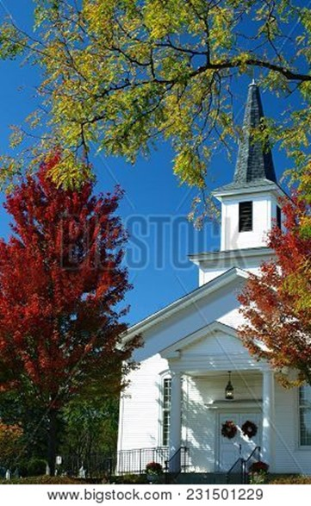
…the fruit of the Spirit is love, joy, peace, patience, kindness, goodness, faithfulness, gentleness, self-control; against such things there is no law.

~ Galatians 5:22-23 (ESV)

You were cleansed from your sins when you obeyed the truth,
so now
you must show
sincere love to each other as brothers
and sisters.
Love each other deeply with all your heart.

~ 1 Peter 1:22 (NLT)

In your relationships with one another, have the same mindset as Christ Jesus:
Who, being in very nature God, did not consider equality with God something to be used to his
own advantage; rather, he made himself nothing
by taking the very nature of a servant…

~ Philippians 2:5-7a (NIV)

May the God of endurance and encouragement grant you to live in such harmony with one another, in accord with Christ Jesus, that together you may with one voice glorify the God and Father of our Lord Jesus Christ.

~ Romans 15:5-6 (ESV)
If anyone has material possessions and sees his brother
in need but has no pity on him, how can the love of God
be in him?
Dear children, let us not love with words or tongue
but with actions and in truth.

~ 1 John 3:17-18 (NIV)

…make every effort to
add to your faith goodness;
and to goodness, knowledge;
and to knowledge, self-control;
and to self-control, perseverance;
and to perseverance, godliness;
and to godliness, mutual affection;
and to mutual affection, love.
For if you possess these qualities in increasing measure, they will keep you from being ineffective and unproductive in your knowledge of our Lord Jesus Christ…
For if you do these things, you will never stumble, and
you will receive a rich welcome into the eternal kingdom of our Lord and Savior Jesus Christ.

~ 2 Peter 1:5b-11 (NIV)

Do everything in love.

~ 1 Corinthians 16:14 (NIV)

Don’t just pretend to love others. Really love them.

~ Romans 12:9a (NLT)

Pursue love…

~ 1 Corinthians 14:1a (ESV)

There is no fear in love, but perfect love casts out fear.

~ 1 John 4:18a (ESV)

For God has not given us a spirit of fear, but of power
and of love and of a sound mind.

~ 2 Timothy 1:7 (NKJV)

Finally, all of you, be like-minded, be sympathetic,
love one another, be compassionate and humble.

~ 1 Peter 3:8 (NIV)

Guard Your Tongue

Death and life are in the power of the tongue…

~ Proverbs 18:21a (ESV)

Those who consider themselves religious and yet do not keep a tight rein on their tongues deceive themselves,
and their religion is worthless.

~ James 1:26 (NIV)

Do not let any unwholesome talk come out of your mouths, but only what is helpful for building others up according to their needs, that it may benefit those who listen.

~ Ephesians 4:29 (NIV)



Then those who feared the Lord talked with each other, and the Lord listened and heard. A scroll of remembrance was written in his presence concerning those who feared the Lord and honored his name.

~ Malachi 3:16 (NIV)
A gentle answer turns away wrath,
but a harsh word stirs up anger.

~ Proverbs 15:1 (NIV)

Avoiding a fight is a mark of honor;
only fools insist on quarreling.

~ Proverbs 20:3 (NLT)

An offended friend is harder to win back than a fortified city. Arguments separate friends…

~ Proverbs 18:19a (NLT)

Starting a quarrel is like opening a floodgate,
so stop before a dispute breaks out.

~ Proverbs 17:14 (NLT)



A truly wise person uses few words….

~ Proverbs 17:27a (NLT)
…make it your ambition to lead a quiet life: You should mind your own business and work with your hands…

~ 1 Thessalonians 4:11a (NIV)

We all stumble in many ways. Anyone who is never at fault in what they say is perfect, able to keep their whole body in check.
When we put bits into the mouths of horses to make them obey us, we can turn the whole animal. Or take ships as
an example. Although they are so large and are driven by strong winds, they are steered by a very small rudder wherever the pilot wants to go.
Likewise, the tongue is a small part of the body, but it makes great boasts.
Consider what a great forest is set on fire by a small spark.
The tongue also is a fire, a world of evil among the parts
of the body.
It corrupts the whole body, sets the whole course of one’s life on fire, and is itself set on fire by hell.
All kinds of animals, birds, reptiles and sea creatures
are being tamed and have been tamed by mankind,
but no human being can tame the tongue.
It is a restless evil, full of deadly poison.
With the tongue we praise our Lord and Father, and
with it we curse human beings, who have been made
in God’s likeness.
Out of the same mouth come praise and cursing.
My brothers and sisters, this should not be.

~ James 3:2-10 (NIV)

Whoever of you loves life
and desires to see many good days,
keep your tongue from evil
and your lips from telling lies.

~ Psalm 34:12-13 (NIV)

…I will watch what I do and not sin in what I say.

~ Psalm 39:1b (NLT)
Avoid godless chatter, because those who indulge in it
will become more and more ungodly.

~ 2 Timothy 2:16 (NIV)

Whoever belittles his neighbor lacks sense,
but a man of understanding remains silent.

~ Proverbs 11:12 (ESV)

A gossip betrays a confidence;
so avoid anyone who talks too much.

~ Proverbs 20:19 (NIV)

Without wood a fire goes out;
without a gossip a quarrel dies down.

~ Proverbs 26:20 (NIV)

“There is nothing concealed that will not be disclosed,
or hidden that will not be made known.
“What you have said in the dark will be heard in the daylight, and what you have whispered in the ear in the inner rooms will be proclaimed from the roofs.”

~ Luke 12:2-3 (NIV)

“It’s not what goes into your mouth that defiles you;
you are defiled by the words that come out of your mouth.”

~ Matthew 15:11 (NLT)

“A good man brings good things out of the good
stored up in him, and an evil man brings evil things
out of the evil stored up in him.”

~ Matthew 12:35 (NIV)

“For the mouth speaks what the heart is full of.”

~ Matthew 12:34b (NIV)

“For whatever is in your heart determines what you say.”

~ Matthew 12:34b (NLT)

“For out of the abundance of the heart the mouth speaks.”

~ Matthew 12:34b (ESV)

“But I tell you that everyone will have to give account on the day of judgment for every empty word they have spoken.
“For by your words you will be acquitted, and by your words you will be condemned.”

~ Matthew 12:36-37 (NIV)

Forgive

“Forgive, and you will be forgiven.”

~ Luke 6:37b (NKJV)

“For if you forgive other people when they sin against you, your heavenly Father will also forgive you.
“But if you do not forgive others their sins, your Father will not forgive your sins.”

~ Matthew 6:14-15 (NIV)

“And forgive us our debts, as we forgive our debtors.”

~ Matthew 6:12 (KJV)



“And whenever you stand praying, if you have anything against anyone, forgive him, that your Father in heaven may also forgive you your trespasses.”

~ Mark 11:25 (NKJV)

“Therefore, if you are offering your gift at the altar and there remember that your brother or sister has something against you, leave your gift there in front of the altar. First go and be reconciled to them; then come and offer your gift.”

~ Matthew 5:23-24 (NIV)
“If your brother or sister sins against you, rebuke them; and if they repent, forgive them.”

~ Luke 17:3b (NIV)

“Therefore, the kingdom of heaven is like a king who wanted to settle accounts with his servants.
“As he began the settlement, a man who owed him
ten thousand bags of gold was brought to him.
“Since he was not able to pay, the master ordered that
he and his wife and his children and all that he had be
sold to repay the debt.
“At this the servant fell on his knees before him.
“‘Be patient with me,’ he begged, ‘and I will pay back everything.’
“The servant’s master took pity on him, canceled the debt and let him go.
“But when that servant went out, he found one of his
fellow servants who owed him a hundred silver coins.
“He grabbed him and began to choke him. ‘Pay back
what you owe me!’ he demanded.
His fellow servant fell to his knees and begged him,
“‘Be patient with me, and I will pay it back.’
“But he refused. Instead, he went off and had the man thrown into prison until he could pay the debt.
“When the other servants saw what had happened, they were outraged and went and told their master…
“Then the master called the servant in. ‘You wicked servant,’ he said, ‘I canceled all that debt of yours because you begged me to. Shouldn’t you have had mercy on your
fellow servant just as I had on you?’
“In anger his master handed him over to the jailers to be tortured, until he should pay back all he owed.
“This is how my heavenly Father will treat each of you unless you forgive your brother or sister from your heart.”

~ Matthew 18:23-35 (NIV)
Be kind and compassionate to one another, forgiving
each other, just as in Christ God forgave you.

~ Ephesians 4:32 (NIV)

Bear with each other and forgive one another if any of you has a grievance against someone.
Forgive as the Lord forgave you.
And over all these virtues put on love, which binds them all together in perfect unity.

~ Colossians 3:13-14 (NIV)

Make allowance for each other’s faults, and forgive anyone who offends you.

~ Colossians 3:13a (NLT)

…I have forgiven in the sight of Christ for your sake,
in order that Satan might not outwit us.
~ 2 Corinthians 2:10b-11a (NIV)

Beloved, never avenge yourselves, but leave it to the
wrath of God, for it is written, “Vengeance is mine,
I will repay, says the Lord.”
To the contrary, “if your enemy is hungry, feed him;
if he is thirsty, give him something to drink…”

~ Romans 12:19-20a (ESV)

Do not be overcome by evil, but overcome evil with good.

~ Romans 12:21 (ESV)

Do not repay evil with evil or insult with insult.
On the contrary, repay evil with blessing, because to this you were called so that you may inherit a blessing.

~ 1 Peter 3:9 (NIV)

Do not say, “I’ll pay you back for this wrong!”
Wait for the Lord, and he will avenge you.

~ Proverbs 20:22 (NIV)

“Do not seek revenge or bear a grudge against anyone among your people, but love your neighbor as yourself.
“I am the Lord.”

~ Leviticus 19:18 (NIV)

In Your Anger
Do Not Sin

“In your anger do not sin”:
Do not let the sun go down while you are still angry, and do not give the devil a foothold.

~ Ephesians 4:26-27 (NIV)

Don’t sin by letting anger control you.

~ Psalm 4:4a (NLT)

You must all be quick to listen, slow to speak, and
slow to get angry.

~ James 1:19b (NLT)

Fools give full vent to their rage...

~ Proverbs 29:11a (NIV)

He who is slow to anger is better than the mighty, and
he who rules his spirit than he who takes a city.

~ Proverbs 16:32 (NKJV)

Better to be patient than powerful;
better to have self-control than to conquer a city.

~ Proverbs 16:32 (NLT)

…it is to one’s glory to overlook an offense.

~ Proverbs 19:11b (NIV)

So prepare your minds for action and exercise self-control.

~ 1 Peter 1:13a (NLT)

But now you must also rid yourselves of all such things
as these: anger, rage, malice, slander, and filthy language from your lips.

~ Colossians 3:8 (NIV)

Get rid of all bitterness, rage and anger, brawling
and slander, along with every form of malice.
Be kind and compassionate to one another, forgiving
each other, just as in Christ God forgave you.

~ Ephesians 4:31-32 (NIV)

Show Mercy

“Blessed are the merciful, for they will be shown mercy.”

~ Matthew 5:7 (NIV)

And what does the Lord require of you?
To act justly and
to love mercy and
to walk humbly with your God.

~ Micah 6:8b (NIV)

“For I desire mercy, not sacrifice, and acknowledgment
of God rather than burnt offerings.”

~ Hosea 6:6 (NIV)

“This is what the Lord Almighty said: Administer true justice; show mercy and compassion to one another.”

~ Zechariah 7:9 (NIV)

And you must show mercy to those whose faith is wavering.
Rescue others by snatching them from the flames of judgment. Show mercy to still others, but do so with great caution, hating the sins that contaminate their lives.

~ Jude 1:22-23 (NLT)

…judgment without mercy will be shown to anyone who has not been merciful.
Mercy triumphs over judgment.

~ James 2:13 (NIV)



Seek Peace and Pursue It

…His name will be called…Prince of Peace.

~ Isaiah 9:6b (NKJV)

Live in peace with each other.

~ 1 Thessalonians 5:13b (NIV)

…those who promote peace have joy.

~ Proverbs 12:20b (NIV)

…a wonderful future awaits those who love peace.

~ Psalm 37:37b (NLT)

Therefore let us pursue the things which make for
peace and the things by which one may edify another.

~ Romans 14:19 (NKJV)

If it is possible, as far as it depends on you, live at
peace with everyone.

~ Romans 12:18 (NIV)

Seek peace and pursue it.

~ Psalm 34:14b (NKJV)

Pursue peace with all people…

~ Hebrews 12:14a (NKJV)

…the wisdom that comes from heaven is first of all
pure; then peace-loving, considerate, submissive,
full of mercy and good fruit, impartial and sincere.

~ James 3:17 (NIV)

Better a dry crust eaten in peace than a house filled
with feasting—and conflict.

~ Proverbs 17:1 (NLT)

When a man’s ways please the Lord, he makes even
his enemies to be at peace with him.

~ Proverbs 16:7 (ESV)

Make every effort to keep the unity of the Spirit through the bond of peace.

~ Ephesians 4:3 (NIV)
“Blessed are the peacemakers: for they shall be called
the children of God.”

~ Matthew 5:9 (KJV)



Grace and peace be yours in abundance.

~ 1 Peter 1:2b (NIV)

May grace and peace be multiplied to you.

~ 1 Peter 1:2b (ESV)

Your Relationship
with God

God loves you abundantly, and has made a way for you to live forever in His glorious kingdom. However, first He had to pay an enormous price for you to be forgiven of your sin, in order to receive this eternal glory. This section explains His plan to forgive and save you. In summary:
God loves you, but your sin separates you from Him, and because of it, God’s wrath will come. However, Jesus died as a sacrifice to save you from your sins, from God’s wrath, and from death itself. When you confess your sins, repent and accept the forgiveness that Christ offers, God will forgive you. By trusting in Christ you become God’s child, and as His child, you will inherit eternal life and heaven will be your home.

God Loves You

…God’s love has been poured out into our hearts through the Holy Spirit, who has been given to us.

~ Romans 5:5b (NIV)


We know how much God loves us, and we have put our trust in his love. God is love...

~ 1 John 4:16a (NLT)

We love Him because He first loved us.

~ 1 John 4:19 (NKJV)

Every good and perfect gift is from above, coming down from the Father of the heavenly lights…

~ James 1:17a (NIV)

Oh, that men would give thanks to the Lord for His goodness, and for His wonderful works to the children of men!

~ Psalm 107:15 (NKJV)

I will give thanks to you, Lord, with all my heart;
I will tell of all your wonderful deeds.

~ Psalm 9:1 (NIV)

For You, Lord, are good, and ready to forgive, and abundant in mercy to all those who call upon You.

~ Psalm 86:5 (NKJV)

How great is the goodness
you have stored up for those who fear you.
You lavish it on those who come to you for protection,
blessing them before the watching world.

~ Psalm 31:19 (NLT)

How precious is your unfailing love, O God! All humanity finds shelter in the shadow of your wings.

~ Psalm 36:7 (NLT)

What is man, that you make so much of him, and that you set your heart on him…

~ Job 7:17 (ESV)

…what is man that you are mindful of him…

~ Psalm 8:4a (ESV)

For you created my inmost being;
you knit me together in my mother’s womb…
Your eyes saw my unformed body;
all the days ordained for me were written in your book
before one of them came to be.

~ Psalm 139:13-16 (NIV)
But Your Sin Separates You from God

But your iniquities have separated you from your God;

And your sins have hidden His face from you,

So that He will not hear.

~ Isaiah 59:2 (NKJV)

Don’t you realize that those who do wrong will not inherit the Kingdom of God?

~ 1 Corinthians 6:9a (NLT)

The acts of the flesh are obvious: sexual immorality, impurity and debauchery; idolatry and witchcraft;
hatred, discord, jealousy, fits of rage, selfish ambition, dissensions, factions and envy; drunkenness, orgies,
and the like.
I warn you, as I did before, that those who live like this
will not inherit the kingdom of God.

~ Galatians 5:19-21 (NIV)

For of this you can be sure: No immoral, impure or
greedy person—such a person is an idolater—has any inheritance in the kingdom of Christ and of God.
Let no one deceive you with empty words, for because of such things God’s wrath comes on those who are disobedient.

~ Ephesians 5:5-6 (NIV)


The Day of God’s Wrath Will Come

“Then I will draw near to you for judgment.
“I will be a swift witness
against the sorcerers,
against the adulterers,
against those who swear falsely,
against those who oppress the hired worker in his wages, the widow and the fatherless,
against those who thrust aside the sojourner,
“and do not fear me,” says the Lord of hosts.

~ Malachi 3:5 (ESV)

“I will put an end to the arrogance of the haughty and will humble the pride of the ruthless.”

~ Isaiah 13:11b (NIV)

He will guard the feet of his faithful servants, but the wicked will be silenced in the place of darkness.

~ 1 Samuel 2:9a (NIV)

They will be punished with everlasting destruction and shut out from the presence of the Lord and from the glory of his might…

~ 2 Thessalonians 1:9 (NIV)

…forever separated from the Lord and from his glorious power.

~ 2 Thessalonians 1:9b (NLT)

Confess Your Sin and Repent

“But unless you repent, you too will all perish.”

~ Luke 13:3b (NIV)

The Lord is…not willing that any should perish but that all should come to repentance.

~ 2 Peter 3:9 (NKJV)

So get rid of all the filth and evil in your lives and humbly accept the word God has planted in your hearts, for it has the power to save your souls.

~ James 1:21 (NLT)
Jesus Died to Save You…

…From Your Sin

Jesus gave his life for our sins, just as God our Father planned, in order to rescue us from this evil world in which we live.

~ Galatians 1:4 (NLT)

For God presented Jesus as the sacrifice for sin.
People are made right with God when they believe that Jesus sacrificed his life, shedding his blood.

~ Romans 3:25a (NLT)

He gave his life to free us from every kind of sin,
to cleanse us, and to make us his very own people,
totally committed to doing good deeds.

~ Titus 2:14 (NLT)

…From God’s Wrath

Jesus, whom God raised from the dead…is the one who has rescued us from the terrors of the coming judgment.

~ 1 Thessalonians 1:10b (NLT)

For God did not appoint us to suffer wrath but to receive salvation through our Lord Jesus Christ.

~ 1 Thessalonians 5:9 (NIV)

Who then will condemn us? No one—for Christ Jesus died for us and was raised to life for us, and he is sitting in the place of honor at God’s right hand, pleading for us.

~ Romans 8:34 (NLT)

…everyone who calls on the name of the Lord will be saved.

~ Acts 2:21 (NLT)

…From Death

He broke the power of death and illuminated the way
to life and immortality through the Good News.

~ 2 Timothy 1:10b (NLT)

For the wages of sin is death, but the free gift of God is eternal life in Christ Jesus our Lord.

~ Romans 6:23 (ESV)
God Bought You at a Price

You are not your own; you were bought at a price. Therefore honor God with your bodies.

~ 1 Corinthians 6:19b-20 (NIV)



In Christ You Are Forgiven

…without the shedding of blood there is no forgiveness
of sins.

~ Hebrews 9:22b (ESV)

…without holiness no one will see the Lord.

~ Hebrews 12:14b (NIV)

And so Jesus also suffered outside the city gate to make the people holy through his own blood.

~ Hebrews 13:12 (NIV)

Therefore, my friends, I want you to know that through Jesus the forgiveness of sins is proclaimed to you.

~ Acts 13:38 (NIV)

For with the Lord there is mercy, and with Him is abundant redemption.

~ Psalm 130:7b (NKJV)

For he has rescued us from the dominion of darkness and brought us into the kingdom of the Son he loves, in whom we have redemption, the forgiveness of sins.

~ Colossians 1:13-14 (NIV)
God Demonstrates His Love Through Christ

“For God so loved the world that He gave His only begotten Son, that whoever believes in Him should
not perish but have everlasting life.”

~ John 3:16 (NKJV)

Follow God’s example, therefore, as dearly loved children and walk in the way of love, just as Christ loved us and gave himself up for us...

~ Ephesians 5:1-2a (NIV)

Salvation Is Through Christ Alone

Salvation is found in no one else, for there is no other name under heaven given to mankind by which we must be saved.

~ Acts 4:12 (NIV)

Jesus said to him, “I am the way, the truth, and the life. No one comes to the Father except through Me.”

~ John 14:6 (NKJV)

“Enter through the narrow gate.
“For wide is the gate and broad is the road that leads to destruction, and many enter through it.
“But small is the gate and narrow the road that leads to life, and only a few find it.”

~ Matthew 7:13-14 (NIV)

“I am the gate; whoever enters through me will be saved.”

~ John 10:9a (NIV)

“…whoever comes to me I will never drive away.”

~ John 6:37b (NIV)

“Let the little children come to me and do not hinder them, for to such belongs the kingdom of heaven.”

~ Matthew 19:14b (ESV)

“Truly I tell you, anyone who will not receive the kingdom of God like a little child will never enter it.”

~ Luke 18:17 (NIV)

“…your Father in heaven is not willing that any of these little ones should perish.”

~ Matthew 18:14b (NIV)
Salvation Is a Gift: Free and Undeserved

For it is by grace you have been saved, through faith—and this not from yourselves, it is the gift of God—
not by works, so that no one can boast.

~ Ephesians 2:8-9 (NIV)

Salvation is not a reward for the good things we have done, so none of us can boast about it.

~ Ephesians 2:9 (NLT)

…he saved us, not because of the righteous things we
had done, but because of his mercy.

~ Titus 3:5a (NLT)



Accept This Gift of Salvation

If you declare with your mouth, “Jesus is Lord,” and believe in your heart that God raised him from the dead, you will be saved.

~ Romans 10:9 (NIV)

…how shall we escape if we ignore so great a salvation?

~ Hebrews 2:3a (NIV)
You Belong to God Through Faith in Christ
and Have Become His Child

Even before he made the world, God loved us and chose us in Christ to be holy and without fault in his eyes.
God decided in advance to adopt us into his own family
by bringing us to himself through Jesus Christ. This is what he wanted to do, and it gave him great pleasure.

~ Ephesians 1:4-5 (NLT)

See what great love the Father has lavished on us,
that we should be called children of God!

~ 1 John 3:1a (NIV)



Everyone who believes that Jesus is the Christ has become a child of God.

~ 1 John 5:1a (NLT)

And since you are his child, God has made you his heir.

~ Galatians 4:7b (NLT)

Now if we are children, then we are heirs—heirs of God and co-heirs with Christ, if indeed we share in his sufferings in order that we may also share in his glory.

~ Romans 8:17 (NIV)
Eternal Life Is Yours Through Christ

Jesus answered him,
“Truly I tell you, today you will be with me in paradise.”

~ Luke 23:43 (NIV)

“Most assuredly, I say to you, he who believes in Me has everlasting life.”

~ John 6:47 (NKJV)

“For my Father’s will is that everyone who looks to the Son and believes in him shall have eternal life, and I will raise them up at the last day.”

~ John 6:40 (NIV)

“In My Father’s house are many mansions; if it were not so, I would have told you.
“I go to prepare a place for you. And if I go and prepare a place for you, I will come again and receive you to Myself; that where I am, there you may be also.”

~ John 14:2-3 (NKJV)

“…rejoice because your names are written in heaven.”

~ Luke 10:20b (NKJV)

“And people will come from all over the world—from
east and west, north and south—to take their places in
the Kingdom of God.
“And note this: Some who seem least important now will be the greatest then, and some who are the greatest now will be least important then.”

~ Luke 13:29-30 (NLT)

“Blessed are those who are persecuted because of righteousness, for theirs is the kingdom of heaven.”

~ Matthew 5:10 (NIV)

“So don’t be afraid, little flock. For it gives your Father great happiness to give you the Kingdom.”

~ Luke 12:32 (NLT)

“And be sure of this:
“I am with you always, even to the end of the age.”

~ Matthew 28:20b (NLT)
Heaven Is Your Home

Jesus answered,
“My kingdom is not of this world.”

~ John 18:36a (ESV)

“The kingdom of heaven is like treasure hidden in a field.
“When a man found it, he hid it again, and then in his
joy went and sold all he had and bought that field.”

~ Matthew 13:44 (NIV)

Then He who sat on the throne said,
“Behold, I make all things new.”

~ Revelation 21:5a (NKJV)

“See, I will create
new heavens and a new earth.
The former things will not be remembered,
nor will they come to mind.
But be glad and rejoice forever
in what I will create…”

~ Isaiah 65:17-19 (NIV)

All your works praise you, Lord;
your faithful people extol you.
They tell of the glory of your kingdom
and speak of your might,
so that all people may know of your mighty acts
and the glorious splendor of your kingdom.
Your kingdom is an everlasting kingdom,
and your dominion endures through all generations.

~ Psalm 145:10-13a (NIV)

…we are receiving a kingdom that cannot be shaken…

~ Hebrews 12:28a (ESV)

Since we are receiving a Kingdom that is unshakable,
let us be thankful and please God by worshiping him
with holy fear and awe.

~ Hebrews 12:28 (NLT)

His dominion is an everlasting dominion that will not pass away, and his kingdom is one that will never be destroyed.

~ Daniel 7:14b (NIV)
No eye has seen, no ear has heard, and no mind has imagined what God has prepared for those who love him.

~ 1 Corinthians 2:9b (NLT)

Now we live with great expectation, and we have a priceless inheritance—an inheritance that is kept in heaven for you, pure and undefiled...

~ 1 Peter 1:3b-4a (NLT)


Point out anything in me that offends you, and lead me along the path of everlasting life.

~ Psalm 139:24 (NLT)

Yet I still belong to you; you hold my right hand.
You guide me with your counsel, leading
me to a glorious destiny.

~ Psalm 73:23-24 (NLT)

You make known to me the path of life;
you will fill me with joy in your presence,
with eternal pleasures at your right hand.

~ Psalm 16:11 (NIV)
Praise God for His Gift of Eternal Life

Thanks be to God for his indescribable gift!

~ 2 Corinthians 9:15 (NIV)

May you be filled with joy, always thanking the Father.
He has enabled you to share in the inheritance that belongs to his people, who live in the light.

~ Colossians 1:11b-12 (NLT)

For His merciful kindness is great toward us, and the truth of the Lord endures forever. Praise the Lord!

~ Psalm 117:2 (NKJV)

The Spirit is God’s guarantee that he will give us the inheritance he promised and that he has purchased us
to be his own people.
He did this so we would praise and glorify him.

~ Ephesians 1:14 (NLT)

So we praise God for the glorious grace he has poured out on us who belong to his dear Son.

~ Ephesians 1:6 (NLT)


Bigstock Photo ID: 153464024
Praise God for His Great and Awesome Name

Praise God for the privilege of being called by his name!

~ 1 Peter 4:16b (NLT)

…at the name of Jesus every knee should bow, in heaven and on earth and under the earth, and every tongue acknowledge that Jesus Christ is Lord…

~ Philippians 2:10-11a (NIV)

…giving thanks always for all things to God the Father
in the name of our Lord Jesus Christ…

~ Ephesians 5:20 (ESV)

Let them praise the name of the Lord,
For His name alone is exalted;
His glory is above the earth and heaven.

~ Psalm 148:13 (NKJV)

Give praise to the Lord, proclaim his name; make known among the nations what he has done, and proclaim that his name is exalted.

~ Isaiah 12:4b (NIV)

Glory in his holy name; let the hearts of those who seek the Lord rejoice!

~ 1 Chronicles 16:10 (ESV)

Lord, there is no one like you!
For you are great, and your name is full of power.

~ Jeremiah 10:6 (NLT)

I will praise you forever, O God, for what you have done.
I will trust in your good name…

~ Psalm 52:9a (NLT)

I will praise you, Lord my God, with all my heart;
I will glorify your name forever.

~ Psalm 86:12 (NIV)

I will exalt you, my God the King;
I will praise your name for ever and ever.
Every day I will praise you
and extol your name for ever and ever.

~ Psalm 145:1-2 (NIV)
Rejoice in the Lord

Rejoice in the Lord always. I will say it again: Rejoice!

~ Philippians 4:4 (NIV)

...rejoice in all the good things the Lord your God has given to you and your household.

~ Deuteronomy 26:11b (NIV)

Rejoice always, pray continually, give thanks in
all circumstances; for this is God’s will for you in
Christ Jesus.
~ 1 Thessalonians 5:16-18 (NIV)

Let us be glad and rejoice and give Him glory…

~ Revelation 19:7a (NKJV)

And always be thankful.
Let the message about Christ, in all its richness, fill your lives.
Teach and counsel each other with all the wisdom he gives.
Sing psalms and hymns and spiritual songs to God with thankful hearts.

~ Colossians 3:15b-16 (NLT)



Sing and make music from your heart to the Lord, always giving thanks to God the Father for everything, in the name of our Lord Jesus Christ.

~ Ephesians 5:19b-20 (NIV)

Your Relationship
with Friends

A friend loves at all times…

~ Proverbs 17:17a (ESV)

Love prospers when a fault is forgiven, but dwelling on it separates close friends.

~ Proverbs 17:9 (NLT)

“Greater love has no one than this, than to lay down
one’s life for his friends.”

~ John 15:13 (NKJV)

Let each of us please his neighbor for his good, to build him up.

~ Romans 15:2 (ESV)

The godly give good advice to their friends…

~ Proverbs 12:26a (NLT)

Never abandon a friend–either yours or your father’s.
When disaster strikes, you won’t have to ask your brother for assistance.
It’s better to go to a neighbor than to a brother who lives far away.

~ Proverbs 27:10 (NLT)

Do not make friends with a hot-tempered person, do not associate with one easily angered, or you may learn their ways and get yourself ensnared.

~ Proverbs 22:24-25 (NIV)

A perverse person stirs up conflict, and a gossip separates close friends.

~ Proverbs 16:28 (NIV)

One who has unreliable friends soon comes to ruin…

~ Proverbs 18:24a (NIV)

Do not be misled: “Bad company corrupts good character.”

~ 1 Corinthians 15:33 (ESV)

Your Relationship
with Enemies

“Love your enemies, do good to those who hate you,
bless those who curse you, pray for those who mistreat you.
“If someone slaps you on one cheek, turn to them the other also. If someone takes your coat, do not withhold your shirt from them.
“Give to everyone who asks you, and if anyone takes what belongs to you, do not demand it back.
“Do to others as you would have them do to you.”

~ Luke 6:27b-31 (NIV)

…if your enemy is hungry, feed him; if he is thirsty,
give him something to drink…

~ Romans 12:20a (ESV)

“But I say, love your enemies!
“Pray for those who persecute you!
“In that way, you will be acting as true children of your Father in heaven.”

~ Matthew 5:44-45a (NLT)

“If you love only those who love you, what reward is there for that?…If you are kind only to your friends, how are you different from anyone else?...
“But you are to be perfect, even as your Father in heaven is perfect.”

~ Matthew 5:46-48 (NLT)

“But love your enemies, do good to them, and lend to them without expecting to get anything back.
“Then your reward will be great, and you will be children of the Most High, because he is kind to the ungrateful and wicked.
“Be merciful, just as your Father is merciful.”

~ Luke 6:35-36 (NIV)
The Parable of the Good Samaritan
A note on the historical context: At the time of Christ there was animosity between Jews and Samaritans.

“A man was going down from Jerusalem to Jericho,
when he was attacked by robbers. They stripped him of
his clothes, beat him and went away, leaving him half dead.



“A priest happened to be going down the same road, and when he saw the man, he passed by on the other side.
“So too, a Levite, when he came to the place and saw him, passed by on the other side.
“But a Samaritan, as he traveled, came where the man was; and when he saw him, he took pity on him. He went to him and bandaged his wounds, pouring on oil and wine. Then he put the man on his own donkey, brought him to an inn and took care of him.
“The next day he took out two denarii and gave them to the innkeeper. ‘Look after him,’ he said, ‘and when I return,
I will reimburse you for any extra expense you may have.’
“Which of these three do you think was a neighbor to the man who fell into the hands of robbers?”
The expert in the law replied, “The one who had mercy on him.”
Jesus told him, “Go and do likewise.”

~ Luke 10:30b-37 (NIV)

Dating Relationships

“For I know the plans I have for you,” declares the Lord,
“plans to prosper you and not to harm you,
“plans to give you hope and a future.”

~ Jeremiah 29:11 (NIV)

Trust in the Lord and do good;
dwell in the land and enjoy safe pasture.
Take delight in the Lord,
and he will give you the desires of your heart.

~ Psalm 37:3-4 (NIV)



Guard Your Heart

Guard your heart above all else, for it determines the course of your life.

~ Proverbs 4:23 (NLT)

Do not be unequally yoked with unbelievers.
For what partnership has righteousness with lawlessness?
Or what fellowship has light with darkness?…
Or what portion does a believer share with an unbeliever?

~ 2 Corinthians 6:14-15 (ESV)
Promise me, O women of Jerusalem…not to awaken love until the time is right.

~ Song of Solomon 2:7 (NLT)

He who finds a wife finds what is good and receives favor from the Lord.

~ Proverbs 18:22 (NIV)

Flee from Sexual Immorality

Flee from sexual immorality.
All other sins a person commits are outside the body,
but whoever sins sexually, sins against their own body.
Do you not know that your bodies are temples of the
Holy Spirit, who is in you, whom you have received
from God?
You are not your own; you were bought at a price.
Therefore honor God with your bodies.

~ 1 Corinthians 6:18-20 (NIV)

Have nothing to do with sexual immorality, impurity, lust, and evil desires.

~ Colossians 3:5b (NLT)

Run from anything that stimulates youthful lusts.

~ 2 Timothy 2:22a (NLT)

…treat younger women with all purity as you would your own sisters.

~ 1 Timothy 5:2b (NLT)

Finally, dear brothers and sisters, we urge you in the name of the Lord Jesus to live in a way that pleases God…
God’s will is for you to be holy, so stay away from all sexual sin…
God has called us to live holy lives, not impure lives.
~ 1 Thessalonians 4:1-7 (NLT)

…offer your bodies as a living sacrifice, holy and pleasing to God…

~ Romans 12:1a (NIV)
Seek Wisdom and Advice

If any of you lacks wisdom, you should ask God,
who gives generously to all without finding fault,
and it will be given to you.
But when you ask, you must believe and not doubt, because the one who doubts is like a wave of the sea, blown and tossed by the wind.
That person should not expect to receive anything
from the Lord.

~ James 1:5-7 (NIV)

For the Lord gives wisdom; from his mouth come knowledge and understanding. He holds success in
store for the upright…

~ Proverbs 2:6-7a (NIV)

Listen to advice and accept instruction, that you may
gain wisdom in the future.

~ Proverbs 19:20 (ESV)

Plans go wrong for lack of advice; many advisers bring success.

~ Proverbs 15:22 (NLT)

My son, keep your father’s command and do not forsake your mother’s teaching.

~ Proverbs 6:20 (NIV)

See to it that no one takes you captive through hollow and deceptive philosophy, which depends on human tradition…

~ Colossians 2:8a (NIV)

Be very careful, then, how you live—not as unwise but
as wise, making the most of every opportunity, because the days are evil.

~ Ephesians 5:15-16 (NIV)

Trust in the Lord with all your heart,
And lean not on your own understanding;
In all your ways acknowledge Him,
And He shall direct your paths.

~ Proverbs 3:5-6 (NKJV)

Marital Relationships

Enjoy life with your wife, whom you love…

~ Ecclesiastes 9:9a (NIV)

The Lord God said, “It is not good for the man to be alone. I will make a helper suitable for him.”

~ Genesis 2:18 (NIV)

Therefore a man shall leave his father and mother and
be joined to his wife, and they shall become one flesh.

~ Genesis 2:24 (NKJV)

“Therefore what God has joined together, let no one separate.”

~ Matthew 19:6b (NIV)

“Haven’t you read the Scriptures?” Jesus replied.
“They record that from the beginning ‘God made them male and female…’
“This explains why a man leaves his father and mother and is joined to his wife, and the two are united into one.
“Since they are no longer two but one, let no one split apart what God has joined together.”

~ Matthew 19:4-6 (NLT)

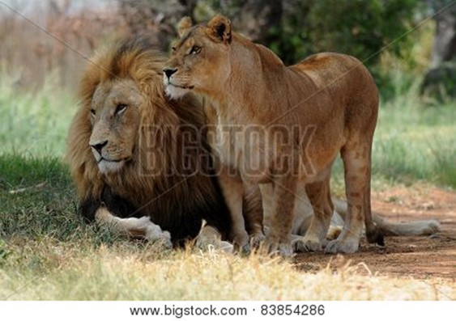
Two are better than one,
because they have a good return for their labor:
If either of them falls down,
one can help the other up.
But pity anyone who falls
and has no one to help them up.
Also, if two lie down together, they will keep warm.
But how can one keep warm alone?
Though one may be overpowered,
two can defend themselves.

~ Ecclesiastes 4:9-12a (NIV)

But because of the temptation to sexual immorality,
each man should have his own wife and each woman
her own husband.
The husband should give to his wife her conjugal rights, and likewise the wife to her husband. For the wife does not have authority over her own body, but the husband does. Likewise the husband does not have authority over his own body, but the wife does.
Do not deprive one another, except perhaps by agreement for a limited time, that you may devote yourselves to prayer; but then come together again, so that Satan may not tempt you because of your lack of self-control.

~ 1 Corinthians 7:2-5 (ESV)


Roles Within Marriage

Submit to one another out of reverence for Christ.

~ Ephesians 5:21 (NIV)

The Role of Husbands

Husbands, love your wives, just as Christ also loved the church and gave Himself for her, that He might sanctify and cleanse her with the washing of water by the word, that He might present her to Himself a glorious church…
So husbands ought to love their own wives as their own bodies; he who loves his wife loves himself.

~ Ephesians 5:25-28 (NKJV)

Husbands, love your wives, and do not be harsh with them.

~ Colossians 3:19 (ESV)

Husbands, in the same way be considerate as you live
with your wives, and treat them with respect as the weaker partner and as heirs with you of the gracious gift of life,
so that nothing will hinder your prayers.

~ 1 Peter 3:7 (NIV)

…each one of you also must love his wife as he loves himself...

~ Ephesians 5:33a (ESV)

But I want you to understand that
the head of every man is Christ,
the head of a wife is her husband,
and the head of Christ is God.

~ 1 Corinthians 11:3 (ESV)

The Role of Wives

Wives, submit to your own husbands, as to the Lord.
For the husband is head of the wife, as also Christ is head of the church; and He is the Savior of the body.
Therefore, just as the church is subject to Christ, so let
the wives be to their own husbands in everything.

~ Ephesians 5:22-24 (NKJV)
Wives, in the same way submit yourselves to your own husbands so that, if any of them do not believe the word, they may be won over without words by the behavior of their wives, when they see the purity and reverence of your lives.
Your beauty should not come from outward adornment, such as elaborate hairstyles and the wearing of gold jewelry or fine clothes.
Rather, it should be that of your inner self, the
unfading beauty of a gentle and quiet spirit, which
is of great worth in God’s sight.

~ 1 Peter 3:1-4 (NIV)

You should clothe yourselves instead with the beauty
that comes from within…

~ 1 Peter 3:4a (NLT)

Charm is deceptive, and beauty is fleeting;
but a woman who fears the Lord is to be praised.

~ Proverbs 31:30 (NIV)



…the wife must respect her husband.

~ Ephesians 5:33b (NLT)
A wife of noble character who can find?
She is worth far more than rubies.
Her husband has full confidence in her
and lacks nothing of value.
She brings him good, not harm,
all the days of her life…
She gets up while it is still night;
she provides food for her family
and portions for her female servants.
She considers a field and buys it;
out of her earnings she plants a vineyard.
She sees that her trading is profitable,
and her lamp does not go out at night…
She opens her arms to the poor
and extends her hands to the needy.
When it snows, she has no fear for her household;
for all of them are clothed in scarlet.
She makes coverings for her bed;
she is clothed in fine linen and purple.
Her husband is respected at the city gate,
where he takes his seat among the elders of the land.
She makes linen garments and sells them,
and supplies the merchants with sashes.
She is clothed with strength and dignity;
she can laugh at the days to come.
She speaks with wisdom,
and faithful instruction is on her tongue.
She watches over the affairs of her household
and does not eat the bread of idleness.
Her children arise and call her blessed;
her husband also, and he praises her:
“Many women do noble things,
but you surpass them all.”
Charm is deceptive, and beauty is fleeting;
but a woman who fears the Lord is to be praised.

~ Proverbs 31:10-30 (NIV)
Warnings Against Adultery

“You shall not commit adultery.”

~ Exodus 20:14 (NKJV)

“You have heard that it was said, ‘You shall not commit adultery.’
“But I tell you that anyone who looks at a woman lustfully has already committed adultery with her in his heart.”

~ Matthew 5:27-28 (NIV)

I will not look with approval on anything that is vile.

~ Psalm 101:3a (NIV)

Marriage should be honored by all, and the marriage bed kept pure, for God will judge the adulterer and all the sexually immoral.

~ Hebrews 13:4 (NIV)

For of this you can be sure: No immoral, impure or greedy person—such a person is an idolater—has any inheritance in the kingdom of Christ and of God.

~ Ephesians 5:5 (NIV)

The acts of the flesh are obvious: sexual immorality, impurity and debauchery; idolatry and witchcraft;
hatred, discord, jealousy, fits of rage, selfish ambition, dissensions, factions and envy; drunkenness, orgies,
and the like.
I warn you, as I did before, that those who live like this
will not inherit the kingdom of God.

~ Galatians 5:19-21 (NIV)

So guard your heart; remain loyal to the wife of your youth.

~ Malachi 2:15b (NLT)

Wisdom will save you also from the adulterous woman,
from the wayward woman with her seductive words…
Surely her house leads down to death
and her paths to the spirits of the dead.
None who go to her return
or attain the paths of life.

~ Proverbs 2:16-19 (NIV)
For the lips of the adulterous woman drip honey,
and her speech is smoother than oil;
but in the end she is bitter as gall,
sharp as a double-edged sword.
Her feet go down to death;
her steps lead straight to the grave.
Drink water from your own cistern,
running water from your own well…
May your fountain be blessed,
and may you rejoice in the wife of your youth…
For your ways are in full view of the Lord,
and he examines all your paths.
~ Excerpts from Proverbs 5 (NIV)

Can a man scoop fire into his lap
without his clothes being burned?...
So is he who sleeps with another man’s wife;
no one who touches her will go unpunished.

~ Proverbs 6:27-29 (NIV)

“Woe to the world for temptations to sin! For it is necessary that temptations come, but woe to the one by whom the temptation comes!”

~ Matthew 18:7 (ESV)

“Watch and pray that you may not enter into temptation. The spirit indeed is willing, but the flesh is weak.”

~ Matthew 26:41 (ESV)

No temptation has overtaken you that is not common to man. God is faithful, and he will not let you be tempted beyond your ability, but with the temptation he will also provide the way of escape, that you may be able to endure it.

~ 1 Corinthians 10:13 (ESV)

Warnings Against Divorce

“…whoever divorces his wife, except for sexual immorality, and marries another, commits adultery.”

~ Matthew 19:9b (ESV)

A wife must not separate from her husband. But if she does, she must remain unmarried or else be reconciled
to her husband. And a husband must not divorce his wife.

~ 1 Corinthians 7:10b-11 (NIV)

Family Relationships

“If a kingdom is divided against itself, that kingdom cannot stand.
“And if a house is divided against itself, that house
cannot stand.”

~ Mark 3:24-25 (NKJV)

The greedy bring ruin to their households…

~ Proverbs 15:27a (NIV)

Whoever brings ruin on their family will inherit only wind…

~ Proverbs 11:29a (NIV)

Anyone who does not provide for their relatives,
and especially for their own household, has denied
the faith and is worse than an unbeliever.

~ 1 Timothy 5:8 (NIV)

Parent’s Relationship with Their Children

I have no greater joy than to hear that my children are walking in the truth.

~ 3 John 1:4 (ESV)

We will not hide these truths from our children;
we will tell the next generation
about the glorious deeds of the Lord,
about his power and his mighty wonders…
He commanded our ancestors
to teach them to their children,
so the next generation might know them—
even the children not yet born—
and they in turn will teach their own children.
So each generation should set its hope anew on God,
not forgetting his glorious miracles
and obeying his commands.

~ Psalm 78:4-7 (NLT)

These commandments that I give you today are to be
on your hearts. Impress them on your children.

~ Deuteronomy 6:6-7a (NIV)
One generation commends your works to another;
They speak of the glorious splendor of your majesty…
They tell of the power of your awesome works…
They celebrate your abundant goodness...

~ Psalm 145:4-7 (NIV)

Fix these words of mine in your hearts and minds...
Teach them to your children, talking about them
when you sit at home and
when you walk along the road,
when you lie down and
when you get up.

~ Deuteronomy 11:18-19 (NIV)

Direct your children onto the right path...

~ Proverbs 22:6a (NLT)



Fathers, do not provoke your children, lest they become discouraged.

~ Colossians 3:21 (ESV)

Fathers, do not exasperate your children; instead, bring them up in the training and instruction of the Lord.

~ Ephesians 6:4 (NIV)
Children are a heritage from the Lord,
offspring a reward from him.
Like arrows in the hands of a warrior
are children born in one’s youth.
Blessed is the man
whose quiver is full of them.

~ Psalm 127:3-5a (NIV)


Shutterstock Photo ID 107576840
Children’s Relationship with Their Parents

Children, obey your parents in everything, for this pleases the Lord.

~ Colossians 3:20 (ESV)

Children, obey your parents because you belong to the Lord, for this is the right thing to do.
“Honor your father and mother.”
This is the first commandment with a promise:
If you honor your father and mother, “things will go well for you, and you will have a long life on the earth.”

~ Ephesians 6:1-3 (NLT)

Adult’s Relationship with Their Parents

“Honor your father and your mother, so that you may live long in the land the Lord your God is giving you.”

~ Exodus 20:12 (NIV)

“Each of you must respect your mother and father, and you must observe my Sabbaths. I am the Lord your God.”

~ Leviticus 19:3 (NIV)

Listen, my son, to your father’s instruction
and do not forsake your mother’s teaching.

~ Proverbs 1:8 (NIV)

Listen to your father who gave you life,
and do not despise your mother when she is old.

~ Proverbs 23:22 (ESV)

A wise son brings joy to his father,
but a foolish man despises his mother.

~ Proverbs 15:20 (NIV)

When Jesus [while dying on the cross] saw his mother standing there beside the disciple he loved, he said to her, “Dear woman, here is your son.”
And he said to this disciple, “Here is your mother.”
And from then on this disciple took her into his home.

~ John 19:26-27 (NLT)

Remaining Single

Each of you, dear brothers and sisters, should remain as you were when God first called you…
Because of the present crisis, I think it is best to remain as you are. If you have a wife, do not seek to end the marriage. If you do not have a wife, do not seek to get married…those who get married at this time will have troubles, and I am trying to spare you those problems…
The time that remains is very short…For this world as we know it will soon pass away.
I want you to be free from the concerns of this life.
An unmarried man can spend his time doing the Lord’s work and thinking how to please him. But a married man has to think about his earthly responsibilities and how to please his wife. His interests are divided. In the same way, a woman who is no longer married or has never been married can be devoted to the Lord and holy in body and in spirit…
I want you to do whatever will help you serve the Lord best, with as few distractions as possible.

~ 1 Corinthians 7:24-35 (NLT)

To the unmarried and the widows I say that it is good for them to remain single as I am.

~ 1 Corinthians 7:8 (ESV)

“And I say to you, whoever divorces his wife, except for sexual immorality, and marries another, commits adultery; and whoever marries her who is divorced commits adultery.” His disciples said to Him, “If such is the case of the man with his wife, it is better not to marry.”
But He said to them, “All cannot accept this saying, but only those to whom it has been given…He who is able to accept it, let him accept it.”

~ Matthew 19:9-12 (NKJV)

For your Maker is your husband, the Lord of hosts
is His name…

~ Isaiah 54:5a (NKJV)

Church Relationships

For more verses on this subject, see Acts 2, Acts 4, 1 Corinthians 12, Ephesians 4, 2 Thessalonians 3, the book of 1 Timothy, and 1 Peter 5.

The Church is the Bride of Christ

…as a bridegroom rejoices over his bride, so will your God rejoice over you.

~ Isaiah 62:5b (NIV)

…Christ loved the church.
He gave up his life for her to make her holy and clean, washed by the cleansing of God’s word.
He did this to present her to himself as a glorious church without a spot or wrinkle or any other blemish. Instead, she will be holy and without fault.

~ Ephesians 5:25b-27 (NLT)

He did this to present her to himself as a glorious church…

~ Ephesians 5:27a (NLT)

…so that he might present the church to himself in splendor…

~ Ephesians 5:27a (ESV)

…to present her to himself as a radiant church…

~ Ephesians 5:25b-27 (NIV)

Let us rejoice and be glad and give him glory!
For the wedding of the Lamb has come, and his bride has made herself ready.
Fine linen, bright and clean, was given her to wear. (Fine linen stands for the righteous acts of God’s holy people.)

~ Revelation 19:7-8 (NIV)

Then I saw “a new heaven and a new earth…” I saw the Holy City, the new Jerusalem, coming down out of heaven from God, prepared as a bride beautifully dressed for her husband…
It shone with the glory of God…

~ Revelation 21:1-11a (NIV)
“…I will build my church,
and all the powers of hell will not conquer it.”

~ Matthew 16:18b (ESV)

“…I will build my church,
and the gates of hell shall not prevail against it.”

~ Matthew 16:18b (ESV)

Love Your Brothers and Sisters in Christ

May the Lord make your love increase and overflow
for each other and for everyone else…

~ 1 Thessalonians 3:12a (NIV)

…show sincere love to each other as brothers and sisters.
Love each other deeply with all your heart.

~ 1 Peter 1:22b (NLT)

…love one another fervently with a pure heart…

~ 1 Peter 1:22b (NKJV)

Those who love God must also love their fellow believers.

~ 1 John 4:21b (NLT)

Everyone who believes that Jesus is the Christ has
become a child of God.
And everyone who loves the Father loves his children, too.

~ 1 John 5:1 (NLT)

We know that we have passed out of death into life, because we love the brothers.

~ 1 John 3:14a (ESV)

This is how we know what love is:
Jesus Christ laid down his life for us. And we ought to lay down our lives for our brothers and sisters.

~ 1 John 3:16 (NIV)

Make every effort to keep the unity of the Spirit through the bond of peace.

~ Ephesians 4:3 (NIV)

…make my joy complete by being like-minded, having the same love, being one in spirit and of one mind.

~ Philippians 2:2 (NIV)
Enjoy the Companionship of Other Believers

Enjoy the companionship of those who call on the Lord with pure hearts.

~ 2 Timothy 2:22b (NLT)

When we get together, I want to encourage you in your faith, but I also want to be encouraged by yours.

~ Romans 1:12 (NLT)

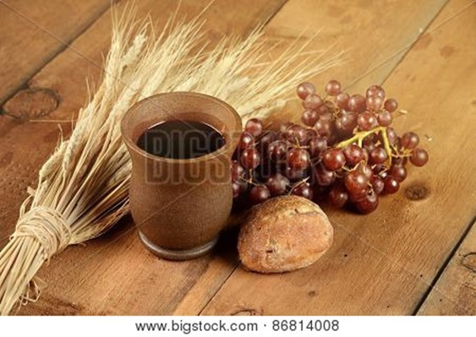
All the believers devoted themselves to the apostles’ teaching, and to fellowship, and to sharing
in meals (including the Lord’s Supper), and to prayer…
They worshiped together at the Temple each day, met in homes for the Lord’s Supper, and shared their meals with great joy and generosity—all the while praising God and enjoying the goodwill of all the people.
And each day the Lord added to their fellowship those who were being saved.

~ Acts 2:42-47 (NLT)

And the Lord added to their number daily those who were being saved.

~ Acts 2:47b (NIV)

They all joined together constantly in prayer…

~ Acts 1:14a (NIV)

All these with one accord were devoting themselves
to prayer…

~ Acts 1:14a (ESV)
Live Peacefully With Each Other

Be devoted to one another in love.
Honor one another above yourselves.
Never be lacking in zeal, but keep your spiritual fervor, serving the Lord.
Be joyful in hope, patient in affliction, faithful in prayer.
Share with the Lord’s people who are in need.
Practice hospitality.
Bless those who persecute you; bless and do not curse.
Rejoice with those who rejoice; mourn with those who mourn.
Live in harmony with one another.
Do not be proud, but be willing to associate with people
of low position. Do not be conceited.
Do not repay anyone evil for evil.
Be careful to do what is right in the eyes of everyone.
If it is possible, as far as it depends on you, live at peace with everyone.

~ Romans 12:10-18 (NIV)


Dear brothers and sisters, honor those who are your leaders in the Lord’s work. They work hard among you and give you spiritual guidance.
Show them great respect and wholehearted love because of their work.
And live peacefully with each other.
Brothers and sisters, we urge you to warn those who are lazy.
Encourage those who are timid.
Take tender care of those who are weak.
Be patient with everyone.
~ 1 Thessalonians 5:12-14 (NLT)

Never speak harshly to an older man, but appeal to him respectfully as you would to your own father. Talk to younger men as you would to your own brothers.
Treat older women as you would your mother, and treat younger women with all purity as you would your own sisters.

~ 1 Timothy 5:1-2 (NLT)

…you younger people, submit yourselves to your elders.

~ 1 Peter 5:5a (NKJV)

Take care of any widow who has no one else to care for her.

~ 1 Timothy 5:3 (NLT)

Brothers and sisters, if someone is caught in a sin, you who live by the Spirit should restore that person gently. But watch yourselves, or you also may be tempted.
Carry each other’s burdens, and in this way you will
fulfill the law of Christ.

~ Galatians 6:1-2a (NIV)

And you must show mercy to those whose faith is wavering.

~ Jude 1:22 (NLT)

“If another believer sins against you, go privately and point out the offense. If the other person listens and confesses it, you have won that person back. But if you are unsuccessful, take one or two others with you and go back again…If the person still refuses to listen, take your case to the church.”

~ Matthew 18:15-17a (NLT)
Maintain Unity Within the Church

I appeal to you, brothers and sisters, in the name of our Lord Jesus Christ, that all of you agree with one another in what you say and that there be no divisions among you, but that you be perfectly united in mind and thought.

~ 1 Corinthians 1:10 (NIV)

…live in such a way that you will not cause another believer to stumble and fall.

~ Romans 14:13b (NLT)

Whatever happens, conduct yourselves in a manner worthy of the gospel of Christ. Then…I will know that
you stand firm in the one Spirit, striving together as one
for the faith of the gospel…

~ Philippians 1:27 (NIV)

…standing together with one spirit and one purpose, fighting together for the faith, which is the Good News.

~ Philippians 1:27b (NLT)

God Has Given Each of You a Spiritual Gift

God has given each of you a gift from his great variety
of spiritual gifts.
Use them well to serve one another.
Do you have the gift of speaking? Then speak as though God himself were speaking through you.
Do you have the gift of helping others? Do it with all the strength and energy that God supplies.

~ 1 Peter 4:10-11a (NLT)

If your gift is prophesying, then prophesy in accordance with your faith;
if it is serving, then serve;
if it is teaching, then teach;
if it is to encourage, then give encouragement;
if it is giving, then give generously;
if it is to lead, do it diligently;
if it is to show mercy, do it cheerfully.

~ Romans 12:6b-8 (NIV)
All of You Together Are Christ’s Body

The human body has many parts, but the many parts make up one whole body. So it is with the body of Christ...
If the foot says, “I am not a part of the body because I am not a hand,” that does not make it any less a part of the body…
If the whole body were an eye, how would you hear? Or if your whole body were an ear, how would you smell anything?
But our bodies have many parts, and God has put each part just where he wants it…
In fact, some parts of the body that seem weakest and least important are actually the most necessary…
If one part suffers, all the parts suffer with it, and if
one part is honored, all the parts are glad.
All of you together are Christ’s body, and each of you
is a part of it.
~ 1 Corinthians 12:12-27 (NLT)

All of You Together are God’s Temple

…all of you together are the temple of God…

~ 1 Corinthians 3:16a (NLT)

Don’t you know that you yourselves are God’s temple and that God’s Spirit dwells in your midst? If anyone destroys God’s temple, God will destroy that person; for God’s temple is sacred, and you together are that temple.

~ 1 Corinthians 3:16-17 (NIV)

…you are living stones that God is building into his spiritual temple.

~ 1 Peter 2:5a (NLT)

You are members of God’s family.
Together, we are his house, built on the foundation
of the apostles and the prophets. And the cornerstone
is Christ Jesus himself.
We are carefully joined together in him, becoming a
holy temple for the Lord…where God lives by his Spirit.

~ Ephesians 2:19b-22 (NLT)
Share With and Serve Each Other

Share with the Lord’s people who are in need.
Practice hospitality.

~ Romans 12:13 (NIV)

So then, as we have opportunity, let us do good to everyone, and especially to those who are of the household of faith.

~ Galatians 6:10 (ESV)

Pray For and Pray With Each Other

Stay alert and be persistent in your prayers for all believers everywhere.

~ Ephesians 6:18b (NLT)

“…if two of you agree on earth concerning anything that they ask, it will be done for them by My Father in heaven.
“For where two or three are gathered together in My name, I am there in the midst of them.”

~ Matthew 18:19-20 (NKJV)



Dear brothers and sisters, I close my letter with these
last words:
Be joyful. Grow to maturity. Encourage each other. Live in harmony and peace.
Then the God of love and peace will be with you.

~ 2 Corinthians 13:11 (NLT)

Booklet Titles in the Series



www.TheWordOfGodSeries.com

Booklet Titles in the Series

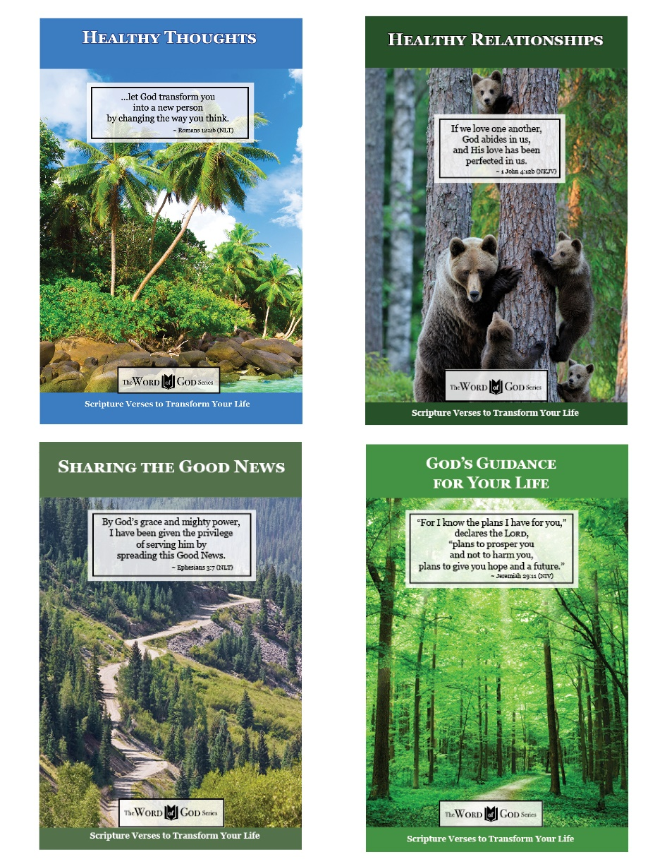

www.TheWordOfGodSeries.com

Booklet Titles in the Series

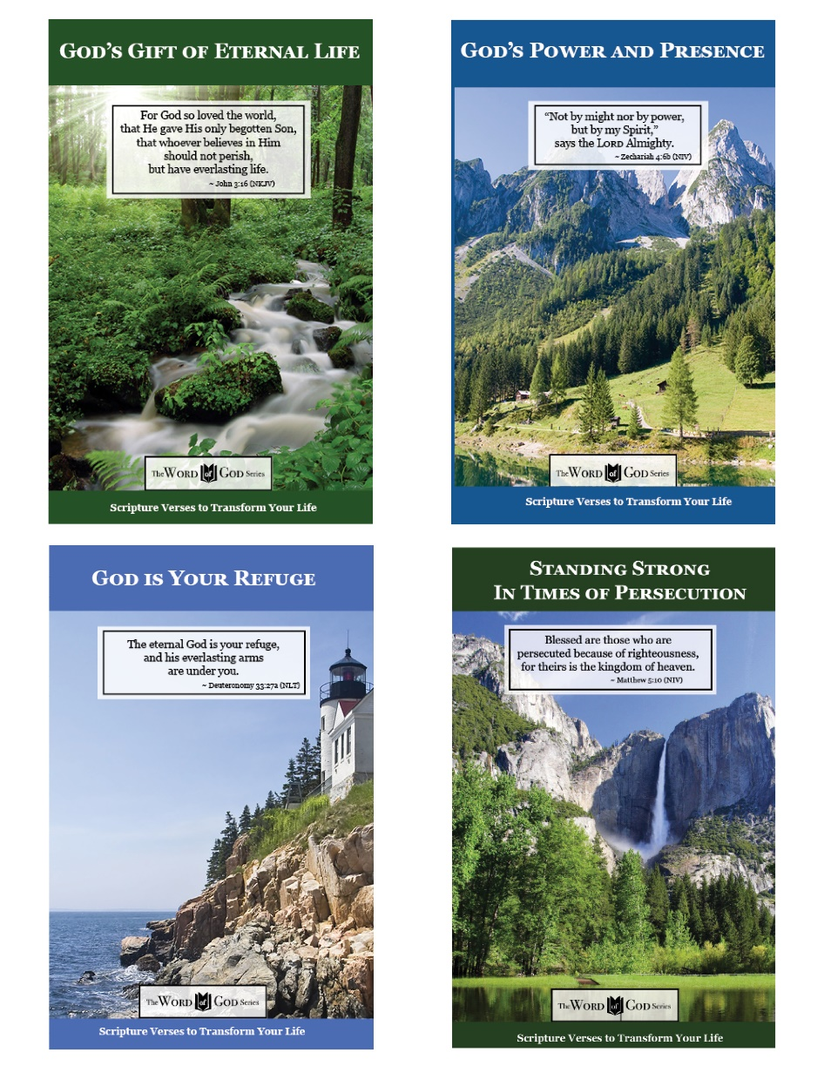

www.TheWordOfGodSeries.com

Booklet Titles in the Series

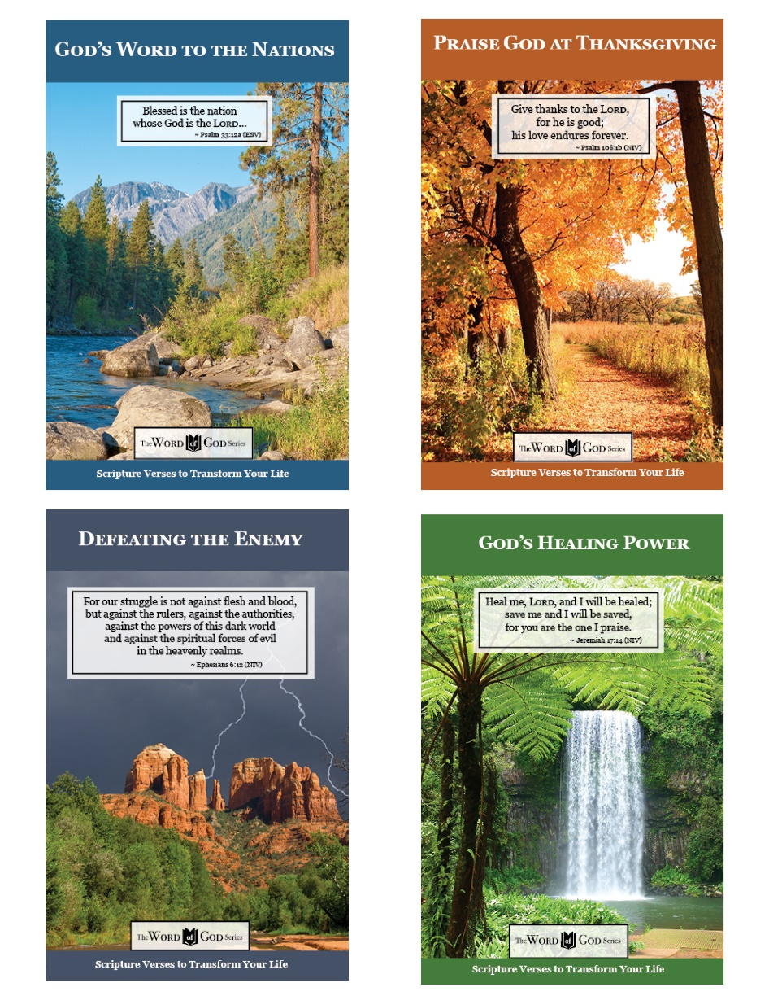

www.TheWordOfGodSeries.com

Booklet Titles in the Series

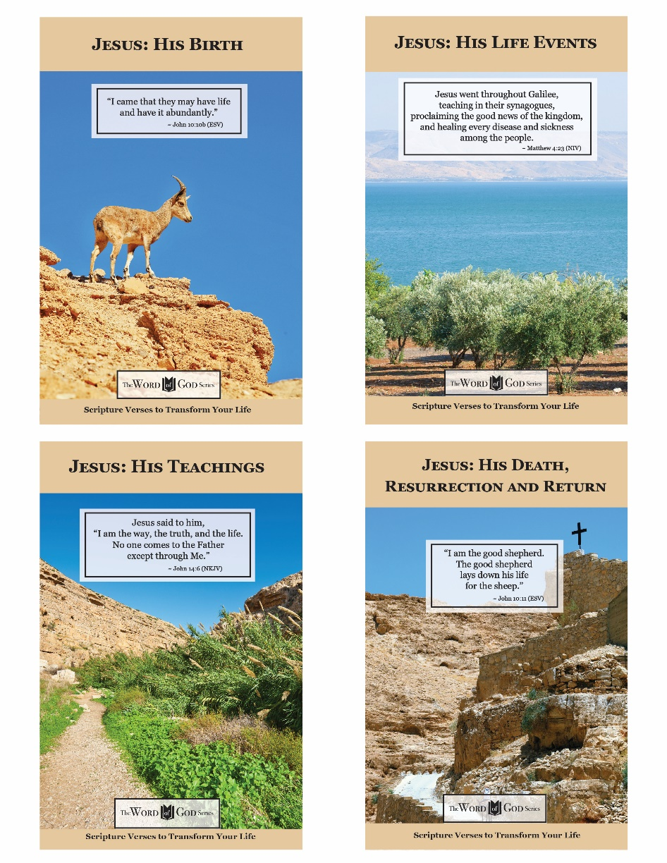

www.TheWordOfGodSeries.com

Photo Copyright Info

Note: when purchasing the rights to use the photos,
you may want to purchase an Extended License
for the cover image.


Bigstock Photo ID: 530082
Editing suggestion: Slightly brighten photo
Horses Grazing In The Mountains
wild horses grazing beside a river that flows down a mountain.
Stock Photo ID: 530082
Copyright: sumnersgraphicsinc


Bigstock Photo ID: 465320239
Close up of a Red deer stag with a hind during rutting season, autumn in UK.
Stock Photo ID: 465320239
Copyright: Giedriius

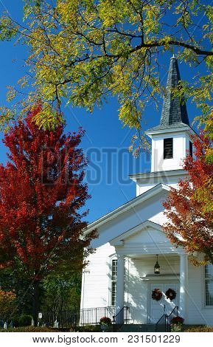
Bigstock Photo ID: 231501229
Pretty Church with White Steeple in Autumn with Fall Foliage and Bright Blue Sky
Stock Photo ID: 231501229
Copyright: SusansPhotos


Bigstock Photo ID: 62439587
Picturesque lane with flowers in an Italian hill town
Stock Photo ID: 62439587
Copyright: Jeni Foto


Bigstock Photo ID: 108260957
Shoshone Falls Idaho
Spectacular aerial view of Shoshone Falls or Niagara of the West, Snake River, Idaho, United States.
Stock Photo ID: 108260957
Copyright: bennymarty


Bigstock Photo ID: 408926978
Blue sky and beautiful sand beach in Koh Tao, Thailand. Vacation holidays
background wallpaper. View of nice tropical beach. Travel summer holiday background concept.
Stock Photo ID: 408926978
Copyright: Preto Perola


Bigstock Photo ID: 102326006
Panoramic Alpine Scenery Of Yellow And Green Aspen And Snow Covered Mountains During Foliage Season
panoramic landscape view of the colorful alpine scenery with snow covered mountains during foliage season at Kebler and Ohio Passes
Stock Photo ID: 102326006
Copyright: Alexey Kamenskiy


Bigstock Photo ID: 231501256
Lush Green Weeping Willow Tree with Picturesque Bridge, Summer Landscape
Stock Photo ID: 231501256
Copyright: SusansPhotos


Bigstock Photo ID: 86953208
Editing suggestion: Rotate image so waterfall flows to center of page
World heritage area Lamington National Park. Waterfall in the gold coast hinterlands on the NSW border.
Stock Photo ID: 86953208
Copyright: artistrobd


Bigstock Photo ID: 70991158
Boulders and Joshua Trees in Joshua Tree National Park California. ** Note: Visible grain at 100%, best at smaller sizes
Stock Photo ID: 70991158
Copyright: Gary Tognoni


Bigstock Photo ID: 48888983
Closeup Of A Cross On A Church Rooftop
Cross on a church rooftop on the top of Mount San Salvatore with mountain panorama landscape view in Lugano Lake Como district at Italian and Swiss border
Stock Photo 48888983
Copyright: Anna-Mari West


Bigstock Photo ID: 95424050
Majestic mountain lake in Canada. Upper Joffre Lake Trail View.
Stock Photo ID: 95424050
Copyright: karamysh


Bigstock Photo ID: 38163910
Active volcano Mt. Merapi in Central Java - Indonesia.
Stock Photo ID: 38163910
Copyright: Rudy Tanjung


Bigstock Photo ID: 133044932
Summer path
Stock Photo ID: 133044932
Copyright: maksheb

Bigstock Photo ID: 153464024
Healthy Relationships-15-Bigstock-153464024
Thailand, Phi Phi Don island, Krabi province.
Stock Photo ID: 153464024
Copyright: sorincolac


Bigstock Photo ID: 83420027
Veliki Medjed mountain and river Zabljak Montenegro
Stock Photo ID: 83420027
Copyright: saiko3p


Bigstock Photo ID: 39328984
Dead Sea, Israel. The ancient mountains in the winter morning.
by kavram, Stock Photo 39328984
Copyright: kavram

Bigstock Photo ID: 430733021
Editing suggestion: Rotate so trees are on the left side of the page
Lake Matheson is glacial lake. New Zealand. Mountain peaks covered with snow. Glacial lake surrounded by forests. The concept of ecological, active and photo tourism
Stock Photo ID: 430733021
Copyright: kavram

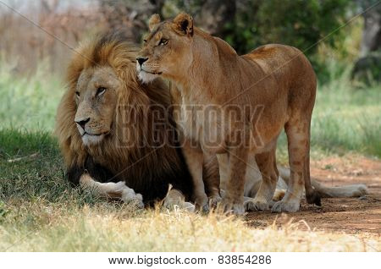
Bigstock Photo ID: 83854286
Editing suggestion: brighten lion photo
Lion and lioness sitting on grass South Africa
Stock Photo ID: 83854286
Copyright: halitomer


Bigstock Photo ID: 95824967
Mountain panorama
Panoramic view over the mountain ridge and rhododendrons meadow
Stock Photo ID: 95824967
Copyright: Cristian Balate Photography


Bigstock Photo ID: 54673898
Editing suggestion: Lighten photo
Hut in a spring
hut in the spring flower garden Keukenhof, Netherlands
Stock Photo ID: 54673898
Copyright: neirfy


Bigstock Photo ID: 98275037
Swiss Mountains Trail. Swiss Alps Summer Trail.
Stock Photo ID: 98275037
Copyright: duallogic

Shutterstock Photo ID 107576840
Brown bear with cubs in forest. Bear family.
Photo Contributor: Erik Mandre

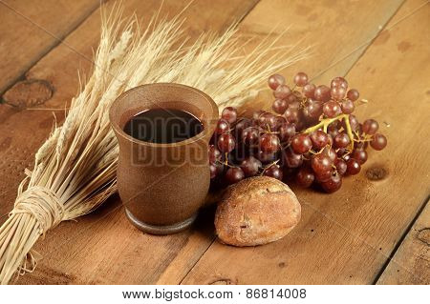
Bigstock Photo ID: 86814008
Communion elements with wine and bread on wooden table
Stock Photo ID: 86814008
Copyright: Gino Santa Maria


Bigstock Photo ID: 78313532
Hunawihr, Alsace, France
Stock Photo ID: 78313532
Copyright: RicSem76


Bigstock Photo ID: 101058452
Editing suggestion: Sharpen photo
A zebra mother and foal in profile are standing head to head. The foal has brown and white stripes while the mother has black and white stripes. They are both looking at the camera with trees and bushes in the background.
Stock Photo ID: 101058452
Copyright: Nick Dale

