Template for Healthy Thoughts
The Word of God Series is a collection of 20 booklets that present Scripture verses in an easy-to-read format, with each booklet focused on a different topic.
Titles include Healthy Relationships, A Joy-Filled Life, Freedom from Depression, and many others.
The booklets are available in both paperback and digital formats at www.TheWordOfGodSeries.com or Amazon.com.
Why This Template?
Because I believe in the power of God’s Word to transform people’s lives, I have dedicated several years of my life to
bring this series to fruition.
I am passionate about using these booklets to reach
a dark and dying world with the love of Christ and
the hope of the Gospel.
Initially, I had expected this series would be a small business. But one day, when I asked God what my next steps should be,
He spoke to me through His Word and told me to:
“…complete the ministry God has given you.”
~ 2 Timothy 4:5 (NLT, 1996 version)
So, I shifted the focus from a business to a ministry.
My vision, also, has evolved over time and I have come to believe that it is possible for millions of these booklets to be distributed (in both print and digital formats) around the world (see the document entitled The Vision at www.TheWordOfGodSeries.com for more info.)
In order to make this a far-reaching ministry, accessing populations that I couldn’t on my own, I decided to invite others to partner with me in producing and distributing these booklets to their own personal networks. To help get it started, I have made templates of each booklet freely available to anyone who would like them.
This way you (whether you are a church, Christian organization or an individual) can easily re-create the booklets in your own ministry’s name, and distribute them to the people you minister to.
I hope that this template will save you:
- Time – so you can benefit from the thousands of hours
of development time that has been invested so far
- Money – eliminate layers of profit margin, and save on shipping costs (especially for large quantities)

Whether you simply replicate and reproduce what has already been done, build on it, or take this idea in a different direction, you won’t have to waste time starting with a blank page.
I hope you can easily get these finalized and printed, so you can begin sharing them with the people in your sphere of influence.
On the following pages you will find document formatting and printing tips.
Photo editing tips are also presented, as well as the preview images of each photo (with the Photo ID#), so you to easily find it on either bigstockphoto.com or shutterstock.com.

Photo Editing Tips
At the end of this document you will find the copyright and descriptive info for each photo in the booklet, as well as editing suggestions for a few of them.
Many photos will need to be slightly stretched or cropped to fit the page.
Most of the editing suggestions below (especially brightening or increasing color saturation) should be very slight adjustments.
Editing photos within this document
Wrapping text around the photo: Doubleclick the photo, click
on Wrap Text and select Square. Then, drag the image by the corner until it is the right size to wrap the text around it.
Rotate: Doubleclick the photo, click on the Rotate Object icon.

Editing photos in the Pictures editing app in MS Word
Navigate to your Pictures folder, doubleclick the photo, and click on the blue Edit button on left
Most of the editing can be done by using one of these 3 options:


Crop: Click on the Crop icon and drag edges to desired spot
Brighten a photo: Adjustment icon / Light / Brightness
Increase color saturation: Adjustment icon / Color / Saturation or Warmth
Remove distracting elements from a photo: Click on the Generative Erase icon, select a brush size and click on the part of the photo you want removed.

Photo Searching Tips
Occasionally photographers pull their photos from the sites,
so there may be some in this booklet that are no longer available.
You can try using the same key words to search for the photo
on other sites (scroll to the end of this document for more descriptive information about each photo.)
Or, you can search for another photo on Bigstock. Under
All Images select Photos and search by key word. At the next screen, make sure that Safe Search is on. In the Category field, select either Landscapes, Nature or Animals.

Booklet Formatting Tips
If you make any changes to this document that results in changing the number of lines on a page, then the page will need to be re-formatted for everything to fit.
Often changing the spacing between the characters or between the lines in one verse is enough to re-format it.
Changing the spacing between the characters
Home / Font / Advanced / Character Spacing
Choose Expanded or Condensed, and select a numeric value (best from .1 to .3)


Changing the spacing between the lines
Highlight all the text in the passage or page and click on:
Layout / Paragraph / Line Spacing / Multiple
Select a numeric value (best from .98 to 1.02)


Saving the document as a PDF
Adobe Acrobat Pro subscriptions are available at www.adobe.com/creativecloud/plans.html. You could also
ask your library tech center if they carry Adobe products.
When the Word doc is final: File / Save as Adobe PDF

Viewing the PDF as a booklet
Remove the first blank page of the doc: Edit / Trash icon.
Enter pages 1 to 1 to delete. Then exit from the Edit mode.
To view the document as a booklet, click on the page icon
(on right side of page, below the rotate button) and select
Two-page view and Show cover page.


Adding page numbers to the PDF
Edit / Header & Footer / Add / Add New
Under Font Name choose your font (this document uses the Georgia font) and under Size enter 8 pt.
Under Margins, in the Bottom box, enter .4
Click in box under Center Footer Text and click on the Insert Page Number button.
Click on Page Range Options. The Pages From _ to _
will depend on which page in your document you want read as Page 1 in the PDF.
In these booklets, the verses begin on Page 5 (after the forward page, copyright page, and Table of Contents).
If you plan to develop several booklets, select Save Settings.


Printing the Booklets
You can print these as regular paperbacks with a binding, (which look a bit nicer) or, you can print them with a staple binding. The staple binding does require a certain type of machine that can print them in a way that they open fully to any page (not just the center page) and lay flat. Your local printer may or may not have that capability, so discuss options with them.
A glossy cover is recommended, as it has a better feel than a matte finish. You may want to request the booklets be printed on Cougar® paper, which has a very smooth finish.

Stuck on a Step Above and Need Help?
If you want to do this project on your own, but are having tech issues with one of the steps above, feel free to contact me at Susan@TheWordOfGodSeries.com. I may be able to assist you, since I’ve gone through this whole process myself!

Need Help with the Whole Project?
If you want these booklets set up in your own in your own ministry’s name, but don’t have the resources to do the whole project yourself,
I may be able to manage that process for you for a one-time project fee.
This would include the following services:
- Set up an account with Bigstock and Shutterstock in your ministry’s name and purchase the rights for you to use each of the photos
- Download and name the photos
- Edit photos as needed
- Create a cover with your church or ministry logo
- Request the rights to use the various Bible translations from each of the publishers (if applicable)
Feel free to contact me at Susan@TheWordOfGodSeries.com to discuss pricing options.
I hope that this information will help you finalize this document with ease so you can begin distributing it to the people in your realm of influence.
Thank you for partnering with me in this effort. I wish you the best as you make God’s Word known and share His love with others!
Warmly in Christ,
Susan

Soli Deo gloria



Feel free to edit this forward page to align to your own ministry’s vision and goals.

The Bible is the best-selling and most transformative book in history. Written over 2,000 years ago, it is still living and powerful today.
Throughout the pages of Scripture you will find inspiration and joy, comfort and peace, healing and hope.
Most importantly, you will learn of God’s abundant love for you, and His plan to give you a glorious, eternal inheritance.
The Word of God Series is a collection of booklets which presents Scripture by topic, so you can focus on verses that are relevant to you at different stages and circumstances throughout your life.
All of the booklets in this series feature Scripture exclusively—
just the powerful, undiluted Word of God.
Let God’s Word permeate your mind and transform your life.
Here are a few suggestions to help you fully benefit from Scripture:
Meditate
As you read, pause and reflect on the verses, and even meditate on them throughout the day.
Memorize
A great memorization technique is to repeat the verse several times, each time emphasizing a different word.
May all my thoughts be pleasing to him…
May all my thoughts be pleasing to him…
May all my thoughts be pleasing to him…
~ Psalm 104:34 (NLT)
Pray
Pray God’s Word back to Him. For example,
Dear Lord, please guide and direct all my thoughts so that they will be pleasing to You.
Do What It Says
Do not merely listen to the word, and so deceive yourselves.
Do what it says.
~ James 1:22 (NIV)

My prayer for you, as you read this booklet, is that you will seek to please God in all your thoughts, and that you will be transformed by the renewing of your mind.
Let the word of Christ dwell in you richly…
~ Colossians 3:16a (ESV)

A few comments about this series:

- The booklets in this series provide you with a sample of what the Bible offers, but it is important that you also read the Bible itself, preferably with a book-by-book focus.

- Passages in quotation marks are the actual words of God, either through His prophets in the Old Testament, or the words of Christ
in the New Testament.

- Every booklet includes a section that details God’s plan of salvation (commonly referred to as “The Gospel.”) The booklet entitled God’s Gift of Eternal Life
is devoted to the Gospel message.

This series presents verses in the following translations:

NIV: New International Version
Scripture quotations marked NIV are taken from the Holy Bible, New International Version®, NIV®. Copyright © 1973, 1978, 1984, 2011 by Biblica, Inc.™ Used by permission of Zondervan. All rights reserved worldwide. www.zondervan.com. The "NIV" and "New International Version" are trademarks registered in the United States Patent and Trademark Office by Biblica, Inc.™

NLT: New Living Translation
Scripture quotations marked NLT are taken from the Holy Bible, New Living Translation, Copyright© 1996, 2004, 2015 by Tyndale House Foundation. Used by permission of Tyndale House Publishers, Inc., Carol Stream, Illinois 60188. All rights reserved.

ESV: English Standard Version
Scripture quotations marked ESV are taken from the ESV Bible® (The Holy Bible, English Standard Version®), copyright © 2001 by Crossway Bibles, a publishing ministry of Good News Publishers. Used by permission. All rights reserved.

KJV: King James Version
Public Domain

NKJV: New King James Version
Scripture quotations marked NKJV are taken from the New King James Version®. Copyright © 1982 by Thomas Nelson, Inc. Used by permission.

Since this is a template booklet featuring preview photos, it is not copyrighted, so you are free to purchase licenses to use the photos and develop your own booklets for print. Be sure to determine whether or not you need to request permission (and in some cases pay) for the rights to use the various Bible translations. Scripture verses were sourced from www.BibleGateway.com.
If it would be easier for you to simply purchase this booklet, the copyrighted version is available at www.TheWordOfGodSeries.com or www.amazon.com.
ISBN info for the copyrighted booklets is as follows:
The ISBN is 978-1-964538-12-9 and the Amazon ISBN is 9798359851282.
Healthy Thoughts

Contents

Guard Your Thoughts 1
Focus Your Thoughts on God
Forget What is Behind

Don’t Grieve the Lord with Your Thoughts
Meditate on God’s Word

Guard Your Heart 9

Guard Your Tongue 11

Wisdom About the Tongue: from Proverbs

Wisdom About the Tongue: Quotes of Jesus

Meditate on the Psalms 16
Psalms of Confession
Psalm 51, Psalm 32
Psalms of Praise
Psalm 145, Psalm 103, Psalm 100
Psalms of Assurance
Psalm 37, Psalm 23
Focus Your Thoughts on God’s Gift 24
of Eternal Life
Focus Your Thoughts on Praising God 40
Let All That I am Praise the Lord
Give Thanks to the Lord, for He is Good
Life a Life of Praise
Praise God for His Greatness
Praise God for His Goodness
Set Your Mind on Things Above 46

Guard Your Thoughts

Focus Your Thoughts on God

May all my thoughts be pleasing to him, for I rejoice
in the Lord.
~ Psalm 104:34 (NLT)

May the words of my mouth and the meditation of my heart
be pleasing to you, O Lord,
my rock and my redeemer.

~ Psalm 19:14 (NLT)

I will meditate on the glorious splendor of Your majesty,
and on Your wondrous works.
~ Psalm 145:5a (NKJV)



“For My thoughts are not your thoughts,
Nor are your ways My ways,” says the Lord.
“For as the heavens are higher than the earth,
So are My ways higher than your ways,
And My thoughts than your thoughts.”
~ Isaiah 55:8-9 (NKJV)
Be alert and of sober mind. Your enemy the devil prowls around like a roaring lion looking for someone to devour.
~ 1 Peter 5:8 (NIV)

Get rid of all bitterness, rage and anger, brawling and slander, along with every form of malice.
~ Ephesians 4:31 (NIV)

…God has not given us a spirit of fear,
but of power
and of love
and of a sound mind.
~ 2 Timothy 1:7 (NKJV)

…be renewed in the spirit of your mind…

~ Ephesians 4:23 (NKJV)

See to it that no one takes you captive through hollow and deceptive philosophy, which depends on human tradition and the elemental spiritual forces of this world rather than on Christ.
~ Colossians 2:8 (NIV)

But in your hearts revere Christ as Lord.
~ 1 Peter 3:15a (NIV)

For though we live in the world, we do not wage war
as the world does.
The weapons we fight with are not the weapons of
the world. On the contrary, they have divine power to demolish strongholds.
We demolish arguments and every pretension that sets itself up against the knowledge of God, and we take captive every thought to make it obedient to Christ.
~ 2 Corinthians 10:3-5 (NIV)

Those who are dominated by the sinful nature think
about sinful things, but those who are controlled by the Holy Spirit think about things that please the Spirit.
So letting your sinful nature control your mind leads to death. But letting the Spirit control your mind leads to
life and peace.
~ Romans 8:5-6 (NLT)
Think about the things of heaven, not the things of earth.
~ Colossians 3:2 (NLT)

…set your hearts on things above, where Christ is…
Set your minds on things above, not on earthly things.
~ Colossians 3:1b-2 (NIV)

…let God transform you into a new person by changing
the way you think.
~ Romans 12:2b (NLT)

Do not conform to the pattern of this world, but be transformed by the renewing of your mind.
~ Romans 12:2a (NIV)

Finally, brothers and sisters,
whatever is true,
whatever is noble,
whatever is right,
whatever is pure,
whatever is lovely,
whatever is admirable,
if anything is excellent or praiseworthy,
think about such things.

~ Philippians 4:8 (NIV)


Shutterstock Photo ID: 357886112
Forget What Is Behind

Let your eyes look straight ahead; fix your gaze directly before you.
~ Proverbs 4:25 (NIV)

This is what the Lord says—he who made a way through the sea, a path through the mighty waters…
“Forget the former things;
do not dwell on the past.
“See, I am doing a new thing!
Now it springs up; do you not perceive it?
“I am making a way in the wilderness
and streams in the wasteland.”
~ Isaiah 43:16-19 (NIV)

“See, I will create
new heavens and a new earth.
“The former things will not be remembered,
nor will they come to mind.”
~ Isaiah 65:17 (NIV)

He will wipe away every tear from their eyes, and
death shall be no more, neither shall there be mourning, nor crying, nor pain anymore, for the former things have passed away.
~ Revelation 21:4 (ESV)

You were taught, with regard to your former way of life,
to put off your old self, which is being corrupted by its deceitful desires; to be made new in the attitude of your minds; and to put on the new self, created to be like God in true righteousness and holiness.
~ Ephesians 4:22-24 (NIV)

There is therefore now no condemnation for those
who are in Christ Jesus.
~ Romans 8:1 (ESV)

Therefore, if anyone is in Christ, he is a new creation.
The old has passed away; behold, the new has come.
~ 2 Corinthians 5:17 (ESV)
Forgetting what is behind and straining toward what is ahead,
I press on toward the goal to win the prize for which God has called me heavenward in Christ Jesus.
~ Philippians 3:13b-14 (NIV)



Don’t Grieve the Lord With Your Thoughts

The Lord saw that the wickedness of man was great in the earth, and that every intention of the thoughts of his heart was only evil continually. And the Lord regretted that he had made man on the earth, and it grieved him to his heart.
~ Genesis 6:5-6 (ESV)

The Lord detests the thoughts of the wicked…
~ Proverbs 15:26a (NIV)

How long shall your wicked thoughts lodge within you?
~ Jeremiah 4:14b (ESV)

…let the wicked forsake his way, and the unrighteous man his thoughts…
~ Isaiah 55:7a (ESV)

“The human heart is the most deceitful of all things, and desperately wicked. Who really knows how bad it is?
“But I, the Lord, search all hearts and examine secret motives.
“I give all people their due rewards, according to what their actions deserve.”
~ Jeremiah 17:9-10 (NLT)
Meditate on God’s Word

Let the word of Christ dwell in you richly…
~ Colossians 3:16a (ESV)

For the word of God is living and powerful...
~ Hebrews 4:12a (NKJV)

…man does not live on bread alone but on every word
that comes from the mouth of the Lord.
~ Deuteronomy 8:3b (NIV)

The tempter came to him and said, “If you are the
Son of God, tell these stones to become bread.”
Jesus answered,
“It is written: ‘Man shall not live on bread alone,
but on every word that comes from the mouth
of God.’”
~ Matthew 4:3-4 (NIV)

…the word of God abides in you, and you have overcome the evil one.
~ 1 John 2:14b (ESV)

“If you abide in my word, you are truly my disciples, and you will know the truth, and the truth will set you free.”
~ John 8:31b-32 (ESV)

“If you remain in me and my words remain in you,
ask whatever you wish, and it will be done for you.”
~ John 15:7 (NIV)

“…everyone who hears these words of mine and puts
them into practice is like a wise man who built his house on the rock.”
~ Matthew 7:24 (NIV)

Do not merely listen to the word, and so deceive yourselves. Do what it says.
~ James 1:22 (NIV)

So get rid of all the filth and evil in your lives, and humbly accept the word God has planted in your hearts, for it has the power to save your souls.
~ James 1:21 (NLT)
Guide my steps by your word,
so I will not be overcome by evil.
~ Psalm 119:133 (NLT)

Order my steps in thy word:
and let not any iniquity have dominion over me.
~ Psalm 119:133 (KJV)

Direct my footsteps according to your word;
let no sin rule over me.
~ Psalm 119:133 (NIV)



Thy word is a lamp unto my feet, and a light unto my path.
~ Psalm 119:105 (KJV)

I have stored up your word in my heart, that I might not sin against you.
~ Psalm 119:11 (ESV)

…I trust in Your word.
~ Psalm 119:42b (NKJV)
All Scripture is God-breathed and is useful for teaching, rebuking, correcting and training in righteousness,
so that the servant of God may be thoroughly equipped
for every good work.
~ 2 Timothy 3:16 (NIV)

Blessed is the one…whose delight is in the law of the Lord, and who meditates on his law day and night.
That person is like a tree planted by streams of water, which yields its fruit in season and whose leaf does
not wither—whatever they do prospers.
~ Psalm 1:1-3 (NIV)

Keep this Book of the Law always on your lips;
meditate on it day and night, so that you may
be careful to do everything written in it.
Then you will be prosperous and successful.
~ Joshua 1:8 (NIV)

Take the helmet of salvation and the sword of the Spirit, which is the word of God.
~ Ephesians 6:17 (NIV)

The instructions of the Lord are perfect,
reviving the soul.
The decrees of the Lord are trustworthy,
making wise the simple.
The commandments of the Lord are right,
bringing joy to the heart.
The commands of the Lord are clear,
giving insight for living…
They are a warning to your servant,
a great reward for those who obey them.
~ Psalm 19:7-11 (NLT)

“Most assuredly, I say to you, he who hears My word and believes in Him who sent Me has everlasting life, and shall not come into judgment, but has passed from death into life.”
~ John 5:24 (NKJV)

For you have been born again, but not to a life that will quickly end. Your new life will last forever because it comes from the eternal, living word of God.
~ 1 Peter 1:23 (NLT)

Guard Your Heart

Above all else, guard your heart, for everything you do flows from it.
~ Proverbs 4:23 (NIV)

…for it determines the course of your life.
~ Proverbs 4:23b (NLT)

Search me, O God, and know my heart;
test me and know my anxious thoughts.
Point out anything in me that offends you,
and lead me along the path of everlasting life.
~ Psalm 139:23-24 (NLT)

How can I know all the sins lurking in my heart? Cleanse me from these hidden faults.
~ Psalm 19:12 (NLT)

I know, my God, that you test the heart and are pleased with integrity.
~ 1 Chronicles 29:17a (NIV)

Create in me a pure heart, O God, and renew a steadfast spirit within me.
~ Psalm 51:10 (NIV)


Bigstock Photo ID: 138415412

“I will give you a new heart and put a new spirit in you;
“I will remove from you your heart of stone and give you
a heart of flesh.”
~ Ezekiel 36:26 (NIV)
Let the peace of Christ rule in your hearts…
~ Colossians 3:15a (NIV)

…the peace of God, which transcends all understanding, will guard your hearts and your minds in Christ Jesus.
~ Philippians 4:7 (NIV)

For God is not the author of confusion but of peace…
~ 1 Corinthians 14:33a (NKJV)

A heart at peace gives life to the body, but envy rots
the bones.
~ Proverbs 14:30 (NIV)

But if you harbor bitter envy and selfish ambition in
your hearts, do not boast about it or deny the truth.
Such “wisdom” does not come down from heaven but
is earthly, unspiritual, demonic.
~ James 3:14-15 (NIV)

Beloved, if our heart does not condemn us, we have confidence before God...
~ 1 John 3:21 (ESV)

If I had cherished sin in my heart, the Lord would
not have listened…
~ Psalm 66:18 (NIV)

“For from within, out of a person’s heart, come
evil thoughts, sexual immorality, theft, murder,
adultery, greed, wickedness, deceit, lustful desires,
envy, slander, pride, and foolishness.
“All these vile things come from within…”
~ Mark 7:21-23a (NLT)

I will not look with approval on anything that is vile.
~ Psalm 101:3a (NIV)

…acknowledge the God of your father, and serve him
with wholehearted devotion and with a willing mind,
for the Lord searches every heart and understands
every desire and every thought.
~ 1 Chronicles 28:9a (NIV)

…wash your heart from evil, that you may be saved.
~ Jeremiah 4:14a (ESV)

Guard Your Tongue

Death and life are in the power of the tongue…
~ Proverbs 18:21a (ESV)

Those who consider themselves religious and yet do not keep a tight rein on their tongues deceive themselves,
and their religion is worthless.
~ James 1:26 (NIV)

…many words mark the speech of a fool.
~ Ecclesiastes 5:3b (NIV)

…make it your ambition to lead a quiet life: You should mind your own business and work with your hands…
~ 1 Thessalonians 4:11a (NIV)

Whoever of you loves life
and desires to see many good days,
keep your tongue from evil
and your lips from telling lies.
~ Psalm 34:12-13 (NIV)



I am determined not to sin in what I say.
~ Psalm 17:3b (NLT)

I will hold my tongue when the ungodly are around me.
~ Psalm 39:1b (NLT)
Do not let any unwholesome talk come out of your mouths, but only what is helpful for building others up according to their needs, that it may benefit those who listen.
~ Ephesians 4:29 (NIV)

Avoid godless chatter, because those who indulge in it
will become more and more ungodly.
~ 2 Timothy 2:16 (NIV)

We all stumble in many ways. Anyone who is never at fault in what they say is perfect, able to keep their whole body in check.
When we put bits into the mouths of horses to make them obey us, we can turn the whole animal. Or take ships as an example. Although they are so large and are driven by strong winds, they are steered by a very small rudder wherever the pilot wants to go.
Likewise, the tongue is a small part of the body, but it makes great boasts.
Consider what a great forest is set on fire by a small spark.
The tongue also is a fire, a world of evil among the parts
of the body. It corrupts the whole body, sets the whole course of one’s life on fire, and is itself set on fire by hell.
All kinds of animals, birds, reptiles and sea creatures
are being tamed and have been tamed by mankind, but
no human being can tame the tongue. It is a restless evil,
full of deadly poison.
With the tongue we praise our Lord and Father, and with it we curse human beings, who have been made in God’s likeness. Out of the same mouth come praise and cursing. My brothers and sisters, this should not be.
~ James 3:2-10 (NIV)

Do not be quick with your mouth,
do not be hasty in your heart
to utter anything before God.
God is in heaven
and you are on earth,
so let your words be few.
~ Ecclesiastes 5:2 (NIV)
Then those who feared the Lord talked with each other, and the Lord listened and heard. A scroll of remembrance was written in his presence concerning those who feared the Lord and honored his name.
~ Malachi 3:16 (NIV)

Wisdom About the Tongue: from Proverbs

Those who guard their mouths and their tongues keep themselves from calamity.
~ Proverbs 21:23 (NIV)

Even fools are thought wise if they keep silent,
and discerning if they hold their tongues.
~ Proverbs 17:28 (NIV)

The wise don’t make a show of their knowledge,
but fools broadcast their foolishness.
~ Proverbs 12:23 (NLT)

Fools find no pleasure in understanding
but delight in airing their own opinions.
~ Proverbs 18:2 (NIV)



When words are many, transgression is not lacking,
but whoever restrains his lips is prudent.
~ Proverbs 10:19 (ESV)
Avoiding a fight is a mark of honor;
only fools insist on quarreling.
~ Proverbs 20:3 (NLT)

A gentle answer turns away wrath,
but a harsh word stirs up anger.
~ Proverbs 15:1 (NIV)

An offended friend is harder to win back than a fortified city. Arguments separate friends…
~ Proverbs 18:19a (NLT)

Starting a quarrel is like opening a floodgate,
so stop before a dispute breaks out.
~ Proverbs 17:14 (NLT)



Death and life are in the power of the tongue…
~ Proverbs 18:21a (ESV)

A truly wise person uses few words….
~ Proverbs 17:27a (NLT)

Whoever belittles his neighbor lacks sense,
but a man of understanding remains silent.
~ Proverbs 11:12 (ESV)

Without wood a fire goes out;
without a gossip a quarrel dies down.
~ Proverbs 26:20 (NIV)

A gossip betrays a confidence;
so avoid anyone who talks too much.
~ Proverbs 20:19 (NIV)

Wisdom About the Tongue: Quotes of Jesus

“A good man brings good things out of the good stored up in him, and an evil man brings evil things out of the evil stored up in him.”
~ Matthew 12:35 (NIV)

“For the mouth speaks what the heart is full of.”
~ Matthew 12:34b (NIV)

“For whatever is in your heart determines what you say.”
~ Matthew 12:34b (NLT)

“For out of the abundance of the heart the mouth speaks.”
~ Matthew 12:34b (ESV)

“There is nothing concealed that will not be disclosed,
or hidden that will not be made known.
“What you have said in the dark will be heard in the daylight, and what you have whispered in the ear in the inner rooms will be proclaimed from the roofs.”
~ Luke 12:2-3 (NIV)

“But I tell you that everyone will have to give account on
the day of judgment for every empty word they have spoken.
“For by your words you will be acquitted, and by your words you will be condemned.”
~ Matthew 12:36-37 (NIV)

Meditate on the Psalms

Psalms of Confession

Psalm 51

Have mercy on me, O God,
according to your unfailing love;
according to your great compassion
blot out my transgressions.
Wash away all my iniquity
and cleanse me from my sin.
For I know my transgressions,
and my sin is always before me.
Against you, you only, have I sinned
and done what is evil in your sight…
Cleanse me with hyssop, and I will be clean;
wash me, and I will be whiter than snow.
Let me hear joy and gladness;
let the bones you have crushed rejoice.
Hide your face from my sins
and blot out all my iniquity.
Create in me a pure heart, O God,
and renew a steadfast spirit within me.
Do not cast me from your presence
or take your Holy Spirit from me.
Restore to me the joy of your salvation
and grant me a willing spirit, to sustain me.
Then I will teach transgressors your ways,
so that sinners will turn back to you…
You do not delight in sacrifice, or I would bring it;
you do not take pleasure in burnt offerings.
My sacrifice, O God, is a broken spirit;
a broken and contrite heart
you, God, will not despise…
~ Excerpts from Psalm 51 (NIV)
Psalm 32

Blessed is the one
whose transgressions are forgiven,
whose sins are covered.
Blessed is the one
whose sin the Lord does not count against them
and in whose spirit is no deceit.
When I kept silent,
my bones wasted away
through my groaning all day long.
For day and night
your hand was heavy on me;
my strength was sapped as in the heat of summer.
Then I acknowledged my sin to you
and did not cover up my iniquity.
I said, “I will confess
my transgressions to the Lord.”
And you forgave
the guilt of my sin.
Therefore let all the faithful pray to you
while you may be found…
You are my hiding place;
you will protect me from trouble
and surround me with songs of deliverance…
Many are the woes of the wicked,
but the Lord’s unfailing love
surrounds the one who trusts in him…
~ Excerpts from Psalm 32 (NIV)


Bigstock Photo ID: 127531766
Psalms of Praise

Psalm 145

I will exalt you, my God the King;
I will praise your name for ever and ever.
Every day I will praise you
and extol your name for ever and ever.
Great is the Lord and most worthy of praise;
his greatness no one can fathom.
One generation commends your works to another;
they tell of your mighty acts.
They speak of the glorious splendor of your majesty—
and I will meditate on your wonderful works.
They tell of the power of your awesome works—
and I will proclaim your great deeds.
They celebrate your abundant goodness
and joyfully sing of your righteousness.
The Lord is gracious and compassionate,
slow to anger and rich in love.
The Lord is good to all;
he has compassion on all he has made.
All your works praise you, Lord;
your faithful people extol you.
They tell of the glory of your kingdom
and speak of your might,
so that all people may know of your mighty acts
and the glorious splendor of your kingdom.
Your kingdom is an everlasting kingdom,
and your dominion endures through all generations.
The Lord is trustworthy in all he promises
and faithful in all he does.
The Lord upholds all who fall
and lifts up all who are bowed down.
The eyes of all look to you,
and you give them their food at the proper time.
You open your hand
and satisfy the desires of every living thing.
The Lord is righteous in all his ways
and faithful in all he does.
The Lord is near to all who call on him,
to all who call on him in truth.
He fulfills the desires of those who fear him;
he hears their cry and saves them.
The Lord watches over all who love him,
but all the wicked he will destroy.
My mouth will speak in praise of the Lord.
Let every creature praise his holy name
for ever and ever.
~ Psalm 145 (NIV)


Psalm 103

Praise the Lord, my soul;
all my inmost being, praise his holy name.
Praise the Lord, my soul,
and forget not all his benefits—
who forgives all your sins
and heals all your diseases,
who redeems your life from the pit
and crowns you with love and compassion,
who satisfies your desires with good things
so that your youth is renewed like the eagle’s…
The Lord is compassionate and gracious,
slow to anger, abounding in love.
He will not always accuse,
nor will he harbor his anger forever;
he does not treat us as our sins deserve
or repay us according to our iniquities.
For as high as the heavens are above the earth,
so great is his love for those who fear him;
as far as the east is from the west,
so far has he removed our transgressions from us.
As a father has compassion on his children,
so the Lord has compassion on those who fear him;
for he knows how we are formed,
he remembers that we are dust.
The life of mortals is like grass,
they flourish like a flower of the field;
the wind blows over it and it is gone,
and its place remembers it no more.
But from everlasting to everlasting
the Lord’s love is with those who fear him,
and his righteousness with their children’s children...
Praise the Lord, all his works
everywhere in his dominion.
Praise the Lord, my soul.
~ Psalm 103 (NIV)
Psalm 100

Shout for joy to the Lord, all the earth.
Worship the Lord with gladness;
come before him with joyful songs.
Know that the Lord is God.
It is he who made us, and we are his;
we are his people, the sheep of his pasture.
Enter his gates with thanksgiving
and his courts with praise;
give thanks to him and praise his name.
For the Lord is good
and his love endures forever;
his faithfulness continues through all generations.
~ Psalm 100 (NIV)

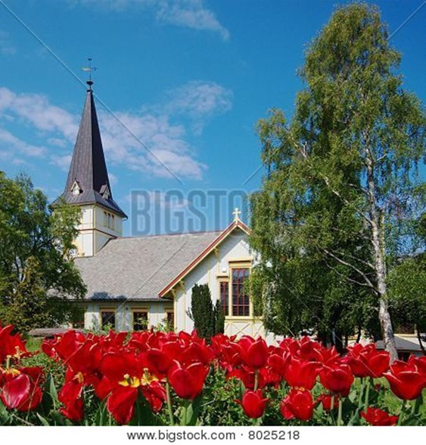
Psalms of Assurance

Psalm 37

Do not fret because of those who are evil
or be envious of those who do wrong;
for like the grass they will soon wither,
like green plants they will soon die away.
Trust in the Lord and do good;
dwell in the land and enjoy safe pasture.
Take delight in the Lord,
and he will give you the desires of your heart.
Commit your way to the Lord;
trust in him and he will do this:
He will make your righteous reward shine like the dawn,
your vindication like the noonday sun.
Be still before the Lord
and wait patiently for him…
Refrain from anger and turn from wrath;
do not fret—it leads only to evil…
The blameless spend their days under the Lord’s care,
and their inheritance will endure forever.
In times of disaster they will not wither;
in days of famine they will enjoy plenty…
The Lord makes firm the steps
of the one who delights in him;
though he may stumble, he will not fall,
for the Lord upholds him with his hand…
Turn from evil and do good;
then you will dwell in the land forever…
The righteous will inherit the land
and dwell in it forever…
Hope in the Lord
and keep his way.
He will exalt you to inherit the land…
~ Excerpts from Psalm 37 (NIV)
Psalm 23

The Lord is my shepherd;
I shall not want.
He makes me to lie down in green pastures;
He leads me beside the still waters.
He restores my soul;
He leads me in the paths of righteousness
For His name’s sake.
Yea, though I walk through the valley of the shadow of death,
I will fear no evil;
For You are with me;
Your rod and Your staff, they comfort me.
You prepare a table before me in the presence of my enemies;
You anoint my head with oil;
My cup runs over.
Surely goodness and mercy shall follow me
All the days of my life;
And I will dwell in the house of the Lord
Forever.
~ Psalm 23 (NKJV)



Focus Your Thoughts
on God’s Gift of Eternal Life

God loves you abundantly, and has made a way for you to live forever in His glorious kingdom. However, first He had to pay an enormous price for you to be forgiven of your sin, in order to receive this eternal glory. This section explains His plan to forgive and save you. In summary:
God loves you, but your sin separates you from Him, and because of it, God’s wrath will come. However, Jesus died as a sacrifice to save you from your sins, from God’s wrath, and from death itself. When you confess your sins, repent and accept the salvation that Christ offers, God will forgive you. By trusting in Christ you become God’s child, and as His child, you will inherit eternal life and heaven will be your home.

God Loves You

The Lord is gracious and compassionate,
slow to anger and rich in love.
The Lord is good to all;
he has compassion on all he has made.

~ Psalm 145:8-9 (NIV)

Give thanks to the Lord, for he is good.
His love endures forever.

~ Psalm 136:1 (NIV)

For the Lord is good;
His mercy is everlasting, and
His truth endures to all generations.

~ Psalm 100:5 (NKJV)

Taste and see that the Lord is good...
~ Psalm 34:8a (NIV)

Oh, that men would give thanks to the Lord for His goodness,
and for His wonderful works to the children of men!

~ Psalm 107:15 (NKJV)

No good thing does he withhold
from those who walk uprightly.
~ Psalm 84:11b (ESV)
The earth is full of the goodness of the Lord.

~ Psalm 33:5b (NKJV)

…the earth is full of the steadfast love of the Lord.

~ Psalm 33:5b (ESV)

…the unfailing love of the Lord fills the earth.

~ Psalm 33:5b (NLT)

Every good and perfect gift is from above, coming down from the Father of the heavenly lights…

~ James 1:17a (NIV)


…You, Lord, are good, and ready to forgive, and abundant in mercy to all those who call upon You.

~ Psalm 86:5 (NKJV)

…abounding in steadfast love to all who call upon you.

~ Psalm 86:5b (ESV)

…full of unfailing love for all who ask for your help.

~ Psalm 86:5b (NLT)

…I have always been mindful of your unfailing love
and have lived in reliance on your faithfulness.

~ Psalm 26:3 (NIV)



…I will sing of your strength, in the morning I will sing of your love…

~ Psalm 59:16a (NIV)

Your unfailing love is better than life itself; how I praise you!

~ Psalm 63:3 (NLT)

…let Your lovingkindness and Your truth continually preserve me.

~ Psalm 40:11b (NKJV)
But Your Sin Separates You from God

…for all have sinned and fall short of the glory of God…

~ Romans 3:23 (ESV)

We are all infected and impure with sin. When we display our righteous deeds, they are nothing but filthy rags.

~ Isaiah 64:6a (NLT)

Don’t you realize that those who do wrong will not inherit the Kingdom of God?

~ 1 Corinthians 6:9a (NLT)

For of this you can be sure: No immoral, impure or greedy person—such a person is an idolater—has any inheritance in the kingdom of Christ and of God.
Let no one deceive you with empty words, for because of such things God’s wrath comes on those who are disobedient.

~ Ephesians 5:5-6 (NIV)

The Day of God’s Wrath Will Come

The wrath of God is being revealed from heaven against all the godlessness and wickedness of people, who suppress the truth by their wickedness, since what may be known about God is plain to them, because God has made it plain to them.
For since the creation of the world God’s invisible qualities—his eternal power and divine nature—have been clearly seen, being understood from what has been made, so that people are without excuse.
For although they knew God, they neither glorified him as God nor gave thanks to him, but their thinking became futile and their foolish hearts were darkened...
Furthermore, just as they did not think it worthwhile to retain the knowledge of God, so God gave them over to a depraved mind…They have become filled with every kind of wickedness, evil, greed and depravity.
They are full of envy, murder, strife, deceit and malice…
they have no understanding, no fidelity, no love, no mercy.

~ Romans 1:18-31 (NIV)
“Therefore I will make the heavens tremble,
and the earth will be shaken out of its place…”

~ Isaiah 13:13a (ESV)

“For a fire will be kindled by my wrath,
one that burns down to the realm of the dead below.
It will devour the earth and its harvests
and set afire the foundations of the mountains.”

~ Deuteronomy 32:22 (NIV)

“Whom have you so dreaded and feared
that you have not been true to me…
Is it not because I have long been silent
that you do not fear me?”

~ Isaiah 57:11 (NIV)

“But I will show you whom you should fear:
“Fear Him who, after He has killed, has power to
cast into hell; yes, I say to you, fear Him!”

~ Luke 12:5 (NKJV)

He will guard the feet of his faithful servants, but
the wicked will be silenced in the place of darkness.

~ 1 Samuel 2:9a (NIV)

They will be punished with everlasting destruction and shut out from the presence of the Lord and from the
glory of his might…

~ 2 Thessalonians 1:9 (NIV)

Confess Your Sin and Repent

That is why the Lord says,
“Turn to me now, while there is time.
Give me your hearts.
Come with fasting, weeping, and mourning.”

~ Joel 2:12 (NLT)

For godly sorrow produces repentance leading to salvation…

~ 2 Corinthians 7:10a (NKJV)

Therefore, let all the godly pray to you while there is still time, that they may not drown in the floodwaters of judgment.

~ Psalm 32:6 (NLT)
…the present heavens and earth are reserved for fire, being kept for the day of judgment and destruction of the ungodly.
But do not forget this one thing, dear friends: With the Lord a day is like a thousand years, and a thousand years are like a day.
The Lord is not slow in keeping his promise, as some understand slowness.
Instead he is patient with you, not wanting anyone to perish, but everyone to come to repentance.
But the day of the Lord will come like a thief.
The heavens will disappear with a roar; the elements will be destroyed by fire, and the earth and everything done in it will be laid bare.
Since everything will be destroyed in this way, what kind of people ought you to be?
You ought to live holy and godly lives as you look forward to the day of God and speed its coming. That day will bring about the destruction of the heavens by fire, and the elements will melt in the heat.
But in keeping with his promise we are looking forward to
a new heaven and a new earth, where righteousness dwells.

~ 2 Peter 3:7b-13 (NIV)


Jesus Died to Save You…

…From Your Sin

…God made Christ, who never sinned, to be the offering for our sin, so that we could be made right with God through Christ.

~ 2 Corinthians 5:21 (NLT)

He gave his life to free us from every kind of sin,
to cleanse us, and to make us his very own people,
totally committed to doing good deeds.

~ Titus 2:14 (NLT)

…From God’s Wrath

For God did not appoint us to suffer wrath but to receive salvation through our Lord Jesus Christ.

~ 1 Thessalonians 5:9 (NIV)

…Christ Jesus died for us and was raised to life for us, and he is sitting in the place of honor at God’s right hand, pleading for us.

~ Romans 8:34b (NLT)

Since we have now been justified by his blood, how much more shall we be saved from God’s wrath through him!

~ Romans 5:9 (NIV)

…From Death

For the wages of sin is death, but the free gift of God is eternal life in Christ Jesus our Lord.

~ Romans 6:23 (ESV)

I pray that your hearts will be flooded with light so that you can understand the confident hope he has given to those he called…
I also pray that you will understand the incredible greatness of God’s power for us who believe him.
This is the same mighty power that raised Christ from the dead and seated him in the place of honor at God’s right hand in the heavenly realms.

~ Ephesians 1:18-20 (NLT)
God Bought You at a Price

God paid a high price for you, so don’t be enslaved by
the world.

~ 1 Corinthians 7:23 (NLT)

Do you not know that your bodies are temples of the Holy Spirit, who is in you, whom you have received from God?
You are not your own; you were bought at a price.
Therefore honor God with your bodies.

~ 1 Corinthians 6:19-20 (NIV)



…let us throw off everything that hinders and the sin that so easily entangles.
And let us run with perseverance the race marked out for us, fixing our eyes on Jesus, the pioneer and perfecter of faith.
For the joy set before him he endured the cross, scorning its shame, and sat down at the right hand of the throne of God.

~ Hebrews 12:1b-2 (NIV)
In Christ You Are Forgiven

…God paid a ransom to save you from the empty life
you inherited from your ancestors. And it was not
paid with mere gold or silver...
It was the precious blood of Christ, the sinless, spotless Lamb of God…
You were cleansed from your sins when you obeyed the truth, so now you must show sincere love to each other as brothers and sisters.
Love each other deeply with all your heart.
For you have been born again, but not to a life that will quickly end. Your new life will last forever because it comes from the eternal, living word of God.

~ 1 Peter 1:18b-23 (NLT)

“For God so loved the world that He gave His only begotten Son, that whoever believes in Him should
not perish but have everlasting life.”

~ John 3:16 (NKJV)

…he has rescued us from the dominion of darkness and brought us into the kingdom of the Son he loves,
in whom we have redemption, the forgiveness of sins.

~ Colossians 1:13-14 (NIV)


God Demonstrates His Love Through Christ

But God demonstrates his own love for us in this:
While we were still sinners, Christ died for us.

~ Romans 5:8 (NIV)

Follow God’s example, therefore, as dearly loved children and walk in the way of love, just as Christ loved us and gave himself up for us...

~ Ephesians 5:1-2a (NIV)

The grace of our Lord was poured out on me abundantly, along with the faith and love that are in Christ Jesus.

~ 1 Timothy 1:14 (NIV)

And I pray that you, being rooted and established in love, may have power, together with all the Lord’s holy people, to grasp how wide and long and high and deep is the love of Christ, and to know this love that surpasses knowledge...

~ Ephesians 3:17b-19a (NIV)

Salvation is Through Christ Alone

Jesus said to him, “I am the way, the truth, and the life. No one comes to the Father except through Me.”

~ John 14:6 (NKJV)

“Enter through the narrow gate.
“For wide is the gate and broad is the road that leads to destruction, and many enter through it.
“But small is the gate and narrow the road that leads to life, and only a few find it.”

~ Matthew 7:13-14 (NIV)

“You can enter God’s Kingdom only through the narrow gate.”

~ Matthew 7:13a (NLT)

“I am the gate; whoever enters through me will be saved.”

~ John 10:9a (NIV)

“The thief comes only to steal and kill and destroy.
“I came that they may have life and have it abundantly.”

~ John 10:10 (ESV)
Salvation is found in no one else, for there is no other name under heaven given to mankind by which we must be saved.

~ Acts 4:12 (NIV)

Because of Christ and our faith in him, we can now come boldly and confidently into God’s presence.

~ Ephesians 3:12 (NLT)

…because Jesus lives forever…he is able, once and forever, to save those who come to God through him.
He lives forever to intercede with God on their behalf.

~ Hebrews 7:24-25 (NLT)

Who then will condemn us? No one—for Christ Jesus
died for us and was raised to life for us, and he is sitting
in the place of honor at God’s right hand, pleading for us.

~ Romans 8:34 (NLT)

…God exalted him to the highest place
and gave him the name that is above every name,
that at the name of Jesus every knee should bow,
in heaven and on earth and under the earth,
and every tongue acknowledge that Jesus Christ is Lord…

~ Philippians 2:9-11a (NIV)


Salvation is a Gift: Free and Undeserved

…because of his great love for us, God, who is rich in mercy, made us alive with Christ even when we were dead in transgressions—it is by grace you have been saved.

~ Ephesians 2:4-5 (NIV)

For it is by grace you have been saved, through faith—
and this not from yourselves, it is the gift of God—
not by works, so that no one can boast.

~ Ephesians 2:8-9 (NIV)

…God saved us and called us to live a holy life. He did this, not because we deserved it, but because that was his plan from before the beginning of time…

~ 2 Timothy 1:9a (NLT)

And since it is through God’s kindness, then it is not
by their good works. For in that case, God’s grace would
not be what it really is—free and undeserved.

~ Romans 11:6 (NLT)

Accept This Gift of Salvation

If you declare with your mouth, “Jesus is Lord,” and believe in your heart that God raised him from the dead, you will be saved.

~ Romans 10:9 (NIV)

For God says, “At just the right time, I heard you. On the day of salvation, I helped you.” Indeed, the “right time”
is now. Today is the day of salvation.

~ 2 Corinthians 6:2 (NLT)

What are you waiting for? Get up and be baptized. Have your sins washed away by calling on the name of the Lord.

~ Acts 22:16 (NLT)

This is all the more urgent, for you know how late it is; time is running out. Wake up, for our salvation is nearer now than when we first believed. The night is almost gone; the day of salvation will soon be here.

~ Romans 13:11-12a (NLT)
You Belong to God Through Faith in Christ
and Have Become His Child

For you are all children of God through faith in
Christ Jesus.

~ Galatians 3:26 (NLT)

And since you are his child, God has made you his heir.

~ Galatians 4:7b (NLT)

Now if we are children, then we are heirs—heirs of God and co-heirs with Christ, if indeed we share in his sufferings in order that we may also share in his glory.

~ Romans 8:17 (NIV)

So we praise God for the glorious grace he has poured out on us who belong to his dear Son.

~ Ephesians 1:6 (NLT)

“If you belonged to the world, it would love you as its own. As it is, you do not belong to the world, but I have chosen you out of the world.”

~ John 15:19a (NIV)


…you are
a chosen generation,
a royal priesthood,
a holy nation,
His own
special people, that you may proclaim the praises of Him who
called you
out of darkness into His marvelous light...
~ 1 Peter 2:9 (NKJV)
Eternal Life Is Yours Through Christ

…God gave us eternal life, and this life is in his Son.

~ 1 John 5:11b (ESV)

Since he did not spare even his own Son but gave him up for us all, won’t he also give us everything else?

~ Romans 8:32 (NLT)

…keep yourselves in God’s love as you wait for the mercy of our Lord Jesus Christ to bring you to eternal life.

~ Jude 1:21 (NIV)

…we wait for the blessed hope—the appearing of the glory of our great God and Savior, Jesus Christ...

~ Titus 2:13 (NIV)

If only for this life we have hope in Christ, we are of all people most to be pitied.

~ 1 Corinthians 15:19 (NIV)

When Christ who is your life appears, then you also will appear with him in glory.

~ Colossians 3:4 (ESV)

For our light and momentary troubles are achieving for us an eternal glory that far outweighs them all.
So we fix our eyes not on what is seen, but on what is unseen, since what is seen is temporary, but what is unseen is eternal.

~ 2 Corinthians 4:17-18 (NIV)

I have fought the good fight,
I have finished the race,
I have kept the faith.
Now there is in store for me the crown of righteousness, which the Lord, the righteous Judge, will award to me on that day—and not only to me, but also to all who have longed for his appearing.

~ Romans 8:34 (NIV)

The Lord will rescue me from every evil attack and will bring me safely to his heavenly kingdom. To him be glory for ever and ever. Amen.

~ 2 Timothy 4:18 (NIV)
Heaven Is Your Home

Jesus answered,
“My kingdom is not of this world.”

~ John 18:36a (ESV)

“The kingdom of heaven is like treasure hidden in a field.
“When a man found it, he hid it again, and then in his joy went and sold all he had and bought that field.”

~ Matthew 13:44 (NIV)

“…rejoice because your names are written in heaven.”

~ Luke 10:20b (NKJV)

Jesus answered him,
“Truly I tell you, today you will be with me in paradise.”

~ Luke 23:43 (NIV)

“For my Father’s will is that everyone who looks to
the Son and believes in him shall have eternal life, and
I will raise them up at the last day.”

~ John 6:40 (NIV)

Then He who sat on the throne said,
“Behold, I make all things new.”

~ Revelation 21:5a (NKJV)

“All who are victorious will be clothed in white.
“I will never erase their names from the Book of Life, but
I will announce before my Father and his angels that
they are mine.”

~ Revelation 3:5 (NLT)

“To the one who is victorious, I will give the right to eat from the tree of life, which is in the paradise of God.”

~ Revelation 2:7b (NIV)

“All who are victorious will inherit all these blessings, and I will be their God, and they will be my children.”

~ Revelation 21:7 (NLT)

“And be sure of this:
“I am with you always, even to the end of the age.”

~ Matthew 28:20b (NLT)
Surely you have granted him unending blessings
and made him glad with the joy of your presence.

~ Psalm 21:6 (NIV)

Point out anything in me that offends you,
and lead me along the path of everlasting life.

~ Psalm 139:24 (NLT)

You make known to me the path of life;
you will fill me with joy in your presence,
with eternal pleasures at your right hand.

~ Psalm 16:11 (NIV)

Yet I still belong to you; you hold my right hand.
You guide me with your counsel, leading me to
a glorious destiny.

~ Psalm 73:23-24 (NLT)



Surely goodness and mercy shall follow me
All the days of my life;
And I will dwell in the house of the Lord
Forever.

~ Psalm 23:6 (NKJV)

Focus Your Thoughts
on Praising God

Let All That I am Praise the Lord

Let all that I am praise the Lord; with my whole heart,
I will praise his holy name.

~ Psalm 103:1 (NLT)

I will magnify him with thanksgiving.

~ Psalm 69:30b (ESV)

I will praise the Lord all my life;
I will sing praise to my God as long as I live.

~ Psalm 146:2 (NIV)

I will sing to the Lord, because he has dealt bountifully with me.

~ Psalm 13:6 (ESV)



You are my God, and I will give thanks to you;
you are my God; I will extol you.

~ Psalm 118:28 (ESV)

Each morning I will sing with joy about your unfailing love.

~ Psalm 59:16b (NLT)
I will be filled with joy because of you.
I will sing praises to your name, O Most High.

~ Psalm 9:2 (NLT)

I will exalt you, my God the King;
I will praise your name for ever and ever.
~ Psalm 145:1 (NIV)

I will give thanks to you, Lord, with all my heart.
I will tell of all your wonderful deeds.
~ Psalm 9:1 (NIV)

I will praise you forever, O God, for what you have done.
I will trust in your good name…

~ Psalm 52:9a (NLT)

I will meditate on your majestic, glorious splendor...

~ Psalm 145:5a (NLT)

I will offer to You the sacrifice of thanksgiving…

~ Psalm 116:17a (NKJV)

I will praise you, Lord my God, with all my heart;
I will glorify your name forever.

~ Psalm 86:12 (NIV)

Give Thanks to the Lord, for He is Good

Since we are receiving a Kingdom that is unshakable,
let us be thankful and please God by worshiping him
with holy fear and awe.

~ Hebrews 12:28 (NLT)

Thanks be to God for his indescribable gift!

~ 2 Corinthians 9:15 (NIV)

Give thanks to the Lord, for he is good; his love endures forever.

~ Psalm 106:1b (NIV)

…His mercy endures forever.

~ Psalm 106:1b (NKV)

...rejoice in all the good things the Lord your God has given to you and your household.

~ Deuteronomy 26:11b (NIV)
Live a Life of Praise

May you be filled with joy, always thanking the Father.
He has enabled you to share in the inheritance that belongs to his people, who live in the light.

~ Colossians 1:11b-12 (NLT)

Let us come into his presence with thanksgiving…

~ Psalm 95:2a (ESV)

Rejoice always, pray continually, give thanks in
all circumstances; for this is God’s will for you in
Christ Jesus.

~1 Thessalonians 5:16-18 (NIV)

Let the peace of Christ rule in your hearts...
And be thankful.
Let the message of Christ dwell among you richly as you teach and admonish one another with all wisdom through psalms, hymns, and songs from the Spirit, singing to God with gratitude in your hearts.

~ Colossians 3:15-16 (NIV)

Do not be anxious about anything, but in every situation, by prayer and petition, with thanksgiving, present your requests to God.
And the peace of God, which transcends all understanding, will guard your hearts and your minds in Christ Jesus.

~ Philippians 4:6-7 (NIV)

Devote yourselves to prayer with an alert mind and
a thankful heart.

~ Colossians 4:2 (NLT)

This is the day which the Lord hath made; we will
rejoice and be glad in it.

~ Psalm 118:24 (KJV)

Praise be to the God and Father of our Lord Jesus Christ, who has blessed us in the heavenly realms with every spiritual blessing in Christ.

~ Ephesians 1:3 (NIV)
The Spirit is God’s guarantee that he will give us the inheritance he promised and that he has purchased us
to be his own people.
He did this so we would praise and glorify him.

~ Ephesians 1:14 (NLT)

So we praise God for the glorious grace he has poured out on us who belong to his dear Son.

~ Ephesians 1:6 (NLT)



Now therefore, our God, we thank thee, and praise thy glorious name.

~ 1 Chronicles 29:13 (KJV)
Praise God for His Greatness

How great you are, O Sovereign Lord!
There is no one like you.

~ 2 Samuel 7:22a (NLT)

O Lord my God, you are very great! You are clothed with splendor and majesty…

~ Psalm 104:1b (ESV)

Yours, O Lord, is the greatness, the power, the glory,
the victory, and the majesty. Everything in the heavens and on earth is yours, O Lord, and this is your kingdom.
We adore you as the one who is over all things.

~ 1 Chronicles 29:11 (NLT)

Lord, there is no one like you!
For you are great, and your name is full of power.

~ Jeremiah 10:6 (NLT)

Surely the righteous shall give thanks to Your name;
The upright shall dwell in Your presence.

~ Psalm 140:13 (ESV)

O Lord, our Lord, how majestic is your name in all the earth!

~ Psalm 8:1a (ESV)

Let them praise your great and awesome name.
Your name is holy!

~ Psalm 99:3 (NLT)

Holy, holy, holy is the Lord Almighty; the whole earth is full of his glory.

~ Isaiah 6:3b (NIV)

The heavens declare the glory of God, and the sky above proclaims his handiwork.

~ Psalm 19:1 (ESV)

Now to him who is able to do immeasurably more than
all we ask or imagine, according to his power that is at work within us, to him be glory in the church and in Christ Jesus throughout all generations, for ever and ever! Amen.

~ Ephesians 3:20-21 (NIV)

Praise God for His Goodness

…You, O Lord, are a God full of compassion, and gracious, longsuffering and abundant in mercy...

~ Psalm 86:15a (NKJV)

How great is the goodness
you have stored up for those who fear you.
You lavish it on those who come to you for protection,
blessing them before the watching world.

~ Psalm 31:19 (NLT)

How abundant are the good things
that you have stored up for those who fear you…

~ Psalm 31:19a (NLT)



Set Your Mind on Things Above

Set your mind on things above, not on things on the earth.
~ Colossians 3:2 (NKJV)

Think about the things of heaven, not the things of earth.
~ Colossians 3:2 (NLT)

No eye has seen, no ear has heard, and no mind has imagined what God has prepared for those who love him.

~ 1 Corinthians 2:9b (NLT)

So we fix our eyes not on what is seen, but on what is unseen…

~ 2 Corinthians 4:18a (NIV)



…make every effort to
add to your faith goodness;
and to goodness, knowledge;
and to knowledge, self-control;
and to self-control, perseverance;
and to perseverance, godliness;
and to godliness, mutual affection;
and to mutual affection, love.
For if you possess these qualities in increasing measure, they will keep you from being ineffective and unproductive in your knowledge of our Lord Jesus Christ…
For if you do these things, you will never stumble, and
you will receive a rich welcome into the eternal kingdom of our Lord and Savior Jesus Christ.

~ 2 Peter 1:5b-11 (NIV)

Booklet Titles in the Series

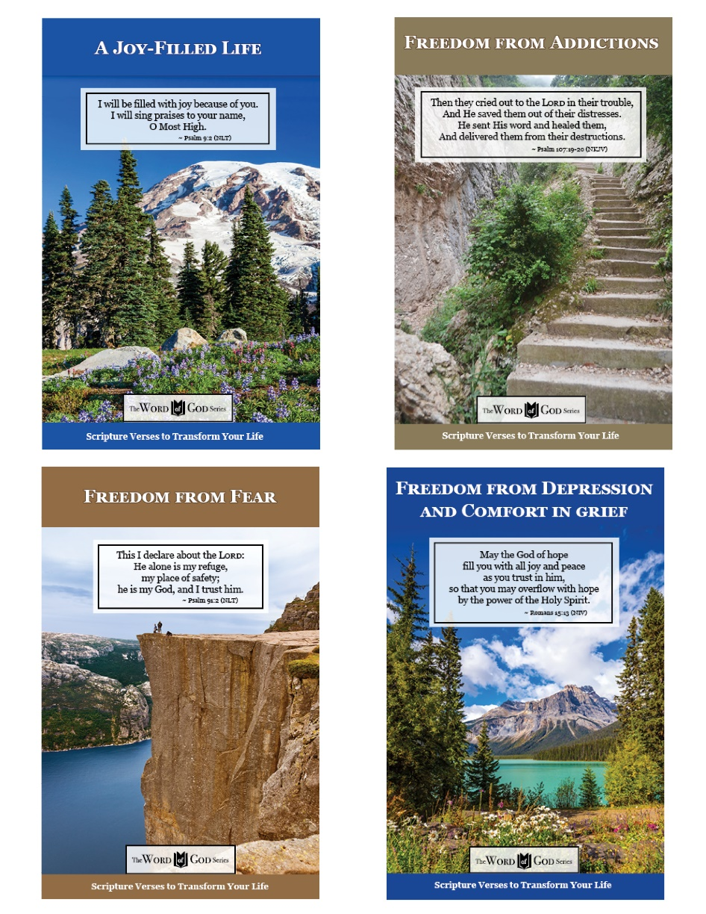

www.TheWordOfGodSeries.com

Booklet Titles in the Series

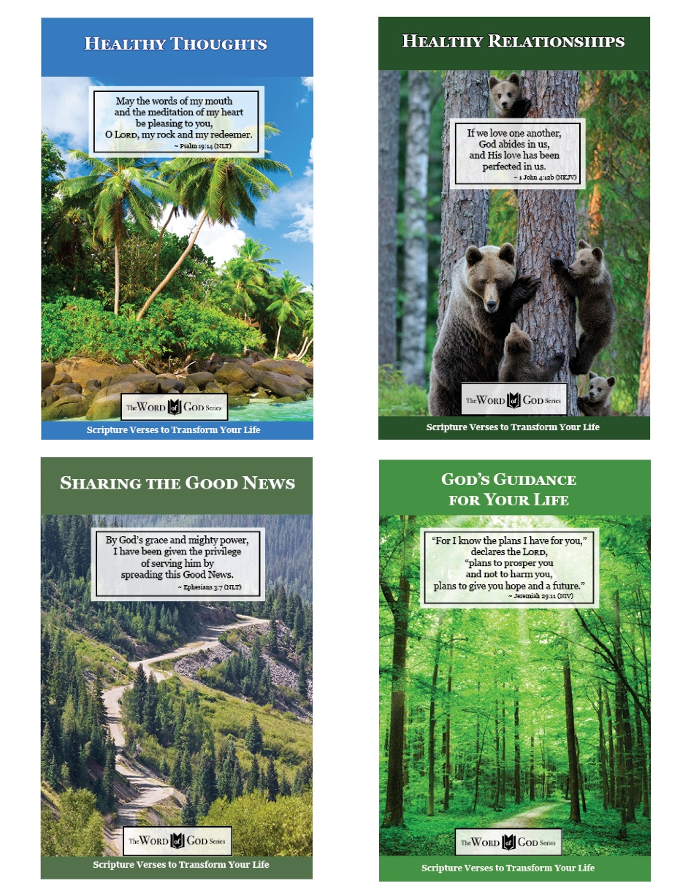

www.TheWordOfGodSeries.com

Booklet Titles in the Series

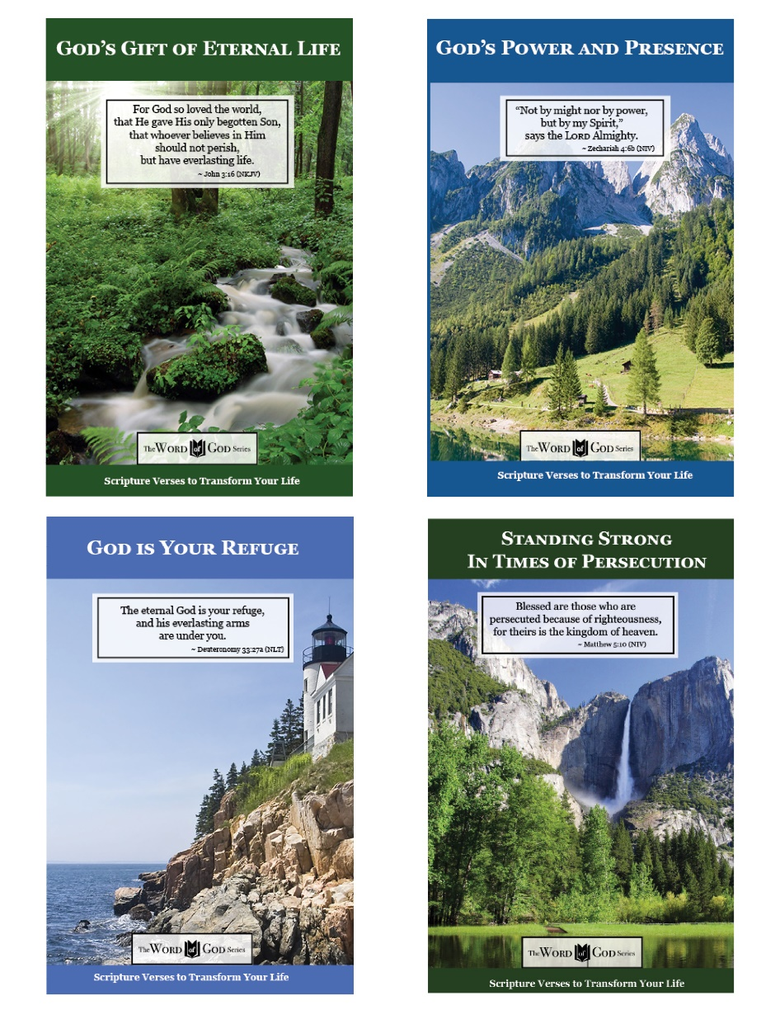

www.TheWordOfGodSeries.com

Booklet Titles in the Series

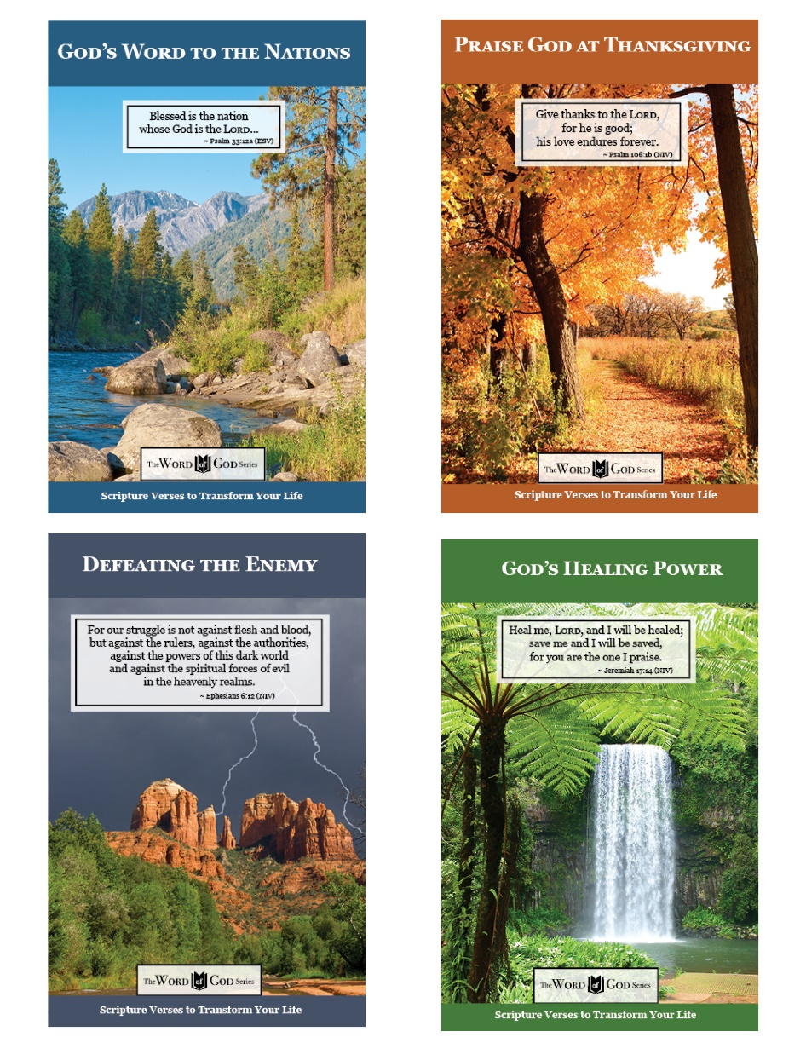

www.TheWordOfGodSeries.com

Booklet Titles in the Series

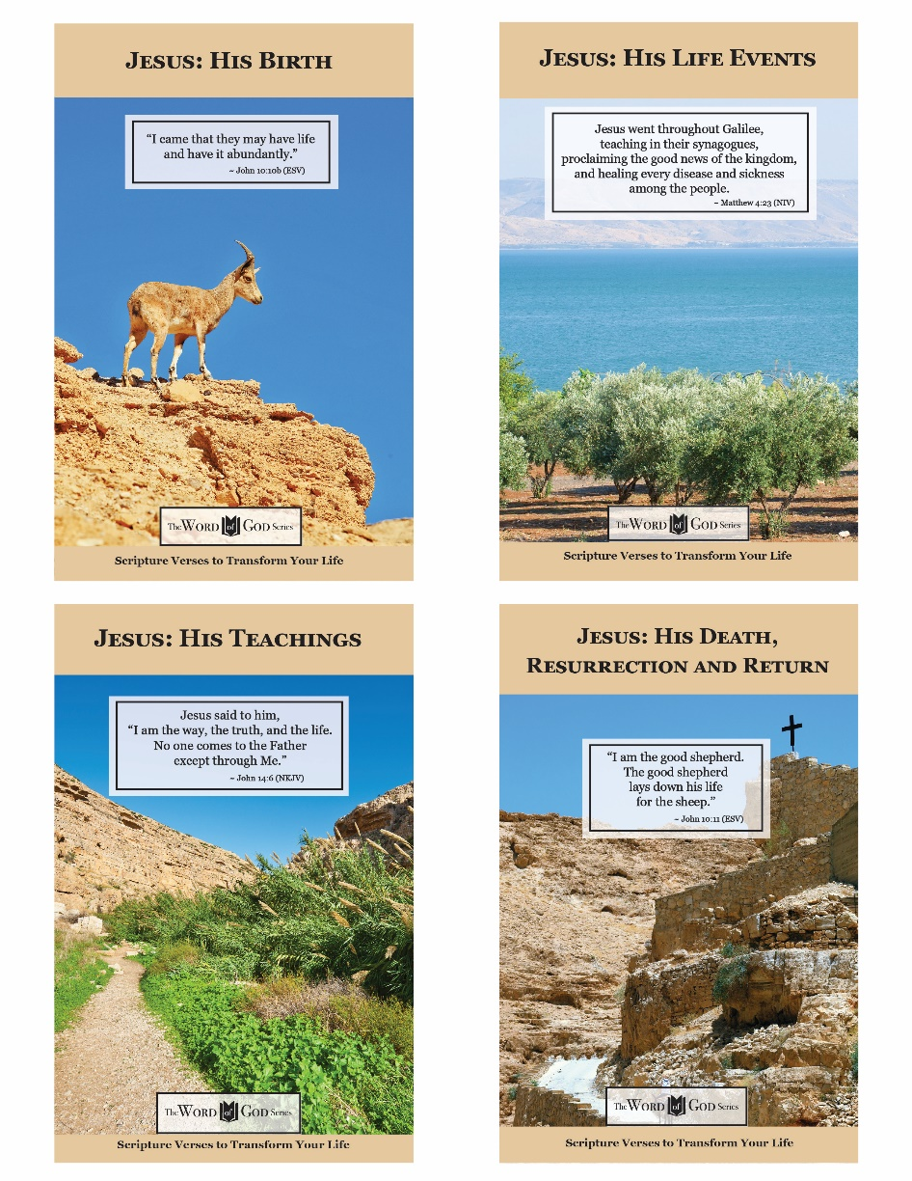

www.TheWordOfGodSeries.com

Photo Copyright Info

Note: when purchasing the rights to use the photos,
you may want to purchase an Extended License
for the cover image.



Bigstock Photo ID: 94850696

Beautiful view of the mountain lake Strbske Pleso in National Park High Tatra, Slovakia, Europe
Stock Photo ID: 94850696
Copyright: a3nkamonika


Shutterstock Photo ID: 357886112
View of mount St. Salvatore and lake of Lugano from Park Ciani
Photo Contributor
disto89



Bigstock Photo ID: 109117823

Majestic view on turquoise water and sunny beams in the famous resort Plitvice Lakes National Park. Croatia. Europe. Dramatic scene. Beauty world. Retro and vintage style. Instagram toning effect.
Stock Photo ID: 109117823
Copyright: Leonid Tit

Bigstock Photo ID: 441921725
Path through a spring forest in bright sun. Shallow depth of field.
Stock Photo ID: 441921725
Copyright: AlinaMD


Bigstock Photo ID: 138415412

Beautiful summer landscape view of the lake, pine trees and mountains on the background
Stock Photo ID: 138415412
Copyright: Kisa_Markiza


Bigstock Photo ID: 103229735

Majestic mountain lake in Canada. Moraine Lake in Alberta, Canada.
Stock Photo ID: 103229735
Copyright: karamysh


Bigstock Photo ID: 35418878
Arches National Park Utah
Arches National Park has many hiking trails to view the rugged scenery of Utah.
Stock Photo ID: 35418878
Copyright: Wirepec


Bigstock Photo ID: 59715362
waterfall in jungle,Mexico
Stock Photo ID: 59715362
Copyright: Andrushko Galyna

Bigstock Photo ID: 127531766
Editing suggestion: crop out bottom of the photo
Picturesque nature rural landscape with poppies plantation.
Stock Photo ID: 127531766
Copyright: plotnikov



Bigstock Photo ID: 105570383

Paradise Ocean Season
Stock Photo ID: 105570383
Copyright: VibrantImage

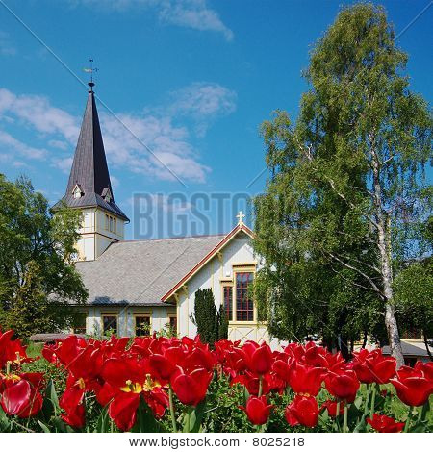
Bigstock Photo ID: 8025218
Church in Grimstad (Norway)
A white wooden church in Grimstad with red tulips in the foreground in the South of Norway
Stock Photo 8025218
Copyright: Ildi Papp


Bigstock Photo ID: 230136298
Still Water Lake in Serene Park Setting
Stock Photo ID: 230136298
Copyright: SusansPhotos


Bigstock Photo ID: 215723287
Editing suggestion: Rotate photo so waterfall flows to the center of the page
Tat Kuang Si Waterfalls. Beautiful landscape. Luang Prabang. Laos.
Stock Photo ID: 215723287
Copyright: GoodOlga


Bigstock Photo ID: 61074857
Editing suggestion: Rotate photo so bear is facing center of page
A norwegian brown male-bear eating. Brown bear (Ursus arctos) is a large bear distributed across much of northern Eurasia and North America. Adult bears generally weigh between 100 and 600 kg.
Stock Photo ID: 61074857
Copyright: kjekol


Bigstock Photo ID: 43050829
Rainbow Over Cathedral Rock
a rainbow sits over iconic cathedral rock near sedona arizona
Stock Photo ID: 43050829
Copyright: twildlife


Bigstock Photo ID: 25715468
Editing suggestion: crop out top of photo
Cross on Sand Dune at Beach
Stock Photo ID: 25715468
Copyright: CherylCasey


Bigstock Photo ID: 90067208
Forest Panorama With Rays Of Sunlight
Panorama of a scenic forest of fresh green deciduous trees with the sun casting its rays of light through the foliage
Stock Photo ID: 90067208
Copyright: Smileus


Bigstock Photo ID: 78084170
Picture Lake Evergreens Mount Shuksan Mount Baker Highway Snow Mountain Trees Washington Pacific Northwest USA
Stock Photo ID: 78084170
Copyright: BILLPERRY


Bigstock Photo ID: 465297503
Wonderful views of the blue Mediterranean Sea. Sunny rocks, waves with foam and splashing water. The wave crashes into the rocks on the shore
Stock Photo ID: 465297503
Copyright: dmitrytph


Bigstock Photo ID: 44407210
Forest Landscape With Turquoise Water And The Sun
Landscape with the sun shining through the foliage with a clear turquoise lake behind the trees
Stock Photo ID: 44407210
Copyright: Smileus


Bigstock Photo ID: 3746283
The Oxbow Bend Turnout Area in Grand Teton National Park ** Note: Slight blurriness, best at smaller sizes
Stock Photo ID: 3746283
Copyright: gary718


Bigstock Photo ID: 3718948
The Millaa Millaa Falls
The Millaa Millaa falls in Queensland Australia
Stock Photo ID: 3718948
Copyright: wtolenaars


Bigstock Photo ID: 55993949
Summer Mountain Landscape. Montana Natural Scenery United States.
Stock Photo ID: 55993949
Copyright: duallogic

Bigstock Photo ID: 26235854
A path on Mt. Rainier with Wildflowers in Bloom ** Note: Slight blurriness, best at smaller sizes
Copyright: Christopher Boswell

