Template for Jesus: His Birth
The Word of God Series is a collection of 20 booklets that present Scripture verses in an easy-to-read format, with each booklet focused on a different topic.
Titles include Healthy Relationships, A Joy-Filled Life, Freedom from Depression, and many others.
The booklets are available in both paperback and digital formats at www.TheWordOfGodSeries.com or Amazon.com.
Why This Template?
Because I believe in the power of God’s Word to transform people’s lives, I have dedicated several years of my life to
bring this series to fruition.
I am passionate about using these booklets to reach
a dark and dying world with the love of Christ and
the hope of the Gospel.
Initially, I had expected this series would be a small business. But one day, when I asked God what my next steps should be,
He spoke to me through His Word and told me to:
“…complete the ministry God has given you.”
~ 2 Timothy 4:5 (NLT, 1996 version)
So, I shifted the focus from a business to a ministry.
My vision, also, has evolved over time and I have come to believe that it is possible for millions of these booklets to be distributed (in both print and digital formats) around the world (see the document entitled The Vision at www.TheWordOfGodSeries.com for more info.)
In order to make this a far-reaching ministry, accessing populations that I couldn’t on my own, I decided to invite others to partner with me in producing and distributing these booklets to their own personal networks. To help get it started, I have made templates of each booklet freely available to anyone who would like them.
This way you (whether you are a church, Christian organization or an individual) can easily re-create the booklets in your own ministry’s name, and distribute them to the people you minister to.
I hope that this template will save you:
- Time – so you can benefit from the thousands of hours
of development time that has been invested so far
- Money – eliminate layers of profit margin, and save on shipping costs (especially for large quantities)

Whether you simply replicate and reproduce what has already been done, build on it, or take this idea in a different direction, you won’t have to waste time starting with a blank page.
I hope you can easily get these finalized and printed, so you can begin sharing them with the people in your sphere of influence.
On the following pages you will find document formatting and printing tips.
Photo editing tips are also presented, as well as the preview images of each photo (with the Photo ID#), so you to easily find it on either bigstockphoto.com or shutterstock.com.

Photo Editing Tips
At the end of this document you will find the copyright and descriptive info for each photo in the booklet, as well as editing suggestions for a few of them.
Many photos will need to be slightly stretched or cropped to fit the page.
Most of the editing suggestions below (especially brightening or increasing color saturation) should be very slight adjustments.
Editing photos within this document
Wrapping text around the photo: Doubleclick the photo, click
on Wrap Text and select Square. Then, drag the image by the corner until it is the right size to wrap the text around it.
Rotate: Doubleclick the photo, click on the Rotate Object icon.

Editing photos in the Pictures editing app in MS Word
Navigate to your Pictures folder, doubleclick the photo, and click on the blue Edit button on left
Most of the editing can be done by using one of these 3 options:


Crop: Click on the Crop icon and drag edges to desired spot
Brighten a photo: Adjustment icon / Light / Brightness
Increase color saturation: Adjustment icon / Color / Saturation or Warmth
Remove distracting elements from a photo: Click on the Generative Erase icon, select a brush size and click on the part of the photo you want removed.

Photo Searching Tips
Occasionally photographers pull their photos from the sites,
so there may be some in this booklet that are no longer available.
You can try using the same key words to search for the photo
on other sites (scroll to the end of this document for more descriptive information about each photo.)
Or, you can search for another photo on Bigstock. Under
All Images select Photos and search by key word. At the next screen, make sure that Safe Search is on. In the Category field, select either Landscapes, Nature or Animals.

Booklet Formatting Tips
If you make any changes to this document that results in changing the number of lines on a page, then the page will need to be re-formatted for everything to fit.
Often changing the spacing between the characters or between the lines in one verse is enough to re-format it.
Changing the spacing between the characters
Home / Font / Advanced / Character Spacing
Choose Expanded or Condensed, and select a numeric value (best from .1 to .3)

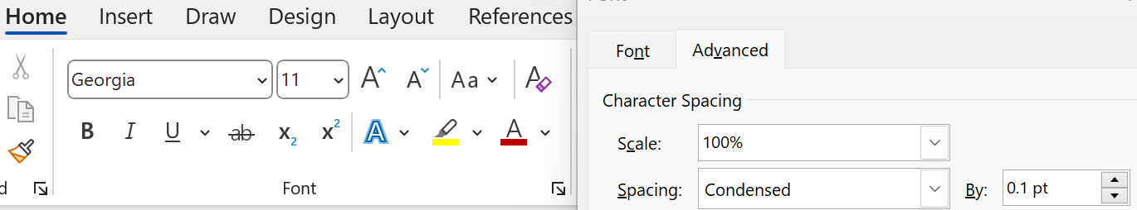
Changing the spacing between the lines
Highlight all the text in the passage or page and click on:
Layout / Paragraph / Line Spacing / Multiple
Select a numeric value (best from .98 to 1.02)
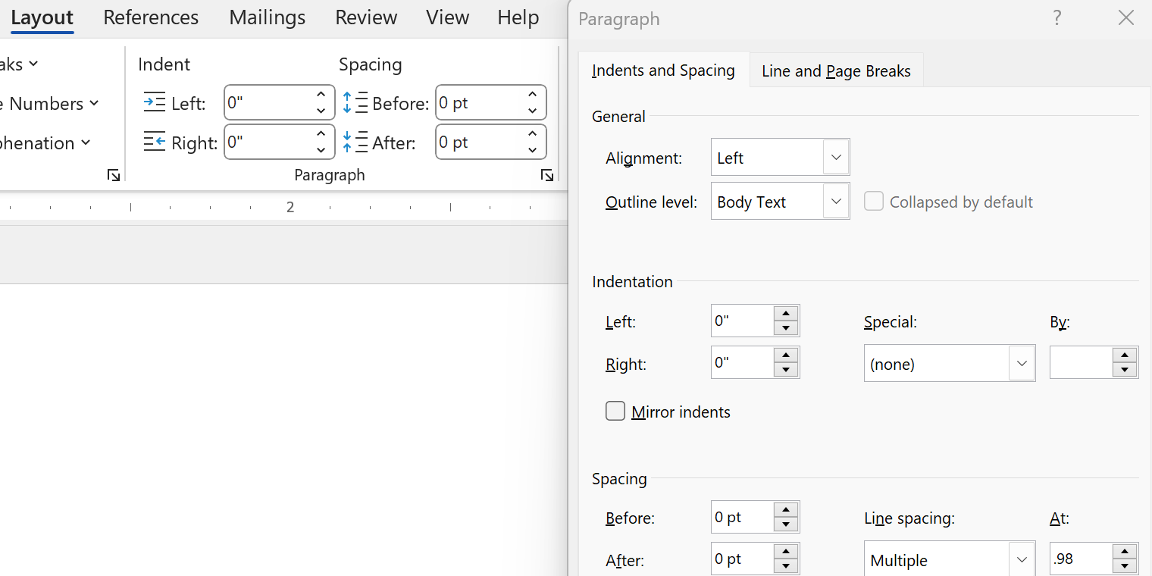

Saving the document as a PDF
Adobe Acrobat Pro subscriptions are available at www.adobe.com/creativecloud/plans.html. You could also
ask your library tech center if they carry Adobe products.
When the Word doc is final: File / Save as Adobe PDF

Viewing the PDF as a booklet
Remove the first blank page of the doc: Edit / Trash icon.
Enter pages 1 to 1 to delete. Then exit from the Edit mode.
To view the document as a booklet, click on the page icon
(on right side of page, below the rotate button) and select
Two-page view and Show cover page.


Adding page numbers to the PDF
Edit / Header & Footer / Add / Add New
Under Font Name choose your font (this document uses the Georgia font) and under Size enter 8 pt.
Under Margins, in the Bottom box, enter .4
Click in box under Center Footer Text and click on the Insert Page Number button.
Click on Page Range Options. The Pages From _ to _
will depend on which page in your document you want read as Page 1 in the PDF.
In these booklets, the verses begin on Page 5 (after the forward page, copyright page, and Table of Contents).
If you plan to develop several booklets, select Save Settings.


Printing the Booklets
You can print these as regular paperbacks with a binding, (which look a bit nicer) or, you can print them with a staple binding. The staple binding does require a certain type of machine that can print them in a way that they open fully to any page (not just the center page) and lay flat. Your local printer may or may not have that capability, so discuss options with them.
A glossy cover is recommended, as it has a better feel than a matte finish. You may want to request the booklets be printed on Cougar® paper, which has a very smooth finish.

Stuck on a Step Above and Need Help?
If you want to do this project on your own, but are having tech issues with one of the steps above, feel free to contact me at Susan@TheWordOfGodSeries.com. I may be able to assist you, since I’ve gone through this whole process myself!

Need Help with the Whole Project?
If you want these booklets set up in your own in your own ministry’s name, but don’t have the resources to do the whole project yourself,
I may be able to manage that process for you for a one-time project fee.
This would include the following services:
- Set up an account with Bigstock and Shutterstock in your ministry’s name and purchase the rights for you to use each of the photos
- Download and name the photos
- Edit photos as needed
- Create a cover with your church or ministry logo
- Request the rights to use the various Bible translations from each of the publishers (if applicable)
Feel free to contact me at Susan@TheWordOfGodSeries.com to discuss pricing options.
I hope that this information will help you finalize this document with ease so you can begin distributing it to the people in your realm of influence.
Thank you for partnering with me in this effort. I wish you the best as you make God’s Word known and share His love with others!
Warmly in Christ,
Susan

Soli Deo gloria



Feel free to edit this forward page to align to your own ministry’s vision and goals.

The Bible is the best-selling and most transformative book in history. Written over 2,000 years ago, it is still living and powerful today.
Throughout the pages of Scripture you will find inspiration and joy, comfort and peace, healing and hope.
Most importantly, you will learn of God’s abundant love for you, and His plan to give you a glorious, eternal inheritance.
The Word of God Series is a collection of booklets which presents Scripture by topic, so you can focus on verses that are relevant to you at different stages and circumstances throughout your life.
All of the booklets in this series feature Scripture exclusively—
just the powerful, undiluted Word of God.
Let God’s Word permeate your mind and transform your life.
This is one of a four-booklet mini-series about Jesus Christ, the most influential and singular person in history. The titles in this series are:
Jesus: His Birth
Jesus: His Life Events
Jesus: His Teachings
Jesus: His Death, Resurrection and Return
The verses in this series are drawn primarily from the gospel accounts (the first four books of the New Testament: Matthew, Mark, Luke and John) which present a narrative on the life and ministry of Jesus.
This series includes many of the life events and teachings of Jesus, but it not comprehensive, so you are encouraged to also read each of the gospel accounts in their entirety.
In this series, text in italics are prophecies about the coming Messiah and “text in quotation marks” are the words of Christ.
Most of the imagery in this mini-series is from the Holy Land.
This booklet, Jesus: His Birth, presents all the various elements of the story of the birth of Christ and explains the reason He came.
It’s a great devotional to read during the Christmas season.
My prayer for you, as you read this series about Christ, is that you will accept the gift of eternal life that He died to give you and know that you belong to Him. I pray you will spend the remainder of your life seeking to look, live and love more like Jesus.
Let the word of Christ dwell in you richly…
~ Colossians 3:16a (ESV)

A few comments about this series:

- The booklets in this series provide you with a sample of what the Bible offers, but it is important that you also read the Bible itself, preferably with a book-by-book focus.

- Passages in quotation marks are the actual words of God, either through His prophets in the Old Testament, or the words of Christ
in the New Testament.

- Every booklet includes a section that details God’s plan of salvation (commonly referred to as “The Gospel.”) The booklet entitled God’s Gift of Eternal Life
is devoted to the Gospel message.

This series presents verses in the following translations:

NIV: New International Version
Scripture quotations marked NIV are taken from the Holy Bible, New International Version®, NIV®. Copyright © 1973, 1978, 1984, 2011 by Biblica, Inc.™ Used by permission of Zondervan. All rights reserved worldwide. www.zondervan.com. The "NIV" and "New International Version" are trademarks registered in the United States Patent and Trademark Office by Biblica, Inc.™

NLT: New Living Translation
Scripture quotations marked NLT are taken from the Holy Bible, New Living Translation, Copyright© 1996, 2004, 2015 by Tyndale House Foundation. Used by permission of Tyndale House Publishers, Inc., Carol Stream, Illinois 60188. All rights reserved.

ESV: English Standard Version
Scripture quotations marked ESV are taken from the ESV Bible® (The Holy Bible, English Standard Version®), copyright © 2001 by Crossway Bibles, a publishing ministry of Good News Publishers. Used by permission. All rights reserved.

KJV: King James Version
Public Domain

NKJV: New King James Version
Scripture quotations marked NKJV are taken from the New King James Version®. Copyright © 1982 by Thomas Nelson, Inc. Used by permission.

Since this is a template booklet featuring preview photos, it is not copyrighted, so you are free to purchase licenses to use the photos and develop your own booklets for print. Be sure to determine whether or not you need to request permission (and in some cases pay) for the rights to use the various Bible translations. Scripture verses were sourced from www.BibleGateway.com.
If it would be easier for you to simply purchase this booklet, the copyrighted version is available at www.TheWordOfGodSeries.com or www.amazon.com.
ISBN info for the copyrighted booklets is as follows:
The ISBN is 978-1-964538-00-6 and the Amazon ISBN is 9798356812026.
Jesus: His Birth

Contents

Prophecies About the Birth of Christ 1
An Introduction to Christ 3
The Birth of John the Baptist 4
The Birth of John the Baptist Foretold
John’s Birth
Zechariah’s Song
The Birth of Jesus 8
The Birth of Jesus Foretold
Mary’s Song
Jesus’ Birth
The Shepherds and the Angels
Jesus Presented in the Temple
The Magi from the East
Accounts of Jesus’ Childhood
Why Jesus Came 19
The remainder of this book presents the Gospel message.
It explains God’s plan to bring us to Himself through Christ.
This message can be summarized as follows:
God Loves You
But Your Sin Separates You from God
The Day of God’s Wrath Will Come
Confess Your Sin and Repent
Jesus Died to Save You
God Bought You at a Price
In Christ You Are Forgiven
God Demonstrates His Love Through Christ
Salvation is Through Christ Alone
Salvation is a Gift: Free and Undeserved
Accept This Salvation
You Belong to God Through Faith in Christ
Eternal Life is Yours Through Christ
Heaven is Your Home
Praise God for His Gift of Eternal Life
Praise God for His Great and Awesome Name
Praise His Glorious Name Forever

Prophecies About
The Birth of Christ

The people walking in darkness
have seen a great light;
on those living in the land of deep darkness
a light has dawned.

~ Isaiah 9:2 (NIV)

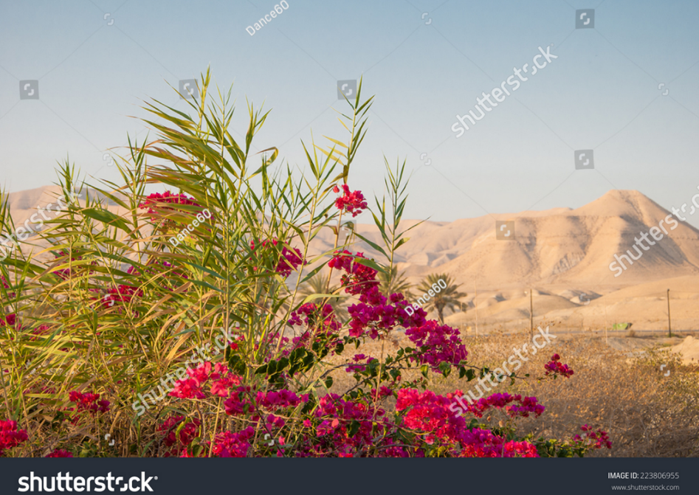
Shutterstock Photo ID: 223806955

Judean mountains

For unto us a Child is born,
Unto us a Son is given;
And the government will be upon His shoulder.
And His name will be called
Wonderful, Counselor, Mighty God,
Everlasting Father, Prince of Peace.

~ Isaiah 9:6 (NKJV)
Therefore the Lord himself will give you a sign:
The virgin will conceive
and give birth to a son,
and will call him Immanuel.

~ Isaiah 7:14 (NIV)

But you, Bethlehem Ephrathah,
though you are small among the clans of Judah,
out of you will come for me
one who will be ruler over Israel,
whose origins are from of old,
from ancient times.

~ Micah 5:2 (NIV)

“You will do more than restore the people of Israel
to me.
“I will make you a light to the Gentiles, and you will bring my salvation to the ends of the earth.”

~ Isaiah 49:6b (NLT)

“I will give you as a covenant for the people, a light
for the nations…”

~ Isaiah 42:6b (ESV)

There shall come forth a shoot from the stump of Jesse,
and a branch from his roots shall bear fruit.
And the Spirit of the Lord shall rest upon him,
the Spirit of wisdom and understanding,
the Spirit of counsel and might,
the Spirit of knowledge and the fear of the Lord.

~ Isaiah 11:1-2 (ESV)

“Here is my servant, whom I uphold,
my chosen one in whom I delight;
I will put my Spirit on him,
and he will bring justice to the nations.
He will not shout or cry out,
or raise his voice in the streets…
In faithfulness he will bring forth justice;
he will not falter or be discouraged
till he establishes justice on earth.
In his teaching the islands will put their hope.”

~ Isaiah 42:1-4 (NIV)

An Introduction to Christ

In the beginning was the Word, and the Word was with God, and the Word was God. He was in the beginning with God. All things were made through Him…
In Him was life, and the life was the light of men.
And the light shines in the darkness, and the darkness
did not comprehend it…
He was in the world, and the world was made through Him, and the world did not know Him. He came to His own, and His own did not receive Him.
But as many as received Him, to them He gave the right to become children of God, to those who believe in His name...
And the Word became flesh and dwelt among us, and we beheld His glory…

~ John 1:1-14a (NKJV)

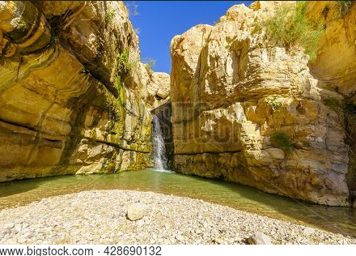

Ein Gedi Nature Reserve, Israel

The Birth of John the Baptist

The Birth of John the Baptist Foretold

When Herod was king of Judea, there was a Jewish
priest named Zechariah…
Zechariah and Elizabeth were righteous in God’s eyes, careful to obey all of the Lord’s commandments and regulations. They had no children because Elizabeth
was unable to conceive, and they were both very old.
One day Zechariah was serving God in the Temple…
While the incense was being burned, a great crowd
stood outside, praying.
While Zechariah was in the sanctuary, an angel of the Lord appeared to him, standing to the right of the
incense altar. Zechariah was shaken and overwhelmed with fear when he saw him.
But the angel said, “Don’t be afraid, Zechariah! God has heard your prayer. Your wife, Elizabeth, will give you a son, and you are to name him John.
“You will have great joy and gladness, and many will rejoice at his birth, for he will be great in the eyes of the Lord. He must never touch wine or other alcoholic drinks.
“He will be filled with the Holy Spirit, even before his birth.
“And he will turn many Israelites to the Lord their God.
“He will be a man with the spirit and power of Elijah.
“He will prepare the people for the coming of the Lord.
“He will turn the hearts of the fathers to their children, and he will cause those who are rebellious to accept the wisdom of the godly.”
Zechariah said to the angel, “How can I be sure this
will happen? I’m an old man now, and my wife is also
well along in years.”
Then the angel said, “I am Gabriel! I stand in the very presence of God. It was he who sent me to bring you this good news! But now, since you didn’t believe what I said, you will be silent and unable to speak until the child is born. For my words will certainly be fulfilled at the proper time.”
Meanwhile, the people were waiting for Zechariah to come out of the sanctuary, wondering why he was taking so long. When he finally did come out, he couldn’t speak to them. Then they realized from his gestures and his silence that he must have seen a vision in the sanctuary.
When Zechariah’s week of service in the Temple was over, he returned home. Soon afterward his wife, Elizabeth, became pregnant and went into seclusion for five months. “How kind the Lord is!” she exclaimed. “He has taken away my disgrace of having no children.”

~ Luke 1:5-25 (NLT)

John’s Birth

When it was time for Elizabeth to have her baby, she gave birth to a son. Her neighbors and relatives heard that the Lord had shown her great mercy, and they shared her joy. On the eighth day they came to circumcise the child, and they were going to name him after his father Zechariah, but his mother spoke up and said, “No! He is to be called John.” They said to her, “There is no one among your relatives who has that name.”
Then they made signs to his father, to find out what he would like to name the child. He asked for a writing tablet, and to everyone’s astonishment he wrote, “His name is John.” Immediately his mouth was opened and his tongue set free, and he began to speak, praising God. All the neighbors were filled with awe, and throughout the hill country of Judea people were talking about all these things. Everyone who heard this wondered about it, asking, “What then is this child going to be?” For the Lord’s hand was with him.

~ Luke 1:57-66 (NIV)

Zechariah’s Song

“I will send my messenger, who will prepare the way before me.”

~ Malachi 3:1a (NIV)

The voice of one crying in the wilderness:
“Prepare the way of the Lord;
Make straight in the desert
A highway for our God.”

~ Isaiah 40:3 (NKJV)

Then his father, Zechariah, was filled with the Holy Spirit and gave this prophecy:
Praise the Lord, the God of Israel,
because he has visited and redeemed his people.
He has sent us a mighty Savior
from the royal line of his servant David,
just as he promised through his holy prophets long ago.
Now we will be saved from our enemies
and from all who hate us.
He has been merciful to our ancestors
by remembering his sacred covenant—the covenant
he swore with an oath to our ancestor Abraham.
We have been rescued from our enemies
so we can serve God without fear,
in holiness and righteousness for as long as we live.
And you, my little son,
will be called the prophet of the Most High,
because you will prepare the way for the Lord.
You will tell his people how to find salvation
through forgiveness of their sins.
Because of God’s tender mercy,
the morning light from heaven is about to break upon us,
to give light to those who sit in darkness and in the shadow of death, and to guide us to the path of peace.

~ Luke 1:67-79 (NLT)

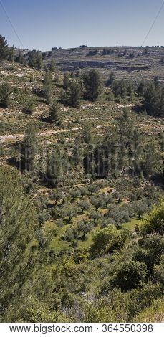

Judean Wilderness

The Birth of Jesus

Because of God’s tender mercy,
the morning light from heaven is about to break upon us,
to give light to those who sit in darkness and in the
shadow of death, and to guide us to the path of peace.

~ Luke 1:78-79 (NLT)

The Birth of Jesus Foretold

In the sixth month of Elizabeth’s pregnancy, God sent
the angel Gabriel to Nazareth, a town in Galilee, to a virgin pledged to be married to a man named Joseph,
a descendant of David.
The virgin’s name was Mary. The angel went to her and said, “Greetings, you who are highly favored! The Lord
is with you.”
Mary was greatly troubled at his words and wondered what kind of greeting this might be.
But the angel said to her, “Do not be afraid, Mary;
you have found favor with God. You will conceive
and give birth to a son, and you are to call him Jesus.
“He will be great and will be called the Son of the Most High.
“The Lord God will give him the throne of his father David, and he will reign over Jacob’s descendants forever;
his kingdom will never end.”
“How will this be,” Mary asked the angel, “since I am
a virgin?”
The angel answered, “The Holy Spirit will come on you, and the power of the Most High will overshadow you.
“So the holy one to be born will be called the Son of God.
“Even Elizabeth your relative is going to have a child in her old age, and she who was said to be unable to conceive is in her sixth month. For no word from God will ever fail.”
“I am the Lord’s servant,” Mary answered. “May your word to me be fulfilled.” Then the angel left her.

~ Luke 1:26-38 (NIV)

At that time Mary got ready and hurried to a town in the hill country of Judea, where she entered Zechariah’s home and greeted Elizabeth.
When Elizabeth heard Mary’s greeting, the baby leaped
in her womb, and Elizabeth was filled with the Holy Spirit. In a loud voice she exclaimed:
“Blessed are you among women, and blessed is the child you will bear!
“But why am I so favored, that the mother of my Lord should come to me?
“As soon as the sound of your greeting reached my ears, the baby in my womb leaped for joy. Blessed is she who has believed that the Lord would fulfill his promises to her!”

~ Luke 1:39-45 (NIV)

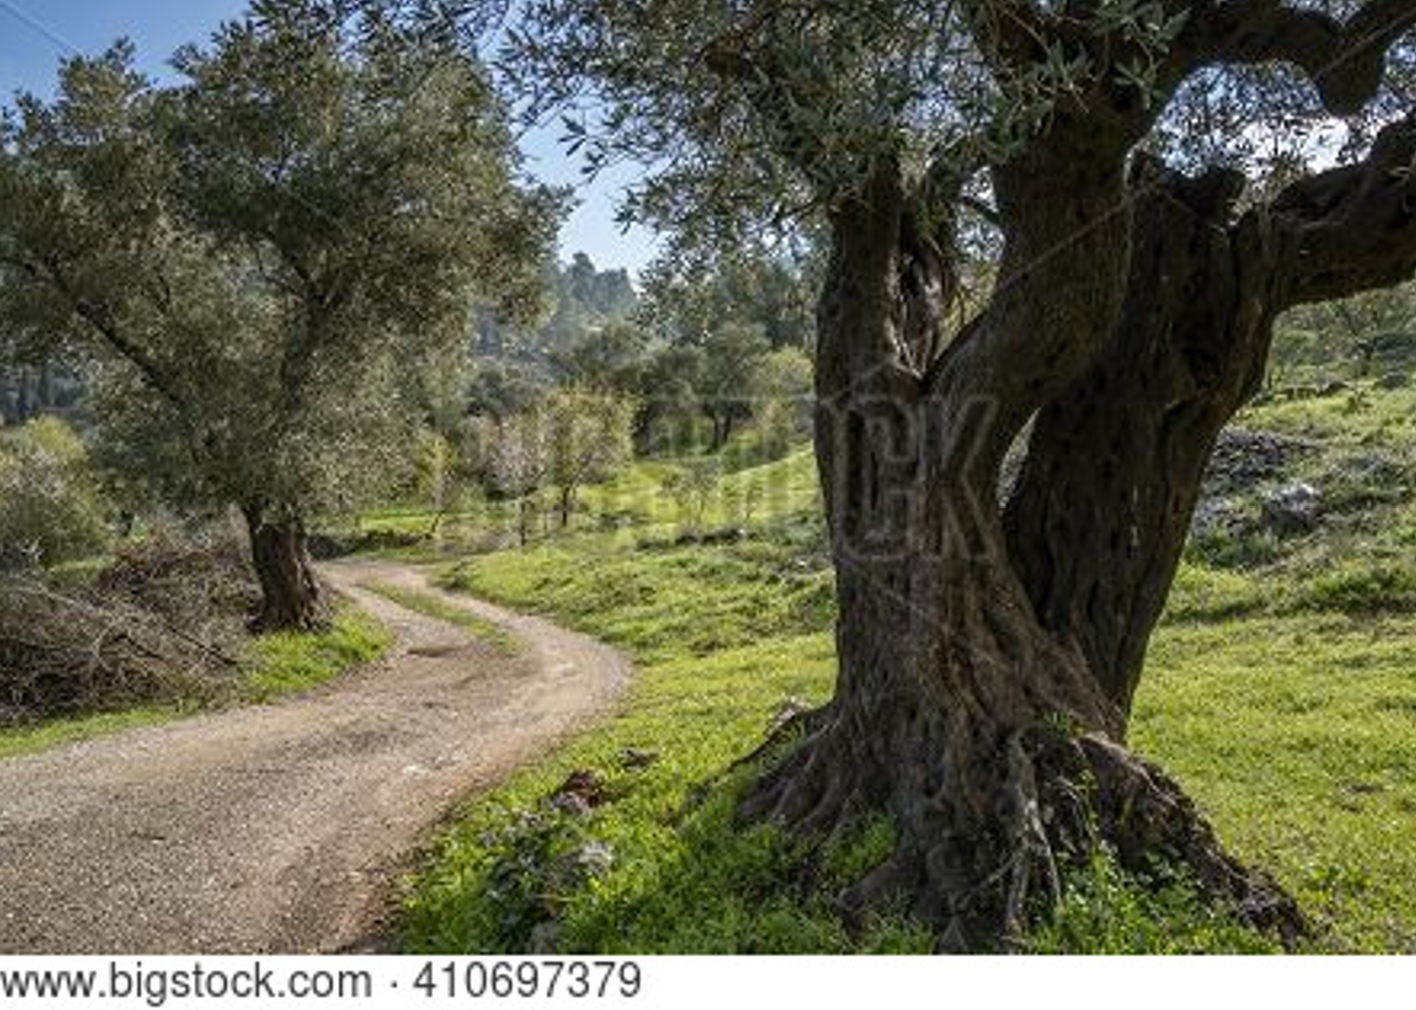

Path in the Judean mountains

Mary’s Song

And Mary said:
My soul glorifies the Lord
and my spirit rejoices in God my Savior,
for he has been mindful
of the humble state of his servant.
From now on all generations will call me blessed,
for the Mighty One has done great things for me—
holy is his name.
His mercy extends to those who fear him,
from generation to generation.
He has performed mighty deeds with his arm;
he has scattered those who are proud in their
inmost thoughts.
He has brought down rulers from their thrones
but has lifted up the humble.
He has filled the hungry with good things
but has sent the rich away empty.
He has helped his servant Israel,
remembering to be merciful
to Abraham and his descendants forever,
just as he promised our ancestors.
Mary stayed with Elizabeth for about three months and then returned home.

~ Luke 1:46-56 (NIV)

Jesus’ Birth

This is how the birth of Jesus the Messiah came about: His mother Mary was pledged to be married to Joseph, but before they came together, she was found to be pregnant through the Holy Spirit.
Because Joseph her husband was faithful to the law, and yet did not want to expose her to public disgrace, he had in mind to divorce her quietly.
But after he had considered this, an angel of the Lord appeared to him in a dream and said, “Joseph son of David, do not be afraid to take Mary home as your wife, because what is conceived in her is from the Holy Spirit.
“She will give birth to a son, and you are to give him the name Jesus, because he will save his people from their sins.”
All this took place to fulfill what the Lord had said through the prophet: “The virgin will conceive and give birth to a son, and they will call him Immanuel” (which means “God with us”).
When Joseph woke up, he did what the angel of the Lord had commanded him and took Mary home as his wife.
But he did not consummate their marriage until she gave birth to a son. And he gave him the name Jesus.

~ Matthew 1:18-25 (NIV)

And it came to pass in those days that a decree went out from Caesar Augustus that all the world should be registered...So all went to be registered, everyone to
his own city.
Joseph also went up from Galilee, out of the city of Nazareth, into Judea, to the city of David, which is called Bethlehem, because he was of the house and lineage of David, to be registered with Mary, his betrothed wife,
who was with child. So it was, that while they were there, the days were completed for her to be delivered.
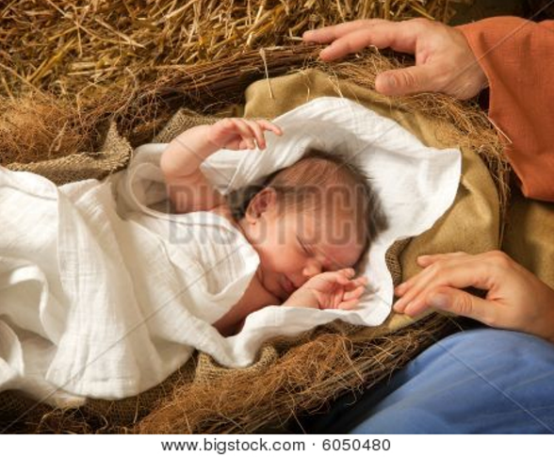
And she
brought forth
her firstborn Son,
and wrapped Him in swaddling cloths, and laid Him in a manger, because there
was no room for them in the inn.

~ Luke 2:1-7 (NKJV)

The Shepherds and the Angels

Now there were in the same country shepherds living out in the fields, keeping watch over their flock by night.
And behold, an angel of the Lord stood before them, and the glory of the Lord shone around them, and they were greatly afraid.
Then the angel said to them, “Do not be afraid, for behold,
I bring you good tidings of great joy which will be to
all people.
“For there is born to you this day in the city of David
a Savior, who is Christ the Lord.
“And this will be the sign to you: You will find a Babe wrapped in swaddling cloths, lying in a manger.”
And suddenly there was with the angel a multitude of the heavenly host praising God and saying: “Glory to God in the highest, and on earth peace, goodwill toward men!”

~ Luke 2:8-14 (NKJV)

When the angels had left them and gone into heaven,
the shepherds said to one another, “Let’s go to Bethlehem and see this thing that has happened, which the Lord has told us about.”
So they hurried off and found Mary and Joseph, and
the baby, who was lying in the manger.
When they had seen him, they spread the word concerning what had been told them about this child,
and all who heard it were amazed at what the shepherds said to them.
But Mary treasured up all these things and pondered them in her heart.
The shepherds returned, glorifying and praising God for all the things they had heard and seen, which were just as they had been told.

~ Luke 2:15-20 (NIV)

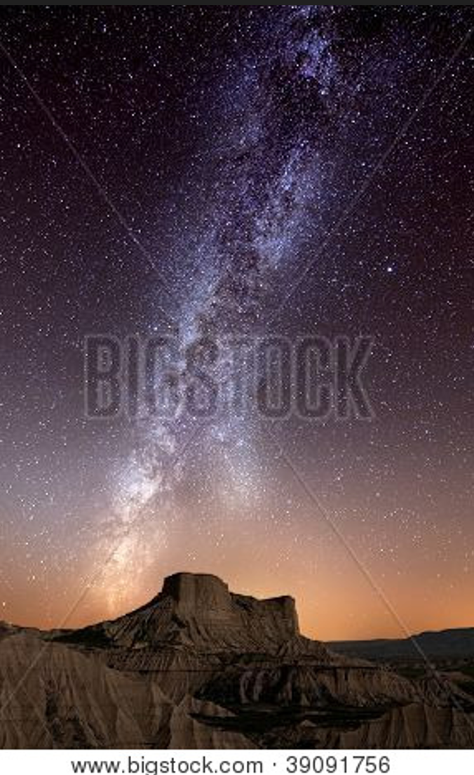
Jesus Presented in the Temple

Eight days later, when the baby was circumcised,
he was named Jesus, the name given him by the angel
even before he was conceived.
Then it was time for their purification offering, as required by the law of Moses after the birth of a child;
so his parents took him to Jerusalem to present him to
the Lord. The law of the Lord says, “If a woman’s first child is a boy, he must be dedicated to the Lord.” So they offered the sacrifice required in the law of the Lord—“either a pair of turtledoves or two young pigeons.”
At that time there was a man in Jerusalem named Simeon. He was righteous and devout and was eagerly waiting for the Messiah to come and rescue Israel. The Holy Spirit was upon him and had revealed to him that he would
not die until he had seen the Lord’s Messiah.
That day the Spirit led him to the Temple. So when Mary and Joseph came to present the baby Jesus to the Lord as the law required, Simeon was there. He took the child in his arms and praised God, saying,
Sovereign Lord, now let your servant die in peace,
as you have promised.
I have seen your salvation,
which you have prepared for all people.
He is a light to reveal God to the nations,
and he is the glory of your people Israel!
Jesus’ parents were amazed at what was being said
about him.
Then Simeon blessed them, and he said to Mary, the baby’s mother, “This child is destined to cause many in Israel to fall, but he will be a joy to many others. He has been sent as a sign from God, but many will oppose him. As a result, the deepest thoughts of many hearts will be revealed. And a sword will pierce your very soul.”

~ Luke 2:21-35 (NLT)
Anna, a prophet, was also there in the Temple. She was the daughter of Phanuel from the tribe of Asher, and she was very old. Her husband died when they had been married only seven years. Then she lived as a widow to
the age of eighty-four.
She never left the Temple but stayed there day and night, worshiping God with fasting and prayer.
She came along just as Simeon was talking with Mary and Joseph, and she began praising God.
She talked about the child to everyone who had been waiting expectantly for God to rescue Jerusalem.

~ Luke 2:36-38 (NLT)

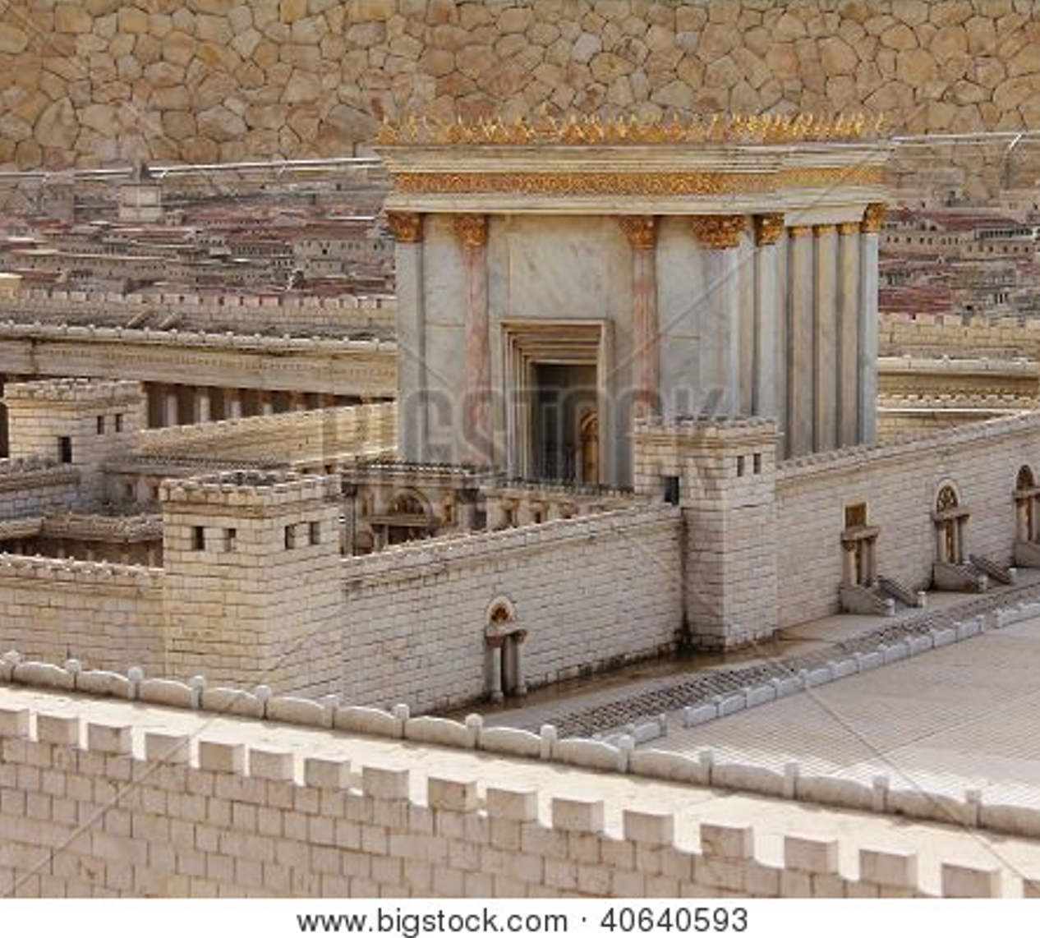

Model of Jerusalem’s ancient Temple, displayed in the Israel Museum

The Magi from the East

But you, Bethlehem Ephrathah,
though you are small among the clans of Judah,
out of you will come for me
one who will be ruler over Israel…

~ Micah 5:2a (NIV)

A voice is heard in Ramah,
mourning and great weeping,
Rachel weeping for her children
and refusing to be comforted,
because they are no more.

~ Jeremiah 31:15b (NIV)

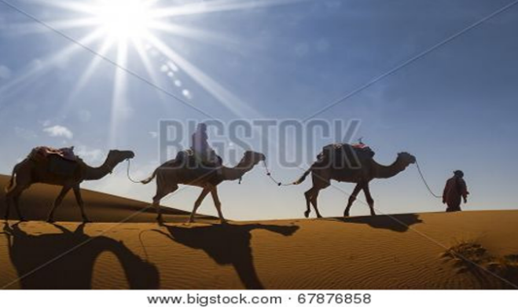
After Jesus
was born in Bethlehem in Judea, during the time of
King Herod, Magi from the east came to Jerusalem and asked,
“Where is the one who has been born king of the Jews?
We saw his star when it rose and have come to worship him.”
When King Herod heard this he was disturbed, and all Jerusalem with him.
When he had called together all the people’s chief priests and teachers of the law, he asked them where the Messiah was to be born.
“In Bethlehem in Judea,” they replied, “for this is what the prophet has written:
But you, Bethlehem, in the land of Judah,
are by no means least among the rulers of Judah;
for out of you will come a ruler
who will shepherd my people Israel.”

~ Matthew 2:1-6 (NIV)
Then Herod called the Magi secretly and found out from them the exact time the star had appeared.
He sent them to Bethlehem and said, “Go and search carefully for the child. As soon as you find him, report to me, so that I too may go and worship him.”
After they had heard the king, they went on their way, and the star they had seen when it rose went ahead of them until it stopped over the place where the child was.
When they saw the star, they were overjoyed. On coming to the house, they saw the child with his mother Mary, and they bowed down and worshiped him.
Then they opened their treasures and presented him with gifts of gold, frankincense and myrrh.
And having been warned in a dream not to go back to Herod, they returned to their country by another route.

~ Matthew 2:7-12 (NIV)

When they had gone, an angel of the Lord appeared to Joseph in a dream.
“Get up,” he said, “take the child and his mother and escape to Egypt. Stay there until I tell you, for Herod is going to search for the child to kill him.”
So he got up, took the child and his mother during the night and left for Egypt...

~ Matthew 2:13-14 (NIV)

When Herod realized that he had been outwitted by the Magi, he was furious, and he gave orders to kill all the boys in Bethlehem and its vicinity who were two years old and under, in accordance with the time he had learned from the Magi. Then what was said through the prophet Jeremiah was fulfilled:
A voice is heard in Ramah,
weeping and great mourning,
Rachel weeping for her children
and refusing to be comforted,
because they are no more.

~ Matthew 2:16-18 (NIV)

Accounts of Jesus’ Childhood

“When Israel was a child, I loved him, and out of Egypt
I called my son.”

~ Hosea 11:1 (ESV)

So [Joseph] got up, took the child and his mother during the night and left for Egypt, where he stayed until the
death of Herod. And so was fulfilled what the Lord had said through the prophet: “Out of Egypt I called my son.”

~ Matthew 2:14-15 (NIV)

When Herod died, an angel of the Lord appeared in
a dream to Joseph in Egypt. “Get up!” the angel said.
“Take the child and his mother back to the land of Israel, because those who were trying to kill the child are dead.”
So Joseph got up and returned to the land of Israel with Jesus and his mother…So the family went and lived in a town called Nazareth.

~ Matthew 2:19-23a (NLT)

When Joseph and Mary had done everything required by the Law of the Lord, they returned to Galilee to their own town of Nazareth. And the child grew and became strong; he was filled with wisdom, and the grace of God was on him.

~ Luke 2:39-40 (NIV)

Every year Jesus’ parents went to Jerusalem for the Passover festival. When Jesus was twelve years old,
they attended the festival as usual.
After the celebration was over, they started home to Nazareth, but Jesus stayed behind in Jerusalem…
Three days later they finally discovered him in the Temple, sitting among the religious teachers, listening
to them and asking questions. All who heard him were amazed at his understanding and his answers…
Then he returned to Nazareth with them and was obedient to them. And his mother stored all these things
in her heart. Jesus grew in wisdom and in stature and
in favor with God and all the people.

~ Luke 2:41-52 (NLT)

Why Jesus Came

God loves you abundantly, and has made a way for you to live forever in His glorious kingdom. However, first He had to pay an enormous price for you to be forgiven of your sin, in order to receive this eternal glory. This section explains His plan to forgive and save you. In summary:
God loves you, but your sin separates you from Him, and because of it, God’s wrath will come. However, Jesus died as a sacrifice to save you from your sins, from God’s wrath, and from death itself. When you confess your sins, repent and accept the salvation that Christ offers, God will forgive you. By trusting in Christ you become God’s child, and as His child, you will inherit eternal life and heaven will be your home.

God Loves You

“I came that they may have life and have it abundantly.”

~ John 10:10b (ESV)

Even before he made the world, God loved us and chose us in Christ to be holy and without fault in his eyes.

~ Ephesians 1:4 (NLT)

We know how much God loves us, and we have put our trust in his love.
God is love, and all who live in love live in God, and God lives in them.

~ 1 John 4:16 (NLT)



Odem Forest, Golan Heights
Praise the Lord, my soul,
and forget not all his benefits—
who forgives all your sins
and heals all your diseases,
who redeems your life from the pit
and crowns you with love and compassion,
who satisfies your desires with good things
so that your youth is renewed like the eagle’s…
The Lord is compassionate and gracious,
slow to anger, abounding in love…
he does not treat us as our sins deserve
or repay us according to our iniquities.
For as high as the heavens are above the earth,
so great is his love for those who fear him;
as far as the east is from the west,
so far has he removed our transgressions from us.

~ Psalm 103:2-12 (NIV)

The Lord is my shepherd;
I shall not want.
He makes me to lie down in green pastures;
He leads me beside the still waters.
He restores my soul;
He leads me in the paths of righteousness
For His name’s sake.
Yea, though I walk through the valley of the shadow of death,
I will fear no evil;
For You are with me;
Your rod and Your staff, they comfort me.
You prepare a table before me in the presence of my enemies;
You anoint my head with oil;
My cup runs over.
Surely goodness and mercy shall follow me
All the days of my life;
And I will dwell in the house of the Lord
Forever.

~ Psalm 23 (NKJV)
“I am the good shepherd.”

~ John 10:11a (NIV)

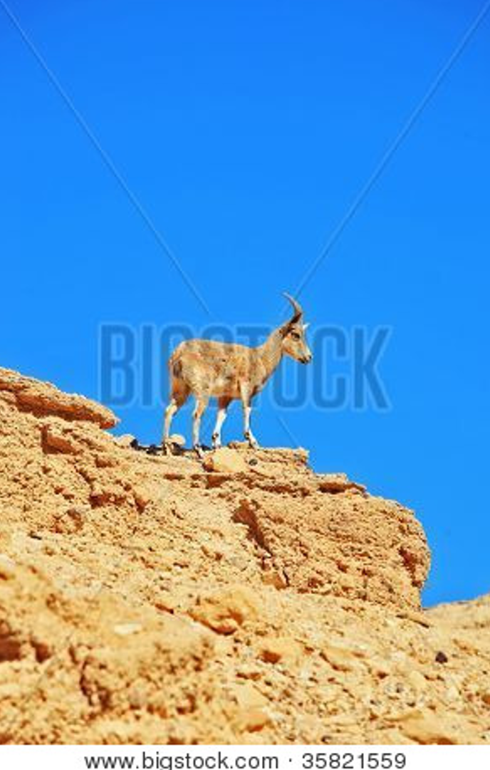
“Suppose one of you has a hundred sheep and loses one of them. Doesn’t he leave the ninety-nine in the open country and go after the lost sheep until he finds it?
“And when
he finds it,
he joyfully puts it
on his shoulders
and goes home.
“Then he calls his friends and neighbors together
and says,
“Rejoice with me; I have found my lost sheep.”

~ Luke 15:4-6 (NIV)

For this is what the Sovereign Lord says:
“I myself will search for my sheep and look after them.”

~ Ezekiel 34:11 (NIV)

“My sheep listen to my voice;
“I know them, and they follow me.
“I give them eternal life, and they will never perish…”

~ John 10:27-28a (NLT)

But Your Sin Separates You from God

Don’t you realize that those who do wrong will not inherit the Kingdom of God?

~ 1 Corinthians 6:9a (NLT)

For of this you can be sure: No immoral, impure or greedy person—such a person is an idolater—has any inheritance in the kingdom of Christ and of God.

~ Ephesians 5:5 (NIV)

The Day of God’s Wrath Will Come

“When the master of the house has locked the door,
it will be too late.”

~ Luke 13:25a (NLT)

“I will punish the world for its evil,
the wicked for their sins.
I will put an end to the arrogance of the haughty
and will humble the pride of the ruthless.”

~ Isaiah 13:11 (NIV)

Wealth is worthless in the day of wrath…

~ Proverbs 11:4a (NIV)

“Their silver and gold
will not be able to deliver them
in the day of the Lord’s wrath.
“It will not satisfy their hunger
or fill their stomachs,
for it has caused them to stumble into sin.”

~ Ezekiel 7:19b (NIV)

“Watch out! Don’t let your hearts be dulled by carousing and drunkenness, and by the worries of this life. Don’t let that day catch you unaware, like a trap.”

~ Luke 21:34-35a (NLT)

Seek the Lord, all you humble of the land, you who
do what he commands.
Seek righteousness, seek humility; perhaps you
will be sheltered on the day of the Lord’s anger.

~ Zephaniah 2:3 (NIV)

Confess Your Sin and Repent

The Lord is…not willing that any should perish but that all should come to repentance.

~ 2 Peter 3:9 (NKJV)

For with the Lord there is mercy, and with Him is abundant redemption.

~ Psalm 130:7b (NKJV)

“In overflowing anger for a moment I hid my face from you, but with everlasting love I will have compassion on you,” says the Lord, your Redeemer.

~ Isaiah 54:8 (ESV)

Repent, then, and turn to God, so that your sins may
be wiped out, that times of refreshing may come from
the Lord…

~ Acts 3:19 (NIV)

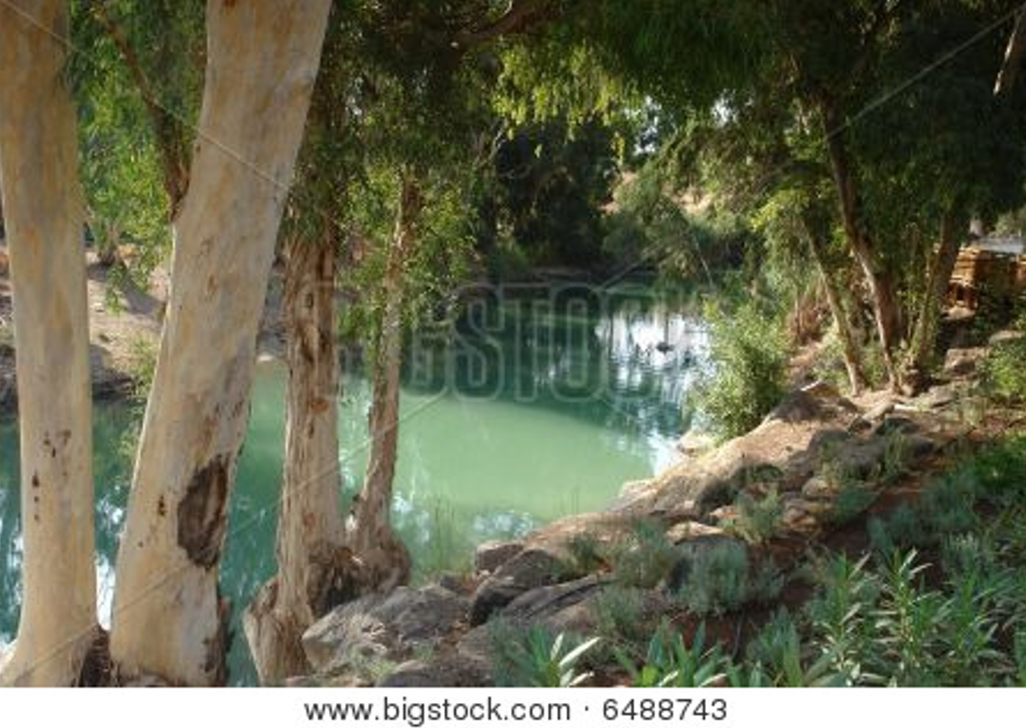

Jordan River

If we confess our sins, he is faithful and just to forgive us our sins, and to cleanse us from all unrighteousness.

~ 1 John 1:9 (ESV)
Jesus Died to Save You

…From Your Sin

She will give birth to a son, and you are to give him the name Jesus, because he will save his people from their sins.

~ Matthew 1:21 (NIV)

In his name the nations will put their hope.

~ Matthew 12:21 (NIV)

…Christ Jesus came into the world to save sinners…

~ 1 Timothy 1:15b (ESV)

…From God’s Wrath

“For God did not send His Son into the world to condemn the world, but that the world through Him might be saved.”

~ John 3:17 (NKJV)

…From Death

For the wages of sin is death, but the free gift of God
is eternal life in Christ Jesus our Lord.

~ Romans 6:23 (ESV)

Because God’s children are human beings—made of
flesh and blood—the Son also became flesh and blood.
For only as a human being could he die, and only by dying could he break the power of the devil, who had the power of death.

~ Hebrews 2:14 (NLT)

But God raised him from the dead…

~ Acts 2:24a (NIV)

We know that God, who raised the Lord Jesus, will also raise us with Jesus…

~ 2 Corinthians 4:14a (NLT)

For we know that since Christ was raised from the dead, he cannot die again; death no longer has mastery over him...In the same way, count yourselves dead to sin but alive to God in Christ Jesus.

~ Romans 6:9-11 (NIV)

God Bought You at a Price

God paid a high price for you, so don’t be enslaved by
the world.

~ 1 Corinthians 7:23 (NLT)

…have the same mindset as Christ Jesus:
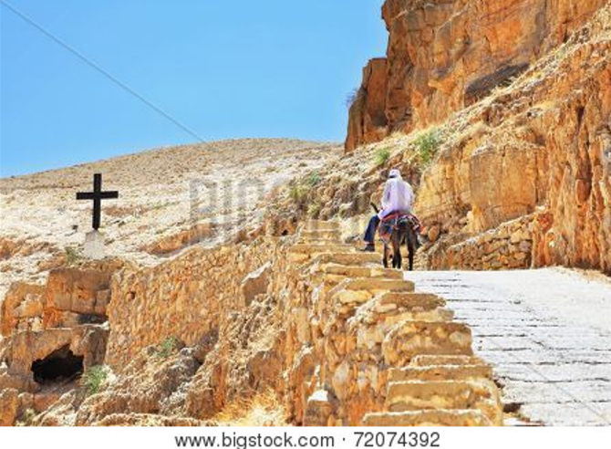
Who, being in very nature God, did not consider equality with God something to be used to his own advantage; rather, he made himself nothing by taking the very nature of a servant, being made in human likeness.
And being found in appearance
as a man,
he humbled himself by becoming obedient to death—
even death on a cross!

~ Philippians 2:5b-8 (NIV)

Christ redeemed us from the curse of the law by becoming a curse for us…so that in Christ Jesus the blessing of Abraham might come to the Gentiles, so that we might receive the promised Spirit through faith.

~ Galatians 3:13-14 (ESV)

In Christ You Are Forgiven

Therefore, since we have been made right in God’s sight by faith, we have peace with God because of what Jesus Christ our Lord has done for us.
Because of our faith, Christ has brought us into this place of undeserved privilege where we now stand, and we confidently and joyfully look forward to sharing God’s glory.

~ Romans 5:1-2 (NLT)

God Demonstrates His Love Through Christ

This is love: not that we loved God, but that he loved us and sent his Son as an atoning sacrifice for our sins.

~ 1 John 4:10 (NIV)

“For God so loved the world that He gave His only begotten Son, that whoever believes in Him should
not perish but have everlasting life.”

~ John 3:16 (NKJV)

Who shall separate us from the love of Christ?
Shall trouble or hardship or persecution or famine
or nakedness or danger or sword?...
No, in all these things we are more than conquerors through him who loved us.
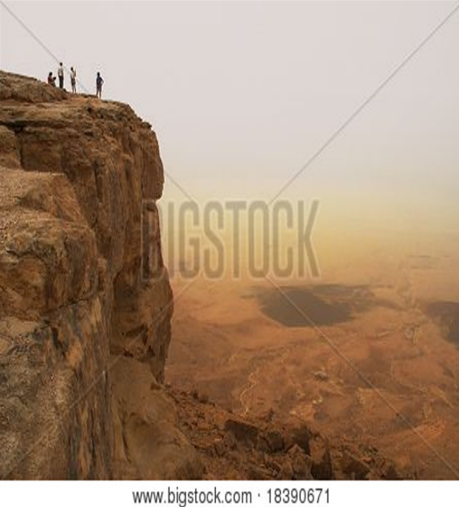
For I am convinced that neither death nor life,
neither angels nor demons, neither the present nor
the future,
nor any powers,
neither height nor depth,
nor anything else in all creation,
will be able to separate us from the love of God that is in Christ Jesus our Lord.

~ Romans 8:35-39 (NIV) Ramon Crater, Negev Desert

And I pray that you, being rooted and established in love, may have power…to grasp how wide and long and high and deep is the love of Christ…

~ Ephesians 3:17b-18 (NIV)

Salvation is Through Christ Alone

God promised this Good News long ago through his prophets in the holy Scriptures.
The Good News is about his Son.
In his earthly life he was born into King David’s family line, and he was shown to be the Son of God when he
was raised from the dead by the power of the Holy Spirit.
He is Jesus Christ our Lord.

~ Romans 1:2-4 (NLT)

Salvation is found in no one else, for there is no other name under heaven given to mankind by which we must be saved.

~ Acts 4:12 (NIV)

Jesus said to him, “I am the way, the truth, and the life. No one comes to the Father except through Me.”

~ John 14:6 (NKJV)

“…whoever comes to me I will never drive away.”

~ John 6:37b (NIV)

“No one can come to Me unless the Father who sent Me draws him...”

~ John 6:44a (NKJV)

“And this is the will of God, that I should not lose even one of all those he has given me, but that I should raise them up at the last day.”

~ John 6:39 (NLT)

“For the Son of Man came to seek and to save the lost.”

~ Luke 19:10 (ESV)

“And I, when I am lifted up from the earth, will draw
all people to myself.”

~ John 12:32 (ESV)

“Most assuredly, I say to you, he who believes in Me has everlasting life.”

~ John 6:47 (NKJV)

Jesus said to her, “I am the resurrection and the life. Whoever believes in me, though he die, yet shall he live...”

~ John 11:25 (ESV)
Jesus replied, “I tell you the truth, unless you are
born again, you cannot see the Kingdom of God.”

~ John 3:3 (NLT)

“You can enter God’s Kingdom only through the narrow gate.”

~ Matthew 7:13a (NLT)

“Enter through the narrow gate.
“For wide is the gate and broad is the road that leads to destruction, and many enter through it.
“But small is the gate and narrow the road that leads to life, and only a few find it.”

~ Matthew 7:13-14 (NIV)

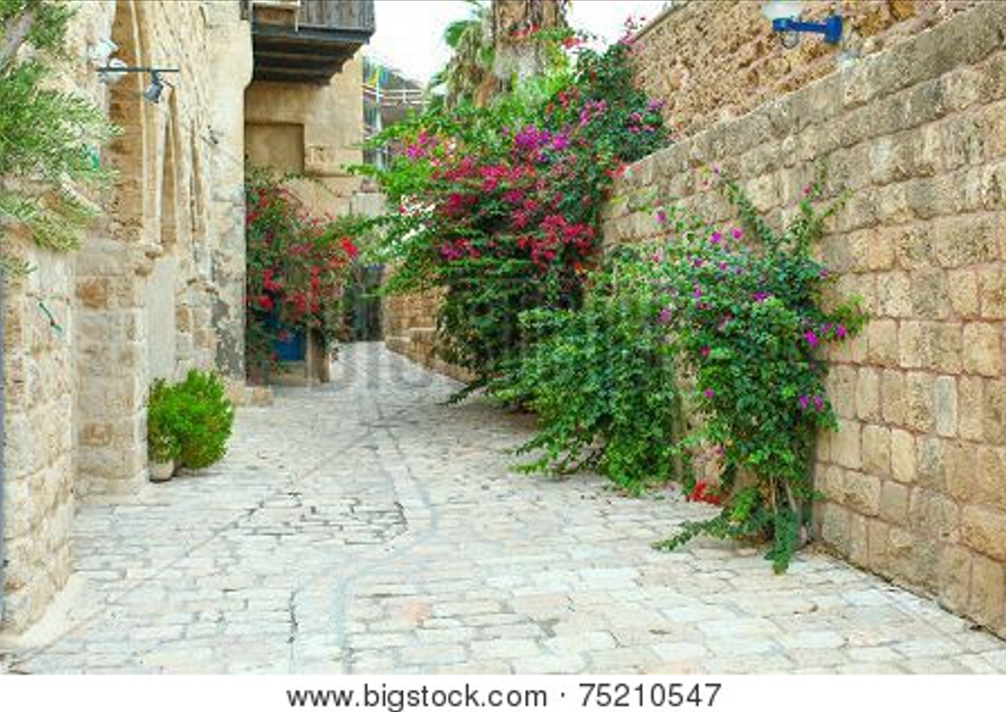

Jaffa, Israel

If anyone acknowledges that Jesus is the Son of God,
God lives in them and they in God.

~ 1 John 4:15 (NIV)

The reward for trusting him will be the salvation of
your souls.

~ 1 Peter 1:9 (NLT)

Salvation is a Gift: Free and Undeserved

For it is by grace you have been saved, through faith—
and this not from yourselves, it is the gift of God—
not by works, so that no one can boast.

~ Ephesians 2:8-9 (NIV)

Salvation is not a reward for the good things we have done, so none of us can boast about it.

~ Ephesians 2:9 (NLT)

…because of his great love for us, God, who is rich in mercy, made us alive with Christ even when we were dead in transgressions—it is by grace you have been saved.

~ Ephesians 2:4-5 (NIV)

…he saved us, not because of the righteous things we
had done, but because of his mercy…
Because of his grace he declared us righteous and gave us confidence that we will inherit eternal life.

~ Titus 3:5-7 (NLT)

And since it is through God’s kindness, then it is not
by their good works. For in that case, God’s grace would
not be what it really is—free and undeserved.

~ Romans 11:6 (NLT)

For God saved us and called us to live a holy life.
He did this, not because we deserved it, but because
that was his plan from before the beginning of time—
to show us his grace through Christ Jesus.

~ 2 Timothy 1:9 (NLT)

Accept This Gift of Salvation

Whoever believes in the Son has eternal life...

~ John 3:36a (NIV)

If you declare with your mouth, “Jesus is Lord,” and believe in your heart that God raised him from the dead, you will be saved.

~ Romans 10:9 (NIV)
For God says, “At just the right time, I heard you.
On the day of salvation, I helped you.”
Indeed, the “right time” is now. Today is the day
of salvation.

~ 2 Corinthians 6:2 (NLT)

What are you waiting for? Get up and be baptized.
Have your sins washed away by calling on the name
of the Lord.

~ Acts 22:16 (NLT)

This is all the more urgent, for you know how late it is; time is running out.

~ Romans 13:11a (NLT)

…how shall we escape if we ignore so great a salvation?

~ Hebrews 2:3a (NIV)

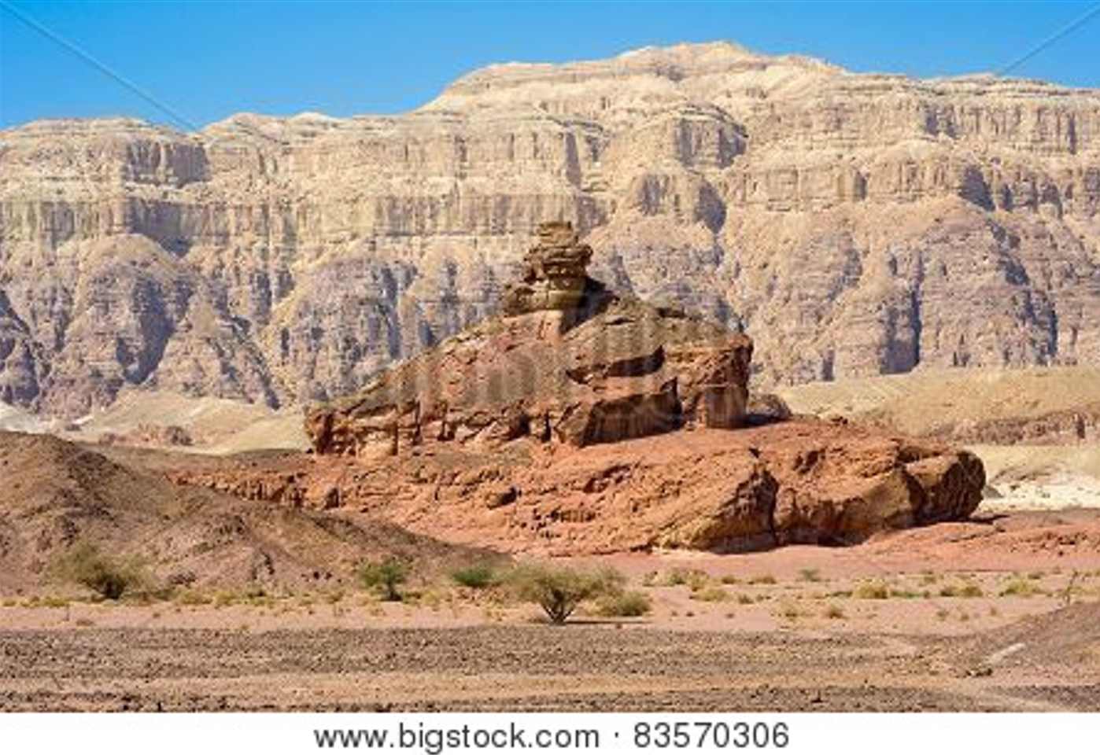

Timna Valley, Israel

You Belong to God Through Faith in Christ
and Have Become His Child

Even before he made the world, God loved us and chose us in Christ to be holy and without fault in his eyes.
God decided in advance to adopt us into his own family
by bringing us to himself through Jesus Christ.
This is what he wanted to do, and it gave him great pleasure.

~ Ephesians 1:4-5 (NLT)

…you belong to Christ, and Christ belongs to God.

~ 1 Corinthians 3:23 (NLT)

See what great love the Father has lavished on us, that we should be called children of God!

~ 1 John 3:1a (NIV)

Everyone who believes that Jesus is the Christ has become a child of God.

~ 1 John 5:1a (NLT)

And since you are his child, God has made you his heir.

~ Galatians 4:7b (NLT)

Now if we are children, then we are heirs—heirs of God and co-heirs with Christ, if indeed we share in his sufferings in order that we may also share in his glory.

~ Romans 8:17 (NIV)

Now all of us can come to the Father through the same Holy Spirit because of what Christ has done for us.

~ Ephesians 2:18 (NLT)

And when you believed in Christ, he identified you as his own by giving you the Holy Spirit, whom he promised
long ago.

~ Ephesians 1:13b (NLT)

He anointed us, set his seal of ownership on us, and put his Spirit in our hearts as a deposit, guaranteeing what is to come.

~ 2 Corinthians 1:21b-22 (NIV)

Eternal Life is Yours Through Christ

Jesus answered him,
“Truly I tell you, today you will be with me in paradise.”

~ Luke 23:43 (NIV)

“In My Father’s house are many mansions; if it were not so, I would have told you.
“I go to prepare a place for you. And if I go and prepare a place for you, I will come again and receive you to Myself; that where I am, there you may be also.”

~ John 14:2-3 (NKJV)

“For my Father’s will is that everyone who looks to
the Son and believes in him shall have eternal life, and
I will raise them up at the last day.”

~ John 6:40 (NIV)

“Let anyone who is thirsty come to me and drink.
“Whoever believes in me, as Scripture has said,
rivers of living water will flow from within them.”

~ John 7:37b-38 (NIV)

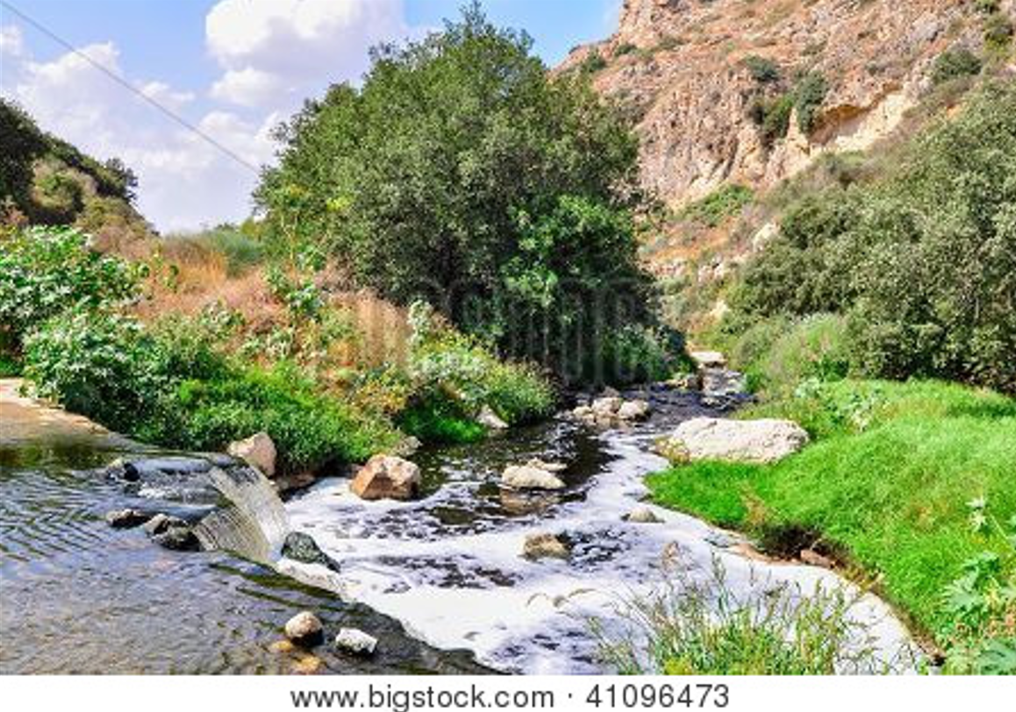

Mountain river near Jerusalem
“Do not store up for yourselves treasures on earth,
where moths and vermin destroy, and where thieves
break in and steal.
“But store up for yourselves treasures in heaven, where moths and vermin do not destroy, and where thieves do not break in and steal.
“For where your treasure is, there your heart will be also.”

~ Matthew 6:19-21 (NIV)

“For the Son of Man is going to come with his angels in the glory of his Father, and then he will repay each person according to what he has done.”

~ Matthew 16:27 (ESV)

“Look, I am coming soon! My reward is with me, and I will give to each person according to what they have done.”

~ Revelation 22:12 (NIV)

“When the Son of Man comes in his glory, and all the angels with him, he will sit on his glorious throne.
“All the nations will be gathered before him, and he will separate the people one from another…
“Then the King will say to those on his right, ‘Come, you who are blessed by my Father; take your inheritance, the kingdom prepared for you since the creation of the world. For
I was hungry and you gave me something to eat,
I was thirsty and you gave me something to drink,
I was a stranger and you invited me in,
I needed clothes and you clothed me,
I was sick and you looked after me,
I was in prison and you came to visit me.
“Then the righteous will answer him, ‘Lord, when did we see you hungry and feed you, or thirsty and give you something to drink?’…
“The King will reply, ‘Truly I tell you, whatever you did for one of the least of these brothers and sisters of mine, you did for me.’”

~ Matthew 25:31-40 (NIV)
Jesus answered,
“My kingdom is not of this world.”

~ John 18:36a (ESV)

“The kingdom of heaven is like treasure hidden in a field.
“When a man found it, he hid it again, and then in his joy went and sold all he had and bought that field.”

~ Matthew 13:44 (NIV)

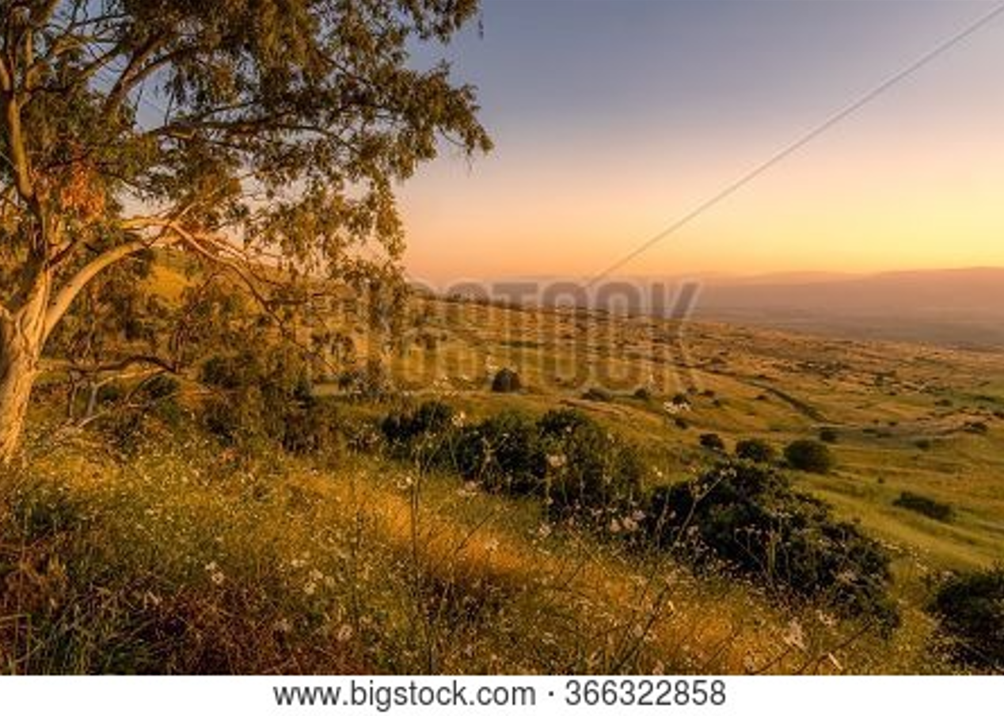

Golan Heights

“The kingdom of heaven is like a mustard seed, which a man took and planted in his field. Though it is the smallest of all seeds, yet when it grows, it is the largest of garden plants and becomes a tree…”

~ Matthew 13:31b-32a (NIV)

“Once again, the kingdom of heaven is like a net that was let down into the lake and caught all kinds of fish. When it was full, the fishermen pulled it up on the shore.
“Then they sat down and collected the good fish in baskets, but threw the bad away.”

~ Matthew 13:47-48 (NIV)
“Again, the kingdom of heaven is like a merchant looking for fine pearls.
“When he found one of great value, he went away and sold everything he had and bought it.”

~ Matthew 13:45-46 (NIV)

And again Jesus spoke to them in parables, saying,
“The kingdom of heaven may be compared to a king who gave a wedding feast for his son, and sent his servants to call those who were invited to the wedding feast, but they would not come.
“Again he sent other servants, saying, ‘Tell those who are invited, “See, I have prepared my dinner, my oxen and my fat calves have been slaughtered, and everything is ready. Come to the wedding feast.”’
“But they paid no attention and went off, one to his farm, another to his business, while the rest seized his servants, treated them shamefully, and killed them.
“The king was angry, and he sent his troops and destroyed those murderers and burned their city.
“Then he said to his servants, ‘The wedding feast is ready, but those invited were not worthy. Go therefore to the main roads and invite to the wedding feast as many as
you find.’
“And those servants went out into the roads and gathered all whom they found, both bad and good.
“So the wedding hall was filled with guests.”

~ Matthew 22:1-10 (ESV)

“I will give you the keys of the kingdom of heaven,
and whatever you bind on earth shall be bound in heaven, and whatever you loose on earth shall be loosed in heaven.”

~ Matthew 16:19 (ESV)

“So don’t be afraid, little flock. For it gives your Father great happiness to give you the Kingdom.”

~ Luke 12:32 (NLT)
“To the one who is victorious, I will give the right to
eat from the tree of life, which is in the paradise of God.”

~ Revelation 2:7b (NIV)

“All who are victorious will be clothed in white.
“I will never erase their names from the Book of Life,
but I will announce before my Father and his angels
that they are mine.”

~ Revelation 3:5 (NLT)

“The one who is victorious will not be hurt at all by the second death.”

~ Revelation 2:11b (NIV)

“To everyone who is victorious I will give some of the manna that has been hidden away in heaven.
“And I will give to each one a white stone, and on the stone will be engraved a new name that no one understands except the one who receives it.”

~ Revelation 2:17b (NLT)

“The one who is victorious I will make a pillar in the temple of my God. Never again will they leave it.”

~ Revelation 3:12a (NIV)

“To the one who is victorious and does my will to the end, I will give authority over the nations…
“I will also give that one the morning star.”

~ Revelation 2:26-28 (NIV)

“To the one who is victorious, I will give the right to sit with me on my throne, just as I was victorious and sat down with my Father on his throne.”

~ Revelation 3:21 (NIV)

“All who are victorious will inherit all these blessings,
and I will be their God, and they will be my children.”

~ Revelation 21:7 (NLT)
“…rejoice because your names are written in heaven.”

~ Luke 10:20b (NKJV)

“Blessed are those who are persecuted because of righteousness, for theirs is the kingdom of heaven...
“Rejoice and be glad, because great is your reward
in heaven…”

~ Matthew 5:10-12a (NIV)

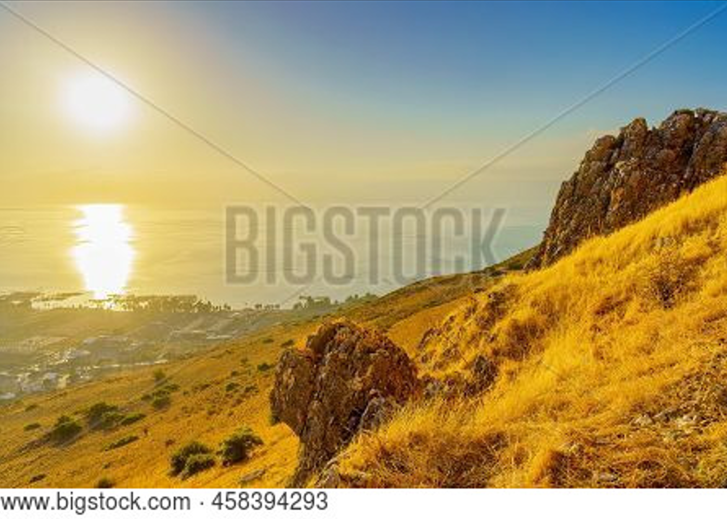

Sea of Galilee

…God gave us eternal life, and this life is in his Son.

~ 1 John 5:11b (ESV)

…we wait for the blessed hope—the appearing of the glory of our great God and Savior, Jesus Christ...

~ Titus 2:13 (NIV)

He will judge everyone according to what they have done.
He will give eternal life to those who keep on doing good, seeking after the glory and honor and immortality that God offers.
But he will pour out his anger and wrath on those who live for themselves, who refuse to obey the truth and instead live lives of wickedness.

~ Romans 2:6-8 (NLT)

When Christ who is your life appears, then you also will appear with him in glory.

~ Colossians 3:4 (ESV)

Heaven is Your Home

Then He who sat on the throne said,
“Behold, I make all things new.”

~ Revelation 21:5a (NKJV)

“See, I will create
new heavens and a new earth.
The former things will not be remembered,
nor will they come to mind.
But be glad and rejoice forever
in what I will create…”

~ Isaiah 65:17-19 (NIV)

In Jerusalem, the Lord of Heaven’s Armies
will spread a wonderful feast
for all the people of the world…
There he will remove the cloud of gloom,
the shadow of death that hangs over the earth.
He will swallow up death forever!
The Sovereign Lord will wipe away all tears.

~ Isaiah 25:6-8a (NLT)

He will wipe away every tear from their eyes, and death shall be no more, neither shall there be mourning, nor crying, nor pain anymore, for the former things have passed away.

~ Revelation 21:4 (ESV)

All your works praise you, Lord;
your faithful people extol you.
They tell of the glory of your kingdom
and speak of your might…
Your kingdom is an everlasting kingdom,
and your dominion endures through all generations.

~ Psalm 145:10-13a (NIV)

His dominion is an everlasting dominion that will not pass away, and his kingdom is one that will never be destroyed.

~ Daniel 7:14b (NIV)

Since we are receiving a Kingdom that is unshakable,
let us be thankful and please God by worshiping him
with holy fear and awe.

~ Hebrews 12:28 (NLT)
Yes, the Sovereign Lord is coming in power.
He will rule with a powerful arm.
See, he brings his reward with him as he comes.
He will feed his flock like a shepherd.
He will carry the lambs in his arms, holding them
close to his heart.

~ Isaiah 40:10-11a (NLT)

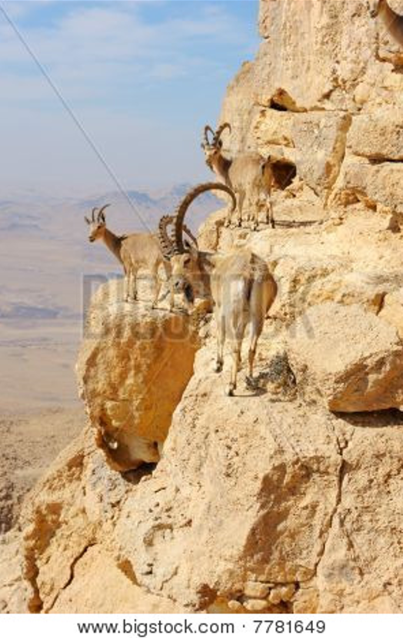
“In that day the wolf and the lamb will live together; the leopard will lie down with the baby goat…
“Nothing
will hurt or destroy in
all my holy mountain…”
~ Isaiah 11:6-9a (NLT)

…the creation looks forward to the day when it
will join God’s children
in glorious freedom from death and decay.
~ Romans 8:21
Wild goats in Makhtesh Ramon (NLT)
No eye has seen, no ear has heard, and no mind has imagined what God has prepared for those who love him.

~ 1 Corinthians 2:9b (NLT)
Since you have been raised to new life with Christ,
set your sights on the realities of heaven, where Christ sits in the place of honor at God’s right hand.
Think about the things of heaven, not the things of earth.

~ Colossians 3:1-2 (NLT)

“See, I will create new heavens and a new earth.”

~ Isaiah 65:17a (NIV)

Then I saw “a new heaven and a new earth,” for the first heaven and the first earth had passed away, and there was no longer any sea. I saw the Holy City, the new Jerusalem, coming down out of heaven from God, prepared as a bride beautifully dressed for her husband.
And I heard a loud voice from the throne saying, “Look! God’s dwelling place is now among the people, and he will dwell with them…
He said to me: “It is done. I am the Alpha and the Omega, the Beginning and the End.
“To the thirsty I will give water without cost from the spring of the water of life.
“Those who are victorious will inherit all this, and I will be their God and they will be my children...”
And he carried me away in the Spirit to a mountain great and high, and showed me the Holy City, Jerusalem, coming down out of heaven from God. It shone with the glory of God, and its brilliance was like that of a very precious jewel, like a jasper, clear as crystal…
The twelve gates were twelve pearls, each gate made of
a single pearl.
The great street of the city was of gold, as pure as transparent glass….
The city does not need the sun or the moon to shine on it, for the glory of God gives it light…
Nothing impure will ever enter it, nor will anyone who does what is shameful or deceitful, but only those whose names are written in the Lamb’s book of life.

~ Excerpts from Revelation 21 (NIV)
…our citizenship is in heaven, and from it we await a Savior, the Lord Jesus Christ...

~ Philippians 3:20 (ESV)

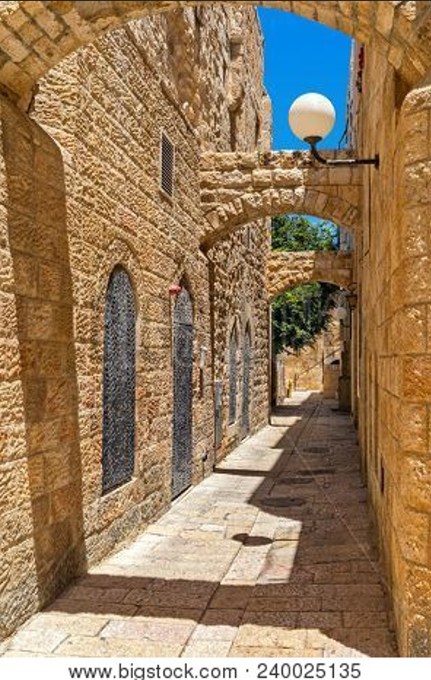
For here we have no lasting city, but we seek the city that is to come.
~ Hebrews 13:14 (ESV)

…we will have a house in heaven, an eternal body made for us by God himself and not by human hands.
~ 2 Corinthians 5:1b (NLT)

But as it is, they desire a better country, that is,
a heavenly one.
Therefore God is not ashamed to be called their God, for he has prepared for them a city.

~ Hebrews 11:16 (ESV)

Old City of Jerusalem

And we believers also groan, even though we have the Holy Spirit within us as a foretaste of future glory, for we long for our bodies to be released from sin and suffering.
We, too, wait with eager hope for the day when God will give us our full rights as his adopted children, including the new bodies he has promised us.

~ Romans 8:23 (NLT)
May you be filled with joy, always thanking the Father.
He has enabled you to share in the inheritance that belongs to his people, who live in the light.

~ Colossians 1:11b-12 (NLT)

For you have been born again, but not to a life that will quickly end. Your new life will last forever because it comes from the eternal, living word of God.

~ 1 Peter 1:23 (NLT)

“I tell you the truth, unless you are born again, you cannot see the Kingdom of God.”

~ John 3:3b (NLT)

Now we live with great expectation, and we have a priceless inheritance—an inheritance that is kept in heaven for you, pure and undefiled, beyond the reach
of change and decay.
And through your faith, God is protecting you by his power until you receive this salvation, which is ready
to be revealed on the last day for all to see.

~ 1 Peter 1:3b-5 (NLT)

…make every effort to
add to your faith goodness;
and to goodness, knowledge;
and to knowledge, self-control;
and to self-control, perseverance;
and to perseverance, godliness;
and to godliness, mutual affection;
and to mutual affection, love.
For if you possess these qualities in increasing measure, they will keep you from being ineffective and unproductive in your knowledge of our Lord Jesus Christ…
For if you do these things, you will never stumble, and
you will receive a rich welcome into the eternal kingdom of our Lord and Savior Jesus Christ.

~ 2 Peter 1:5b-11 (NIV)
You make known to me the path of life;
you will fill me with joy in your presence,
with eternal pleasures at your right hand.

~ Psalm 16:11 (NIV)

Yet I still belong to you; you hold my right hand.
You guide me with your counsel,
leading me to a glorious destiny.

~ Psalm 73:23-24 (NLT)

Point out anything in me that offends you,
and lead me along the path of everlasting life.

~ Psalm 139:24 (NLT)

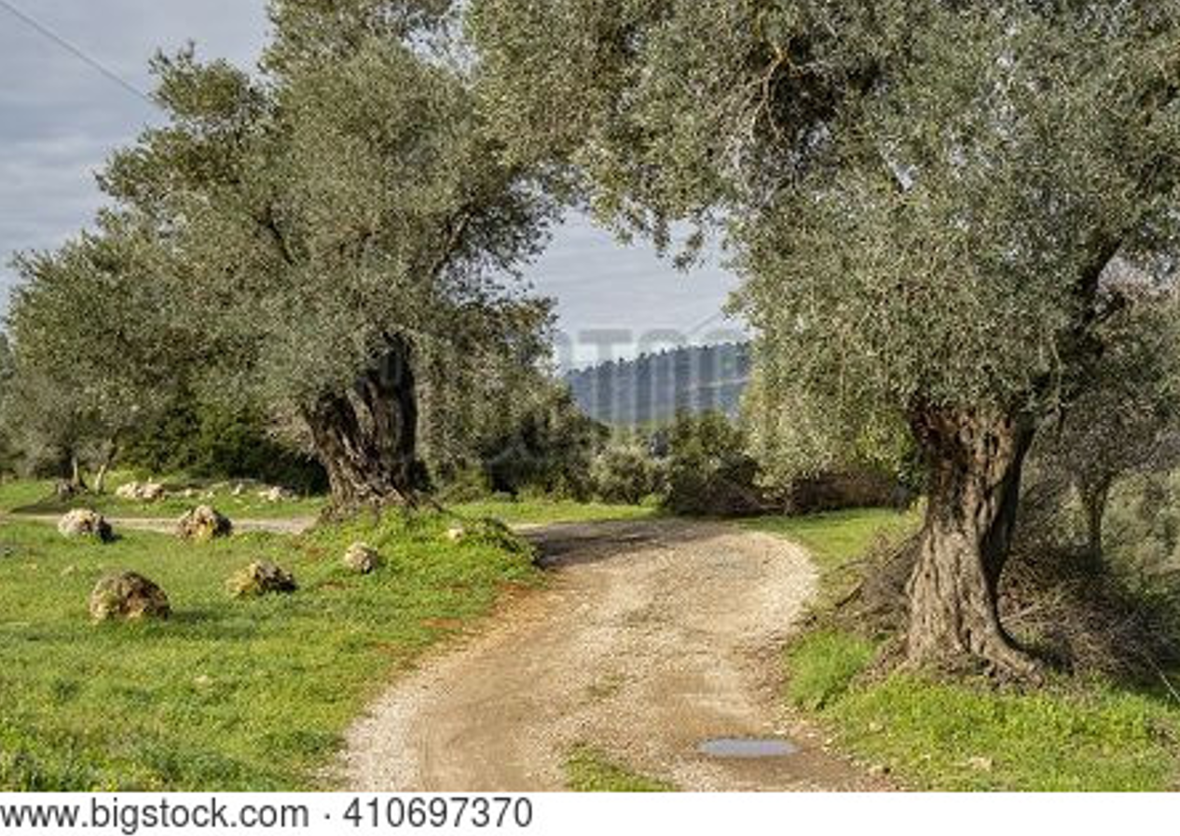

Path in the Judean mountains

Now to him who is able to do immeasurably more than
all we ask or imagine, according to his power that is at work within us, to him be glory in the church and in
Christ Jesus throughout all generations, for ever and ever! Amen.

~ Ephesians 3:20-21 (NIV)

Praise God for His Gift of Eternal Life

Praise be to the Lord, the God of Israel, because he has come to his people and redeemed them.

~ Luke 1:68 (NIV)

Thanks be to God for his indescribable gift!

~ 2 Corinthians 9:15 (NIV)

Thank God for this gift too wonderful for words!

~ 2 Corinthians 9:15 (NLT)

So we praise God for the glorious grace he has poured out on us who belong to his dear Son.

~ Ephesians 1:6 (NLT)

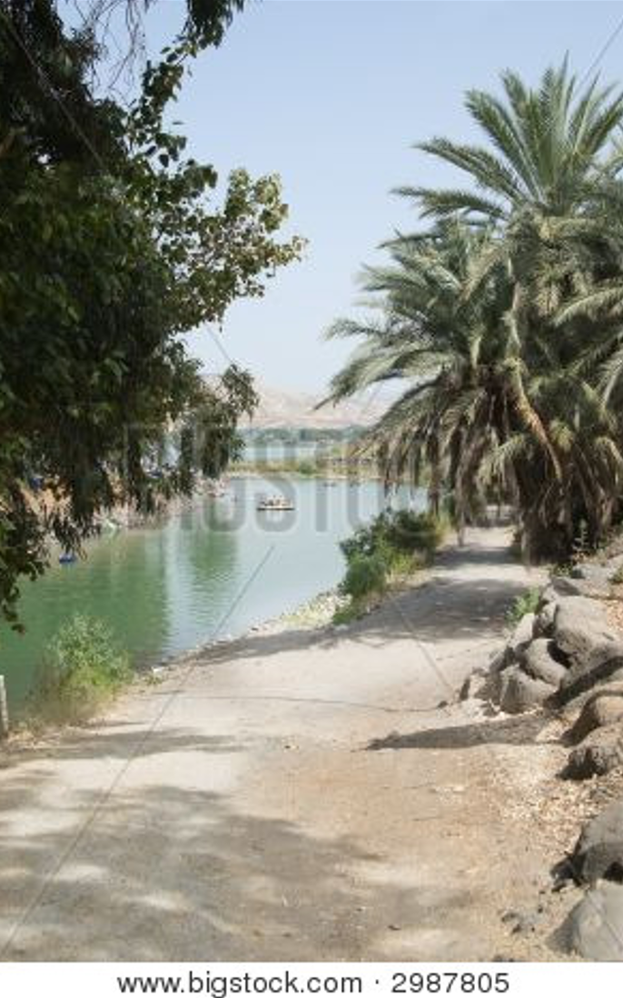

Jordan River
Praise God for His Great and Awesome Name

Praise God for the privilege of being called by his name!

~ 1 Peter 4:16b (NLT)

…at the name of Jesus every knee should bow, in heaven and on earth and under the earth, and every tongue acknowledge that Jesus Christ is Lord…

~ Philippians 2:10-11a (NIV)

Let them praise the name of the Lord,
For His name alone is exalted;
His glory is above the earth and heaven.

~ Psalm 148:13 (NKJV)

Glory in his holy name;
let the hearts of those who seek the Lord rejoice!

~ 1 Chronicles 16:10 (ESV)

Lord, there is no one like you!
For you are great, and your name is full of power.

~ Jeremiah 10:6 (NLT)

Let them praise your great and awesome name.
Your name is holy!

~ Psalm 99:3 (NLT)

All nations whom thou hast made shall come and worship before thee, O Lord; and shall glorify thy name.

~ Psalm 86:9 (KJV)

…you have exalted above all things
your name and
your word.

~ Psalm 138:2b (ESV)

I will praise you forever, O God, for what you have done.
I will trust in your good name…

~ Psalm 52:9a (NLT)

I will praise you, Lord my God, with all my heart;
I will glorify your name forever.

~ Psalm 86:12 (NIV)

Praise His Glorious Name Forever

From the rising of the sun to its setting, the name of
the Lord is to be praised!

~ Psalm 113:3 (ESV)

Blessed be the name of the Lord from this time forth
and forevermore!

~ Psalm 113:2 (ESV)

Blessed be his glorious name forever;
may the whole earth be filled with his glory!
Amen and Amen!

~ Psalm 72:19 (ESV)

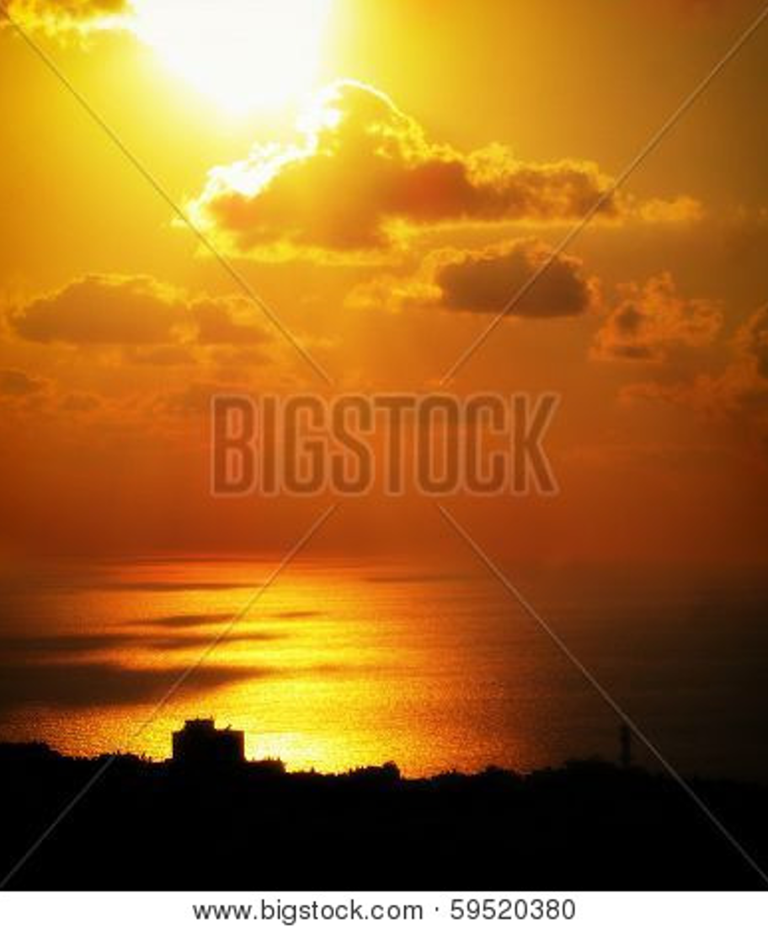

Mediterranean Sea

Booklet Titles in the Series

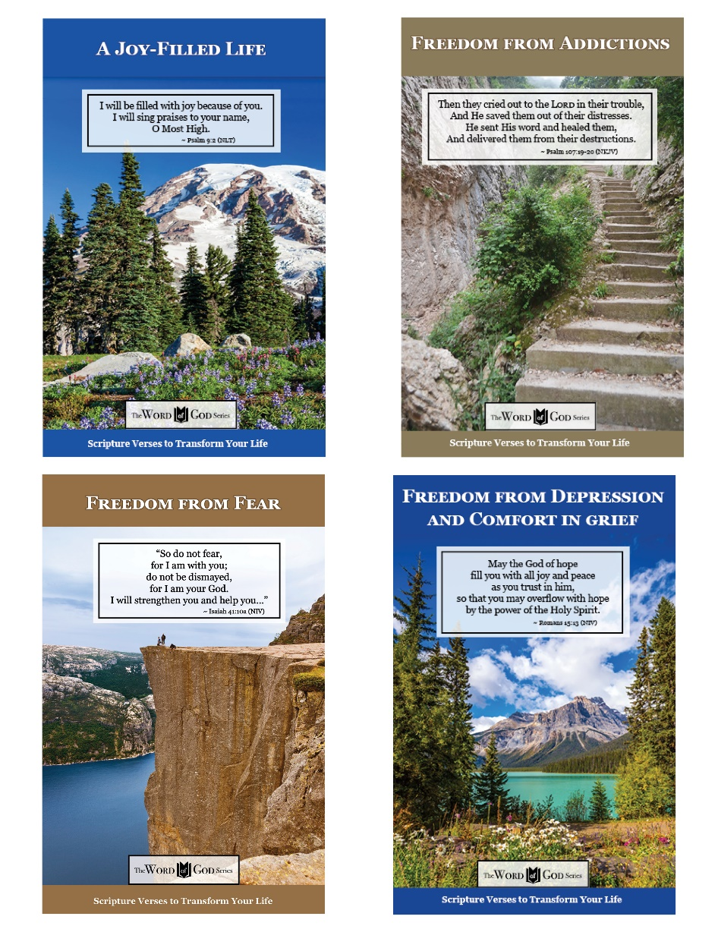

www.TheWordOfGodSeries.com

Booklet Titles in the Series

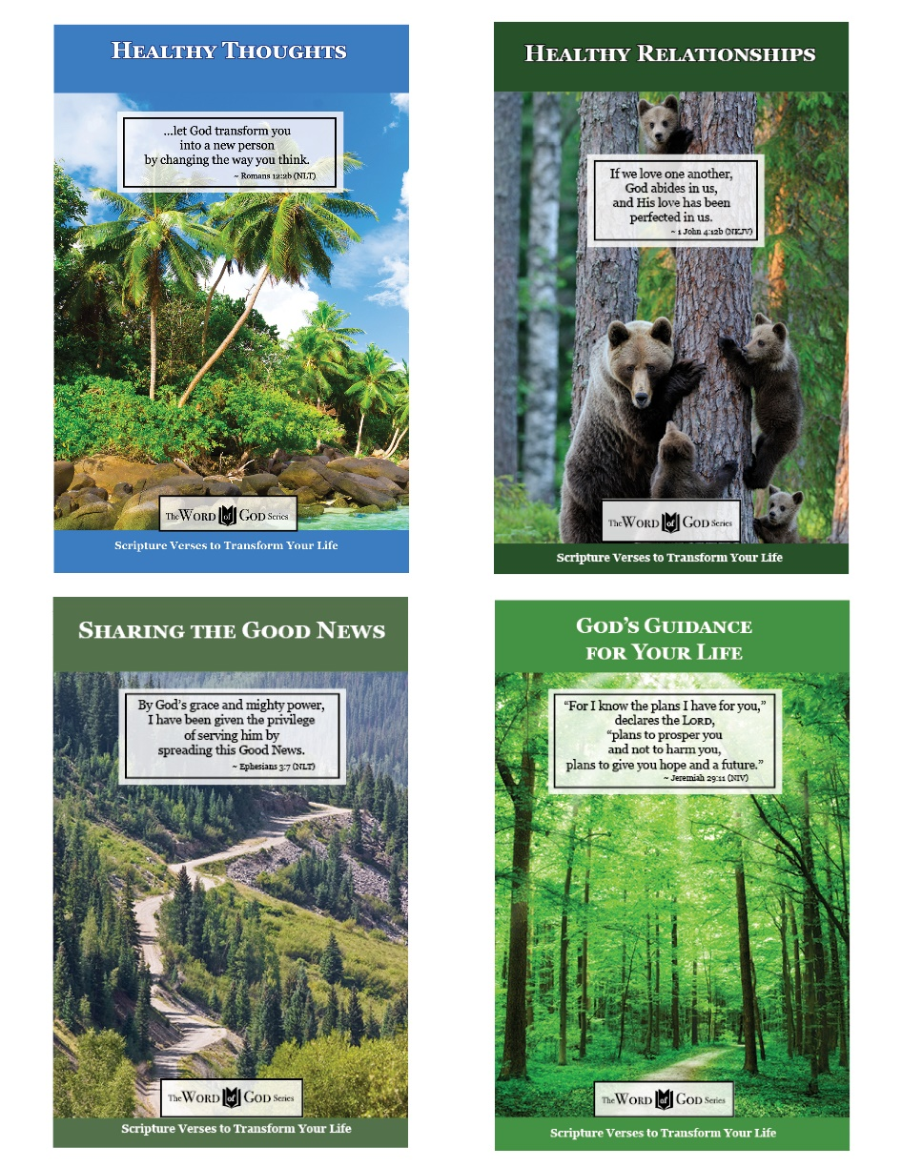

www.TheWordOfGodSeries.com

Booklet Titles in the Series

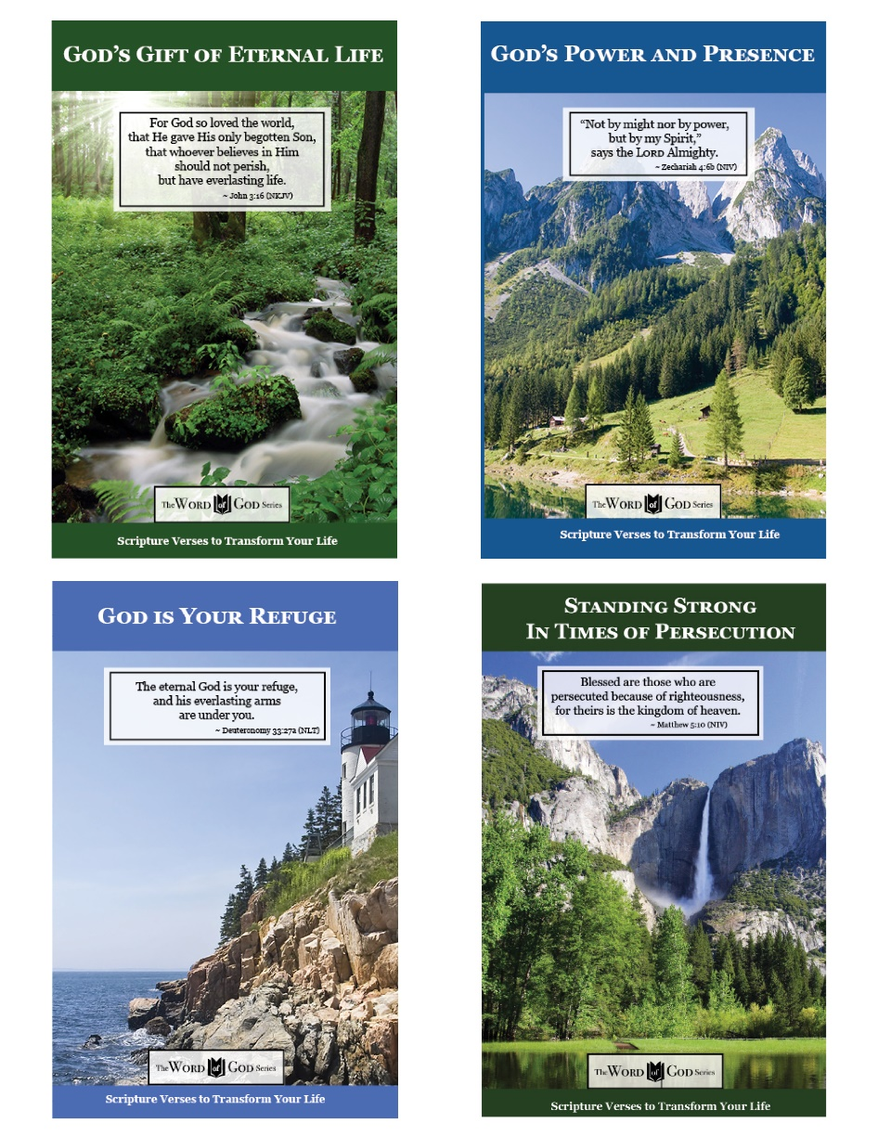

www.TheWordOfGodSeries.com

Booklet Titles in the Series

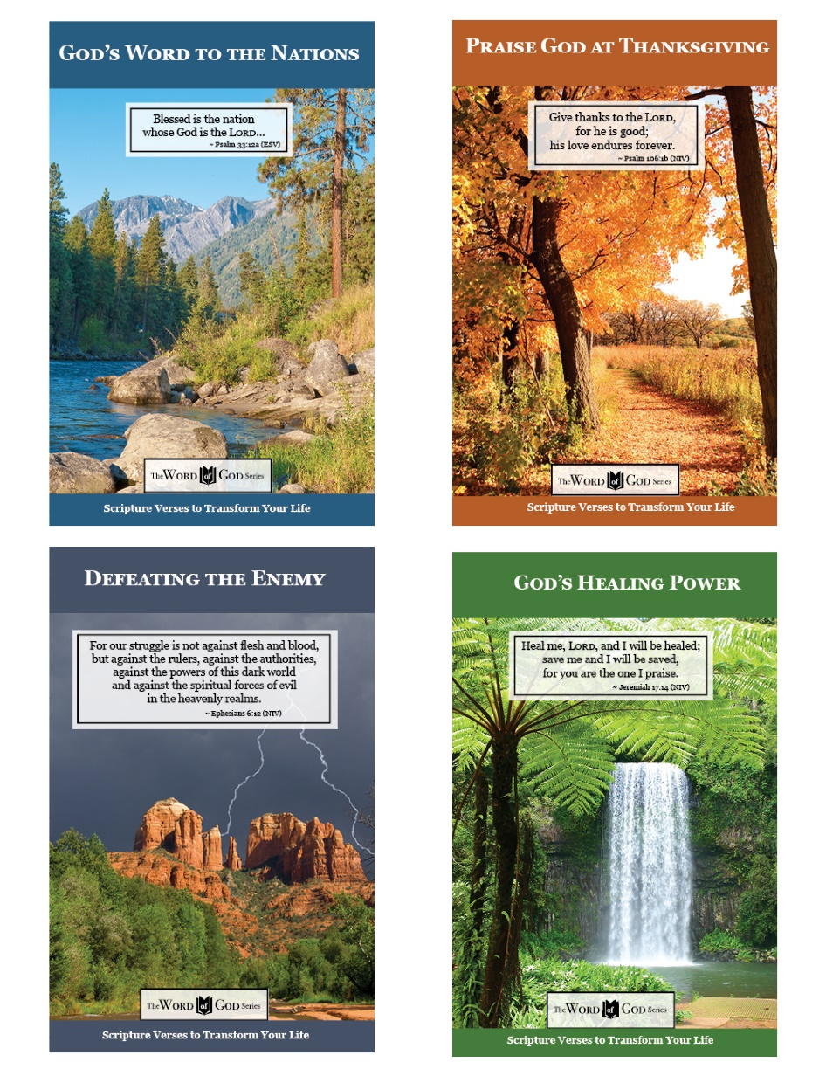

www.TheWordOfGodSeries.com

Booklet Titles in the Series

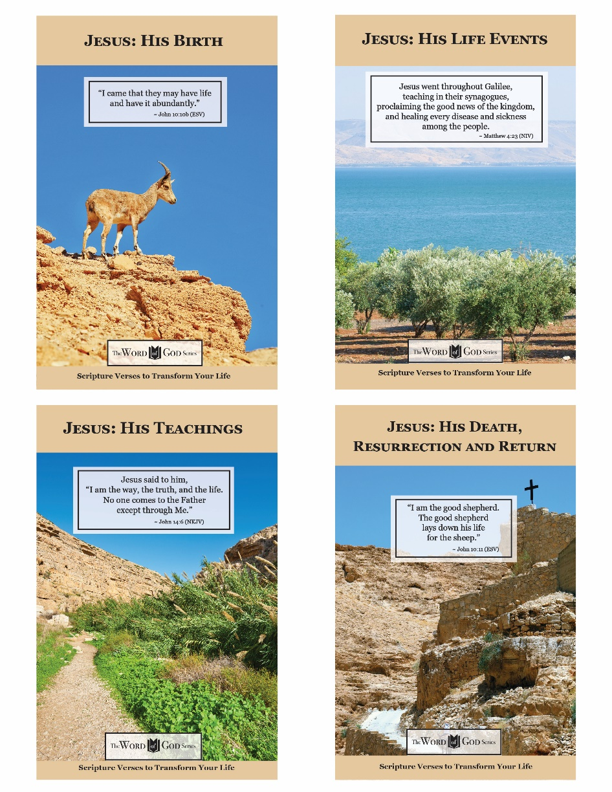

www.TheWordOfGodSeries.com

Photo Copyright Info

Note: when purchasing the rights to use the photos,
you may want to purchase an Extended License
for the cover image.

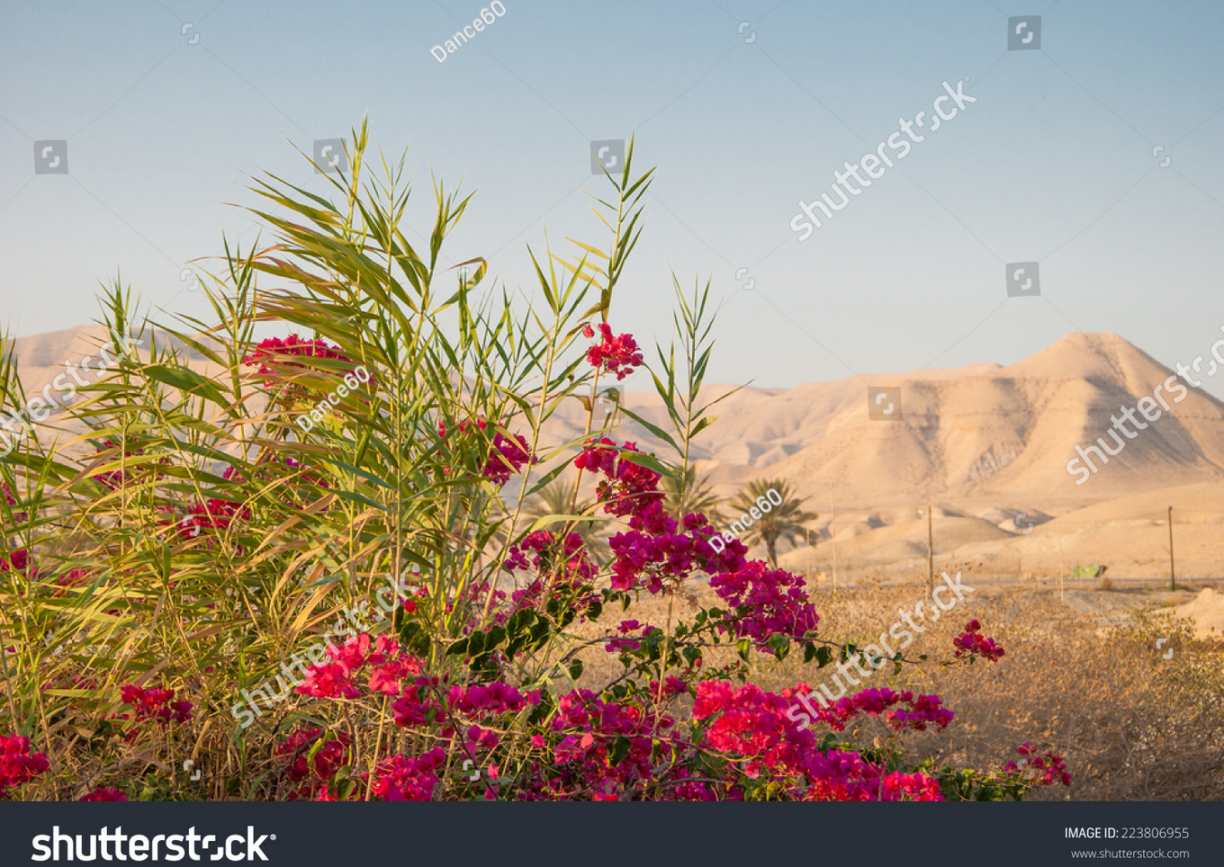
Shutterstock Photo ID: 223806955
Bougainvillea flowers on a background of Judean Mountains in Israel
Photo Contributor Dance60

Bigstock Photo ID: 428690132
Editing suggestion: Slightly crop out left, bottom, and right in order to zoom in on the waterfall
View of the hidden waterfall along the Arugot stream, in Ein Gedi Nature Reserve, near the Dead Sea, Southern Israel
Stock Photo ID: 428690132
Copyright: RnDmS

Bigstock Photo ID: 364550398
Olive groves cultivated in traditional ways, in a valley among the Judea mountains, near Jerusalem, Israel
Stock Photo ID: 364550398
Copyright: Moshe Einhorn

Bigstock Photo ID: 410697379
A path in the Judea mountains, near Jerusalem, Israel, passing in an agricultural area, among old olive and almond trees.
Stock Photo ID: 410697379
Copyright: Moshe Einhorn

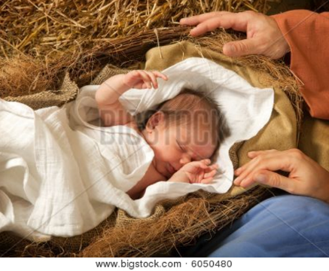
Bigstock Photo ID: 6050480
Christ Is Born
20 days old baby sleeping in a christmas nativity crib
Stock Photo ID: 6050480
Copyright: AnnekaS
Release: Signed model release filed with Bigstock.

Bigstock Photo ID: 39091756
Milky Way Over The Desert
Milky Way over the desert of Bardenas Spain
Stock Photo ID: 39091756
Copyright: inigocia
Bigstock Photo ID: 40640593
Second Temple. Ancient Jerusalem.
Second Temple. Model of the ancient Jerusalem.
Stock Photo ID: 40640593
Copyright: flik47

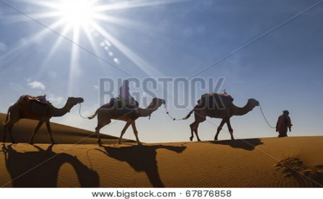
Bigstock Photo ID: 67876858
Camel caravan moving in Sahara desert in morning.
Stock Photo ID: 67876858
Copyright: Pagina

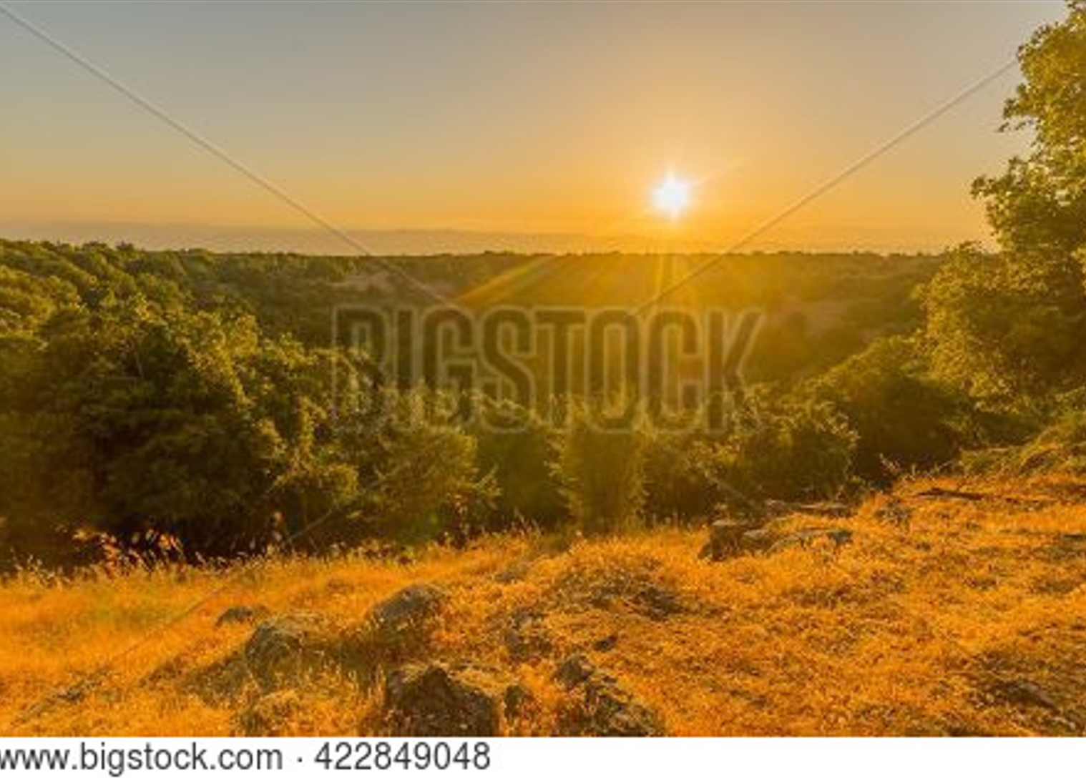
Bigstock Photo ID: 422849048
Sunset view of the volcanic landscape and the Big Joba (Jupta, pit crater) in Odem Forest, the Golan Heights, Northern Israel
Stock Photo ID: 422849048
Copyright: RnDmS

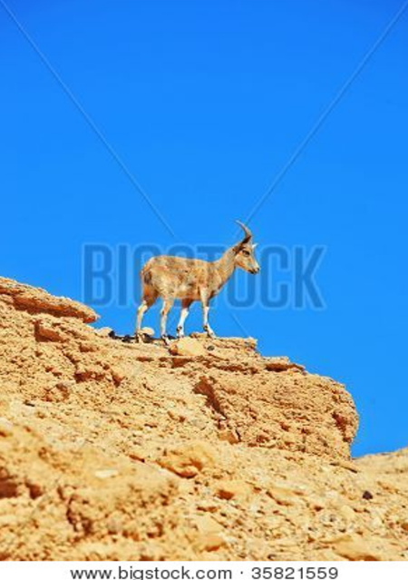
Bigstock Photo ID: 35821559
A wild mountain goat prepares to jump
Stock Photo ID: 35821559
Copyright: kavram
Bigstock Photo ID: 6488743
Jordan River
Detail of Jordan river near Sea of Galilee
Stock Photo ID: 6488743
Copyright: p_e_schan

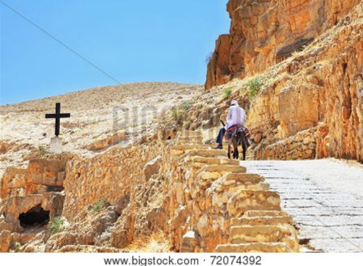
Bigstock Photo ID: 72074392
On the road, paved with stone, climbs on a donkey pilgrim in white clothes. Wadi Kelt, the road to the monastery of St. George
Stock Photo ID: 72074392
Copyright: kavram
Release: Signed model release filed with Bigstock.

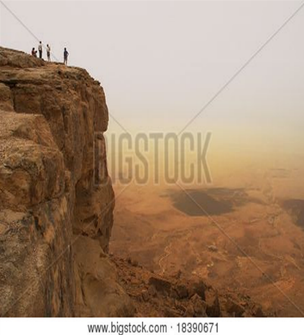
Bigstock Photo ID: 18390671
Cliff over the Ramon Crater in Negev Desert in Israel.
Stock Photo ID: 18390671
Copyright: rglinsky

Bigstock Photo ID: 75210547
Editing suggestion: Crop top of image to remove the blue lantern, slightly crop bottom of photo
Typical view of Jaffa's narrow old alley. Jaffa is part of Tel Aviv, Located to the south and known as an ancient port city that goes back to the bronze age.
Stock Photo ID: 75210547
Copyright: StockNinja

Bigstock Photo ID: 83570306
The spiral hill' in Timna Park in the southern part of the negev desert in Israel
Stock Photo ID: 83570306
Copyright: Robert Hoetink

Bigstock Photo ID: 41096473
Mountain river is flowing in Jerusalem Mountains area
Stock Photo ID: 41096473
Copyright: naxaso

Bigstock Photo ID: 366322858
Sunset view of the slopes of the Golan Heights, and the Hula Valley. Northern Israel
Stock Photo ID: 366322858
Copyright: RnDmS

Bigstock Photo ID: 458394293
Morning view of rocky landscape, and the Sea of Galilee, from Mount Arbel (west side). Northern Israel
Stock Photo ID: 458394293
Copyright: RnDmS

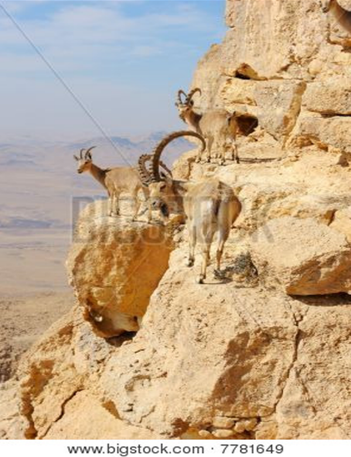
Bigstock Photo ID: 7781649
Mountain Goats In The Makhtesh Ramon
Makhtesh Ramon unique crater in Israel a top view
Stock Photo ID: 7781649
Copyright: Vladimir_Blinov

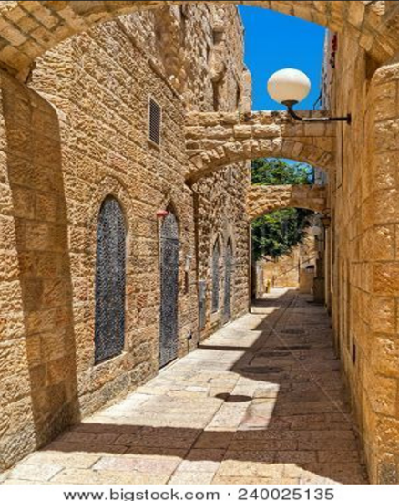
Bigstock Photo ID: 240025135
Narrow street among old stone houses in jewish quarter in Old City of Jerusalem, Israel (vertical composition).
Stock Photo ID: 240025135
Copyright: rglinsky
Bigstock Photo ID: 410697370
Editing suggestion: Crop puddle out of photo
A path in the Judea mountains, near Jerusalem, Israel, passing in an agricultural area, among old olive trees.
Stock Photo ID: 410697370
Copyright: Moshe Einhorn

Bigstock Photo ID: 2987805
Editing suggestion: Crop bottom of photo to remove shadows
The Jordan river with the sea of Galilee in the background
Stock Photo ID: 2987805
Copyright: Daydream.photo

Bigstock Photo ID: 59520380
The sun setting over the Mediterranean Haifa Israel.
Stock Photo ID: 59520380
Copyright: mlane

