Template for Jesus: His Life Events
The Word of God Series is a collection of 20 booklets that present Scripture verses in an easy-to-read format, with each booklet focused on a different topic.
Titles include Healthy Relationships, A Joy-Filled Life, Freedom from Depression, and many others.
The booklets are available in both paperback and digital formats at www.TheWordOfGodSeries.com or Amazon.com.
Why This Template?
Because I believe in the power of God’s Word to transform people’s lives, I have dedicated several years of my life to
bring this series to fruition.
I am passionate about using these booklets to reach
a dark and dying world with the love of Christ and
the hope of the Gospel.
Initially, I had expected this series would be a small business. But one day, when I asked God what my next steps should be,
He spoke to me through His Word and told me to:
“…complete the ministry God has given you.”
~ 2 Timothy 4:5 (NLT, 1996 version)
So, I shifted the focus from a business to a ministry.
My vision, also, has evolved over time and I have come to believe that it is possible for millions of these booklets to be distributed (in both print and digital formats) around the world (see the document entitled The Vision at www.TheWordOfGodSeries.com for more info.)
In order to make this a far-reaching ministry, accessing populations that I couldn’t on my own, I decided to invite others to partner with me in producing and distributing these booklets to their own personal networks. To help get it started, I have made templates of each booklet freely available to anyone who would like them.
This way you (whether you are a church, Christian organization or an individual) can easily re-create the booklets in your own ministry’s name, and distribute them to the people you minister to.
I hope that this template will save you:
- Time – so you can benefit from the thousands of hours
of development time that has been invested so far
- Money – eliminate layers of profit margin, and save on shipping costs (especially for large quantities)

Whether you simply replicate and reproduce what has already been done, build on it, or take this idea in a different direction, you won’t have to waste time starting with a blank page.
I hope you can easily get these finalized and printed, so you can begin sharing them with the people in your sphere of influence.
On the following pages you will find document formatting and printing tips.
Photo editing tips are also presented, as well as the preview images of each photo (with the Photo ID#), so you to easily find it on either bigstockphoto.com or shutterstock.com.

Photo Editing Tips
At the end of this document you will find the copyright and descriptive info for each photo in the booklet, as well as editing suggestions for a few of them.
Many photos will need to be slightly stretched or cropped to fit the page.
Most of the editing suggestions below (especially brightening or increasing color saturation) should be very slight adjustments.
Editing photos within this document
Wrapping text around the photo: Doubleclick the photo, click
on Wrap Text and select Square. Then, drag the image by the corner until it is the right size to wrap the text around it.
Rotate: Doubleclick the photo, click on the Rotate Object icon.

Editing photos in the Pictures editing app in MS Word
Navigate to your Pictures folder, doubleclick the photo, and click on the blue Edit button on left
Most of the editing can be done by using one of these 3 options:


Crop: Click on the Crop icon and drag edges to desired spot
Brighten a photo: Adjustment icon / Light / Brightness
Increase color saturation: Adjustment icon / Color / Saturation or Warmth
Remove distracting elements from a photo: Click on the Generative Erase icon, select a brush size and click on the part of the photo you want removed.

Photo Searching Tips
Occasionally photographers pull their photos from the sites,
so there may be some in this booklet that are no longer available.
You can try using the same key words to search for the photo
on other sites (scroll to the end of this document for more descriptive information about each photo.)
Or, you can search for another photo on Bigstock. Under
All Images select Photos and search by key word. At the next screen, make sure that Safe Search is on. In the Category field, select either Landscapes, Nature or Animals.

Booklet Formatting Tips
If you make any changes to this document that results in changing the number of lines on a page, then the page will need to be re-formatted for everything to fit.
Often changing the spacing between the characters or between the lines in one verse is enough to re-format it.
Changing the spacing between the characters
Home / Font / Advanced / Character Spacing
Choose Expanded or Condensed, and select a numeric value (best from .1 to .3)


Changing the spacing between the lines
Highlight all the text in the passage or page and click on:
Layout / Paragraph / Line Spacing / Multiple
Select a numeric value (best from .98 to 1.02)


Saving the document as a PDF
Adobe Acrobat Pro subscriptions are available at www.adobe.com/creativecloud/plans.html. You could also
ask your library tech center if they carry Adobe products.
When the Word doc is final: File / Save as Adobe PDF

Viewing the PDF as a booklet
Remove the first blank page of the doc: Edit / Trash icon.
Enter pages 1 to 1 to delete. Then exit from the Edit mode.
To view the document as a booklet, click on the page icon
(on right side of page, below the rotate button) and select
Two-page view and Show cover page.


Adding page numbers to the PDF
Edit / Header & Footer / Add / Add New
Under Font Name choose your font (this document uses the Georgia font) and under Size enter 8 pt.
Under Margins, in the Bottom box, enter .4
Click in box under Center Footer Text and click on the Insert Page Number button.
Click on Page Range Options. The Pages From _ to _
will depend on which page in your document you want read as Page 1 in the PDF.
In these booklets, the verses begin on Page 5 (after the forward page, copyright page, and Table of Contents).
If you plan to develop several booklets, select Save Settings.


Printing the Booklets
You can print these as regular paperbacks with a binding, (which look a bit nicer) or, you can print them with a staple binding. The staple binding does require a certain type of machine that can print them in a way that they open fully to any page (not just the center page) and lay flat. Your local printer may or may not have that capability, so discuss options with them.
A glossy cover is recommended, as it has a better feel than a matte finish. You may want to request the booklets be printed on Cougar® paper, which has a very smooth finish.

Stuck on a Step Above and Need Help?
If you want to do this project on your own, but are having tech issues with one of the steps above, feel free to contact me at Susan@TheWordOfGodSeries.com. I may be able to assist you, since I’ve gone through this whole process myself!

Need Help with the Whole Project?
If you want these booklets set up in your own in your own ministry’s name, but don’t have the resources to do the whole project yourself,
I may be able to manage that process for you for a one-time project fee.
This would include the following services:
- Set up an account with Bigstock and Shutterstock in your ministry’s name and purchase the rights for you to use each of the photos
- Download and name the photos
- Edit photos as needed
- Create a cover with your church or ministry logo
- Request the rights to use the various Bible translations from each of the publishers (if applicable)
Feel free to contact me at Susan@TheWordOfGodSeries.com to discuss pricing options.
I hope that this information will help you finalize this document with ease so you can begin distributing it to the people in your realm of influence.
Thank you for partnering with me in this effort. I wish you the best as you make God’s Word known and share His love with others!
Warmly in Christ,
Susan

Soli Deo gloria



Feel free to edit this forward page to align to your own ministry’s vision and goals.

The Bible is the best-selling and most transformative book in history. Written over 2,000 years ago, it is still living and powerful today.
Throughout the pages of Scripture you will find inspiration and joy, comfort and peace, healing and hope.
Most importantly, you will learn of God’s abundant love for you, and His plan to give you a glorious, eternal inheritance.
The Word of God Series is a collection of booklets which presents Scripture by topic, so you can focus on verses that are relevant to you at different stages and circumstances throughout your life.
All of the booklets in this series feature Scripture exclusively—
just the powerful, undiluted Word of God.
Let God’s Word permeate your mind and transform your life.
This is one of a four-booklet mini-series about Jesus Christ, the most influential and singular person in history. The titles in this series are:
Jesus: His Birth
Jesus: His Life Events
Jesus: His Teachings
Jesus: His Death, Resurrection and Return
The verses in this series are drawn primarily from the gospel accounts (the first four books of the New Testament: Matthew, Mark, Luke and John) which present a narrative on the life and ministry of Jesus.
This series includes many of the life events and teachings of Jesus, but it not comprehensive, so you are encouraged to also read each of the gospel accounts in their entirety.
In this series, text in italics are prophecies about the coming Messiah and “text in quotation marks” are the words of Christ.
Most of the imagery in this mini-series is from the Holy Land.

In this booklet, Jesus: His Life Events, you will read the eyewitness accounts testifying to Christ’s miracles and healings. You will also see how His love for people was reflected in His everyday life.
My prayer for you, as you read this series about Christ, is that you will accept the gift of eternal life that He died to give you and know that you belong to Him. I pray you will spend the remainder of your life seeking to look, live and love more like Jesus.
Let the word of Christ dwell in you richly…
~ Colossians 3:16a (ESV)

A few comments about this series:

- The booklets in this series provide you with a sample of what the Bible offers, but it is important that you also read the Bible itself, preferably with a book-by-book focus.

- Passages in quotation marks are the actual words of God, either through His prophets in the Old Testament, or the words of Christ
in the New Testament.

- Every booklet includes a section that details God’s plan of salvation (commonly referred to as “The Gospel.”) The booklet entitled God’s Gift of Eternal Life
is devoted to the Gospel message.

This series presents verses in the following translations:

NIV: New International Version
Scripture quotations marked NIV are taken from the Holy Bible, New International Version®, NIV®. Copyright © 1973, 1978, 1984, 2011 by Biblica, Inc.™ Used by permission of Zondervan. All rights reserved worldwide. www.zondervan.com. The "NIV" and "New International Version" are trademarks registered in the United States Patent and Trademark Office by Biblica, Inc.™

NLT: New Living Translation
Scripture quotations marked NLT are taken from the Holy Bible, New Living Translation, Copyright© 1996, 2004, 2015 by Tyndale House Foundation. Used by permission of Tyndale House Publishers, Inc., Carol Stream, Illinois 60188. All rights reserved.

ESV: English Standard Version
Scripture quotations marked ESV are taken from the ESV Bible® (The Holy Bible, English Standard Version®), copyright © 2001 by Crossway Bibles, a publishing ministry of Good News Publishers. Used by permission. All rights reserved.

KJV: King James Version
Public Domain

NKJV: New King James Version
Scripture quotations marked NKJV are taken from the New King James Version®. Copyright © 1982 by Thomas Nelson, Inc. Used by permission.

Since this is a template booklet featuring preview photos, it is not copyrighted, so you are free to purchase licenses to use the photos and develop your own booklets for print. Be sure to determine whether or not you need to request permission (and in some cases pay) for the rights to use the various Bible translations. Scripture verses were sourced from www.BibleGateway.com.
If it would be easier for you to simply purchase this booklet, the copyrighted version is available at www.TheWordOfGodSeries.com or www.amazon.com.
ISBN info for the copyrighted booklets is as follows:
The ISBN is 978-1-964538-02-0 and the Amazon ISBN is 9798356892073.
Jesus: His Life Events

Contents

John the Baptist Prepares the Way 1
Jesus’ Ministry Begins 3
The Baptism of Jesus
The Temptation of Jesus
Jesus and John the Baptist
Jesus Preaches Repentance
Jesus Chooses His Twelve Apostles
The Ministry of Jesus 11
Jesus Prays
Jesus Performs Miracles
Jesus Heals
Jesus Casts out Demons
Jesus Raises the Dead
Jesus Sends His Disciples
Jesus is Transfigured
How People Responded to Jesus 33
The Crowds Followed Him
The People Were Divided About Him
The Rejection of Jesus 37
Jesus Rejected in His Hometown
and by the People of Jerusalem
Jesus Rejected by the Religious Leaders
Why Jesus Came 42

John the Baptist
Prepares the Way

“Behold, I send My messenger, and he will prepare the way before Me.”

~ Malachi 3:1a (NKJV)

The voice of one crying in the wilderness:
“Prepare the way of the Lord;
Make straight in the desert
A highway for our God.”

~ Isaiah 40:3 (NKJV)

The beginning of the good news about Jesus the Messiah, the Son of God, as it is written in Isaiah the prophet:
“I will send my messenger ahead of you,
who will prepare your way”—
“a voice of one calling in the wilderness,
‘Prepare the way for the Lord,
make straight paths for him.’”
And so John the Baptist appeared in the wilderness, preaching a baptism of repentance for the forgiveness of sins.
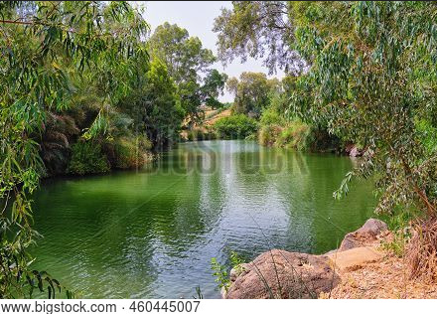
The whole Judean countryside and all the people of Jerusalem went out
to him.
Confessing their sins, they were baptized by him in the Jordan River.

~ Mark 1:1-5 (NIV)

Jordan River
In those days John the Baptist came preaching in the wilderness of Judea, and saying, “Repent, for the
kingdom of heaven is at hand!”

~ Matthew 3:1-2 (NKJV)

But when he saw many Pharisees and Sadducees coming to watch him baptize, he denounced them. “You brood of snakes!” he exclaimed. “Who warned you to flee God’s coming wrath? Prove by the way you live that you have repented of your sins and turned to God.”

~ Matthew 3:7-8 (NLT)

“I indeed baptize you with water unto repentance,
but He who is coming after me is mightier than I,
whose sandals I am not worthy to carry.
“He will baptize you with the Holy Spirit and fire.
“…He will thoroughly clean out His threshing floor, and gather His wheat into the barn; but He will burn up the chaff with unquenchable fire.”

~ Matthew 3:11-12 (NKJV)

“What should we do then?” the crowd asked.
John answered, “Anyone who has two shirts should
share with the one who has none, and anyone who has food should do the same.”
Even tax collectors came to be baptized. “Teacher,” they asked, “what should we do?” “Don’t collect any more than you are required to,” he told them.
Then some soldiers asked him, “And what should we do?” He replied, “Don’t extort money and don’t accuse people falsely—be content with your pay.”
The people were waiting expectantly and were all wondering in their hearts if John might possibly be the Messiah.

~ Luke 3:10-15 (NIV)

This was John’s testimony when the Jewish leaders sent priests and Temple assistants from Jerusalem to ask John, “Who are you?”
He came right out and said, “I am not the Messiah.”

~ John 1:19-20 (NLT)

Jesus’ Ministry Begins

The Baptism of Jesus

The next day John saw Jesus coming toward him, and said, “Behold! The Lamb of God who takes away the sin of the world!”

~ John 1:29 (NKJV)

In those days Jesus came from Nazareth of Galilee and was baptized by John in the Jordan.
And when he came up out of the water, immediately he saw the heavens being torn open and the Spirit descending on him like a dove. And a voice came from heaven, “You are my beloved Son; with you I am well pleased.”

~ Mark 1:9-11 (ESV)


Then John testified,
“I saw the Holy Spirit descending like a dove from heaven and resting upon him.
“I didn’t know he was the one,
God sent me to baptize with water, he told me,
‘The one on whom you see the Spirit descend and rest
is the one who will baptize with the Holy Spirit.’
“I saw this happen to Jesus, so I testify that he is the Chosen One of God.”

~ John 1:32-34 (NLT)

The Temptation of Jesus

Then Jesus, being filled with the Holy Spirit, returned from the Jordan and was led by the Spirit into the wilderness, being tempted for forty days by the devil.

~ Luke 4:1-2a (NKJV)

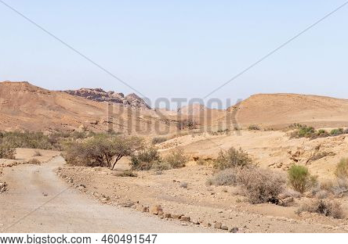

Road in Judean Desert

After fasting forty days and forty nights, he was hungry. The tempter came to him and said,
“If you are the Son of God, tell these stones to become bread.”
Jesus answered, “It is written:
‘Man shall not live on bread alone, but on every word that comes from the mouth of God.’”
Then the devil took him to the holy city and had him stand on the highest point of the temple.
“If you are the Son of God,” he said, “throw yourself down. For it is written: ‘He will command his angels concerning you, and they will lift you up in their hands, so that you will not strike your foot against a stone.’”
Jesus answered him, “It is also written:
‘Do not put the Lord your God to the test.’”
Again, the devil took him to a very high mountain and showed him all the kingdoms of the world and their splendor.
“All this I will give you,” he said, “if you will bow down and worship me.”
Jesus said to him, “Away from me, Satan! For it is written:
‘Worship the Lord your God, and serve him only.’”
Then the devil left him, and angels came and attended him.

~ Matthew 4:2-11 (NIV)

When the devil had finished tempting Jesus, he left him until the next opportunity came.

~ Luke 4:13 (NLT)

Jesus and John the Baptist

They came to John and said to him, “Rabbi, that man
who was with you on the other side of the Jordan—the one you testified about—look, he is baptizing, and everyone is going to him.”
To this John replied, “A person can receive only what is given them from heaven. You yourselves can testify that
I said, ‘I am not the Messiah but am sent ahead of him…’
“He must become greater; I must become less.”

~ John 3:26-30 (NIV)

After Jesus had finished instructing his twelve disciples, he went on from there to teach and preach in the towns
of Galilee.
When John, who was in prison, heard about the deeds of the Messiah, he sent his disciples to ask him, “Are you the one who is to come, or should we expect someone else?”
Jesus replied, “Go back and report to John what you
hear and see:
“The blind receive sight, the lame walk, those who have leprosy are cleansed, the deaf hear, the dead are raised, and the good news is proclaimed to the poor. Blessed is anyone who does not stumble on account of me.”
As John’s disciples were leaving, Jesus began to speak
to the crowd about John…
“This is the one about whom it is written:
‘I will send my messenger ahead of you,
who will prepare your way before you.’
“Truly I tell you, among those born of women there
has not risen anyone greater than John the Baptist;
yet whoever is least in the kingdom of heaven is greater
than he.”

~ Matthew 11:1-11 (NIV)

Jesus Preaches Repentance

In the past he humbled the land of Zebulun and the land of Naphtali, but in the future he will honor Galilee of the nations, by the Way of the Sea, beyond the Jordan—
The people walking in darkness
have seen a great light;
on those living in the land of deep darkness
a light has dawned.

~ Isaiah 9:1b-2 (NIV)

When Jesus heard that John had been put in prison,
he withdrew to Galilee.
Leaving Nazareth, he went and lived in Capernaum,
which was by the lake in the area of Zebulun and Naphtali—to fulfill what was said through the prophet Isaiah:
“Land of Zebulun and land of Naphtali,
the Way of the Sea, beyond the Jordan,
Galilee of the Gentiles—
the people living in darkness
have seen a great light;
on those living in the land of the shadow of death
a light has dawned.”
From that time on Jesus began to preach,
“Repent, for the kingdom of heaven has come near.”

~ Matthew 4:12-17 (NIV)
Very early in the morning, while it was still dark, Jesus got up, left the house and went off to a solitary place, where he prayed. Simon and his companions went to look for him, and when they found him, they exclaimed:
“Everyone is looking for you!”
Jesus replied, “Let us go somewhere else—to the nearby villages—so I can preach there also. That is why I have come.” So he traveled throughout Galilee…

~ Mark 1:35-39a (NIV)

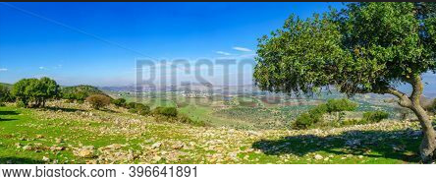

Galilee landscape

Jesus Chooses His Twelve Apostles

One day soon afterward Jesus went up on a mountain to pray, and he prayed to God all night. At daybreak he called together all of his disciples and chose twelve of them to be apostles. Here are their names:
Simon (whom he named Peter),
Andrew (Peter’s brother),
James,
John,
Philip,
Bartholomew,
Matthew,
Thomas,
James (son of Alphaeus),
Simon (who was called the zealot),
Judas (son of James),
Judas Iscariot (who later betrayed him).

~ Luke 6:12-16 (NLT)
And Jesus, walking by the Sea of Galilee, saw two brothers, Simon called Peter, and Andrew his brother, casting a net into the sea; for they were fishermen.
Then He said to them,
“Follow Me, and I will make you fishers of men.”
They immediately left their nets and followed Him.
Going on from there, He saw two other brothers, James the son of Zebedee, and John his brother, in the boat with Zebedee their father, mending their nets. He called them, and immediately they left the boat and their father, and followed Him.

~ Matthew 4:18-22 (NKJV)

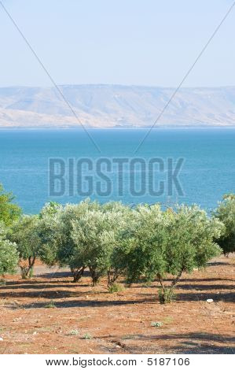

Sea of Galilee
One day as Jesus was preaching on the shore of the
Sea of Galilee, great crowds pressed in on him to listen
to the word of God. He noticed two empty boats at the water’s edge, for the fishermen had left them and were washing their nets. Stepping into one of the boats, Jesus asked Simon, its owner, to push it out into the water.
So he sat in the boat and taught the crowds from there.
When he had finished speaking, he said to Simon,
“Now go out where it is deeper, and let down your nets
to catch some fish.”
“Master,” Simon replied, “we worked hard all last night and didn’t catch a thing. But if you say so, I’ll let the nets down again.”
And this time their nets were so full of fish they began to tear! A shout for help brought their partners in the other boat, and soon both boats were filled with fish and on the verge of sinking.
When Simon Peter realized what had happened, he fell
to his knees before Jesus and said, “Oh, Lord, please
leave me—I’m too much of a sinner to be around you.”
For he was awestruck by the number of fish they had caught, as were the others with him. His partners,
James and John, the sons of Zebedee, were also amazed.
Jesus replied to Simon, “Don’t be afraid! From now on you’ll be fishing for people!” And as soon as they landed, they left everything and followed Jesus.

~ Luke 5:1-11 (NLT)

As Jesus went on from there, he saw a man named Matthew sitting at the tax collector’s booth. “Follow me,” he told him, and Matthew got up and followed him.
While Jesus was having dinner at Matthew’s house, many tax collectors and sinners came and ate with him and his disciples. When the Pharisees saw this, they asked his disciples, “Why does your teacher eat with tax collectors and sinners?” On hearing this, Jesus said, “It is not the healthy who need a doctor, but the sick. But go and learn what this means: ‘I desire mercy, not sacrifice.’ For I have not come to call the righteous, but sinners.”

~ Matthew 9:9-13 (NIV)
The next day Jesus decided to go to Galilee. He found Philip and said to him, “Come, follow me.” Philip was from Bethsaida, Andrew and Peter’s hometown. Philip went to look for Nathanael and told him, “We have found the very person Moses and the prophets wrote about!
His name is Jesus, the son of Joseph from Nazareth.”
“Nazareth!” exclaimed Nathanael. “Can anything good come from Nazareth?”
“Come and see for yourself,” Philip replied. As they approached, Jesus said, “Now here is a genuine son of Israel—a man of complete integrity.”
“How do you know about me?” Nathanael asked.
Jesus replied, “I could see you under the fig tree before Philip found you.”
Then Nathanael exclaimed, “Rabbi, you are the Son of God—the King of Israel!”

~ John 1:43-49 (NLT)

When Jesus came to the region of Caesarea Philippi,
he asked his disciples, “Who do people say that the
Son of Man is?”
“Well,” they replied, “some say John the Baptist,
some say Elijah, and others say Jeremiah or one of
the other prophets.”
Then he asked them, “But who do you say I am?”
Simon Peter answered,
“You are the Messiah, the Son of the living God.”
Jesus replied, “You are blessed, Simon son of John, because my Father in heaven has revealed this to you.
You did not learn this from any human being.
“Now I say to you that you are Peter (which means ‘rock’), and upon this rock I will build my church, and all the powers of hell will not conquer it. And I will give you the keys of the Kingdom of Heaven…”
Then he sternly warned the disciples not to tell anyone that he was the Messiah.

~ Matthew 16:13-20 (NLT)

The Ministry of Jesus

Jesus Prays

Very early in the morning, while it was still dark,
Jesus got up, left the house and went off to a solitary place, where he prayed.

~ Mark 1:35 (NIV)

…he would withdraw to desolate places and pray.

~ Luke 5:16 (ESV)

…when He had sent the multitudes away, He went up
on the mountain by Himself to pray.

~ Matthew 14:23a (NKJV)

…He went out to the mountain to pray, and continued all night in prayer to God.

~ Luke 6:12b (NKJV)

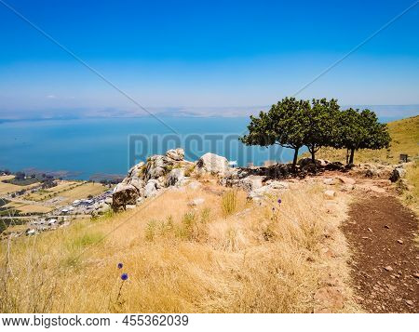

Mount Arbel, overlooking the Sea of Galilee

Jesus Performs Miracles

Jesus Turns Water to Wine
The next day there was a wedding celebration in the village of Cana in Galilee. Jesus’ mother was there, and Jesus and his disciples were also invited to the celebration.
The wine supply ran out during the festivities, so Jesus’ mother told him, “They have no more wine.”
“Dear woman, that’s not our problem,” Jesus replied.
“My time has not yet come.”
But his mother told the servants, “Do whatever he tells you.”
Standing nearby were six stone water jars…Jesus told the servants, “Fill the jars with water.” When the jars had been filled, he said, “Now dip some out, and take it to the master of ceremonies.” So the servants followed his instructions.
When the master of ceremonies tasted the water that was now wine, not knowing where it had come from (though, of course, the servants knew), he called the bridegroom over.
“A host always serves the best wine first,” he said. “Then, when everyone has had a lot to drink, he brings out the less expensive wine. But you have kept the best until now!”
This miraculous sign at Cana in Galilee was the first time Jesus revealed his glory. And his disciples believed in him.

~ John 2:1-11 (NLT)

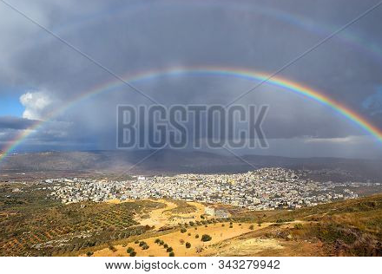

Arab village of Kafr Kanna in Galilee
(associated with the village of Cana depicted in the New Testament)
Jesus Feeds the Four Thousand
During those days another large crowd gathered. Since they had nothing to eat, Jesus called his disciples to him and said,
“I have compassion for these people; they have already been with me three days and have nothing to eat. If I send them home hungry, they will collapse on the way, because some of them have come a long distance.”
His disciples answered, “But where in this remote place can anyone get enough bread to feed them?”
“How many loaves do you have?” Jesus asked.
“Seven,” they replied.
He told the crowd to sit down on the ground.
When he had taken the seven loaves and given thanks,
he broke them and gave them to his disciples to distribute to the people, and they did so.
They had a few small fish as well; he gave thanks for them also and told the disciples to distribute them.
The people ate and were satisfied. Afterward the disciples picked up seven basketfuls of broken pieces that were left over. About four thousand were present.

~ Mark 8:1-9a (NIV)

Jesus Feeds the Five Thousand
Some time after this, Jesus crossed to the far shore of
the Sea of Galilee (that is, the Sea of Tiberias), and a great crowd of people followed him because they saw the signs he had performed by healing the sick.
Then Jesus went up on a mountainside and sat down with his disciples. The Jewish Passover Festival was near.
When Jesus looked up and saw a great crowd coming toward him, he said to Philip, “Where shall we buy bread for these people to eat?” He asked this only to test him, for he already had in mind what he was going to do. Philip answered him, “It would take more than half a year’s wages to buy enough bread for each one to have a bite!”
Another of his disciples, Andrew, Simon Peter’s brother, spoke up, “Here is a boy with five small barley loaves and two small fish, but how far will they go among so many?”
Jesus said, “Have the people sit down.”
There was plenty of grass in that place, and they sat down (about five thousand men were there).
Jesus then took the loaves, gave thanks, and distributed to those who were seated as much as they wanted. He did the same with the fish.
When they had all had enough to eat, he said to his disciples, “Gather the pieces that are left over. Let nothing be wasted.”
So they gathered them and filled twelve baskets with the pieces of the five barley loaves left over by those who had eaten.
After the people saw the sign Jesus performed, they began to say, “Surely this is the Prophet who is to come into the world.”
Jesus, knowing that they intended to come and make him king by force, withdrew again to a mountain by himself.

~ John 6:1-15 (NIV)

Jesus Walks on Water
Immediately he made the disciples get into the boat and go before him to the other side, while he dismissed the crowds.
And after he had dismissed the crowds, he went up on the mountain by himself to pray.
When evening came, he was there alone, but the boat by this time was a long way from the land, beaten by the waves, for the wind was against them.
And in the fourth watch of the night he came to them, walking on the sea.
But when the disciples saw him walking on the sea, they were terrified, and said, “It is a ghost!” and they cried out in fear.
But immediately Jesus spoke to them, saying, “Take heart; it is I. Do not be afraid.”
And Peter answered him, “Lord, if it is you, command me to come to you on the water.”
He said, “Come.” So Peter got out of the boat and walked on the water and came to Jesus.
But when he saw the wind, he was afraid, and beginning to sink he cried out, “Lord, save me.” Jesus immediately reached out his hand and took hold of him, saying to him, “O you of little faith, why did you doubt?” And when they got into the boat, the wind ceased. And those in the boat worshiped him, saying, “Truly you are the Son of God.”

~ Matthew 14:22-33 (ESV)

Jesus Calms the Storm
One day Jesus said to his disciples, “Let us go over to the other side of the lake.” So they got into a boat and set out.
As they sailed, he fell asleep.
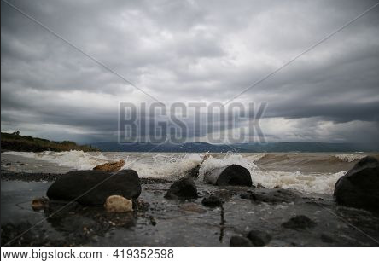
A squall came down on the lake, so that the boat was being swamped, and
they were in
great danger.
The disciples went and woke him, saying, “Master, Master, we’re going to drown!”
Sea of Galilee

He got up and rebuked the wind and the raging waters;
the storm subsided, and all was calm.
“Where is your faith?” he asked his disciples.

In fear and amazement they asked one another,

“Who is this? He commands even the winds and the water, and they obey him.”

~ Luke 8:22-25 (NIV)

Jesus Heals

And the power of the Lord was with Jesus to heal the sick.

~ Luke 5:17b (NIV)

Jesus Heals the Multitudes
Jesus went throughout Galilee, teaching in their synagogues, proclaiming the good news of the kingdom, and healing every disease and sickness among the people.
News about him spread all over Syria, and people brought to him all who were ill with various diseases, those suffering severe pain, the demon-possessed, those having seizures, and the paralyzed; and he healed them.
Large crowds from Galilee, the Decapolis, Jerusalem, Judea and the region across the Jordan followed him.

~ Matthew 4:23-25 (NIV)

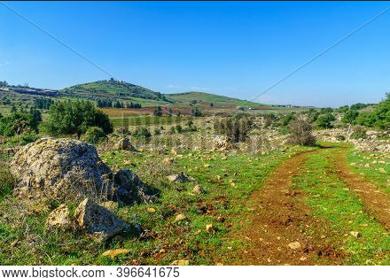

Galilee landscape

He had healed many people that day, so all the sick people eagerly pushed forward to touch him.

~ Mark 3:10 (NLT)
Jesus saw the huge crowd as he stepped from the boat, and he had compassion on them and healed their sick.

~ Matthew 14:14 (NLT)

…He laid His hands on every one of them and healed them.

~ Luke 4:40b (NKJV)

And the whole multitude sought to touch Him, for power went out from Him and healed them all.

~ Luke 6:19 (NKJV)

People brought all their sick to him and begged him to
let the sick just touch the edge of his cloak, and all who touched it were healed.

~ Matthew 14:35b-36 (NIV)

And great crowds came to him, bringing with them the lame, the blind, the crippled, the mute, and many others, and they put them at his feet, and he healed them…
And they glorified the God of Israel.

~ Matthew 15:30-31 (ESV)

Jesus Heals Specific People
So Jesus came again to Cana of Galilee where He had made the water wine. And there was a certain nobleman whose son was sick at Capernaum. When he heard that Jesus had come out of Judea into Galilee, he went to Him and implored Him to come down and heal his son, for he was at the point of death…
Jesus said to him, “Go your way; your son lives.” So the man believed the word that Jesus spoke to him, and he went his way. And as he was now going down, his servants met him and told him, saying, “Your son lives!”
Then he inquired of them the hour when he got better. And they said to him, “Yesterday at the seventh hour the fever left him.”
So the father knew that it was at the same hour in which Jesus said to him, “Your son lives.” And he himself believed, and his whole household.

~ John 4:46-53 (NKJV)
On the way to Jerusalem he was passing along between Samaria and Galilee.
And as he entered a village, he was met by ten lepers,
who stood at a distance and lifted up their voices, saying, “Jesus, Master, have mercy on us.”
When he saw them he said to them, “Go and show yourselves to the priests.” And as they went they were cleansed.
Then one of them, when he saw that he was healed,
turned back, praising God with a loud voice; and he
fell on his face at Jesus’ feet, giving him thanks.
Now he was a Samaritan.
Then Jesus answered, “Were not ten cleansed?
Where are the nine? Was no one found to return and
give praise to God except this foreigner?”
And he said to him,
“Rise and go your way; your faith has made you well.”

~ Luke 17:11-19 (ESV)

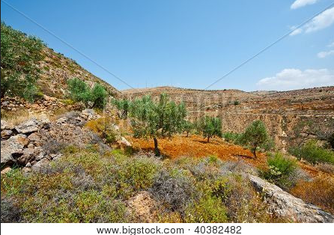

Samaria landscape
Now they came to Jericho. As He went out of Jericho with His disciples and a great multitude, blind Bartimaeus, the son of Timaeus, sat by the road begging.
And when he heard that it was Jesus of Nazareth, he began to cry out and say, “Jesus, Son of David, have mercy on me!” Then many warned him to be quiet; but he cried out all the more, “Son of David, have mercy on me!”
So Jesus stood still and commanded him to be called...
And throwing aside his garment, he rose and came to Jesus.
So Jesus answered and said to him, “What do you want Me to do for you?” The blind man said to Him, “Rabboni, that I may receive my sight.”
Then Jesus said to him, “Go your way; your faith has made you well.” And immediately he received his sight and followed Jesus on the road.

~ Mark 10:46-52 (NKJV)

A large crowd followed and pressed around him. And a woman was there who had been subject to bleeding for twelve years. She had suffered a great deal under the care of many doctors and had spent all she had, yet instead of getting better she grew worse.
When she heard about Jesus, she came up behind him in the crowd and touched his cloak, because she thought,
“If I just touch his clothes, I will be healed.” Immediately her bleeding stopped and she felt in her body that she was freed from her suffering.
At once Jesus realized that power had gone out from him. He turned around in the crowd and asked, “Who touched my clothes?”
“You see the people crowding against you,” his disciples answered, “and yet you can ask, ‘Who touched me?’”
But Jesus kept looking around to see who had done it.
Then the woman, knowing what had happened to her, came and fell at his feet and, trembling with fear, told him the whole truth. He said to her, “Daughter, your faith has healed you. Go in peace and be freed from your suffering.”

~ Mark 5:24b-34 (NIV)
Now when Jesus had entered Capernaum, a centurion came to Him, pleading with Him, saying, “Lord, my servant is lying at home paralyzed, dreadfully tormented.”
And Jesus said to him, “I will come and heal him.”
The centurion answered and said, “Lord, I am not worthy
that You should come under my roof. But only speak a word, and my servant will be healed…”
Then Jesus said to the centurion, “Go your way; and as you have believed, so let it be done for you.” And his servant was healed that same hour.

~ Matthew 8:5-13 (NKJV)

When Jesus returned to Capernaum several days later,
the news spread quickly that he was back home. Soon the house where he was staying was so packed with visitors that there was no more room, even outside the door.
While he was preaching God’s word to them, four men arrived carrying a paralyzed man on a mat. They couldn’t bring him to Jesus because of the crowd, so they dug a hole through the roof above his head. Then they lowered the man on his mat, right down in front of Jesus.
Seeing their faith, Jesus said to the paralyzed man,
“My child, your sins are forgiven.” But some of the teachers of religious law who were sitting there thought to themselves, “What is he saying? This is blasphemy! Only God can forgive sins!”
Jesus knew immediately what they were thinking, so he asked them, “Why do you question this in your hearts?
Is it easier to say to the paralyzed man ‘Your sins are forgiven,’ or ‘Stand up, pick up your mat, and walk’?
So I will prove to you that the Son of Man has the authority on earth to forgive sins.”
Then Jesus turned to the paralyzed man and said,
“Stand up, pick up your mat, and go home!” And the man jumped up, grabbed his mat, and walked out through the stunned onlookers. They were all amazed and praised God, exclaiming, “We’ve never seen anything like this before!”

~ Mark 2:1-12 (NLT)
When Jesus arrived at Peter’s house, Peter’s mother-in-law was sick in bed with a high fever.
But when Jesus touched her hand, the fever left her. Then she got up and prepared a meal for him.

~ Matthew 8:14-15 (NLT)

A man with leprosy came and knelt in front of Jesus, begging to be healed. “If you are willing, you can heal me and make me clean,” he said.
Moved with compassion, Jesus reached out and touched him. “I am willing,” he said. “Be healed!”
Instantly the leprosy disappeared, and the man was healed. Then Jesus sent him on his way with a stern warning: “Don’t tell anyone about this…”
But the man went and spread the word, proclaiming to everyone what had happened.
As a result, large crowds soon surrounded Jesus, and he couldn’t publicly enter a town anywhere. He had to stay out in the secluded places, but people from everywhere kept coming to him.

~ Mark 1:40-45 (NLT)

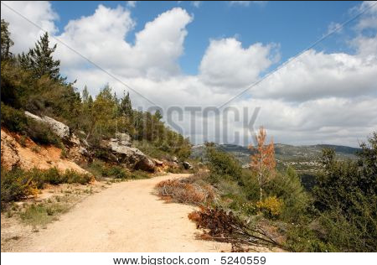

Path near Jerusalem
On a Sabbath Jesus was teaching in one of the synagogues, and a woman was there who had been crippled by a spirit for eighteen years. She was bent
over and could not straighten up at all.
When Jesus saw her, he called her forward and said to her, “Woman, you are set free from your infirmity.”
Then he put his hands on her, and immediately she straightened up and praised God.

~ Luke 13:10-13 (NIV)

Going on from that place, he went into their synagogue, and a man with a shriveled hand was there.
Looking for a reason to bring charges against Jesus,
they asked him, “Is it lawful to heal on the Sabbath?”
He said to them, “If any of you has a sheep and it falls into a pit on the Sabbath, will you not take hold of it and lift it out? How much more valuable is a person than a sheep! Therefore it is lawful to do good on the Sabbath.”
Then he said to the man, “Stretch out your hand.”
So he stretched it out and it was completely restored…
But the Pharisees went out and plotted how they might kill Jesus.

~ Matthew 12:9-14 (NIV)

While he was still speaking [in the Garden of Gethsemane] a crowd came up, and the man who was called Judas, one of the Twelve, was leading them…When Jesus’ followers saw what was going to happen, they said, “Lord, should we strike with our swords?”
And one of them struck the servant of the high priest, cutting off his right ear.
But Jesus answered, “No more of this!” And he touched the man’s ear and healed him.

~ Luke 22:47-51 (NIV)

Further Reading About Jesus’ Healing Miracles
Matthew 8 and 9 Mark 6:53-56 Mark 7:24-30
Mark 7:31-37 Mark 8:22-26 John 9:1-25
Jesus Casts Out Demons

He also drove out many demons, but he would not let
the demons speak because they knew who he was.

~ Mark 1:34b (NIV)

And whenever the unclean spirits saw him, they fell down before him and cried out, “You are the Son of God.”
And he strictly ordered them not to make him known.

~ Mark 3:11-12 (ESV)

Then he went down to Capernaum, a town in Galilee,
and on the Sabbath he taught the people.
They were amazed at his teaching, because his words
had authority.
In the synagogue there was a man possessed by a demon, an impure spirit. He cried out at the top of his voice,
“Go away! What do you want with us, Jesus of Nazareth? Have you come to destroy us? I know who you are—the Holy One of God!”
“Be quiet!” Jesus said sternly. “Come out of him!”
Then the demon threw the man down before them all
and came out without injuring him.
All the people were amazed and said to each other,
“What words these are! With authority and power he
gives orders to impure spirits and they come out!”
And the news about him spread throughout the surrounding area.

~ Luke 4:31-37 (NIV)

When the sun was setting, all those who had any that
were sick with various diseases brought them to Him;
and He laid His hands on every one of them and healed them.
And demons also came out of many, crying out and saying, “You are the Christ, the Son of God!”
And He, rebuking them, did not allow them to speak,
for they knew that He was the Christ.

~ Luke 4:40-41 (NKJV)
So they arrived at the other side of the lake, in the
region of the Gerasenes. When Jesus climbed out of the boat, a man possessed by an evil spirit came out from a
cemetery to meet him.
This man lived among the burial caves and could no longer be restrained, even with a chain. Whenever he was put into chains and shackles—as he often was—he snapped the chains from his wrists and smashed the shackles. No one was strong enough to subdue him.
Day and night he wandered among the burial caves and in the hills, howling and cutting himself with sharp stones.

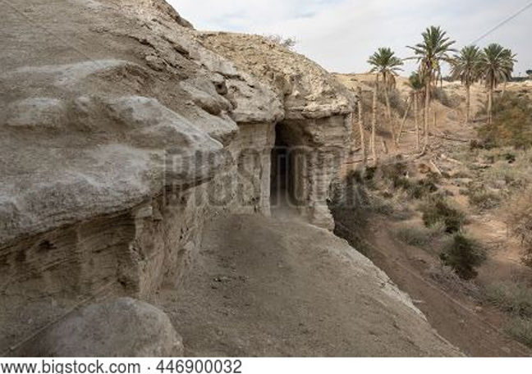

Cave in Judean desert

When Jesus was still some distance away, the man saw him, ran to meet him, and bowed low before him. With a shriek, he screamed, “Why are you interfering with me, Jesus, Son of the Most High God? In the name of God,
I beg you, don’t torture me!” For Jesus had already said
to the spirit, “Come out of the man, you evil spirit.”
Then Jesus demanded, “What is your name?”
And he replied, “My name is Legion, because there are many of us inside this man.”
Then the evil spirits begged him again and again not to send them to some distant place. There happened to be a large herd of pigs feeding on the hillside nearby. “Send us into those pigs,” the spirits begged. “Let us enter them.” So Jesus gave them permission. The evil spirits came out of the man and entered the pigs, and the entire herd of about 2,000 pigs plunged down the steep hillside into the lake and drowned in the water.
The herdsmen fled to the nearby town and the surrounding countryside, spreading the news as they ran.
People rushed out to see what had happened. A crowd soon gathered around Jesus, and they saw the man who had been possessed by the legion of demons. He was sitting there fully clothed and perfectly sane, and they were all afraid.
Then those who had seen what happened told the others about the demon-possessed man and the pigs. And the crowd began pleading with Jesus to go away and leave them alone.
As Jesus was getting into the boat, the man who had been demon possessed begged to go with him.
But Jesus said, “No, go home to your family, and tell them everything the Lord has done for you and how merciful he has been.” So the man started off to visit the Ten Towns of that region and began to proclaim the great things Jesus had done for him; and everyone was amazed at what he told them.

~ Mark 5:1-20 (NLT)

Then they brought him a demon-possessed man who was blind and mute, and Jesus healed him, so that he could both talk and see.
All the people were astonished and said, “Could this be
the Son of David?”

~ Matthew 12:22-23 (NIV)
And when they had come to the multitude, a man came
to Him, kneeling down to Him and saying, “Lord, have mercy on my son, for he is an epileptic and suffers severely; for he often falls into the fire and often into the water. So I brought him to Your disciples, but they could not cure him.”
Then Jesus answered and said, “O faithless and perverse generation, how long shall I be with you? How long shall
I bear with you? Bring him here to Me.”
And Jesus rebuked the demon, and it came out of him; and the child was cured from that very hour.
Then the disciples came to Jesus privately and said,
“Why could we not cast it out?”
So Jesus said to them, “Because of your unbelief; for assuredly, I say to you, if you have faith as a mustard seed, you will say to this mountain, ‘Move from here to there,’ and it will move; and nothing will be impossible for you.
“However, this kind does not go out except by prayer
and fasting.”

~ Matthew 17:14-21 (NKJV)

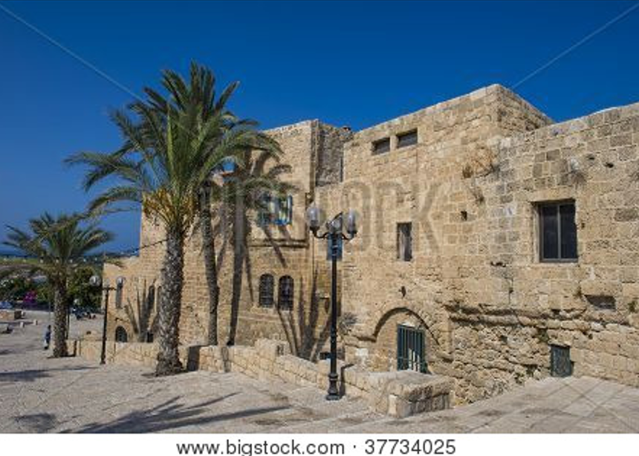

Jaffa, Israel

Jesus Raises the Dead

Jesus Raises a Widow’s Son
Soon afterward Jesus went with his disciples to the village of Nain, and a large crowd followed him. A funeral procession was coming out as he approached the village gate.
The young man who had died was a widow’s only son…
When the Lord saw her, his heart overflowed with compassion. “Don’t cry!” he said. Then he walked over to the coffin and touched it, and the bearers stopped. “Young man,” he said, “I tell you, get up.” Then the dead boy sat up and began to talk! And Jesus gave him back to his mother…
And the news about Jesus spread throughout Judea and the surrounding countryside.

~ Luke 7:11-17 (NLT)

Jesus Raises a Little Girl
Then one of the synagogue leaders, named Jairus, came, and when he saw Jesus, he fell at his feet. He pleaded earnestly with him, “My little daughter is dying. Please come and put your hands on her so that she will be healed and live.” So Jesus went with him…
While Jesus was still speaking, some people came from the house of Jairus, the synagogue leader. “Your daughter is dead,” they said. “Why bother the teacher anymore?” Overhearing what they said, Jesus told him, “Don’t be afraid; just believe.”
He did not let anyone follow him except Peter, James and John the brother of James. When they came to the home of the synagogue leader, Jesus saw a commotion, with people crying and wailing loudly. He went in and said to them, “Why all this commotion and wailing? The child is not dead but asleep.” But they laughed at him.
After he put them all out, he took the child’s father and mother and the disciples who were with him, and went in where the child was. He took her by the hand and said to her, “Talitha koum!” (which means “Little girl, I say to you, get up!”). Immediately the girl stood up and began to walk around (she was twelve years old).

~ Mark 5:22-24a, 35-42a (NIV)
Jesus Raises Lazarus
Now a man named Lazarus was sick. He was from Bethany, the village of Mary and her sister Martha. (This Mary, whose brother Lazarus now lay sick, was the same one who poured perfume on the Lord and wiped his feet with her hair.) So the sisters sent word to Jesus, “Lord, the one you love is sick.”
When he heard this, Jesus said, “This sickness will not end in death. No, it is for God’s glory so that God’s Son may be glorified through it.”
Now Jesus loved Martha and her sister and Lazarus.
So when he heard that Lazarus was sick, he stayed where he was two more days, and then he said to his disciples, “Let us go back to Judea…Our friend Lazarus has fallen asleep; but I am going there to wake him up.”
His disciples replied, “Lord, if he sleeps, he will get better.” Jesus had been speaking of his death, but his disciples thought he meant natural sleep. So then he told them plainly, “Lazarus is dead, and for your sake I am glad I was not there, so that you may believe. But let us go to him…”
On his arrival, Jesus found that Lazarus had already been in the tomb for four days. Now Bethany was less than two miles from Jerusalem, and many Jews had come to Martha and Mary to comfort them in the loss of their brother.
When Martha heard that Jesus was coming, she went out to meet him, but Mary stayed at home.
“Lord,” Martha said to Jesus, “if you had been here, my brother would not have died. But I know that even now God will give you whatever you ask.”
Jesus said to her, “Your brother will rise again.”
Martha answered, “I know he will rise again in the resurrection at the last day.”
Jesus said to her, “I am the resurrection and the life.
The one who believes in me will live, even though they die; and whoever lives by believing in me will never die.
Do you believe this?”
“Yes, Lord,” she replied, “I believe that you are the Messiah, the Son of God, who is to come into the world…”
When Mary reached the place where Jesus was and saw him, she fell at his feet and said, “Lord, if you had been here, my brother would not have died.” When Jesus saw her weeping, and the Jews who had come along with her also weeping, he was deeply moved in spirit and troubled…
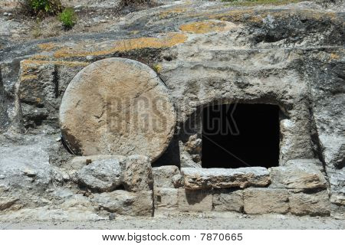
Jesus, once more deeply moved, came
to the tomb.
It was a cave with a stone laid across the entrance.
“Take away
the stone,”
he said…

Then Jesus said, “Did I not tell you that if you believe,
you will see the glory of God?” So they took away the stone.
Then Jesus looked up and said, “Father, I thank you that you have heard me. I knew that you always hear me, but
I said this for the benefit of the people standing here, that they may believe that you sent me.”
When he had said this, Jesus called in a loud voice,
“Lazarus, come out!”
The dead man came out, his hands and feet wrapped with strips of linen, and a cloth around his face. Jesus said to them, “Take off the grave clothes and let him go.”

~ John 11:1-44 (NIV)

Jesus Sends His Disciples

Jesus called his twelve disciples together and gave them authority to cast out evil spirits and to heal every kind of disease and illness…
Jesus sent out the twelve apostles with these instructions: “Don’t go to the Gentiles or the Samaritans, but only to the people of Israel—God’s lost sheep. Go and announce to them that the Kingdom of Heaven is near.
“Heal the sick, raise the dead, cure those with leprosy, and cast out demons. Give as freely as you have received!”

~ Matthew 10:1-8 (NLT)

When Jesus had called the Twelve together, he gave them power and authority to drive out all demons and to cure diseases, and he sent them out to proclaim the kingdom of God and to heal the sick.
He told them: “Take nothing for the journey—no staff,
no bag, no bread, no money, no extra shirt…”
So they set out and went from village to village, proclaiming the good news and healing people everywhere.

~ Luke 9:1-6 (NIV)

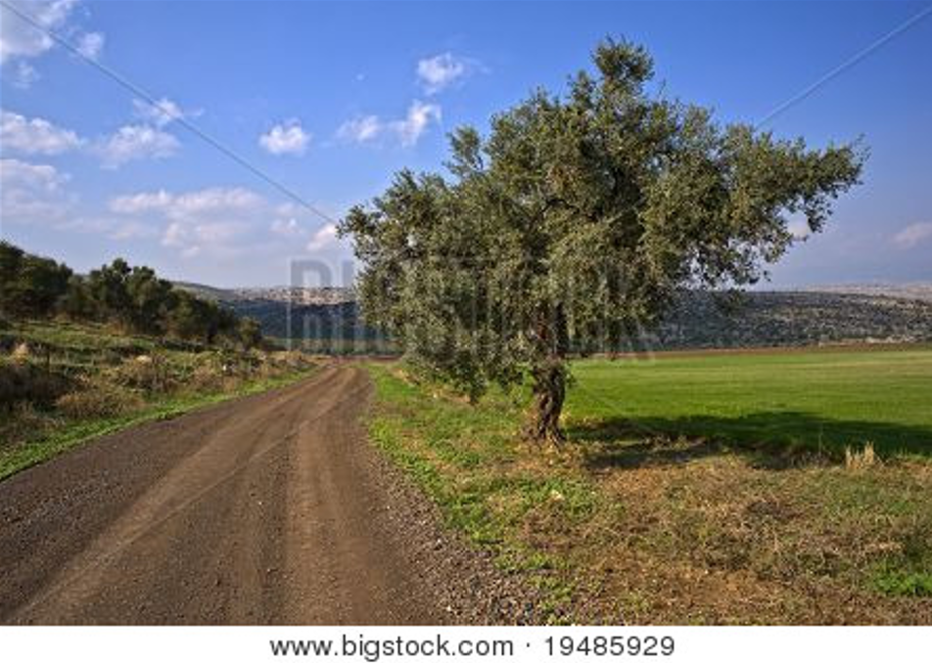

Road in Galilee
After this the Lord appointed seventy-two others and sent them two by two ahead of him to every town and place where he was about to go. He told them,
“The harvest is plentiful, but the workers are few.
“Ask the Lord of the harvest, therefore, to send out workers into his harvest field.
“Go! I am sending you out like lambs among wolves.
“Do not take a purse or bag or sandals; and do not greet anyone on the road.
“When you enter a house, first say, ‘Peace to this house.’
If someone who promotes peace is there, your peace will rest on them; if not, it will return to you. Stay there, eating and drinking whatever they give you, for the worker deserves his wages. Do not move around from house to house.
“When you enter a town and are welcomed, eat what is offered to you. Heal the sick who are there and tell them, ‘The kingdom of God has come near to you.’
“But when you enter a town and are not welcomed, go into its streets and say, ‘Even the dust of your town we wipe from our feet as a warning to you. Yet be sure of this:
The kingdom of God has come near.’ I tell you, it will be more bearable on that day for Sodom than for that town...
“Whoever listens to you listens to me; whoever rejects you rejects me; but whoever rejects me rejects him who sent me.”
The seventy-two returned with joy and said, “Lord, even the demons submit to us in your name.”
He replied, “I saw Satan fall like lightning from heaven.
“I have given you authority to trample on snakes and scorpions and to overcome all the power of the enemy; nothing will harm you.
“However, do not rejoice that the spirits submit to you, but rejoice that your names are written in heaven.”

~ Luke 10:1-20 (NIV)

Jesus is Transfigured

…Jesus took with him Peter, James and John the brother of James, and led them up a high mountain by themselves.
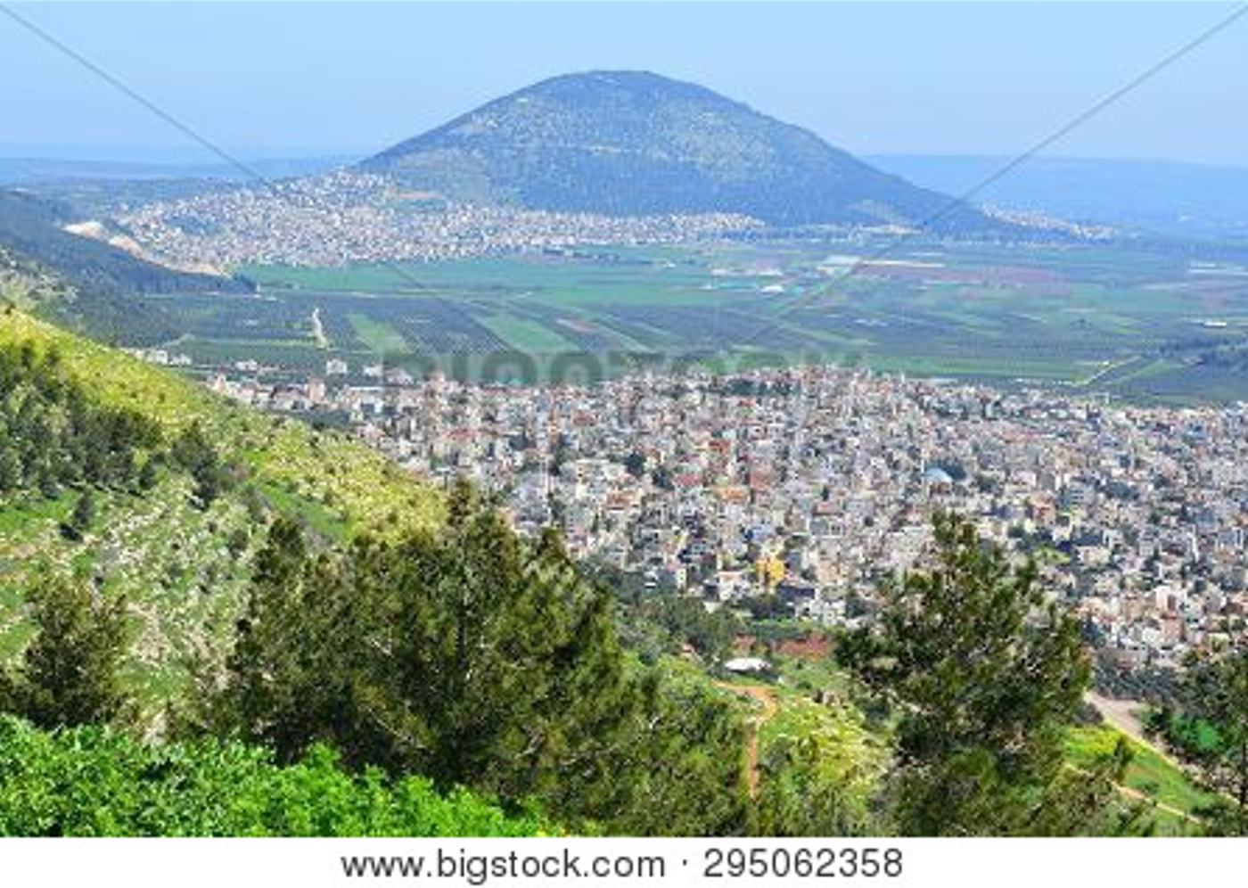

Mount Tabor (believed to be the site of the Transfiguration)

There he was transfigured before them.
His face shone like the sun, and his clothes became
as white as the light.
Just then there appeared before them Moses and Elijah, talking with Jesus. Peter said to Jesus, “Lord, it is good for us to be here. If you wish, I will put up three shelters—one for you, one for Moses and one for Elijah.”
While he was still speaking, a bright cloud covered them, and a voice from the cloud said,
“This is my Son, whom I love;
“with him I am well pleased.
“Listen to him!”
When the disciples heard this, they fell facedown to the ground, terrified. But Jesus came and touched them.
“Get up,” he said. “Don’t be afraid.” When they looked up, they saw no one except Jesus. As they were coming down the mountain, Jesus instructed them, “Don’t tell anyone what you have seen, until the Son of Man has been raised from the dead.”

~ Matthew 17:1b-9 (NIV)

How People Responded

to Jesus

The Crowds Followed Him

Meanwhile, the crowds grew until thousands were milling about and stepping on each other.

~ Luke 12:1a (NLT)

…so many thousands of the people had gathered together that they were trampling one another…

~ Luke 12:1a (ESV)

Jesus withdrew with his disciples to the sea, and a great crowd followed, from Galilee and Judea and Jerusalem and Idumea and from beyond the Jordan and from around Tyre and Sidon.
When the great crowd heard all that he was doing, they came to him. And he told his disciples to have a boat ready for him because of the crowd, lest they crush him, for he had healed many, so that all who had diseases pressed around him to touch him.

~ Mark 3:7-10 (ESV)

And when it was day, he departed and went into a desolate place. And the people sought him and came to him, and would have kept him from leaving them, but he said to them, “I must preach the good news of the kingdom of God to the other towns as well; for I was sent for this purpose.”

~ Luke 4:42-43 (ESV)

And He came down with them and stood on a level place with a crowd of His disciples and a great multitude of people from all Judea and Jerusalem, and from the seacoast of Tyre and Sidon, who came to hear Him and
be healed of their diseases, as well as those who were tormented with unclean spirits. And they were healed.

~ Luke 6:17-18 (NKJV)
Jesus and his companions went to the town of Capernaum.
When the Sabbath day came, he went into the synagogue and began to teach.
The people were amazed at his teaching, for he taught with real authority—quite unlike the teachers of religious law.

~ Mark 1:21-22 (NLT)

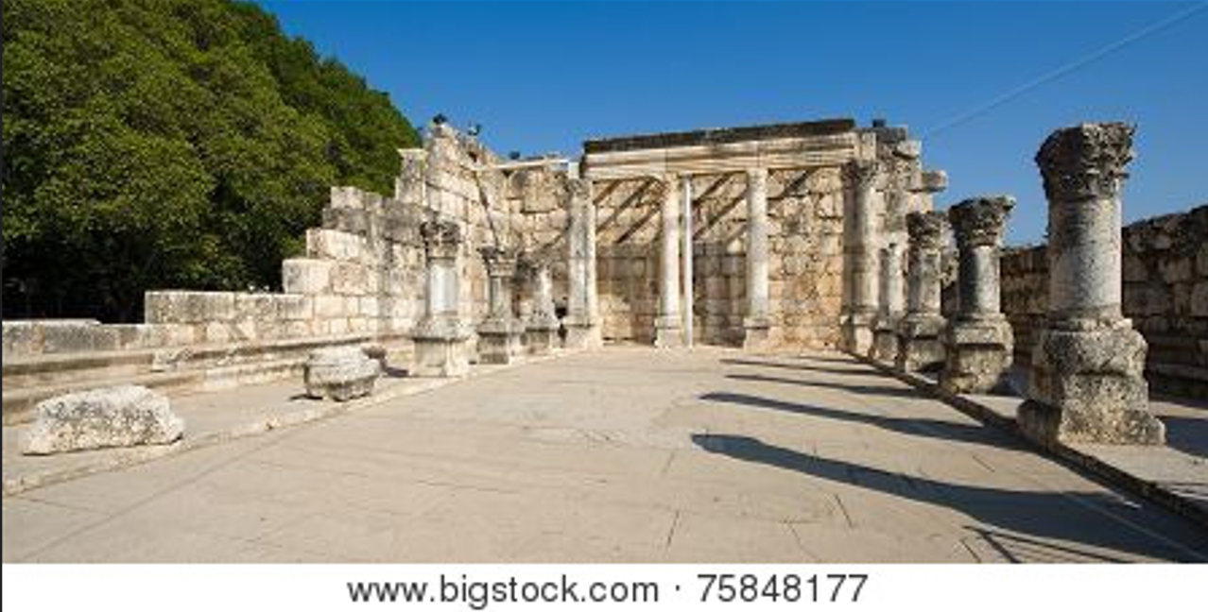

Ancient synagogue ruins in Capernaum

Even as he spoke, many believed in him.

~ John 8:30 (NIV)

As Jesus and his disciples were on their way, he came to
a village where a woman named Martha opened her home to him.
She had a sister called Mary, who sat at the Lord’s feet listening to what he said.
But Martha was distracted by all the preparations that had to be made. She came to him and asked, “Lord, don’t you care that my sister has left me to do the work by myself? Tell her to help me!”
“Martha, Martha,” the Lord answered, “you are worried and upset about many things, but few things are needed—or indeed only one. Mary has chosen what is better, and it will not be taken away from her.”

~ Luke 10:38-42 (NIV)
After this, Jesus traveled about from one town and village to another, proclaiming the good news of the kingdom of God. The Twelve were with him, and also some women who had been cured of evil spirits and diseases: Mary (called Magdalene) from whom seven demons had come out; Joanna the wife of Chuza, the manager of Herod’s household; Susanna; and many others.
These women were helping to support them out of their own means.

~ Luke 8:1-3 (NIV)

Now while he was in Jerusalem at the Passover Festival, many people saw the signs he was performing and believed in his name.
But Jesus would not entrust himself to them, for he knew all people. He did not need any testimony about mankind, for he knew what was in each person.

~ John 2:23-25 (NIV)

When he arrived in Galilee, the Galileans welcomed him. They had seen all that he had done in Jerusalem at the Passover Festival...

~ John 4:45a (NIV)

The People Were Divided About Him

Among the crowds there was widespread whispering about him. Some said, “He is a good man.” Others replied,
“No, he deceives the people.”
But no one would say anything publicly about him for
fear of the leaders.

~ John 7:12-13 (NIV)

At that point some of the people of Jerusalem began to ask, “Isn’t this the man they are trying to kill? Here he is, speaking publicly, and they are not saying a word to him. Have the authorities really concluded that he is the Messiah? But we know where this man is from; when the Messiah comes, no one will know where he is from.”

~ John 7:25-27 (NIV)
Still, many in the crowd believed in him. They said,
“When the Messiah comes, will he perform more signs than this man?” The Pharisees heard the crowd whispering such things about him. Then the chief priests and the Pharisees sent temple guards to arrest him.

~ John 7:31-32 (NIV)

When the Temple guards returned without having arrested Jesus, the leading priests and Pharisees demanded, “Why didn’t you bring him in?”
“We have never heard anyone speak like this!” the guards responded. “Have you been led astray, too?” the Pharisees mocked. “Is there a single one of us rulers or Pharisees who believes in him? This foolish crowd follows him,
but they are ignorant of the law. God’s curse is on them!”
Then Nicodemus, the leader who had met with Jesus earlier, spoke up. “Is it legal to convict a man before he is given a hearing?” he asked. They replied, “Are you from Galilee, too? Search the Scriptures and see for yourself—no prophet ever comes from Galilee!”

~ John 7:45-52 (NLT)

On the last and greatest day of the festival, Jesus stood and said in a loud voice,
“Let anyone who is thirsty come to me and drink.
“Whoever believes in me, as Scripture has said,
rivers of living water will flow from within them.”
By this he meant the Spirit, whom those who believed in him were later to receive. Up to that time the Spirit had not been given, since Jesus had not yet been glorified.
On hearing his words, some of the people said, “Surely this man is the Prophet.” Others said, “He is the Messiah.” Still others asked, “How can the Messiah come from Galilee? Does not Scripture say that the Messiah will come from David’s descendants and from Bethlehem, the town where David lived?”
Thus the people were divided because of Jesus.

~ John 7:37-43 (NIV)

The Rejection of Jesus

He came to his own, and his own people did not receive him. But to all who did receive him, who believed in his name, he gave the right to become children of God…

~ John 1:11-12 (ESV)

The stone the builders rejected has become the cornerstone…

~ Psalm 118:22 (NIV)

“But first he must suffer many things and be rejected
by this generation.”

~ Luke 17:25 (ESV)



Timna Valley, Israel

Who has believed our message? To whom has the Lord revealed his powerful arm?

~ Isaiah 53:1 (NLT)

“Harden the hearts of these people.
Plug their ears and shut their eyes.
That way, they will not see with their eyes,
nor hear with their ears,
nor understand with their hearts
and turn to me for healing.”

~ Isaiah 6:10 (NLT)

Jesus Rejected in His Hometown and by the People in Jerusalem

Jesus left that part of the country and returned with his disciples to Nazareth, his hometown.
The next Sabbath he began teaching in the synagogue,
and many who heard him were amazed. They asked, “Where did he get all this wisdom and the power to perform such miracles?”
Then they scoffed, “He’s just a carpenter, the son of Mary and the brother of James, Joseph, Judas, and Simon.
And his sisters live right here among us.” They were deeply offended and refused to believe in him.
Then Jesus told them, “A prophet is honored everywhere except in his own hometown and among his relatives and his own family.”
And because of their unbelief, he couldn’t do any miracles among them except to place his hands on a few sick people and heal them. And he was amazed at their unbelief.

~ Mark 6:1-6a (NLT)

Then Jesus returned to Galilee, filled with the Holy Spirit’s power. Reports about him spread quickly through the whole region. He taught regularly in their synagogues
and was praised by everyone.
When he came to the village of Nazareth, his boyhood home, he went as usual to the synagogue on the Sabbath and stood up to read the Scriptures. The scroll of Isaiah the prophet was handed to him. He unrolled the scroll and found the place where this was written:
“The Spirit of the Lord is upon me,
for he has anointed me
to bring Good News to the poor.
“He has sent me to proclaim that captives will be released,
that the blind will see,
that the oppressed will be set free,
and that the time of the Lord’s favor has come.”
He rolled up the scroll, handed it back to the attendant, and sat down. All eyes in the synagogue looked at him intently. Then he began to speak to them. “The Scripture you’ve just heard has been fulfilled this very day!”
Everyone spoke well of him and was amazed by the gracious words that came from his lips. “How can this be?” they asked. “Isn’t this Joseph’s son?”
Then he said, “You will undoubtedly quote me this proverb: ‘Physician, heal yourself’—meaning, ‘Do miracles here in your hometown like those you did in Capernaum.’
“But I tell you the truth, no prophet is accepted in his own hometown.
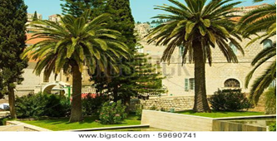

Nazareth, Israel

“Certainly there were many needy widows in Israel in Elijah’s time, when the heavens were closed for three and
a half years, and a severe famine devastated the land. Yet Elijah was not sent to any of them. He was sent instead to a foreigner—a widow of Zarephath in the land of Sidon. And there were many lepers in Israel in the time of the prophet Elisha, but the only one healed was Naaman, a Syrian.”
When they heard this, the people in the synagogue were furious. Jumping up, they mobbed him and forced him
to the edge of the hill on which the town was built. They intended to push him over the cliff, but he passed right through the crowd and went on his way.

~ Luke 4:14-30 (NLT)
Jesus’ brothers said to him, “Leave Galilee and go to Judea… Judea…show yourself to the world.” For even his own brothers did not believe in him.

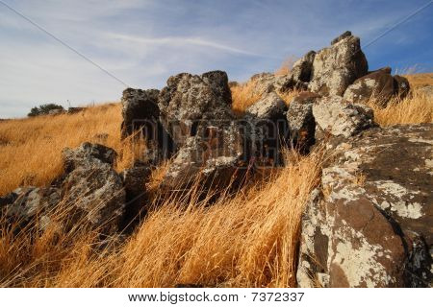
~ John 7:3-5 (NIV)

Landscape near Nazareth

But despite all the miraculous signs Jesus had done, most of the people still did not believe in him.
This is exactly what Isaiah the prophet had predicted:
“Lord, who has believed our message?
To whom has the Lord revealed his powerful arm?”
But the people couldn’t believe, for as Isaiah also said,
“The Lord has blinded their eyes
and hardened their hearts—
so that their eyes cannot see,
and their hearts cannot understand,
and they cannot turn to me
and have me heal them.”
Isaiah was referring to Jesus when he said this, because he saw the future and spoke of the Messiah’s glory.
Many people did believe in him, however, including some of the Jewish leaders. But they wouldn’t admit it for fear that the Pharisees would expel them from the synagogue.

~ John 12:37-42 (NLT)
Jesus said to them, “Have you never read in the Scriptures: ‘The stone the builders rejected has become the cornerstone...’
“Therefore…the kingdom of God will be taken away from you and given to a people who will produce its fruit.”

~ Matthew 21:42-43 (NIV)

The people surrounded him and asked, “How long are you going to keep us in suspense? If you are the Messiah, tell us plainly.” Jesus replied, “I have already told you, and you don’t believe me…But you don’t believe me because you are not my sheep. My sheep listen to my voice; I know them, and they follow me. I give them eternal life…
No one can snatch them away from me, for my Father
has given them to me…The Father and I are one.”
Once again the people picked up stones to kill him. Jesus said, “At my Father’s direction I have done many good works. For which one are you going to stone me?”
They replied, “We’re stoning you not for any good work, but for blasphemy! You, a mere man, claim to be God…” Once again they tried to arrest him, but he got away and left them.

~ John 10:24-39 (NLT)

Jesus Rejected by The Religious Leaders

Then the leading priests and Pharisees called the high council together.
“What are we going to do?” they asked each other.
“This man certainly performs many miraculous signs.
If we allow him to go on like this, soon everyone will believe in him. Then the Roman army will come and destroy both our Temple and our nation.” …
So from that time on, the Jewish leaders began to plot Jesus’ death.

~ John 11:47-53 (NLT)

When all the people heard of Jesus’ arrival, they flocked to see him and also to see Lazarus, the man Jesus had raised from the dead. Then the leading priests decided to kill Lazarus, too, for it was because of him that many of the people had deserted them and believed in Jesus.

~ John 12:9-11 (NLT)

Why Jesus Came

God loves you abundantly, and has made a way for you to live forever in His glorious kingdom. However, first He had to pay an enormous price for you to be forgiven of your sin, in order to receive this eternal glory. This section explains His plan to forgive and save you. In summary:
God loves you, but your sin separates you from Him, and because of it, God’s wrath will come. However, Jesus died as a sacrifice to save you from your sins, from God’s wrath, and from death itself. When you confess your sins, repent and accept the salvation that Christ offers, God will forgive you. By trusting in Christ you become God’s child, and as His child, you will inherit eternal life and heaven will be your home.

God Loves You

The Lord your God in your midst, The Mighty One, will save;
He will rejoice over you with gladness,
He will quiet you with His love,
He will rejoice over you with singing.

~ Zephaniah 3:17 (NKJV)

How great is the goodness
you have stored up for those who fear you.
You lavish it on those who come to you for protection,
blessing them before the watching world.

~ Psalm 31:19 (NLT)

For the Lord is good; His mercy is everlasting, and
His truth endures to all generations.

~ Psalm 100:5 (NKJV)

Taste and see that the Lord is good...

~ Psalm 34:8a (NIV)

The earth is full of the goodness of the Lord.

~ Psalm 33:5b (NKJV)

Oh, that men would give thanks to the Lord for His goodness, and for His wonderful works to the children of men!

~ Psalm 107:15 (NKJV)

Give thanks to the Lord, for he is good.

~ Psalm 136:1a (NIV)
Every good and perfect gift is from above, coming down from the Father of the heavenly lights…

~ James 1:17a (NIV)



Hermon Stream Nature Reserve, Golan Heights

How precious is your unfailing love, O God!
All humanity finds shelter in the shadow of your wings.

~ Psalm 36:7 (NLT)

Let your unfailing love surround us, Lord, for our hope
is in you alone.

~ Psalm 33:22 (NLT)

In your unfailing love you will lead the people you have redeemed.
In your strength you will guide them to your holy dwelling.

~ Exodus 15:13 (NIV)

For your unfailing love is as high as the heavens.
Your faithfulness reaches to the clouds.

~ Psalm 57:10 (NLT)

But Your Sin Separates You from God

…no one is innocent before you.

~ Psalm 143:2b (NLT)

We are all infected and impure with sin. When we display our righteous deeds, they are nothing but filthy rags.

~ Isaiah 64:6a (NLT)

The Day of God’s Wrath Will Come

Even now the ax of God’s judgment is poised, ready to sever the roots of the trees.
Yes, every tree that does not produce good fruit will be chopped down and thrown into the fire.

~ Matthew 3:10 (NLT)

The Lord thunders at the head of his army; his forces
are beyond number, and mighty is the army that obeys
his command.
The day of the Lord is great; it is dreadful. Who can endure it?

~ Joel 2:11 (NIV)

The wrath of God is being revealed from heaven against all the godlessness and wickedness of people, who suppress the truth by their wickedness, since what may be known about God is plain to them, because God has made it plain to them.
For since the creation of the world God’s invisible qualities—his eternal power and divine nature—have been clearly seen, being understood from what has been made, so that people are without excuse.
For although they knew God, they neither glorified him as God nor gave thanks to him, but their thinking became futile and their foolish hearts were darkened.

~ Romans 1:18-21 (NIV)

But because of your stubbornness and your unrepentant heart, you are storing up wrath against yourself for the day of God’s wrath, when his righteous judgment will be revealed.

~ Romans 2:5 (NIV)

Confess Your Sin and Repent

That is why the Lord says,
“Turn to me now, while there is time.
Give me your hearts.
Come with fasting, weeping, and mourning.”

~ Joel 2:12 (NLT)

This is what the Lord says:
“O Israel, my faithless people,
come home to me again,
for I am merciful.
I will not be angry with you forever.
Only acknowledge your guilt.
Admit that you rebelled against the Lord your God…
Confess that you refused to listen to my voice.
I, the Lord, have spoken!”

~ Jeremiah 3:12b-13 (NLT)

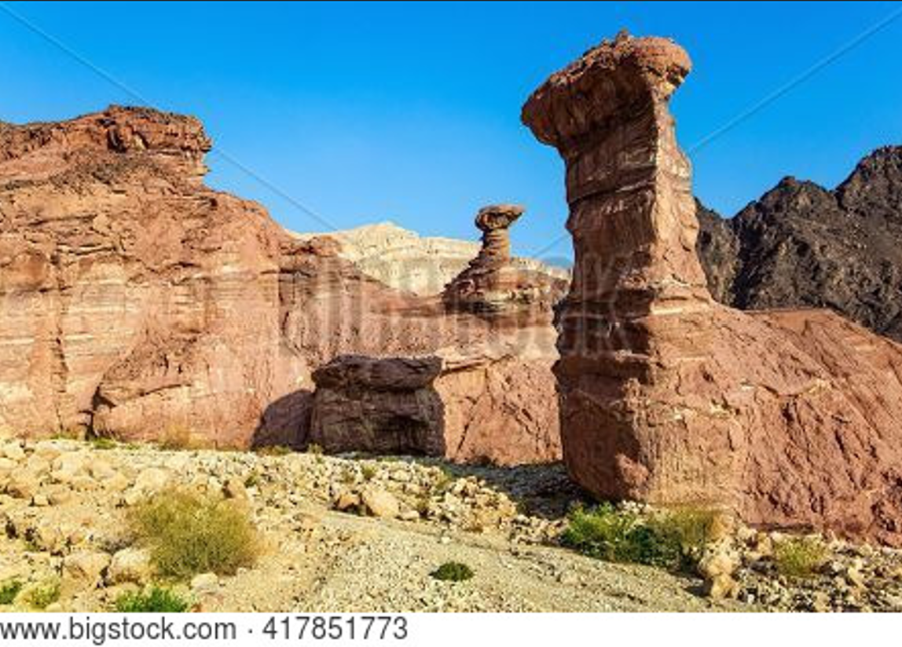

Eilat Mountains, Israel

So get rid of all the filth and evil in your lives and humbly accept the word God has planted in your hearts, for it has the power to save your souls.

~ James 1:21 (NLT)

Jesus Died to Save You…

…From Your Sin

He gave his life to free us from every kind of sin…

~ Titus 2:14a (NLT)

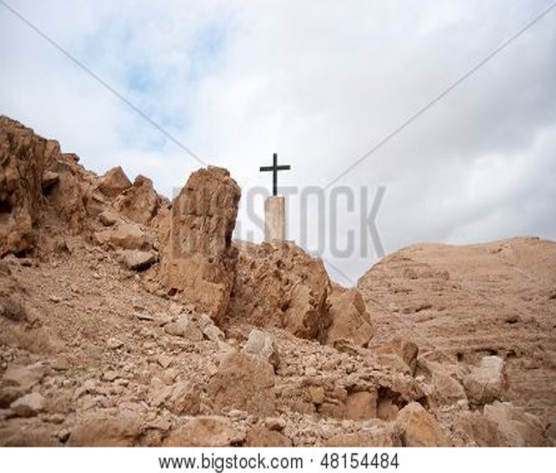
Then God
made you alive with Christ,
for he forgave
all our sins.
He canceled
the record of
the charges against us and took it away
by nailing it
to the cross.
~ Colossians
2:13b-14 (NLT)

Cross in Judean Desert

…the blood of Jesus Christ His Son cleanses us from
all sin.

~ 1 John 1:7b (NKJV)

…From God’s Wrath

Since we have now been justified by his blood, how much more shall we be saved from God's wrath through him!

~ Romans 5:9 (NIV)

…From Death

When Adam sinned, sin entered the world.
Adam’s sin brought death, so death spread to everyone...

~ Romans 5:12a (NLT)

Just as everyone dies because we all belong to Adam, everyone who belongs to Christ will be given new life.

~ 1 Corinthians 15:22 (NLT)

God Bought You at a Price

…without the shedding of blood there is no forgiveness of sins.

~ Hebrews 9:22b (ESV)

…without holiness no one will see the Lord.

~ Hebrews 12:14b (NIV)

…so Jesus also suffered outside the city gate to make the people holy through his own blood.

~ Hebrews 13:12 (NIV)

With his own blood…he entered the Most Holy Place
once for all time and secured our redemption forever.

~ Hebrews 9:12 (NLT)

In Christ You Are Forgiven

We are made right with God by placing our faith in Jesus Christ. And this is true for everyone who believes, no matter who we are.
For everyone has sinned; we all fall short of God’s glorious standard.
Yet God, in his grace, freely makes us right in his sight.
He did this through Christ Jesus when he freed us from
the penalty for our sins.

~ Romans 3:22-24 (NLT)

Oh, what joy for those whose disobedience is forgiven, whose sin is put out of sight!
Yes, what joy for those whose record the Lord has cleared of guilt…

~ Psalm 32:1-2a (NLT)

“For I will forgive their wickedness and will remember their sins no more.”

~ Hebrews 8:12 (NIV)

“I will give you a new heart and put a new spirit in you;
“I will remove from you your heart of stone and give you
a heart of flesh.”

~ Ezekiel 36:26 (NIV)

God Demonstrates His Love Through Christ

“For God so loved the world that He gave His only begotten Son, that whoever believes in Him should
not perish but have everlasting life.”

~ John 3:16 (NKJV)

…we have peace with God because of what Jesus
Christ our Lord has done for us.
Because of our faith, Christ has brought us into this
place of undeserved privilege where we now stand, and
we confidently and joyfully look forward to sharing
God’s glory.

~ Romans 5:1b-2 (NLT)

And I pray that you, being rooted and established in love, may have power, together with all the Lord’s holy people, to grasp how wide and long and high and deep is the love of Christ, and to know this love that surpasses knowledge…

~ Ephesians 3:17b-19a (NIV)

Salvation is Through Christ Alone

We are made right with God by placing our faith in
Jesus Christ.

~ Romans 3:22a (NLT)

Because of Christ and our faith in him, we can now come boldly and confidently into God’s presence.

~ Ephesians 3:12 (NLT)

Salvation is found in no one else, for there is no other name under heaven given to mankind by which we must be saved.

~ Acts 4:12 (NIV)

…he became the source of eternal salvation to all who obey him…

~ Hebrews 5:9b (ESV)

Jesus said to him, “I am the way, the truth, and the life. No one comes to the Father except through Me.”

~ John 14:6 (NKJV)

“Most assuredly, I say to you, he who believes in Me
has everlasting life.”

~ John 6:47 (NKJV)
Scripture foresaw that God would justify the Gentiles by faith, and announced the gospel in advance to Abraham:
“All nations will be blessed through you.”

~ Galatians 3:8 (NIV)

The Lord had said to Abram,
“Go...to the land I will show you.
I will make you into a great nation,
and I will bless you…
I will bless those who bless you,
and whoever curses you I will curse;
and all peoples on earth
will be blessed through you.”

~ Genesis 12:1-3 (NIV)

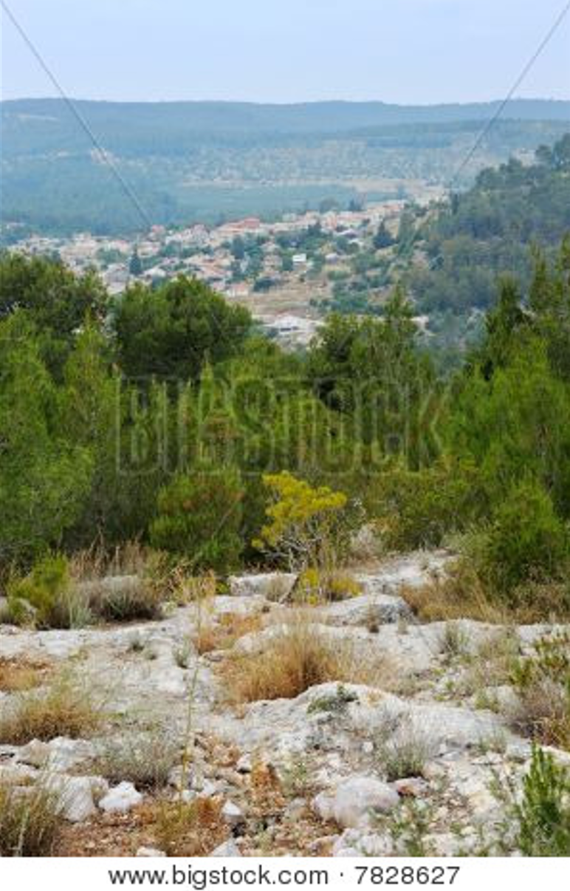
God promised this Good News long ago through his prophets in the holy Scriptures.
The Good News is about his Son.
In his earthly life he was born into King David’s family line, and he was shown to be the Son of God when he was raised from the dead by the power of the Holy Spirit.
He is Jesus Christ our Lord.
~ Romans 1:2-4 (NLT)

Mountain landscape near Jerusalem
Salvation is a Gift: Free and Undeserved

Salvation is not a reward for the good things we have done, so none of us can boast about it.

~ Ephesians 2:9 (NLT)

For it is by grace you have been saved, through faith—
and this not from yourselves, it is the gift of God—
not by works, so that no one can boast.

~ Ephesians 2:8-9 (NIV)

…he saved us, not because of the righteous things we had done, but because of his mercy…
Because of his grace he made us right in his sight and gave us confidence that we will inherit eternal life.

~ Titus 3:5-7 (NLT)

Can we boast, then, that we have done anything to be accepted by God? No, because our acquittal is not based on obeying the law. It is based on faith.

~ Romans 3:27 (NLT)


For God saved us and called us to live a holy life.
He did this, not because we deserved it, but because that was his plan from before the beginning
of time—
to show us his grace through Christ Jesus.

~ 2 Timothy 1:9 (NLT) Sea Caves of Rosh HaNikra
Accept This Gift of Salvation

…I am not ashamed of the gospel, because it is the power of God that brings salvation to everyone who believes: first to the Jew, then to the Gentile.

~ Romans 10:9 (NIV)

If you declare with your mouth, “Jesus is Lord,” and believe in your heart that God raised him from the dead, you will be saved.

~ Romans 10:9 (NIV)

What are you waiting for? Get up and be baptized.
Have your sins washed away by calling on the name
of the Lord.

~ Acts 22:16 (NLT)

This is all the more urgent, for you know how late it is; time is running out.

~ Romans 13:11a (NLT)

God’s promise of entering his rest still stands, so we
ought to tremble with fear that some of you might fail
to experience it.

~ Hebrews 4:1 (NLT)

…how shall we escape if we ignore so great a salvation?

~ Hebrews 2:3a (NIV)

“If you do not remain in me, you are like a branch that is thrown away and withers; such branches are picked up, thrown into the fire and burned.”

~ John 15:6 (NIV)

“…but the one who stands firm to the end will be saved.”

~ Matthew 24:13 (NIV)

But we are not like those who turn away from God to
their own destruction. We are the faithful ones, whose souls will be saved.

~ Hebrews 10:39 (NLT)

For if we are faithful to the end, trusting God just as firmly as when we first believed, we will share in all that belongs to Christ.

~ Hebrews 3:14 (NLT)

You Belong to God Through Faith in Christ
and Have Become His Child

For you are all children of God through faith in
Christ Jesus.

~ Galatians 3:26 (NLT)

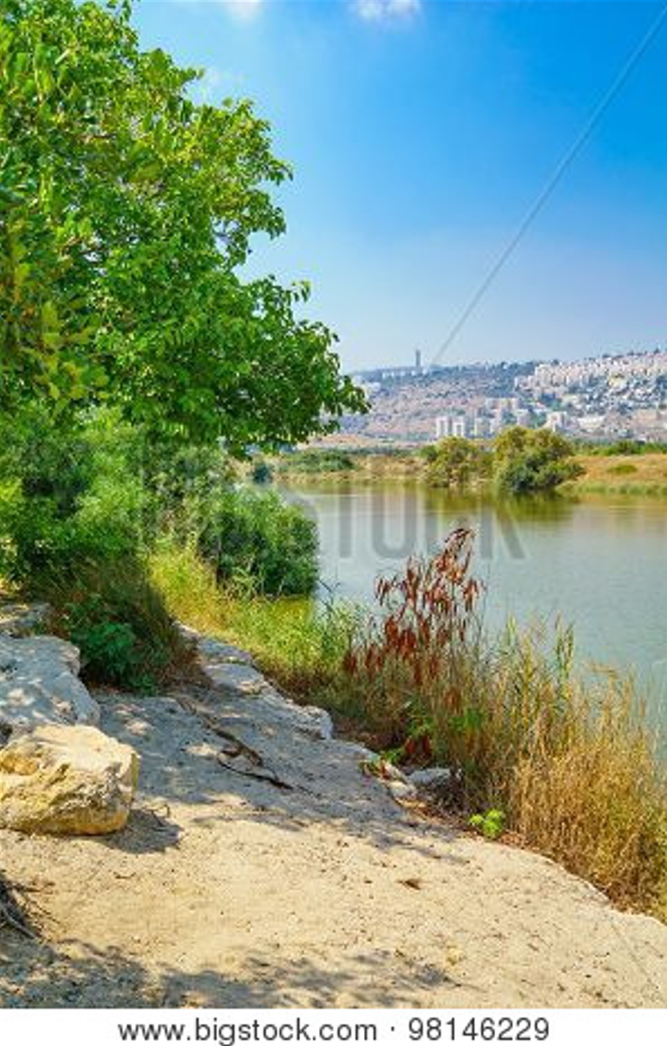
Now all of us can come to the Father through
the same
Holy Spirit because of what Christ has done
for us.
~ Ephesians 2:18 (NLT)

He anointed us, set his seal of ownership on us, and put his Spirit in our hearts as
a deposit, guaranteeing
what is to come.
~ 2 Corinthians 1:21b-22 (NIV)

Anyone who does not have the Spirit of Christ does
not belong
to him.
~ Romans 8:9b (ESV)
Kishon River near Haifa, Israel

Eternal Life is Yours Through Christ

…God gave us eternal life, and this life is in his Son.

~ 1 John 5:11b (ESV)

I pray that your hearts will be flooded with light so that you can understand the confident hope he has given to those he called—his holy people who are his rich and glorious inheritance.

~ Ephesians 1:18 (NLT)

For you have been born again…Your new life will last forever because it comes from the eternal, living word of God.

~ 1 Peter 1:23 (NLT)

And now I entrust you to God and the message of his grace that is able to build you up and give you an inheritance with all those he has set apart for himself.

~ Acts 20:32 (NLT)

You can be sure of this:
The Lord set apart the godly for himself.

~ Psalm 4:3a (NLT)

…our citizenship is in heaven, and from it we await a Savior, the Lord Jesus Christ...

~ Philippians 3:20 (ESV)

…we wait for the blessed hope—the appearing of the glory of our great God and Savior, Jesus Christ...

~ Titus 2:13 (NIV)

When Christ who is your life appears, then you also will appear with him in glory.

~ Colossians 3:4 (ESV)

For the Lord himself will come down from heaven, with
a loud command, with the voice of the archangel and with
the trumpet call of God, and the dead in Christ will rise first.
After that, we who are still alive and are left will be caught up together with them in the clouds to meet the Lord in the air.
And so we will be with the Lord forever.
Therefore encourage one another with these words.

~ 1 Thessalonians 4:16-18 (NIV)
Then He who sat on the throne said,
“Behold, I make all things new.”

~ Revelation 21:5a (NKJV)

“See, I will create
new heavens and a new earth.
The former things will not be remembered,
nor will they come to mind.
But be glad and rejoice forever
in what I will create,
for I will create Jerusalem to be a delight
and its people a joy.
I will rejoice over Jerusalem
and take delight in my people;
the sound of weeping and of crying
will be heard in it no more.”

~ Isaiah 65:17-19 (NIV)

Then I saw “a new heaven and a new earth,” for the first heaven and the first earth had passed away, and there was no longer any sea. I saw the Holy City, the new Jerusalem, coming down out of heaven from God, prepared as a bride beautifully dressed for her husband.
And I heard a loud voice from the throne saying, “Look! God’s dwelling place is now among the people, and he
will dwell with them…”
And he carried me away in the Spirit to a mountain
great and high, and showed me the Holy City, Jerusalem, coming down out of heaven from God. It shone with the glory of God, and its brilliance was like that of a very precious jewel, like a jasper, clear as crystal…
The twelve gates were twelve pearls, each gate made of
a single pearl.
The great street of the city was of gold, as pure as transparent glass….
Nothing impure will ever enter it, nor will anyone who does what is shameful or deceitful, but only those whose names are written in the Lamb’s book of life.

~ Excerpts from Revelation 21 (NIV)
In Jerusalem, the Lord of Heaven’s Armies
will spread a wonderful feast
for all the people of the world.
It will be a delicious banquet
with clear, well-aged wine and choice meat.
There he will remove the cloud of gloom,
the shadow of death that hangs over the earth.
He will swallow up death forever!
The Sovereign Lord will wipe away all tears.

~ Isaiah 25:6-8a (NLT)

He will wipe away every tear from their eyes, and death shall be no more, neither shall there be mourning, nor crying, nor pain anymore, for the former things have passed away.

~ Revelation 21:4 (ESV)
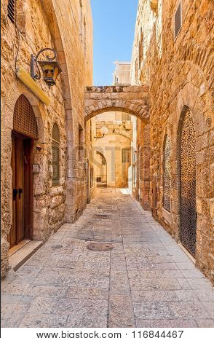

Those who have been ransomed
by the Lord will return.

They will enter Jerusalem singing, crowned
with everlasting joy.

Sorrow and mourning will disappear,
and they will be filled with joy and gladness.

~ Isaiah 51:11 (NLT)

Old City of Jerusalem
In that day the people will proclaim, “This is our God!
We trusted in him, and he saved us!”

~ Isaiah 25:9a (NLT)

“In that day the wolf and the lamb will live together;
the leopard will lie down with the baby goat.
“The calf and the yearling will be safe with the lion,
and a little child will lead them all.
“The cow will graze near the bear.
The cub and the calf will lie down together.
The lion will eat hay like a cow…
“Nothing will hurt or destroy in all my holy mountain…”

~ Isaiah 11:6-9a (NLT)

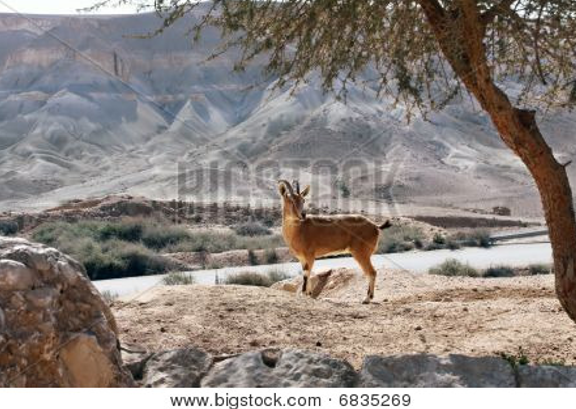

Wild goat in the mountains

…the creation looks forward to the day when it will join God’s children in glorious freedom from death and decay.

~ Romans 8:21 (NLT)

Heaven is Your Home

Jesus answered,
“My kingdom is not of this world.”

~ John 18:36a (ESV)

“The kingdom of heaven is like treasure hidden in a field.
“When a man found it, he hid it again, and then in his joy went and sold all he had and bought that field.”

~ Matthew 13:44 (NIV)

“If you belonged to the world, it would love you as its own.
“As it is, you do not belong to the world, but I have chosen you out of the world.”

~ John 15:19a (NIV)

“For many are called, but few are chosen.”

~ Matthew 22:14 (ESV)

“…rejoice because your names are written in heaven.”

~ Luke 10:20b (NKJV)

Jesus answered him,
“Truly I tell you, today you will be with me in paradise.”

~ Luke 23:43 (NIV)

“For my Father’s will is that everyone who looks to the Son and believes in him shall have eternal life, and I will raise them up at the last day.”

~ John 6:40 (NIV)

“To the one who is victorious, I will give the right to eat from the tree of life, which is in the paradise of God.”

~ Revelation 2:7b (NIV)

“All who are victorious will be clothed in white. I will never erase their names from the Book of Life…”

~ Revelation 3:5a (NLT)

“So don’t be afraid, little flock. For it gives your Father great happiness to give you the Kingdom.”

~ Luke 12:32 (NLT)

“And be sure of this:
“I am with you always, even to the end of the age.”

~ Matthew 28:20b (NLT)
Praise God for His Gift of Eternal Life

“…rejoice because your names are written in heaven.”

~ Luke 10:20b (NKJV)

The Spirit is God’s guarantee that he will give us the inheritance he promised and that he has purchased us
to be his own people.
He did this so we would praise and glorify him.

~ Ephesians 1:14 (NLT)

So we praise God for the glorious grace he has poured out on us who belong to his dear Son.

~ Ephesians 1:6 (NLT)

All your works praise you, Lord;
your faithful people extol you.
They tell of the glory of your kingdom
and speak of your might,
so that all people may know of your mighty acts
and the glorious splendor of your kingdom.
Your kingdom is an everlasting kingdom,
and your dominion endures through all generations.

~ Psalm 145:10-13a (NIV)



Sunset view of the Mediterranean Sea from Mount Carmel, Israel

Booklet Titles in the Series



www.TheWordOfGodSeries.com

Booklet Titles in the Series

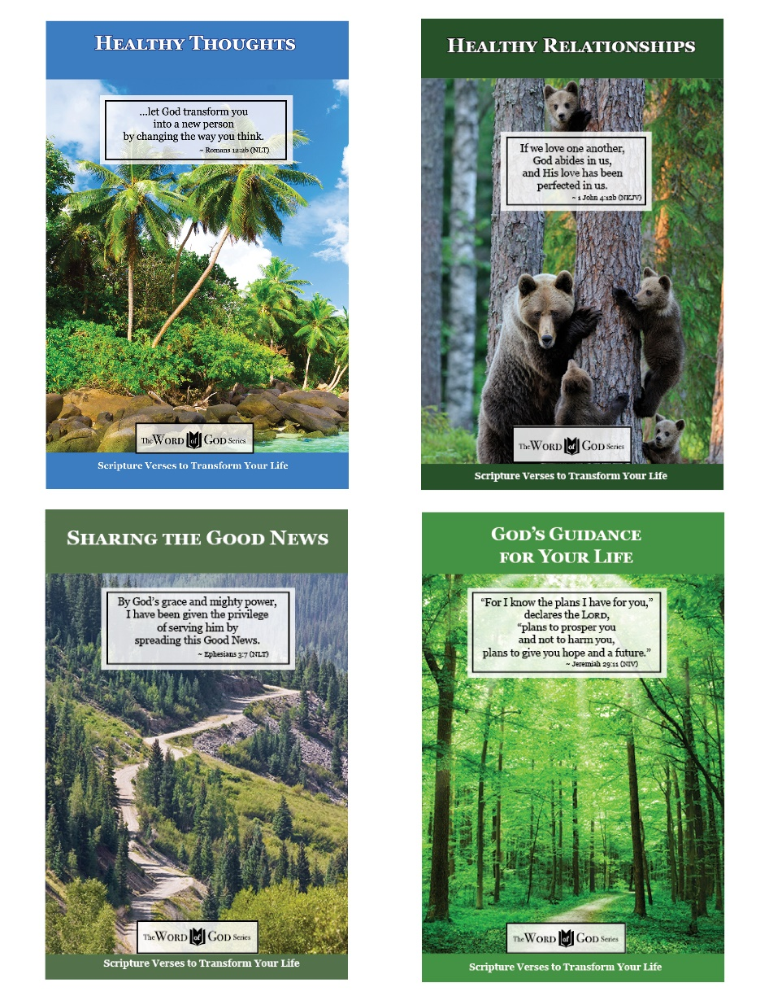

www.TheWordOfGodSeries.com

Booklet Titles in the Series

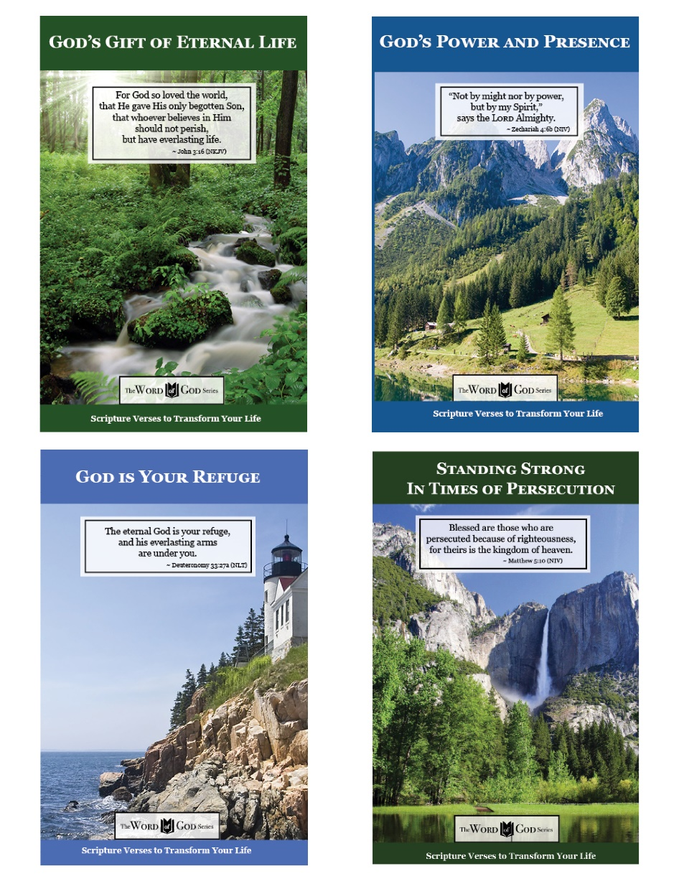

www.TheWordOfGodSeries.com

Booklet Titles in the Series

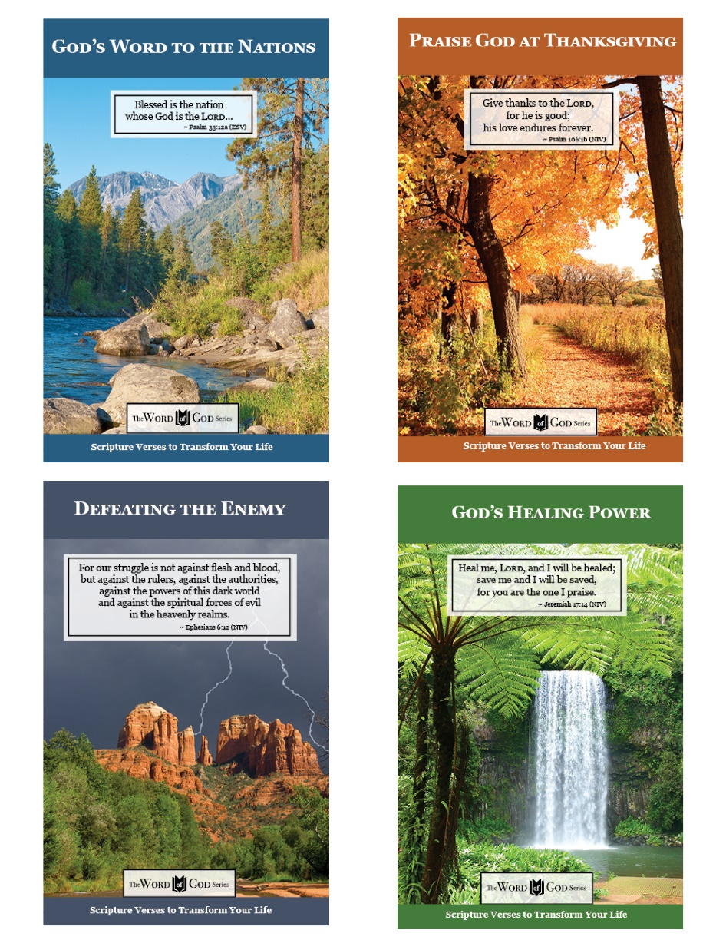

www.TheWordOfGodSeries.com

Booklet Titles in the Series

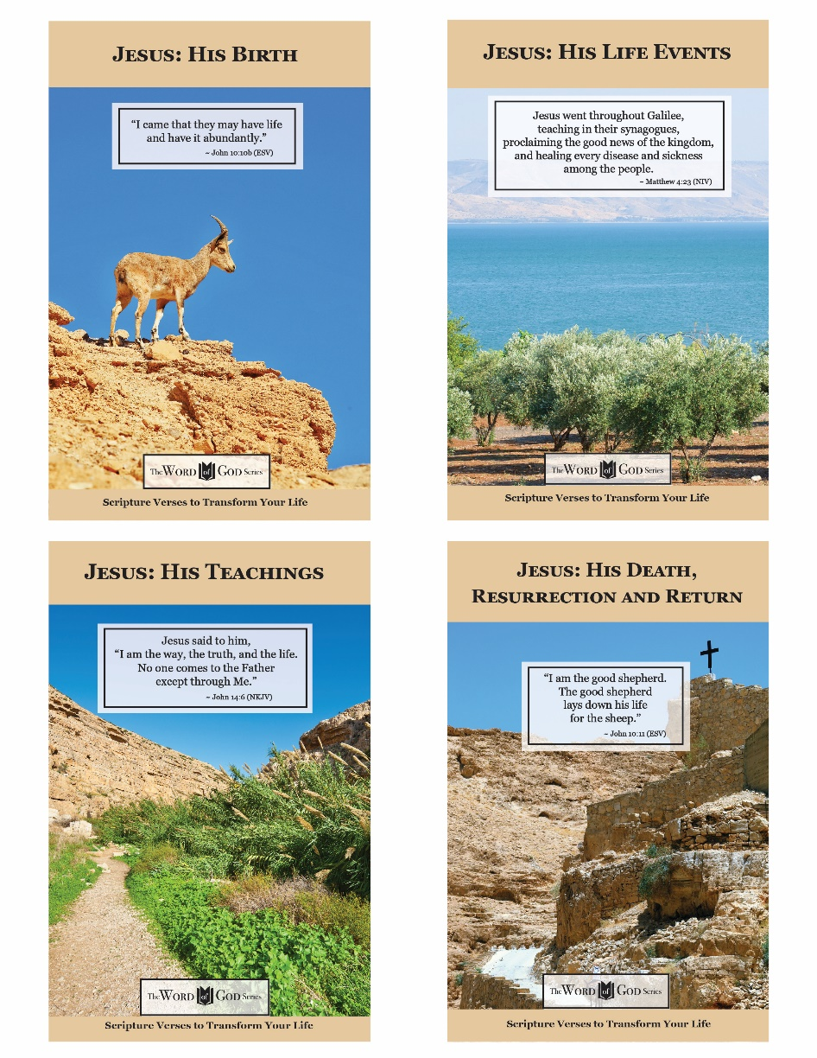

www.TheWordOfGodSeries.com

Photo Copyright Info

Note: when purchasing the rights to use the photos,
you may want to purchase an Extended License
for the cover image.

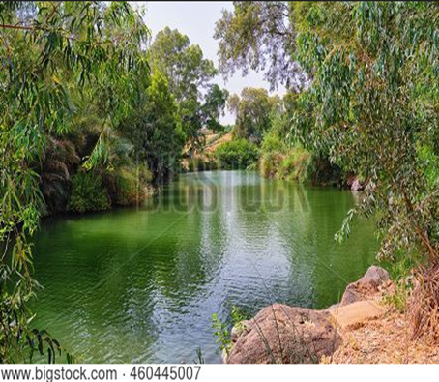

Bigstock Photo ID: 460445007
Holy Land Israel. Yardenit on Jordan River.
Stock Photo ID: 460445007
Copyright: Jivl

Bigstock Photo ID: 41117101
Cape Turtle Dove In Flight
Cape turtle dove (Streptopelia capicola) in flight, Kalahari desert, South Africa
Stock Photo ID: 41117101
Copyright: EcoShot

Bigstock Photo ID: 460491547
The majestic beauty of the boundless stone Judean desert in southern Israel
Stock Photo ID: 460491547
Copyright: svarshik

Bigstock Photo ID: 396641891
Panoramic view from Mount Evyatar in the Upper Galilee towards the Hula Valley and the Golan Heights. Northern Israel
Stock Photo ID: 396641891
Copyright: RnDmS

Bigstock Photo ID: 5187106
Editing Suggestion: Slightly crop top and bottom of photo
Sea Of Galillee
Stock Photo 5187106
Sea of Galillee and The Golan heights in the background
Copyright: Daydream.photo

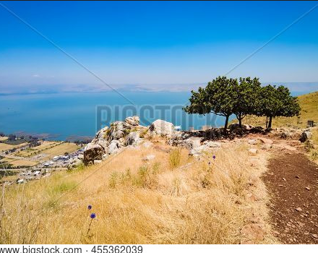
Bigstock Photo ID: 455362039
Arbel mountain over the sea of galilee, Israel
Stock Photo ID: 455362039
Copyright: HD_Premium_shots

Bigstock Photo ID: 343279942
rainbow over the arab village Cana of Galilee ( Kafr Kanna ) in Israel , place where Christ showed first miracle
Stock Photo ID: 343279942
Copyright: irisphoto3

Bigstock Photo ID: 419352598
The waves of the Sea of Galilee crash on the beach of, Israel. High quality photo
Stock Photo ID: 419352598
Copyright: stefanophotographer

Bigstock Photo ID: 396641675
View of Upper Galilee landscape, with hills and vineyards. Northern Israel
Stock Photo ID: 396641675
Copyright: RnDmS
Bigstock Photo ID: 40382482
Olive Grove
Olive Grove on the Slopes of the Mountains of Samaria Israel
Stock Photo ID: 40382482
Copyright: gkuna

Bigstock Photo ID: 5240559
Scenic path curve among wooded hills around Jerusalem
Stock Photo ID: 5240559
Copyright: slavapolo

Bigstock Photo ID: 446900032
The caves of the hermits are located near the Deir Hijleh Monastery - Monastery of Gerasim of Jordan in the Judean Desert in Israel
Stock Photo ID: 446900032
Copyright: svarshik

Bigstock Photo ID: 37734025
A house and palm trees in historic Jaffa Israel
Stock Photo 37734025
Copyright: kobby_dagan

Bigstock Photo ID: 7870665
ancient tomb in northern Israel discovered while widening the road
Stock Photo ID: 7870665
Bigstock Photo ID: 19485929
winding dirt road and olive tree in the Galilee, Israel
Stock Photo ID: 19485929
Copyright: Noam Armonn

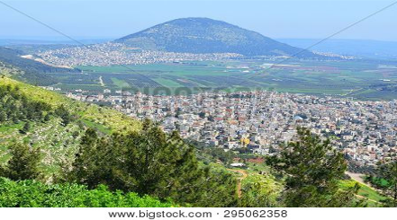
Bigstock Photo ID: 295062358
view of the Jezreel Valley, biblical Mount Tabor and the Arab villages at its foot, neighborhood Nazareth, Israel
Stock Photo ID: 295062358
Copyright: irisphoto3

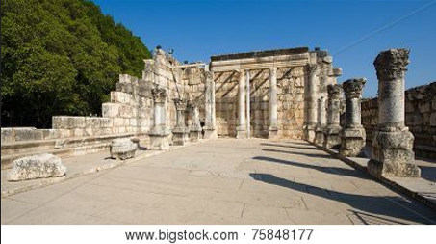
Bigstock Photo ID: 75848177
The ruins of the synagoque in the small town Capernaum on the coast of the lake of Galilee. According to the bible this is the place where Jesus taught
Stock Photo ID: 75848177
Copyright: Robert Hoetink


Bigstock Photo ID: 7450529
Rocks and the moon
Desert and rocks in Timna national park in Israel
Stock Photo ID: 7450529
Copyright: palex66 / ProtasovNA

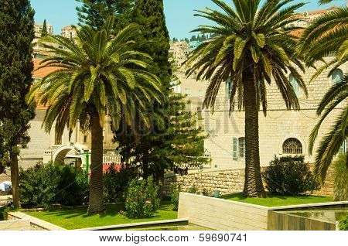
Bigstock Photo ID: 59690741
Ancient street in Nazareth, Israel. Date palm trees
Stock Photo ID: 59690741
Copyright: seqoya

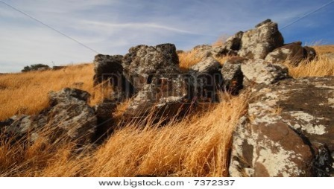
Bigstock Photo ID: 7372337
Landscape of Israel
The picture is taken in the north of Israel near to city Nazareth
Stock Photo ID: 7372337
Copyright: chernenko fine art

Bigstock Photo ID: 456469789
Editing suggestion: Slightly brighten image
Banias waterfall in a Hermon Stream Nature Reserve in northern Israel
Stock Photo ID: 456469789
Copyright: svarshik

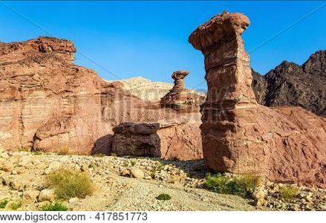
Bigstock Photo ID: 417851773
Multicolored landscape formations. Bizarre forms of weathered sandstone in the mountains. The rocks are composed of sandstones and volcanic rocks. Eilat Mountains.
Stock Photo ID: 417851773
Copyright: kavram

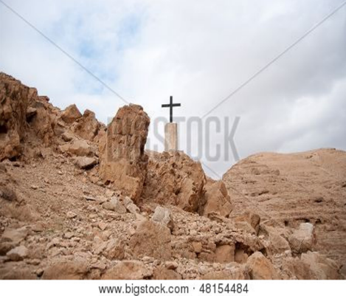
Bigstock Photo ID: 48154484
Editing suggestion: Crop edges to zoom in on cross
Photo cropped in booklet document
Holy Land Desert Christianity
A cross in israeli judean desert - christianity travel
Stock Photo ID: 48154484
Copyright: javax

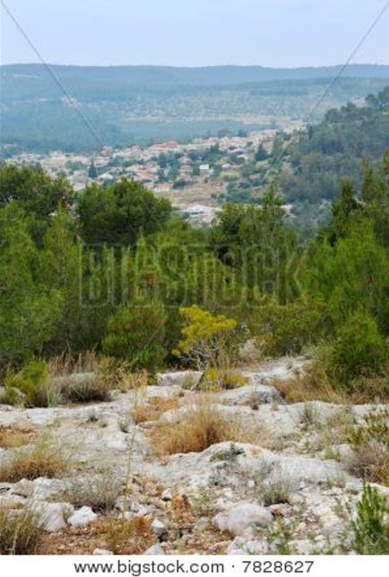
Bigstock Photo ID: 7828627
Mountain landscape in the vicinity of Jerusalem in May
Stock Photo ID: 7828627
Copyright: Vladimir_Blinov

Bigstock Photo ID: 10391096
The sea caves of Rosh HaNikra northern Israel.
Stock Photo ID: 10391096
Copyright: mlane

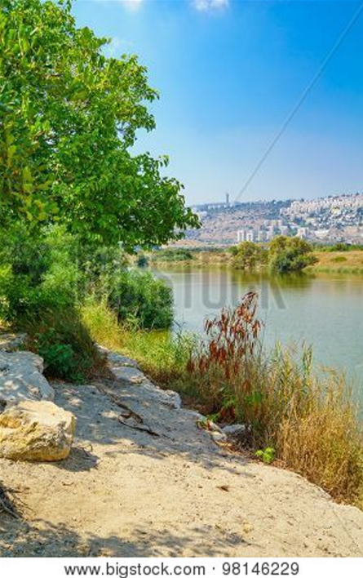
Bigstock Photo ID: 98146229
The Kishon stream and park and the city of Haifa in the background. Haifa Israel
Stock Photo ID: 98146229
Copyright: RnDmS
Bigstock Photo ID: 116844467
Narrow street and typical stoned houses of jewish quarter in Old City of Jerusalem, Israel.
Stock Photo ID: 116844467
Copyright: rglinsky

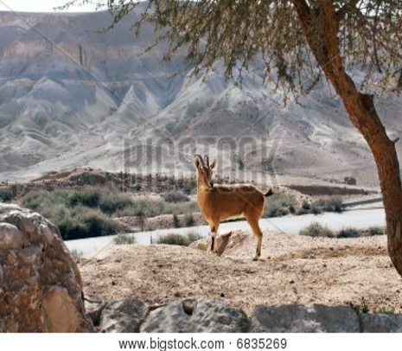
Bigstock Photo ID: 6835269
Editing suggestion: warm color tone
The wild goat standing near the tree against mountains
Stock Photo ID: 6835269
Copyright: iropa


Bigstock Photo ID: 452253225
Sunset view of The Holy Family Chapel, and the Mediterranean Sea, on Mount Carmel, with
a tree and spring wildflowers, Haifa, Northern Israel
Stock Photo ID: 452253225
Copyright: RnDmS

