Template for Jesus: His Teachings
The Word of God Series is a collection of 20 booklets that present Scripture verses in an easy-to-read format, with each booklet focused on a different topic.
Titles include Healthy Relationships, A Joy-Filled Life, Freedom from Depression, and many others.
The booklets are available in both paperback and digital formats at www.TheWordOfGodSeries.com or Amazon.com.
Why This Template?
Because I believe in the power of God’s Word to transform people’s lives, I have dedicated several years of my life to
bring this series to fruition.
I am passionate about using these booklets to reach
a dark and dying world with the love of Christ and
the hope of the Gospel.
Initially, I had expected this series would be a small business. But one day, when I asked God what my next steps should be,
He spoke to me through His Word and told me to:
“…complete the ministry God has given you.”
~ 2 Timothy 4:5 (NLT, 1996 version)
So, I shifted the focus from a business to a ministry.
My vision, also, has evolved over time and I have come to believe that it is possible for millions of these booklets to be distributed (in both print and digital formats) around the world (see the document entitled The Vision at www.TheWordOfGodSeries.com for more info.)
In order to make this a far-reaching ministry, accessing populations that I couldn’t on my own, I decided to invite others to partner with me in producing and distributing these booklets to their own personal networks. To help get it started, I have made templates of each booklet freely available to anyone who would like them.
This way you (whether you are a church, Christian organization or an individual) can easily re-create the booklets in your own ministry’s name, and distribute them to the people you minister to.
I hope that this template will save you:
- Time – so you can benefit from the thousands of hours
of development time that has been invested so far
- Money – eliminate layers of profit margin, and save on shipping costs (especially for large quantities)

Whether you simply replicate and reproduce what has already been done, build on it, or take this idea in a different direction, you won’t have to waste time starting with a blank page.
I hope you can easily get these finalized and printed, so you can begin sharing them with the people in your sphere of influence.
On the following pages you will find document formatting and printing tips.
Photo editing tips are also presented, as well as the preview images of each photo (with the Photo ID#), so you to easily find it on either bigstockphoto.com or shutterstock.com.

Photo Editing Tips
At the end of this document you will find the copyright and descriptive info for each photo in the booklet, as well as editing suggestions for a few of them.
Many photos will need to be slightly stretched or cropped to fit the page.
Most of the editing suggestions below (especially brightening or increasing color saturation) should be very slight adjustments.
Editing photos within this document
Wrapping text around the photo: Doubleclick the photo, click
on Wrap Text and select Square. Then, drag the image by the corner until it is the right size to wrap the text around it.
Rotate: Doubleclick the photo, click on the Rotate Object icon.

Editing photos in the Pictures editing app in MS Word
Navigate to your Pictures folder, doubleclick the photo, and click on the blue Edit button on left
Most of the editing can be done by using one of these 3 options:


Crop: Click on the Crop icon and drag edges to desired spot
Brighten a photo: Adjustment icon / Light / Brightness
Increase color saturation: Adjustment icon / Color / Saturation or Warmth
Remove distracting elements from a photo: Click on the Generative Erase icon, select a brush size and click on the part of the photo you want removed.

Photo Searching Tips
Occasionally photographers pull their photos from the sites,
so there may be some in this booklet that are no longer available.
You can try using the same key words to search for the photo
on other sites (scroll to the end of this document for more descriptive information about each photo.)
Or, you can search for another photo on Bigstock. Under
All Images select Photos and search by key word. At the next screen, make sure that Safe Search is on. In the Category field, select either Landscapes, Nature or Animals.

Booklet Formatting Tips
If you make any changes to this document that results in changing the number of lines on a page, then the page will need to be re-formatted for everything to fit.
Often changing the spacing between the characters or between the lines in one verse is enough to re-format it.
Changing the spacing between the characters
Home / Font / Advanced / Character Spacing
Choose Expanded or Condensed, and select a numeric value (best from .1 to .3)


Changing the spacing between the lines
Highlight all the text in the passage or page and click on:
Layout / Paragraph / Line Spacing / Multiple
Select a numeric value (best from .98 to 1.02)


Saving the document as a PDF
Adobe Acrobat Pro subscriptions are available at www.adobe.com/creativecloud/plans.html. You could also
ask your library tech center if they carry Adobe products.
When the Word doc is final: File / Save as Adobe PDF

Viewing the PDF as a booklet
Remove the first blank page of the doc: Edit / Trash icon.
Enter pages 1 to 1 to delete. Then exit from the Edit mode.
To view the document as a booklet, click on the page icon
(on right side of page, below the rotate button) and select
Two-page view and Show cover page.


Adding page numbers to the PDF
Edit / Header & Footer / Add / Add New
Under Font Name choose your font (this document uses the Georgia font) and under Size enter 8 pt.
Under Margins, in the Bottom box, enter .4
Click in box under Center Footer Text and click on the Insert Page Number button.
Click on Page Range Options. The Pages From _ to _
will depend on which page in your document you want read as Page 1 in the PDF.
In these booklets, the verses begin on Page 5 (after the forward page, copyright page, and Table of Contents).
If you plan to develop several booklets, select Save Settings.


Printing the Booklets
You can print these as regular paperbacks with a binding, (which look a bit nicer) or, you can print them with a staple binding. The staple binding does require a certain type of machine that can print them in a way that they open fully to any page (not just the center page) and lay flat. Your local printer may or may not have that capability, so discuss options with them.
A glossy cover is recommended, as it has a better feel than a matte finish. You may want to request the booklets be printed on Cougar® paper, which has a very smooth finish.

Stuck on a Step Above and Need Help?
If you want to do this project on your own, but are having tech issues with one of the steps above, feel free to contact me at Susan@TheWordOfGodSeries.com. I may be able to assist you, since I’ve gone through this whole process myself!

Need Help with the Whole Project?
If you want these booklets set up in your own in your own ministry’s name, but don’t have the resources to do the whole project yourself,
I may be able to manage that process for you for a one-time project fee.
This would include the following services:
- Set up an account with Bigstock and Shutterstock in your ministry’s name and purchase the rights for you to use each of the photos
- Download and name the photos
- Edit photos as needed
- Create a cover with your church or ministry logo
- Request the rights to use the various Bible translations from each of the publishers (if applicable)
Feel free to contact me at Susan@TheWordOfGodSeries.com to discuss pricing options.
I hope that this information will help you finalize this document with ease so you can begin distributing it to the people in your realm of influence.
Thank you for partnering with me in this effort. I wish you the best as you make God’s Word known and share His love with others!
Warmly in Christ,
Susan

Soli Deo gloria



Feel free to edit this forward page to align to your own ministry’s vision and goals.

The Bible is the best-selling and most transformative book in history. Written over 2,000 years ago, it is still living and powerful today.
Throughout the pages of Scripture you will find inspiration and joy, comfort and peace, healing and hope.
Most importantly, you will learn of God’s abundant love for you, and His plan to give you a glorious, eternal inheritance.
The Word of God Series is a collection of booklets which presents Scripture by topic, so you can focus on verses that are relevant to you at different stages and circumstances throughout your life.
All of the booklets in this series feature Scripture exclusively—
just the powerful, undiluted Word of God.
Let God’s Word permeate your mind and transform your life.
This is one of a four-booklet mini-series about Jesus Christ, the most influential and singular person in history. The titles in this series are:
Jesus: His Birth
Jesus: His Life Events
Jesus: His Teachings
Jesus: His Death, Resurrection and Return
The verses in this series are drawn primarily from the gospel accounts (the first four books of the New Testament: Matthew, Mark, Luke and John) which present a narrative on the life and ministry of Jesus.
This series includes many of the life events and teachings of Jesus, but it not comprehensive, so you are encouraged to also read each of the gospel accounts in their entirety.
In this series, text in italics are prophecies about the coming Messiah and “text in quotation marks” are the words of Christ.
Most of the imagery in this mini-series is from the Holy Land.
This booklet, Jesus: His Teachings, presents Christ’s teachings about love and mercy, prayer and the Holy Spirit, heaven and hell, and other subjects. Learn what Jesus taught about love, life and eternity.
My prayer for you, as you read this series about Christ, is that you will accept the gift of eternal life that He died to give you and know that you belong to Him. I pray you will spend the remainder of your life seeking to look, live and love more like Jesus.
Let the word of Christ dwell in you richly…
~ Colossians 3:16a (ESV)

A few comments about this series:

- The booklets in this series provide you with a sample of what the Bible offers, but it is important that you also read the Bible itself, preferably with a book-by-book focus.

- Passages in quotation marks are the actual words of God, either through His prophets in the Old Testament, or the words of Christ
in the New Testament.

- Every booklet includes a section that details God’s plan of salvation (commonly referred to as “The Gospel.”) The booklet entitled God’s Gift of Eternal Life
is devoted to the Gospel message.

This series presents verses in the following translations:

NIV: New International Version
Scripture quotations marked NIV are taken from the Holy Bible, New International Version®, NIV®. Copyright © 1973, 1978, 1984, 2011 by Biblica, Inc.™ Used by permission of Zondervan. All rights reserved worldwide. www.zondervan.com. The "NIV" and "New International Version" are trademarks registered in the United States Patent and Trademark Office by Biblica, Inc.™

NLT: New Living Translation
Scripture quotations marked NLT are taken from the Holy Bible, New Living Translation, Copyright© 1996, 2004, 2015 by Tyndale House Foundation. Used by permission of Tyndale House Publishers, Inc., Carol Stream, Illinois 60188. All rights reserved.

ESV: English Standard Version
Scripture quotations marked ESV are taken from the ESV Bible® (The Holy Bible, English Standard Version®), copyright © 2001 by Crossway Bibles, a publishing ministry of Good News Publishers. Used by permission. All rights reserved.

KJV: King James Version
Public Domain

NKJV: New King James Version
Scripture quotations marked NKJV are taken from the New King James Version®. Copyright © 1982 by Thomas Nelson, Inc. Used by permission.

Since this is a template booklet featuring preview photos, it is not copyrighted, so you are free to purchase licenses to use the photos and develop your own booklets for print. Be sure to determine whether or not you need to request permission (and in some cases pay) for the rights to use the various Bible translations. Scripture verses were sourced from www.BibleGateway.com.
If it would be easier for you to simply purchase this booklet, the copyrighted version is available at www.TheWordOfGodSeries.com or www.amazon.com.
ISBN info for the copyrighted booklets is as follows:
The ISBN is 978-1-964538-04-4 and the Amazon ISBN: is 9798356892158.
Jesus: His Teachings

Contents

Jesus’ Teachings on Various Subjects 1
Prayer
Love
Mercy and Forgiveness
Judging Others
Obedience
Humility
Our Words
Money
Adultery and Divorce
The Sabbath
The Beatitudes, from Jesus’ Sermon on the Mount
Worry
The Children
The Holy Spirit
Salt and Light
The Lost
The Harvest
Jesus Teaches in Parables 24
Parables About Mercy
Parables About How Jesus Seeks the Lost
Parables About the Harvest
Parables About the Kingdom of Heaven
Jesus Teaches About the Future 32
Jesus’ Warnings 34
Jesus Teaches About the Kingdom of Heaven 36
The Cost of Following Jesus 40
Jesus Teaches About Himself 41
Jesus’ Claims of Divinity 45
Jesus is the “I AM” 49
Jesus is the Way to the Father 50

Jesus’ Teachings
on Various Subjects

Jesus Teaches About Prayer

“Ask and it will be given to you; seek and you will find; knock and the door will be opened to you.
“For everyone who asks receives; the one who seeks finds; and to the one who knocks, the door will be opened.
“Which of you, if your son asks for bread, will give him
a stone? Or if he asks for a fish, will give him a snake?
“If you, then, though you are evil, know how to give good gifts to your children, how much more will your Father in heavive good gifts to those who ask him!”

~ Matthew 7:7-11 (NIV)

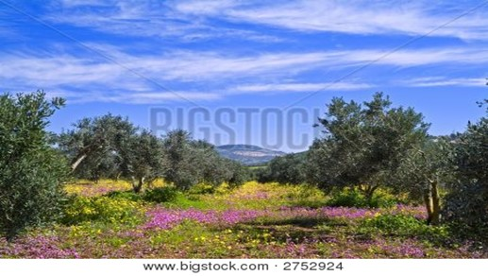

Olive Grove in Galilee, Israel

“If you believe, you will receive whatever you ask for
in prayer.”

~ Matthew 21:22 (NIV)
“Very truly I tell you, my Father will give you whatever you ask in my name. Until now you have not asked for anything in my name.
“Ask and you will receive, and your joy will be complete.”

~ John 16:23b-24 (NIV)

“Again I say to you that if two of you agree on earth concerning anything that they ask, it will be done for them by My Father in heaven.
“For where two or three are gathered together in My name, I am there in the midst of them.”

~ Matthew 18:19-20 (NKJV)

“And I will do whatever you ask in my name, so that
the Father may be glorified in the Son. You may ask me for anything in my name, and I will do it.”

~ John 14:13-14 (NIV)

“Therefore I tell you, whatever you ask in prayer,
believe that you have received it, and it will be yours.”

~ Mark 11:24 (ESV)

“And when you pray, do not be like the hypocrites,
for they love to pray standing in the synagogues and
on the street corners to be seen by others.
“Truly I tell you, they have received their reward in full.
“But when you pray, go into your room, close the door and pray to your Father, who is unseen. Then your Father, who sees what is done in secret, will reward you.”

~ Matthew 6:5-6 (NIV)

“And when you pray, do not keep on babbling like pagans, for they think they will be heard because of their many words. Do not be like them, for your Father knows what you need before you ask him.”

~ Matthew 6:7-8 (NIV)

“And whenever you stand praying, if you have anything against anyone, forgive him, that your Father in heaven may also forgive you your trespasses.”

~ Mark 11:25 (NKJV)
“Love your enemies and pray for those who persecute you…”

~ Matthew 5:44b (ESV)

“Bless those who curse you. Pray for those who hurt you.”

~ Luke 6:28 (NLT)

“Pray then like this:”

~ Matthew 6:9a (ESV)

“Our Father which art in heaven,
Hallowed be thy name.
Thy kingdom come,
Thy will be done in earth, as it is in heaven.
Give us this day our daily bread.
And forgive us our debts, as we forgive our debtors.
And lead us not into temptation, but deliver us from evil:
“For thine is the kingdom, and the power, and the glory, for ever. Amen.”

~ Matthew 6:9b-13 (KJV)



Yehudiya Forest Nature Reserve, Golan Heights

Jesus Teaches About Love

“A new command I give you: Love one another.
“As I have loved you, so you must love one another.
“By this everyone will know that you are my disciples,
if you love one another.”

~ John 13:34-35 (NIV)

“The most important [commandment],” answered Jesus, “is this:
‘Hear, O Israel: The Lord our God, the Lord is one.
‘Love the Lord your God
with all your heart and
with all your soul and
with all your mind and
with all your strength.’
“The second is this:
‘Love your neighbor as yourself.’
“There is no commandment greater than these.”

~ Mark 12:29-31 (NIV)

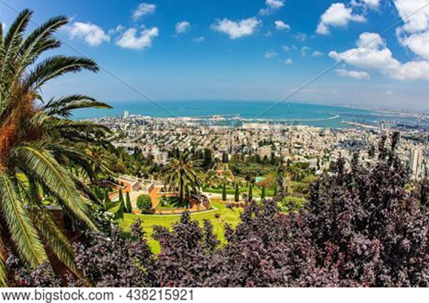

Haifa and the Mediterranean Sea, view from Mount Carmel
“This is my command: Love each other.”

~ John 15:17 (NLT)

“When you give a dinner or a banquet, do not invite
your friends or your brothers or your relatives or rich neighbors, lest they also invite you in return and you
be repaid.
“But when you give a feast, invite the poor, the crippled, the lame, the blind, and you will be blessed, because they cannot repay you.”

~ Luke 14:12b-14a (ESV)

“Do to others as you would have them do to you.”

~ Luke 6:31 (NIV)

“There is no greater love than to lay down one’s life
for one’s friends.”

~ John 15:13 (NLT)

Jesus Teaches About Mercy and Forgiveness

“Love your enemies,
do good to those who hate you,
bless those who curse you,
pray for those who abuse you…
“Give to everyone who begs from you, and from one
who takes away your goods do not demand them back.”

~ Luke 6:27b-30 (ESV)

“Love your enemies and pray for those who persecute you, so that you may be sons of your Father who is in heaven.”

~ Matthew 5:44b-45a (ESV)

Then Peter came to him and asked, “Lord, how often should I forgive someone who sins against me? Seven times?”
“No, not seven times,” Jesus replied, “but seventy times seven!”

~ Matthew 18:21-22 (NLT)

“If your brother sins, rebuke him, and if he repents, forgive him, and if he sins against you seven times in the day,
and turns to you seven times, saying, ‘I repent,’ you must forgive him.”

~ Luke 17:3b-4 (ESV)
“…if you lend to those from whom you expect to receive, what credit is that to you? Even sinners lend to sinners,
to get back the same amount.
“But love your enemies, and do good, and lend, expecting nothing in return, and your reward will be great, and
you will be sons of the Most High, for he is kind to the ungrateful and the evil.
“Be merciful, even as your Father is merciful.”

~ Luke 6:34-36 (ESV)

“You have heard that it was said, ‘Eye for eye, and tooth for tooth.’
“But I tell you, do not resist an evil person. If anyone slaps you on the right cheek, turn to them the other cheek also.
“And if anyone wants to sue you and take your shirt,
hand over your coat as well.
“If anyone forces you to go one mile, go with them two miles.
“Give to the one who asks you, and do not turn away from the one who wants to borrow from you.”

~ Matthew 5:38-42 (NIV)

“If another believer sins against you, go privately and point out the offense. If the other person listens and confesses it, you have won that person back.
“But if you are unsuccessful, take one or two others with you and go back again, so that everything you say may be confirmed by two or three witnesses.”

~ Matthew 18:15-16 (NLT)

“…anyone who is angry with a brother or sister will be subject to judgment…And anyone who says, ‘You fool!’ will be in danger of the fire of hell.”

~ Matthew 5:22b (NIV)

“…if you are offering your gift at the altar and there remember that your brother or sister has something against you, leave your gift there in front of the altar.
First go and be reconciled to them; then come and
offer your gift.”

~ Matthew 5:23-24 (NIV)
“If you love those who love you, what reward will you get? Are not even the tax collectors doing that?
“And if you greet only your own people, what are you doing more than others? Do not even pagans do that?
“Be perfect, therefore, as your heavenly Father is perfect.”

~ Matthew 5:46-48 (NIV)

Jesus Teaches About Judging Others

“Do not judge, or you too will be judged.
“For in the same way you judge others, you will be judged, and with the measure you use, it will be measured to you.
“Why do you look at the speck of sawdust in your brother’s eye and pay no attention to the plank in your own eye?...
“You hypocrite, first take the plank out of your own eye…”

~ Matthew 7:1-5a (NIV)

“Do not judge, and you will not be judged.
“Do not condemn, and you will not be condemned.
“Forgive, and you will be forgiven.”

~ Luke 6:37 (NIV)

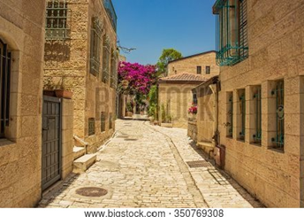

Old City of Jerusalem

Jesus Teaches About Obedience

“If you love me, obey my commandments.”

~ John 14:15 (NLT)

“My command is this: Love each other as I have loved you.”

~ John 15:12 (NIV)

“Those who accept my commandments and obey them
are the ones who love me. And because they love me,
my Father will love them. And I will love them and
reveal myself to each of them.”

~ John 14:21 (NLT)

“If you keep my commands, you will remain in my love, just as I have kept my Father’s commands and remain
in his love.
“I have told you this so that my joy may be in you and
that your joy may be complete.”

~ John 15:10-11 (NIV)

As Jesus was saying these things, a woman in the crowd called out, “Blessed is the mother who gave you birth
and nursed you.”
He replied, “Blessed rather are those who hear the
word of God and obey it.”

~ Luke 11:27-28 (NIV)

Someone told Jesus, “Your mother and your brothers are standing outside, and they want to speak to you.”
Jesus asked, “Who is my mother? Who are my brothers?…
“Anyone who does the will of my Father in heaven is
my brother and sister and mother!”

~ Matthew 12:47-50 (NLT)

Jesus replied, “My mother and my brothers are all those who hear God’s word and obey it.”

~ Luke 8:21 (NLT)

“You are my friends if you do what I command you.
No longer do I call you servants, for the servant does not know what his master is doing; but I have called you friends…”

~ John 15:14-15a (ESV)
“If you abide in my word, you are truly my disciples,
and you will know the truth, and the truth will set you free.”

~ John 8:31b-32 (ESV)

“Why do you call me ‘Lord, Lord,’ and not do what I tell you?
“Everyone who comes to me and hears my words and
does them, I will show you what he is like: he is like a man building a house, who dug deep and laid the foundation on the rock. And when a flood arose, the stream broke against that house and could not shake it, because it had been well built.
“But the one who hears and does not do them is like a man who built a house on the ground without a foundation. When the stream broke against it, immediately it fell, and the ruin of that house was great.”

~ Luke 6:46-49 (ESV)



Sea of Galilee

“If anyone hears my words but does not keep them, I do not judge that person. For I did not come to judge the world, but to save the world. There is a judge for the one who rejects me and does not accept my words; the very words
I have spoken will condemn them at the last day.”

~ John 12:47-48 (NIV)

Jesus Teaches About Humility

When Jesus noticed that all who had come to the dinner were trying to sit in the seats of honor near the head of the table, he gave them this advice:
“When you are invited to a wedding feast, don’t sit in the seat of honor. What if someone who is more distinguished than you has also been invited? The host will come and say, ‘Give this person your seat.’ Then you will be embarrassed, and you will have to take whatever seat is left at the foot of the table!
“Instead, take the lowest place at the foot of the table. Then when your host sees you, he will come and say, ‘Friend, we have a better place for you!’ Then you will
be honored in front of all the other guests.
“For those who exalt themselves will be humbled, and those who humble themselves will be exalted.”

~ Luke 14:7-11 (NLT)

Then the mother of James and John, the sons of Zebedee, came to Jesus with her sons. She knelt respectfully to
ask a favor.
“What is your request?” he asked.
She replied, “In your Kingdom, please let my two sons sit in places of honor next to you, one on your right and the other on your left…”
When the ten other disciples heard what James and John had asked, they were indignant.
But Jesus called them together and said, “You know that the rulers in this world lord it over their people, and officials flaunt their authority over those under them.
“But among you it will be different.
“Whoever wants to be a leader among you must be your servant, and whoever wants to be first among you must become your slave.”

~ Matthew 20:20-27 (NLT)

Jesus Teaches About Our Words

“A good man brings good things out of the good stored up in him, and an evil man brings evil things out of the evil stored up in him.”

~ Matthew 12:35 (NIV)

“For the mouth speaks what the heart is full of.”

~ Matthew 12:34b (NIV)

“For whatever is in your heart determines what you say.”

~ Matthew 12:34b (NLT)

“For out of the abundance of the heart the mouth speaks.”

~ Matthew 12:34b (ESV)

“There is nothing concealed that will not be disclosed,
or hidden that will not be made known.
“What you have said in the dark will be heard in the daylight, and what you have whispered in the ear in the inner rooms will be proclaimed from the roofs.”

~ Luke 12:2-3 (NIV)

“But I tell you that everyone will have to give account on the day of judgment for every empty word they have spoken.
“For by your words you will be acquitted, and by your words you will be condemned.”

~ Matthew 12:36-37 (NIV)

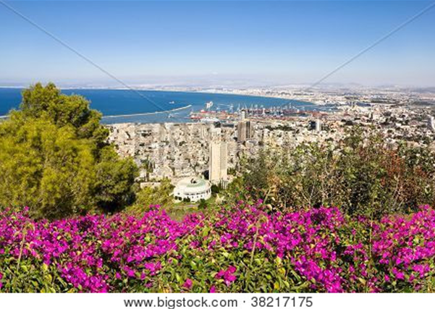

Haifa and the Mediterranean Sea

Jesus Teaches About Money

“Give, and it will be given to you.
“A good measure, pressed down, shaken together and running over, will be poured into your lap.
“For with the measure you use, it will be measured to you.”

~ Luke 6:38 (NIV)

“Do not store up for yourselves treasures on earth,
where moths and vermin destroy, and where thieves
break in and steal.
“But store up for yourselves treasures in heaven,
where moths and vermin do not destroy, and where thieves do not break in and steal.
“For where your treasure is, there your heart will be also.”

~ Matthew 6:19-21 (NIV)

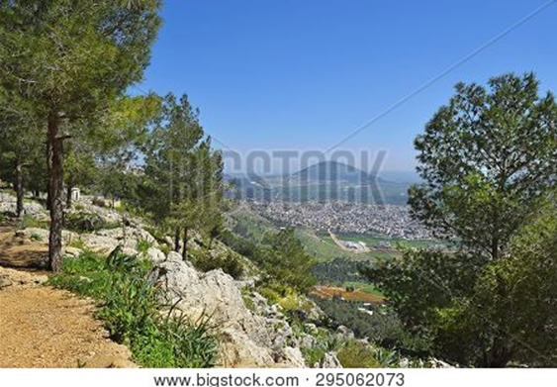

Landscape of Jezreel Valley and Mount Tabor

“Sell your possessions and give to the poor.
“Provide purses for yourselves that will not wear out,
a treasure in heaven that will never fail, where no thief comes near and no moth destroys.
“For where your treasure is, there your heart will be also.”

~ Luke 12:33-34 (NIV)
“From everyone who has been given much, much will be demanded; and from the one who has been entrusted with much, much more will be asked.”

~ Luke 12:48b (NIV)

“Whoever can be trusted with very little can also be trusted with much, and whoever is dishonest with very little will also be dishonest with much. So if you have
not been trustworthy in handling worldly wealth, who
will trust you with true riches? And if you have not been trustworthy with someone else’s property, who will give you property of your own?”

~ Luke 16:10-12 (NIV)

As Jesus started on his way, a man ran up to him and
fell on his knees before him. “Good teacher,” he asked, “what must I do to inherit eternal life?”…
Jesus answered… “You know the commandments:
‘You shall not murder, you shall not commit adultery,
you shall not steal, you shall not give false testimony,
you shall not defraud, honor your father and mother.’”
“Teacher,” he declared, “all these I have kept since I was
a boy.”
Jesus looked at him and loved him. “One thing you lack,” he said. “Go, sell everything you have and give to the poor, and you will have treasure in heaven. Then come, follow me.” At this the man’s face fell. He went away sad, because he had great wealth.
Jesus looked around and said to his disciples, “How hard it is for the rich to enter the kingdom of God!” The disciples were amazed at his words.
But Jesus said again, “Children, how hard it is to enter
the kingdom of God! It is easier for a camel to go through the eye of a needle than for someone who is rich to enter the kingdom of God.” The disciples were even more amazed, and said to each other, “Who then can be saved?”
Jesus looked at them and said, “With man this is impossible, but not with God; all things are possible with God.”

~ Mark 10:17-27 (NIV)
Jesus sat down opposite the place where the offerings were put and watched the crowd putting their money
into the temple treasury. Many rich people threw in
large amounts. But a poor widow came and put in two very small copper coins…
Jesus said, “Truly I tell you, this poor widow has put
more into the treasury than all the others.
“They all gave out of their wealth; but she, out of her poverty, put in everything—all she had to live on.”

~ Mark 12:41-44 (NIV)

“No one can serve two masters…
“You cannot serve both God and money.”

~ Luke 16:13 (NIV)

“Do not work for the food that perishes, but for the
food that endures to eternal life, which the Son of Man will give to you.”

~ John 6:27a (ESV)

“Truly I tell you,” Jesus replied, “no one who has left
home or brothers or sisters or mother or father or
children or fields for me and the gospel will fail to receive a hundred times as much in this present age: homes, brothers, sisters, mothers, children and fields—along
with persecutions—and in the age to come eternal life.”

~ Mark 10:29-30 (NIV)

“Be careful not to practice your righteousness in front
of others to be seen by them. If you do, you will have
no reward from your Father in heaven.
“So when you give to the needy, do not announce it with trumpets, as the hypocrites do in the synagogues and on the streets, to be honored by others.
“Truly I tell you, they have received their reward in full.
“But when you give to the needy, do not let your left hand know what your right hand is doing, so that your giving may be in secret. Then your Father, who sees what is done in secret, will reward you.”

~ Matthew 6:1-4 (NIV)

Jesus Teaches About Adultery and Divorce

“You have heard that it was said, ‘You shall not commit adultery.’
“But I tell you that anyone who looks at a woman lustfully has already committed adultery with her in his heart.”

~ Matthew 5:27-28 (NIV)

They asked, “Is it lawful for a man to divorce his wife for
any and every reason?”
“Haven’t you read,” he replied, “that at the beginning the Creator ‘made them male and female,’ and said, ‘For this reason a man will leave his father and mother and be united to his wife, and the two will become one flesh’? So they are no longer two, but one flesh.
“Therefore what God has joined together, let no one separate.”

~ Matthew 19:3b-6 (NIV)

“I tell you that anyone who divorces his wife, except for sexual immorality, and marries another woman commits adultery.”

~ Matthew 19:9 (NIV)

Jesus Teaches About the Sabbath

“The Sabbath was made for man, not man for the Sabbath. So the Son of Man is Lord even of the Sabbath.”

~ Mark 2:27b-28 (NIV)

…Jesus went into the synagogue, and a man with a shriveled hand was there. Some of them were looking
for a reason to accuse Jesus, so they watched him closely to see if he would heal him on the Sabbath…
Then Jesus asked them, “Which is lawful on the Sabbath: to do good or to do evil, to save life or to kill?” But they remained silent.
He looked around at them in anger and, deeply distressed at their stubborn hearts, said to the man, “Stretch out your hand.” He stretched it out, and his hand was completely restored.
Then the Pharisees went out and began to plot with the Herodians how they might kill Jesus.

~ Mark 3:1-6 (NIV)

The Beatitudes, From Jesus’ Sermon on the Mount

“Blessed are the poor in spirit,
for theirs is the kingdom of heaven.
“Blessed are those who mourn,
for they will be comforted.
“Blessed are the meek,
for they will inherit the earth.
“Blessed are those who hunger and thirst for righteousness,
for they will be filled.
“Blessed are the merciful,
for they will be shown mercy.
“Blessed are the pure in heart,
for they will see God.
“Blessed are the peacemakers,
for they will be called children of God.
“Blessed are those who are persecuted because of righteousness,
for theirs is the kingdom of heaven.
“Blessed are you when people insult you, persecute you
and falsely say all kinds of evil against you because of me.
“Rejoice and be glad, because great is your reward in heaven...”

~ Matthew 5:3-12a (NIV)

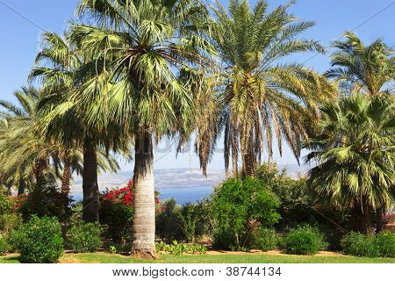

Mount of Beatitudes on the Sea of Galilee

Jesus Teaches About Worry

“Peace I leave with you; my peace I give you.
“I do not give to you as the world gives. Do not let your hearts be troubled and do not be afraid.”

~ John 14:27 (NIV)

“Therefore I tell you, do not worry about your life, what you will eat or drink; or about your body, what you will wear. Is not life more than food, and the body more than clothes?
“Look at the birds of the air; they do not sow or reap or store away in barns, and yet your heavenly Father feeds them. Are you not much more valuable than they? Can any one of you by worrying add a single hour to your life?
“And why do you worry about clothes? See how the flowers of the field grow. They do not labor or spin. Yet I tell you that not even Solomon in all his splendor was dressed like one of these. If that is how God clothes the grass of the field, which is here today and tomorrow is thrown into the fire, will he not much more clothe you—you of little faith?
“So do not worry, saying, ‘What shall we eat?’ or ‘What shall we drink?’ or ‘What shall we wear?’ For the pagans run after all these things, and your heavenly Father knows that you need them.
“But seek first his kingdom and his righteousness, and all these things will be given to you as well. Therefore do not worry about tomorrow, for tomorrow will worry about itself. Each day has enough trouble of its own.”

~ Matthew 6:25-34 (NIV)

“…not a single sparrow can fall to the ground without your Father knowing it. And the very hairs on your head are all numbered. So don’t be afraid; you are more valuable to God than a whole flock of sparrows.”

~ Matthew 10:29b-31 (NLT)

“So don’t be afraid, little flock. For it gives your Father great happiness to give you the Kingdom.”

~ Luke 12:32 (NLT)

Jesus Teaches About the Children

“Let the little children come to me and do not hinder them, for to such belongs the kingdom of heaven.”

~ Matthew 19:14b (ESV)

People were bringing little children to Jesus for him to place his hands on them, but the disciples rebuked them. When Jesus saw this, he was indignant.
He said to them, “Let the little children come to me,
and do not hinder them, for the kingdom of God
belongs to such as these.
“Truly I tell you, anyone who will not receive the
kingdom of God like a little child will never enter it.”
And he took the children in his arms, placed his hands
on them and blessed them.

~ Mark 10:13-16 (NIV)

At that time the disciples came to Jesus and asked,
“Who, then, is the greatest in the kingdom of heaven?”
He called a little child to him, and placed the child
among them.
And he said: “Truly I tell you, unless you change and become like little children, you will never enter the kingdom of heaven.
“Therefore, whoever takes the lowly position of this child
is the greatest in the kingdom of heaven.”

~ Matthew 18:1-4 (NIV)

“Whoever receives this little child in My name receives Me; and whoever receives Me receives Him who sent Me.”

~ Luke 9:48b (NKJV)

“…your Father in heaven is not willing that any of these little ones should perish.”

~ Matthew 18:14b (NIV)

“See that you do not despise one of these little ones.
For I tell you that their angels in heaven always see the face of my Father in heaven.”

~ Matthew 18:10 (NIV)


Wild Ibex in Makhtesh Ramon

“If anyone causes one of these little ones—those who believe in me—to stumble, it would be better for them to have a large millstone hung around their neck and to be drowned in the depths of the sea.
“Woe to the world because of the things that cause people to stumble! Such things must come, but woe to the person through whom they come!”

~ Matthew 18:6-7 (NIV)

Jesus Teaches About the Holy Spirit

“When the Spirit of truth comes, he will guide you into
all truth. He will not speak on his own but will tell you what he has heard. He will tell you about the future.”

~ John 16:13 (NLT)

“…he will tell you what is yet to come.”

~ John 16:13b (NIV)

“And I will ask the Father, and he will give you another Advocate, who will never leave you.
“He is the Holy Spirit, who leads into all truth. The world cannot receive him, because it isn’t looking for him and doesn’t recognize him.
“But you know him, because he lives with you now and later will be in you.”

~ John 14:16-17 (NLT)

“But in fact, it is best for you that I go away, because if
I don’t, the Advocate won’t come. If I do go away, then
I will send him to you.
“And when he comes, he will convict the world of its sin, and of God’s righteousness, and of the coming judgment.”

~ John 16:7-8 (NLT)

“But the Helper, the Holy Spirit, whom the Father will send in My name, He will teach you all things, and bring to your remembrance all things that I said to you.”

~ John 14:26 (NKJV)

“Which of you fathers, if your son asks for a fish, will give him a snake instead? Or if he asks for an egg, will give him a scorpion? If you then, though you are evil, know how to give good gifts to your children, how much more will your Father in heaven give the Holy Spirit to those who ask him!”

~ Luke 11:11-13 (NIV)

“Truly I tell you, people can be forgiven all their sins and every slander they utter, but whoever blasphemes against the Holy Spirit will never be forgiven; they are guilty of
an eternal sin.”

~ Mark 3:28-29 (NIV)
“God will give you the right words at the right time.
For it is not you who will be speaking—it will be the
Spirit of your Father speaking through you.”

~ Matthew 10:19b-20 (NLT)

“For the Holy Spirit will teach you in that very hour what you ought to say.”

~ Luke 12:12 (NKJV)

Jesus Teaches About Salt and Light

“You are the salt of the earth.
“But if the salt loses its saltiness, how can it be made salty again? It is no longer good for anything, except to be thrown out and trampled underfoot.”

~ Matthew 5:13 (NIV)

“You are the light of the world.
“A town built on a hill cannot be hidden.
“Neither do people light a lamp and put it under a bowl.
“Instead they put it on its stand, and it gives light to everyone in the house.
“In the same way, let your light shine before others, that they may see your good deeds and glorify your Father
in heaven.”

~ Matthew 5:14-16 (NIV)

“If you are filled with light, with no dark corners,

then your whole
life will be radiant,
as though
a floodlight were filling you with
light.”

~ Luke 11:36
(NLT)

Mediterranean Sea

Jesus Teaches About the Lost

“Suppose one of you has a hundred sheep and loses one
of them. Doesn’t he leave the ninety-nine in the open country and go after the lost sheep until he finds it?
“And when he finds it, he joyfully puts it on his shoulders and goes home.
“Then he calls his friends and neighbors together and says, ‘Rejoice with me; I have found my lost sheep.’”

~ Luke 15:4-6 (NIV)

While Jesus was having dinner at Levi’s house, many
tax collectors and sinners were eating with him and his disciples, for there were many who followed him.
When the teachers of the law who were Pharisees saw him…they asked his disciples: “Why does he eat with
tax collectors and sinners?”
On hearing this, Jesus said to them, “It is not the healthy who need a doctor, but the sick. I have not come to call the righteous, but sinners.”

~ Mark 2:15-17 (NIV)

Jesus entered Jericho and made his way through the town. There was a man there named Zacchaeus. He was the chief tax collector in the region, and he had become very rich. He tried to get a look at Jesus, but he was too short to see over the crowd. So he ran ahead and climbed a sycamore-fig tree…
When Jesus came by, he looked up at Zacchaeus and called him by name. “Zacchaeus!” he said. “Quick, come down! I must be a guest in your home today.” Zacchaeus quickly climbed down and took Jesus to his house in great excitement and joy. But the people were displeased.
“He has gone to be the guest of a notorious sinner,” they grumbled. Meanwhile, Zacchaeus stood before the Lord and said, “I will give half my wealth to the poor, Lord, and if I have cheated people on their taxes, I will give them back four times as much!”
Jesus responded, “Salvation has come to this home today...
For the Son of Man came to seek and save those who are lost.”

~ Luke 19:1-10 (NLT)

For more of Jesus’ teachings about the lost, see page 27.

Jesus Teaches About the Harvest

“The harvest is plentiful but the workers are few.”

~ Matthew 9:37b (NIV)

Jesus went through all the towns and villages, teaching
in their synagogues, proclaiming the good news of the kingdom and healing every disease and sickness.
When he saw the crowds, he had compassion on them, because they were harassed and helpless...
Then he said to his disciples, “The harvest is plentiful but the workers are few. Ask the Lord of the harvest, therefore, to send out workers into his harvest field.”

~ Matthew 9:35-38 (NIV)

“I tell you, open your eyes and look at the fields! They are ripe for harvest.”

~ John 4:35b (NIV)

“The harvesters are paid good wages, and the fruit they harvest is people brought to eternal life.
“What joy awaits both the planter and the harvester alike...
“I sent you to harvest where you didn’t plant; others had already done the work, and now you will get to gather the harvest.”

~ John 4:36-38 (NLT)

Jesus called his twelve disciples together and gave them authority to cast out evil spirits and to heal every kind of disease and illness…Jesus sent out the twelve apostles
with these instructions: “Don’t go to the Gentiles or the Samaritans, but only to the people of Israel—God’s lost sheep.
“Go and announce to them that the Kingdom of Heaven is near. Heal the sick, raise the dead, cure those with leprosy, and cast out demons. Give as freely as you have received! Don’t take any money in your money belts—no gold, silver, or even copper coins. Don’t carry a traveler’s bag with a change of clothes and sandals or even a walking stick.”

~ Matthew 10:1-10a (NLT)

“I am sending you out like sheep among wolves.
“Therefore be as shrewd as snakes and as innocent as doves.”

~ Matthew 10:16 (NIV)

Jesus Teaches in Parables

“I will open my mouth with a parable;
“I will utter hidden things, things from of old…”

~ Psalm 78:2 (NIV)

Jesus spoke all these things to the crowd in parables;
he did not say anything to them without using a parable. So was fulfilled what was spoken through the prophet:
“I will open my mouth in parables, I will utter things hidden since the creation of the world.”

~ Matthew 13:34-35 (NIV)

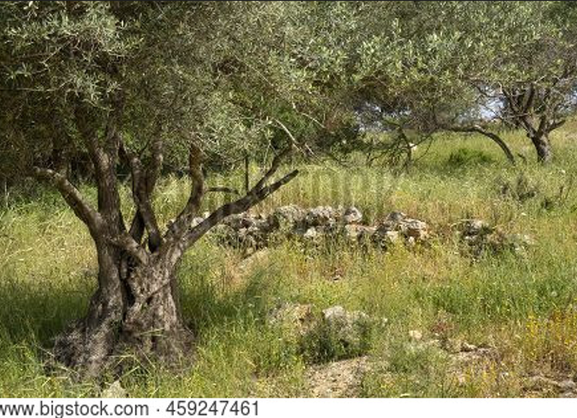

Olive trees in the Judean mountains

The disciples came to him and asked, “Why do you speak to the people in parables?” He replied, “Because the knowledge of the secrets of the kingdom of heaven has been given to you, but not to them.”

~ Matthew 13:10-11 (NIV)

With many similar parables Jesus spoke the word to them, as much as they could understand…But when he was alone with his own disciples, he explained everything.

~ Mark 4:33-34 (NIV)

Parables About Mercy

Parable of the Unforgiving Debtor
“Therefore, the Kingdom of Heaven can be compared to
a king who decided to bring his accounts up to date with servants who had borrowed money from him.
“In the process, one of his debtors was brought in who owed him millions of dollars. He couldn’t pay, so his master ordered that he be sold—along with his wife,
his children, and everything he owned—to pay the debt.
“But the man fell down before his master and begged him, ‘Please, be patient with me, and I will pay it all.’
“Then his master was filled with pity for him, and he released him and forgave his debt.
“But when the man left the king, he went to a fellow servant who owed him a few thousand dollars. He grabbed him by the throat and demanded instant payment.
“His fellow servant fell down before him and begged for a little more time. ‘Be patient with me, and I will pay it,’ he pleaded.
“But his creditor wouldn’t wait. He had the man arrested and put in prison until the debt could be paid in full.
“When some of the other servants saw this, they were very upset. They went to the king and told him everything that had happened.
“Then the king called in the man he had forgiven and said, ‘You evil servant! I forgave you that tremendous debt because you pleaded with me.
“Shouldn’t you have mercy on your fellow servant, just as
I had mercy on you?’ Then the angry king sent the man to prison to be tortured until he had paid his entire debt.
“That’s what my heavenly Father will do to you if you refuse to forgive your brothers and sisters from your heart.”

~ Matthew 18:23-35 (NLT)
Parable of the Good Samaritan
On one occasion an expert in the law stood up to test Jesus. “Teacher,” he asked, “what must I do to inherit eternal life?”
“What is written in the Law?” he replied. “How do you read it?”
He answered, “‘Love the Lord your God with all your heart and with all your soul and with all your strength and with all your mind’; and, ‘Love your neighbor as yourself.’”
“You have answered correctly,” Jesus replied. “Do this and you will live.”
But he wanted to justify himself, so he asked Jesus,
“And who is my neighbor?”
In reply Jesus said: “A man was going down from Jerusalem to Jericho, when he was attacked by robbers. They stripped him of his clothes, beat him and went away, leaving him half dead.
“A priest happened to be going down the same road,
and when he saw the man, he passed by on the other side. So too, a Levite, when he came to the place and saw him, passed by on the other side.
“But a Samaritan, as he traveled, came where the man was; and when he saw him, he took pity on him. He went to him and bandaged his wounds, pouring on oil and wine. Then he put the man on his own donkey, brought him to an inn and took care of him. The next day he took out two denarii and gave them to the innkeeper. ‘Look after him,’ he said, ‘and when I return, I will reimburse you for any extra expense you may have.’
“Which of these three do you think was a neighbor to the man who fell into the hands of robbers?” The expert in the law replied, “The one who had mercy on him.” Jesus told him, “Go and do likewise.”

~ Luke 10:25-37 (NIV)

Parables About How Jesus Seeks the Lost

Parable of the Lost Son
“There was a man who had two sons. The younger one said to his father, ‘Father, give me my share of the estate.’
“…the younger son got together all he had, set off for a distant country and there squandered his wealth in wild living. After he had spent everything, there was a severe famine in that whole country, and he began to be in need.
“So he went and hired himself out to a citizen of that country, who sent him to his fields to feed pigs…When he came to his senses, he said, ‘How many of my father’s hired servants have food to spare, and here I am starving to death! I will set out and go back to my father and say to him: Father, I have sinned against heaven and against you. I am no longer worthy to be called your son; make me like one of your hired servants.’ So he got up and went to his father.
“But while he was still a long way off, his father saw him and was filled with compassion for him; he ran to his son, threw his arms around him and kissed him…
“…the father said to his servants, ‘Quick! Bring the best robe and put it on him…Bring the fattened calf and kill it. Let’s have a feast and celebrate.
“‘For this son of mine was dead and is alive again; he was lost and is found.’”

~ Luke 15:11-24a (NIV)

Parable of the Lost Sheep
Then Jesus told them this parable: “Suppose one of you has a hundred sheep and loses one of them.
“Doesn’t he leave the ninety-nine in the open country
and go after the lost sheep until he finds it?
“And when he finds it, he joyfully puts it on his shoulders and goes home.
“Then he calls his friends and neighbors together and says, ‘Rejoice with me; I have found my lost sheep.’”

~ Luke 15:3-6 (NIV)

Parables About the Harvest

Parable of the Sower
“A farmer went out to plant his seed.
“As he scattered it across his field, some seed fell on a footpath, where it was stepped on, and the birds ate it. Other seed fell among rocks. It began to grow, but the plant soon wilted and died for lack of moisture. Other seed fell among thorns that grew up with it and choked out the tender plants.
“Still other seed fell on fertile soil. This seed grew and produced a crop that was a hundred times as much as
had been planted…
“This is the meaning of the parable:
“The seed is God’s word.
“The seeds that fell on the footpath represent those who hear the message, only to have the devil come and take it away from their hearts and prevent them from believing and being saved.
“The seeds on the rocky soil represent those who hear the message and receive it with joy. But since they don’t have deep roots, they believe for a while, then they fall away when they face temptation.
“The seeds that fell among the thorns represent those who hear the message, but all too quickly the message is crowded out by the cares and riches and pleasures of this life. And so they never grow into maturity.
“And the seeds that fell on the good soil represent honest, good-hearted people who hear God’s word, cling to it, and patiently produce a huge harvest.”

~ Luke 8:5-8a, 11-15 (NLT)

Parable of the Mustard Seed
He told them another parable: “The kingdom of heaven is like a mustard seed, which a man took and planted in his field. Though it is the smallest of all seeds, yet when it grows, it is the largest of garden plants...”

~ Matthew 13:31-32a (NIV)

Parables About the Kingdom of Heaven

Parable of the Hidden Treasure
“The kingdom of heaven is like treasure hidden in a field.
“When a man found it, he hid it again, and then in his joy went and sold all he had and bought that field.”

~ Matthew 13:44 (NIV)



Galilee landscape

Parable of the Pearl of Great Value
“Again, the kingdom of heaven is like a merchant looking for fine pearls.
“When he found one of great value, he went away and sold everything he had and bought it.”

~ Matthew 13:45-46 (NIV)

Parable of the Growing Seed
Jesus also said, “The Kingdom of God is like a farmer who scatters seed on the ground.
“Night and day, while he’s asleep or awake, the seed sprouts and grows, but he does not understand how it happens. The earth produces the crops on its own…”

~ Mark 4:26-28a (NLT)
Parable of the Fishing Net
“Again, the Kingdom of Heaven is like a fishing net that was thrown into the water and caught fish of every kind. When the net was full, they dragged it up onto the shore, sat down, and sorted the good fish into crates, but threw the bad ones away.
“That is the way it will be at the end of the world.
‘The angels will come and separate the wicked people from the righteous, throwing the wicked into the fiery furnace...”

~ Matthew 13:47-50a (NLT)

Parable of the Weeds
Jesus told them another parable: “The kingdom of heaven is like a man who sowed good seed in his field. But while everyone was sleeping, his enemy came and sowed weeds among the wheat…
“The owner’s servants came to him and said, ‘Sir, didn’t you sow good seed in your field? Where then did the weeds come from?’
“‘An enemy did this,’ he replied.
“The servants asked him, ‘Do you want us to go and pull them up?’
“‘No,’ he answered, ‘because while you are pulling the weeds, you may uproot the wheat with them. Let both grow together until the harvest. At that time I will tell the harvesters:
First collect the weeds and tie them in bundles to be burned; then gather the wheat and bring it into my barn…’”
His disciples came to him and said, “Explain to us the parable of the weeds in the field.”
He answered, “The one who sowed the good seed is the Son of Man. The field is the world, and the good seed stands for the people of the kingdom.
“The weeds are the people of the evil one, and the enemy who sows them is the devil. The harvest is the end of the age, and the harvesters are angels.
“As the weeds are pulled up and burned in the fire, so it will be at the end of the age.
“The Son of Man will send out his angels, and they will weed out of his kingdom everything that causes sin and
all who do evil. They will throw them into the blazing furnace, where there will be weeping and gnashing of teeth.
“Then the righteous will shine like the sun in the kingdom of their Father.”

~ Matthew 13:24-30, 36b-43a (NIV)



Mediterranean Sea

Other Parables Taught by Jesus
Parables About Prayer
The Persistent Widow: Luke 18:1-8
The Pharisee and the Tax Collector: Luke 18:9-14

Parables About Money
The Talents: Matthew 25:14-30
The Rich Fool: Luke 12:13-21

Parable About Hell
The Rich Man and Lazarus: Luke 16:19-31

Parables About the Kingdom of Heaven
The Workers in the Vineyard: Matthew 20:1-15
The Tenants: Matthew 21:33-46
The Wedding Feast: Matthew 22:1-14

Jesus Teaches
About the Future

Jesus’ teachings the future, as well as His prediction about the destruction of the Temple in Jerusalem (which happened in 70 A.D.)
are recorded in Matthew 24, Mark 13 and Luke 21:5-36.

As Jesus was sitting on the Mount of Olives, the disciples came to him privately. “Tell us…what will be the sign of your coming and of the end of the age?”
Jesus answered: “Watch out that no one deceives you.
For many will come in my name, claiming, ‘I am the Messiah,’ and will deceive many.
“You will hear of wars and rumors of wars…There will be famines and earthquakes in various places. All these are the beginning of birth pains. Then you will be handed over to be persecuted and put to death, and you will be hated by all nations because of me. At that time many will turn away from the faith and will betray and hate each other, and many false prophets will appear and deceive many people. Because of the increase of wickedness, the love of most will grow cold, but the one who stands firm to the end will be saved.
“And this gospel of the kingdom will be preached in the whole world as a testimony to all nations, and then the
end will come…
“At that time if anyone says to you, ‘Look, here is the Messiah!’ or, ‘There he is!’ do not believe it. For false messiahs and false prophets will appear and perform great signs and wonders to deceive, if possible, even the elect…
“Then will appear the sign of the Son of Man in heaven. And then all the peoples of the earth will mourn when they see the Son of Man coming on the clouds of heaven, with power and great glory…
“But about that day or hour no one knows, not even the angels in heaven, nor the Son, but only the Father…
the Son of Man will come at an hour when you do not expect him...”

~ Excerpts from Matthew 24 (NIV)
“On the earth, nations will be in anguish and perplexity at the roaring and tossing of the sea…At that time they will see the Son of Man coming in a cloud with power and great glory...”

~ Luke 21:25b-27 (NIV)

“You will be betrayed even by parents, brothers and sisters, relatives and friends, and they will put some of you to death. Everyone will hate you because of me. But not a hair of your head will perish. Stand firm, and you will win life.”

~ Luke 21:16-19 (NIV)

“If the world hates you, keep in mind that it hated me first.
“If you belonged to the world, it would love you as its own. As it is, you do not belong to the world, but I have chosen you out of the world. That is why the world hates you.”

~ John 15:18-19 (NIV)

“Remember the word that I said to you, ‘A servant is not greater than his master.’ If they persecuted Me, they will also persecute you.”

~ John 15:20a (NKJV)

“Be careful, or your hearts will be weighed down with carousing, drunkenness and the anxieties of life, and that day will close on you suddenly like a trap.”

~ Luke 21:34 (NIV)

“Keep alert at all times. And pray that you might be strong enough to escape these coming horrors and stand before the Son of Man.”

~ Luke 21:36 (NLT)

“Very truly I tell you, you will weep and mourn while
the world rejoices. You will grieve, but your grief will turn to joy…I will see you again and you will rejoice,
and no one will take away your joy.”

~ John 16:20-22 (NIV)

“I have said all these things to you to keep you from falling away.”

~ John 16:1 (ESV)

“I have told you these things, so that in me you may have peace. In this world you will have trouble. But take heart! I have overcome the world.”

~ John 16:33 (NIV)

Jesus’ Warnings

Jesus Warns About Hell

“Not everyone who says to Me, ‘Lord, Lord,’ shall enter the kingdom of heaven, but he who does the will of My Father in heaven.”

~ Matthew 7:21 (NKJV)

“Enter through the narrow gate.
“For wide is the gate and broad is the road that leads to destruction, and many enter through it.
“But small is the gate and narrow the road that leads to life, and only a few find it.”

~ Matthew 7:13-14 (NIV)

“For many are called, but few are chosen.”

~ Matthew 22:14 (ESV)

Someone asked him, “Lord, will only a few be saved?”
He replied, “Work hard to enter the narrow door to
God’s Kingdom, for many will try to enter but will fail.
“When the master of the house has locked the door,
it will be too late. You will stand outside knocking and pleading, ‘Lord, open the door for us!’ But he will reply,
‘I don’t know you or where you come from.’”

~ Luke 13:23-25 (NLT)

“…do not be afraid of those who kill the body, and after that have no more that they can do.
“But I will show you whom you should fear: Fear Him who, after He has killed, has power to cast into hell…”

~ Luke 12:4b-5a (NKJV)

“The Son of Man will send out his angels, and they will weed out of his kingdom everything that causes sin and
all who do evil…
“The angels will come and separate the wicked from the righteous and throw them into the blazing furnace,
where there will be weeping and gnashing of teeth.”

~ Matthew 13:41, 49b-50 (NIV)
“I tell you, many will come from east and west and recline at table with Abraham, Isaac, and Jacob in the kingdom of heaven, while the sons of the kingdom will be thrown into the outer darkness.”

~ Matthew 8:11-12a (ESV)

“…but you yourselves cast out.”

~ Luke 13:28b (ESV)

“But unless you repent, you too will all perish.”

~ Luke 13:5b (NIV)

Jesus Warns the Pharisees

“Woe to you, teachers of the law and Pharisees, you hypocrites!
“You shut the door of the kingdom of heaven in people’s faces. You yourselves do not enter, nor will you let those enter who are trying to…
“You are like whitewashed tombs, which look beautiful on the outside but on the inside are full of the bones of the dead and everything unclean. In the same way, on the outside you appear to people as righteous but on the inside you are full of hypocrisy and wickedness…
“You snakes! You brood of vipers! How will you escape being condemned to hell?”

~ Matthew 23:13-33 (NIV)

“You hypocrites! Isaiah was right when he prophesied about you:
‘These people honor me with their lips,
but their hearts are far from me.
‘They worship me in vain;
their teachings are merely human rules.’”

~ Matthew 15:7-9 (NIV)

Jesus Warns the People About the Pharisees

“Everything they do is for show…They love to receive respectful greetings…and to be called ‘Rabbi.’ Don’t let anyone call you ‘Rabbi,’ for you have only one teacher…
“And don’t address anyone here on earth as ‘Father,’
for only God in heaven is your spiritual Father.”

~ Matthew 23:5-9 (NLT)

Jesus Teaches About

the Kingdom of Heaven

Jesus answered, “My kingdom is not of this world.”

~ John 18:36a (ESV)

“The Kingdom of God is near! Repent of your sins and believe the Good News!”

~ Mark 1:15b (NLT)

“Enter through the narrow gate…small is the gate and narrow the road that leads to life, and only a few find it.”

~ Matthew 7:13-14 (NIV)

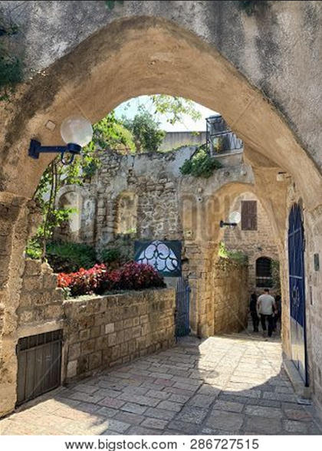

Street in Jaffa, Israel
“When the Son of Man comes in his glory, and all the angels with him, he will sit on his glorious throne. All the nations will be gathered before him, and he will separate the people one from another as a shepherd separates the sheep from the goats. He will put the sheep on his right and the goats on his left.
“Then the King will say to those on his right, ‘Come, you who are blessed by my Father; take your inheritance, the kingdom prepared for you since the creation of the world. For
I was hungry and you gave me something to eat,
I was thirsty and you gave me something to drink,
I was a stranger and you invited me in,
I needed clothes and you clothed me,
I was sick and you looked after me,
I was in prison and you came to visit me.
“Then the righteous will answer him, ‘Lord, when did
we see you hungry and feed you, or thirsty and give you something to drink?’…
“The King will reply, ‘Truly I tell you, whatever you did for one of the least of these brothers and sisters of mine, you did for me.’
“Then he will say to those on his left, ‘Depart from me,
you who are cursed, into the eternal fire prepared for the devil and his angels. For
I was hungry and you gave me nothing to eat,
I was thirsty and you gave me nothing to drink,
I was a stranger and you did not invite me in,
I needed clothes and you did not clothe me,
I was sick and in prison and you did not look after me.
“They also will answer, ‘Lord, when did we see you hungry or thirsty or a stranger or needing clothes or sick or in prison, and did not help you?’ “He will reply, ‘Truly I tell you, whatever you did not do for one of the least of these, you did not do for me.’
“Then they will go away to eternal punishment, but the righteous to eternal life.”

~ Matthew 25:31-46 (NIV)
“…I will build my church,
and all the powers of hell will not conquer it.”

~ Matthew 16:18b (NLT)

“…I will build my church;
and the gates of hell shall not prevail against it.”

~ Matthew 16:18b (ESV)

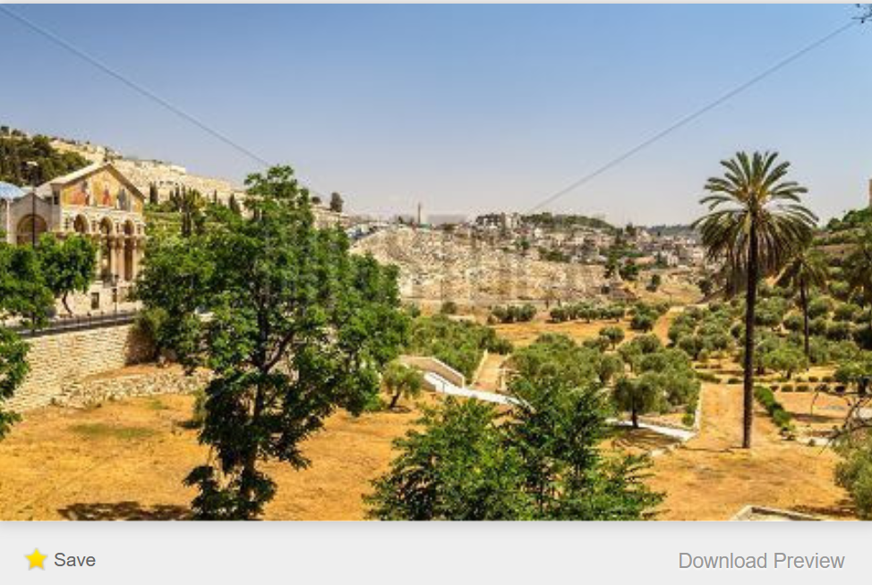
Bigstock Photo ID: 141033635

Kidron Valley, Jerusalem

“And people will come from all over the world—from
east and west, north and south—to take their places in
the Kingdom of God. And note this: Some who seem
least important now will be the greatest then, and some who are the greatest now will be least important then.”

~ Luke 13:29-30 (NLT)

“Everyone who acknowledges me publicly here on earth,
I will also acknowledge before my Father in heaven.
“But everyone who denies me here on earth, I will also deny before my Father in heaven.”

~ Matthew 10:32-33 (NLT)

“For whoever is ashamed of Me and My words in this adulterous and sinful generation, of him the Son of Man also will be ashamed when He comes in the glory of His Father with the holy angels.”

~ Mark 8:38 (NKJV)
“Look, I am coming soon! My reward is with me, and I will give to each person according to what they have done.”

~ Revelation 22:12 (NIV)

“For the Son of Man is going to come with his angels in the glory of his Father, and then he will repay each person according to what he has done.”

~ Matthew 16:27 (ESV)

“Indeed, the time is coming when all the dead in their graves will hear the voice of God’s Son, and they will
rise again.
“Those who have done good will rise to experience eternal life, and those who have continued in evil will rise to experience judgment.”

~ John 5:28b-29 (NLT)

“Then the righteous will shine like the sun in the kingdom of their Father.”

~ Matthew 13:43a (ESV)

“Blessed are you when people hate you, when they exclude you and insult you and reject your name as evil, because of the Son of Man.
“Rejoice in that day and leap for joy, because great is your reward in heaven.”

~ Luke 6:22-23a (NIV)

“Let not your heart be troubled; you believe in God, believe also in Me.
“In My Father’s house are many mansions; if it were not so, I would have told you.
“I go to prepare a place for you. And if I go and prepare a place for you, I will come again and receive you to Myself; that where I am, there you may be also.”

~ John 14:1-3 (NKJV)

“Most assuredly, I say to you, he who hears My word and believes in Him who sent Me has everlasting life, and shall not come into judgment, but has passed from death into life.”

~ John 5:24 (NKJV)

The Cost of

Following Jesus

“Whoever desires to come after Me, let him deny himself, and take up his cross, and follow Me.
“For whoever desires to save his life will lose it, but whoever loses his life for My sake and the gospel’s
will save it. For what will it profit a man if he gains the whole world, and loses his own soul? Or what will a man give in exchange for his soul?”

~ Mark 8:34b-37 (NKJV)

As they were walking along the road, a man said to him,
“I will follow you wherever you go.” Jesus replied,
“Foxes have dens and birds have nests, but the Son of Man has no place to lay his head.” He said to another man, “Follow me.” But he replied, “Lord, first let me go and bury my father.” Jesus said to him, “Let the dead bury their own dead, but you go and proclaim the kingdom of God.” Still another said, “I will follow you, Lord; but first let me go back and say goodbye to my family.”
Jesus replied, “No one who puts a hand to the plow and looks back is fit for service in the kingdom of God.”

~ Luke 9:57-62 (NIV)

“But don’t begin until you count the cost. For who would begin construction of a building without first calculating the cost to see if there is enough money to finish it?”

~ Luke 14:28 (NLT)

“Anyone who loves their father or mother more than me
is not worthy of me; anyone who loves their son or daughter more than me is not worthy of me.”

~ Matthew 10:37 (NIV)

“…whoever of you does not forsake all that he has cannot be My disciple.”

~ Luke 14:33b (NKJV)

Jesus Teaches

About Himself

“Remain in me, as I also remain in you.
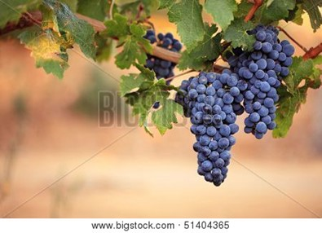
“No branch can bear fruit by itself; it must remain in
the vine.
“Neither
can you bear fruit unless you remain
in me.
“I am
the vine;
you are
the branches.

“If you remain in me and I in you, you will bear much fruit; apart from me you can do nothing.
“If you do not remain in me, you are like a branch that is thrown away and withers; such branches are picked up, thrown into the fire and burned.
“If you remain in me and my words remain in you,
ask whatever you wish, and it will be done for you.
“This is to my Father’s glory, that you bear much fruit, showing yourselves to be my disciples.”

~ John 15:4-8 (NIV)

“You did not choose me, but I chose you and appointed you so that you might go and bear fruit—fruit that will last—and so that whatever you ask in my name the Father will give you.
“This is my command: Love each other.”

~ John 15:16-17 (NIV)
Now he had to go through Samaria…and Jesus, tired as he was from the journey, sat down by the well. It was about noon.

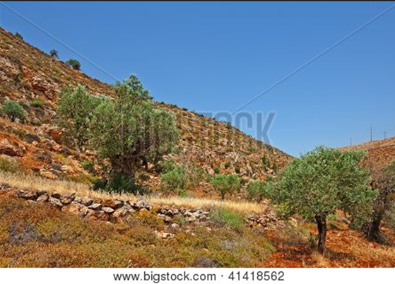

Olive grove in Samaria

When a Samaritan woman came to draw water, Jesus said to her, “Will you give me a drink?”…
The Samaritan woman said to him, “You are a Jew and
I am a Samaritan woman. How can you ask me for a drink?”
Jesus answered her, “If you knew the gift of God and who it is that asks you for a drink, you would have asked him and he would have given you living water.”
“Sir,” the woman said, “you have nothing to draw with and the well is deep. Where can you get this living water?”…
Jesus answered, “Everyone who drinks this water will be thirsty again, but whoever drinks the water I give them will never thirst. Indeed, the water I give them will become in them a spring of water welling up to eternal life...”
The woman said to him, “Sir, give me this water…”
He told her, “Go, call your husband and come back.”
“I have no husband,” she replied. Jesus said to her, “You are right when you say you have no husband. The fact is, you have had five husbands, and the man you now have is not your husband. What you have just said is quite true.”…
“Woman,” Jesus replied, “believe me, a time is coming when you will worship the Father neither on this mountain nor in Jerusalem...a time is coming and has now come when the true worshipers will worship the Father in the Spirit and in truth, for they are the kind of worshipers the Father seeks. God is spirit, and his worshipers must worship in the Spirit and in truth.”
The woman said, “I know that Messiah” (called Christ) “is coming. When he comes, he will explain everything to us.”
Then Jesus declared, “I, the one speaking to you—I am he.”

~ John 4:4-26 (NIV)

“You call me ‘Teacher’ and ‘Lord,’ and you are right, because that’s draw what I am.”

~ John 13:13 (NLT)

Jesus replied, “I tell you the truth, unless you are born again, you cannot see the Kingdom of God...I assure you, no one can enter the Kingdom of God without being born of water and the Spirit. Humans can reproduce only human life, but the Holy Spirit gives birth to spiritual life.”

~ John 3:3-6 (NLT)

“Believe me when I say that I am in the Father and the Father is in me; or at least believe on the evidence of the works themselves.
“Very truly I tell you, whoever believes in me will do the works I have been doing, and they will do even greater things than these, because I am going to the Father.
“And I will do whatever you ask in my name, so that the Father may be glorified in the Son.
“You may ask me for anything in my name, and I will do it.”

~ John 14:11-14 (NIV)

“Look, I have given you authority over all the power of the enemy, and you can walk among snakes and scorpions and crush them. Nothing will injure you.”

~ Luke 10:19 (NLT)

“You will be hated by everyone because of me, but the one who stands firm to the end will be saved.”

~ Matthew 10:22 (NIV)
“I have come as a light to shine in this dark world,
so that all who put their trust in me will no longer
remain in the dark.”

~ John 12:46 (NLT)

“This is the verdict: Light has come into the world,
but people loved darkness instead of light because
their deeds were evil.”

~ John 3:19 (NIV)

He said to them, “You are from below; I am from above. You are of this world; I am not of this world.”

~ John 8:23 (ESV)

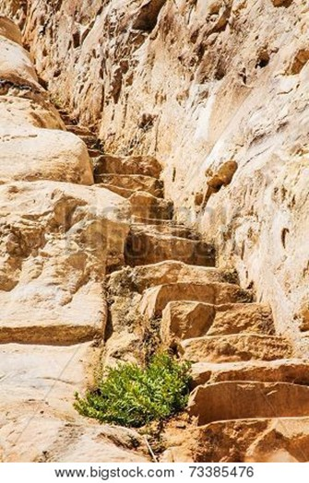
“No one has ascended into heaven except
he who descended from heaven,
the Son of Man.
“And as Moses lifted up the serpent in the wilderness, so must the Son of Man be lifted up, that whoever believes in him may have
eternal life.”
~ John 3:13-15 (ESV)

“And I, when
I am lifted up from the earth, will draw all people to myself.”
~ John 12:32 (ESV)

“…if you do not believe that I am He, you will die in
your sins.”

~ John 8:24b (NKJV)

Jesus’ Claims
of Divinity

Jesus Equates Himself with God

God said to Moses, “I am who I am. This is what you are to say to the Israelites: ‘I am has sent me to you.’”

~ Exodus 3:14 (NIV)

Jesus said to them, “Most assuredly, I say to you, before Abraham was, I AM.”
Then they took up stones to throw at Him…

~ John 8:58-59a (NKJV)

“The Father and I are one.”
Once again the people picked up stones to kill him.
Jesus said, “At my Father’s direction I have done many good works. For which one are you going to stone me?”
They replied, “We’re stoning you not for any good work, but for blasphemy! You, a mere man, claim to be God.”

~ John 10:30-33 (NLT)

Jesus Forgives a Man’s Sins

When Jesus saw their faith, he said to the paralyzed man, “Son, your sins are forgiven…”
Now some teachers of the law were sitting there, thinking to themselves, “Why does this fellow talk like that?
He’s blaspheming! Who can forgive sins but God alone?”
Immediately Jesus knew in his spirit that this was what they were thinking in their hearts, and he said to them
“…I want you to know that the Son of Man has authority on earth to forgive sins.”
So he said to the man, “I tell you, get up, take your mat and go home.” He got up, took his mat and walked out
in full view of them all.

~ Mark 2:5-12a (NIV)

Jesus Claims to be the Messiah
The woman said to Him, “I know that Messiah is coming” (who is called Christ).
“When He comes, He will tell us all things.”
Jesus said to her, “I who speak to you am He.”

~ John 4:25-26 (NKJV)

“For many will come in my name, claiming, ‘I am the Messiah,’ and will deceive many.”

~ Matthew 24:5 (NIV)

The high priest said to him, “I charge you under oath by the living God: Tell us if you are the Messiah, the Son of God.”

~ Matthew 26:63b (NIV)

Again the high priest asked him, “Are you the Messiah,
the Son of the Blessed One?”
“I am,” said Jesus.
“And you will see the Son of Man sitting at the right hand of the Mighty One and coming on the clouds of heaven.”

~ Mark 14:61b-62 (NIV)

People Worshiped Jesus

When [the Magi] saw the star, they were overjoyed.
On coming to the house, they saw the child with his mother Mary, and they bowed down and worshiped him.
Then they opened their treasures and presented him with gifts of gold, frankincense and myrrh.

~ Matthew 2:10-11 (NIV)

About three o’clock in the morning Jesus came toward them, walking on the water.
When the disciples saw him walking on the water, they were terrified.
In their fear, they cried out, “It’s a ghost!”
But Jesus spoke to them at once. “Don’t be afraid,” he said. “Take courage. I am here!”
Then Peter called to him, “Lord, if it’s really you, tell me to come to you, walking on the water.”
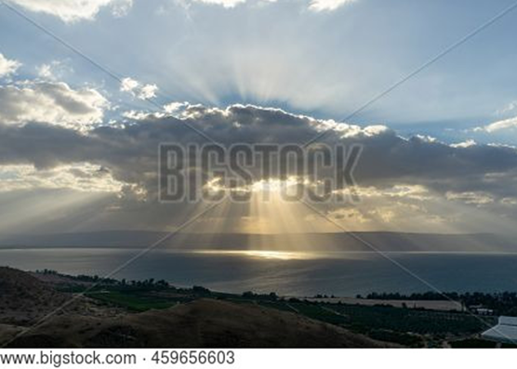
“Yes, come,”
Jesus said.
So Peter went over the side of the boat and walked on the water toward Jesus.
But when he saw the strong wind and the waves,
he was terrified and began to sink.
“Save me, Lord!”
he shouted.

Sea of Galilee

Jesus immediately reached out and grabbed him.
“You have so little faith,” Jesus said. “Why did you doubt me?” When they climbed back into the boat, the wind stopped.
Then the disciples worshiped him.
“You really are the Son of God!” they exclaimed.

~ Matthew 14:25-33 (NLT)

The angel said to the women, “Do not be afraid, for I know that you are looking for Jesus, who was crucified.
“He is not here; he has risen, just as he said…”
Suddenly Jesus met them. “Greetings,” he said.
They came to him, clasped his feet and worshiped him.

~ Matthew 28:5-9 (NIV)

Then Jesus led them to Bethany, and lifting his hands
to heaven, he blessed them. While he was blessing them, he left them and was taken up to heaven.
So they worshiped him and then returned to Jerusalem filled with great joy.

~ Luke 24:50-52 (NLT)

Jesus Said He Gives Eternal Life

“My sheep listen to my voice…I give them eternal life…”

~ John 10:27-28a (NLT)

“For my Father’s will is that everyone who looks to
the Son and believes in him shall have eternal life,
and I will raise them up at the last day.”

~ John 6:40 (NIV)

Jesus Called God His Father
…Jesus said to them, “My Father is always at his work to this very day, and I too am working.”
For this reason they tried all the more to kill him; not only was he breaking the Sabbath, but he was even calling God his own Father, making himself equal with God.

~ John 5:17b-18 (NIV)

“My Father has entrusted everything to me. No one truly knows the Son except the Father...”

~ Matthew 11:27a (NLT)

Jesus Was Recognized as God

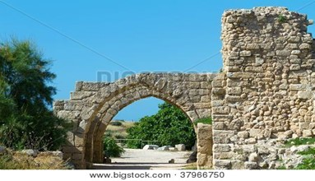
When Jesus came to the region of Caesarea Philippi,
he asked his disciples, “Who do people say the Son of
Man is? Caesarea, Israel

They replied, “Some say John the Baptist; others say Elijah; and still others, Jeremiah or one of the prophets.”
“But what about you?” he asked. “Who do you say I am?”
Simon Peter answered, “You are the Messiah, the Son of the living God.”

~ Matthew 16:13-16 (NIV)

Jesus is the “I AM”

God said to Moses, “I am who I am. This is what you are to say to the Israelites: ‘I am has sent me to you.’”

~ Exodus 3:14 (NIV)

Jesus said to them, “Most assuredly, I say to you, before Abraham was, I am.”

~ John 8:58 (NKJV)

“I am the way, the truth, and the life.
“No one comes to the Father except through Me.”

~ John 14:6 (NKJV)

“I am the light of the world.
“Whoever follows me will not walk in darkness, but will have the light of life.”

~ John 8:12b (ESV)

“I am the bread of life.
“He who comes to Me shall never hunger, and he who believes in Me shall never thirst.”

~ John 6:35b (NKJV)

“I am the vine...
“If you remain in me and I in you, you will bear much fruit; apart from me you can do nothing.”

~ John 15:5 (NIV)

“I am the good shepherd.
“The good shepherd lays down his life for the sheep.”

~ John 10:11 (NIV)

“I am the gate;
“whoever enters through me will be saved. They will come in and go out, and find pasture.”

~ John 10:9 (NIV)

“I am the resurrection and the life.
“Whoever believes in me, though he die, yet shall he live…”

~ John 11:25b (ESV)

Jesus is the Way
to the Father

God loves you abundantly, and has made a way for you to live forever in His glorious kingdom. However, first He had to pay an enormous price for you to be forgiven of your sin, in order to receive this eternal glory. This section explains His plan to forgive and save you. In summary:
God loves you, but your sin separates you from Him, and because of it, God’s wrath will come. However, Jesus died as a sacrifice to save you from your sins, from God’s wrath, and from death itself. When you confess your sins, repent and accept the salvation that Christ offers, God will forgive you. By trusting in Christ you become God’s child, and as His child, you will inherit eternal life and heaven will be your home.

God Loves You

“I have loved you with an everlasting love;
“I have drawn you with unfailing kindness.”

~ Jeremiah 31:3b (NIV)

“Before I formed you in the womb I knew you,
before you were born I set you apart…”

~ Jeremiah 1:5a (NIV)

“I have called you by your name; you are Mine.”

~ Isaiah 43:1b (NKJV)

“See, I have inscribed you on the palms of My hands…”

~ Isaiah 49:16a (NKJV)

“And even the very hairs of your head are all numbered.”

~ Matthew 10:30 (NIV)

“…I lavish unfailing love for a thousand generations
on those who love me and obey my commands.”

~ Deuteronomy 5:10 (NLT)

“I am slow to anger and filled with unfailing love...”

~ Exodus 34:6b (NLT)

“…the Lord God, merciful and gracious, longsuffering, and abundant in goodness and truth...”

~ Exodus 34:6b (KJV)
“I am the good shepherd.”

~ John 10:11a (NIV)

“My sheep listen to my voice; I know them, and they follow me.
“I give them eternal life, and they will never perish.
“No one can snatch them away from me, for my Father has given them to me, and he is more powerful than anyone else.
“No one can snatch them from the Father’s hand.”

~ John 10:27-29 (NLT)

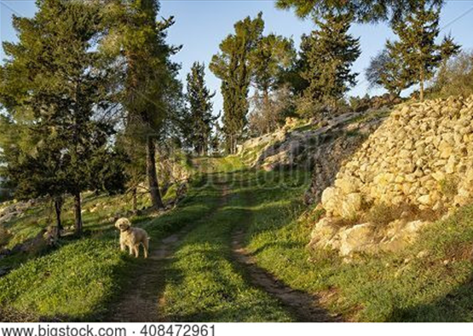

Path in Judean mountains

Know that the Lord is God.
It is he who made us, and we are his;
we are his people, the sheep of his pasture.

~ Psalm 100:3 (NIV)

Yes, the Sovereign Lord is coming in power…
He will feed his flock like a shepherd.
He will carry the lambs in his arms, holding them close
to his heart.

~ Isaiah 40:10-11a (NLT)

But Your Sin Separates You from God

The acts of the flesh are obvious: sexual immorality, impurity and debauchery; idolatry and witchcraft;
hatred, discord, jealousy, fits of rage, selfish ambition, dissensions, factions and envy; drunkenness, orgies,
and the like.
I warn you, as I did before, that those who live like this will not inherit the kingdom of God.

~ Galatians 5:19-21 (NIV)

The Day of God’s Wrath Will Come

“Then I will draw near to you for judgment.
“I will be a swift witness
against the sorcerers,
against the adulterers,
against those who swear falsely,
against those who oppress the hired worker in his wages, the widow and the fatherless,
against those who thrust aside the sojourner,
“and do not fear me,” says the Lord of hosts.

~ Malachi 3:5 (ESV)

“…the cowardly, the unbelieving, the vile, the murderers, the sexually immoral, those who practice magic arts, the idolaters and all liars—they will be consigned to the fiery lake of burning sulfur. This is the second death.”

~ Revelation 21:8 (NIV)

“Whom have you so dreaded and feared
that you have not been true to me…
Is it not because I have long been silent
that you do not fear me?”

~ Isaiah 57:11 (NIV)

“But I will show you whom you should fear:
“Fear Him who, after He has killed, has power to
cast into hell; yes, I say to you, fear Him!”

~ Luke 12:5 (NKJV)

Confess Your Sin and Repent

Have mercy on me, O God,
according to your unfailing love;
according to your great compassion
blot out my transgressions.
Wash away all my iniquity
and cleanse me from my sin.

~ Psalm 51:1-2 (NIV)

…Jesus went into Galilee, where he preached…
“The Kingdom of God is near! Repent of your sins and believe the Good News!”

~ Mark 1:14b-15 (NLT)

“But unless you repent, you too will all perish.”

~ Luke 13:3b (NIV)

If we confess our sins, he is faithful and just to forgive us our sins, and to cleanse us from all unrighteousness.

~ 1 John 1:9 (ESV)

Repent and be baptized, every one of you, in the name of Jesus Christ for the forgiveness of your sins.

~ Acts 2:38a (NIV)

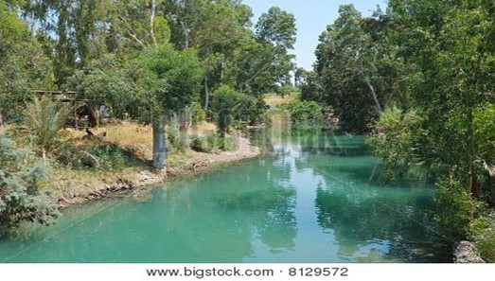

Jordan River

Jesus Died to Save You…

…From Your Sin

Jesus gave his life for our sins, just as God our Father planned, in order to rescue us from this evil world in which we live.

~ Galatians 1:4 (NLT)

All glory to him who loves us and has freed us from
our sins by shedding his blood for us…
All glory and power to him forever and ever! Amen.

~ Revelation 1:5b-6 (NLT)

…From God’s Wrath

Jesus, whom God raised from the dead…is the one who has rescued us from the terrors of the coming judgment.

~ 1 Thessalonians 1:10b (NLT)

For God did not appoint us to suffer wrath but to receive salvation through our Lord Jesus Christ.

~ 1 Thessalonians 5:9 (NIV)

…From Death

He broke the power of death and illuminated the way to life and immortality through the Good News.

~ 2 Timothy 1:10b (NLT)

For the wages of sin is death, but the free gift of God
is eternal life in Christ Jesus our Lord.

~ Romans 6:23 (ESV)

…he placed his right hand on me and said:
“Do not be afraid.
I am the First and the Last.
I am the Living One;
I was dead, and now look,
I am alive for ever and ever!”

~ Revelation 1:17b-18a (NIV)

…because you belong to him, the power of the life-giving Spirit has freed you from the power of sin that leads to death.

~ Romans 8:2 (NLT)

God Bought You at a Price

You are not your own; you were bought at a price.

~ 1 Corinthians 6:19b-20a (NIV)

…God paid a ransom to save you from the empty life
you inherited from your ancestors. And it was not paid with mere gold or silver…
It was the precious blood of Christ, the sinless, spotless Lamb of God.

~ 1 Peter 1:18b-19 (NLT)

But he was pierced for our transgressions,
he was crushed for our iniquities;
the punishment that brought us peace was on him,
and by his wounds we are healed.

~ Isaiah 53:5 (NIV)

In Christ You Are Forgiven

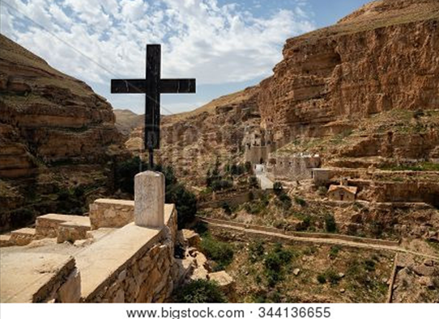
Then God made you alive
with Christ, for he forgave
all our sins.
He canceled the record
of the charges against us
and took it away by
nailing it to the cross.

~ Colossians 2:13b-14 (NLT)

For with the Lord there
is mercy, and with Him
is abundant redemption.
~ Psalm 130:7b (NKJV)

His redemption overflows.
~ Psalm 130:7b (NLT)
Monastery of St. George

For as high as the heavens are above the earth,
so great is his love for those who fear him;
as far as the east is from the west,
so far has he removed our transgressions from us.

~ Psalm 103:11-12 (NIV)

God Demonstrates His Love Through Christ

But God demonstrates his own love for us in this:
While we were still sinners, Christ died for us.

~ Romans 5:8 (NIV)

“For God so loved the world that He gave His only begotten Son, that whoever believes in Him should
not perish but have everlasting life.”

~ John 3:16 (NKJV)

Salvation is Through Christ Alone

Salvation is found in no one else, for there is no other name under heaven given to mankind by which we must be saved.

~ Acts 4:12 (NIV)

Jesus said to him, “I am the way, the truth, and the life. No one comes to the Father except through Me.”

~ John 14:6 (NKJV)

“Most assuredly, I say to you, he who believes in Me
has everlasting life.”

~ John 6:47 (NKJV)

Then Jesus said, “Come to me, all of you who are weary and carry heavy burdens, and I will give you rest.”

~ Matthew 11:28 (NLT)

“No one can come to Me unless the Father who sent Me draws him; and I will raise him up at the last day.”

~ John 6:44 (NKJV)

“…whoever comes to me I will never drive away.”

~ John 6:37b (NIV)

“All those the Father gives me will come to me, and whoever comes to me I will never drive away.
“For I have come down from heaven not to do my will but to do the will of him who sent me. And this is the will of him who sent me, that I shall lose none of all those he has given me, but raise them up at the last day.
“For my Father’s will is that everyone who looks to the Son and believes in him shall have eternal life, and I will raise them up at the last day.”

~ John 6:37-40 (NIV)

Salvation is a Gift: Free and Undeserved

“The Spirit alone gives eternal life. Human effort accomplishes nothing.”

~ John 6:63a (NLT)

For it is by grace you have been saved, through faith—
and this not from yourselves, it is the gift of God—
not by works, so that no one can boast.

~ Ephesians 2:8-9 (NIV)

Can we boast, then, that we have done anything to be accepted by God? No, because our acquittal is not based on obeying the law. It is based on faith.

~ Romans 3:27 (NLT)

And since it is through God’s kindness, then it is not by their good works.
For in that case, God’s grace would not be what it really is—free and undeserved.

~ Romans 11:6 (NLT)

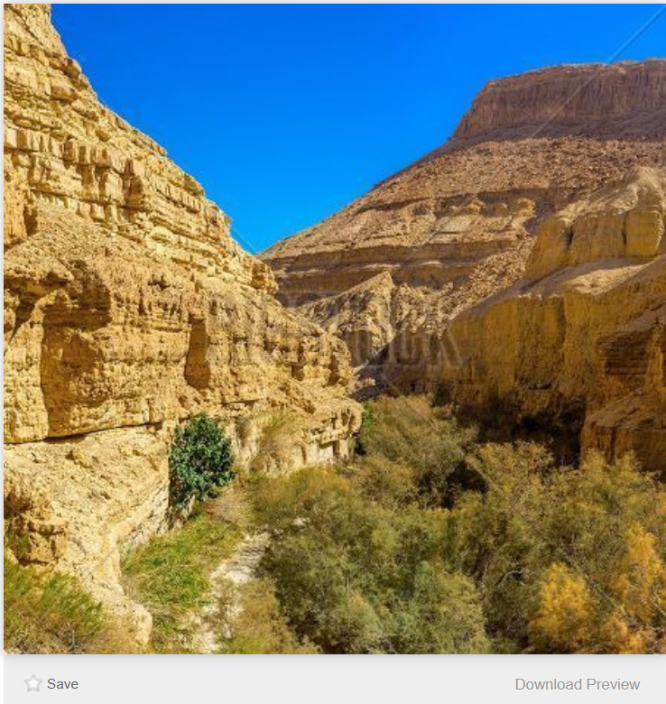
Bigstock Photo ID: 140173880

Ein Gedi Nature Reserve, Israel

Accept This Gift of Salvation

If you declare with your mouth, “Jesus is Lord,” and believe in your heart that God raised him from the dead, you will be saved.

~ Romans 10:9 (NIV)

You Belong to God Through Faith in Christ
and Have Become His Child

Everyone who believes that Jesus is the Christ has become a child of God.

~ 1 John 5:1a (NLT)

See what great love the Father has lavished on us,
that we should be called children of God!

~ 1 John 3:1a (NIV)

…you belong to Christ, and Christ belongs to God.

~ 1 Corinthians 3:23b (NLT)

“My prayer is not for the world, but for those you have given me, because they belong to you. All who are mine belong to you...”

~ John 17:9-10a (NLT)



Nubian Ibex in Jerusalem Biblical Zoo

Eternal Life is Yours Through Christ

…God gave us eternal life, and this life is in his Son.

~ 1 John 5:11b (ESV)

For you have been born again…
Your new life will last forever because it comes from the eternal, living word of God.

~ 1 Peter 1:23 (NLT)

No eye has seen, no ear has heard, and no mind has imagined what God has prepared for those who love him.

~ 1 Corinthians 2:9b (NLT)

So we fix our eyes not on what is seen, but on what is unseen, since what is seen is temporary, but what is unseen is eternal.

~ 2 Corinthians 4:18 (NIV)

His dominion is an everlasting dominion that will not pass away, and his kingdom is one that will never be destroyed.

~ Daniel 7:14b (NIV)

…our citizenship is in heaven, and from it we await a Savior, the Lord Jesus Christ...

~ Philippians 3:20 (ESV)

…we wait for the blessed hope—the appearing of the glory of our great God and Savior, Jesus Christ...

~ Titus 2:13 (NIV)

When Christ who is your life appears, then you also will appear with him in glory.

~ Colossians 3:4 (ESV)

For the Lord himself will come down from heaven, with
a loud command, with the voice of the archangel and
with the trumpet call of God, and the dead in Christ will rise first.
After that, we who are still alive and are left will be caught up together with them in the clouds to meet the Lord in the air.
And so we will be with the Lord forever.
Therefore encourage one another with these words.

~ 1 Thessalonians 4:16-18 (NIV)
“I am the Alpha and the Omega, the Beginning and the End.
“To the thirsty I will give water without cost from the spring of the water of life.”

~ Revelation 21:6b (NIV)

“Come, everyone who thirsts,
come to the waters;
and he who has no money,
come, buy and eat!”

~ Isaiah 55:1a (ESV)

“Let anyone who is thirsty come to me and drink.
“Whoever believes in me, as Scripture has said,
rivers of living water will flow from within them.”

~ John 7:37b-38 (NIV)


Then the angel showed me the river of the water
of life,
as clear
as crystal, flowing from the throne of God and
of the Lamb down the middle of the great street of
the city.
On each side of the river stood the tree of life…
~ Revelation
22:1-2a (NIV)

Parod River in Galilee

Praise God for His Gift of Eternal Life

Thanks be to God for His indescribable gift!

~ 2 Corinthians 9:15 (NKJV)

May you be filled with joy, always thanking the Father.
He has enabled you to share in the inheritance that belongs to his people, who live in the light.

~ Colossians 1:11b-12 (NLT)

Praise be to the God and Father of our Lord Jesus Christ, who has blessed us in the heavenly realms with every spiritual blessing in Christ.

~ Ephesians 1:3 (NIV)

Since we are receiving a Kingdom that is unshakable,
let us be thankful and please God by worshiping him
with holy fear and awe.

~ Hebrews 12:28 (NLT)

Heaven is Your Home

You make known to me the path of life;
you will fill me with joy in your presence,
with eternal pleasures at your right hand.

~ Psalm 16:11 (NIV)

Point out anything in me that offends you,
and lead me along the path of everlasting life.

~ Psalm 139:24 (NLT)

Yet I still belong to you;
you hold my right hand.
You guide me with your counsel,
leading me to a glorious destiny.

~ Psalm 73:23-24 (NLT)

Surely you have granted him unending blessings
and made him glad with the joy of your presence.

~ Psalm 21:6 (NIV)

Surely goodness and mercy shall follow me
All the days of my life;
And I will dwell in the house of the Lord
Forever.

~ Psalm 23:6 (NKJV)
Jesus answered him,
“Truly I tell you, today you will be with me in paradise.”

~ Luke 23:43 (NIV)

“In My Father’s house are many mansions…I go to prepare a place for you.”

~ John 14:2 (NKJV)

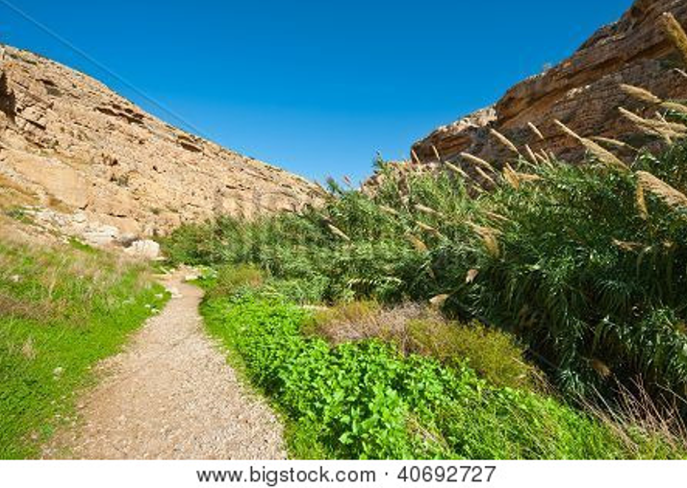

Path in Judean mountains

“So don’t be afraid, little flock. For it gives your Father great happiness to give you the Kingdom.”

~ Luke 12:32 (NLT)

“To the one who is victorious, I will give the right to
eat from the tree of life, which is in the paradise of God.”

~ Revelation 2:7b (NIV)

“…rejoice because your names are written in heaven.”

~ Luke 10:20b (NKJV)

“And be sure of this:
“I am with you always, even to the end of the age.”

~ Matthew 28:20b (NLT)

Booklet Titles in the Series



www.TheWordOfGodSeries.com

Booklet Titles in the Series

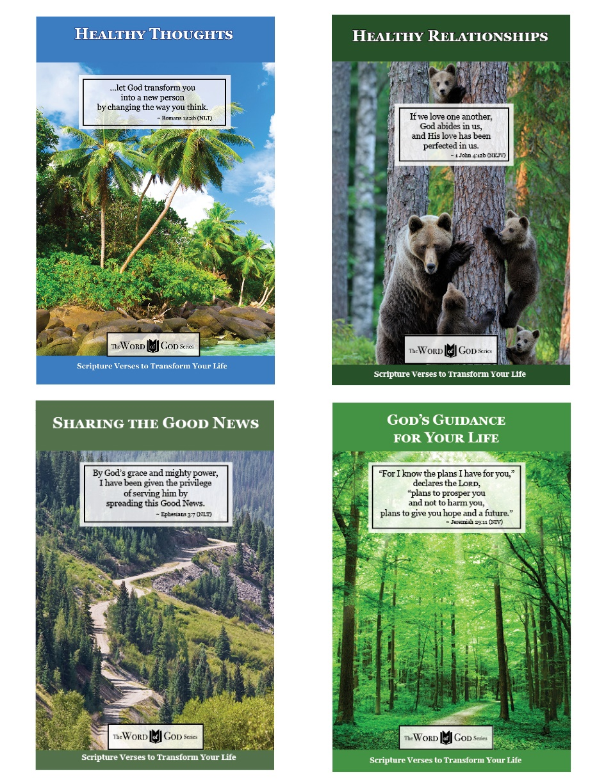

www.TheWordOfGodSeries.com

Booklet Titles in the Series

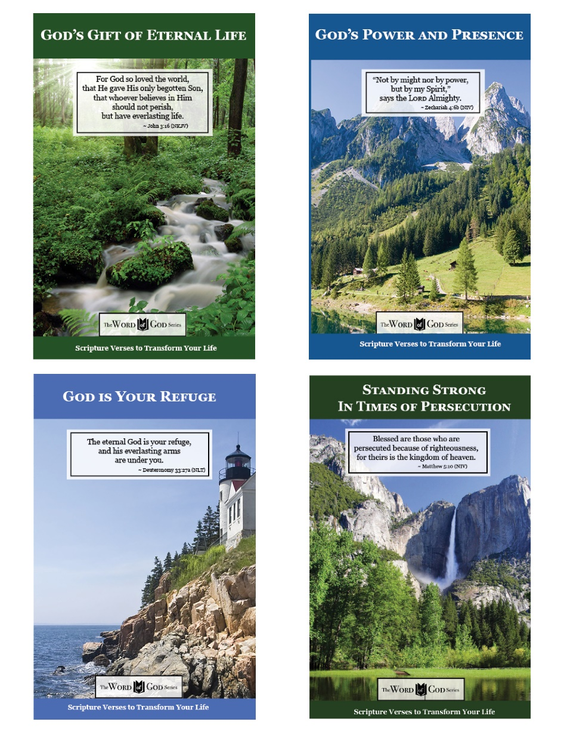

www.TheWordOfGodSeries.com

Booklet Titles in the Series

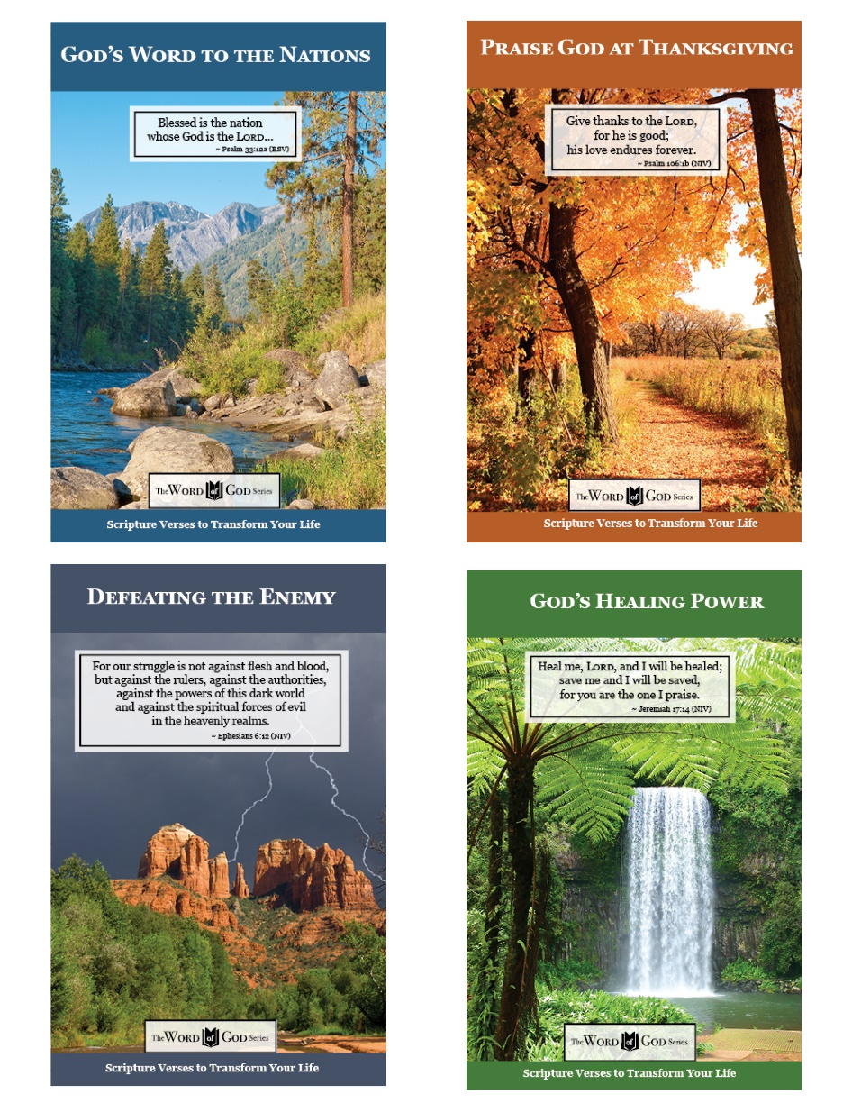

www.TheWordOfGodSeries.com

Booklet Titles in the Series

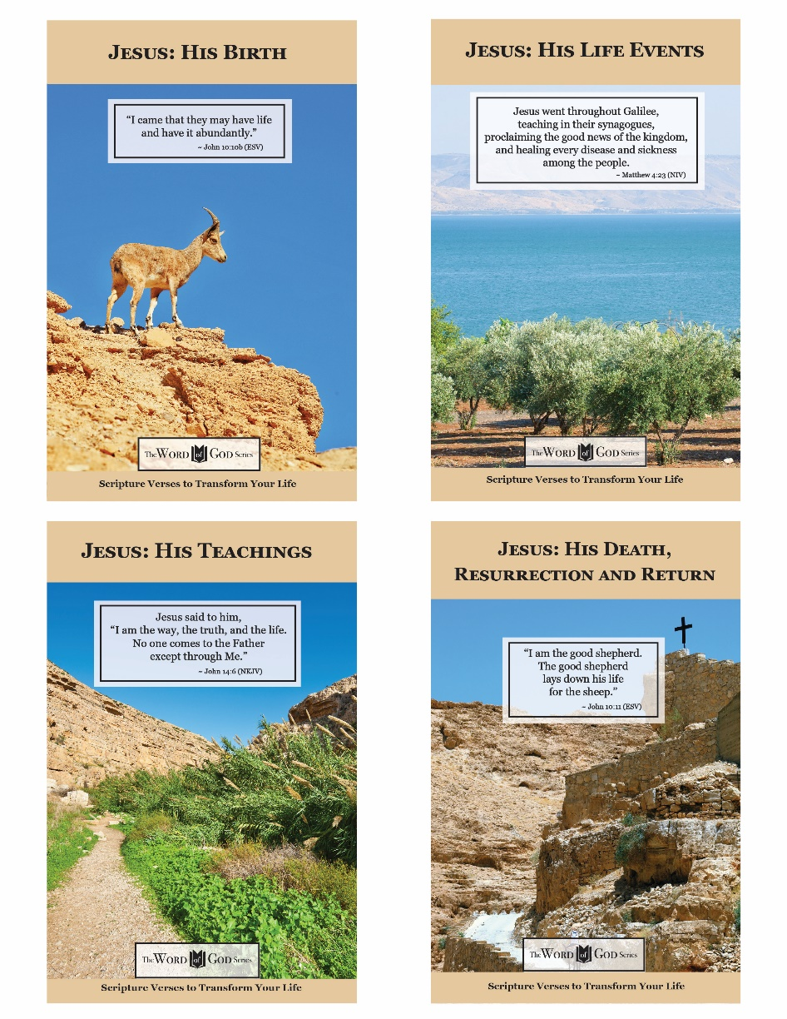

www.TheWordOfGodSeries.com

Photo Copyright Info

Note: when purchasing the rights to use the photos,
you may want to purchase an Extended License
for the cover image.

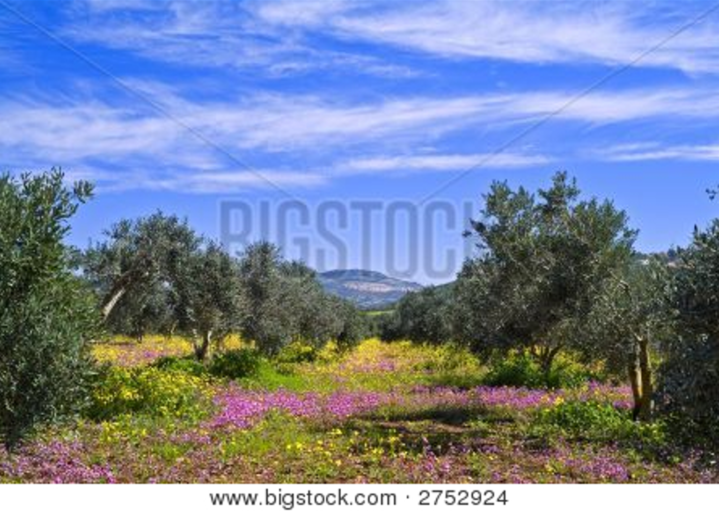
Bigstock Photo ID: 2752924
Olive Grove
olive grove with pink and yellow flowers in the Galilee Israel ** Note: Slight blurriness, best at smaller sizes
Stock Photo 2752924
Copyright: Noam Armonn


Bigstock Photo ID: 366321937
View of the Zavitan waterfall, in Yehudiya Forest Nature Reserve, the Golan Heights, Northern Israel
Stock Photo ID: 366321937
Copyright: RnDmS

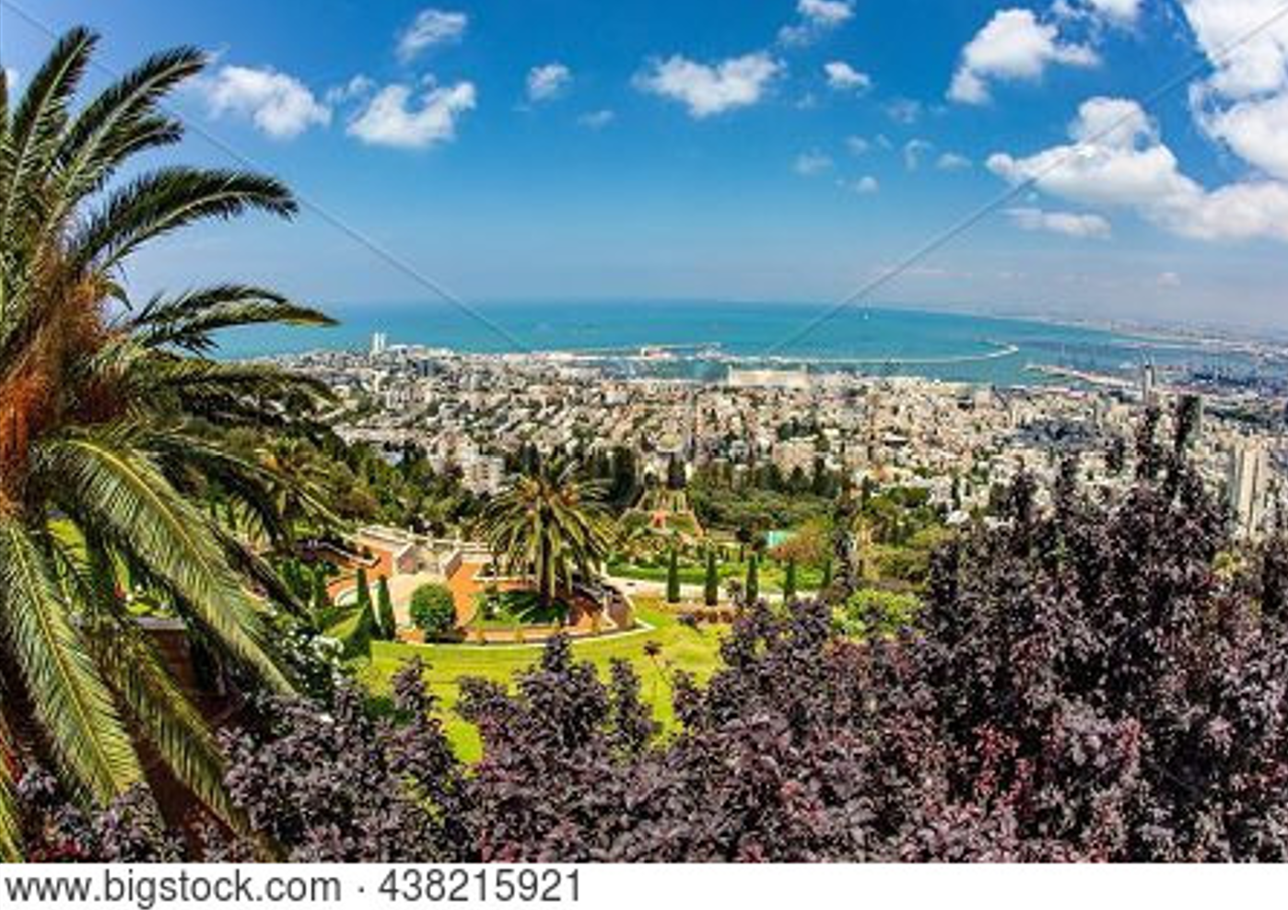
Bigstock Photo ID: 438215921
Clear sunny day by the sea. Haifa, Israel. View from Mount Carmel to the international seaport of Haifa. The descent to the Mediterranean Sea.
Stock Photo ID: 438215921
Copyright: kavram

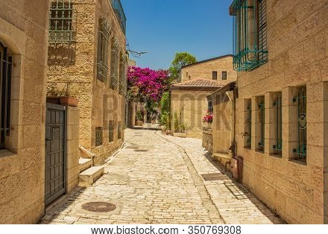
Bigstock Photo ID: 350769308
Jerusalem Israeli capital ancient city street stone paved walk side alley between living building in summer season bright sunny day time
Stock Photo ID: 350769308
Copyright: artemkniaz

Bigstock Photo ID: 460975615
Editing suggestion: Crop out leaves on right-hand side
Sunrise view of the Sea of Galilee, from Mount Arbel (west side). Northern Israel. Text on sign: Sea of Galilee Lookout
Stock Photo ID: 460975615
Copyright: RnDmS

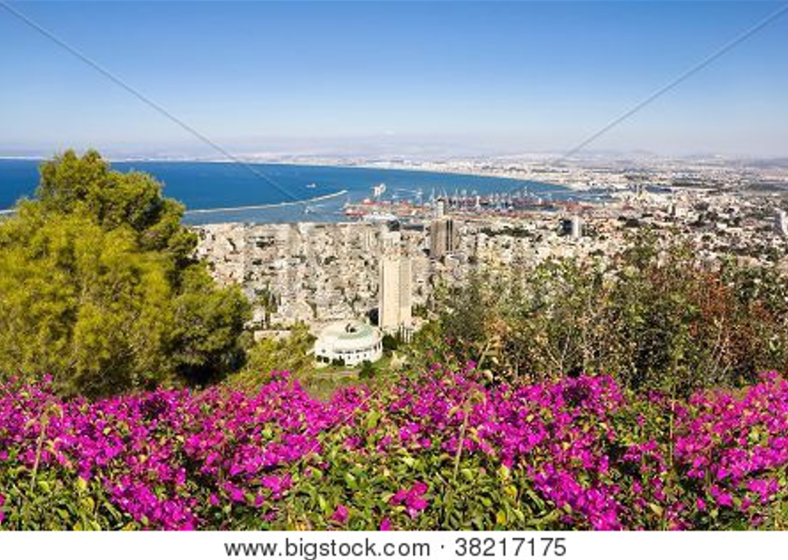
Bigstock Photo ID: 38217175
View From Mount Carmel To Port And Haifa In Israel
View from Mount Carmel to port and Haifa in Israel.Sunny Mediterranean landscape
Stock Photo 38217175
Copyright: toshket

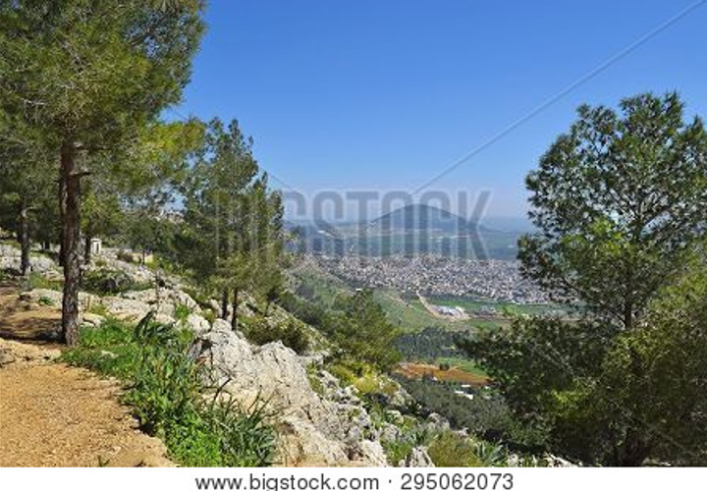
Bigstock Photo ID: 295062073
view of the Jezreel Valley, biblical Mount Tabor and the Arab villages at its foot, neighborhood Nazareth, Israel
Stock Photo ID: 295062073
Copyright: irisphoto3

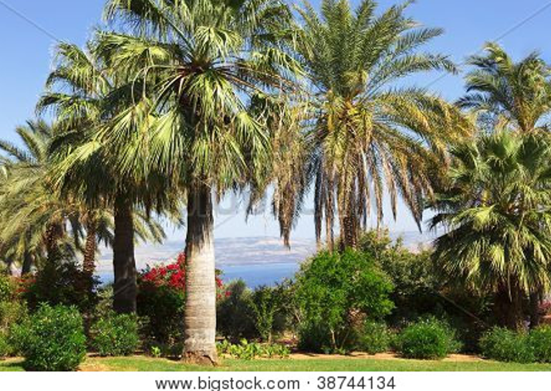
Bigstock Photo ID: 38744134
Israel,Sea of Galilee, Mount of Beatitudes, gardens
Stock Photo ID: 38744134
Copyright: majeczka-majeczka


Bigstock Photo ID: 7828757
mountain goats on the slopes of the crater Makhtesh Ramon Israel
Stock Photo ID: 7828757
Copyright: Vladimir_Blinov

Bigstock Photo ID: 32760494
Editing suggestion: Brighten photo and crop out dark wave. Crop so sun is centered
peaceful orange sunset over the mediterranean sea
Stock Photo 32760494
Copyright: barbarag58

Bigstock Photo ID: 459247461
Olive trees and and ancient stone wall in the Judea mountains, near Jerusalem, Israel, on a sunny day.
Stock Photo ID: 459247461
Copyright: Moshe Einhorn


Bigstock Photo ID: 5162219
Galilee
Forest Landscape Of North Galilee In Early Spring Israel.
Stock Photo ID: 5162219
Copyright: gkuna


Bigstock Photo ID: 7919477
Editing suggestion: Brighten and crop out dark portions of bottom of photo
Orange Sunset
orange sunset in the Mediterranean - photo from Israel
Stock Photo ID: 7919477
Copyright: asaf eliason

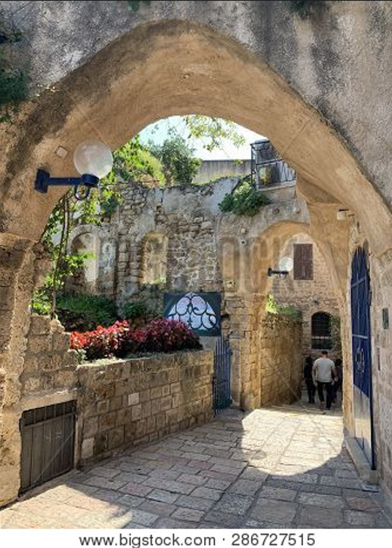
Bigstock Photo ID: 286727515
Editing suggestion: Crop bottom of photo
Narrow old street in the historical part of the city of Jaffa
Stock Photo ID: 286727515
Copyright: iropa
Bigstock Photo ID: 41033635
Church of All Nations in the Kidron Valley - Jerusalem, Israel
Stock Photo ID: 141033635
Copyright: Leonid Andronov

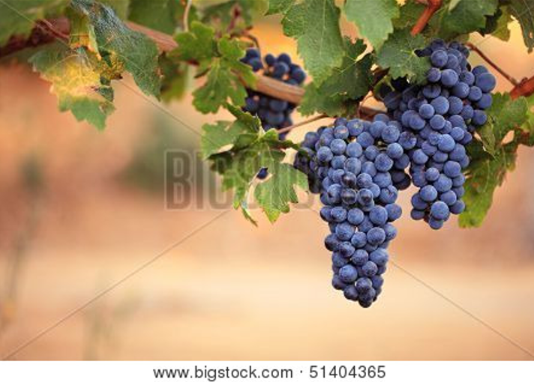
Bigstock Photo ID: 51404365
Close-up of large bunches of red wine grapes on the vine, with warm blurred background and copy space.
Stock Photo ID: 51404365
Copyright: AndrewHagen

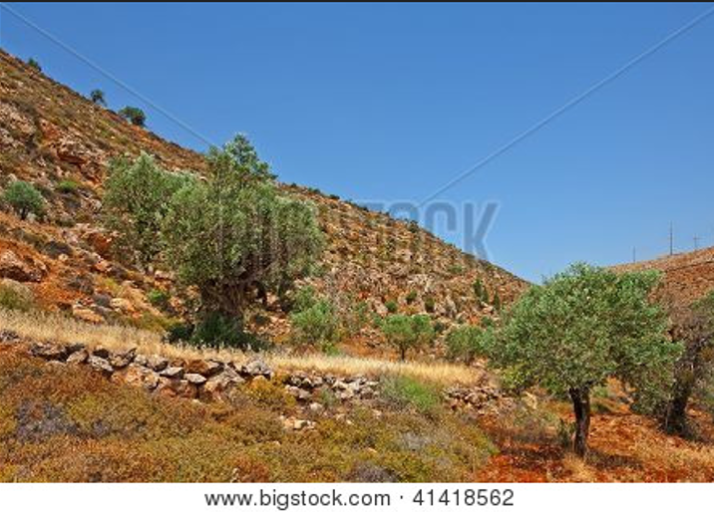
Bigstock Photo ID: 41418562
Olive Grove on the Slopes of the Mountains of Samaria Israel
Stock Photo ID: 41418562
Copyright: gkuna
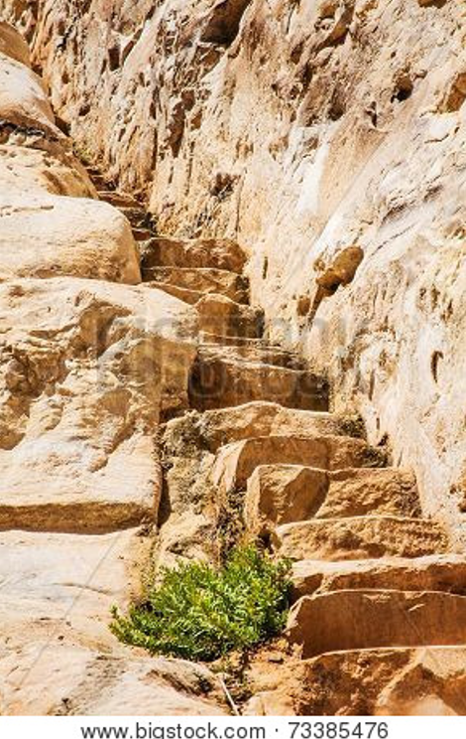
Bigstock Photo ID: 73385476
Stone Staircase Leads
stone staircase leads up to the rock
Stock Photo ID: 73385476
Copyright: Olexandr

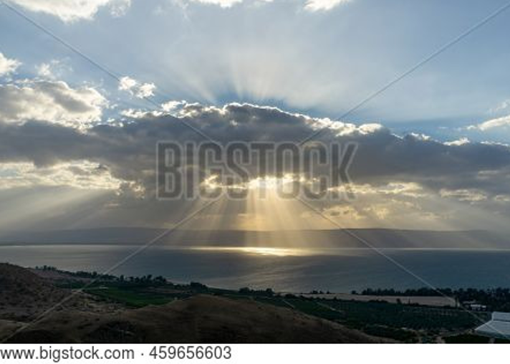
Bigstock Photo ID: 459656603
Sunlight shinning on the sea through the rain clouds. Sea of Galilee, Israel
Stock Photo ID: 459656603
Copyright: K_Pegg

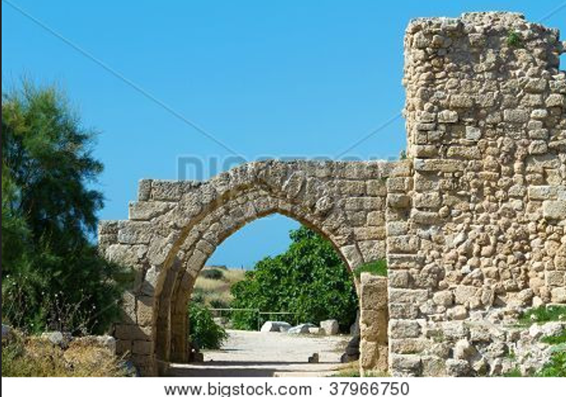
Bigstock Photo ID: 37966750
Ancient Ruins
The ruins of the ancient city of Caesarea. Israel
Stock Photo ID: 37966750
Copyright: sergey02

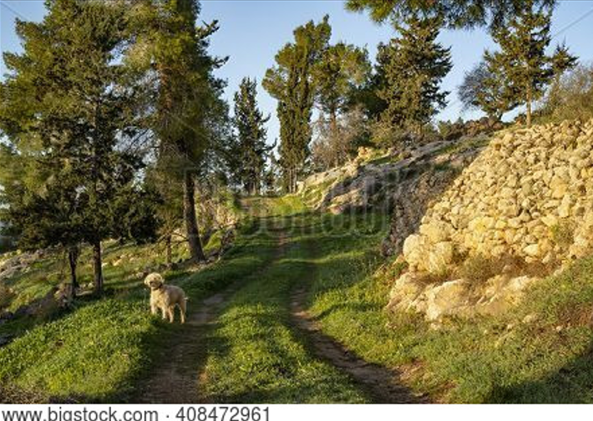
Bigstock Photo ID: 408472961
Editing suggestion: Brighten path image
A half breed dog standing on a path in a forest in the Judea mountains, Israel, at dawn, on a clear sunny day.
Stock Photo ID: 408472961
Copyright: Moshe Einhorn

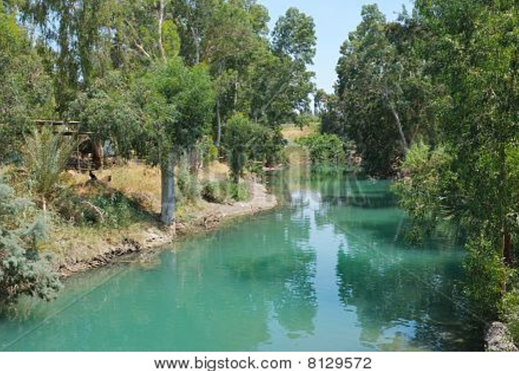
Bigstock Photo ID: 8129572
River Jordan
River Jordan in Israel near lake Kinneret
Stock Photo 8129572
Copyright: Vladimir_Blinov
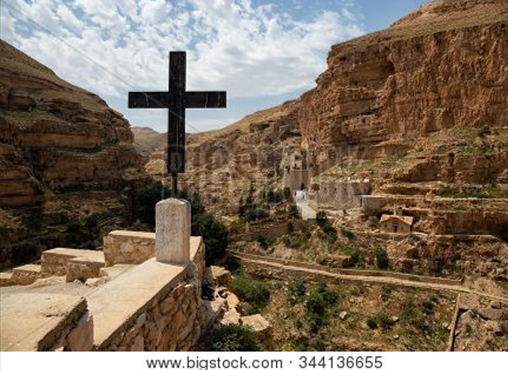
Bigstock Photo ID: 344136655
Editing suggestion: Warm image and crop so cross is centered in the photo
Beautiful view of Monastery of St. George in a rocky canyon during a sunny day. Located near Jerusalem in Wadi Qelt, Israel.
Stock Photo ID: 344136655
Copyright: Edgar Bullon

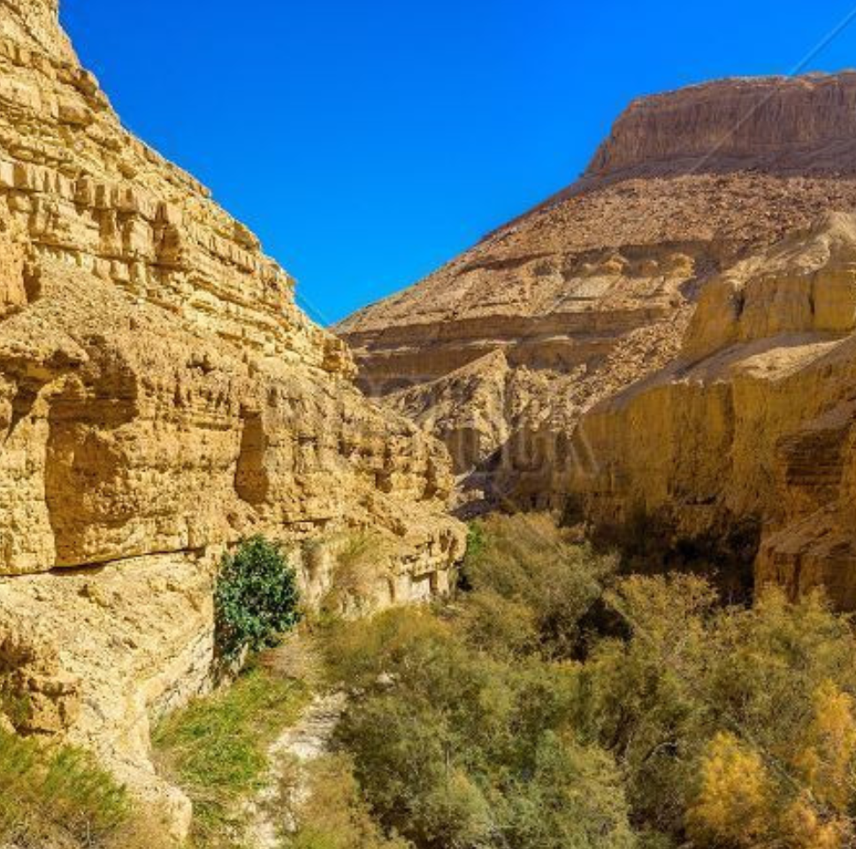
Bigstock Photo ID: 140173880
A lot of green trees grow in rocky gorge of Ein Gedi Nature Reserve Israel.
Stock Photo ID: 140173880
Copyright: efesenko


Bigstock Photo ID: 84005324
Editing suggestion: Rotate photo so ibex is facing center of page
Male Nubian ibex in Jerusalem Biblical Zoo Jerusalem Israel.
Stock Photo ID: 84005324
Copyright: Rafael Ben Ari

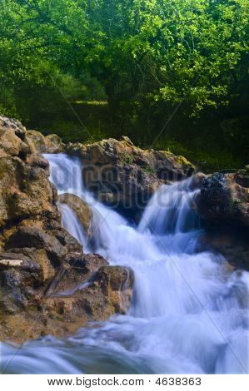
Bigstock Photo ID: 4638363
Editing suggestion: Brighten photo
Parod River Israel
Flowing water the Parod river in the Galilee Israel
Stock Photo ID: 4638363
Copyright: Noam Armonn

Bigstock Photo ID: 40692727
The Riverbed in the Judean Mountain Israel
Stock Photo ID: 40692727
Copyright: gkuna

