Template for God is Your Refuge in an eBooklet Format

The Word of God Series is a collection of 20 booklets that present Scripture verses in an easy-to-read format, with each booklet focused on a different topic.
Titles include Healthy Relationships, A Joy-Filled Life, Freedom from Depression, and many others. Click here to see other titles.
The booklets are available in both paperback and digital formats at www.TheWordOfGodSeries.com or Amazon.com.
Why This Template?
Because I believe in the power of God’s Word to transform people’s lives, I have dedicated several years of my life to bring this series to fruition.
I am passionate about using these booklets to reach a dark and dying world with the love of Christ and the hope of the Gospel.
Initially, I had expected this series would be a small business. But one day, when I asked God what my next steps should be, He spoke to me through His Word and told me to:
“…complete the ministry God has given you.”
~ 2 Timothy 4:5 (NLT, 1996 version)
So, I shifted the focus from being a business to a ministry.
My vision, also, has evolved over time and I have come to believe that it is possible for millions of these booklets to be distributed (in both print and digital formats) around the world (see the document entitled The Vision at www.TheWordOfGodSeries.com for more info.)
In order to make this a far-reaching ministry, accessing populations that I couldn’t on my own, I decided to invite others to partner with me in producing and distributing these booklets to their own personal networks. To help get it started, I have made templates of each booklet freely available to anyone who would like them.
This way you (whether you are a church, Christian organization or an individual) can easily re-create the booklets in your own ministry’s name, and distribute them to the people you minister to.
I hope that this template will save you:
- Time – so you can benefit from the thousands of hours of development time that has been invested so far
- Money – eliminate layers of profit margin
Whether you simply replicate and reproduce what has already been done, build on it, or take this idea in a different direction, you won’t have to waste time starting with a blank page.
I hope you can easily get these finalized, so you can begin sharing them with the people in your sphere of influence.
On the following pages you will find document formatting tips.
Photo editing tips are also presented, as well as the preview images of each photo (with the Photo ID#), so you to easily find it on either bigstockphoto.com or shutterstock.com. Copyright and general info for each photo can be found here.
Formatting Tips (if making changes to this document)
This document is ready to be exported to an eBook format. The app I used is through Amazon called Kindle Create.
If you make any changes to this document (such as pasting additional verses or entire sections into it), you’ll want follow the steps below.
If you are not making any changes to this document, then just skip these steps.
When converting a document to eBook format, it’s best to remove tabs, indentations and soft returns. While using these formatting tricks in a print format can make the page much more readable (by adding white space to the page), in a digital format, these same tricks can disrupt the flow of the text and make it more difficult to read (since the view can change depending on the type of device, font size selected, etc.)
- Remove all tabs, indentations and soft returns (Note, if a passage is too long, you can always add white space by inserting a
hard return (the Enter key only) after a sentence, with a 6 pt spacing after the line. (Layout / Spacing / After / 6 pt)


- Ensure that the spacing between the lines is consistent throughout the document. When the document is completed, select the entire document (Ctrl + A) and click on Layout / Paragraph / Multiple (under Line Spacing) and change the number to “1”


- Ensure that the spacing between the characters is consistent throughout the document. After completing step 2 above, while the entire document is still selected, click on Home / Font / Advanced and change the Spacing to Normal


Photo Editing Tips
At the end of this document you will find the copyright and descriptive info for each photo in the booklet, as well as editing suggestions for a few of them.
For the digital view, try to keep the photos as large on the page as possible, otherwise they will appear too small on devices. The preview photos in this document are a good size for digital format, so try to keep your photos the same size.
Most of the editing suggestions (especially brightening or increasing color saturation) should be very slight adjustments.
Editing photos within this document
Rotate: Doubleclick the photo, click on the Rotate Object icon.
Note: rotating an image is more important in the print format, so that certain objects in the photo will face the center of the page (such as animal pics). This doesn’t matter in a digital format, but the suggestion to rotate certain photos is included below in order to keep the digital and print formats consistent (in case someone reads both the print and digital booklets.)

Editing photos in the Pictures editing app in MS Word
Navigate to your Pictures folder, doubleclick the photo, and click on the blue Edit button on left
Most of the editing can be accomplished using one of these 3 options:


Crop: Click on the Crop icon and drag edges to desired spot
Brighten a photo: Adjustment icon / Light / Brightness
Increase color saturation: Adjustment icon / Color / Saturation or Warmth
Remove distracting elements from a photo: Click on the Generative Erase icon, select a brush size and click on the part of the photo you want removed.

Photo Searching Tips
Occasionally photographers pull their photos from the sites, so there may be some in this document that are no longer available. You can try using the same key words to search for the photo on other sites. Or, you can search for another photo on Bigstock:
- Under All Images select Photos and search by key word.
- At the next screen, make sure that Safe Search is on.
- In the Category field, select either Landscapes, Nature or Animals.
Forward Page | Copyright Page | Table of Contents

Below are sample Forward and Copyright pages. Feel free to edit to reflect your ministry’s mission and vision.
The Table of Contents in this document contains links to each of the section headings. If you add any new sections to this document, be sure to:
- Assign the Heading Style to the new section heading (in this document, it is referred to as Heading).
Highlight the heading, click on Home, then Heading in the Styles box


- Bookmark the new section heading: Put your cursor after the first letter in the section heading, click on Insert / Bookmark and then give name the bookmark (no spaces in the name!)



- Add the new section heading to the Table of Contents page and add a link to the bookmark you just created: Highlight the text, click on Insert / Link / Place in this Document and select the section heading bookmark.


Kindle Create
Should you decide to use Kindle Create to export this to an eBook format, see the steps below. You can use Kindle Create to export to a Kindle KPF file and/or EPUB file:

Begin at https://kdp.amazon.com/en_US/bookshelf to set up the booklets on Amazon and install the Kindle Create app.
At the first screen, select Create New and Choose

At the next Screen click on Continue. At the next screen click on Choose File, select the document, and click on Open. Then click on Continue and Get Started.
At the next screen you will see a box labeled Suggested Chapter Titles. Click on Reject All.
Next, left-justify the entire document (a quirk with this application is that some portions of the document may be centered, while others portions are left-justified). Highlight the entire document, click on Formatting, and then the left-justify icon.
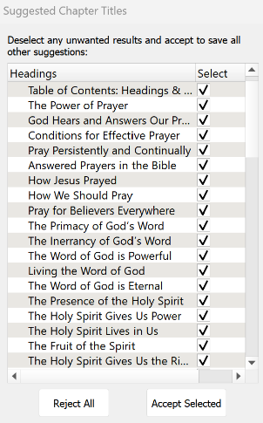
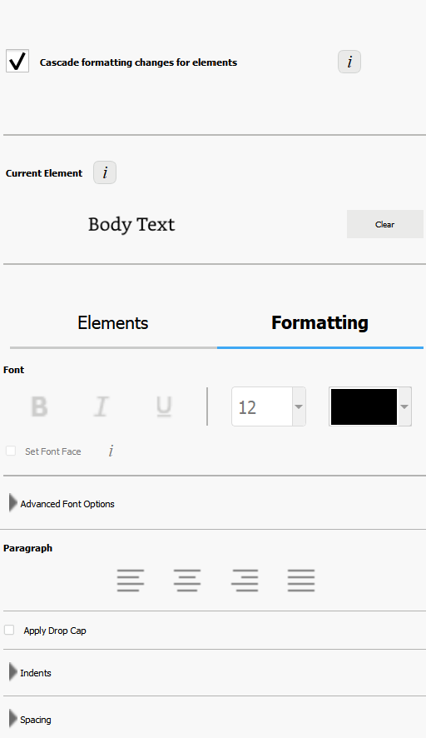
Now you can begin assigning different elements to the Headings and Subheadings in the document so that, when someone is reading the eBook, they can easily jump to another section via the Table of Contents.
I use 2 elements: Chapter Title (for the key headings in the Brittanica Bold font) and Subheading (for the underlined subheadings).
As you begin assigning the elements, be sure to start by assigning the Chapter Title element to the Table of Contents: Headings and Subheadings heading. Then go through the rest of the document and assign either the Chapter Title or Subheading elements.
You can change the formatting from the Kindle Create default, if you want. Below are the formatting options that I use for the eBooklets.
Feel free to customize to suit your preferences.

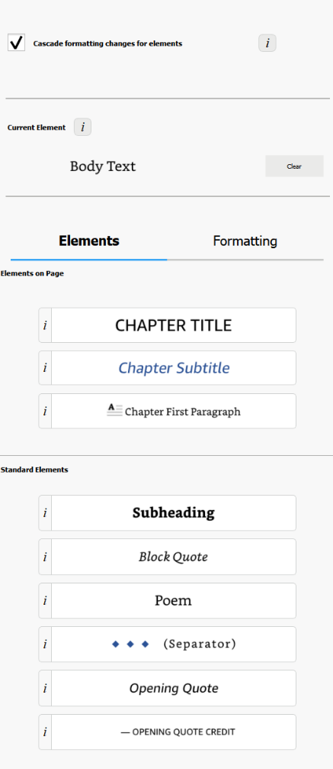
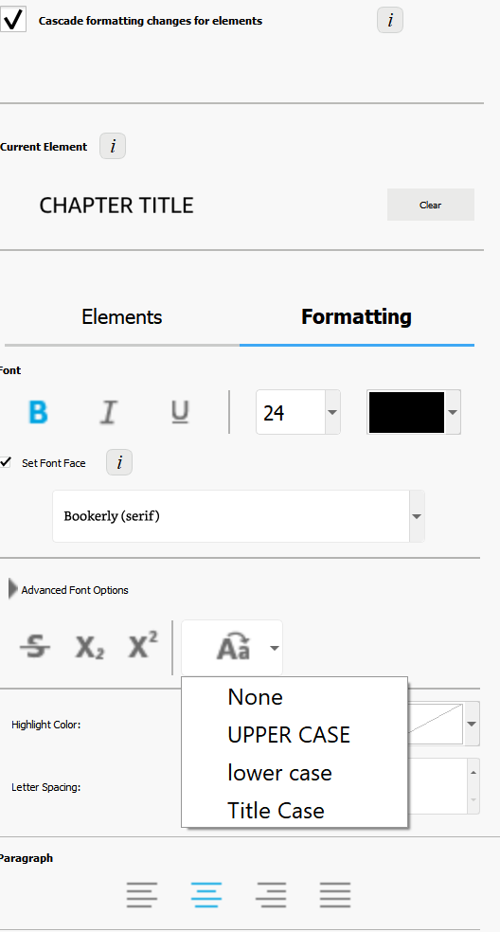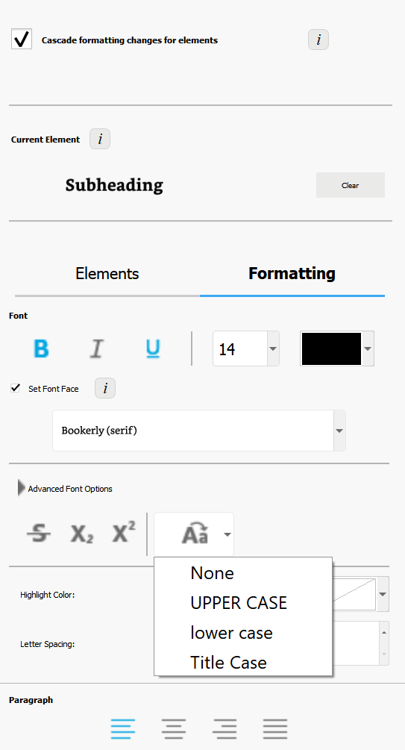

Finally, go through the document and click on each photo and change it to “Full Size.” (Note, another quirk with this app is that some photos just can’t be changed to full size, so they will appear smaller in the eBooklet).
When complete, first, save the document (File / Save Project). This will automatically put it in a folder. So when you export the document, be sure you export it to that folder.
To export, click on File / Export / KPF (Kindle and print). At the next screen, click on the file name to select it, and then click on Export.
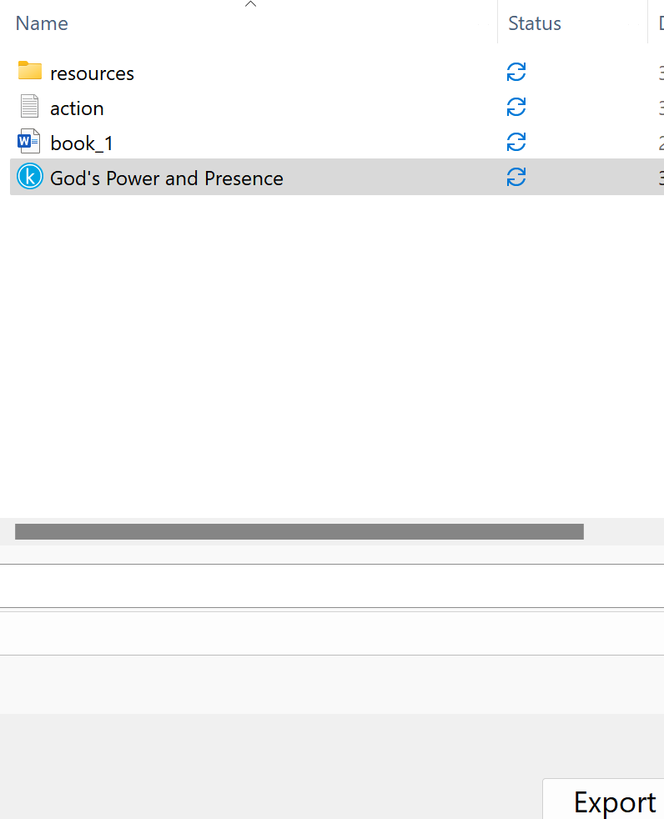

If you want the file in an EPUB format, go through the steps above and select File / Export / EPUB

Stuck on a Step Above and Need Help?
If you want to do this project on your own, but are having tech issues with one of the steps above, feel free to contact me at Susan@TheWordOfGodSeries.com. I may be able to assist you, since I’ve gone through this whole process myself!

Need Help with the Whole Project?
If you want these booklets set up in your own in your own ministry’s name, but don’t have the resources to do the whole project yourself,
I may be able to manage that process for you for a one-time project fee.
This would include the following services:
- Set up an account with Bigstock and Shutterstock in your ministry’s name and purchase the rights for you to use each of the photos
- Download and name the photos
- Edit photos as needed
- Create a cover with your church or ministry logo
- Request the rights to use the various Bible translations from each of the publishers (if applicable)
Feel free to contact me at Susan@TheWordOfGodSeries.com to discuss pricing options.

I hope that this information will help you finalize this document with ease so you can begin distributing it
to the people in your realm of influence.
Thank you for partnering with me in this effort. I wish you the best as you make God’s Word known and
share His love with others!
Warmly in Christ,
Susan

Soli Deo gloria


Feel free to edit this forward page to align to your own ministry’s vision and goals.

The Bible is the best-selling and most transformative book in history. Written over 2,000 years ago, it is still living and powerful today.
Throughout the pages of Scripture you will find inspiration and joy, comfort and peace, healing and hope.
Most importantly, you will learn of God’s abundant love for you, and His plan to give you a glorious, eternal inheritance.
The Word of God Series is a collection of booklets which presents Scripture by topic, so you can focus on verses that are relevant to you at different stages and circumstances throughout your life.
All of the booklets in this series feature Scripture exclusively—just the powerful, undiluted Word of God.
Let God’s Word permeate your mind and transform your life.
Here are a few suggestions to help you fully benefit from Scripture:
Meditate
Pause and reflect on the verses as you read, and even meditate on them throughout the day.
Memorize
A great memorization technique is to repeat the verse several times, each time emphasizing a different word.
He alone is my refuge, my place of safety…
He alone is my refuge, my place of safety…
He alone is my refuge, my place of safety…

~ Psalm 91:2b (NLT)

Pray
Pray God’s Word back to Him. For example,
Heavenly Father, thank you for being my refuge and my place of safety.

Do What it Says
Do not merely listen to the word, and so deceive yourselves. Do what it says.

~ James 1:22 (NIV)

My prayer for you, as you read this booklet, is that during times of difficulty you will find the assurances in God’s Word which will bring you peace, comfort and hope.
Let the word of Christ dwell in you richly…

~ Colossians 3:16a (ESV)

A few comments about The Word of God Series:

- The booklets in this series provide you with a sample of what the Bible offers, but it is important that you also read the Bible itself, preferably with a book-by-book focus.

- Passages in quotation marks are the actual words of God, either through His prophets in the Old Testament, or the words of Christ in the New Testament.

- Every booklet includes a section that details God’s plan of salvation (commonly referred to as “The Gospel.”) The booklet entitled God’s Gift of Eternal Life is devoted to the Gospel message.

This series presents verses in the following translations:

NIV: New International Version
Scripture quotations marked NIV are taken from the Holy Bible, New International Version®, NIV®. Copyright © 1973, 1978, 1984, 2011 by Biblica, Inc.™ Used by permission of Zondervan. All rights reserved worldwide. www.zondervan.com. The "NIV" and "New International Version" are trademarks registered in the United States Patent and Trademark Office by Biblica, Inc.™

NLT: New Living Translation
Scripture quotations marked NLT are taken from the Holy Bible, New Living Translation, Copyright© 1996, 2004, 2015 by Tyndale House Foundation. Used by permission of Tyndale House Publishers, Inc., Carol Stream, Illinois 60188. All rights reserved.

ESV: English Standard Version
Scripture quotations marked ESV are taken from the ESV Bible® (The Holy Bible, English Standard Version®), copyright © 2001 by Crossway Bibles, a publishing ministry of Good News Publishers. Used by permission. All rights reserved.

KJV: King James Version
Public Domain

NKJV: New King James Version
Scripture quotations marked NKJV are taken from the New King James Version®. Copyright © 1982 by Thomas Nelson, Inc. Used by permission.

Since this is a template booklet featuring preview photos, it is not copyrighted, so you are free to purchase licenses to use the photos and develop your own booklets. Be sure to determine whether or not you need to request permission (and in some cases pay) for the rights to use the various Bible translations. Scripture verses were sourced from www.BibleGateway.com.

If it would be easier for you to simply purchase this booklet, the copyrighted version is available at www.TheWordOfGodSeries.com or www.amazon.com. ISBN info for the copyrighted booklets is as follows: 978-1-964538-32-7 (print booklet), 978-1-964538-33-4 (eBooklet), 9798322915072 (print booklet on Amazon).

Table of Contents: Headings & Sub-Headings

God is Your Refuge in Times of Adversity

God is Your Deliverer in Times of Fear

Do Not Fear
Do Not Fear the Future
Do Not Fear Your Enemies

God is Your Hope in Times of Trouble

God is Your Power in Times of Difficulty

God is Your Strength in Times of Weakness

God is Your Light in Times of Darkness

God is Your Joy in Times of Despair

God is Your Trust in Times of Uncertainty

God is Your Salvation in the Day of Wrath

God is Your Peace in Times of Turmoil

See also the booklet in this series entitled Freedom from Fear

Note: The verse references in this document contain links to the BibleGateway.com page that will display the passage in all 5 translations that are used in this series (NIV, NLT, ESV, NKJV, KJV).

Other Booklets in the Series

God is Your Refuge

in Times of Adversity

The Lord is good, a refuge in times of trouble.
He cares for those who trust in him…

~ Nahum 1:7 (NIV)

The Lord is my rock, my fortress, and my savior; my God is my rock, in whom I find protection.
He is my shield, the power that saves me, and my place of safety.

~ Psalm 18:2 (NLT)

God is our refuge and strength, a very present help in trouble.

~ Psalm 46:1 (ESV)

The eternal God is your refuge, and his everlasting arms are under you.

~ Deuteronomy 33:27a (NLT)

Let your unfailing love surround us, Lord, for our hope is in you alone.

~ Psalm 33:22 (NLT)



How great is the goodness you have stored up for those who fear you.
You lavish it on those who come to you for protection, blessing them before the watching world.

~ Psalm 31:19 (NLT)

How precious is your unfailing love, O God!
All humanity finds shelter in the shadow of your wings.

~ Psalm 36:7 (NLT)

For you have been a stronghold to the poor, a stronghold to the needy in his distress, a shelter from the storm and a shade from the heat…

~ Isaiah 25:4a (ESV)

Be merciful to me, O God, be merciful to me, for in you my soul takes refuge; in the shadow of your wings I will take refuge, till the storms of destruction pass by.

~ Psalm 57:1 (ESV)

Preserve me, O God: for in thee do I put my trust.

~ Psalm 16:1 (KJV)

But you, O Lord, are a shield around me…

~ Psalm 3:3a (NLT)



You are my refuge and my shield…

~ Psalm 119:114a (NLT)

But as for me, I will sing about your power.
Each morning I will sing with joy about your unfailing love.
For you have been my refuge, a place of safety when I am in distress.

~ Psalm 59:16 (NLT)

Let me live forever in your sanctuary, safe beneath the shelter of your wings!

~ Psalm 61:4 (NLT)

The Lord is a shelter for the oppressed, a refuge in times of trouble.

~ Psalm 9:9 (NLT)

I keep my eyes always on the Lord. With him at my right hand, I will not be shaken.

~ Psalm 16:8 (NIV)

He alone is my rock and my salvation, my fortress where I will not be shaken.

~ Psalm 62:6 (NLT)

God’s way is perfect.
All the Lord’s promises prove true.
He is a shield for all who look to him for protection.

~ 2 Samuel 22:31 (NLT)

The name of the Lord is a fortified tower; the righteous run to it and are safe.

~ Proverbs 18:10 (NIV)

Many are the afflictions of the righteous, but the Lord delivers him out of them all.

~ Psalm 34:19 (ESV)

Those who fear the Lord are secure; he will be a refuge for their children.

~ Proverbs 14:26 (NLT)

The wicked are crushed by disaster, but the godly have a refuge when they die.

~ Proverbs 14:32 (NLT)

Those who walk uprightly enter into peace; they find rest as they lie in death.

~ Isaiah 57:2 (NIV)

Psalm 91

Those who live in the shelter of the Most High will find rest in the shadow of the Almighty.
This I declare about the Lord:
He alone is my refuge, my place of safety; he is my God, and I trust him.
For he will rescue you from every trap and protect you from deadly disease.
He will cover you with his feathers.
He will shelter you with his wings.
His faithful promises are your armor and protection.
Do not be afraid of the terrors of the night, nor the arrow that flies in the day.
Do not dread the disease that stalks in darkness, nor the disaster that strikes at midday. Though a thousand fall at your side, though ten thousand are dying around you, these evils will not touch you. Just open your eyes, and see how the wicked are punished.
If you make the Lord your refuge, if you make the Most High your shelter, no evil will conquer you; no plague will come near your home.
For he will order his angels to protect you wherever you go. They will hold you up with their hands so you won’t even hurt your foot on a stone.
You will trample upon lions and cobras; you will crush fierce lions and serpents under your feet!
The Lord says,
“I will rescue those who love me.
“I will protect those who trust in my name.
“When they call on me, I will answer;
“I will be with them in trouble.
“I will rescue and honor them.
“I will reward them with a long life and give them my salvation.”

~ Psalm 91 (NLT)

This I declare about the Lord: He alone is my refuge, my place of safety; he is my God, and I trust him.

~ Psalm 91:2 (NLT)

He is my loving ally and my fortress, my tower of safety, my rescuer.
He is my shield, and I take refuge in him.

~ Psalm 144:2a (NLT)

My victory and honor come from God alone.
He is my refuge, a rock where no enemy can reach me.

~ Psalm 62:7 (NLT)

Lead me to the rock that is higher than I, for you have been my refuge, a strong tower against the enemy.

~ Psalm 61:2b-3 (ESV)

For thou art my rock and my fortress; therefore for thy name’s sake lead me, and guide me.

~ Psalm 31:3 (KJV)



Be my rock of refuge, to which I can always go…

~ Psalm 71:3a (NIV)

Further Reading
Psalm 18
Psalm 34
Psalm 37

God is Your Deliverer

in Times of Fear

Do Not Fear

“Do not fear, for I have redeemed you; I have summoned you by name; you are mine.
“When you pass through the waters, I will be with you; and when you pass through the rivers, they will not sweep over you.
“When you walk through the fire, you will not be burned; the flames will not set you ablaze.
“For I am the Lord your God, the Holy One of Israel, your Savior…”

~ Isaiah 43:1b-3a (NIV)

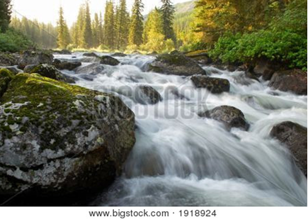

“So do not fear, for I am with you;
“do not be dismayed, for I am your God.
“I will strengthen you and help you;
“I will uphold you with my righteous right hand.”

~ Isaiah 41:10 (NIV)

“Don’t be afraid,” he said, “for you are very precious to God.
“Peace! Be encouraged! Be strong!”

~ Daniel 10:19a (NLT)

“So don’t be afraid, little flock. For it gives your Father great happiness to give you the Kingdom.”

~ Luke 12:32 (NLT)

“Do not tremble; do not be afraid.
“Did I not proclaim my purposes for you long ago?
“You are my witnesses—is there any other God?
“No! There is no other Rock—not one!”

~ Isaiah 44:8 (NLT)

The Lord himself goes before you and will be with you; he will never leave you nor forsake you.
Do not be afraid; do not be discouraged.

~ Deuteronomy 31:8 (NIV)

For God has not given us a spirit of fear,
but of power
and of love
and of a sound mind.

~ 2 Timothy 1:7 (NKJV)

The Lord your God in your midst, The Mighty One, will save;
He will rejoice over you with gladness,
He will quiet you with His love,
He will rejoice over you with singing.

~ Zephaniah 3:17 (NKJV)

I sought the Lord, and he answered me and delivered me from all my fears.

~ Psalm 34:4 (ESV)

The Lord will rescue me from every evil attack and will bring me safely to his heavenly kingdom.

~ 2 Timothy 4:18a (NIV)

The Lord is my shepherd; I shall not want.
He makes me to lie down in green pastures;
He leads me beside the still waters.
He restores my soul;
He leads me in the paths of righteousness for His name’s sake.
Yea, though I walk through the valley of the shadow of death, I will fear no evil; for You are with me; Your rod and Your staff, they comfort me.
You prepare a table before me in the presence of my enemies;
You anoint my head with oil.
My cup runs over.
Surely goodness and mercy shall follow me all the days of my life;
And I will dwell in the house of the Lord forever.

~ Psalm 23 (NKJV)


Shutterstock Photo ID: 2521594467

Trust in the Lord forever, for the Lord, the Lord himself, is the Rock eternal.

~ Isaiah 26:4 (NIV)

In righteousness you will be established:
Tyranny will be far from you; you will have nothing to fear.
Terror will be far removed; it will not come near you.

~ Isaiah 54:14 (NIV)

Cast all your anxiety on him because he cares for you.

~ 1 Peter 5:7 (NIV)

Cast your burden on the Lord, and he will sustain you; he will never permit the righteous to be moved.

~ Psalm 55:22 (ESV)

No king is saved by the size of his army; no warrior escapes by his great strength…
But the eyes of the Lord are on those who fear him, on those whose hope is in his unfailing love, to deliver them from death and keep them alive in famine.

~ Psalm 33:16-19 (NIV)

Help us, O God of our salvation, for the glory of thy name: and deliver us…

~ Psalm 79:9a (KJV)

Do Not Fear the Future

You need not be afraid of sudden disaster or the destruction that comes upon the wicked, for the Lord is your security.

~ Proverbs 3:25-26a (NLT)

“Therefore I tell you, do not worry about your life, what you will eat or drink…
“Look at the birds of the air; they do not sow or reap or store away in barns, and yet your heavenly Father feeds them.
“Are you not much more valuable than they?”

~ Matthew 6:25-26 (NIV)

So we will not fear when earthquakes come and the mountains crumble into the sea.

~ Psalm 46:2 (NLT)

He gives food to every creature. His love endures forever.

~ Psalm 136:25 (NIV)



The eyes of all look expectantly to You, and You give them their food in due season.

~ Psalm 145:15 (NKJV)

The blameless spend their days under the Lord’s care, and their inheritance will endure forever.
In times of disaster they will not wither; in days of famine they will enjoy plenty.

~ Psalm 37:18-19 (NIV)

Once I was young, and now I am old. Yet I have never seen the godly abandoned or their children begging for bread.

~ Psalm 37:25 (NLT)

He provides food for those who fear him; he remembers his covenant forever.

~ Psalm 111:5 (ESV)

Do Not Fear Your Enemies

The Lord is with me; I will not be afraid. What can mere mortals do to me?

~ Psalm 118:6 (NIV)

You must not fear them, for the Lord your God Himself fights for you.

~ Deuteronomy 3:22 (NKJV)

This what the Lord says to you:
“Do not be afraid or discouraged because of this vast army. For the battle is not yours, but God’s…
“You will not have to fight this battle.
“Take up your positions; stand firm and see the deliverance the Lord will give you…Go out to face them tomorrow, and the Lord will be with you.”

~ 2 Chronicles 20:15b-17 (NIV)

“They will fight against you but will not overcome you, for I am with you and will rescue you,” declares the Lord.

~ Jeremiah 1:19 (NIV)

“Do not fear the reproach of men...”

~ Isaiah 51:7b (NKJV)

“You must worship only the Lord your God. He is the one who will rescue you from all your enemies.”

~ 2 Kings 17:39 (NLT)

Serve only the Lord your God and fear him alone.

~ Deuteronomy 13:4a (NLT)

Don’t be intimidated in any way by your enemies.
This will be a sign to them that they are going to be destroyed, but that you are going to be saved, even by God himself.

~ Philippians 1:28 (NLT)

Say to those with fearful hearts, “Be strong, and do not fear, for your God is coming to destroy your enemies. He is coming to save you.”

~ Isaiah 35:4 (NLT)

Do not be terrified by them, for the Lord your God, who is among you, is a great and awesome God.

~ Deuteronomy 7:21 (NIV)

Moses answered the people, “Do not be afraid. Stand firm and you will see the deliverance the Lord will bring you today. The Egyptians you see today you will never see again.”

~ Exodus 14:13 (NIV)

The Lord will fight for you; you need only to be still.

~ Exodus 14:14 (NIV)

“Do I lack the strength to rescue you?
“By a mere rebuke I dry up the sea, I turn rivers into a desert…”

~ Isaiah 50:2b (NIV)

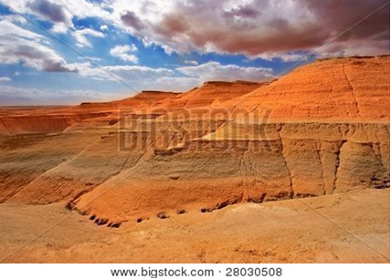

“Have I not commanded you? Be strong and courageous.
“Do not be afraid; do not be discouraged, for the Lord your God will be with you wherever you go.”

~ Joshua 1:9 (NIV)

Be strong and courageous. Do not be afraid or discouraged because of the king of Assyria and the vast army with him, for there is a greater power with us than with him.

~ 2 Chronicles 32:7 (NIV)

Then they cried out to the Lord in their trouble, and He saved them out of their distresses.
He sent His word and healed them, and delivered them from their destructions.

~ Psalm 107:19-20 (NKJV)

He rescued me from my strong enemy, from those who hated me, for they were too mighty for me.
They confronted me in the day of my calamity, but the Lord was my support.

~ 2 Samuel 22:18-19 (ESV)

God is Your Hope

in Times of Trouble

May the God of hope fill you with all joy and peace as you trust in him, so that you may overflow with hope by the power of the Holy Spirit.

~ Romans 15:13 (NIV)

Be joyful in hope, patient in affliction, faithful in prayer.

~ Romans 12:12 (NIV)

We wait in hope for the Lord; he is our help and our shield.

~ Psalm 33:20 (NIV)

…we have our hope set on the living God, who is the Savior of all people…

~ 1 Timothy 4:10b (ESV)

Therefore, since we have such a hope, we are very bold.

~ 2 Corinthians 3:12 (NIV)

So be strong and courageous, all you who put your hope in the Lord!

~ Psalm 31:24 (NLT)

It is of the Lord’s mercies that we are not consumed, because his compassions fail not.
They are new every morning: great is thy faithfulness.

~ Lamentations 3:22-23 (KJV)

…God has given both his promise and his oath…
Therefore, we who have fled to him for refuge can have great confidence as we hold to the hope that lies before us.
This hope is a strong and trustworthy anchor for our souls.

~ Hebrews 6:18-19a (NLT)

But hope that is seen is no hope at all. Who hopes for what they already have?
But if we hope for what we do not yet have, we wait for it patiently.

~ Romans 8:24b-25 (NIV)

“For I know the plans I have for you,” declares the Lord,
“plans to prosper you and not to harm you,
“plans to give you hope and a future.”

~ Jeremiah 29:11 (NIV)



“There is hope for your future,” declares the Lord...

~ Jeremiah 31:17a (ESV)

There is surely a future hope for you, and your hope will not be cut off.

~ Proverbs 23:18 (NIV)

Let your unfailing love surround us, Lord, for our hope is in you alone.

~ Psalm 33:22 (NLT)

By awesome deeds you answer us with righteousness, O God of our salvation, the hope of all the ends of the earth…

~ Psalm 65:5a (ESV)

Consider it pure joy, my brothers and sisters, whenever you face trials of many kinds, because you know that the testing of your faith produces perseverance.
Let perseverance finish its work so that you may be mature and complete, not lacking anything.

~ James 1:2-4 (NIV)

Beloved, do not think it strange concerning the fiery trial which is to try you, as though some strange thing happened to you; but rejoice to the extent that you partake of Christ’s sufferings, that when His glory is revealed, you may also be glad with exceeding joy.

~ 1 Peter 4:12-13 (NKJV)

So be truly glad.
There is wonderful joy ahead, even though you have to endure many trials for a little while.
These trials will show that your faith is genuine…
So when your faith remains strong through many trials, it will bring you much praise and glory and honor on the day when Jesus Christ is revealed to the whole world.

~ 1 Peter 1:6-7 (NLT)

Therefore, preparing your minds for action, and being sober-minded, set your hope fully on the grace that will be brought to you at the revelation of Jesus Christ.

~ 1 Peter 1:13 (ESV)

So each generation should set its hope anew on God, not forgetting his glorious miracles and obeying his commands.

~ Psalm 78:7 (NLT)

Let us hold unswervingly to the hope we profess, for he who promised is faithful.

~ Hebrews 10:23 (NIV)

May our Lord Jesus Christ himself and God our Father, who loved us and by his grace gave us eternal encouragement and good hope, encourage your hearts and strengthen you in every good deed and word.

~ 2 Thessalonians 2:16-17 (NIV)

God is Your Power

in Times of Difficulty

Lord, there is no one like you!
For you are great, and your name is full of power.

~ Jeremiah 10:6 (NLT)

Yours, O Lord, is the greatness, the power, the glory, the victory, and the majesty.
Everything in the heavens and on earth is yours, O Lord, and this is your kingdom.
We adore you as the one who is over all things.

~ 1 Chronicles 29:11 (NLT)

You alone are the Lord.
You made the heavens, even the highest heavens, and all their starry host, the earth and all that is on it, the seas and all that is in them.
You give life to everything, and the multitudes of heaven worship you.

~ Nehemiah 9:6 (NIV)

Summon your might, O God.
Display your power, O God, as you have in the past.

~ Psalm 68:28 (NLT)

Lord, there is no one like you to help the powerless against the mighty.
Help us, Lord our God, for we rely on you, and in your name we have come against this vast army.
Lord, you are our God; do not let mere mortals prevail against you.

~ 2 Chronicles 14:11b (NIV)

Your right hand, Lord, was majestic in power.
Your right hand, Lord, shattered the enemy.
In the greatness of your majesty you threw down those who opposed you.

~ Exodus 15:6-7a (NIV)

Powerful is your arm! Strong is your hand!
Your right hand is lifted high in glorious strength.

~ Psalm 89:13 (NLT)

Power and might are in your hand, and no one can withstand you.

~ 2 Chronicles 20:6b (NIV)

Power and might are in your hand, and at your discretion people are made great and given strength.

~ 1 Chronicles 29:12b (NLT)

I lift my eyes to you, O God, enthroned in heaven.

~ Psalm 123:1 (NLT)

I lift up my eyes to the mountains—where does my help come from?
My help comes from the Lord, the Maker of heaven and earth.

~ Psalm 121:1-2 (NIV)

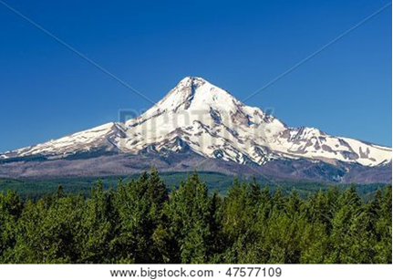

Who is the King of glory?
The Lord, strong and mighty; the Lord, invincible in battle.

~ Psalm 24:8 (NLT)

The Lord has established his throne in the heavens, and his kingdom rules over all.

~ Psalm 103:19 (ESV)

Jehoshaphat stood before the community of Judah and Jerusalem in front of the new courtyard at the Temple of the Lord.
He prayed, “O Lord, God of our ancestors, you alone are the God who is in heaven.
“You are ruler of all the kingdoms of the earth.
“You are powerful and mighty; no one can stand against you...
“We are powerless against this mighty army that is about to attack us. We do not know what to do, but we are looking to you for help.”
As all the men of Judah stood before the Lord with their little ones, wives, and children, the Spirit of the Lord came upon one of the men standing there…
He said, “Listen, all you people of Judah and Jerusalem! Listen, King Jehoshaphat! This is what the Lord says:
“Do not be afraid! Don’t be discouraged by this mighty army, for the battle is not yours, but God’s.
“Tomorrow, march out against them…

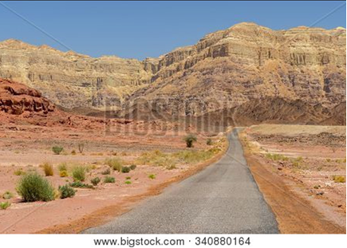

“But you will not even need to fight. Take your positions; then stand still and watch the Lord’s victory. He is with you, O people of Judah and Jerusalem.
“Do not be afraid or discouraged. Go out against them tomorrow, for the Lord is with you!”
Then King Jehoshaphat bowed low with his face to the ground. And all the people of Judah and Jerusalem did the same, worshiping the Lord.
Early the next morning the army of Judah went out into the wilderness of Tekoa. On the way Jehoshaphat stopped and said, “Listen to me, all you people of Judah and Jerusalem!
“Believe in the Lord your God, and you will be able to stand firm. Believe in his prophets, and you will succeed.”
After consulting the people, the king appointed singers to walk ahead of the army, singing to the Lord and praising him for his holy splendor.
This is what they sang:
“Give thanks to the Lord; his faithful love endures forever!”
At the very moment they began to sing and give praise, the Lord caused the armies of Ammon, Moab, and Mount Seir to start fighting among themselves…
So when the army of Judah arrived at the lookout point in the wilderness, all they saw were dead bodies lying on the ground as far as they could see.
Not a single one of the enemy had escaped.

~ 2 Chronicles 20:5-24 (NLT)

“I am the Lord, and there is no other; apart from me there is no God.”

~ Isaiah 45:5a (NIV)

“Not by might nor by power, but by my Spirit,” says the Lord Almighty.

~ Zechariah 4:6b (NIV)

The Lord Almighty is with us…

~ Psalm 46:7a (NIV)

So remember this and keep it firmly in mind: The Lord is God both in heaven and on earth, and there is no other.

~ Deuteronomy 4:39 (NLT)

God is Your Strength

in Times of Weakness

The Lord is my strength and shield.
I trust him with all my heart.
He helps me, and my heart is filled with joy.
I burst out in songs of thanksgiving.

~ Psalm 28:7 (NLT)

The Lord is my light and my salvation; whom shall I fear?
The Lord is the strength of my life; of whom shall I be afraid?

~ Psalm 27:1 (NKJV)

Surely God is my salvation; I will trust and not be afraid.
The Lord, the Lord himself, is my strength and my defense; he has become my salvation.

~ Isaiah 12:2 (NIV)

You formed the mountains by your power and armed yourself with mighty strength.

~ Psalm 65:6 (NLT)

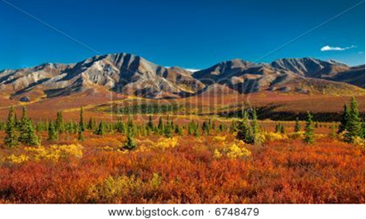

The Lord gives strength to his people...

~ Psalm 29:11a (NIV)

For the eyes of the Lord run to and fro throughout the whole earth, to show Himself strong on behalf of those whose heart is loyal to Him.

~ 2 Chronicles 16:9a (NKJV)

For God says, “I will break the strength of the wicked, but I will increase the power of the godly.”

~ Psalm 75:10 (NLT)

He gives strength to the weary and increases the power of the weak.

~ Isaiah 40:29 (NIV)

But we have this treasure in jars of clay, to show that the surpassing power belongs to God and not to us.

~ 2 Corinthians 4:7 (ESV)

…we ourselves are like fragile clay jars containing this great treasure. This makes it clear that our great power is from God, not from ourselves.

~ 2 Corinthians 4:7b (NLT)

But he said to me, “My grace is sufficient for you, for my power is made perfect in weakness.”
Therefore I will boast all the more gladly about my weaknesses, so that Christ’s power may rest on me.

~ 2 Corinthians 12:9 (NIV)

That is why, for Christ’s sake, I delight in weaknesses, in insults, in hardships, in persecutions, in difficulties.
For when I am weak, then I am strong.

~ 2 Corinthians 12:10 (NIV)

I can do all things through Christ who strengthens me.

~ Philippians 4:13 (NKJV)

It is God who arms me with strength and keeps my way secure.

~ 2 Samuel 22:33 (NIV)

I love you, Lord; you are my strength.

~ Psalm 18:1 (NLT)

Be strong and courageous…for it is the Lord your God who goes with you. He will not leave you or forsake you.

~ Deuteronomy 31:6 (ESV)

So be strong and courageous, all you who put your hope in the Lord!

~ Psalm 31:24 (NLT)

David also said to Solomon his son, “Be strong and courageous, and do the work.
“Do not be afraid or discouraged, for the Lord God, my God, is with you.”

~ 1 Chronicles 28:20a (NIV)

But as for you, be strong and do not give up, for your work will be rewarded.

~ 2 Chronicles 15:7 (NIV)

And the God of all grace, who called you to his eternal glory in Christ, after you have suffered a little while, will himself restore you and make you strong, firm and steadfast.

~ 1 Peter 5:10 (NIV)

The wicked flee though no one pursues, but the righteous are as bold as a lion.

~ Proverbs 28:1 (NIV)

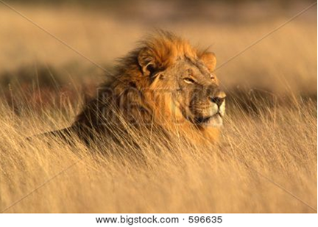

I pray that out of his glorious riches he may strengthen you with power through his Spirit in your inner being, so that Christ may dwell in your hearts through faith.

~ Ephesians 3:16-17a (NIV)

I also pray that you will understand the incredible greatness of God’s power for us who believe him.
This is the same mighty power that raised Christ from the dead and seated him in the place of honor at God’s right hand in the heavenly realms.

~ Ephesians 1:19-20 (NLT)

We also pray that you will be strengthened with all his glorious power so you will have all the endurance and patience you need.

~ Colossians 1:11a (NLT)

Therefore, my dear brothers and sisters, stand firm. Let nothing move you.

~ 1 Corinthians 15:58a (NIV)

So then, just as you received Christ Jesus as Lord, continue to live your lives in him, rooted and built up in him, strengthened in the faith as you were taught, and overflowing with thankfulness.

~ Colossians 2:6-7 (NIV)

I write to you, young men,
because you are strong,
and the word of God abides in you,
and you have overcome the evil one.

~ 1 John 2:14b (ESV)

Be on guard. Stand firm in the faith. Be courageous. Be strong.

~ 1 Corinthians 16:13 (NLT)

Finally, my brethren, be strong in the Lord, and in the power of his might.

~ Ephesians 6:10 (KJV)

He will keep you strong to the end so that you will be free from all blame on the day when our Lord Jesus Christ returns.

~ 1 Corinthians 1:8 (NLT)

God is Your Light

in Times of Darkness

…God is light and in Him is no darkness at all.

~ 1 John 1:5b (NKJV)

The light shines in the darkness, and the darkness can never extinguish it.

~ John 1:5 (NLT)

…God said, “Let there be light,” and there was light.

~ Genesis 1:3 (ESV)

…God, who said, “Let there be light in the darkness,” has made this light shine in our hearts so we could know the glory of God that is seen in the face of Jesus Christ.

~ 2 Corinthians 4:6 (NLT)

Again Jesus spoke to them, saying,
“I am the light of the world.
“Whoever follows me will not walk in darkness, but will have the light of life.”

~ John 8:12 (ESV)



“I have come as a light to shine in this dark world, so that all who put their trust in me will no longer remain in the dark.”

~ John 12:46 (NLT)

“Walk in the light while you can, so the darkness will not overtake you.”

~ John 12:35b (NLT)

“Put your trust in the light while there is still time…”

~ John 12:36a (NLT)

“Arise, shine, for your light has come, and the glory of the Lord rises upon you.
“See, darkness covers the earth and thick darkness is over the peoples, but the Lord rises upon you and his glory appears over you.”

~ Isaiah 60:1-2 (NIV)

“You are the light of the world.
“A town built on a hill cannot be hidden.
“Neither do people light a lamp and put it under a bowl.
“Instead they put it on its stand, and it gives light to everyone in the house.
“In the same way, let your light shine before others, that they may see your good deeds and glorify your Father in heaven.”

~ Matthew 5:14-16 (NIV)

“Feed the hungry, and help those in trouble.
“Then your light will shine out from the darkness, and the darkness around you will be as bright as noon.”

~ Isaiah 58:10 (NLT)

“If you are filled with light, with no dark corners, then your whole life will be radiant, as though a floodlight were filling you with light.”

~ Luke 11:36 (NLT)

“Your sun will never set again, and your moon will wane no more; the Lord will be your everlasting light...”

~ Isaiah 60:20a (NIV)

The people walking in darkness have seen a great light; on those living in the land of deep darkness a light has dawned.

~ Isaiah 9:2 (NIV)

Because of God’s tender mercy, the morning light from heaven is about to break upon us, to give light to those who sit in darkness and in the shadow of death, and to guide us to the path of peace.

~ Luke 1:78-79 (NLT)

…God, the blessed and only Ruler, the King of kings and Lord of lords, who alone is immortal and who lives in unapproachable light…

~ 1 Timothy 6:15b-16a (NIV)

The Lord, my God, lights up my darkness.

~ Psalm 18:28b (NLT)

You, Lord, are my lamp; the Lord turns my darkness into light.

~ 2 Samuel 22:29 (NIV)

Thy word is a lamp unto my feet, and a light unto my path.

~ Psalm 119:105 (KVJ)

Even in darkness light dawns for the upright, for those who are gracious and compassionate and righteous.

~ Psalm 112:4 (NIV)



For this light within you produces only what is good and right and true.

~ Ephesians 5:9 (NLT)

Anyone who loves their brother and sister lives in the light, and there is nothing in them to make them stumble.

~ 1 John 2:10 (NIV)

Light shines in the darkness for the godly.

~ Psalm 112:4a (NLT)

Light shines on the righteous and joy on the upright in heart.

~ Psalm 97:11 (NIV)

I pray that your hearts will be flooded with light so that you can understand the confident hope he has given to those he called…

~ Ephesians 1:18a (NLT)

…for he called you out of the darkness into his wonderful light.

~ 1 Peter 2:9b (NLT)

The way of the righteous is like the first gleam of dawn, which shines ever brighter until the full light of day.

~ Proverbs 4:18 (NLT)

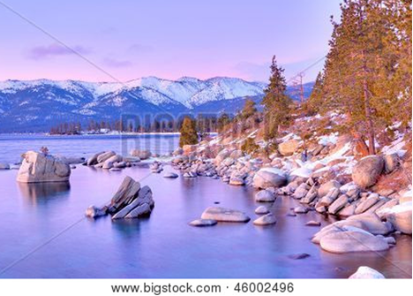

…the darkness is passing away and the true light is already shining.

~ 1 John 2:8b (ESV)

Satan, who is the god of this world, has blinded the minds of those who don’t believe.
They are unable to see the glorious light of the Good News.

~ 2 Corinthians 4:4a (NLT)

The night is nearly over; the day is almost here.
So let us put aside the deeds of darkness and put on the armor of light.

~ Romans 13:12 (NIV)

You are all children of the light and children of the day.
We do not belong to the night or to the darkness.

~ 1 Thessalonians 5:5 (NIV)

For you were once darkness, but now you are light in the Lord. Live as children of light…

~ Ephesians 5:8 (NIV)

God is Your Joy

in Times of Despair

May you be filled with joy, always thanking the Father.
He has enabled you to share in the inheritance that belongs to his people, who live in the light.

~ Colossians 1:11b-12 (NLT)

So be truly glad. There is wonderful joy ahead...

~ 1 Peter 1:6a (NLT)

Those who look to him for help will be radiant with joy…

~ Psalm 34:5a (NLT)

Weeping may last through the night, but joy comes with the morning.

~ Psalm 30:5b (NLT)

Those who sow in tears shall reap in joy.

~ Psalm 126:5 (NKJV)

To the person who pleases him, God gives wisdom, knowledge and happiness…

~ Ecclesiastes 2:26a (NIV)

How joyful are those who fear the Lord and delight in obeying his commands.

~ Psalm 112:1b (NLT)

The commandments of the Lord are right, bringing joy to the heart.

~ Psalm 19:8a (NLT)

There is joy for those who deal justly with others and always do what is right.

~ Psalm 106:3 (NLT)

The humble will be filled with fresh joy from the Lord.

~ Isaiah 29:19a (NLT)

Joyful are people of integrity…

~ Psalm 119:1a (NLT)

…those who promote peace have joy.

~ Proverbs 12:20b (NIV)

You make known to me the path of life;
you will fill me with joy in your presence,
with eternal pleasures at your right hand.

~ Psalm 16:11 (NIV)

I will be filled with joy because of you.
I will sing praises to your name, O Most High.

~ Psalm 9:2 (NLT)

For you, O Lord, have made me glad by your work;
at the works of your hands I sing for joy.

~ Psalm 92:4 (ESV)

You have turned my mourning into joyful dancing.
You have taken away my clothes of mourning and clothed me with joy…

~ Psalm 30:11 (NLT)

Create in me a pure heart, O God, and renew a steadfast spirit within me…
Restore to me the joy of your salvation and grant me a willing spirit, to sustain me.

~ Psalm 51:10-12 (NIV)

Satisfy us in the morning with your steadfast love, that we may rejoice and be glad all our days.

~ Psalm 90:14 (ESV)

May all who seek you rejoice and be glad in you!
May those who love your salvation say evermore, “God is great!”

~ Psalm 70:4 (ESV)

…let all who take refuge in you rejoice;
let them sing joyful praises forever.
Spread your protection over them, that all who love your name may be filled with joy.

~ Psalm 5:11 (NLT)

For You have made him most blessed forever;
You have made him exceedingly glad with Your presence.

~ Psalm 21:6 (NKJV)

Surely you have granted him unending blessings and made him glad with the joy of your presence.

~ Psalm 21:6 (NIV)

“Ask, using my name, and you will receive, and you will have abundant joy.”

~ John 16:24b (NLT)

“I have told you these things so that you will be filled with my joy.
“Yes, your joy will overflow!
“This is my commandment: Love each other in the same way I have loved you.”

~ John 15:11-12 (NLT)



“If you keep your feet from breaking the Sabbath and from doing as you please on my holy day…then you will find your joy in the Lord…”

~ Isaiah 58:13-14a (NIV)

“A woman giving birth to a child has pain because her time has come; but when her baby is born she forgets the anguish because of her joy that a child is born into the world.
“So with you: Now is your time of grief, but I will see you again and you will rejoice, and no one will take away your joy.”

~ John 16:21-22 (NIV)

“I will turn their mourning into gladness;
“I will give them comfort and joy instead of sorrow.”

~ Jeremiah 31:13b (NIV)

“Your days of mourning will come to an end.”

~ Isaiah 60:20b (NLT)

Worship the Lord with gladness…

~ Psalm 100:2a (NIV)

Let us be glad and rejoice and give Him glory…

~ Revelation 19:7a (NKJV)

…let the godly rejoice.
Let them be glad in God’s presence.
Let them be filled with joy.

~ Psalm 68:3 (NLT)

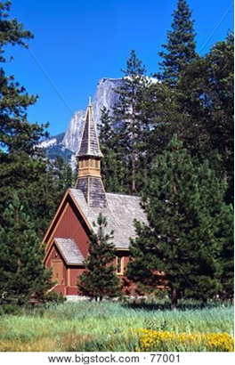

Then I will go to the altar of God, to God my exceeding joy…

~ Psalm 43:4a (ESV)

Rejoice in the Lord always. I will say it again: Rejoice!

~ Philippians 4:4 (NIV)

…you rejoice with a glorious, inexpressible joy.

~ 1 Peter 1:8b (NLT)

…ye rejoice with joy unspeakable and full of glory.

~ 1 Peter 1:8b (KJV)

Delight yourself in the Lord, and he will give you the desires of your heart.

~ Psalm 37:4 (ESV)

The Lord has done great things for us, and we are filled with joy.

~ Psalm 126:3 (NIV)

And the disciples were filled with joy and with the Holy Spirit.

~ Acts 13:52 (NKJV)

…I am overflowing with joy.

~ 2 Corinthians 7:4b (ESV)

Those who have been ransomed by the Lord will return.
They will enter Jerusalem singing, crowned with everlasting joy.
Sorrow and mourning will disappear, and they will be filled with joy and gladness.

~ Isaiah 51:11 (NLT)

O Lord of Heaven’s Armies, what joy for those who trust in you.

~ Psalm 84:12 (NLT)

What joy for those whose strength comes from the Lord…

~ Psalm 84:5a (NLT)

…may all who search for you be filled with joy and gladness in you.

~ Psalm 40:16a (NLT)

Now all glory to God, who is able to keep you from falling away and will bring you with great joy into his glorious presence without a single fault.

~ Jude 1:24 (NLT)

God is Your Trust

in Times of Uncertainty

Trust in the Lord forever, for the Lord, the Lord himself, is the Rock eternal.

~ Isaiah 26:4 (NIV)

Trust in the Lord with all your heart, and lean not on your own understanding;
In all your ways acknowledge Him, and He shall direct your paths.

~ Proverbs 3:5-6 (NKJV)

Trust in the Lord and do good; dwell in the land and enjoy safe pasture.

~ Psalm 37:3 (NIV)

I waited patiently for the Lord; he turned to me and heard my cry.
He lifted me out of the slimy pit, out of the mud and mire;
he set my feet on a rock and gave me a firm place to stand.
He put a new song in my mouth, a hymn of praise to our God.
Many will see and fear the Lord and put their trust in him.

~ Psalm 40:1-3 (NIV)

…those who trust in the Lord will lack no good thing.

~ Psalm 34:10b (NLT)

Have faith in the Lord your God and you will be upheld...

~ 2 Chronicles 20:20b (NIV)

O Lord of hosts, blessed is the one who trusts in you!

~ Psalm 84:12 (ESV)

…I am trusting you, O Lord, saying, “You are my God!” My future is in your hands.

~ Psalm 31:14-15a (NLT)

We know how much God loves us, and we have put our trust in his love. God is love…

~ 1 John 4:16a (NLT)

So do not throw away this confident trust in the Lord. Remember the great reward it brings you!

~ Hebrews 10:35 (NLT)

…those who hope in the Lord will renew their strength.
They will soar on wings like eagles;
they will run and not grow weary,
they will walk and not be faint.

~ Isaiah 40:31 (NIV)



In the Lord I put my trust…

~ Psalm 11:1a (NKJV)

For God alone, O my soul, wait in silence, for my hope is from him.

~ Psalm 62:5 (ESV)

…I know the one in whom I trust, and I am sure that he is able to guard what I have entrusted to him.

~ 2 Timothy 1:12b (NLT)

I trust in the steadfast love of God forever and ever.

~ Psalm 52:8b (ESV)

This is what the Lord says:
“Cursed are those who put their trust in mere humans, who rely on human strength and turn their hearts away from the Lord.
“They are like stunted shrubs in the desert, with no hope for the future. They will live in the barren wilderness, in an uninhabited salty land.
“But blessed are those who trust in the Lord and have made the Lord their hope and confidence.
“They are like trees planted along a riverbank, with roots that reach deep into the water. Such trees are not bothered by the heat or worried by long months of drought. Their leaves stay green, and they never stop producing fruit.”

~ Jeremiah 17:5-8 (NLT)



Blessed is the man who makes the Lord his trust…

~ Psalm 40:4a (ESV)

Don’t put your confidence in powerful people; there is no help for you there. When they breathe their last, they return to the earth, and all their plans die with them.
But joyful are those who have the God of Israel as their helper, whose hope is in the Lord their God.
He made heaven and earth, the sea, and everything in them. He keeps every promise forever.

~ Psalm 146:3-6 (NLT)

Stop trusting in mere humans, who have but a breath in their nostrils. Why hold them in esteem?

~ Isaiah 2:22 (NIV)

What sorrow awaits those who look to Egypt for help, trusting their horses, chariots, and charioteers and depending on the strength of human armies instead of looking to the Lord, the Holy One of Israel.

~ Isaiah 31:1 (NLT)

But the Lord of hosts, him you shall honor as holy.
Let him be your fear, and let him be your dread.

~ Isaiah 8:13 (ESV)

Some trust in chariots and some in horses, but we trust in the name of the Lord our God.

~ Psalm 20:7 (ESV)

It is better to take refuge in the Lord than to trust in man.

~ Psalm 118:8 (ESV)

Give us help from trouble, for the help of man is useless.
Through God we will do valiantly, for it is He who shall tread down our enemies.

~ Psalm 108:12-13 (NKJV)

In God, whose word I praise—in God I trust and am not afraid. What can mere mortals do to me?

~ Psalm 56:4 (NIV)

Fear of man will prove to be a snare, but whoever trusts in the Lord is kept safe.

~ Proverbs 29:25 (NIV)

God is Your Salvation

in the Day of Wrath

God loves you abundantly, and has made a way for you to live forever in His glorious kingdom. However, first He had to pay an enormous price for you to be forgiven of your sin, in order to receive this eternal glory. This section explains His plan to forgive and save you. In summary:
God loves you, but your sin separates you from Him, and because of it, God’s wrath will come. However, Jesus died as a sacrifice to save you from your sins, from God’s wrath, and from death itself. When you confess your sins, repent and accept the salvation that Christ offers, God will forgive you. By trusting in Christ you become God’s child, and as His child, you will inherit eternal life and heaven will be your home.

God Loves You

“I have loved you with an everlasting love;
“I have drawn you with unfailing kindness.”

~ Jeremiah 31:3b (NIV)

“Though the mountains be shaken and the hills be removed, yet my unfailing love for you will not be shaken nor my covenant of peace be removed,” says the Lord, who has compassion on you.

~ Isaiah 54:10 (NIV)

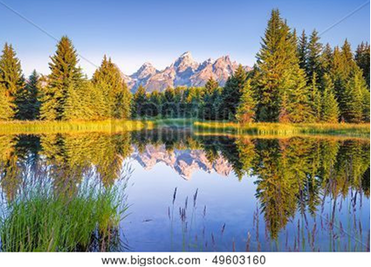

Your unfailing love is better than life itself; how I praise you!

~ Psalm 63:3 (NLT)

All your works praise you, Lord; your faithful people extol you.
They tell of the glory of your kingdom and speak of your might, so that all people may know of your mighty acts and the glorious splendor of your kingdom.
Your kingdom is an everlasting kingdom, and your dominion endures through all generations.

~ Psalm 145:10-13a (NIV)

For you, O Lord, are good and forgiving, abounding in steadfast love to all who call upon you.

~ Psalm 86:5 (ESV)

…full of unfailing love for all who ask for your help.

~ Psalm 86:5b (NLT)

…abundant in mercy to all those who call upon You.

~ Psalm 86:5b (NKJV)

…plenteous in mercy unto all them that call upon thee.

~ Psalm 86:5b (KJV)

…what is man that you are mindful of him, and the son of man that you care for him?

~ Psalm 8:4 (ESV)

For you created my inmost being; you knit me together in my mother’s womb…
Your eyes saw my unformed body; all the days ordained for me were written in your book before one of them came to be.

~ Psalm 139:13-16 (NIV)

But Your Sin Separates You from God

We are all infected and impure with sin.
When we display our righteous deeds, they are nothing but filthy rags.

~ Isaiah 64:6a (NLT)

For all have sinned, and come short of the glory of God…

~ Romans 3:23 (KJV)

The Day of God’s Wrath Will Come

Don’t you realize that those who do wrong will not inherit the Kingdom of God?
Don’t fool yourselves.

~ 1 Corinthians 6:9a (NLT)

Even now the ax of God’s judgment is poised, ready to sever the roots of the trees.
Yes, every tree that does not produce good fruit will be chopped down and thrown into the fire.

~ Matthew 3:10 (NLT)

“Whom have you so dreaded and feared that you have not been true to me…
“Is it not because I have long been silent that you do not fear me?”

~ Isaiah 57:11 (NIV)

“But I will show you whom you should fear:
“Fear Him who, after He has killed, has power to cast into hell; yes, I say to you, fear Him!”

~ Luke 12:5 (NKJV)

He will guard the feet of his faithful servants, but the wicked will be silenced in the place of darkness.

~ 1 Samuel 2:9a (NIV)

Confess Your Sin and Repent

“But unless you repent, you too will all perish.”

~ Luke 13:3b (NIV)

Seek the Lord while He may be found,
Call upon Him while He is near.
Let the wicked forsake his way, and the unrighteous man his thoughts;
Let him return to the Lord, and He will have mercy on him;
And to our God, for He will abundantly pardon.

~ Isaiah 55:6-7 (NKJV)

So get rid of all the filth and evil in your lives and humbly accept the word God has planted in your hearts, for it has the power to save your souls.

~ James 1:21 (NLT)

Jesus Died to Save You

…From Your Sin

Jesus gave his life for our sins, just as God our Father planned, in order to rescue us from this evil world in which we live.

~ Galatians 1:4 (NLT)

…From Your God’s Wrath

Jesus, whom God raised from the dead…is the one who has rescued us from the terrors of the coming judgment.

~ 1 Thessalonians 1:10b (NLT)

For God did not appoint us to suffer wrath but to receive salvation through our Lord Jesus Christ.

~ 1 Thessalonians 5:9 (NIV)



…everyone who calls on the name of the Lord will be saved.

~ Acts 2:21 (NLT)

…From Death

He broke the power of death and illuminated the way to life and immortality through the Good News.

~ 2 Timothy 1:10b (NLT)

The Lord will rescue me from every evil attack and will bring me safely to his heavenly kingdom.

~ 2 Timothy 4:18a (NIV)

God Demonstrates His Love Through Christ

…God demonstrates His own love toward us, in that while we were still sinners, Christ died for us.

~ Romans 5:8 (NKJV)

“For God so loved the world that He gave His only begotten Son, that whoever believes in Him should not perish but have everlasting life.”

~ John 3:16 (NKJV)

The grace of our Lord was poured out on me abundantly, along with the faith and love that are in Christ Jesus.

~ 1 Timothy 1:14 (NIV)

…I am convinced that neither death nor life, neither angels nor demons, neither the present nor the future, nor any powers, neither height nor depth, nor anything else in all creation, will be able to separate us from the love of God that is in Christ Jesus our Lord.

~ Romans 8:38-39 (NIV)

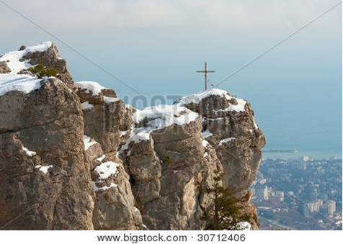

And I pray that you, being rooted and established in love, may have power, together with all the Lord’s holy people, to grasp how wide and long and high and deep is the love of Christ, and to know this love that surpasses knowledge—that you may be filled to the measure of all the fullness of God.

~ Ephesians 3:17b-19 (NIV)

God Bought You at a Price

…God paid a ransom to save you from the empty life you inherited from your ancestors.
And it was not paid with mere gold or silver...
It was the precious blood of Christ, the sinless, spotless Lamb of God.

~ 1 Peter 1:18b-19 (NLT)

He gave his life to free us from every kind of sin, to cleanse us, and to make us his very own people, totally committed to doing good deeds.

~ Titus 2:14 (NLT)

…he has purchased us to be his own people.

~ Ephesians 1:14b (NLT)

In Christ You Are Forgiven

Therefore, my friends, I want you to know that through Jesus the forgiveness of sins is proclaimed to you.

~ Acts 13:38 (NIV)

For with the Lord there is mercy, and with Him is abundant redemption.

~ Psalm 130:7b (NKJV)

Praise the Lord, my soul, and forget not all his benefits—who forgives all your sins and heals all your diseases, who redeems your life from the pit and crowns you with love and compassion…
For as high as the heavens are above the earth, so great is his love for those who fear him; as far as the east is from the west, so far has he removed our transgressions from us.

~ Psalm 103:2-4, 11-12 (NIV)

…he has rescued us from the dominion of darkness and brought us into the kingdom of the Son he loves, in whom we have redemption, the forgiveness of sins.

~ Colossians 1:13-14 (NIV)

Salvation is Through Christ Alone

Because of Christ and our faith in him, we can now come boldly and confidently into God’s presence.

~ Ephesians 3:12 (NLT)

Salvation is found in no one else, for there is no other name under heaven given to mankind by which we must be saved.

~ Acts 4:12 (NIV)

Jesus said to him, “I am the way, the truth, and the life. No one comes to the Father except through Me.”

~ John 14:6 (NKJV)

“I have come as a light to shine in this dark world, so that all who put their trust in me will no longer remain in the dark.”

~ John 12:46 (NLT)

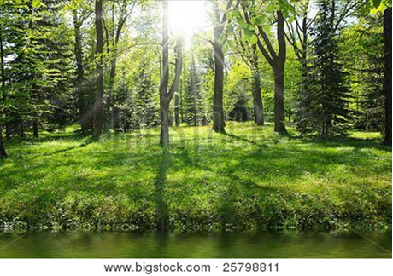

“I am the gate; whoever enters through me will be saved.”

~ John 10:9a (NIV)

“…whoever comes to me I will never drive away.”

~ John 6:37b (NIV)

The reward for trusting him will be the salvation of your souls.

~ 1 Peter 1:9 (NLT)

Salvation is a Gift: Free and Undeserved

…the wages of sin is death, but the free gift of God is eternal life in Christ Jesus our Lord.

~ Romans 6:23 (ESV)

…he saved us, not because of the righteous things we had done, but because of his mercy…

~ Titus 3:5a (NLT)

…because of his great love for us, God, who is rich in mercy, made us alive with Christ even when we were dead in transgressions—it is by grace you have been saved.

~ Ephesians 2:4-5 (NIV)

For it is by grace you have been saved, through faith—and this not from yourselves, it is the gift of God—not by works, so that no one can boast.

~ Ephesians 2:8-9 (NIV)

And since it is through God’s kindness, then it is not by their good works.
For in that case, God’s grace would not be what it really is—free and undeserved.

~ Romans 11:6 (NLT)

Accept this Gift of Salvation

…how shall we escape if we ignore so great a salvation?

~ Hebrews 2:3a (NIV)

If you declare with your mouth, “Jesus is Lord,” and believe in your heart that God raised him from the dead, you will be saved.

~ Romans 10:9 (NIV)

But you must continue to believe this truth and stand firmly in it.

Don’t drift away from the assurance you received when you heard the Good News.

~ Colossians 1:23a (NLT)

But we are not like those who turn away from God to their own destruction.
We are the faithful ones, whose souls will be saved.

~ Hebrews 10:39 (NLT)

You Belong to God Through Faith in Christ and Have Become His Child

Even before he made the world, God loved us and chose us in Christ to be holy and without fault in his eyes.
God decided in advance to adopt us into his own family by bringing us to himself through Jesus Christ.
This is what he wanted to do, and it gave him great pleasure.

~ Ephesians 1:4-5 (NLT)

Everyone who believes that Jesus is the Christ has become a child of God.

~ 1 John 5:1a (NLT)

Now if we are children, then we are heirs—heirs of God and co-heirs with Christ, if indeed we share in his sufferings in order that we may also share in his glory.

~ Romans 8:17 (NIV)

“If you belonged to the world, it would love you as its own.
“As it is, you do not belong to the world, but I have chosen you out of the world.”

~ John 15:19a (NIV)

So, whether we live or die, we belong to the Lord.

~ Romans 14:8b (NIV)

We know that we are children of God, and that the whole world is under the control of the evil one.

~ 1 John 5:19 (NIV)

But you are a chosen generation, a royal priesthood, a holy nation, His own special people, that you may proclaim the praises of Him who called you out of darkness into His marvelous light…

~ 1 Peter 2:9 (NKJV)

And now I entrust you to God and the message of his grace that is able to build you up and give you an inheritance with all those he has set apart for himself.

~ Acts 20:32 (NLT)

You can be sure of this: The Lord set apart the godly for himself.

~ Psalm 4:3a (NLT)

Eternal Life is Yours Through Christ

Now we live with great expectation, and we have a priceless inheritance—an inheritance that is kept in heaven for you, pure and undefiled, beyond the reach of change and decay.
And through your faith, God is protecting you by his power until you receive this salvation…

~ 1 Peter 1:3b-5a (NLT)

For if we are faithful to the end, trusting God just as firmly as when we first believed, we will share in all that belongs to Christ.

~ Hebrews 3:14 (NLT)

…keep yourselves in God’s love as you wait for the mercy of our Lord Jesus Christ to bring you to eternal life.

~ Jude 1:21 (NIV)

When Christ who is your life appears, then you also will appear with him in glory.

~ Colossians 3:4 (ESV)

It will happen in a moment, in the blink of an eye, when the last trumpet is blown.
For when the trumpet sounds, those who have died will be raised to live forever.

~ 1 Corinthians 15:52a (NLT)

For the Lord himself will come down from heaven, with a loud command, with the voice of the archangel and with the trumpet call of God, and the dead in Christ will rise first.
After that, we who are still alive and are left will be caught up together with them in the clouds to meet the Lord in the air.
And so we will be with the Lord forever.
Therefore encourage one another with these words.

~ 1 Thessalonians 4:16-18 (NIV)



For our light and momentary troubles are achieving for us an eternal glory that far outweighs them all.
So we fix our eyes not on what is seen, but on what is unseen.
For what is seen is temporary, but what is unseen is eternal.

~ 2 Corinthians 4:17-18 (NIV)

…the creation looks forward to the day when it will join God’s children in glorious freedom from death and decay.

~ Romans 8:21 (NLT)

“In that day the wolf and the lamb will live together;
“the leopard will lie down with the baby goat.
“The calf and the yearling will be safe with the lion, and a little child will lead them all.
“The cow will graze near the bear…
“The lion will eat hay like a cow.…
“Nothing will hurt or destroy in all my holy mountain…”

~ Isaiah 11:6-9a (NLT)

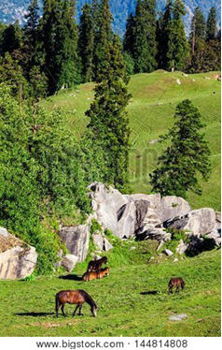

Heaven is Your Home

Then He who sat on the throne said, “Behold, I make all things new.”

~ Revelation 21:5a (NKJV)

“See, I will create new heavens and a new earth.
“The former things will not be remembered, nor will they come to mind.
“But be glad and rejoice forever in what I will create…”

~ Isaiah 65:17-18a (NIV)

For here we have no lasting city, but we seek the city that is to come.

~ Hebrews 13:14 (ESV)

Since you have been raised to new life with Christ, set your sights on the realities of heaven, where Christ sits in the place of honor at God’s right hand.
Think about the things of heaven, not the things of earth.

~ Colossians 3:1-2 (NLT)

In Jerusalem, the Lord of Heaven’s Armies will spread a wonderful feast for all the people of the world...
There he will remove the cloud of gloom, the shadow of death that hangs over the earth.
He will swallow up death forever!
The Sovereign Lord will wipe away all tears…

~ Isaiah 25:6-8a (NLT)

He will wipe away every tear from their eyes, and death shall be no more, neither shall there be mourning, nor crying, nor pain anymore, for the former things have passed away.

~ Revelation 21:4 (ESV)

Yet I still belong to you; you hold my right hand.
You guide me with your counsel, leading me to a glorious destiny.

~ Psalm 73:23-24 (NLT)

Jesus answered, “My kingdom is not of this world.”

~ John 18:36a (ESV)

“The kingdom of heaven is like treasure hidden in a field.
“When a man found it, he hid it again, and then in his joy went and sold all he had and bought that field.”

~ Matthew 13:44 (NIV)

“…rejoice because your names are written in heaven.”

~ Luke 10:20b (NKJV)

“In My Father’s house are many mansions; if it were not so, I would have told you.
“I go to prepare a place for you.
“And if I go and prepare a place for you, I will come again and receive you to Myself…”

~ John 14:2-3a (NKJV)

Jesus answered him, “Truly I tell you, today you will be with me in paradise.”

~ Luke 23:43 (NIV)



“To the one who is victorious, I will give the right to eat from the tree of life, which is in the paradise of God.”

~ Revelation 2:7b (NIV)

“The one who is victorious will not be hurt at all by the second death.”

~ Revelation 2:11b (NIV)

“All who are victorious will be clothed in white.
“I will never erase their names from the Book of Life, but I will announce before my Father and his angels that they are mine.”

~ Revelation 3:5 (NLT)

“So don’t be afraid, little flock. For it gives your Father great happiness to give you the Kingdom.”

~ Luke 12:32 (NLT)

“And be sure of this: I am with you always, even to the end of the age.”

~ Matthew 28:20b (NLT)

No eye has seen, no ear has heard, and no mind has imagined what God has prepared for those who love him.

~ 1 Corinthians 2:9b (NLT)

His dominion is an everlasting dominion that will not pass away, and his kingdom is one that will never be destroyed.

~ Daniel 7:14b (NIV)

…we are receiving a kingdom which cannot be shaken…

~ Hebrews 12:28a (NIV)

Since we are receiving a Kingdom that is unshakable, let us be thankful and please God by worshiping him with holy fear and awe.

~ Hebrews 12:28 (NLT)

Praise God for His Gift of Eternal Life

Praise be to the God and Father of our Lord Jesus Christ, who has blessed us in the heavenly realms with every spiritual blessing in Christ.

~ Ephesians 1:3 (NIV)

Thanks be to God for his indescribable gift!

~ 2 Corinthians 9:15 (NIV)



Who can list the glorious miracles of the Lord? Who can ever praise him enough?

~ Psalm 106:2 (NLT)

Rejoice always, pray continually, give thanks in all circumstances; for this is God’s will for you in Christ Jesus.

~ 1 Thessalonians 5:16-18 (NIV)

May you be filled with joy, always thanking the Father.
He has enabled you to share in the inheritance that belongs to his people, who live in the light.

~ Colossians 1:11b-12 (NLT)

Give thanks to him who made the heavenly lights—His faithful love endures forever.

~ Psalm 136:7 (NLT)

The Spirit is God’s guarantee that he will give us the inheritance he promised and that he has purchased us to be his own people.
He did this so we would praise and glorify him.

~ Ephesians 1:14 (NLT)

So we praise God for the glorious grace he has poured out on us who belong to his dear Son.

~ Ephesians 1:6 (NLT)

Give praise to the Lord, proclaim his name; make known among the nations what he has done, and proclaim that his name is exalted.

~ Isaiah 12:4b (NIV)

Let them praise the name of the Lord, for His name alone is exalted; His glory is above the earth and heaven.

~ Psalm 148:13 (NKJV)

For in him all things were created:
things in heaven and on earth,
visible and invisible,
whether thrones or powers or rulers or authorities;
all things have been created through him and for him.
He is before all things, and in him all things hold together.

~ Colossians 1:16-17 (NIV)

Blessing and glory and wisdom, thanksgiving and honor and power and might, be to our God forever and ever. Amen.

~ Revelation 7:12b (NKJV)

I will praise you forever, O God, for what you have done. I will trust in your good name…

~ Psalm 52:9a (NLT)

I will give thanks to you, Lord, with all my heart…

~ Psalm 9:1a (NIV)

I will be filled with joy because of you.
I will sing praises to your name, O Most High.

~ Psalm 9:2 (NLT)

I will meditate on your majestic, glorious splendor and your wonderful miracles.

~ Psalm 145:5 (NLT)

I will exalt thee, I will praise thy name; for thou hast done wonderful things…

~ Isaiah 25:1b (KJV)

I will exalt you, my God the King; I will praise your name for ever and ever.
Every day I will praise you and extol your name for ever and ever.

~ Psalm 145:1-2 (NIV)

Each morning I will sing with joy about your unfailing love.

~ Psalm 59:16b (NLT)

Your unfailing love is better than life itself; how I praise you!
I will praise you as long as I live, lifting up my hands to you in prayer.
You satisfy me more than the richest feast. I will praise you with songs of joy.

~ Psalm 63:3-5 (NLT)

You alone are the Lord.

~ Nehemiah 9:6a (NIV)

Be exalted, O God, above the heavens, and Your glory above all the earth…

~ Psalm 108:5 (NKJV)

Who is like you—majestic in holiness, awesome in glory, working wonders?

~ Exodus 15:11b (NIV)

Lord, there is no one like you!
For you are great, and your name is full of power.

~ Jeremiah 10:6 (NLT)

I will trust in your good name…

~ Psalm 52:9b (NLT)

O Lord, our Lord, how majestic is your name in all the earth!
You have set your glory above the heavens.

~ Psalm 8:1 (ESV)

Be exalted, O God, above the heavens, and Your glory above all the earth…

~ Psalm 108:5 (NKJV)

Before the mountains were born or you brought forth the whole world, from everlasting to everlasting you are God.

~ Psalm 90:2 (NIV)

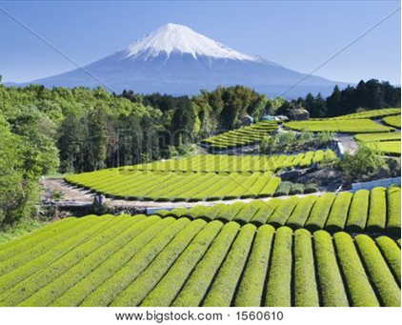

…O Lord my God, I will give thanks to You forever.

~ Psalm 30:12b (NKJV)

God is Your Peace

in Times of Turmoil

You will keep in perfect peace
all who trust in you,
all whose thoughts are fixed on you!.

~ Isaiah 26:3 (NLT)

In peace I will lie down and sleep, for you alone, O Lord, will keep me safe.

~ Psalm 4:8 (NLT)



“Peace I leave with you; my peace I give you.
“I do not give to you as the world gives.
“Do not let your hearts be troubled and do not be afraid.”

~ John 14:27 (NIV)

“I will heal my people and will let them enjoy abundant peace and security.”

~ Jeremiah 33:6b (NIV)

“You will go out in joy and be led forth in peace…”

~ Isaiah 55:12a (NIV)

“Oh, that you had listened to my commands! Then you would have had peace flowing like a gentle river and righteousness rolling over you like waves in the sea.”

~ Isaiah 48:18 (NLT)

Great peace have those who love your law; nothing can make them stumble.

~ Psalm 119:165 (ESV)

Let the peace of Christ rule in your hearts…
And be thankful.
Let the message of Christ dwell among you richly as you teach and admonish one another with all wisdom through psalms, hymns, and songs from the Spirit, singing to God with gratitude in your hearts.

~ Colossians 3:15-16 (NIV)

Grace to you and peace from God our Father and the Lord Jesus Christ.

~ 1 Corinthians 1:3 (NKJV)

Do not be anxious about anything, but in every situation, by prayer and petition, with thanksgiving, present your requests to God.
And the peace of God, which transcends all understanding, will guard your hearts and your minds in Christ Jesus.

~ Philippians 4:6-7 (NIV)

May the God of peace be with you all. Amen.

~ Romans 15:33 (ESV)

Dear brothers and sisters, I close my letter with these last words:
Be joyful.
Grow to maturity.
Encourage each other.
Live in harmony and peace.
Then the God of love and peace will be with you.

~ 2 Corinthians 13:11 (NLT)



The Lord bless you and keep you;
the Lord make his face shine on you and be gracious to you;
the Lord turn his face toward you and give you peace.

~ Numbers 6:24-26 (NIV)

Photo Copyright Info

Note: when purchasing the rights to use the photos, you may want to purchase an Extended License for the cover image.


Bigstock Photo ID: 37017265

The beautiful secluded romantic Jobson Cove Beach on the south side of Bermuda.
Stock Photo ID: 37017265
Copyright: onepony


Bigstock Photo ID: 64633126

Majestic mountain lake in Canada.
Stock Photo ID: 64633126
Copyright: karamysh


Bigstock Photo ID: 2362249
Sedona 21
a with the unique rock formations vegetation and beautiful colors picture of the beauty that is Sedona Arizona ** Note: Slight graininess, best at smaller sizes
Stock Photo ID: 2362249
Copyright: stellar60

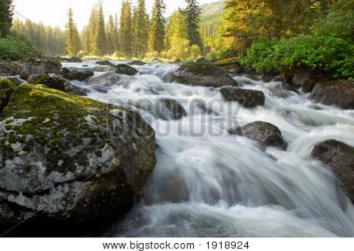
Bigstock Photo ID: 1918924
Sunrise And Mountain Flowing Stream
Sunrise mist and flowing stream in mountains
Stock Photo ID: 1918924
Copyright: Petrichuk


Shutterstock Photo ID: 2521594467
Stock Photo ID: 2521594467
Serene, peaceful lake with lush green grass and trees
Susan's Nature Photos


Bigstock Photo ID: 41744689
Brown bear on Alaska
Stock Photo ID: 41744689
Copyright: Andrushko Galyna

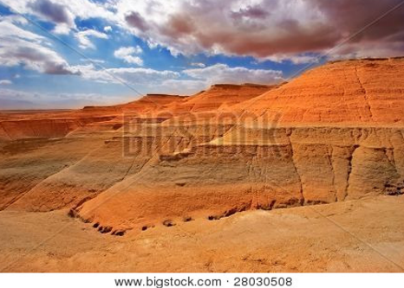
Bigstock Photo ID: 28030508
Picturesque ancient mountains about the Dead Sea in Israel
Stock Photo 28030508
Copyright: kavram


Bigstock Photo ID: 30669227
Road In Jungle
gound road in jungle at summer day Thailand
Stock Photo ID: 30669227
Copyright: AberratioN

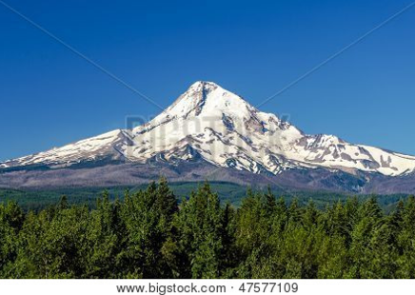
Bigstock Photo ID: 47577109
Snow capped Mt. Hood rising high above a forest
Stock Photo ID: 47577109
Copyright: jkraft5

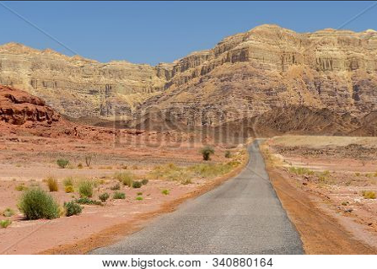
Bigstock Photo ID: 340880164
Lonely asphalt road through the hills and desert in Timna National Park, Israel.
Stock Photo ID: 340880164
Copyright: cezaryw

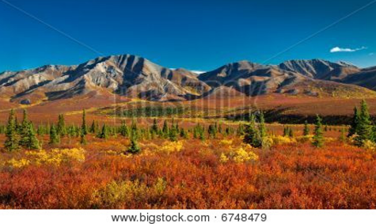
Bigstock Photo ID: 6748479
Denali National Park in autumn
Autumnal Denali Nt Park Scenery with mountain range ** Note: Slight graininess, best at smaller sizes
by simsi, Stock Photo 6748479

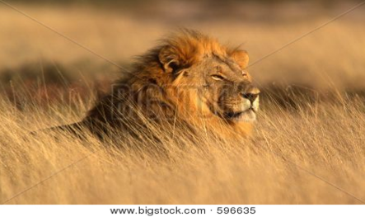
Bigstock Photo ID: 596635
Big Male African Lion
Big male African lion (Panthera leo) lying in the grass, Etosha National Park, Namibia, southern Africa
Stock Photo 596635
Copyright: EcoShot


Bigstock Photo ID: 37045321
Editing suggestion: Rotate photo so sun rays are facing center of the page
forest trees. nature green wood sunlight backgrounds.
Stock Photo 37045321
Copyright: Kalina Vova


Bigstock Photo ID: 8959930
Bass Harbor Head Light, Maine
The Bass Harbor Head Light, a lighthouse in Acadia National Park, Maine, USA
Stock Photo ID: 8959930
Copyright: KennethKeifer

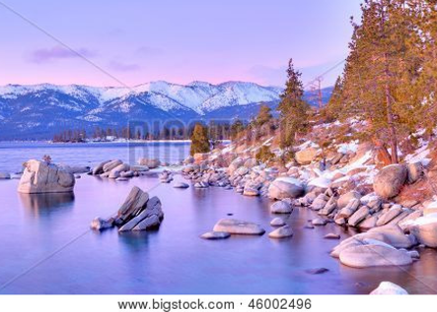
Bigstock Photo ID: 46002496
Editing suggestion: Rotate photo to be consistent with the print booklet
Lake Tahoe
Lake Tahoe in winter at sunset, California.
Stock Photo 46002496
Copyright: Anton Foltin


Bigstock Photo ID: 12755105
waterfall in deep forest of Croatia
Stock Photo 12755105
Copyright: Iakov Kalinin

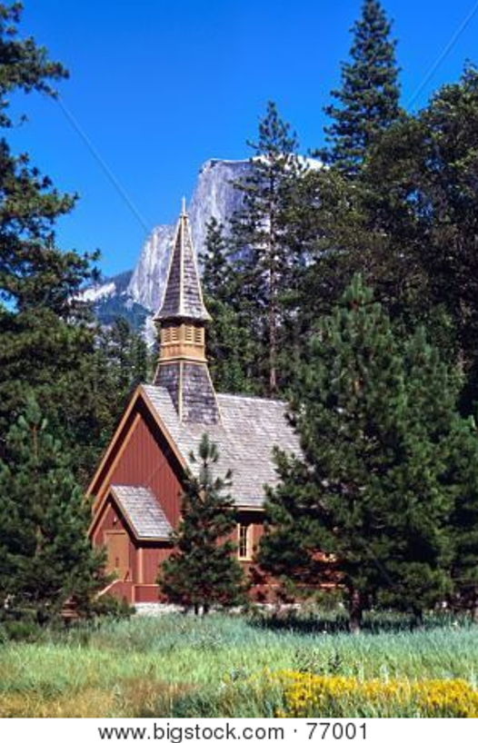
Bigstock Photo ID: 77001
Editing suggestion: Rotate photo to be consistent with the print booklet
Yosemite Chapel
yosemite chapel
Stock Photo 77001
Copyright: GoBigPicture

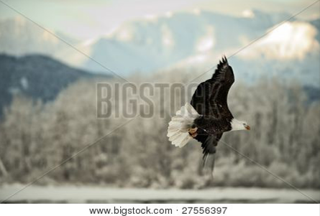
Bigstock Photo ID: 27556397
Flying Bald Eagle.
A flying Bald eagle against snow-covered mountains.
Stock Photo 27556397
Copyright: SURZ


Bigstock Photo ID: 64153
Editing suggestion: Brighten photo
Lush Mountain Stream
Smoky Mountain Stream
Stock Photo ID: 64153
Copyright: digitalphotonut

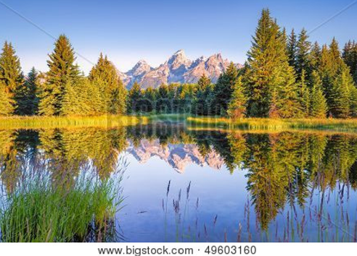
Bigstock Photo ID: 49603160
The Teton range's reflection upon the Snake River. Photographed at dawn at Schwabacher Landing in Grand Teton National Park WY
Stock Photo ID: 49603160
Copyright: Dean Fikar


Bigstock Photo ID: 29882183
Lake Powell and Glen Canyon in Arizona, USA
Stock Photo 29882183
Copyright: videowokart

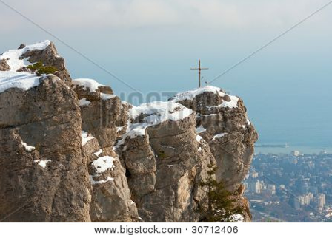
Bigstock Photo ID: 30712406
cross on rock in snowy mountain
Stock Photo 30712406
Copyright: pavel_klimenko


Bigstock Photo ID: 25798811
Green forest near river in sunny day
Stock Photo ID: 25798811
Copyright: Valentina R.


Bigstock Photo ID: 15101420
dark sky with sun
Stock Photo ID: 15101420
Copyright: lilkar

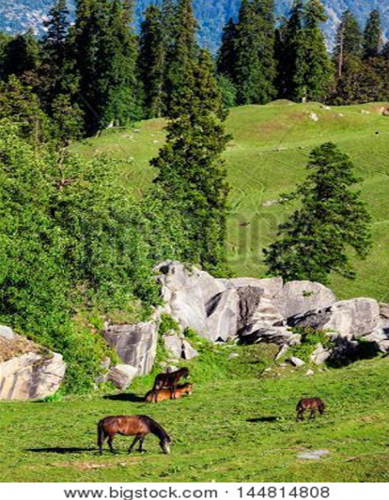
Bigstock Photo ID: 144814808
Horses grazing in Himalayas mountains. Kullu valley, Himachal Pradesh, India
Stock Photo ID: 144814808
Copyright: f9photos


Bigstock Photo ID: 4631941
Editing suggestion: Slightly brighten and crop darker portions out of bottom of photo

The Millaa Millaa falls in Queensland Australia
Stock Photo ID: 4631941
Copyright: wtolenaars

Bigstock Photo ID: 94974650

Turquoise water of Plitvice lakes national park in Croatia ** Note: Visible grain at 100%, best at smaller sizes
Stock Photo ID: 94974650
Copyright: xbrchx


Bigstock Photo ID: 1560610
Rows of fresh green tea with Mount Fuji
Stock Photo ID: 1560610
Copyright: rssfhs


Bigstock Photo ID: 13681454
Editing suggestion: Rotate photo to be consistent with the print booklet
Whitetail Deer Fawn
Whitetail deer fawn resting in tall grass.
Stock Photo 13681454
Copyright: brm1949


Bigstock Photo ID: 34489793
Hawaiian palm tree sunset
Hawaiian palm tree sunset on Big Island, Anaehoomalu Bay
Stock Photo 34489793
Copyright: krisrobin

Booklet Titles in the Series
www.TheWordOfGodSeries.com
Relational and Emotional Health Topics

A Joy-Filled Life

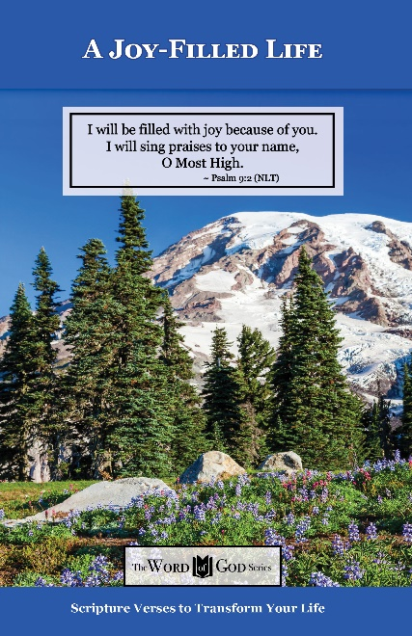
Relational and Emotional Health Topics

Healthy Relationships

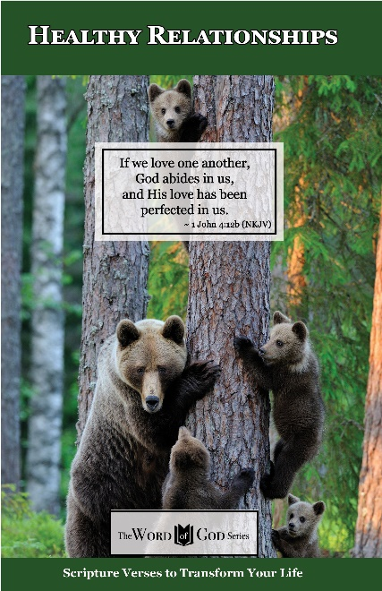
Relational and Emotional Health Topics

Healthy Thoughts

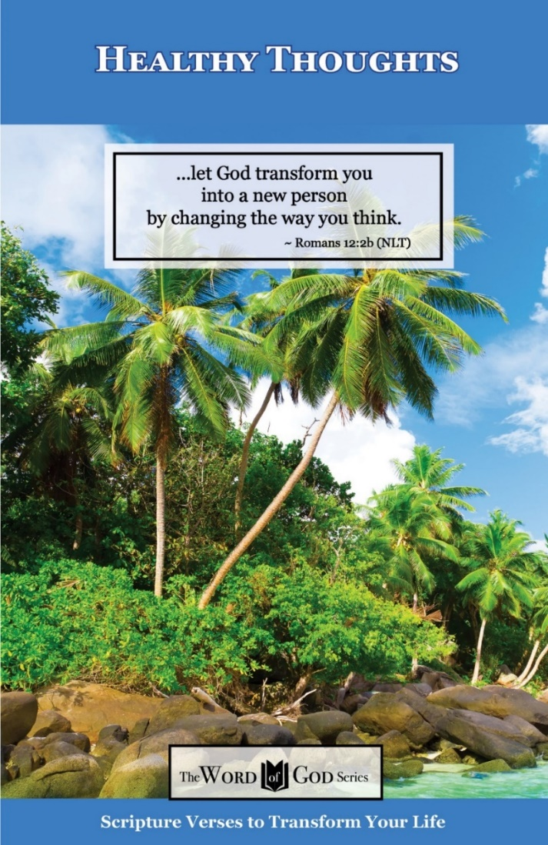
Relational and Emotional Health Topics

Freedom from Depression and Comfort in Grief

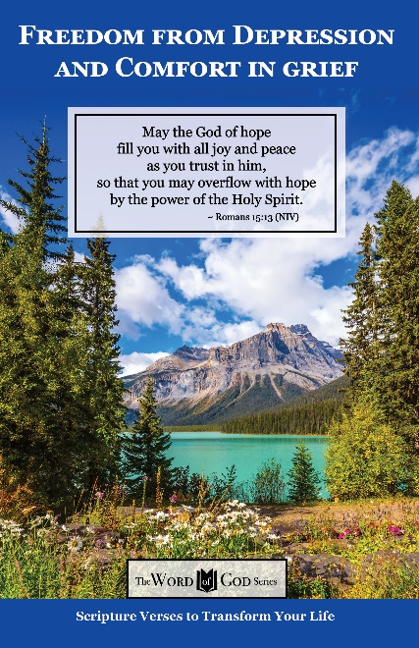
Relational and Emotional Health Topics

Freedom from Fear

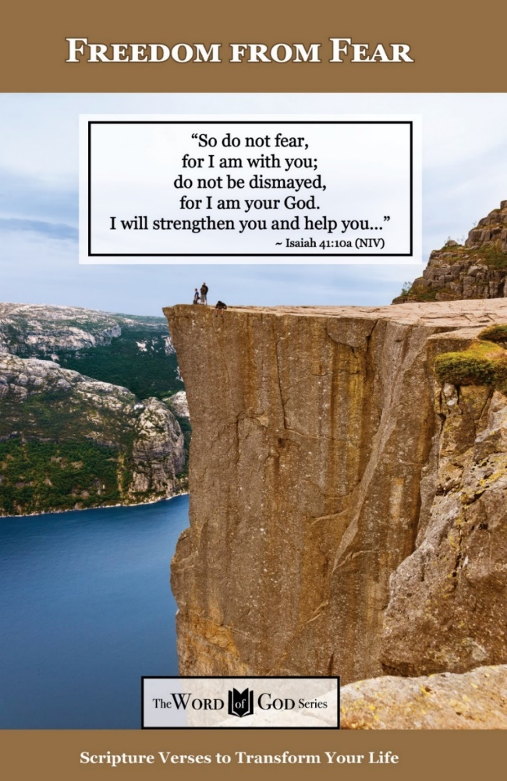
Relational and Emotional Health Topics

Freedom from Addictions

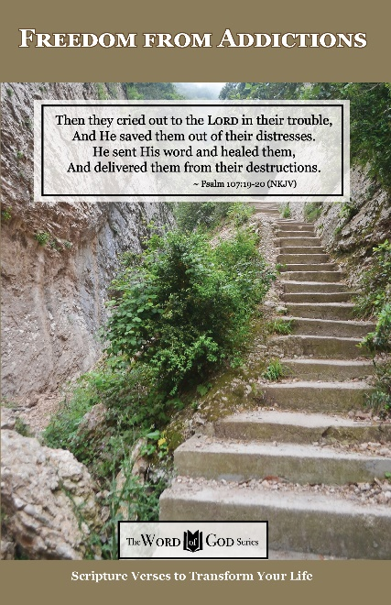
The Life and Ministry of Christ Series

Jesus: His Birth

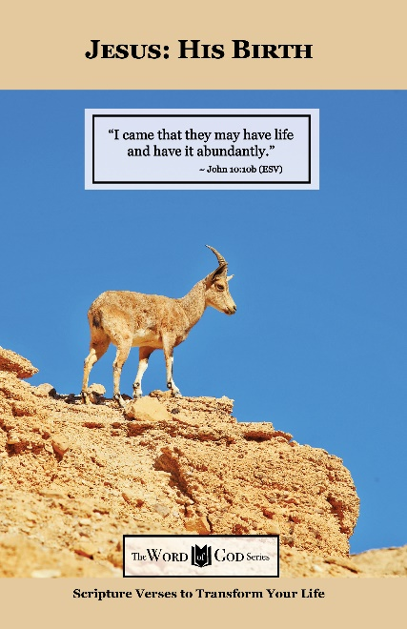
The Life and Ministry of Christ Series

Jesus: His Life Events

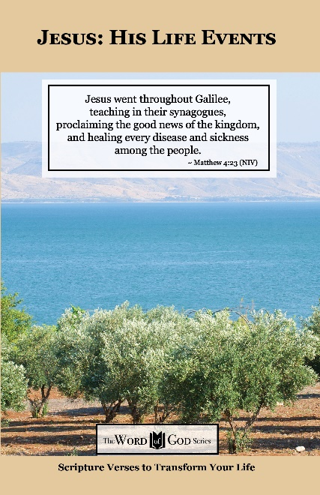
The Life and Ministry of Christ Series

Jesus: His Teachings

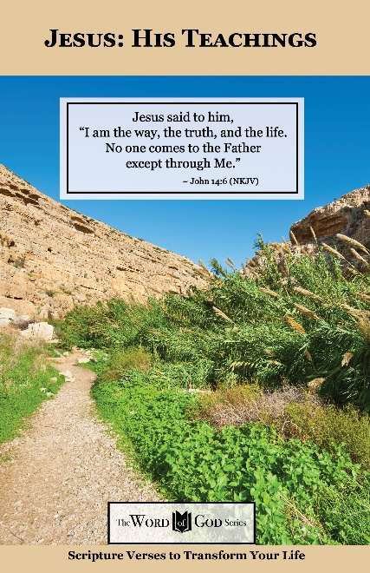
The Life and Ministry of Christ Series

Jesus: His Death, Resurrection and Return

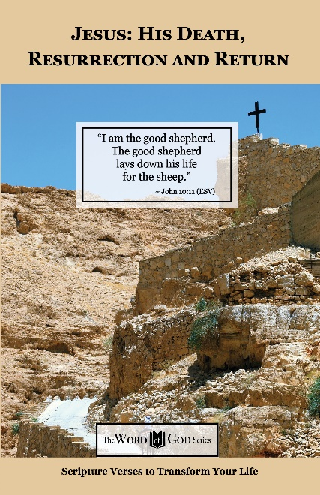
Spiritual Growth Topics

God’s Power and Presence

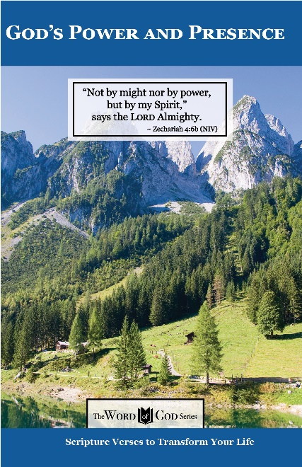
Spiritual Growth Topics

God’s Gift of Eternal Life

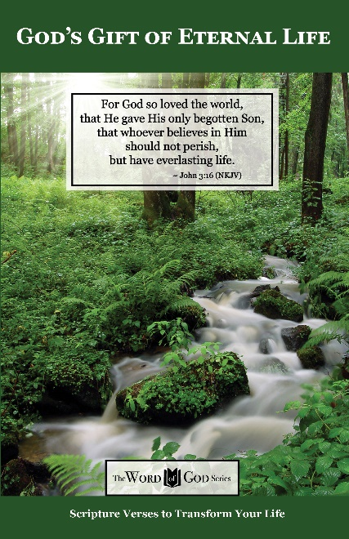
Spiritual Growth Topics

Sharing the Good News

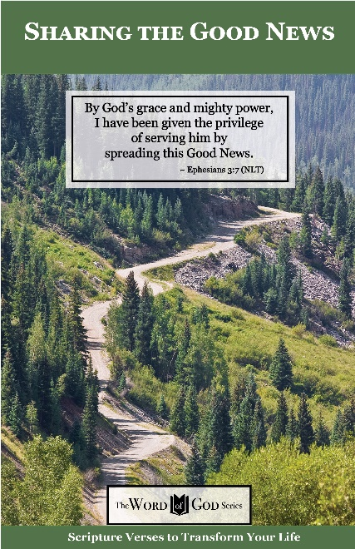
Spiritual Growth Topics

Defeating the Enemy

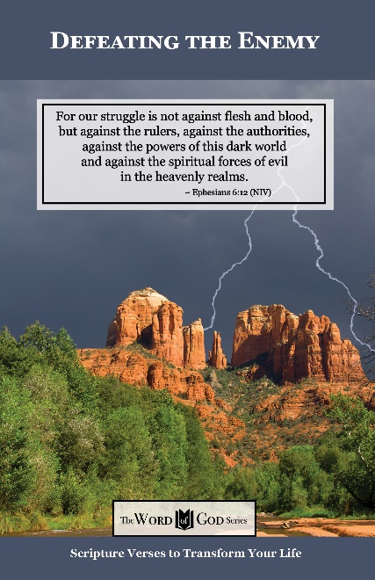
Spiritual Growth Topics

Standing Strong in Persecution

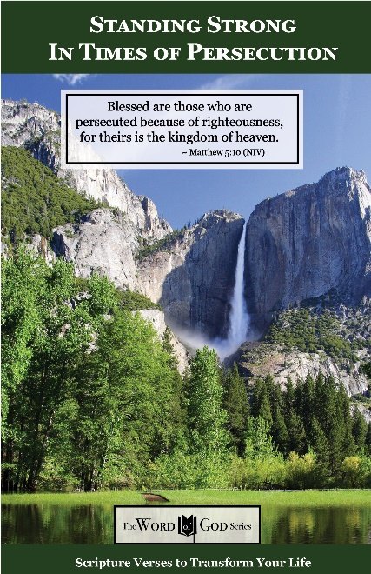
Everyday Life Topics

God’s Healing Power

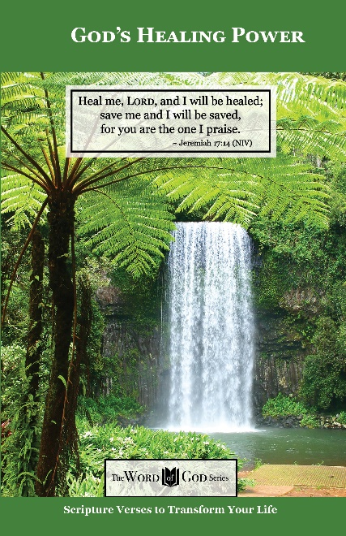
Everyday Life Topics

God is Your Refuge

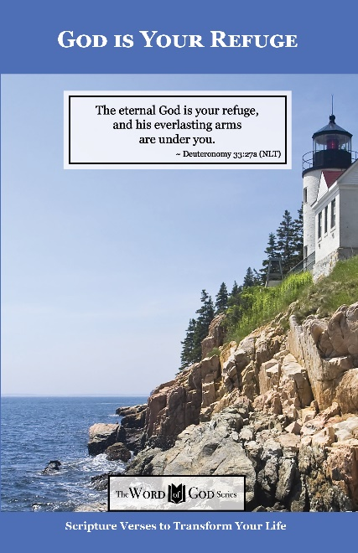
Everyday Life Topics

God’s Guidance for Your Life

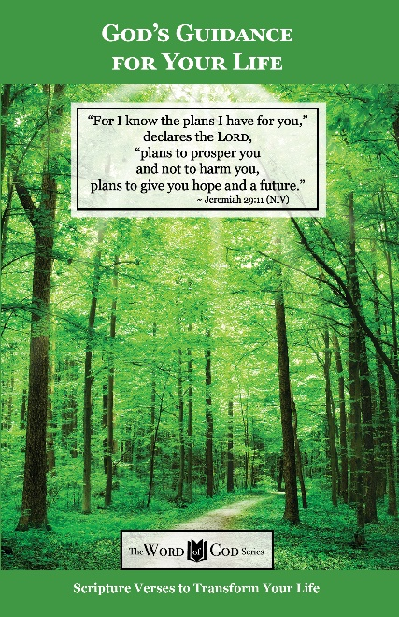
Everyday Life Topics

God’s Word to the Nations

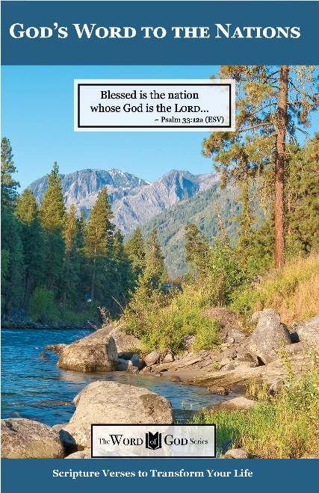
Everyday Life Topics

Praise God at Thanksgiving

