Template for God’s Gift of Eternal Life in an eBooklet Format

The Word of God Series is a collection of 20 booklets that present Scripture verses in an easy-to-read format, with each booklet focused on a different topic.
Titles include Healthy Relationships, A Joy-Filled Life, Freedom from Depression, and many others. Click here to see other titles.
The booklets are available in both paperback and digital formats at www.TheWordOfGodSeries.com or Amazon.com.
Why This Template?
Because I believe in the power of God’s Word to transform people’s lives, I have dedicated several years of my life to bring this series to fruition.
I am passionate about using these booklets to reach a dark and dying world with the love of Christ and the hope of the Gospel.
Initially, I had expected this series would be a small business. But one day, when I asked God what my next steps should be, He spoke to me through His Word and told me to:
“…complete the ministry God has given you.”
~ 2 Timothy 4:5 (NLT, 1996 version)
So, I shifted the focus from being a business to a ministry.
My vision, also, has evolved over time and I have come to believe that it is possible for millions of these booklets to be distributed (in both print and digital formats) around the world (see the document entitled The Vision at www.TheWordOfGodSeries.com for more info.)
In order to make this a far-reaching ministry, accessing populations that I couldn’t on my own, I decided to invite others to partner with me in producing and distributing these booklets to their own personal networks. To help get it started, I have made templates of each booklet freely available to anyone who would like them.
This way you (whether you are a church, Christian organization or an individual) can easily re-create the booklets in your own ministry’s name, and distribute them to the people you minister to.
I hope that this template will save you:
- Time – so you can benefit from the thousands of hours of development time that has been invested so far
- Money – eliminate layers of profit margin
Whether you simply replicate and reproduce what has already been done, build on it, or take this idea in a different direction, you won’t have to waste time starting with a blank page.
I hope you can easily get these finalized, so you can begin sharing them with the people in your sphere of influence.
On the following pages you will find document formatting tips.
Photo editing tips are also presented, as well as the preview images of each photo (with the Photo ID#), so you to easily find it on either bigstockphoto.com or shutterstock.com. Copyright and general info for each photo can be found here.
Formatting Tips (if making changes to this document)
This document is ready to be exported to an eBook format. The app I used is through Amazon called Kindle Create.
If you make any changes to this document (such as pasting additional verses or entire sections into it), you’ll want follow the steps below.
If you are not making any changes to this document, then just skip these steps.
When converting a document to eBook format, it’s best to remove tabs, indentations and soft returns. While using these formatting tricks in a print format can make the page much more readable (by adding white space to the page), in a digital format, these same tricks can disrupt the flow of the text and make it more difficult to read (since the view can change depending on the type of device, font size selected, etc.)
- Remove all tabs, indentations and soft returns (Note, if a passage is too long, you can always add white space by inserting a
hard return (the Enter key only) after a sentence, with a 6 pt spacing after the line. (Layout / Spacing / After / 6 pt)


- Ensure that the spacing between the lines is consistent throughout the document. When the document is completed, select the entire document (Ctrl + A) and click on Layout / Paragraph / Multiple (under Line Spacing) and change the number to “1”


- Ensure that the spacing between the characters is consistent throughout the document. After completing step 2 above, while the entire document is still selected, click on Home / Font / Advanced and change the Spacing to Normal


Photo Editing Tips
At the end of this document you will find the copyright and descriptive info for each photo in the booklet, as well as editing suggestions for a few of them.
For the digital view, try to keep the photos as large on the page as possible, otherwise they will appear too small on devices. The preview photos in this document are a good size for digital format, so try to keep your photos the same size.
Most of the editing suggestions (especially brightening or increasing color saturation) should be very slight adjustments.
Editing photos within this document
Rotate: Doubleclick the photo, click on the Rotate Object icon.
Note: rotating an image is more important in the print format, so that certain objects in the photo will face the center of the page (such as animal pics). This doesn’t matter in a digital format, but the suggestion to rotate certain photos is included below in order to keep the digital and print formats consistent (in case someone reads both the print and digital booklets.)

Editing photos in the Pictures editing app in MS Word
Navigate to your Pictures folder, doubleclick the photo, and click on the blue Edit button on left
Most of the editing can be accomplished using one of these 3 options:


Crop: Click on the Crop icon and drag edges to desired spot
Brighten a photo: Adjustment icon / Light / Brightness
Increase color saturation: Adjustment icon / Color / Saturation or Warmth
Remove distracting elements from a photo: Click on the Generative Erase icon, select a brush size and click on the part of the photo you want removed.

Photo Searching Tips
Occasionally photographers pull their photos from the sites, so there may be some in this document that are no longer available. You can try using the same key words to search for the photo on other sites. Or, you can search for another photo on Bigstock:
- Under All Images select Photos and search by key word.
- At the next screen, make sure that Safe Search is on.
- In the Category field, select either Landscapes, Nature or Animals.
Forward Page | Copyright Page | Table of Contents

Below are sample Forward and Copyright pages. Feel free to edit to reflect your ministry’s mission and vision.
The Table of Contents in this document contains links to each of the section headings. If you add any new sections to this document, be sure to:
- Assign the Heading Style to the new section heading (in this document, it is referred to as Heading).
Highlight the heading, click on Home, then Heading in the Styles box


- Bookmark the new section heading: Put your cursor after the first letter in the section heading, click on Insert / Bookmark and then give name the bookmark (no spaces in the name!)



- Add the new section heading to the Table of Contents page and add a link to the bookmark you just created: Highlight the text, click on Insert / Link / Place in this Document and select the section heading bookmark.


Kindle Create
Should you decide to use Kindle Create to export this to an eBook format, see the steps below. You can use Kindle Create to export to a Kindle KPF file and/or EPUB file:

Begin at https://kdp.amazon.com/en_US/bookshelf to set up the booklets on Amazon and install the Kindle Create app.
At the first screen, select Create New and Choose

At the next Screen click on Continue. At the next screen click on Choose File, select the document, and click on Open. Then click on Continue and Get Started.
At the next screen you will see a box labeled Suggested Chapter Titles. Click on Reject All.
Next, left-justify the entire document (a quirk with this application is that some portions of the document may be centered, while others portions are left-justified). Highlight the entire document, click on Formatting, and then the left-justify icon.
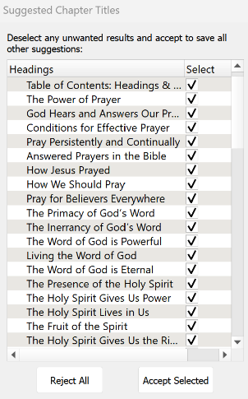

Now you can begin assigning different elements to the Headings and Subheadings in the document so that, when someone is reading the eBook, they can easily jump to another section via the Table of Contents.
I use 2 elements: Chapter Title (for the key headings in the Brittanica Bold font) and Subheading (for the underlined subheadings).
As you begin assigning the elements, be sure to start by assigning the Chapter Title element to the Table of Contents: Headings and Subheadings heading. Then go through the rest of the document and assign either the Chapter Title or Subheading elements.
You can change the formatting from the Kindle Create default, if you want. Below are the formatting options that I use for the eBooklets.
Feel free to customize to suit your preferences.

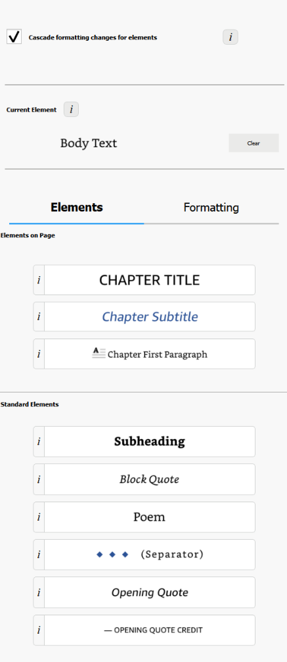
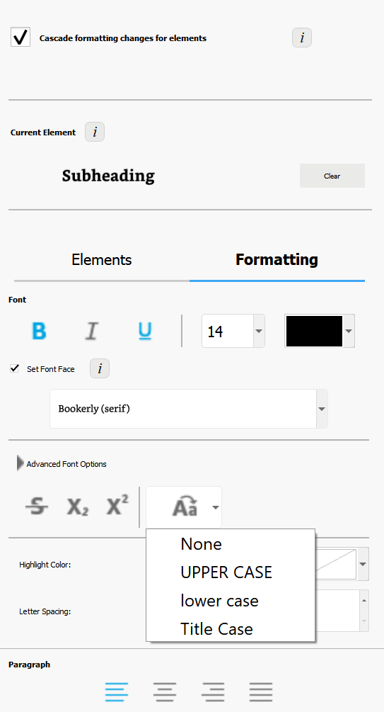

Finally, go through the document and click on each photo and change it to “Full Size.” (Note, another quirk with this app is that some photos just can’t be changed to full size, so they will appear smaller in the eBooklet).
When complete, first, save the document (File / Save Project). This will automatically put it in a folder. So when you export the document, be sure you export it to that folder.
To export, click on File / Export / KPF (Kindle and print). At the next screen, click on the file name to select it, and then click on Export.
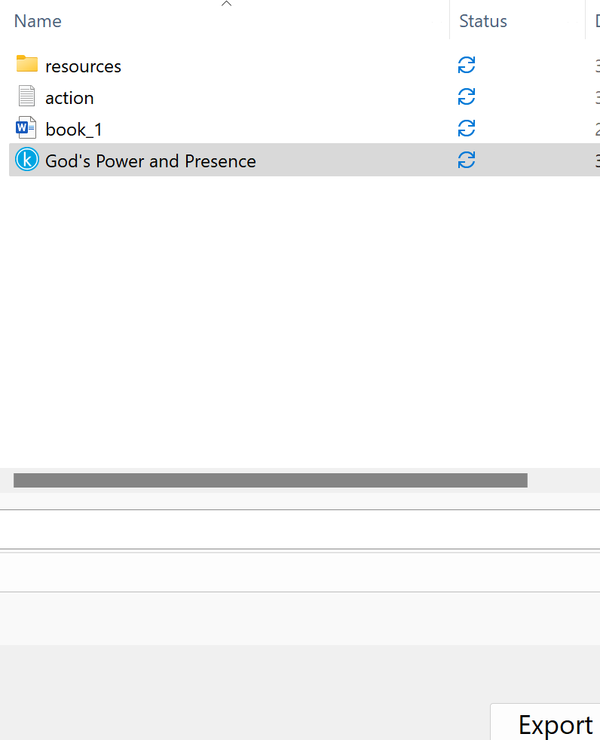

If you want the file in an EPUB format, go through the steps above and select File / Export / EPUB

Stuck on a Step Above and Need Help?
If you want to do this project on your own, but are having tech issues with one of the steps above, feel free to contact me at Susan@TheWordOfGodSeries.com. I may be able to assist you, since I’ve gone through this whole process myself!

Need Help with the Whole Project?
If you want these booklets set up in your own in your own ministry’s name, but don’t have the resources to do the whole project yourself,
I may be able to manage that process for you for a one-time project fee.
This would include the following services:
- Set up an account with Bigstock and Shutterstock in your ministry’s name and purchase the rights for you to use each of the photos
- Download and name the photos
- Edit photos as needed
- Create a cover with your church or ministry logo
- Request the rights to use the various Bible translations from each of the publishers (if applicable)
Feel free to contact me at Susan@TheWordOfGodSeries.com to discuss pricing options.

I hope that this information will help you finalize this document with ease so you can begin distributing it
to the people in your realm of influence.
Thank you for partnering with me in this effort. I wish you the best as you make God’s Word known and
share His love with others!
Warmly in Christ,
Susan

Soli Deo gloria


Feel free to edit this forward page to align to your own ministry’s vision and goals.

The Bible is the best-selling and most transformative book in history. Written over 2,000 years ago, it is still living and powerful today.
Throughout the pages of Scripture you will find inspiration and joy, comfort and peace, healing and hope.
Most importantly, you will learn of God’s abundant love for you, and His plan to give you a glorious, eternal inheritance.
The Word of God Series is a collection of booklets which presents Scripture by topic, so you can focus on verses that are relevant to you at different stages and circumstances throughout your life.
All of the booklets in this series feature Scripture exclusively—just the powerful, undiluted Word of God.
Let God’s Word permeate your mind and transform your life.
Here are a few suggestions to help you fully benefit from Scripture:
Meditate
Pause and reflect on the verses as you read, and even meditate on them throughout the day.
Memorize
A great memorization technique is to repeat the verse several times, each time emphasizing a different word.
…the free gift of God is eternal life in Christ Jesus our Lord.
…the free gift of God is eternal life in Christ Jesus our Lord.
…the free gift of God is eternal life in Christ Jesus our Lord.

~ Romans 6:23 (ESV)
Pray
Pray God’s Word back to Him. For example,
Dear Lord Jesus, thank you for the gift of eternal life that You have so freely given to me.

Do What It Says
Do not merely listen to the word, and so deceive yourselves. Do what it says.

~ James 1:22 (NIV)

My prayer for you, as you read this booklet, is that you will accept the gift of eternal life that Jesus so freely offers, share this Good News with others and, out of gratitude, live a life that is pleasing to Him.
Let the word of Christ dwell in you richly…

~ Colossians 3:16a (ESV)

A few comments about The Word of God Series:

- The booklets in this series provide you with a sample of what the Bible offers, but it is important that you also read the Bible itself, preferably with a book-by-book focus.

- Passages in quotation marks are the actual words of God, either through His prophets in the Old Testament, or the words of Christ in the New Testament.

- Every booklet includes a section that details God’s plan of salvation (commonly referred to as “The Gospel.”) The booklet entitled God’s Gift of Eternal Life is devoted to the Gospel message.

This series presents verses in the following translations:

NIV: New International Version
Scripture quotations marked NIV are taken from the Holy Bible, New International Version®, NIV®. Copyright © 1973, 1978, 1984, 2011 by Biblica, Inc.™ Used by permission of Zondervan. All rights reserved worldwide. www.zondervan.com. The "NIV" and "New International Version" are trademarks registered in the United States Patent and Trademark Office by Biblica, Inc.™

NLT: New Living Translation
Scripture quotations marked NLT are taken from the Holy Bible, New Living Translation, Copyright© 1996, 2004, 2015 by Tyndale House Foundation. Used by permission of Tyndale House Publishers, Inc., Carol Stream, Illinois 60188. All rights reserved.

ESV: English Standard Version
Scripture quotations marked ESV are taken from the ESV Bible® (The Holy Bible, English Standard Version®), copyright © 2001 by Crossway Bibles, a publishing ministry of Good News Publishers. Used by permission. All rights reserved.

KJV: King James Version
Public Domain

NKJV: New King James Version
Scripture quotations marked NKJV are taken from the New King James Version®. Copyright © 1982 by Thomas Nelson, Inc. Used by permission.

Since this is a template booklet featuring preview photos, it is not copyrighted, so you are free to purchase licenses to use the photos and develop your own booklets. Be sure to determine whether or not you need to request permission (and in some cases pay) for the rights to use the various Bible translations. Scripture verses were sourced from www.BibleGateway.com.

If it would be easier for you to simply purchase this booklet, the copyrighted version is available at www.TheWordOfGodSeries.com or www.amazon.com. ISBN info for the copyrighted booklets is as follows: 978-1-964538-22-8 (print booklet), 978-1-964538-23-5 (eBooklet), 9798360255772 (print booklet on Amazon).

Table of Contents: Headings & Sub-Headings

God loves you abundantly, and has made a way for you to live forever in His glorious kingdom. However, first He had to pay an enormous price for you to be forgiven of your sin, in order to receive this eternal glory. This section explains His plan to forgive and save you. In summary:
God loves you, but your sin separates you from Him, and because of it, God’s wrath will come. However, Jesus died as a sacrifice to save you from your sins, from God’s wrath, and from death itself. When you confess your sins, repent and accept the salvation that Christ offers, God will forgive you. By trusting in Christ you become God’s child, and as His child, you will inherit eternal life and heaven will be your home.

God Loves You
But Your Sin Separates You from God
The Day of God’s Wrath Will Come
Confess Your Sin and Repent
Jesus Died to Save You
…From Your Sin
…From God’s Wrath
…From Death
God Bought You at a Price
The Gospel
In Christ You are Forgiven
God Demonstrates His Love Through Christ
Salvation is Through Christ Alone
Salvation is a Gift: Free and Undeserved
Accept This Gift of Salvation
You Belong to God Through Faith in Christ and Have Become His Child
Eternal Life is Yours Through Christ
Praise God for His Gift of Eternal Life
Heaven is Your Home

A more comprehensive listing of verses about God’s plan of salvation can be found at
www.TheWordOfGodSeries.com.

Note: The verse references in this document contain links to the BibleGateway.com page that will display the passage in all 5 translations that are used in this series (NIV, NLT, ESV, NKJV, KJV).

Other Booklets in the Series

God Loves You

“I have loved you with an everlasting love;
“I have drawn you with unfailing kindness.”

~ Jeremiah 31:3b (NIV)

“I have called you by your name; You are Mine.”

~ Isaiah 43:1b (NKJV)

“Before I formed you in the womb I knew you…”

~ Jeremiah 1:5a (NIV)

“See, I have inscribed you on the palms of My hands…”

~ Isaiah 49:16av (NKJV)

“And even the very hairs of your head are all numbered.”

~ Matthew 10:30 (NIV)



“…I lavish unfailing love for a thousand generations on those who love me and obey my commands.”

~ Deuteronomy 5:10 (NLT)

How great is the goodness you have stored up for those who fear you.
You lavish it on those who come to you for protection, blessing them before the watching world.

~ Psalm 31:19 (NLT)

Let your unfailing love surround us, Lord, for our hope is in you alone.

~ Psalm 33:22 (NLT)

For your unfailing love is as high as the heavens.

~ Psalm 57:10a (NLT)

How precious is your unfailing love, O God!
All humanity finds shelter in the shadow of your wings.

~ Psalm 36:7 (NLT)

…I have always been mindful of your unfailing love and have lived in reliance on your faithfulness.

~ Psalm 26:3 (NIV)

For you, O Lord, are good and forgiving, abounding in steadfast love to all who call upon you.

~ Psalm 86:5 (ESV)

…full of unfailing love for all who ask for your help.

~ Psalm 86:5b (NLT)

…abundant in mercy to all those who call upon You.

~ Psalm 86:5b (NKJV)

You, O Lord, are a God full of compassion...

~ Psalm 86:15a (NKJV)

In your unfailing love you will lead the people you have redeemed…you will guide them to your holy dwelling.

~ Exodus 15:13 (NIV)

What is man, that you make so much of him, and that you set your heart on him…

~ Job 7:17 (ESV)

…what is mankind that you are mindful of them, human beings that you care for them?

~ Psalm 8:4 (NIV)

For you created my inmost being; you knit me together in my mother’s womb…
Your eyes saw my unformed body; all the days ordained for me were written in your book before one of them came to be.

~ Psalm 139:13-16 (NIV)

The Lord is good…

~ Nahum 1:7a (NIV)

Taste and see that the Lord is good...

~ Psalm 34:8a (NIV)

The earth is full of the goodness of the Lord.

~ Psalm 33:5b (NKJV)

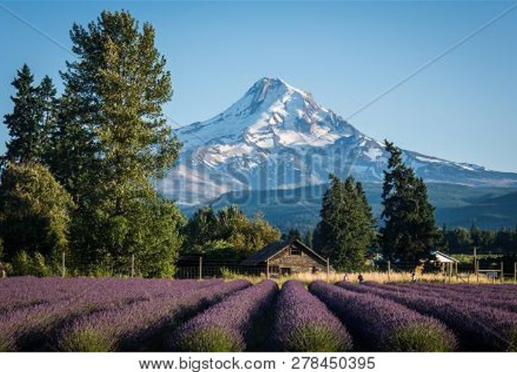

…the Lord is good; His mercy is everlasting, and His truth endures to all generations.

~ Psalm 100:5 (NKJV)

Oh, that men would give thanks to the Lord for His goodness, and for His wonderful works to the children of men!

~ Psalm 107:15 (NKJV)

Give thanks to the Lord, for he is good. His love endures forever.

~ Psalm 106:1b (NIV)

Even before he made the world, God loved us and chose us in Christ to be holy and without fault in his eyes.
God decided in advance to adopt us into his own family by bringing us to himself through Jesus Christ.
This is what he wanted to do, and it gave him great pleasure.

~ Ephesians 1:4-5 (NLT)

…we know how dearly God loves us, because he has given us the Holy Spirit to fill our hearts with his love.

~ Romans 5:5b (NLT)

…the love of God is shed abroad in our hearts by the Holy Ghost which is given unto us.

~ Romans 5:5b (KJV)

…God’s love has been poured out into our hearts through the Holy Spirit, who has been given to us.

~ Romans 5:5b (NIV)



We know how much God loves us, and we have put our trust in his love.
God is love, and all who live in love live in God, and God lives in them.

~ 1 John 4:16 (NLT)

We love Him because He first loved us.

~ 1 John 4:19 (NKJV)

…God loves you and has chosen you to be his own people.

~ 1 Thessalonians 1:4b (NLT)

…the Lord longs to be gracious to you…

~ Isaiah 30:18a (NIV)

…for God is love.

~ 1 John 4:8b (NKJV)

…God, the blessed and only Ruler, the King of kings and Lord of lords, who alone is immortal and who lives in unapproachable light...

~ 1 Timothy 6:15b-16a (NIV)

The Lord your God in your midst, The Mighty One, will save;
He will rejoice over you with gladness,
He will quiet you with His love,
He will rejoice over you with singing.

~ Zephaniah 3:17 (NKJV)

The Lord is gracious and compassionate, slow to anger and rich in love.
The Lord is good to all; he has compassion on all he has made.

~ Psalm 145:8-9 (NIV)

It is of the Lord’s mercies that we are not consumed, because his compassions fail not.
They are new every morning: great is thy faithfulness.

~ Lamentations 3:22-23 (KJV)

…His merciful kindness is great toward us…

~ Psalm 117:2a (NKJV)

May the grace of the Lord Jesus Christ,
and the love of God,
and the fellowship of the Holy Spirit be with you all.

~ 2 Corinthians 13:14 (NIV)

The Lord is my shepherd; I shall not want.
He makes me to lie down in green pastures;
He leads me beside the still waters.
He restores my soul;
He leads me in the paths of righteousness for His name’s sake.
Yea, though I walk through the valley of the shadow of death, I will fear no evil; for You are with me; Your rod and Your staff, they comfort me.
You prepare a table before me in the presence of my enemies;
You anoint my head with oil.
My cup runs over.
Surely goodness and mercy shall follow me all the days of my life;
And I will dwell in the house of the Lord forever.

~ Psalm 23 (NKJV)

Shout for joy to the Lord, all the earth.
Worship the Lord with gladness; come before him with joyful songs.
Know that the Lord is God. It is he who made us, and we are his; we are his people, the sheep of his pasture.
Enter his gates with thanksgiving and his courts with praise; give thanks to him and praise his name.
For the Lord is good and his love endures forever; his faithfulness continues through all generations.

~ Psalm 100 (NIV)

Yes, the Sovereign Lord is coming in power.
He will rule with a powerful arm.
See, he brings his reward with him as he comes.
He will feed his flock like a shepherd.
He will carry the lambs in his arms, holding them close to his heart.

~ Isaiah 40:10-11a (NLT)

“For this is what the Sovereign Lord says:
“I myself will search and find my sheep.
“I will be like a shepherd looking for his scattered flock.
“I will find my sheep and rescue them from all the places where they were scattered on that dark and cloudy day.”

~ Ezekiel 34:11-12 (NLT)

“I am the good shepherd…”

~ John 10:14a (NIV)

“My sheep listen to my voice; I know them, and they follow me.
“I give them eternal life, and they shall never perish; no one will snatch them out of my hand.”
~ John 10:27-28 (NIV)

Then Jesus told them this parable: “Suppose one of you has a hundred sheep and loses one of them.
“Doesn’t he leave the ninety-nine in the open country and go after the lost sheep until he finds it?
“And when he finds it, he joyfully puts it on his shoulders and goes home.
“Then he calls his friends and neighbors together and says, ‘Rejoice with me; I have found my lost sheep.’”

~ Luke 15:3-6 (NIV)

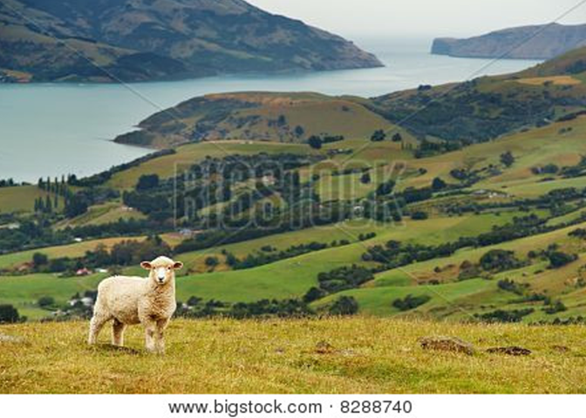

Psalm 103

Praise the Lord, my soul; all my inmost being, praise his holy name.
Praise the Lord, my soul, and forget not all his benefits—who forgives all your sins and heals all your diseases, who redeems your life from the pit and crowns you with love and compassion, who satisfies your desires with good things so that your youth is renewed like the eagle’s…
The Lord is compassionate and gracious, slow to anger, abounding in love.
He will not always accuse, nor will he harbor his anger forever; he does not treat us as our sins deserve or repay us according to our iniquities.
For as high as the heavens are above the earth, so great is his love for those who fear him; as far as the east is from the west, so far has he removed our transgressions from us.
As a father has compassion on his children, so the Lord has compassion on those who fear him; for he knows how we are formed, he remembers that we are dust. The life of mortals is like grass, they flourish like a flower of the field; the wind blows over it and it is gone, and its place remembers it no more.
But from everlasting to everlasting the Lord’s love is with those who fear him, and his righteousness with their children’s children…
The Lord has established his throne in heaven, and his kingdom rules over all…
Praise the Lord, all his works everywhere in his dominion.
Praise the Lord, my soul.

~ Psalm 103 (NIV)

Every good and perfect gift is from above, coming down from the Father of the heavenly lights…

~ James 1:17a (NIV)



But Your Sin Separates You from God

But your iniquities have separated you from your God; and your sins have hidden His face from you, so that He will not hear.

~ Isaiah 59:2 (NKJV)

As the Scriptures say, “No one is righteous—not even one.”

~ Romans 3:10 (NLT)

…for all have sinned and fall short of the glory of God…

~ Romans 3:23 (NKJV)

We are all infected and impure with sin.
When we display our righteous deeds, they are nothing but filthy rags.

~ Isaiah 64:6a (NLT)

Once you were dead because of your disobedience and your many sins.
You used to live in sin, just like the rest of the world…
By our very nature we were subject to God’s anger…

~ Ephesians 2:1-3a (NLT)

Don’t you realize that those who do wrong will not inherit the Kingdom of God?

~ 1 Corinthians 6:9a (NLT)

The acts of the flesh are obvious: sexual immorality, impurity and debauchery; idolatry and witchcraft; hatred, discord, jealousy, fits of rage, selfish ambition, dissensions, factions and envy; drunkenness, orgies, and the like.
I warn you, as I did before, that those who live like this will not inherit the kingdom of God.

~ Galatians 5:19-21 (NIV)

For of this you can be sure: No immoral, impure or greedy person—such a person is an idolater—has any inheritance in the kingdom of Christ and of God.
Let no one deceive you with empty words, for because of such things God’s wrath comes on those who are disobedient.

~ Ephesians 5:5-6 (NIV)

The Day of God’s Wrath Will Come

The wrath of God is being revealed from heaven against all the godlessness and wickedness of people who suppress the truth by their wickedness…

~ Romans 1:18 (NIV)

But because of your stubbornness and your unrepentant heart, you are storing up wrath against yourself for the day of God’s wrath, when his righteous judgment will be revealed.

~ Romans 2:5 (NIV)

Even now the ax of God’s judgment is poised, ready to sever the roots of the trees.
Yes, every tree that does not produce good fruit will be chopped down and thrown into the fire.

~ Matthew 3:10 (NLT)



The wicked shall be turned into hell…

~ Psalm 9:17a (KJV)

For you are not a God who delights in wickedness; evil may not dwell with you.

~ Psalm 5:4 (ESV)

“See, the day of the Lord is coming—a cruel day, with wrath and fierce anger—to make the land desolate and destroy the sinners within it.”

~ Isaiah 13:9 (NIV)

“It will be a day when the Lord’s anger is poured out—a day of terrible distress and anguish, a day of ruin and desolation, a day of darkness and gloom, a day of clouds and blackness...”

~ Zephaniah 1:15 (NLT)

“I will be a swift witness
against the sorcerers,
against the adulterers,
against those who swear falsely,
against those who oppress the hired worker in his wages, the widow and the fatherless,
against those who thrust aside the sojourner,
“and do not fear me,” says the Lord of hosts.

~ Malachi 3:5b (ESV)

“Whom have you so dreaded and feared that you have not been true to me…
“Is it not because I have long been silent that you do not fear me?”

~ Isaiah 57:11 (NIV)

“But I will show you whom you should fear:
“Fear Him who, after He has killed, has power to cast into hell; yes, I say to you, fear Him!”

~ Luke 12:5 (NKJV)

“The angels will come and separate the wicked from the righteous…”

~ Matthew 13:49b (NIV)

“…they will weed out of his kingdom everything that causes sin and all who do evil.
“They will throw them into the blazing furnace, where there will be weeping and gnashing of teeth.”

~ Matthew 13:41b-42 (NIV)

Sinners will have no place among the godly.

~ Psalm 1:5b (NLT)

…the wicked will be silenced in the place of darkness.

~ 1 Samuel 2:9a (NIV)

“…cast out into outer darkness.”

~ Matthew 8:12b (NKJV)

Anyone whose name was not found recorded in the Book of Life was thrown into the lake of fire.

~ Revelation 20:15 (NLT)

They will be punished with everlasting destruction and shut out from the presence of the Lord and from the glory of his might…

~ 2 Thessalonians 1:9 (NIV)

…forever separated from the Lord and from his glorious power.

~ 2 Thessalonians 1:9b (NLT)

…the present heavens and earth are reserved for fire, being kept for the day of judgment and destruction of the ungodly.
But do not forget this one thing, dear friends: With the Lord a day is like a thousand years, and a thousand years are like a day.
The Lord is not slow in keeping his promise, as some understand slowness.
Instead he is patient with you, not wanting anyone to perish, but everyone to come to repentance.
But the day of the Lord will come like a thief. The heavens will disappear with a roar; the elements will be destroyed by fire, and the earth and everything done in it will be laid bare.
Since everything will be destroyed in this way, what kind of people ought you to be?
You ought to live holy and godly lives as you look forward to the day of God and speed its coming.
That day will bring about the destruction of the heavens by fire, and the elements will melt in the heat.
But in keeping with his promise we are looking forward to a new heaven and a new earth, where righteousness dwells.

~ 2 Peter 3:7b-13 (NIV)

Confess Your Sin and Repent

“But unless you repent, you too will all perish.”

~ Luke 13:3b (NIV)

That is why the Lord says,
“Turn to me now, while there is time.
“Give me your hearts.
“Come with fasting, weeping, and mourning.”

~ Joel 2:12 (NLT)

“As surely as I live, says the Sovereign Lord, I take no pleasure in the death of wicked people.
“I only want them to turn from their wicked ways so they can live.”
“Turn! Turn from your wickedness…Why should you die?”

~ Ezekiel 33:11 (NLT)

The Lord is…not willing that any should perish but that all should come to repentance.

~ 2 Peter 3:9 (NKJV)

Therefore, let all the godly pray to you while there is still time, that they may not drown in the floodwaters of judgment.

~ Psalm 32:6 (NLT)

For godly sorrow produces repentance leading to salvation, not to be regretted; but the sorrow of the world produces death.

~ 2 Corinthians 7:10 (NKJV)

So put to death the sinful, earthly things lurking within you.
Have nothing to do with sexual immorality, impurity, lust, and evil desires.

~ Colossians 3:5a (NLT)

So get rid of all the filth and evil in your lives and humbly accept the word God has planted in your hearts, for it has the power to save your souls.

~ James 1:21 (NLT)

Seek the Lord while He may be found,
Call upon Him while He is near.
Let the wicked forsake his way, and the unrighteous man his thoughts;
Let him return to the Lord, and He will have mercy on him; and to our God, for He will abundantly pardon.

~ Isaiah 55:6-7 (NKJV)

For with the Lord there is mercy, and with Him is abundant redemption.

~ Psalm 130:7b (NKJV)



Repent, then, and turn to God, so that your sins may be wiped out, that times of refreshing may come from the Lord…

~ Acts 3:19 (NIV)

Have mercy on me, O God, according to your unfailing love; according to your great compassion blot out my transgressions.
Wash away all my iniquity and cleanse me from my sin.
For I know my transgressions, and my sin is always before me.
Against you, you only, have I sinned and done what is evil in your sight…
Cleanse me with hyssop, and I will be clean; wash me, and I will be whiter than snow…
Create in me a pure heart, O God, and renew a steadfast spirit within me.
Do not cast me from your presence or take your Holy Spirit from me.
Restore to me the joy of your salvation and grant me a willing spirit, to sustain me…
You do not delight in sacrifice, or I would bring it; you do not take pleasure in burnt offerings.
My sacrifice, O God, is a broken spirit; a broken and contrite heart you, God, will not despise.
~ Excerpts from Psalm 51 (NIV)

Blessed is the one whose sin the Lord does not count against them and in whose spirit is no deceit.

~ Psalm 32:2 (NIV)

“The time promised by God has come at last!” [Jesus] announced.
“The Kingdom of God is near!
“Repent of your sins and believe the Good News!”

~ Mark 1:15 (NLT)

Repent and be baptized, every one of you, in the name of Jesus Christ for the forgiveness of your sins.
And you will receive the gift of the Holy Spirit.

~ Acts 2:38b (NIV)

Jesus Died to Save You

…From Your Sin

She will give birth to a son, and you are to give him the name Jesus, because he will save his people from their sins.

~ Matthew 1:21 (NIV)

In his name the nations will put their hope.

~ Matthew 12:21 (NIV)

…Christ Jesus came into the world to save sinners…

~ 1 Timothy 1:15b (ESV)

Jesus gave his life for our sins, just as God our Father planned, in order to rescue us from this evil world in which we live.

~ Galatians 1:4 (NLT)

…God presented Jesus as the sacrifice for sin.
People are made right with God when they believe that Jesus sacrificed his life, shedding his blood.

~ Romans 3:25a (NLT)



He gave his life to free us from every kind of sin, to cleanse us, and to make us his very own people, totally committed to doing good deeds.

~ Titus 2:14 (NLT)

Then God made you alive with Christ, for he forgave all our sins.
He canceled the record of the charges against us and took it away by nailing it to the cross.

~ Colossians 2:13b-14 (NLT)

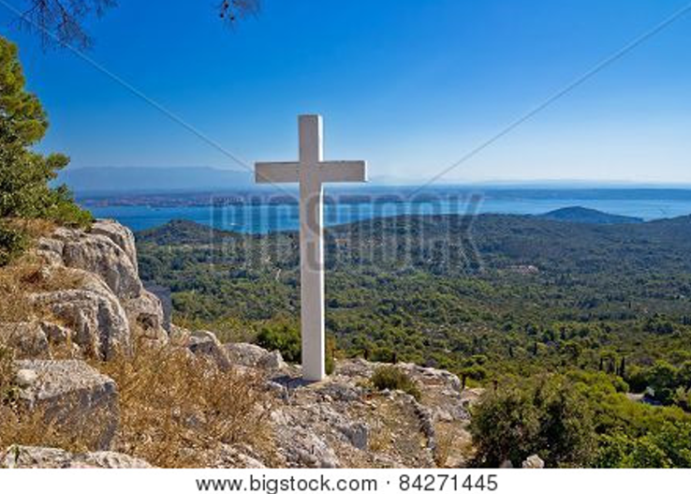

This includes you who were once far away from God.
You were his enemies, separated from him by your evil thoughts and actions.
Yet now he has reconciled you to himself through the death of Christ in his physical body.
As a result, he has brought you into his own presence, and you are holy and blameless as you stand before him without a single fault.

~ Colossians 1:21-22 (NLT)

Don’t you see how wonderfully kind, tolerant, and patient God is with you? Does this mean nothing to you?
Can’t you see that his kindness is intended to turn you from your sin?

~ Romans 2:4 (NLT)

All glory to him who loves us and has freed us from our sins by shedding his blood for us…
All glory and power to him forever and ever! Amen.

~ Revelation 1:5b-6 (NLT)

…From God’s Wrath

…Jesus, whom God raised from the dead…is the one who has rescued us from the terrors of the coming judgment.

~ 1 Thessalonians 1:10b (NLT)

For God did not appoint us to suffer wrath but to receive salvation through our Lord Jesus Christ.

~ 1 Thessalonians 5:9 (NIV)

Whoever believes in the Son has eternal life, but whoever rejects the Son will not see life, for God’s wrath remains on them.

~ John 3:36 (NIV)

For there is one God, and there is one mediator between God and men, the man Christ Jesus, who gave himself as a ransom for all…

~ 1 Timothy 2:5-6a (ESV)

…everyone who calls on the name of the Lord will be saved.

~ Acts 2:21 (NLT)

Since we have now been justified by his blood, how much more shall we be saved from God’s wrath through him!

~ Romans 5:9 (NIV)

In that day the people will proclaim,
“This is our God!
“We trusted in him, and he saved us!
“This is the Lord, in whom we trusted.
“Let us rejoice in the salvation he brings!”

~ Isaiah 25:9 (NLT)

…From Death

For the wages of sin is death, but the free gift of God is eternal life in Christ Jesus our Lord.

~ Romans 6:23 (ESV)

…God raised him from the dead, freeing him from the agony of death, because it was impossible for death to keep its hold on him.

~ Acts 2:24 (NIV)

…God, who raised the Lord Jesus, will also raise us…

~ 2 Corinthians 4:14a (NLT)

Because God’s children are human beings—made of flesh and blood—the Son also became flesh and blood.
For only as a human being could he die, and only by dying could he break the power of the devil, who had the power of death.

~ Hebrews 2:14 (NLT)

He broke the power of death and illuminated the way to life and immortality through the Good News.

~ 2 Timothy 1:10b (NLT)

When Adam sinned, sin entered the world. Adam’s sin brought death, so death spread to everyone…

~ Romans 5:12a (NLT)

Just as everyone dies because we all belong to Adam, everyone who belongs to Christ will be given new life.

~ 1 Corinthians 15:22 (NLT)

So just as sin ruled over all people and brought them to death, now God’s wonderful grace rules instead, giving us right standing with God and resulting in eternal life through Jesus Christ our Lord.

~ Romans 5:21 (NLT)

So now there is no condemnation for those who belong to Christ Jesus.
And because you belong to him, the power of the life-giving Spirit has freed you from the power of sin that leads to death.

~ Romans 8:1-2 (NLT)

Who then will condemn us?
No one—for Christ Jesus died for us and was raised to life for us, and he is sitting in the place of honor at God’s right hand, pleading for us.

~ Romans 8:34 (NLT)

“I am the Living One; I was dead, and now look, I am alive for ever and ever!
“And I hold the keys of death and Hades.”

~ Revelation 1:18 (NIV)

He delivered us from such a deadly peril, and he will deliver us.
On him we have set our hope that he will deliver us again.

~ 2 Corinthians 1:10 (ESV)

God Bought You at a Price

You are not your own; you were bought at a price.

~ 1 Corinthians 6:19b-20a (NIV)



…God paid a ransom to save you from the empty life you inherited from your ancestors.
And it was not paid with mere gold or silver…
It was the precious blood of Christ, the sinless, spotless Lamb of God.
God chose him as your ransom long before the world began…

~ 1 Peter 1:18b-20a (NLT)

…without the shedding of blood there is no forgiveness of sins.

~ Hebrews 9:22b (ESV)

…without holiness no one will see the Lord.

~ Hebrews 12:14b (NIV)

And so Jesus also suffered outside the city gate to make the people holy through his own blood.

~ Hebrews 13:12 (NIV)

For the joy set before him he endured the cross...

~ Hebrews 12:2b (NIV)

With his own blood…he entered the Most Holy Place once for all time and secured our redemption forever.

~ Hebrews 9:12 (NLT)

He was despised and rejected by mankind, a man of suffering, and familiar with pain…
Surely he took up our pain and bore our suffering, yet we considered him punished by God, stricken by him, and afflicted.
But he was pierced for our transgressions, he was crushed for our iniquities; the punishment that brought us peace was on him, and by his wounds we are healed.
We all, like sheep, have gone astray, each of us has turned to our own way; and the Lord has laid on him the iniquity of us all.
He was oppressed and afflicted, yet he did not open his mouth; he was led like a lamb to the slaughter, and as a sheep before its shearers is silent, so he did not open his mouth.
By oppression and judgment he was taken away.
Yet who of his generation protested?
For he was cut off from the land of the living; for the transgression of my people he was punished.
He was assigned a grave with the wicked, and with the rich in his death, though he had done no violence, nor was any deceit in his mouth.
Yet it was the Lord’s will to crush him and cause him to suffer, and though the Lord makes his life an offering for sin…
After he has suffered, he will see the light of life and be satisfied; by his knowledge my righteous servant will justify many, and he will bear their iniquities…because he poured out his life unto death, and was numbered with the transgressors.
For he bore the sin of many, and made intercession for the transgressors.

~ Excerpts from Isaiah 53 (NIV)

The Gospel

I want you to know, brothers and sisters, that the gospel I preached is not of human origin.

~ Galatians 1:11 (NIV)

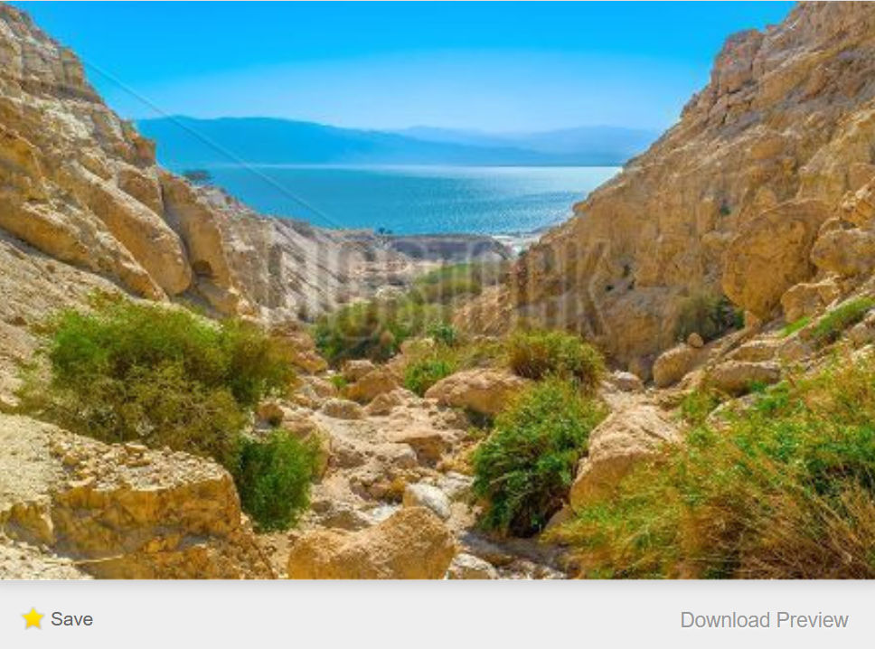
Bigstock Photo ID: 138520277

Now, brothers and sisters, I want to remind you of the gospel I preached to you, which you received and on which you have taken your stand.
By this gospel you are saved, if you hold firmly to the word I preached to you.
Otherwise, you have believed in vain.
For what I received I passed on to you as of first importance: that Christ died for our sins according to the Scriptures, that he was buried, that he was raised on the third day according to the Scriptures, and that he appeared to Cephas, and then to the Twelve.
After that, he appeared to more than five hundred of the brothers and sisters at the same time, most of whom are still living, though some have fallen asleep. Then he appeared to James, then to all the apostles, and last of all he appeared to me…

~ 1 Corinthians 15:1-8a (NIV)

Then Peter stood up with the Eleven, raised his voice and addressed the crowd…
“Fellow Israelites, listen to this: Jesus of Nazareth was a man accredited by God to you by miracles, wonders and signs, which God did among you through him, as you yourselves know.
“This man was handed over to you by God’s deliberate plan and foreknowledge; and you, with the help of wicked men, put him to death by nailing him to the cross.
“But God raised him from the dead, freeing him from the agony of death, because it was impossible for death to keep its hold on him…
“God has raised this Jesus to life, and we are all witnesses of it.
“Exalted to the right hand of God, he has received from the Father the promised Holy Spirit and has poured out what you now see and hear…
“Therefore let all Israel be assured of this: God has made this Jesus, whom you crucified, both Lord and Messiah.”
When the people heard this, they were cut to the heart and said to Peter and the other apostles, “Brothers, what shall we do?”
Peter replied, “Repent and be baptized, every one of you, in the name of Jesus Christ for the forgiveness of your sins.
“And you will receive the gift of the Holy Spirit.”

~ Acts 2:14-38 (NIV)

But even if we, or an angel from heaven, preach any other gospel to you than what we have preached to you, let him be accursed.

~ Galatians 1:8 (NKJV)

For the time will come when people will not put up with sound doctrine.
Instead, to suit their own desires, they will gather around them a great number of teachers to say what their itching ears want to hear. They will turn their ears away from the truth and turn aside to myths.

~ 2 Timothy 4:3-4 (NIV)

In Christ You are Forgiven

“Come now, and let us reason together,” says the Lord:
“though your sins are like scarlet,
“they shall be as white as snow…”

~ Isaiah 1:18a (NKJV)



For everyone has sinned; we all fall short of God’s glorious standard.
Yet God, in his grace, freely makes us right in his sight.
He did this through Christ Jesus when he freed us from the penalty for our sins.

~ Romans 3:23-24 (NLT)

Oh, what joy for those whose disobedience is forgiven, whose sins are put out of sight.
Yes, what joy for those whose record the Lord has cleared of sin.

~ Romans 4:7-8 (NLT)

Therefore, my friends, I want you to know that through Jesus the forgiveness of sins is proclaimed to you.

~ Acts 13:38 (NIV)

For he has rescued us from the dominion of darkness and brought us into the kingdom of the Son he loves, in whom we have redemption, the forgiveness of sins.

~ Colossians 1:13-14 (NIV)

For with the Lord there is mercy, and with Him is abundant redemption.

~ Psalm 130:7b (NKJV)

Praise the Lord, my soul, and forget not all his benefits—who forgives all your sins and heals all your diseases, who redeems your life from the pit and crowns you with love and compassion…
For as high as the heavens are above the earth, so great is his love for those who fear him;
As far as the east is from the west, so far has he removed our transgressions from us.

~ Psalm 103:2-4, 11-12 (NIV)

Follow God’s example, therefore, as dearly loved children and walk in the way of love, just as Christ loved us and gave himself up for us as a fragrant offering and sacrifice to God.

~ Ephesians 5:1-2 (NIV)

Imitate God, therefore, in everything you do, because you are his dear children.
Live a life filled with love, following the example of Christ.
He loved us and offered himself as a sacrifice for us, a pleasing aroma to God.

~ Ephesians 5:1-2 (NLT)

Be kind and compassionate to one another, forgiving each other, just as in Christ God forgave you.

~ Ephesians 4:32 (NIV)

God Demonstrates His Love Through Christ

“For God so loved the world that He gave His only begotten Son, that whoever believes in Him should not perish but have everlasting life.”

~ John 3:16 (NKJV)

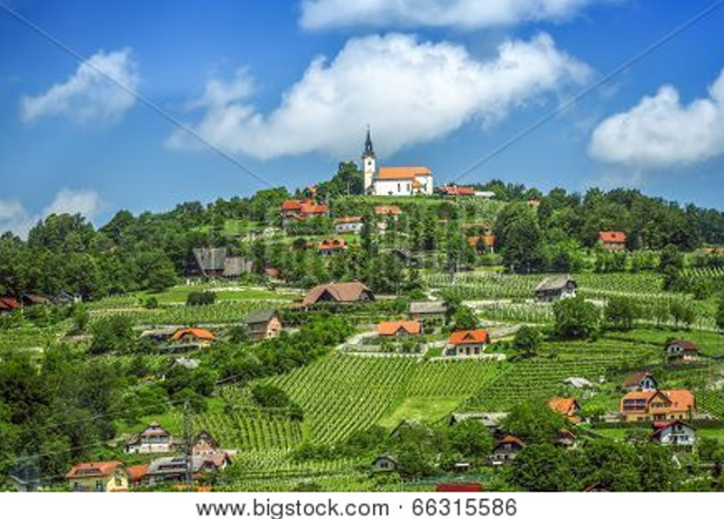

Who shall separate us from the love of Christ?
Shall trouble or hardship or persecution or famine or nakedness or danger or sword?...
No, in all these things we are more than conquerors through him who loved us.
For I am convinced that
neither death nor life,
neither angels nor demons,
neither the present nor the future,
nor any powers,
neither height nor depth,
nor anything else in all creation,
will be able to separate us from the love of God that is in Christ Jesus our Lord.

~ Romans 8:35-39 (NIV)

This is love: not that we loved God, but that he loved us and sent his Son as an atoning sacrifice for our sins.

~ 1 John 4:10 (NIV)

…God demonstrates His own love toward us, in that while we were still sinners, Christ died for us.

~ Romans 5:8 (NKJV)

In this the love of God was made manifest among us, that God sent his only Son into the world, so that we might live through him.

~ 1 John 4:9 (ESV)

The life I now live in the body, I live by faith in the Son of God, who loved me and gave himself for me.

~ Galatians 2:20b (NIV)

Therefore, since we have been made right in God’s sight by faith, we have peace with God because of what Jesus Christ our Lord has done for us.
Because of our faith, Christ has brought us into this place of undeserved privilege where we now stand, and we confidently and joyfully look forward to sharing God’s glory.

~ Romans 5:1-2 (NLT)

The grace of our Lord was poured out on me abundantly, along with the faith and love that are in Christ Jesus.

~ 1 Timothy 1:14 (NIV)

And I pray that you, being rooted and established in love, may have power, together with all the Lord’s holy people, to grasp how wide and long and high and deep is the love of Christ, and to know this love that surpasses knowledge—that you may be filled to the measure of all the fullness of God.

~ Ephesians 3:17b-19 (NIV)

May our Lord Jesus Christ himself and God our Father, who loved us and by his grace gave us eternal encouragement and good hope, encourage your hearts and strengthen you in every good deed and word.
~ 2 Thessalonians 2:16-17 (NIV)

Salvation is Through Christ Alone

Salvation is found in no one else, for there is no other name under heaven given to mankind by which we must be saved.

~ Acts 4:12 (NIV)



“For God did not send His Son into the world to condemn the world, but that the world through Him might be saved.”

~ John 3:17 (NKJV)

…he became the source of eternal salvation to all who obey him…

~ Hebrews 5:9b (ESV)

…God exalted him to the highest place and gave him the name that is above every name, that at the name of Jesus every knee should bow, in heaven and on earth and under the earth, and every tongue acknowledge that Jesus Christ is Lord…

~ Philippians 2:9-11a (NIV)

Because of Christ and our faith in him, we can now come boldly and confidently into God’s presence.

~ Ephesians 3:12 (NLT)

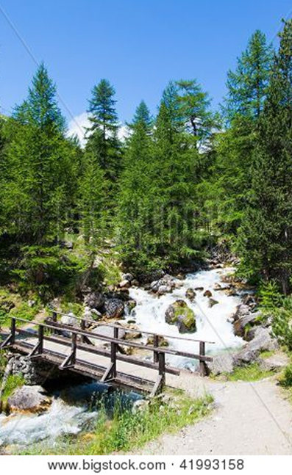

…because Jesus lives forever…he is able, once and forever, to save those who come to God through him.
He lives forever to intercede with God on their behalf.

~ Hebrews 7:24-25 (NLT)

We are made right with God by placing our faith in Jesus Christ.

~ Romans 3:22a (NLT)

Jesus said to him, “I am the way, the truth, and the life. No one comes to the Father except through Me.”

~ John 14:6 (NKJV)

“Most assuredly, I say to you, he who believes in Me has everlasting life.”

~ John 6:47 (NKJV)

“I have come as a light to shine in this dark world, so that all who put their trust in me will no longer remain in the dark.”

~ John 12:46 (NLT)

Then Jesus said, “Come to me, all of you who are weary and carry heavy burdens, and I will give you rest.”

~ Matthew 11:28 (NLT)

“No one can come to Me unless the Father who sent Me draws him...”

~ John 6:44a (NKJV)

“…whoever comes to me I will never drive away.”

~ John 6:37b (NIV)

“Let the little children come to me and do not hinder them, for to such belongs the kingdom of heaven.”

~ Matthew 19:14b (ESV)

“…your Father in heaven is not willing that any of these little ones should perish.”

~ Matthew 18:14b (NIV)

“Truly I tell you, anyone who will not receive the kingdom of God like a little child will never enter it.”

~ Luke 18:17 (NIV)

“Let anyone who is thirsty come to me and drink.
“Whoever believes in me, as Scripture has said, rivers of living water will flow from within them.”

~ John 7:37b-38 (NIV)

And Jesus said to them, “I am the bread of life.
“He who comes to Me shall never hunger, and he who believes in Me shall never thirst.”

~ John 6:35 (NKJV)

“You can enter God’s Kingdom only through the narrow gate.”

~ Matthew 7:13a (NLT)

“Enter through the narrow gate.
“For wide is the gate and broad is the road that leads to destruction, and many enter through it.
“But small is the gate and narrow the road that leads to life, and only a few find it.”

~ Matthew 7:13-14 (NIV)

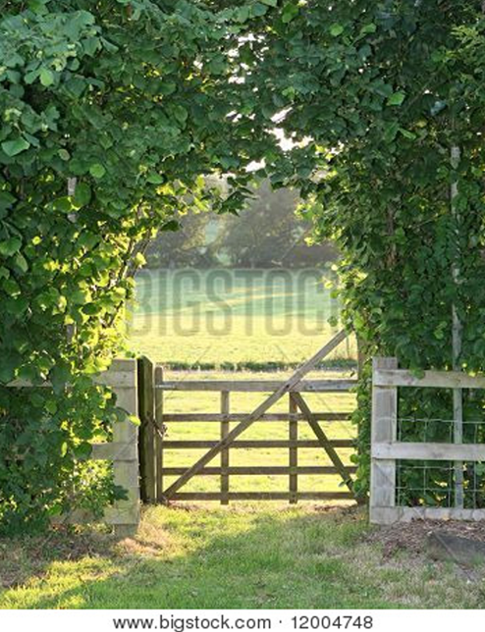

“I am the door. If anyone enters by Me, he will be saved, and will go in and out and find pasture.”

~ John 10:9 (NKJV)

“Very truly I tell you, I am the gate for the sheep.
“All who have come before me are thieves and robbers, but the sheep have not listened to them.
“I am the gate; whoever enters through me will be saved. They will come in and go out, and find pasture.”

~ John 10:7b-9 (NIV)

“The thief comes only to steal and kill and destroy.
“I came that they may have life and have it abundantly.”

~ John 10:10 (ESV)

“I have come that they may have life, and have it to the full.”

~ John 10:10b (NIV)

“My sheep listen to my voice. I know them, and they follow me.
“I give them eternal life, and they will never perish.
“No one can snatch them away from me…”

~ John 10:27-28 (NLT)

“For the Son of Man came to seek and to save the lost.”

~ Luke 19:10 (ESV)

“…I came not to judge the world, but to save the world.”

~ John 12:47b (KJV)

“And this is the will of God, that I should not lose even one of all those he has given me, but that I should raise them up at the last day.”

~ John 6:39 (NLT)

“And I, when I am lifted up from the earth, will draw all people to myself.”

~ John 12:32 (ESV)

Jesus said to her, “I am the resurrection and the life. Whoever believes in me, though he die, yet shall he live, and everyone who lives and believes in me shall never die.”

~ John 11:25-26a (ESV)

“And be sure of this: I am with you always, even to the end of the age.”

~ Matthew 28:20b (NLT)

Salvation is a Gift: Free and Undeserved

For it is by grace you have been saved, through faith—and this not from yourselves, it is the gift of God—not by works, so that no one can boast.

~ Ephesians 2:8-9 (NIV)

Salvation is not a reward for the good things we have done…

~ Ephesians 2:9 (NLT)

…he saved us, not because of the righteous things we had done, but because of his mercy…
Because of his grace he declared us righteous and gave us confidence that we will inherit eternal life.

~ Titus 3:5-7 (NLT)

And since it is through God’s kindness, then it is not by their good works.
For in that case, God’s grace would not be what it really is—free and undeserved.

~ Romans 11:6 (NLT)

For God saved us and called us to live a holy life.
He did this, not because we deserved it, but because that was his plan from before the beginning of time…

~ 2 Timothy 1:9a (NLT)

Can we boast, then, that we have done anything to be accepted by God?
No, because our acquittal is not based on obeying the law. It is based on faith.

~ Romans 3:27 (NLT)

“The Spirit alone gives eternal life. Human effort accomplishes nothing.”

~ John 6:63a (NLT)

But because of his great love for us, God, who is rich in mercy, made us alive with Christ even when we were dead in transgressions—it is by grace you have been saved.

~ Ephesians 2:4-5 (NIV)

Accept This Gift of Salvation

Whoever believes in the Son has eternal life…

~ John 3:36a (NIV)



If you declare with your mouth, “Jesus is Lord,” and believe in your heart that God raised him from the dead, you will be saved.

~ Romans 10:9 (NIV)

For it is by believing in your heart that you are made right with God, and it is by openly declaring your faith that you are saved.

~ Romans 10:10 (NLT)

“A farmer went out to sow his seed.
“As he was scattering the seed, some fell along the path; it was trampled on, and the birds ate it up.
“Some fell on rocky ground, and when it came up, the plants withered because they had no moisture.
“Other seed fell among thorns, which grew up with it and choked the plants.
“Still other seed fell on good soil. It came up and yielded a crop, a hundred times more than was sown…
“This is the meaning of the parable: The seed is the word of God.
“Those along the path are the ones who hear, and then the devil comes and takes away the word from their hearts, so that they may not believe and be saved.
“Those on the rocky ground are the ones who receive the word with joy when they hear it, but they have no root. They believe for a while, but in the time of testing they fall away.
“The seed that fell among thorns stands for those who hear, but as they go on their way they are choked by life’s worries, riches and pleasures, and they do not mature.
“But the seed on good soil stands for those with a noble and good heart, who hear the word, retain it, and by persevering produce a crop.”

~ Luke 8:5-8a, 11-15 (NIV)



“Whoever believes in him is not condemned, but whoever does not believe stands condemned already because they have not believed in the name of God’s one and only Son.
“This is the verdict: Light has come into the world, but people loved darkness instead of light because their deeds were evil.”

~ John 3:18-19 (NIV)

…God says, “At just the right time, I heard you. On the day of salvation, I helped you.”
Indeed, the “right time” is now.
Today is the day of salvation.

~ 2 Corinthians 6:2 (NLT)

If we confess our sins, he is faithful and just to forgive us our sins and to cleanse us from all unrighteousness.

~ 1 John 1:9 (ESV)

…how shall we escape if we ignore so great a salvation?

~ Hebrews 2:3a (NIV)

God’s promise of entering his rest still stands, so we ought to tremble with fear that some of you might fail to experience it.

~ Hebrews 4:1 (NLT)

What are you waiting for? Get up and be baptized.
Have your sins washed away by calling on the name of the Lord.

~ Acts 22:16 (NLT)

This is all the more urgent, for you know how late it is; time is running out…
The night is almost gone; the day of salvation will soon be here.

~ Romans 13:11-12a (NLT)

But you must continue to believe this truth and stand firmly in it.

Don’t drift away from the assurance you received when you heard the Good News.

~ Colossians 1:23a (NLT)

For if we are faithful to the end, trusting God just as firmly as when we first believed, we will share in all that belongs to Christ.

~ Hebrews 3:14 (NLT)

You Belong to God Through Faith in Christ and Have Become His Child

Even before he made the world, God loved us and chose us in Christ to be holy and without fault in his eyes.
God decided in advance to adopt us into his own family by bringing us to himself through Jesus Christ.
This is what he wanted to do, and it gave him great pleasure.

~ Ephesians 1:4-5 (NLT)

See what great love the Father has lavished on us, that we should be called children of God!

~ 1 John 3:1a (NIV)

…to all who believed him and accepted him, he gave the right to become children of God.

~ John 1:12 (NLT)

…he has purchased us to be his own people. He did this so we would praise and glorify him.

~ Ephesians 1:14b (NLT)

So we praise God for the glorious grace he has poured out on us who belong to his dear Son.

~ Ephesians 1:6 (NLT)

Praise God for the privilege of being called by his name!

~ 1 Peter 4:16b (NLT)

Dear friends, we are already God’s children, but he has not yet shown us what we will be like when Christ appears.

~ 1 John 3:2a (NLT)

We know that we are children of God and that the world around us is under the control of the evil one.

~ 1 John 5:19 (NLT)

Anyone who does not have the Spirit of Christ does not belong to him.

~ Romans 8:9b (ESV)

Everyone who believes that Jesus is the Christ has become a child of God.

~ 1 John 5:1a (NLT)

…you belong to Christ, and Christ belongs to God.

~ 1 Corinthians 3:23 (NLT)

…you are all children of God through faith in Christ Jesus.

~ Galatians 3:26 (NLT)

And since you are his child, God has made you his heir.

~ Galatians 4:7b (NLT)

Now if we are children, then we are heirs—heirs of God and co-heirs with Christ, if indeed we share in his sufferings in order that we may also share in his glory.

~ Romans 8:17 (NIV)



“If you belonged to the world, it would love you as its own.
“As it is, you do not belong to the world, but I have chosen you out of the world.”

~ John 15:19a (NIV)

You can be sure of this: The Lord set apart the godly for himself.

~ Psalm 4:3a (NLT)

…you are a people holy to the Lord your God.
The Lord your God has chosen you out of all the peoples on the face of the earth to be his people, his treasured possession.

~ Deuteronomy 7:6 (NIV)

And now that you belong to Christ, you are the true children of Abraham.
You are his heirs, and God’s promise to Abraham belongs to you.

~ Galatians 3:29 (NLT)

And now you Gentiles have also heard the truth, the Good News that God saves you.
And when you believed in Christ, he identified you as his own by giving you the Holy Spirit, whom he promised long ago.

~ Ephesians 1:13 (NLT)

When you believed, you were marked in him with a seal, the promised Holy Spirit…

~ Ephesians 1:13b (NIV)

For we know, brothers and sisters loved by God, that he has chosen you, because our gospel came to you not simply with words but also with power, with the Holy Spirit and deep conviction.

~ 1 Thessalonians 1:4-5a (NIV)

He anointed us, set his seal of ownership on us, and put his Spirit in our hearts as a deposit, guaranteeing what is to come.

~ 2 Corinthians 1:21b-22 (NIV)

He has commissioned us, and he has identified us as his own by placing the Holy Spirit in our hearts as the first installment that guarantees everything he has promised us.

~ 2 Corinthians 1:21b-22 (NLT)

…you are a chosen generation,
a royal priesthood,
a holy nation,
His own special people,
that you may proclaim the praises of Him who called you out of darkness into His marvelous light…

~ 1 Peter 2:9 (NKJV)



And now I entrust you to God and the message of his grace that is able to build you up and give you an inheritance with all those he has set apart for himself.

~ Acts 20:32 (NLT)

So, whether we live or die, we belong to the Lord.

~ Romans 14:8b (NIV)

Eternal Life is Yours Through Christ

[Jesus] said to them: “…you will receive power when the Holy Spirit comes on you; and you will be my witnesses in Jerusalem, and in all Judea and Samaria, and to the ends of the earth.”
After he said this, he was taken up before their very eyes, and a cloud hid him from their sight.
They were looking intently up into the sky as he was going, when suddenly two men dressed in white stood beside them.
“Men of Galilee,” they said, “why do you stand here looking into the sky? This same Jesus, who has been taken from you into heaven, will come back in the same way you have seen him go into heaven.”

~ Acts 1:7-11 (NIV)

It will happen in a moment, in the blink of an eye, when the last trumpet is blown.
For when the trumpet sounds, those who have died will be raised to live forever.
And we who are living will also be transformed.

~ 1 Corinthians 15:52 (NLT)



For the Lord himself will come down from heaven, with a loud command, with the voice of the archangel and with the trumpet call of God, and the dead in Christ will rise first.
After that, we who are still alive and are left will be caught up together with them in the clouds to meet the Lord in the air.
And so we will be with the Lord forever.
Therefore encourage one another with these words.

~ 1 Thessalonians 4:16-18 (NIV)

When Christ who is your life appears, then you also will appear with him in glory.
~ Colossians 3:4 (ESV)

“For my Father’s will is that everyone who looks to the Son and believes in him shall have eternal life, and I will raise them up at the last day.”

~ John 6:40 (NIV)

Those who have been ransomed by the Lord will return.
They will enter Jerusalem singing, crowned with everlasting joy.
Sorrow and mourning will disappear, and they will be filled with joy and gladness.

~ Isaiah 51:11 (NLT)

But those who die in the Lord will live; their bodies will rise again!
Those who sleep in the earth will rise up and sing for joy!

~ Isaiah 26:19a (NLT)

He will take our weak mortal bodies and change them into glorious bodies like his own...

~ Philippians 3:21a (NLT)

I pray that your hearts will be flooded with light so that you can understand the confident hope he has given to those he called…

~ Ephesians 1:18a (NLT)

I pray that the eyes of your heart may be enlightened in order that you may know the hope to which he has called you, the riches of his glorious inheritance in his holy people, and his incomparably great power for us who believe.
That power is the same as the mighty strength he exerted when he raised Christ from the dead and seated him at his right hand in the heavenly realms, far above all rule and authority, power and dominion, and every name that is invoked, not only in the present age but also in the one to come.

~ Ephesians 1:18-21 (NIV)

May you be filled with joy, always thanking the Father.
He has enabled you to share in the inheritance that belongs to his people, who live in the light.

~ Colossians 1:11b-12 (NLT)

God gave us eternal life, and this life is in his Son...
I write these things to you who believe in the name of the Son of God that you may know that you have eternal life.

~ 1 John 5:11b-13 (ESV)

For you have been born again, but not to a life that will quickly end.
Your new life will last forever because it comes from the eternal, living word of God.

~ 1 Peter 1:23 (NLT)

For our light and momentary troubles are achieving for us an eternal glory that far outweighs them all.
So we fix our eyes not on what is seen, but on what is unseen,
since what is seen is temporary, but what is unseen is eternal.

~ 2 Corinthians 4:17-18 (NIV)

He will keep you strong to the end so that you will be free from all blame on the day when our Lord Jesus Christ returns.

~ 1 Corinthians 1:8 (NLT)

…keep yourselves in God’s love as you wait for the mercy of our Lord Jesus Christ to bring you to eternal life.

~ Jude 1:21 (NIV)

…in hope of eternal life which God, who cannot lie, promised before time began…

~ Titus 1:2 (NKJV)

He has planted eternity in the human heart...

~ Ecclesiastes 3:11b (NLT)

“All who are victorious will be clothed in white.
“I will never erase their names from the Book of Life, but I will announce before my Father and his angels that they are mine.”

~ Revelation 3:5 (NLT)

“The one who is victorious will not be hurt at all by the second death.”

~ Revelation 2:11b (NIV)

“To the one who is victorious, I will give the right to eat from the tree of life, which is in the paradise of God.”

~ Revelation 2:7b (NIV)



“To the one who is victorious, I will give the right to sit with me on my throne, just as I was victorious and sat down with my Father on his throne.”

~ Revelation 3:21 (NIV)

“All who are victorious will inherit all these blessings, and I will be their God, and they will be my children.”

~ Revelation 21:7 (NLT)

And I saw a great white throne and the one sitting on it.
The earth and sky fled from his presence, but they found no place to hide.
I saw the dead, both great and small, standing before God’s throne.
And the books were opened, including the Book of Life…
And anyone whose name was not found recorded in the Book of Life was thrown into the lake of fire.

~ Revelation 20:11-15 (NLT)

Then I saw a new heaven and a new earth, for the first heaven and the first earth had passed away, and the sea was no more.
And I saw the holy city, new Jerusalem, coming down out of heaven from God, prepared as a bride adorned for her husband.
And I heard a loud voice from the throne saying, “Behold, the dwelling place of God is with man. He will dwell with them, and they will be his people, and God himself will be with them as their God…
“He will wipe away every tear from their eyes, and death shall be no more, neither shall there be mourning, nor crying, nor pain anymore, for the former things have passed away.”
And he who was seated on the throne said, “Behold, I am making all things new…I am the Alpha and the Omega, the beginning and the end. To the thirsty I will give from the spring of the water of life without payment. The one who conquers will have this heritage, and I will be his God and he will be my son.
“But as for the cowardly, the faithless, the detestable, as for murderers, the sexually immoral, sorcerers, idolaters, and all liars, their portion will be in the lake that burns with fire and sulfur, which is the second death.”
Then came one of the seven angels who had the seven bowls full of the seven last plagues and spoke to me, saying, “Come, I will show you the Bride, the wife of the Lamb.”
And he carried me away in the Spirit to a great, high mountain, and showed me the holy city Jerusalem coming down out of heaven from God, having the glory of God, its radiance like a most rare jewel, like a jasper, clear as crystal. It had a great, high wall, with twelve gates…
And the twelve gates were twelve pearls, each of the gates made of a single pearl, and the street of the city was pure gold, like transparent glass.
And I saw no temple in the city, for its temple is the Lord God the Almighty and the Lamb…
But nothing unclean will ever enter it, nor anyone who does what is detestable or false, but only those who are written in the Lamb’s book of life.

~ Excerpts from Revelation 21 (ESV)

Then the angel showed me the river of the water of life, as clear as crystal, flowing from the throne of God and of the Lamb down the middle of the great street of the city…
The angel said to me, “These words are trustworthy and true...Do not seal up the words of the prophecy of this scroll, because the time is near.
“Let the one who does wrong continue to do wrong; let the vile person continue to be vile; let the one who does right continue to do right; and let the holy person continue to be holy.
“Look, I am coming soon! My reward is with me, and I will give to each person according to what they have done.
“I am the Alpha and the Omega, the First and the Last, the Beginning and the End.
“Blessed are those who wash their robes, that they may have the right to the tree of life and may go through the gates into the city.
“Outside are the dogs, those who practice magic arts, the sexually immoral, the murderers, the idolaters and everyone who loves and practices falsehood.
“I, Jesus, have sent my angel to give you this testimony for the churches…”
Let the one who is thirsty come; and let the one who wishes take the free gift of the water of life.

~ Revelation 22:1-17 (NIV)

Praise God for His Gift of Eternal Life

Praise be to the God and Father of our Lord Jesus Christ, who has blessed us in the heavenly realms with every spiritual blessing in Christ.

~ Ephesians 1:3 (NIV)

So we praise God for the glorious grace he has poured out on us who belong to his dear Son.

~ Ephesians 1:6 (NLT)

Thanks be to God for His indescribable gift!

~ 2 Corinthians 9:15 (NKJV)

Thank God for this gift too wonderful for words!

~ 2 Corinthians 9:15 (NLT)

Rejoice in the Lord always. I will say it again: Rejoice!

~ Philippians 4:4 (NIV)



...rejoice in all the good things the Lord your God has given to you and your household.

~ Deuteronomy 26:11 (NIV)

Praise God for His Greatness

Lord, there is no one like you!
For you are great, and your name is full of power.

~ Jeremiah 10:6 (NLT)

Yours, O Lord, is the greatness, the power, the glory, the victory, and the majesty.
Everything in the heavens and on earth is yours, O Lord, and this is your kingdom.
We adore you as the one who is over all things.

~ 1 Chronicles 29:11 (NLT)

Praise God for His Goodness

How great is the goodness you have stored up for those who fear you.
You lavish it on those who come to you for protection, blessing them before the watching world.

~ Psalm 31:19 (NLT)

For you, O Lord, are good and forgiving, abounding in steadfast love to all who call upon you.

~ Psalm 86:5 (ESV)

…so full of unfailing love for all who ask for your help.

~ Psalm 86:5b (NLT)

…abundant in mercy to all those who call upon You.

~ Psalm 86:5b (NKJV)

I Will Give Thanks to You, Lord

I will give thanks to you, Lord, with all my heart;
I will tell of all your wonderful deeds.

~ Psalm 9:1 (NIV)

I will be filled with joy because of you.
I will sing praises to your name, O Most High.

~ Psalm 9:2 (NLT)

I will praise thee, O Lord my God, with all my heart: and
I will glorify thy name for evermore.

~ Psalm 86:12 (KJV)

Praise the Lord, my soul; all my inmost being, praise his holy name.
Praise the Lord, my soul, and forget not all his benefits—who forgives all your sins and heals all your diseases, who redeems your life from the pit and crowns you with love and compassion, who satisfies your desires with good things so that your youth is renewed like the eagle’s…
The Lord is compassionate and gracious, slow to anger, abounding in love.
He will not always accuse, nor will he harbor his anger forever;
he does not treat us as our sins deserve or repay us according to our iniquities.
For as high as the heavens are above the earth, so great is his love for those who fear him;
As far as the east is from the west, so far has he removed our transgressions from us.
As a father has compassion on his children, so the Lord has compassion on those who fear him; for he knows how we are formed, he remembers that we are dust.
The life of mortals is like grass, they flourish like a flower of the field; the wind blows over it and it is gone, and its place remembers it no more.
But from everlasting to everlasting the Lord’s love is with those who fear him, and his righteousness with their children’s children...
Praise the Lord, all his works everywhere in his dominion.
Praise the Lord, my soul.
~ Psalm 103 (NIV)

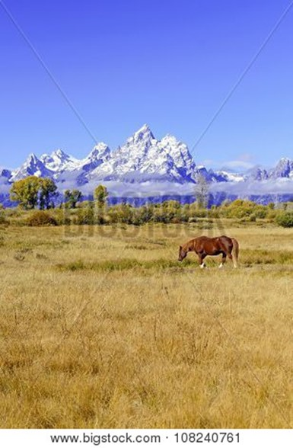

Shout for joy to the Lord, all the earth.
Worship the Lord with gladness; come before him with joyful songs.
Know that the Lord is God. It is he who made us, and we are his; we are his people, the sheep of his pasture.
Enter his gates with thanksgiving and his courts with praise; give thanks to him and praise his name.
For the Lord is good and his love endures forever; his faithfulness continues through all generations.
~ Psalm 100 (NIV)

Heaven is Your Home

Jesus answered, “My kingdom is not of this world.”

~ John 18:36a (ESV)

“The kingdom of heaven is like treasure hidden in a field.
“When a man found it, he hid it again, and then in his joy went and sold all he had and bought that field.”

~ Matthew 13:44 (NIV)

“…rejoice because your names are written in heaven.”

~ Luke 10:20b (NKJV)

“And people will come from all over the world—from east and west, north and south—to take their places in the Kingdom of God.
“And note this: Some who seem least important now will be the greatest then, and some who are the greatest now will be least important then.”

~ Luke 13:29-30 (NLT)

All your works praise you, Lord; your faithful people extol you.
They tell of the glory of your kingdom and speak of your might, so that all people may know of your mighty acts and the glorious splendor of your kingdom.
Your kingdom is an everlasting kingdom, and your dominion endures through all generations.

~ Psalm 145:10-13a (NIV)

His dominion is an everlasting dominion that will not pass away, and his kingdom is one that will never be destroyed.

~ Daniel 7:14b (NIV)

…we are receiving a kingdom that cannot be shaken

~ Hebrews 12:28b (NIV)

Since we are receiving a Kingdom that is unshakable, let us be thankful and please God by worshiping him with holy fear and awe.

~ Hebrews 12:28 (NLT)

Jesus answered him, “Truly I tell you, today you will be with me in paradise.”

~ Luke 23:43 (NIV)



“Blessed are those who are persecuted because of righteousness, for theirs is the kingdom of heaven…
“Rejoice and be glad, because great is your reward in heaven…

~ Matthew 5:10-12a (NIV)

“So don’t be afraid, little flock. For it gives your Father great happiness to give you the Kingdom.”

~ Luke 12:32 (NLT)

“In that day the wolf and the lamb will live together; the leopard will lie down with the baby goat…
“Nothing will hurt or destroy in all my holy mountain…”

~ Isaiah 11:6-9a (NLT)



…the creation looks forward to the day when it will join God’s children in glorious freedom from death and decay.

~ Romans 8:21 (NLT)

No eye has seen, no ear has heard, and no mind has imagined what God has prepared for those who love him.

~ 1 Corinthians 2:9b (NLT)

“Most assuredly, I say to you, he who hears My word and believes in Him who sent Me has everlasting life, and shall not come into judgment, but has passed from death into life.”

~ John 5:24 (NKJV)

Then He who sat on the throne said, “Behold, I make all things new.”

~ Revelation 21:5a (NKJV)

“See, I will create new heavens and a new earth.
“The former things will not be remembered, nor will they come to mind.
“But be glad and rejoice forever in what I will create, for I will create Jerusalem to be a delight and its people a joy.
“I will rejoice over Jerusalem and take delight in my people; the sound of weeping and of crying will be heard in it no more.”

~ Isaiah 65:17-19 (NIV)

In Jerusalem, the Lord of Heaven’s Armies will spread a wonderful feast for all the people of the world.
It will be a delicious banquet with clear, well-aged wine and choice meat.
There he will remove the cloud of gloom, the shadow of death that hangs over the earth.
He will swallow up death forever!
The Sovereign Lord will wipe away all tears…
The Lord has spoken!

~ Isaiah 25:6-8 (NLT)

“In My Father’s house are many mansions; if it were not so, I would have told you.
“I go to prepare a place for you.
“And if I go and prepare a place for you, I will come again and receive you to Myself; that where I am, there you may be also.”

~ John 14:2-3 (NKJV)

…our citizenship is in heaven, and from it we await a Savior, the Lord Jesus Christ...

~ Philippians 3:20 (ESV)

For here we have no lasting city, but we seek the city that is to come.

~ Hebrews 13:14 (ESV)

…we will have a house in heaven, an eternal body made for us by God himself and not by human hands.

~ 2 Corinthians 5:1b (NLT)



For if we are faithful to the end, trusting God just as firmly as when we first believed, we will share in all that belongs to Christ.

~ Hebrews 3:14 (NLT)

“And be sure of this: I am with you always, even to the end of the age.”
~ Matthew 28:20b (NLT)

Since you have been raised to new life with Christ, set your sights on the realities of heaven, where Christ sits in the place of honor at God’s right hand.
Think about the things of heaven, not the things of earth.

~ Colossians 3:1-2 (NLT)

“Do not store up for yourselves treasures on earth, where moths and vermin destroy, and where thieves break in and steal.
“But store up for yourselves treasures in heaven, where moths and vermin do not destroy, and where thieves do not break in and steal.
“For where your treasure is, there your heart will be also.”

~ Matthew 6:19-21 (NIV)

…make every effort to
add to your faith goodness;
and to goodness, knowledge;
and to knowledge, self-control;
and to self-control, perseverance;
and to perseverance, godliness;
and to godliness, mutual affection;
and to mutual affection, love.
For if you possess these qualities in increasing measure, they will keep you from being ineffective and unproductive in your knowledge of our Lord Jesus Christ….
For if you do these things, you will never stumble, and you will receive a rich welcome into the eternal kingdom of our Lord and Savior Jesus Christ.

~ 2 Peter 1:5b-11 (NIV)

Now we live with great expectation, and we have a priceless inheritance—an inheritance that is kept in heaven for you, pure and undefiled, beyond the reach of change and decay.

~ 1 Peter 1:3b-4 (NLT)

You make known to me the path of life;
you will fill me with joy in your presence,
with eternal pleasures at your right hand.

~ Psalm 16:11 (NIV)

Point out anything in me that offends you,
and lead me along the path of everlasting life.

~ Psalm 139:24 (NLT)

…and lead me in the way everlasting.

~ Psalm 139:24b (NIV)

Yet I still belong to you; you hold my right hand.
You guide me with your counsel, leading me to a glorious destiny.

~ Psalm 73:23-24 (NLT)



Surely you have granted him unending blessings
and made him glad with the joy of your presence.

~ Psalm 21:6 (NIV)

Surely goodness and mercy shall follow me all the days of my life;
and I will dwell in the house of the Lord forever.
~ Psalm 23:6 (NKJV)

Photo Copyright Info

Note: when purchasing the rights to use the photos, you may want to purchase an Extended License for the cover image.

Bigstock Photo ID: 91018313
Exotic bay view with boats and palm trees, Phuket area, Thailand ** Note: Soft Focus at 100%, best at smaller sizes
Stock Photo ID: 91018313
Copyright: ankamonika

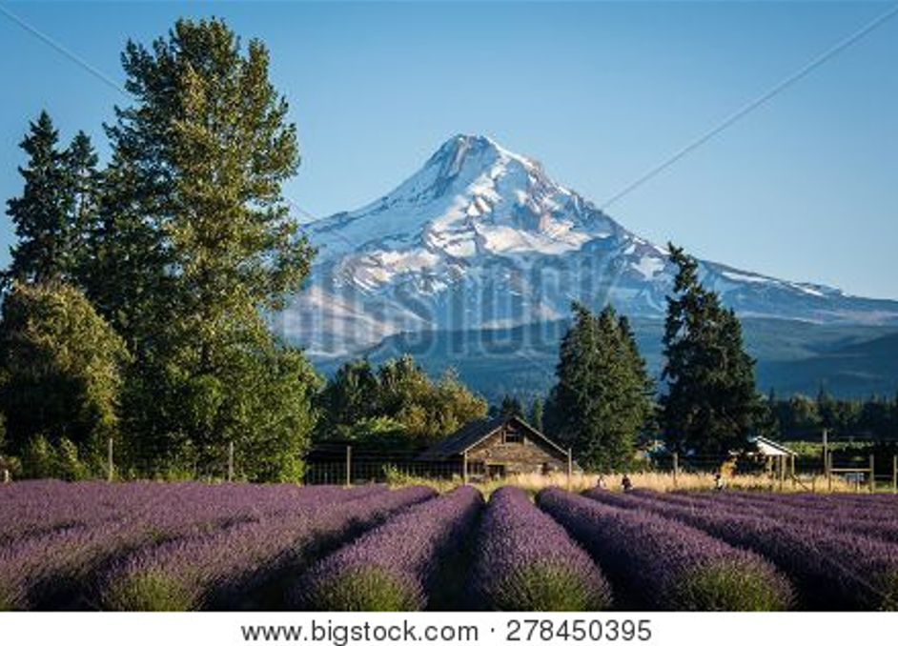
Bigstock Photo ID: 278450395
Lavender flower field near Mt. Hood in Oregon, with an abandoned barn.
Stock Photo ID: 278450395
Copyright: Melissa Kopka


Bigstock Photo ID: 7138221
Tropical Cascading Waterfall
A cascading tropical waterfall in Milla Milla Queensland Australia
Stock Photo ID: 7138221
Copyright: Johan Larson
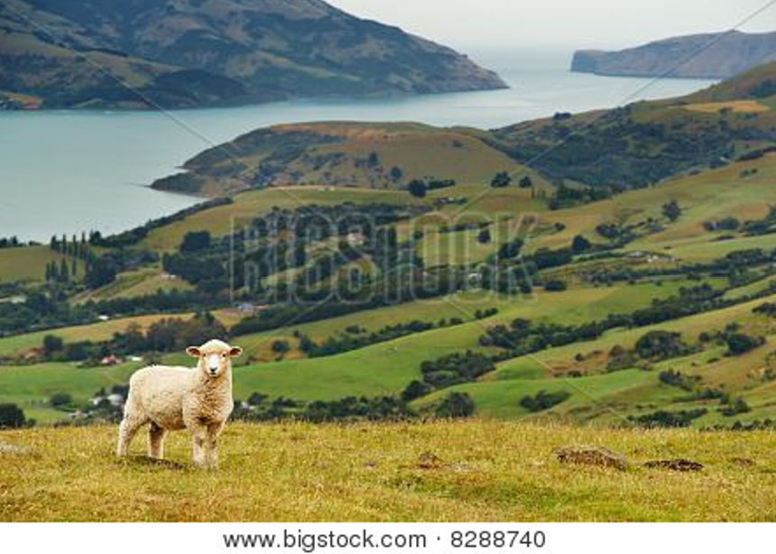
Bigstock Photo ID: 8288740
New Zealand Landscape
Rural landscape, farmland, Banks Peninsula, New Zealand
Stock Photo 8288740
Copyright: DmitryP

Bigstock Photo ID: 22751690
Mountain creek in the National Park Tercino valley in the mountains Novohradske-Czech Republic
Stock Photo 22751690
Copyright: volrab vaclav


Bigstock Photo ID: 18669857
morning english fog in a park, warm light
Stock Photo 18669857
Copyright: lenka


Bigstock Photo ID: 13184399
Plitvice Lakes, Waterfalls
Plitvice Lakes, one of the most beautiful natural phenomena in Europe. National Park of Croatia.
Stock Photo ID: 13184399
Copyright: Micond

Bigstock Photo ID: 20180846
Editing suggestion: Crop shadows out of bottom
Endless sand dunes at sunset - Murzuq Desert Sahara Libya
Stock Photo ID: 20180846
Copyright: Patrick Poendl
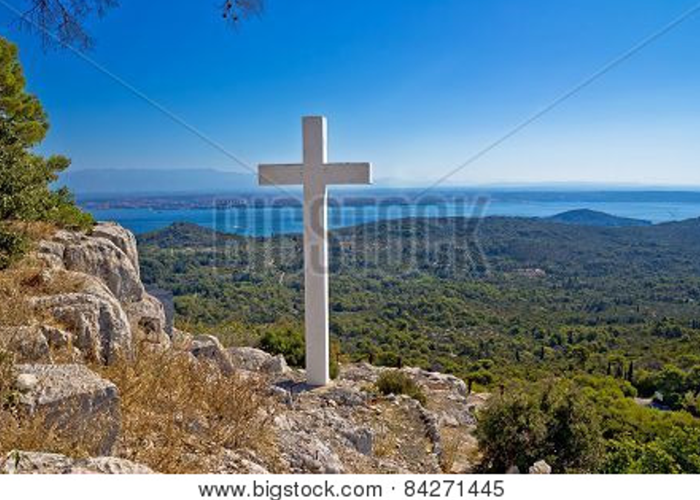
Bigstock Photo ID: 84271445
Editing suggestion: Crop distracting branches out of top of photo
Cross overlooking islands of Croatia top of Ugljan island in Dalmatia region
Stock Photo ID: 84271445
Copyright: xbrchx


Bigstock Photo ID: 177044989
Aerial view of Opunohu Cook’s Bay and lagoon in Moorea Island. French Polynesia
Stock Photo ID: 177044989
Copyright: daboost

Bigstock Photo ID: 138520277
The green oasis in gorge among the Judean desert with the Dead Sea on background Israel.
Stock Photo ID: 138520277
Copyright: efesenko


Bigstock Photo ID: 70327675
Winter Forest
Winter's Tale. beautiful landscape places in Europe.
Stock Photo ID: 70327675
Copyright: Aliaksei Skreidzeleu

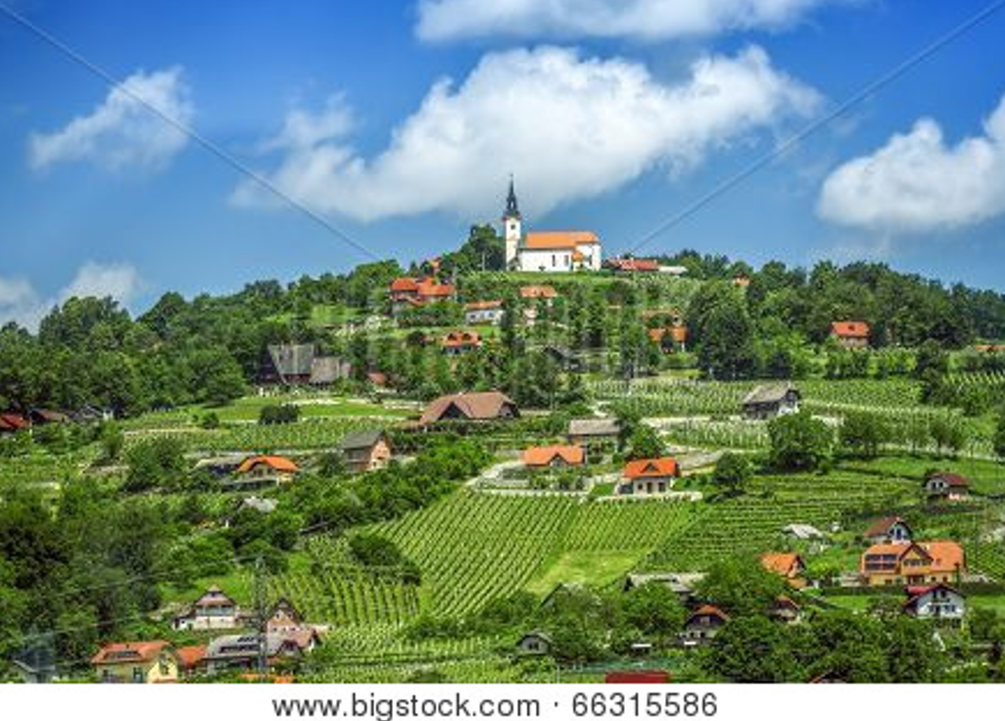
Bigstock Photo ID: 66315586
Panoramic View At Beautiful Village In Slovenia
Panoramic view at beautiful village in Slovenia
Stock Photo ID: 66315586
Copyright: valio84sl


Bigstock Photo ID: 198813430
Editing suggestion: Slightly brighten
Romantic Halong bay sunset over limestone rocks in Vietnam
Stock Photo ID: 198813430
Copyright: Creative Family

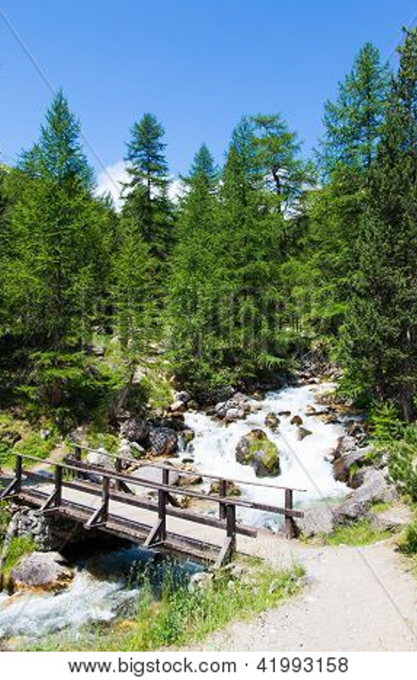
Bigstock Photo ID: 41993158
Bardonecchia area Piemonte Region Italian Alps. Bridge on the river in Alpine forest.
Stock Photo ID: 41993158
Copyright: Paolo Gallo

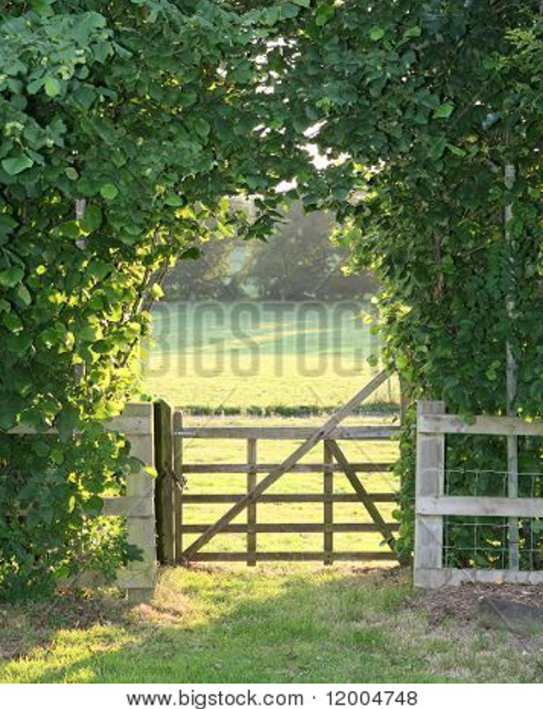
Bigstock Photo ID: 12004748
Wooden gate and beech hedge
Stock Photo 12004748
Copyright: joegough


Bigstock Photo ID: 79103725
Broken Arch In Arches National Park
Broken Arch in Arches National Park Utah USA.
Stock Photo ID: 79103725
Copyright: Photosbyjam

Bigstock Photo ID: 15514604
corn field
Stock Photo ID: 15514604
Copyright: Serg64


Bigstock Photo ID: 84336950

Mountain River And Coniferous Forest

A mountain river,waterfall and a coniferous forest
Stock Photo ID: 84336950
Copyright: AlinaMD

Bigstock Photo ID: 49786730
Moss around the wooden walkway in rain forest - Chiang Mai Province Thailand
Stock Photo ID: 49786730
Copyright: anekoho


Bigstock Photo ID: 16725188
Editing suggestion: Crop out dark edges and slightly brighten
Sun rays
Stock Photo ID: 16725188
Copyright: alexfiodorov


Bigstock Photo ID: 61659800
Editing suggestion: Brighten photo
Golden Sunset
Beautiful golden sunrise on a greek island framed by palm leaves silhouettes.
Stock Photo 61659800
Copyright: PetarPaunchev


Bigstock Photo ID: 306697243
beautiful spring landscape with blooming purple flowers in meadow and sunrise. blurred scenery background of flowering wildflowers on field
Stock Photo ID: 306697243
Copyright: Yanika

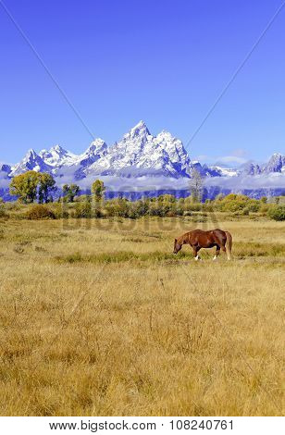
Bigstock Photo ID: 108240761-Edited
Editing suggestion: Crop top and bottom of photo to be consistent with print booklet
Grand Teton and the Teton Range, Grand Teton National Park, Wyoming, USA
Stock Photo ID: 108240761
Copyright: robert cicchetti


Bigstock Photo ID: 46421911
Editing suggestion: Rotate photo to be consistent with print booklet
Coconut palm tree leaves over Tropical ocean with bungalows
Stock Photo ID: 46421911
Copyright: Martin Valigursky


Bigstock Photo ID: 68139301

A close up shot of an African Leopard ** Note: Visible grain at 100%, best at smaller sizes
Stock Photo ID: 68139301
Copyright: Kitch Bain


Bigstock Photo ID: 90323594
Editing suggestion: Rotate photo to be consistent with print booklet
Greek studio with flowers and white teracce Greece
Panoramic view on typical Greek studio with flowers and white teracce having clear view on sea landspace with islands, Greece
Stock Photo ID: 90323594
Copyright: ankamonika

Booklet Titles in the Series
www.TheWordOfGodSeries.com
Relational and Emotional Health Topics

A Joy-Filled Life

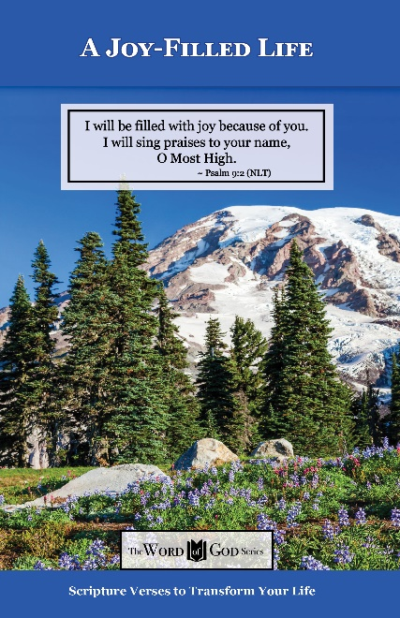
Relational and Emotional Health Topics

Healthy Relationships

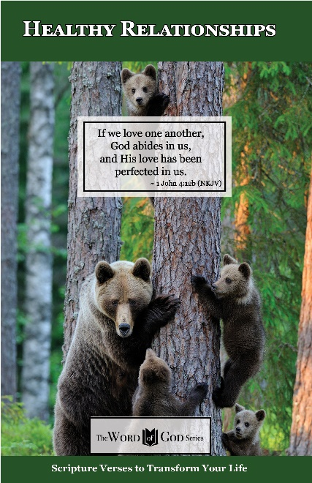
Relational and Emotional Health Topics

Healthy Thoughts

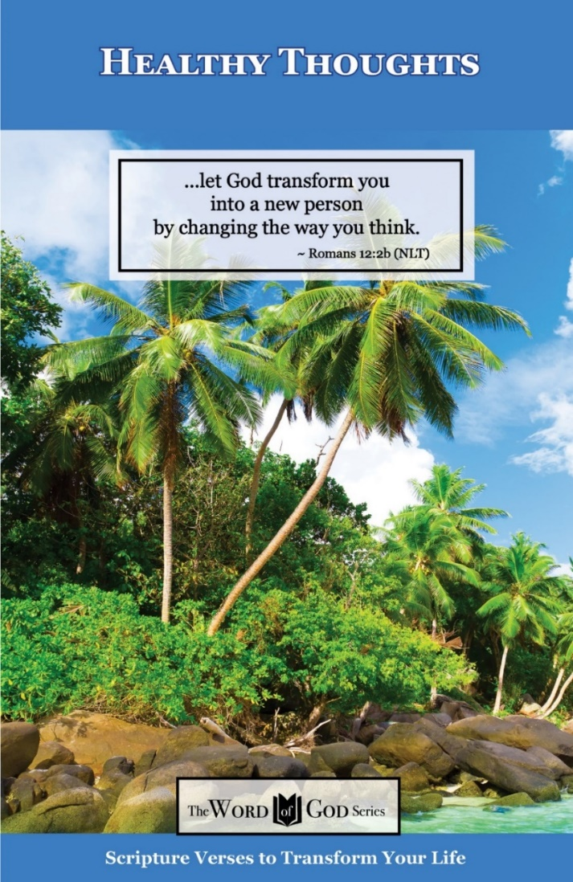
Relational and Emotional Health Topics

Freedom from Depression and Comfort in Grief

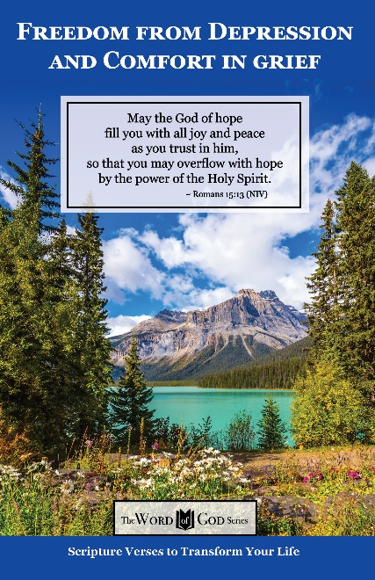
Relational and Emotional Health Topics

Freedom from Fear

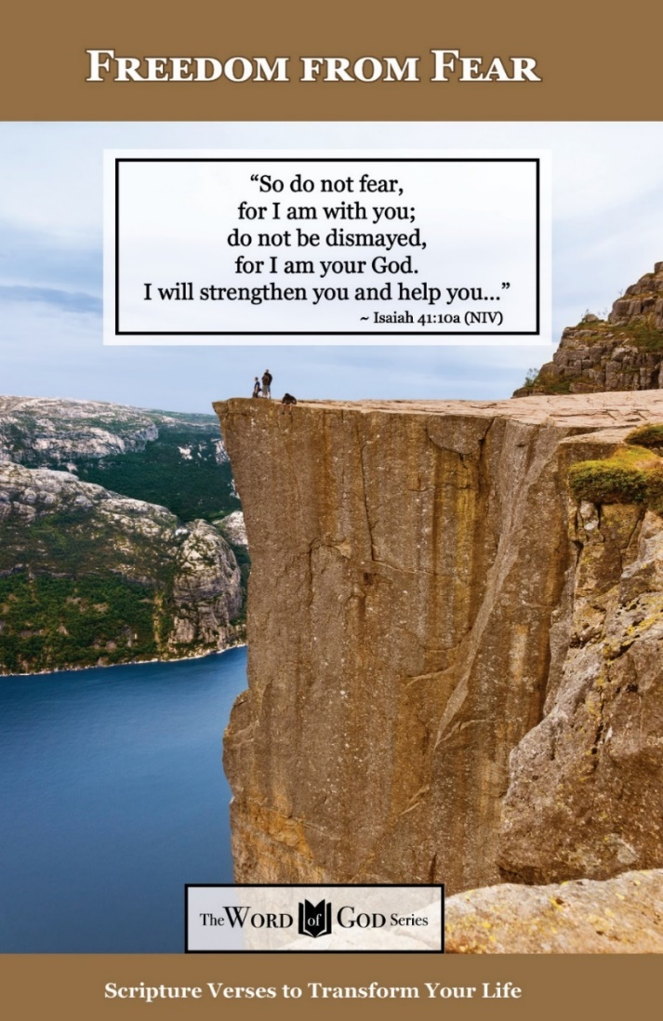
Relational and Emotional Health Topics

Freedom from Addictions

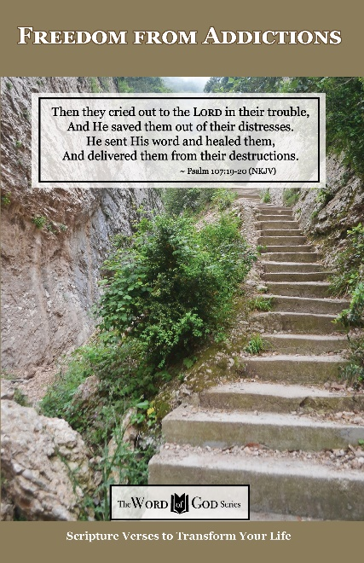
The Life and Ministry of Christ Series

Jesus: His Birth

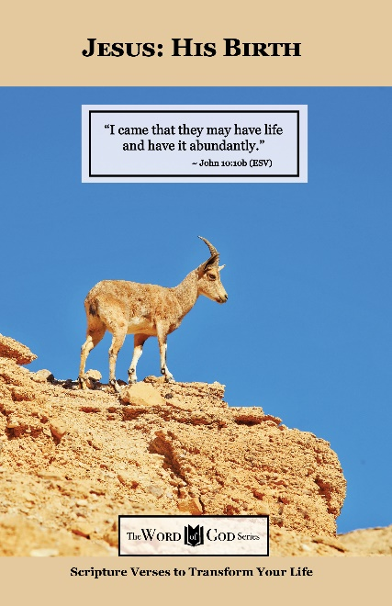
The Life and Ministry of Christ Series

Jesus: His Life Events

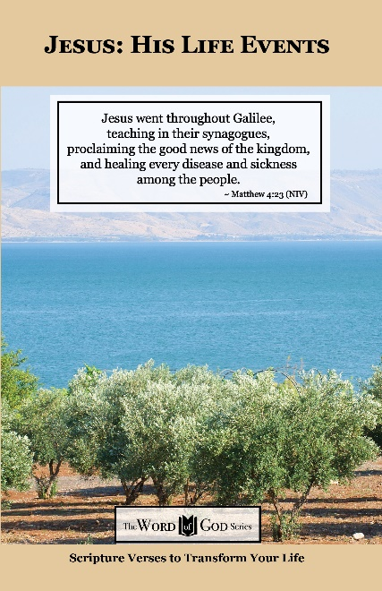
The Life and Ministry of Christ Series

Jesus: His Teachings

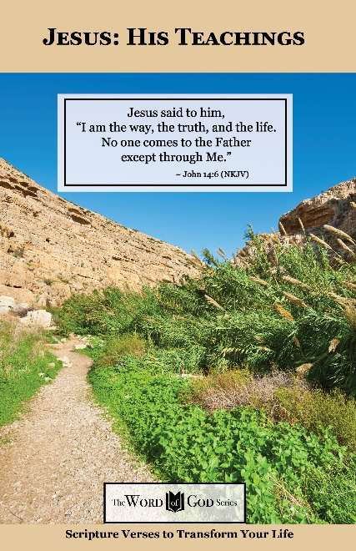
The Life and Ministry of Christ Series

Jesus: His Death, Resurrection and Return

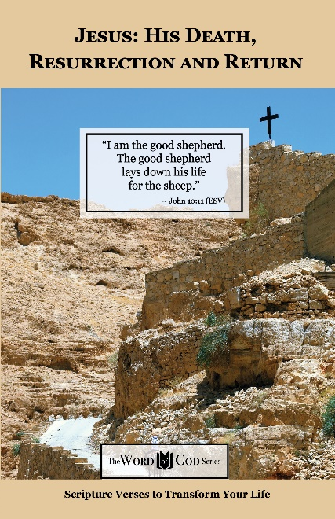
Spiritual Growth Topics

God’s Power and Presence

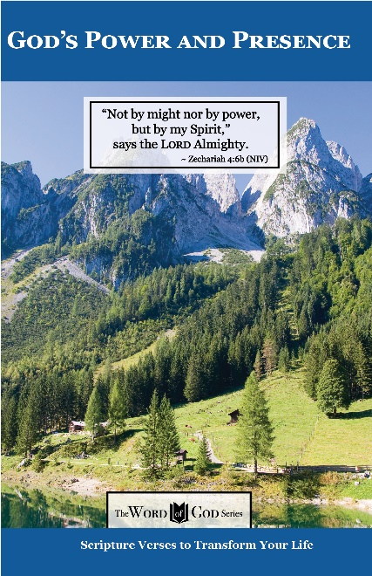
Spiritual Growth Topics

God’s Gift of Eternal Life

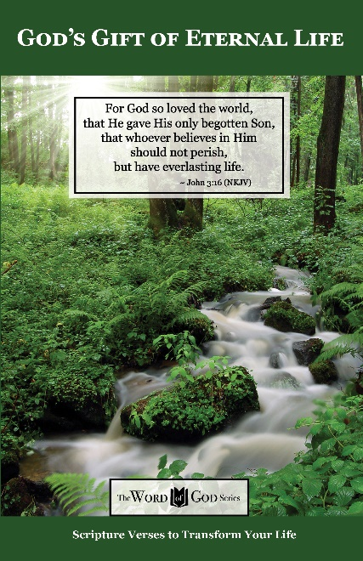
Spiritual Growth Topics

Sharing the Good News

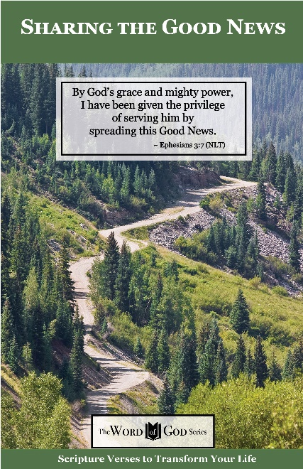
Spiritual Growth Topics

Defeating the Enemy

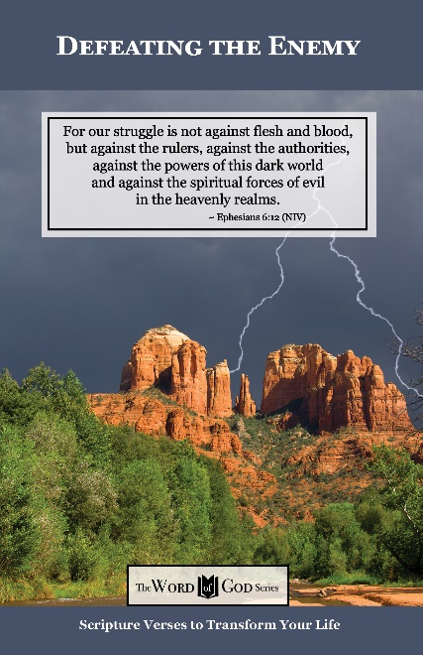
Spiritual Growth Topics

Standing Strong in Persecution

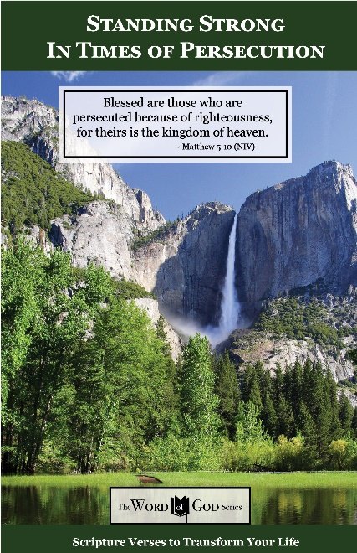
Everyday Life Topics

God’s Healing Power

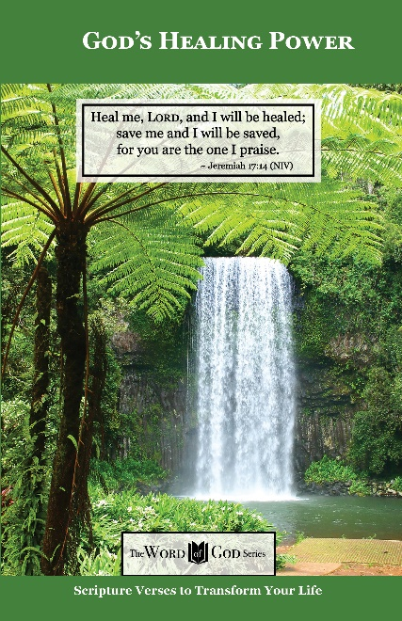
Everyday Life Topics

God is Your Refuge

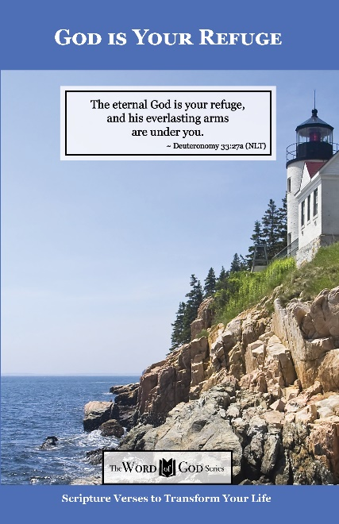
Everyday Life Topics

God’s Guidance for Your Life

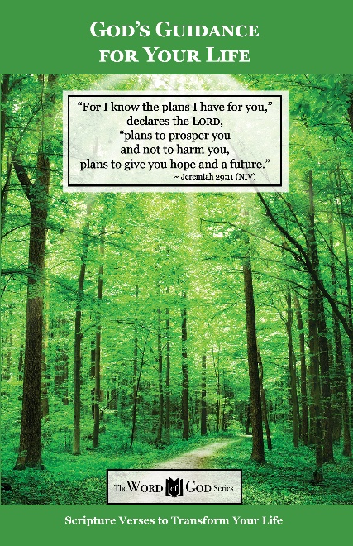
Everyday Life Topics

God’s Word to the Nations

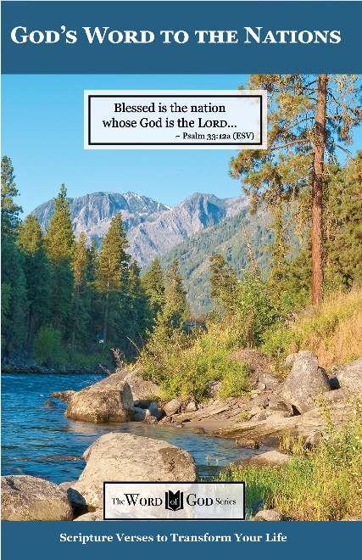
Everyday Life Topics

Praise God at Thanksgiving

