Template for God’s Word to the Nations in an eBooklet Format

The Word of God Series is a collection of 20 booklets that present Scripture verses in an easy-to-read format, with each booklet focused on a different topic.
Titles include Healthy Relationships, A Joy-Filled Life, Freedom from Depression, and many others. Click here to see other titles.
The booklets are available in both paperback and digital formats at www.TheWordOfGodSeries.com or Amazon.com.
Why This Template?
Because I believe in the power of God’s Word to transform people’s lives, I have dedicated several years of my life to bring this series to fruition.
I am passionate about using these booklets to reach a dark and dying world with the love of Christ and the hope of the Gospel.
Initially, I had expected this series would be a small business. But one day, when I asked God what my next steps should be, He spoke to me through His Word and told me to:
“…complete the ministry God has given you.”
~ 2 Timothy 4:5 (NLT, 1996 version)
So, I shifted the focus from being a business to a ministry.
My vision, also, has evolved over time and I have come to believe that it is possible for millions of these booklets to be distributed (in both print and digital formats) around the world (see the document entitled The Vision at www.TheWordOfGodSeries.com for more info.)
In order to make this a far-reaching ministry, accessing populations that I couldn’t on my own, I decided to invite others to partner with me in producing and distributing these booklets to their own personal networks. To help get it started, I have made templates of each booklet freely available to anyone who would like them.
This way you (whether you are a church, Christian organization or an individual) can easily re-create the booklets in your own ministry’s name, and distribute them to the people you minister to.
I hope that this template will save you:
- Time – so you can benefit from the thousands of hours of development time that has been invested so far
- Money – eliminate layers of profit margin
Whether you simply replicate and reproduce what has already been done, build on it, or take this idea in a different direction, you won’t have to waste time starting with a blank page.
I hope you can easily get these finalized, so you can begin sharing them with the people in your sphere of influence.
On the following pages you will find document formatting tips.
Photo editing tips are also presented, as well as the preview images of each photo (with the Photo ID#), so you to easily find it on either bigstockphoto.com or shutterstock.com. Copyright and general info for each photo can be found here.
Formatting Tips (if making changes to this document)
This document is ready to be exported to an eBook format. The app I used is through Amazon called Kindle Create.
If you make any changes to this document (such as pasting additional verses or entire sections into it), you’ll want follow the steps below.
If you are not making any changes to this document, then just skip these steps.
When converting a document to eBook format, it’s best to remove tabs, indentations and soft returns. While using these formatting tricks in a print format can make the page much more readable (by adding white space to the page), in a digital format, these same tricks can disrupt the flow of the text and make it more difficult to read (since the view can change depending on the type of device, font size selected, etc.)
- Remove all tabs, indentations and soft returns (Note, if a passage is too long, you can always add white space by inserting a
hard return (the Enter key only) after a sentence, with a 6 pt spacing after the line. (Layout / Spacing / After / 6 pt)

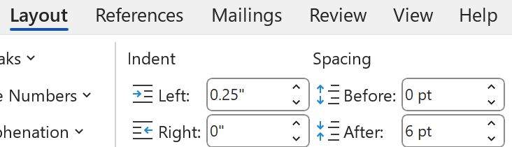
- Ensure that the spacing between the lines is consistent throughout the document. When the document is completed, select the entire document (Ctrl + A) and click on Layout / Paragraph / Multiple (under Line Spacing) and change the number to “1”


- Ensure that the spacing between the characters is consistent throughout the document. After completing step 2 above, while the entire document is still selected, click on Home / Font / Advanced and change the Spacing to Normal
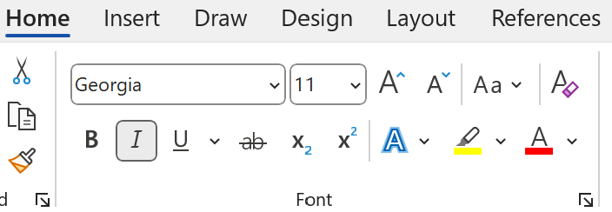

Photo Editing Tips
At the end of this document you will find the copyright and descriptive info for each photo in the booklet, as well as editing suggestions for a few of them.
For the digital view, try to keep the photos as large on the page as possible, otherwise they will appear too small on devices. The preview photos in this document are a good size for digital format, so try to keep your photos the same size.
Most of the editing suggestions (especially brightening or increasing color saturation) should be very slight adjustments.
Editing photos within this document
Rotate: Doubleclick the photo, click on the Rotate Object icon.
Note: rotating an image is more important in the print format, so that certain objects in the photo will face the center of the page (such as animal pics). This doesn’t matter in a digital format, but the suggestion to rotate certain photos is included below in order to keep the digital and print formats consistent (in case someone reads both the print and digital booklets.)

Editing photos in the Pictures editing app in MS Word
Navigate to your Pictures folder, doubleclick the photo, and click on the blue Edit button on left
Most of the editing can be accomplished using one of these 3 options:


Crop: Click on the Crop icon and drag edges to desired spot
Brighten a photo: Adjustment icon / Light / Brightness
Increase color saturation: Adjustment icon / Color / Saturation or Warmth
Remove distracting elements from a photo: Click on the Generative Erase icon, select a brush size and click on the part of the photo you want removed.

Photo Searching Tips
Occasionally photographers pull their photos from the sites, so there may be some in this document that are no longer available. You can try using the same key words to search for the photo on other sites. Or, you can search for another photo on Bigstock:
- Under All Images select Photos and search by key word.
- At the next screen, make sure that Safe Search is on.
- In the Category field, select either Landscapes, Nature or Animals.
Forward Page | Copyright Page | Table of Contents

Below are sample Forward and Copyright pages. Feel free to edit to reflect your ministry’s mission and vision.
The Table of Contents in this document contains links to each of the section headings. If you add any new sections to this document, be sure to:
- Assign the Heading Style to the new section heading (in this document, it is referred to as Heading).
Highlight the heading, click on Home, then Heading in the Styles box


- Bookmark the new section heading: Put your cursor after the first letter in the section heading, click on Insert / Bookmark and then give name the bookmark (no spaces in the name!)



- Add the new section heading to the Table of Contents page and add a link to the bookmark you just created: Highlight the text, click on Insert / Link / Place in this Document and select the section heading bookmark.


Kindle Create
Should you decide to use Kindle Create to export this to an eBook format, see the steps below. You can use Kindle Create to export to a Kindle KPF file and/or EPUB file:

Begin at https://kdp.amazon.com/en_US/bookshelf to set up the booklets on Amazon and install the Kindle Create app.
At the first screen, select Create New and Choose

At the next Screen click on Continue. At the next screen click on Choose File, select the document, and click on Open. Then click on Continue and Get Started.
At the next screen you will see a box labeled Suggested Chapter Titles. Click on Reject All.
Next, left-justify the entire document (a quirk with this application is that some portions of the document may be centered, while others portions are left-justified). Highlight the entire document, click on Formatting, and then the left-justify icon.
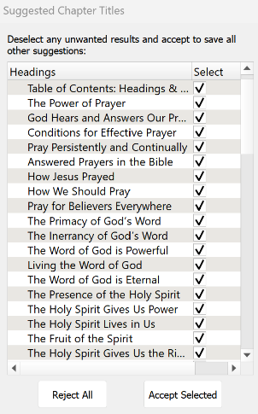
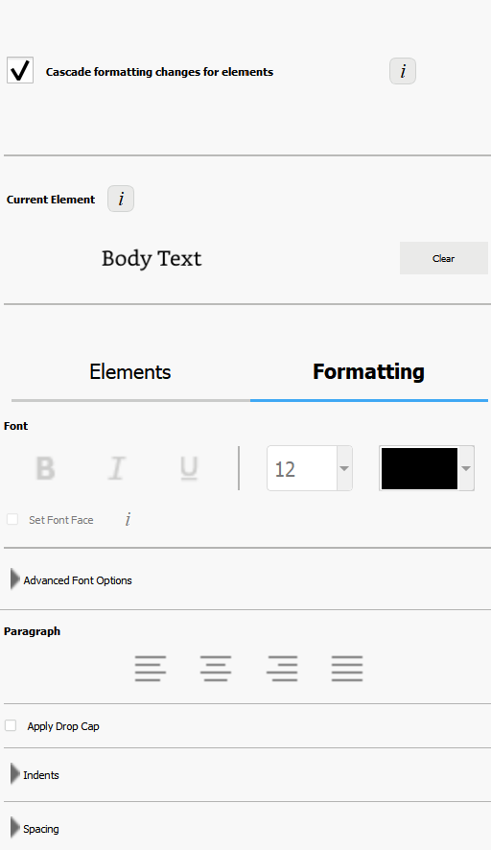
Now you can begin assigning different elements to the Headings and Subheadings in the document so that, when someone is reading the eBook, they can easily jump to another section via the Table of Contents.
I use 2 elements: Chapter Title (for the key headings in the Brittanica Bold font) and Subheading (for the underlined subheadings).
As you begin assigning the elements, be sure to start by assigning the Chapter Title element to the Table of Contents: Headings and Subheadings heading. Then go through the rest of the document and assign either the Chapter Title or Subheading elements.
You can change the formatting from the Kindle Create default, if you want. Below are the formatting options that I use for the eBooklets.
Feel free to customize to suit your preferences.

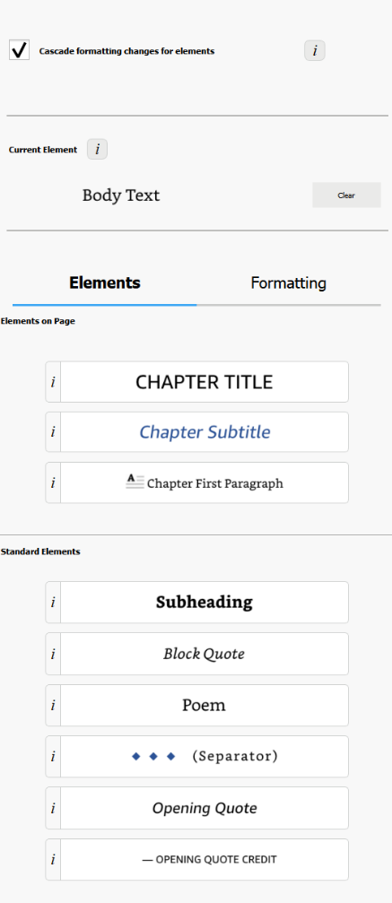
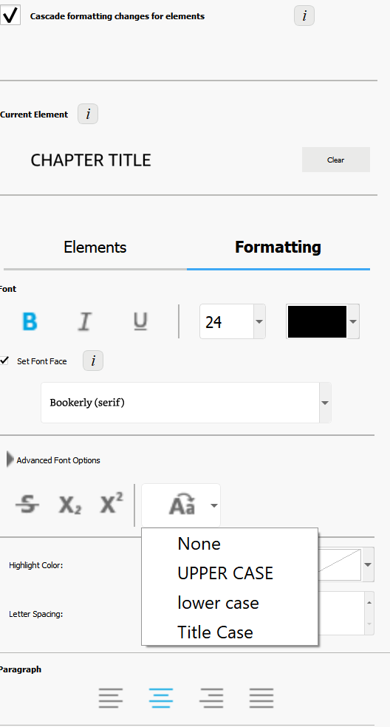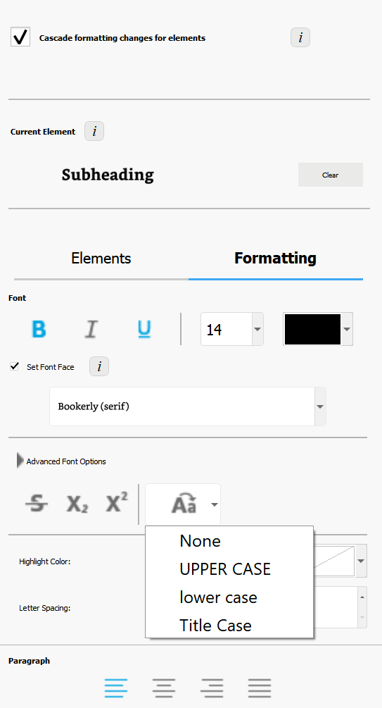

Finally, go through the document and click on each photo and change it to “Full Size.” (Note, another quirk with this app is that some photos just can’t be changed to full size, so they will appear smaller in the eBooklet).
When complete, first, save the document (File / Save Project). This will automatically put it in a folder. So when you export the document, be sure you export it to that folder.
To export, click on File / Export / KPF (Kindle and print). At the next screen, click on the file name to select it, and then click on Export.
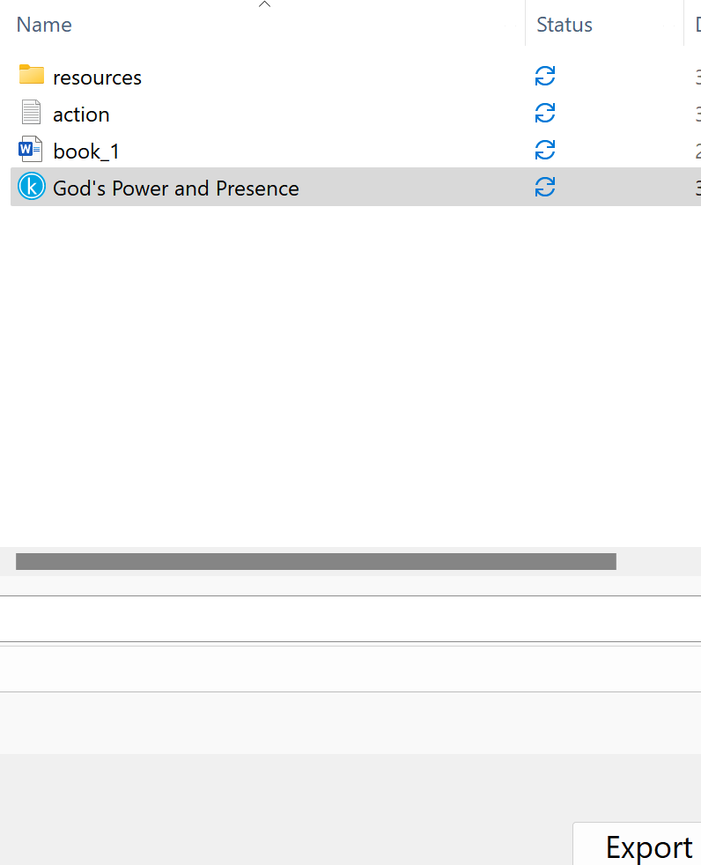

If you want the file in an EPUB format, go through the steps above and select File / Export / EPUB

Stuck on a Step Above and Need Help?
If you want to do this project on your own, but are having tech issues with one of the steps above, feel free to contact me at Susan@TheWordOfGodSeries.com. I may be able to assist you, since I’ve gone through this whole process myself!

Need Help with the Whole Project?
If you want these booklets set up in your own in your own ministry’s name, but don’t have the resources to do the whole project yourself,
I may be able to manage that process for you for a one-time project fee.
This would include the following services:
- Set up an account with Bigstock and Shutterstock in your ministry’s name and purchase the rights for you to use each of the photos
- Download and name the photos
- Edit photos as needed
- Create a cover with your church or ministry logo
- Request the rights to use the various Bible translations from each of the publishers (if applicable)
Feel free to contact me at Susan@TheWordOfGodSeries.com to discuss pricing options.

I hope that this information will help you finalize this document with ease so you can begin distributing it
to the people in your realm of influence.
Thank you for partnering with me in this effort. I wish you the best as you make God’s Word known and
share His love with others!
Warmly in Christ,
Susan

Soli Deo gloria


Feel free to edit this forward page to align to your own ministry’s vision and goals.

The Bible is the best-selling and most transformative book in history. It was written over 2,000 years ago, and is still living and powerful today.
Throughout the pages of Scripture you will find inspiration and joy, comfort and peace, healing and hope.
Most importantly, you will learn of God’s abundant love for you, and His plan to give you a glorious, eternal inheritance.
The Word of God Series is a collection of booklets which presents Scripture by topic, so you can focus on verses that are relevant to you at different stages and circumstances throughout your life.
All of the booklets in this series feature Scripture exclusively—just the powerful, undiluted Word of God.
Let God’s Word permeate your mind and transform your life.
Here are a few suggestions for you as you read:
Meditate
As you read, pause and reflect on the verses, and even meditate on them throughout the day.
Memorize
A great memorization technique is to repeat the verse several times, each time emphasizing a different word.
Blessed is the nation whose God is the Lord…
Blessed is the nation whose God is the Lord…
Blessed is the nation whose God is the Lord…

~ Psalm 33:12a (ESV)
Pray
Pray God’s Word back to Him. For example,
Dear Father, thank you for blessing this nation. May we continue to acknowledge You as Lord.

Do What It Says
Do not merely listen to the word, and so deceive yourselves. Do what it says.

~ James 1:22 (NIV)

My prayer for you, as you read this booklet, is that you will seek God’s forgiveness and blessing on behalf of your nation, for the sake of this generation and all the generations that will follow.
Let the word of Christ dwell in you richly…

~ Colossians 3:16a (ESV)

A few comments about The Word of God Series:

- The booklets in this series provide you with a sample of what the Bible offers, but it is important that you also read the Bible itself, preferably with a book-by-book focus.

- Passages in quotation marks are the actual words of God, either through His prophets in the Old Testament, or the words of Christ in the New Testament.

- Every booklet includes a section that details God’s plan of salvation (commonly referred to as “The Gospel.”) The booklet entitled God’s Gift of Eternal Life is devoted to the Gospel message.

This series presents verses in the following translations:

NIV: New International Version
Scripture quotations marked NIV are taken from the Holy Bible, New International Version®, NIV®. Copyright © 1973, 1978, 1984, 2011 by Biblica, Inc.™ Used by permission of Zondervan. All rights reserved worldwide. www.zondervan.com. The "NIV" and "New International Version" are trademarks registered in the United States Patent and Trademark Office by Biblica, Inc.™

NLT: New Living Translation
Scripture quotations marked NLT are taken from the Holy Bible, New Living Translation, Copyright© 1996, 2004, 2015 by Tyndale House Foundation. Used by permission of Tyndale House Publishers, Inc., Carol Stream, Illinois 60188. All rights reserved.

ESV: English Standard Version
Scripture quotations marked ESV are taken from the ESV Bible® (The Holy Bible, English Standard Version®), copyright © 2001 by Crossway Bibles, a publishing ministry of Good News Publishers. Used by permission. All rights reserved.

KJV: King James Version
Public Domain

NKJV: New King James Version
Scripture quotations marked NKJV are taken from the New King James Version®. Copyright © 1982 by Thomas Nelson, Inc. Used by permission.

Since this is a template booklet featuring preview photos, it is not copyrighted, so you are free to purchase licenses to use the photos and develop your own booklets. Be sure to determine whether or not you need to request permission (and in some cases pay) for the rights to use the various Bible translations. Scripture verses were sourced from www.BibleGateway.com.

If it would be easier for you to simply purchase this booklet, the copyrighted version is available at www.TheWordOfGodSeries.com or www.amazon.com. ISBN info for the copyrighted booklets is as follows: 978-1-964538-36-5 (print booklet), 978-1-964538-37-2 (eBooklet), 9798322917786 (print booklet on Amazon).

Table of Contents: Headings & Sub-Headings

God is Sovereign Over All Nations
How a Nation Can Receive God’s Blessings
Live in Righteousness
Live in Liberty
Live in Obedience to God
Ask God for Forgiveness
Honor the Sabbath
Love the Immigrant
Choose Life
Praise the Lord
Proclaim that His Name is Exalted
Worship and Serve God Alone
God’s Warnings to the Nations
Warnings to Nations Disobedient to God
Warnings Against the Wickedness of Man
Warnings About the Wrath of God
Standing in the Gap
God Will Rescue the Righteous
When it is Too Late for a Nation
When a Nation Turns to God for Mercy
Biblical Principles for Government
Trust in God Rather than People
Pray for Peace in Jerusalem
God’s Gift of Eternal Life
Inspire the Next Generation

Note: The verse references in this document contain links to the BibleGateway.com page that will display the passage in all 5 translations that are used in this series (NIV, NLT, ESV, NKJV, KJV).

Other Booklets in the Series

God is Sovereign Over All Nations

From one man he made all the nations, that they should inhabit the whole earth; and he marked out their appointed times in history and the boundaries of their lands.

~ Acts 17:26 (NIV)

O nations of the world, recognize the Lord; recognize that the Lord is glorious and strong.
Give to the Lord the glory he deserves!
Bring your offering and come into his courts.
Worship the Lord in all his holy splendor.
Let all the earth tremble before him.
Tell all the nations, “The Lord reigns!”
The world stands firm and cannot be shaken.

~ Psalm 96:7-10a (NLT)

He makes nations great, and destroys them; he enlarges nations, and disperses them.

~ Job 12:23 (NIV)

“Be still, and know that I am God;
“I will be exalted among the nations,
“I will be exalted in the earth!”

~ Psalm 46:10 (NKJV)

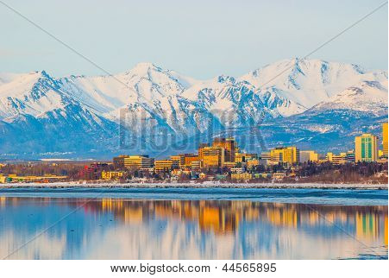

“I, even I, am the Lord, and apart from me there is no savior.”

~ Isaiah 43:11 (NIV)

“I am the Lord, and there is no other, besides me there is no God;
“I equip you, though you do not know me, that people may know, from the rising of the sun and from the west, that there is none besides me;
“I am the Lord, and there is no other.
“I form light and create darkness,
“I make well-being and create calamity,
“I am the Lord, who does all these things.”

~ Isaiah 45:5-7 (ESV)

“My mercy and justice are coming soon.
“My salvation is on the way.
“My strong arm will bring justice to the nations.
“All distant lands will look to me and wait in hope for my powerful arm.”

~ Isaiah 51:5 (NLT)

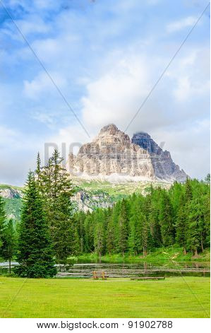

“I have a plan for the whole earth, a hand of judgment upon all the nations.
“The Lord of Heaven’s Armies has spoken—who can change his plans?
“When his hand is raised, who can stop him?”

~ Isaiah 14:26-27 (NLT)

Arise, O Lord! Let not man prevail; let the nations be judged before you!
Put them in fear, O Lord!
Let the nations know that they are but men!

~ Psalm 9:19-20 (ESV)

All the nations are as nothing before him, they are accounted by him as less than nothing and emptiness.

~ Isaiah 40:17 (ESV)

All the nations of the world will stand amazed at what the Lord will do for you.
They will be embarrassed at their feeble power…
They will fear him greatly, trembling in terror at his presence.

~ Micah 7:16 (NLT)

Has not the Lord Almighty determined that the people’s labor is only fuel for the fire, that the nations exhaust themselves for nothing?
For the earth will be filled with the knowledge of the glory of the Lord as the waters cover the sea.

~ Habakkuk 2:13-14 (NIV)

The Lord frustrates the plans of the nations and thwarts all their schemes.
But the Lord’s plans stand firm forever; his intentions can never be shaken.

~ Psalm 33:10-11 (NLT)

How a Nation Can Receive God’s Blessings

Blessed is the nation whose God is the Lord…

~ Psalm 33:12a (ESV)

Live in Righteousness

Righteousness exalts a nation…

~ Proverbs 14:34a (NKJV)

Surely his salvation is near to those who fear him, so our land will be filled with his glory.

~ Psalm 85:9 (NLT)

“But seek first the kingdom of God and his righteousness, and all these things will be added to you.”

~ Matthew 6:33 (NKJV)

In righteousness you will be established:
Tyranny will be far from you; you will have nothing to fear.
Terror will be far removed; it will not come near you.

~ Isaiah 54:14 (NIV)

“Listen to me, you who pursue righteousness and who seek the Lord:
“Look to the rock from which you were cut and to the quarry from which you were hewn…”

~ Isaiah 51:1 (NIV)

“Get your sins out of my sight.
“Give up your evil ways.”

~ Isaiah 1:16b (NLT)

For the upright will inhabit the land, and those with integrity will remain in it...

~ Proverbs 2:21 (ESV)

For the wicked will be destroyed, but those who trust in the Lord will possess the land.

~ Psalm 37:9 (NLT)

Live in Liberty

…where the Spirit of the Lord is, there is liberty.

~ 2 Corinthians 3:17b (KJV)

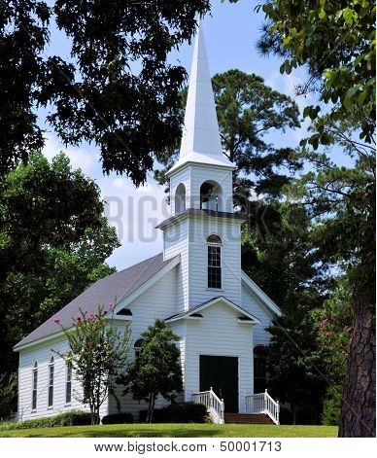

Stand fast therefore in the liberty by which Christ has made us free, and do not be entangled again with a yoke of bondage.

~ Galatians 5:1 (NKJV)

Live in Obedience to God

The 10 Commandments
“I am the Lord your God who brought you out of the land of Egypt, out of the house of bondage.
“You shall have no other gods before Me.
“You shall not make for yourself a carved image—any likeness of anything that is in heaven above, or that is in the earth beneath, or that is in the water under the earth; you shall not bow down to them nor serve them. For I, the Lord your God, am a jealous God, visiting the iniquity of the fathers upon the children to the third and fourth generations of those who hate Me, but showing mercy to thousands, to those who love Me and keep My commandments.
“You shall not take the name of the Lord your God in vain, for the Lord will not hold him guiltless who takes His name in vain.
“Observe the Sabbath day, to keep it holy, as the Lord your God commanded you. Six days you shall labor and do all your work, but the seventh day is the Sabbath of the Lord your God. In it you shall do no work: you, nor your son, nor your daughter, nor your male servant, nor your female servant, nor your ox, nor your donkey, nor any of your cattle, nor your stranger who is within your gates, that your male servant and your female servant may rest as well as you. And remember that you were a slave in the land of Egypt, and the Lord your God brought you out from there by a mighty hand and by an outstretched arm; therefore the Lord your God commanded you to keep the Sabbath day.
“Honor your father and your mother, as the Lord your God has commanded you, that your days may be long, and that it may be well with you in the land which the Lord your God is giving you.
“You shall not murder.
“You shall not commit adultery.
“You shall not steal.
“You shall not bear false witness against your neighbor.
“You shall not covet your neighbor’s wife; and you shall not desire your neighbor’s house, his field, his male servant, his female servant, his ox, his donkey, or anything that is your neighbor’s.”

~ Deuteronomy 5:6-21 (NKJV)

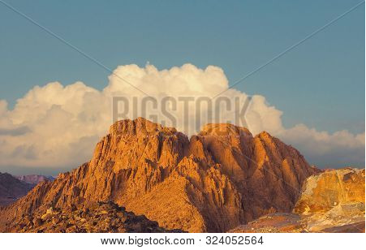

Mount Sinai, where Moses received the 10 Commandments

“Now therefore, if you will indeed obey My voice and keep My covenant, then you shall be a special treasure to Me above all people; for all the earth is Mine.”

~ Exodus 19:5 (NKJV)

Today I am giving you a choice between life and death, between prosperity and disaster.
For I command you this day to love the Lord your God and to keep his commands, decrees, and regulations by walking in his ways.
If you do this, you will live and multiply, and the Lord your God will bless you and the land you are about to enter and occupy.
But if your heart turns away and you refuse to listen, and if you are drawn away to serve and worship other gods, then I warn you now that you will certainly be destroyed.

~ Deuteronomy 30:15b-18a (NLT)

“If you follow my decrees and are careful to obey my commands, I will send you the seasonal rains.
“The land will then yield its crops, and the trees of the field will produce their fruit. Your threshing season will overlap with the grape harvest, and your grape harvest will overlap with the season of planting grain.
“You will eat your fill and live securely in your own land.
“I will give you peace in the land, and you will be able to sleep with no cause for fear.
“I will rid the land of wild animals and keep your enemies out of your land. In fact, you will chase down your enemies and slaughter them with your swords. Five of you will chase a hundred, and a hundred of you will chase ten thousand! All your enemies will fall beneath your sword.
“I will look favorably upon you, making you fertile and multiplying your people. And I will fulfill my covenant with you.
“You will have such a surplus of crops that you will need to clear out the old grain to make room for the new harvest!
“I will live among you, and I will not despise you.
“I will walk among you; I will be your God, and you will be my people.”

~ Leviticus 26:3-12 (NLT)

“If you will only obey me, you will have plenty to eat.”

~ Isaiah 1:19 (NLT)

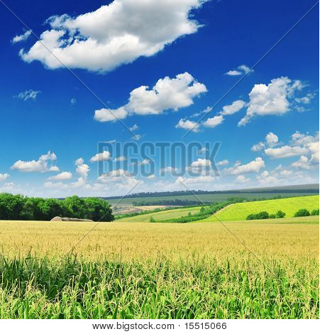

When you have eaten your fill, be sure to praise the Lord your God for the good land he has given you.
But that is the time to be careful!
Beware that in your plenty you do not forget the Lord your God and disobey his commands, regulations, and decrees that I am giving you today.
For when you have become full and prosperous and have built fine homes to live in, and when your flocks and herds have become very large and your silver and gold have multiplied along with everything else, be careful!
Do not become proud at that time and forget the Lord your God…

~ Deuteronomy 8:10-14a (NLT)

If you fully obey the Lord your God and carefully follow all his commands I give you today, the Lord your God will set you high above all the nations on earth.
All these blessings will come on you and accompany you if you obey the Lord your God:
You will be blessed in the city and blessed in the country.
The fruit of your womb will be blessed, and the crops of your land and the young of your livestock—the calves of your herds and the lambs of your flocks. Your basket and your kneading trough will be blessed.
You will be blessed when you come in and blessed when you go out.
The Lord will grant that the enemies who rise up against you will be defeated before you. They will come at you from one direction but flee from you in seven.
The Lord will send a blessing on your barns and on everything you put your hand to.
The Lord your God will bless you in the land he is giving you.
The Lord will establish you as his holy people, as he promised you on oath, if you keep the commands of the Lord your God and walk in obedience to him.
Then all the peoples on earth will see that you are called by the name of the Lord, and they will fear you.
The Lord will grant you abundant prosperity—in the fruit of your womb, the young of your livestock and the crops of your ground—in the land he swore to your ancestors to give you.
The Lord will open the heavens, the storehouse of his bounty, to send rain on your land in season and to bless all the work of your hands.
You will lend to many nations but will borrow from none.

~ Deuteronomy 28:1-12 (NIV)

“Bring the whole tithe into the storehouse, that there may be food in my house.
“Test me in this,” says the Lord Almighty, “and see if I will not throw open the floodgates of heaven and pour out so much blessing that there will not be room enough to store it…
“Then all the nations will call you blessed, for yours will be a delightful land,” says the Lord Almighty.

~ Malachi 3:10-12 (NIV)

Keep this Book of the Law always on your lips;
meditate on it day and night, so that you may be careful to do everything written in it.
Then you will be prosperous and successful.

~ Joshua 1:8 (NIV)

Be careful to obey all the commands of the Lord your God, so that you may continue to possess this good land and leave it to your children as a permanent inheritance.

~ 1 Chronicles 28:8b (NLT)

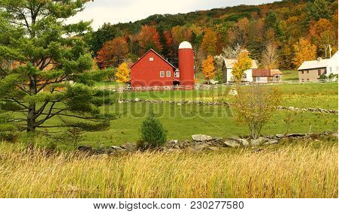

Ask God for Forgiveness

“If at any time I announce that a nation or kingdom is to be uprooted, torn down and destroyed, and if that nation I warned repents of its evil, then I will relent and not inflict on it the disaster I had planned.”

~ Jeremiah 18:7-8 (NIV)

“…if my people, who are called by my name, will
humble themselves and
pray and
seek my face and
turn from their wicked ways,
“then I will hear from heaven, and I will forgive their sin and will heal their land.”

~ 2 Chronicles 7:14 (NIV)

Then I turned my face to the Lord God, seeking him by prayer and pleas for mercy with fasting and sackcloth and ashes.
I prayed to the Lord my God and made confession, saying,
“O Lord, the great and awesome God, who keeps covenant and steadfast love with those who love him and keep his commandments, we have sinned and done wrong…
“O Lord, according to all your righteous acts, let your anger and your wrath turn away from your city Jerusalem…
“For we do not present our pleas before you because of our righteousness, but because of your great mercy.
“O Lord, hear; O Lord, forgive.”

~ Daniel 9:3-19a (ESV)

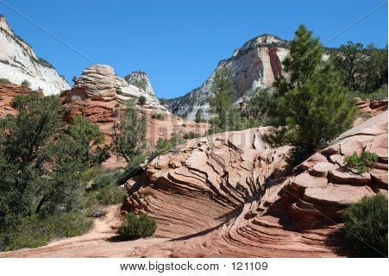

Then the word of the Lord came to Jonah a second time: “Go to the great city of Nineveh and proclaim to it the message I give you.”
Jonah obeyed the word of the Lord and went to Nineveh…proclaiming, “Forty more days and Nineveh will be overthrown.”
The Ninevites believed God.
A fast was proclaimed, and all of them, from the greatest to the least, put on sackcloth.
When Jonah’s warning reached the king of Nineveh, he rose from his throne, took off his royal robes, covered himself with sackcloth and sat down in the dust.
This is the proclamation he issued in Nineveh: “By the decree of the king and his nobles: Do not let people or animals…eat or drink…
“Let everyone call urgently on God.
“Let them give up their evil ways and their violence.
“Who knows? God may yet relent and with compassion turn from his fierce anger so that we will not perish.”
When God saw what they did and how they turned from their evil ways, he relented and did not bring on them the destruction he had threatened.

~ Jonah 3:1-10 (NIV)

What if God, although choosing to show his wrath and make his power known, bore with great patience the objects of his wrath—prepared for destruction?
What if he did this to make the riches of his glory known to the objects of his mercy, whom he prepared in advance for glory…

~ Romans 9:22-23 (NIV)

Honor the Sabbath

“This is what the Lord says: Listen to my warning!
“Stop carrying on your trade at Jerusalem’s gates on the Sabbath day.
“Do not do your work on the Sabbath, but make it a holy day.
“I gave this command to your ancestors, but they did not listen or obey.”

~ Jeremiah 17:21-23a (NLT)

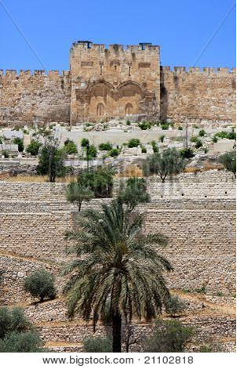

The Golden Gate in Jerusalem, Israel

“Observe the Sabbath day, to keep it holy, as the Lord your God commanded you. Six days you shall labor and do all your work, but the seventh day is the Sabbath of the Lord your God.”

~ Deuteronomy 5:12-14a (NIV)

“Keep the Sabbath day holy.
“Don’t pursue your own interests on that day, but enjoy the Sabbath and speak of it with delight as the Lord’s holy day.
“Honor the Sabbath in everything you do on that day, and don’t follow your own desires or talk idly.”

~ Isaiah 58:13 (NLT)

“You shall keep My Sabbaths and reverence My sanctuary: I am the Lord.”

~ Leviticus 26:2 (NKJV)

Love the Immigrant

And you are to love those who are foreigners…

~ Deuteronomy 10:19a (NIV)

“This is what the Lord Almighty said: ‘Administer true justice; show mercy and compassion to one another. Do not oppress the widow or the fatherless, the foreigner or the poor.’”

~ Zechariah 7:9-10a (NIV)

The stranger who dwells among you shall be to you as one born among you, and you shall love him as yourself…

~ Leviticus 19:34a (NKJV)

Choose Life

So God created mankind in his own image, in the image of God he created them; male and female he created them.

~ Genesis 1:27 (NIV)

For you created my inmost being; you knit me together in my mother’s womb…
Your eyes saw my unformed body; all the days ordained for me were written in your book before one of them came to be.

~ Psalm 139:13-16 (NIV)

The Lord called me before my birth; from within the womb he called me by name…

~ Isaiah 49:1b (NLT)

“Before I formed you in the womb I knew you,
“before you were born I set you apart…”

~ Jeremiah 1:5a (NIV)

“I have called you by your name; You are Mine.”

~ Isaiah 43:1b (NKJV)

“See, I have inscribed you on the palms of My hands...”

~ Isaiah 49:16a (NKJV)

…I have set before you life and death, blessings and curses.
Now choose life, so that you and your children may live…

~ Deuteronomy 30:19b (NIV)

Praise the Lord

Praise the Lord, all you nations.
Praise him, all you people of the earth.

~ Psalm 117:1 (NLT)

Give thanks to the Lord and proclaim his greatness.
Let the whole world know what he has done.

~ 1 Chronicles 16:8 (NLT)

Let all the earth fear the Lord;
Let all the inhabitants of the world stand in awe of Him.

~ Psalm 33:8 (NKJV)

Declare his glory among the nations, his marvelous deeds among all peoples.
For great is the Lord and most worthy of praise…

~ 1 Chronicles 16:24-25a (NIV)

Worship the Lord in the splendor of his holiness.
Tremble before him, all the earth!
The world is firmly established; it cannot be moved.
Let the heavens rejoice, let the earth be glad; let them say among the nations, “The Lord reigns!”

~ 1 Chronicles 16:29b-31 (NIV)

All the ends of the earth will remember and turn to the Lord, and all the families of the nations will bow down before him, for dominion belongs to the Lord and he rules over the nations.

~ Psalm 22:27-28 (NIV)

May God be gracious to us and bless us and make his face shine on us…
May the peoples praise you, God; may all the peoples praise you. The land yields its harvest; God, our God, blesses us.
May God bless us still, so that all the ends of the earth will fear him.

~ Psalm 67:1-7 (NIV)

Yours, O Lord, is the greatness, the power, the glory, the victory, and the majesty.
Everything in the heavens and on earth is yours, O Lord, and this is your kingdom.
We adore you as the one who is over all things.

~ 1 Chronicles 29:11 (NLT)

How great you are, O Sovereign Lord!
There is no one like you.

~ 2 Samuel 7:22a (NLT)

You are worthy, O Lord, to receive glory and honor and power…

~ Revelation 4:11a (NKJV)

You are ruler of all the kingdoms of the earth.
You are powerful and mighty; no one can stand against you!

~ 2 Chronicles 20:6b (NLT)

Through the praise of children and infants you have established a stronghold against your enemies…

~ Psalm 8:2a (NIV)

...you are holy, enthroned on the praises of Israel.

~ Psalm 22:3 (ESV)

Holy, holy, holy is the Lord Almighty;
the whole earth is full of his glory.

~ Isaiah 6:3b (NIV)

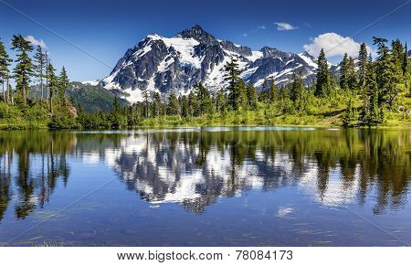

Praise be to the Lord, the God of Israel, from everlasting to everlasting.

~ 1 Chronicles 16:36a (NIV)

Proclaim that His Name is Exalted

Give praise to the Lord, proclaim his name; make known among the nations what he has done, and proclaim that his name is exalted.

~ Isaiah 12:4b (NIV)

Let them praise the name of the Lord,
for His name alone is exalted;
His glory is above the earth and heaven.

~ Psalm 148:13 (NKJV)

Lord, there is no one like you!
For you are great, and your name is full of power.

~ Jeremiah 10:6 (NLT)

Let them praise your great and awesome name.
Your name is holy!

~ Psalm 99:3 (NLT)

All nations whom thou hast made shall come and worship before thee, O Lord; and shall glorify thy name.

~ Psalm 86:9 (KJV)

Now therefore, our God, we thank thee, and praise thy glorious name.

~ 1 Chronicles 29:13 (KJV)

…for you have exalted above all things your name and your word.

~ Psalm 138:2b (ESV)

From the west, people will fear the name of the Lord, and from the rising of the sun, they will revere his glory.

~ Isaiah 59:19a (NIV)

From the rising of the sun to its setting, the name of the Lord is to be praised!

~ Psalm 113:3 (ESV)

Blessed be his glorious name forever; may the whole earth be filled with his glory! Amen and Amen!

~ Psalm 72:19 (ESV)

Worship and Serve God Alone

…choose this day whom you will serve…as for me and my house, we will serve the Lord.

~ Joshua 24:15b (ESV)

Serve only the Lord your God and fear him alone.

~ Deuteronomy 13:4a (NLT)



…serve him with wholehearted devotion and with a willing mind…

~ 1 Chronicles 28:9b (NIV)

“Do not worship any other god, for the Lord, whose name is Jealous, is a jealous God.”

~ Exodus 34:14 (NIV)

“How can I let myself be defamed? I will not yield my glory to another.”

~ Isaiah 48:11b (NIV)

“And I will destroy those who used to worship me but now no longer do.”

~ Zephaniah 1:6a (NLT)

“So set yourselves apart to be holy, for I am the Lord your God.”

~ Leviticus 20:7 (NLT)

God’s Warnings to the Nations

Warnings to Nations Disobedient to God

“But any nation who refuses to obey me will be uprooted and destroyed. I, the Lord, have spoken!”

~ Jeremiah 12:17 (NLT)

“I will pour out my vengeance on all the nations that refuse to obey me.”

~ Micah 5:15 (NLT)

“But if you will not listen to me and carry out all these commands…then I will do this to you:
“I will bring on you sudden terror, wasting diseases and fever...
“You will plant seed in vain, because your enemies will eat it. I will set my face against you so that you will be defeated by your enemies; those who hate you will rule over you…
“I will break down your stubborn pride and make the sky above you like iron and the ground beneath you like bronze. Your strength will be spent in vain, because your soil will not yield its crops, nor will the trees of your land yield their fruit…
“I will turn your cities into ruins and lay waste your sanctuaries...Your land will be laid waste, and your cities will lie in ruins…All the time that it lies desolate, the land will have the rest it did not have during the sabbaths you lived in it.
“As for those of you who are left, I will make their hearts so fearful in the lands of their enemies that the sound of a windblown leaf will put them to flight…They will stumble over one another as though fleeing from the sword, even though no one is pursuing them. So you will not be able to stand before your enemies.”

~ Leviticus 26:14-37 (NIV)

Because you did not serve the Lord your God joyfully and gladly in the time of prosperity, therefore in hunger and thirst, in nakedness and dire poverty, you will serve the enemies the Lord sends against you.

~ Deuteronomy 28:47-48a (NIV)

“And since you have forgotten the law of your God, I also will forget your children.”

~ Hosea 4:6b (ESV)

…with an overwhelming flood he will make an end of Nineveh; he will pursue his foes into the realm of darkness.

~ Nahum 1:8 (NIV)

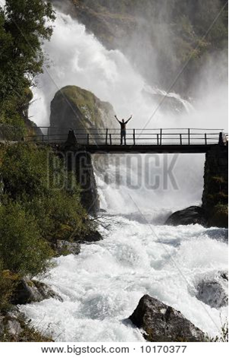

For the nation or kingdom that will not serve you will perish; it will be utterly ruined.

~ Isaiah 60:12 (NIV)

“They will throw their silver into the streets, and their gold will be treated as a thing unclean.
“Their silver and gold will not be able to deliver them in the day of the Lord’s wrath.
“It will not satisfy their hunger or fill their stomachs, for it has caused them to stumble into sin.”

~ Ezekiel 7:19 (NIV)

Wealth is worthless in the day of wrath…

~ Proverbs 11:4a (NIV)

However, if you do not obey the Lord your God and do not carefully follow all his commands and decrees I am giving you today, all these curses will come on you and overtake you:
You will be cursed in the city and cursed in the country.
Your basket and your kneading trough will be cursed. The fruit of your womb will be cursed, and the crops of your land, and the calves of your herds and the lambs of your flocks.
You will be cursed when you come in and cursed when you go out.
The Lord will send on you curses, confusion and rebuke in everything you put your hand to, until you are destroyed and come to sudden ruin because of the evil you have done in forsaking him…
The Lord will strike you with wasting disease, with fever and inflammation, with scorching heat and drought, with blight and mildew, which will plague you until you perish...
The Lord will turn the rain of your country into dust and powder…
The Lord will cause you to be defeated before your enemies. You will come at them from one direction but flee from them in seven, and you will become a thing of horror to all the kingdoms on earth…
The Lord will afflict you with the boils of Egypt and with tumors, festering sores and the itch, from which you cannot be cured.
The Lord will afflict you with madness, blindness and confusion of mind…
A people that you do not know will eat what your land and labor produce, and you will have nothing but cruel oppression all your days. The sights you see will drive you mad…
You will sow much seed in the field but you will harvest little, because locusts will devour it…The foreigners who reside among you will rise above you higher and higher, but you will sink lower and lower. …
Just as it pleased the Lord to make you prosper and increase in number, so it will please him to ruin and destroy you.
You will be uprooted from the land you are entering to possess.

~ Deuteronomy 28:15-63 (NIV)

Even now the ax of God’s judgment is poised, ready to sever the roots of the trees.
Yes, every tree that does not produce good fruit will be chopped down and thrown into the fire.

~ Matthew 3:10 (NLT)

By the wrath of the Lord Almighty the land will be scorched and the people will be fuel for the fire…

~ Isaiah 9:19a (NIV)

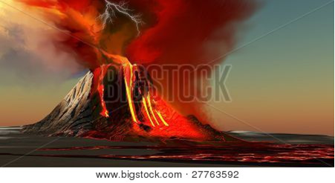

“Hear this, you foolish and senseless people, who have eyes but do not see, who have ears but do not hear:
“Should you not fear me?” declares the Lord.
“Should you not tremble in my presence?”

~ Jeremiah 5:21-22a (NIV)

“You of this generation, consider the word of the Lord…”

~ Jeremiah 2:31a (NIV)

This is what the Lord says:
“I remember the devotion of your youth, how as a bride you loved me and followed me through the wilderness, through a land not sown…
“What fault did your ancestors find in me, that they strayed so far from me?...
“I brought you into a fertile land to eat its fruit and rich produce.
“But you came and defiled my land and made my inheritance detestable…
“Therefore I bring charges against you again,” declares the Lord. “And I will bring charges against your children’s children…
“Be appalled at this, you heavens, and shudder with great horror,” declares the Lord.
“Your wickedness will punish you; your backsliding will rebuke you.
“Consider then and realize how evil and bitter it is for you when you forsake the Lord your God and have no awe of me,” declares the Lord, the Lord Almighty.
“I had planted you like a choice vine of sound and reliable stock.
“How then did you turn against me into a corrupt, wild vine?”

~ Jeremiah 2:2b-21 (NIV)

Our ancestors captured fortified cities and fertile land…
So they ate until they were full and grew fat and enjoyed themselves in all your blessings.
But despite all this, they were disobedient and rebelled against you…
So you handed them over to their enemies, who made them suffer.
But in their time of trouble they cried to you, and you heard them from heaven…
But as soon as they were at peace, your people again committed evil in your sight, and once more you let their enemies conquer them.
Yet whenever your people turned and cried to you again for help, you listened once more from heaven.
In your wonderful mercy, you rescued them many times...
And now, our God, the great and mighty and awesome God, who keeps his covenant of unfailing love, do not let all the hardships we have suffered seem insignificant to you…
We have sinned greatly, and you gave us only what we deserved. Our kings, leaders, priests, and ancestors did not obey your Law or listen to the warnings in your commands and laws.
Even while they had their own kingdom, they did not serve you, though you showered your goodness on them.
You gave them a large, fertile land, but they refused to turn from their wickedness.
So now today we are slaves in the land of plenty that you gave our ancestors for their enjoyment! We are slaves here in this good land.
The lush produce of this land piles up in the hands of the kings whom you have set over us because of our sins. They have power over us and our livestock. We serve them at their pleasure, and we are in great misery.

~ Nehemiah 9:25-37 (NLT)

Warnings Against the Wickedness of Man

They perish because they refused to love the truth and so be saved.
For this reason God sends them a powerful delusion so that they will believe the lie and so that all will be condemned who have not believed the truth but have delighted in wickedness.

~ 2 Thessalonians 2:10b-12 (NIV)

The wrath of God is being revealed from heaven against all the godlessness and wickedness of people, who suppress the truth by their wickedness, since what may be known about God is plain to them, because God has made it plain to them.
For since the creation of the world God’s invisible qualities—his eternal power and divine nature—have been clearly seen, being understood from what has been made, so that people are without excuse.
For although they knew God, they neither glorified him as God nor gave thanks to him, but their thinking became futile and their foolish hearts were darkened. Although they claimed to be wise, they became fools…
Furthermore, just as they did not think it worthwhile to retain the knowledge of God, so God gave them over to a depraved mind, so that they do what ought not to be done.
They have become filled with every kind of wickedness, evil, greed and depravity. They are full of envy, murder, strife, deceit and malice.
They are gossips, slanderers, God-haters, insolent, arrogant and boastful; they invent ways of doing evil; they disobey their parents; they have no understanding, no fidelity, no love, no mercy.

~ Romans 1:18-31 (NIV)

What do you conspire against the Lord? He will make an utter end of it.
Affliction will not rise up a second time.

~ Nahum 1:9 (NKJV)

And don’t forget Sodom and Gomorrah and their neighboring towns, which were filled with immorality and every kind of sexual perversion.
Those cities were destroyed by fire and serve as a warning of the eternal fire of God’s judgment.

~ Jude 1:7 (NLT)

The wicked prowl on every side, when vileness is exalted among the sons of men.

~ Psalm 12:8 (NKJV)

You push away every thought of coming disaster, but your actions only bring the day of judgment closer.

~ Amos 6:3 (NLT)

…you have planted wickedness, you have reaped evil, you have eaten the fruit of deception.

~ Hosea 10:13a (NIV)

Like a muddied spring or a polluted well are the righteous who give way to the wicked.

~ Proverbs 25:26 (NIV)

Warnings About the Wrath of God

“Whom have you so dreaded and feared that you have not been true to me…
“Is it not because I have long been silent that you do not fear me?”

~ Isaiah 57:11 (NIV)

“But I will show you whom you should fear:
“Fear Him who, after He has killed, has power to cast into hell…”

~ Luke 12:5a (NKJV)

“You have abandoned me and turned your back on me,” says the Lord. “Therefore, I will raise my fist to destroy you. I am tired of always giving you another chance.”

~ Jeremiah 15:6 (NLT)

“For my decision is to gather nations, to assemble kingdoms, to pour out upon them my indignation, all my burning anger; for in the fire of my jealousy all the earth shall be consumed.”

~ Zephaniah 3:8b (ESV)

“For my own name’s sake I delay my wrath; for the sake of my praise I hold it back from you, so as not to destroy you completely.”

~ Isaiah 48:9 (NIV)

But the Lord is the true God;
He is the living God and the everlasting King.
At His wrath the earth will tremble, and the nations will not be able to endure His indignation.

~ Jeremiah 10:10 (NKJV)

Standing in the Gap

“I looked for someone among them who would build up the wall and stand before me in the gap on behalf of the land so I would not have to destroy it, but I found no one.”

~ Ezekiel 22:30 (NIV)

“When I came, why was there no one? When I called, why was there no one to answer?”

~ Isaiah 50:2a (NIV)

Abraham Stands in the Gap

Then the Lord said, “The outcry against Sodom and Gomorrah is so great and their sin so grievous that I will go down and see if what they have done is as bad as the outcry that has reached me. If not, I will know.”
The men turned away and went toward Sodom, but Abraham remained standing before the Lord.
Then Abraham approached him and said: “Will you sweep away the righteous with the wicked? What if there are fifty righteous people in the city? Will you really sweep it away and not spare the place for the sake of the fifty righteous people in it? Far be it from you to do such a thing—to kill the righteous with the wicked, treating the righteous and the wicked alike. Far be it from you! Will not the Judge of all the earth do right?”
The Lord said, “If I find fifty righteous people in the city of Sodom, I will spare the whole place for their sake.”
Then Abraham spoke up again: “Now that I have been so bold as to speak to the Lord, though I am nothing but dust and ashes, what if the number of the righteous is five less than fifty? Will you destroy the whole city for lack of five people?”
“If I find forty-five there,” he said, “I will not destroy it…”
Then he said, “May the Lord not be angry, but let me speak just once more. What if only ten can be found there?”
He answered, “For the sake of ten, I will not destroy it.”

~ Genesis 18:20-32 (NIV)

Moses Stands in the Gap

But Moses implored the Lord his God and said, “O Lord, why does your wrath burn hot against your people, whom you have brought out of the land of Egypt with great power and with a mighty hand? Why should the Egyptians say, ‘With evil intent did he bring them out, to kill them in the mountains and to consume them from the face of the earth’?
“Turn from your burning anger and relent from this disaster against your people. Remember Abraham, Isaac, and Israel, your servants…”
And the Lord relented from the disaster that he had spoken of...

~ Exodus 32:11-14a (ESV)

Nehemiah Stands in the Gap

“Lord, the God of heaven, the great and awesome God, who keeps his covenant of love with those who love him and keep his commandments, let your ear be attentive and your eyes open to hear the prayer your servant is praying before you day and night for your servants, the people of Israel.
“I confess the sins we Israelites, including myself and my father’s family, have committed against you. We have acted very wickedly toward you. We have not obeyed the commands, decrees and laws you gave your servant Moses…
“Lord, let your ear be attentive to the prayer of this your servant and to the prayer of your servants who delight in revering your name.”

~ Nehemiah 1:5b-11a (NIV)

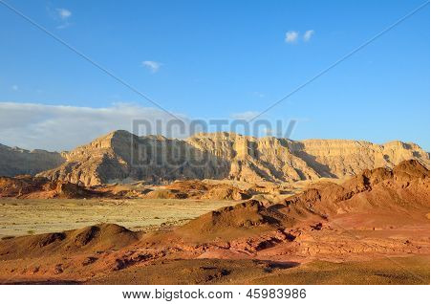

God Will Rescue the Righteous

Those who fear the Lord are secure; he will be a refuge for their children.

~ Proverbs 14:26 (NLT)

“…suppose the people of a country were to sin against me, and I lifted my fist to crush them, cutting off their food supply and sending a famine to destroy both people and animals.
“Even if Noah, Daniel, and Job were there, their righteousness would save no one but themselves, says the Sovereign Lord.”

~ Ezekiel 14:13b-14 (NLT)

For God did not spare even the angels who sinned. He threw them into hell, in gloomy pits of darkness…
And God did not spare the ancient world—except for Noah and the seven others in his family. Noah warned the world of God’s righteous judgment. So God protected Noah when he destroyed the world of ungodly people with a vast flood.
Later, God condemned the cities of Sodom and Gomorrah and turned them into heaps of ashes…But God also rescued Lot out of Sodom because he was a righteous man who was sick of the shameful immorality of the wicked people around him...
So you see, the Lord knows how to rescue godly people from their trials and to hold the unrighteous for punishment on the day of judgment.

~ 2 Peter 2:4-9 (NLT)



When it is Too Late for a Nation

The wicked will go down to the grave.
This is the fate of all the nations who ignore God.

~ Psalm 9:17 (NLT)

Gather together—yes, gather together, you shameless nation.
Gather before judgment begins, before your time to repent is blown away like chaff.
Act now, before the fierce fury of the Lord falls and the terrible day of the Lord’s anger begins.
Seek the Lord, all who are humble, and follow his commands.
Seek to do what is right and to live humbly.
Perhaps even yet the Lord will protect you—protect you from his anger on that day of destruction.

~ Zephaniah 2:1-3 (NLT)

And the Lord God of their fathers sent warnings to them by His messengers…because He had compassion on His people and on His dwelling place.
But they mocked the messengers of God, despised His words, and scoffed at His prophets, until the wrath of the Lord arose against His people, till there was no remedy.

~ 2 Chronicles 36:15-16 (NKJV)

…until the Lord’s anger could no longer be restrained and nothing could be done.

~ 2 Chronicles 36:16b (NLT)

Give glory to the Lord your God before he brings the darkness, before your feet stumble on the darkening hills.
You hope for light, but he will turn it to utter darkness and change it to deep gloom.

~ Jeremiah 13:16 (NIV)

Further Reading
Deuteronomy 8
Deuteronomy 28
The book of Jeremiah

When a Nation Turns to God for Mercy

This is what the Lord of Heaven’s Armies, the God of Israel, says:
“Even now, if you quit your evil ways, I will let you stay in your own land.”

~ Jeremiah 7:3 (NLT)

“Then I will change my mind about the disaster I am ready to pour out on them because of their sins.”

~ Jeremiah 26:3b (NLT)

…if you stop your sinning and begin to obey the Lord your God, he will change his mind about this disaster that he has announced against you.

~ Jeremiah 26:13 (NLT)

Seek the Lord, all you humble of the land, you who do what he commands.
Seek righteousness, seek humility; perhaps you will be sheltered on the day of the Lord’s anger.

~ Zephaniah 2:3 (NIV)

Seek the Lord while He may be found,
Call upon Him while He is near.
Let the wicked forsake his way, and the unrighteous man his thoughts;
Let him return to the Lord, and He will have mercy on him; and to our God, for He will abundantly pardon.

~ Isaiah 55:6-7 (NKJV)

For we do not present our pleas before you because of our righteousness, but because of your great mercy.

~ Daniel 9:18b (ESV)

Surely his salvation is near to those who fear him, so our land will be filled with his glory.

~ Psalm 85:9 (NLT)

That is why the Lord says,
“Turn to me now, while there is time.
“Give me your hearts. Come with fasting, weeping, and mourning.
“Return to the Lord your God, for he is merciful and compassionate, slow to get angry and filled with unfailing love.
“He is eager to relent and not punish. Who knows? Perhaps he will give you a reprieve, sending you a blessing instead of this curse.”

~ Joel 2:12-14a (NLT)

I knew that you are a merciful and compassionate God, slow to get angry and filled with unfailing love. You are eager to turn back from destroying people.

~ Jonah 4:2b (NLT)

…a God who relents from sending calamity.

~ Jonah 4:2b (NIV)

Turn from evil and do good; then you will dwell in the land forever.

~ Psalm 37:27 (NIV)

The land you have given me is a pleasant land. What a wonderful inheritance!

~ Psalm 16:6 (NLT)

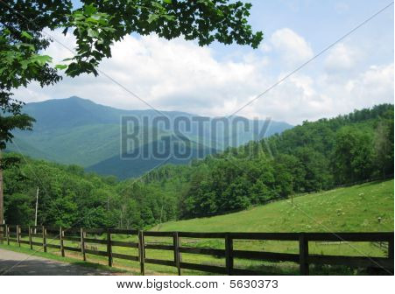

Biblical Principles for Government

I urge you, first of all, to pray for all people.
Ask God to help them; intercede on their behalf, and give thanks for them.
Pray this way for kings and all who are in authority so that we can live peaceful and quiet lives marked by godliness and dignity.

~ 1 Timothy 2:1-2 (NLT)

Let every person be subject to the governing authorities.

~ Romans 13:1a (ESV)

“If a kingdom is divided against itself, that kingdom cannot stand.”

~ Mark 3:24 (NKJV)

For the entire twelve years that I was governor of Judah…neither I nor my officials drew on our official food allowance. The former governors, in contrast, had laid heavy burdens on the people…
But because I feared God, I did not act that way.

~ Nehemiah 5:14-15 (NLT)

Without wise leadership, a nation falls…

~ Proverbs 11:14a (NLT)

…God appeared to Solomon and said, “What do you want? Ask, and I will give it to you!”
Solomon replied to God, “You showed faithful love to David, my father, and now you have made me king in his place…Give me the wisdom and knowledge to lead them…”
God said to Solomon, “Because your greatest desire is to help your people, and you did not ask for wealth, riches, fame, or even the death of your enemies or a long life, but rather you asked for wisdom and knowledge to properly govern my people—I will certainly give you the wisdom and knowledge you requested.”

~ 2 Chronicles 1:7-12a (NLT)

We must obey God rather than any human authority.

~ Acts 5:29b (NLT)

…the elders of Israel gathered together and came to Samuel at Ramah. They said to him, “…appoint a king to lead us, such as all the other nations have.”
But when they said, “Give us a king to lead us,” this displeased Samuel; so he prayed to the Lord.
And the Lord told him: “Listen to all that the people are saying to you; it is not you they have rejected, but they have rejected me as their king…”
Samuel told all the words of the Lord to the people who were asking him for a king. He said,
“This is what the king who will reign over you will claim as his rights:
He will take your sons and make them serve with his chariots and horses...
He will take your daughters to be perfumers and cooks and bakers.
He will take the best of your fields and vineyards and olive groves and give them to his attendants.
He will take a tenth of your grain and of your vintage and give it to his officials and attendants...
He will take a tenth of your flocks, and you yourselves will become his slaves.
“When that day comes, you will cry out for relief from the king you have chosen, but the Lord will not answer you in that day.”
But the people refused to listen to Samuel. “No!” they said. “We want a king over us. Then we will be like all the other nations…”

~ 1 Samuel 8:4-20a (NIV)

Thus says the Lord, the God of Israel, “…today you have rejected your God who saves you from all your calamities…and you have said to him, ‘Set a king over us.’”

~ 1 Samuel 10:18b-19a (ESV)

Trust in God Rather than People

It is better to take refuge in the Lord than to trust in man.

~ Psalm 118:8 (ESV)

For the eyes of the Lord run to and fro throughout the whole earth, to show Himself strong on behalf of those whose heart is loyal to Him.

~ 2 Chronicles 16:9a (NKJV)

Don’t put your confidence in powerful people; there is no help for you there. When they breathe their last, they return to the earth, and all their plans die with them.

~ Psalm 146:3-4 (NLT)

Don’t put your trust in mere humans. They are as frail as breath. What good are they?

~ Isaiah 2:22 (NLT)

…human help is worthless.

~ Psalm 60:11b (NIV)

Putting confidence in an unreliable person in times of trouble is like chewing with a broken tooth or walking on a lame foot.

~ Proverbs 25:19 (NLT)

“What sorrow awaits my rebellious children,” says the Lord. “You make plans that are contrary to mine. You make alliances not directed by my Spirit, thus piling up your sins.
“For without consulting me, you have gone down to Egypt for help. You have put your trust in Pharaoh’s protection. You have tried to hide in his shade. But by trusting Pharaoh, you will be humiliated, and by depending on him, you will be disgraced.”

~ Isaiah 30:1-3 (NLT)

In God I have put my trust…

~ Psalm 56:11a (NKJV)

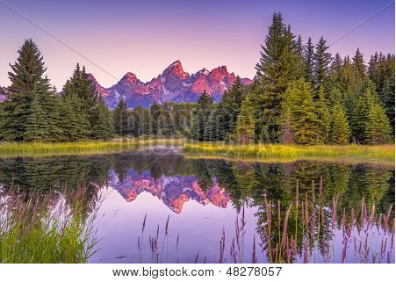

Trust in the Lord with all your heart, and lean not on your own understanding;
In all your ways acknowledge Him, and He shall direct your paths.

~ Proverbs 3:5-6 (NKJV)

Trust in the Lord and do good; dwell in the land and enjoy safe pasture.
Take delight in the Lord, and he will give you the desires of your heart.

~ Psalm 37:3-4 (NIV)

Trust in the Lord forever, for the Lord, the Lord himself, is the Rock eternal.

~ Isaiah 26:4 (NIV)

The Lord is my rock, my fortress, and my savior; my God is my rock, in whom I find protection.
He is my shield, the power that saves me, and my place of safety.

~ Psalm 18:2 (NLT)

This I declare about the Lord: He alone is my refuge, my place of safety; he is my God, and I trust him.

~ Psalm 91:2 (NLT)

This is what the Lord says:
“Cursed are those who put their trust in mere humans, who rely on human strength and turn their hearts away from the Lord.
“They are like stunted shrubs in the desert, with no hope for the future. They will live in the barren wilderness, in an uninhabited salty land.
“But blessed are those who trust in the Lord and have made the Lord their hope and confidence.
“They are like trees planted along a riverbank, with roots that reach deep into the water. Such trees are not bothered by the heat or worried by long months of drought. Their leaves stay green, and they never stop producing fruit.”

~ Jeremiah 17:5-8 (NLT)



O Lord of hosts, blessed is the one who trusts in you!

~ Psalm 84:12 (ESV)

Lord, there is no one like you to help the powerless against the mighty.
Help us, Lord our God, for we rely on you, and in your name we have come against this vast army.
Lord, you are our God; do not let mere mortals prevail against you.

~ 2 Chronicles 14:11b (NIV)

Only by your power can we push back our enemies; only in your name can we trample our foes.
I do not trust in my bow; I do not count on my sword to save me.

~ Psalm 44:5-6 (NLT)

Some trust in chariots and some in horses, but we trust in the name of the Lord our God.
They collapse and fall, but we rise and stand upright.

~ Psalm 20:7-8 (ESV)

A horse is a vain hope for deliverance; despite all its great strength it cannot save.
But the eyes of the Lord are on those who fear him, on those whose hope is in his unfailing love…

~ Psalm 33:17-18 (NIV)

…nothing can hinder the Lord.
He can win a battle whether he has many warriors or only a few!

~ 1 Samuel 14:6b (NLT)

Don’t be intimidated in any way by your enemies.
This will be a sign to them that they are going to be destroyed, but that you are going to be saved, even by God himself.

~ Philippians 1:28 (NLT)

Do not be afraid of them. Remember the Lord, who is great and awesome, and fight for your brothers, your sons, your daughters, your wives, and your homes.

~ Nehemiah 4:14b (ESV)

Do not be terrified by them, for the Lord your God, who is among you, is a great and awesome God.

~ Deuteronomy 7:21 (NIV)

Pray for Peace in Jerusalem

Pray for peace in Jerusalem. May all who love this city prosper.

~ Psalm 122:6 (NLT)

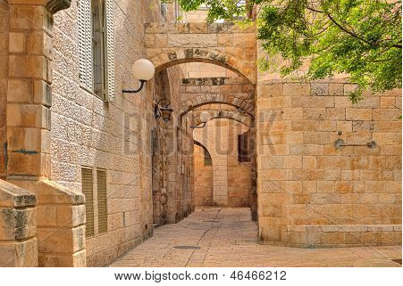

Old City of Jerusalem

The Lord had said to Abram,
“Go from your country, your people and your father’s household to the land I will show you.
“I will make you into a great nation, and I will bless you;
“I will make your name great, and you will be a blessing.
“I will bless those who bless you, and whoever curses you I will curse; and all peoples on earth will be blessed through you.”

~ Genesis 12:1-3 (NIV)

…the gifts and the calling of God are irrevocable.

~ Romans 11:29b (NKJV)

“The day is near when I, the Lord, will judge all godless nations!
“As you have done to Israel, so it will be done to you.
“All your evil deeds will fall back on your own heads.”

~ Obadiah 1:15 (NLT)

“In those days and at that time, when I restore the fortunes of Judah and Jerusalem, I will gather all nations and bring them down to the Valley of Jehoshaphat.
“There I will put them on trial for what they did to my inheritance, my people Israel, because they scattered my people among the nations and divided up my land.”

~ Joel 3:1-2 (NIV)

They are the people of Israel, chosen to be God’s adopted children…Abraham, Isaac, and Jacob are their ancestors, and Christ himself was an Israelite as far as his human nature is concerned…
Dear brothers and sisters, the longing of my heart and my prayer to God is for the people of Israel to be saved…For they don’t understand God’s way of making people right with himself…
I ask, then, has God rejected his own people, the nation of Israel?
Of course not!…No, God has not rejected his own people, whom he chose from the very beginning…
Now if the Gentiles were enriched because the people of Israel turned down God’s offer of salvation, think how much greater a blessing the world will share when they finally accept it…
So now you also receive the blessing God has promised Abraham and his children, sharing in the rich nourishment from the root of God’s special olive tree. But you must not brag about being grafted in to replace the branches that were broken off. You are just a branch, not the root…
Some of the people of Israel have hard hearts, but this will last only until the full number of Gentiles comes to Christ. And so all Israel will be saved…

~ Excerpts from Romans 9-11 (NLT)

God’s Gift of Eternal Life

God loves you abundantly, and has made a way for you to live forever in His glorious kingdom. However, first He had to pay an enormous price for you to be forgiven of your sin, in order to receive this eternal glory. This section explains His plan to forgive and save you. In summary:
God loves you, but your sin separates you from Him, and because of it, God’s wrath will come. However, Jesus died as a sacrifice to save you from your sins, from God’s wrath, and from death itself. When you confess your sins, repent and accept the salvation that Christ offers, God will forgive you. By trusting in Christ you become God’s child, and as His child, you will inherit eternal life and heaven will be your home.

God Loves You

“…I lavish unfailing love for a thousand generations on those who love me and obey my commands.”

~ Deuteronomy 5:10 (NLT)

“I have loved you with an everlasting love;
“I have drawn you with unfailing kindness.”

~ Jeremiah 31:3b (NIV)

“Though the mountains be shaken and the hills be removed, yet my unfailing love for you will not be shaken nor my covenant of peace be removed,” says the Lord, who has compassion on you.

~ Isaiah 54:10 (NIV)

“So do not fear, for I am with you;
“do not be dismayed, for I am your God.
“I will strengthen you and help you;
“I will uphold you with my righteous right hand.”

~ Isaiah 41:10 (NIV)

How great is the goodness you have stored up for those who fear you.
You lavish it on those who come to you for protection, blessing them before the watching world.

~ Psalm 31:19 (NLT)

We know how much God loves us, and we have put our trust in his love.
God is love, and all who live in love live in God, and God lives in them.

~ 1 John 4:16 (NLT)

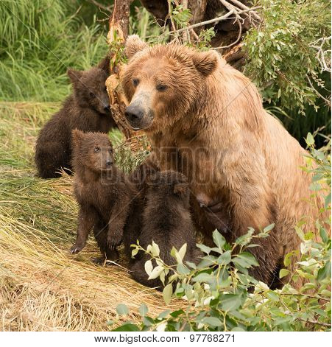

As a father has compassion on his children, so the Lord has compassion on those who fear him…

~ Psalm 103:13 (NIV)

But Your Sin Separates You from God

But your iniquities have separated you from your God; and your sins have hidden His face from you, so that He will not hear.

~ Isaiah 59:2 (NKJV)

For of this you can be sure: No immoral, impure or greedy person—such a person is an idolater—has any inheritance in the kingdom of Christ and of God.
Let no one deceive you with empty words, for because of such things God’s wrath comes on those who are disobedient.

~ Ephesians 5:5-6 (NIV)

The Day of God’s Wrath Will Come

“See, the day of the Lord is coming—a cruel day, with wrath and fierce anger—to make the land desolate and destroy the sinners within it.”

~ Isaiah 13:9 (NIV)

“Then I will draw near to you for judgment.
“I will be a swift witness
against the sorcerers,
against the adulterers,
against those who swear falsely,
against those who oppress the hired worker in his wages, the widow and the fatherless,
against those who thrust aside the sojourner,
“and do not fear me,” says the Lord of hosts.

~ Malachi 3:5 (ESV)

Do not be deceived:
God cannot be mocked. A man reaps what he sows.

~ Galatians 6:7 (NIV)

For God will bring every deed into judgment, including every hidden thing, whether it is good or evil.

~ Ecclesiastes 12:14 (NIV)

He will guard the feet of his faithful servants, but the wicked will be silenced in the place of darkness.

~ 1 Samuel 2:9a (NIV)

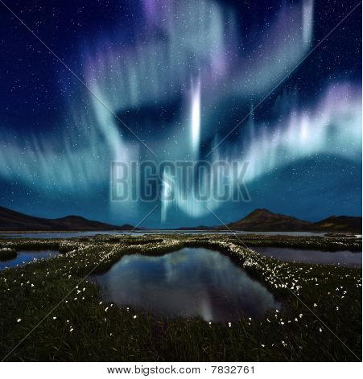

They will be punished with everlasting destruction and shut out from the presence of the Lord and from the glory of his might…

~ 2 Thessalonians 1:9 (NIV)

…forever separated from the Lord and from his glorious power.

~ 2 Thessalonians 1:9b (NLT)

Confess Your Sin and Repent

“But unless you repent, you too will all perish.”

~ Luke 13:3b (NIV)

Have mercy on me, O God, according to your unfailing love; according to your great compassion blot out my transgressions.
Wash away all my iniquity and cleanse me from my sin. For I know my transgressions, and my sin is always before me. Against you, you only, have I sinned and done what is evil in your sight…
Cleanse me with hyssop, and I will be clean; wash me, and I will be whiter than snow.
Let me hear joy and gladness; let the bones you have crushed rejoice.
Hide your face from my sins and blot out all my iniquity.
Create in me a pure heart, O God, and renew a steadfast spirit within me.
Do not cast me from your presence or take your Holy Spirit from me.
Restore to me the joy of your salvation and grant me a willing spirit, to sustain me.
Then I will teach transgressors your ways, so that sinners will turn back to you…

~ Psalm 51:1-13 (NIV)

Jesus Died to Save You

…From Your Sin

Jesus gave his life for our sins, just as God our Father planned, in order to rescue us from this evil world in which we live.

~ Galatians 1:4 (NLT)

In his name the nations will put their hope.

~ Matthew 12:21 (NIV)

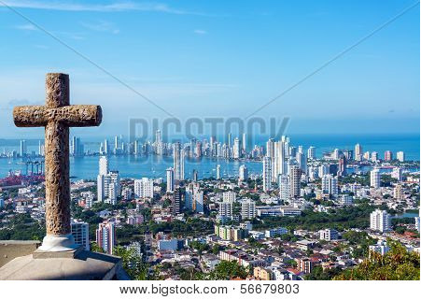

…From God’s Wrath

For God did not appoint us to suffer wrath but to receive salvation through our Lord Jesus Christ.

~ 1 Thessalonians 5:9 (NIV)

…everyone who calls on the name of the Lord will be saved.

~ Acts 2:21 (NLT)

…From Death

For the wages of sin is death, but the free gift of God is eternal life in Christ Jesus our Lord.

~ Romans 6:23 (ESV)

He broke the power of death and illuminated the way to life and immortality through the Good News.

~ 2 Timothy 1:10b (NLT)

God Demonstrates His Love Through Christ

“For God so loved the world that He gave His only begotten Son, that whoever believes in Him should not perish but have everlasting life.”

~ John 3:16 (NKJV)

…God demonstrates his own love for us in this:
While we were still sinners, Christ died for us.

~ Romans 5:8 (NIV)

God Bought You at a Price

You are not your own; you were bought at a price.

~ 1 Corinthians 6:19b-20a (NIV)

God paid a high price for you, so don’t be enslaved by the world.

~ 1 Corinthians 7:23 (NLT)

But he was pierced for our transgressions, he was crushed for our iniquities; the punishment that brought us peace was on him, and by his wounds we are healed.

~ Isaiah 53:5 (NIV)

Therefore God exalted him to the highest place and gave him the name that is above every name, that at the name of Jesus every knee should bow, in heaven and on earth and under the earth, and every tongue acknowledge that Jesus Christ is Lord…

~ Philippians 2:9-11a (NIV)

In Christ You Are Forgiven

Then God made you alive with Christ, for he forgave all our sins.
He canceled the record of the charges against us and took it away by nailing it to the cross.

~ Colossians 2:13b-14 (NLT)

For with the Lord there is mercy, and with Him is abundant redemption.

~ Psalm 130:7b (NKJV)

Salvation is Through Christ Alone

Salvation is found in no one else, for there is no other name under heaven given to mankind by which we must be saved.

~ Acts 4:12 (NIV)

Jesus said to him, “I am the way, the truth, and the life. No one comes to the Father except through Me.”

~ John 14:6 (NKJV)

“I have come as a light to shine in this dark world, so that all who put their trust in me will no longer remain in the dark.”

~ John 12:46 (NLT)

“…whoever comes to me I will never drive away.”

~ John 6:37b (NIV)

“For the Son of Man came to seek and to save the lost.”

~ Luke 19:10 (ESV)

“…your Father in heaven is not willing that any of these little ones should perish.”

~ Matthew 18:14b (NIV)

Salvation is a Gift: Free and Undeserved

For it is by grace you have been saved, through faith—and this not from yourselves, it is the gift of God—not by works, so that no one can boast.

~ Ephesians 2:8-9 (NIV)

Salvation is not a reward for the good things we have done…

~ Ephesians 2:9a (NLT)

Accept This Gift of Salvation

If you declare with your mouth, “Jesus is Lord,” and believe in your heart that God raised him from the dead, you will be saved.

~ Romans 10:9 (NIV)

This is all the more urgent, for you know how late it is; time is running out.

~ Romans 13:11a (NLT)

…how shall we escape if we ignore so great a salvation?

~ Hebrews 2:3a (NIV)

You Belong to God Through Faith in Christ and Have Become His Child

See what great love the Father has lavished on us, that we should be called children of God!

~ 1 John 3:1a (NIV)

We know that we are children of God, and that the whole world is under the control of the evil one.

~ 1 John 5:19 (NIV)

“If you belonged to the world, it would love you as its own.
“As it is, you do not belong to the world, but I have chosen you out of the world.”

~ John 15:19a (NIV)

Everyone who believes that Jesus is the Christ has become a child of God.

~ 1 John 5:1a (NLT)

And since you are his child, God has made you his heir.

~ Galatians 4:7b (NLT)

Eternal Life is Yours Through Christ

…God has given us eternal life, and this life is in His Son.

~ 1 John 5:11b (NKJV)



Your new life will last forever because it comes from the eternal, living word of God.

~ 1 Peter 1:23b (NLT)

Heaven is Your Home

“In My Father’s house are many mansions...
“I go to prepare a place for you.”

~ John 14:2 (NKJV)

No eye has seen, no ear has heard, and no mind has imagined what God has prepared for those who love him.

~ 1 Corinthians 2:9b (NLT)

Since you have been raised to new life with Christ, set your sights on the realities of heaven, where Christ sits in the place of honor at God’s right hand.
Think about the things of heaven, not the things of earth.

~ Colossians 3:1-2 (NLT)

But as it is, they desire a better country, that is, a heavenly one.
Therefore God is not ashamed to be called their God, for he has prepared for them a city.

~ Hebrews 11:16 (ESV)

For here we have no lasting city, but we seek the city that is to come.

~ Hebrews 13:14 (ESV)

…our citizenship is in heaven, and from it we await a Savior, the Lord Jesus Christ...

~ Philippians 3:20 (ESV)

If only for this life we have hope in Christ, we are of all people most to be pitied.

~ 1 Corinthians 15:19 (NIV)

…we wait for the blessed hope—the appearing of the glory of our great God and Savior, Jesus Christ...

~ Titus 2:13 (NIV)

For our light and momentary troubles are achieving for us an eternal glory that far outweighs them all.
So we fix our eyes not on what is seen, but on what is unseen, since what is seen is temporary, but what is unseen is eternal.

~ 2 Corinthians 4:17-18 (NIV)

Jesus answered, “My kingdom is not of this world.”

~ John 18:36a (ESV)

His dominion is an everlasting dominion that will not pass away, and his kingdom is one that will never be destroyed.

~ Daniel 7:14b (NIV)

Since we are receiving a Kingdom that is unshakable, let us be thankful and please God by worshiping him with holy fear and awe.

~ Hebrews 12:28 (NLT)

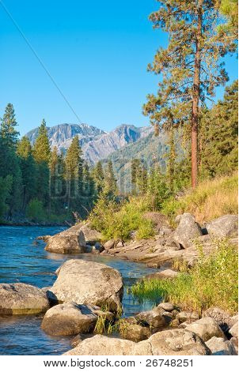

Surely you have granted him unending blessings and made him glad with the joy of your presence.

~ Psalm 21:6 (NIV)

Point out anything in me that offends you, and lead me along the path of everlasting life.

~ Psalm 139:24 (NLT)

See if there is any offensive way in me, and lead me in the way everlasting.

~ Psalm 139:24 (NIV)

You make known to me the path of life;
you will fill me with joy in your presence,
with eternal pleasures at your right hand.

~ Psalm 16:11 (NIV)

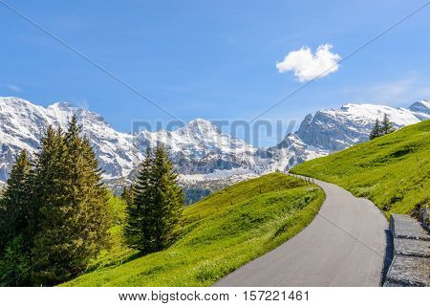

Inspire the Next Generation

Let me proclaim your power to this new generation, your mighty miracles to all who come after me.

~ Psalm 71:18b (NLT)

Let this be recorded for a generation to come, so that a people yet to be created may praise the Lord...

~ Psalm 102:18 (ESV)

One generation commends your works to another…
They speak of the glorious splendor of your majesty…
They tell of the power of your awesome works…
They celebrate your abundant goodness…
They tell of the glory of your kingdom…
Your kingdom is an everlasting kingdom…

~ Psalm 145:4-13a (NIV)

Fix these words of mine in your hearts and minds…
Teach them to your children, talking about them when you sit at home and when you walk along the road, when you lie down and when you get up.

~ Deuteronomy 11:18-19 (NIV)

We will not hide these truths from our children; we will tell the next generation about the glorious deeds of the Lord, about his power and his mighty wonders…
He commanded our ancestors to teach them to their children, so the next generation might know them—even the children not yet born—and they in turn will teach their own children.
So each generation should set its hope anew on God, not forgetting his glorious miracles and obeying his commands.

~ Psalm 78:4-7 (NLT)

For the Lord is good; His mercy is everlasting, and His truth endures to all generations.

~ Psalm 100:5 (NKJV)

But thou, O Lord, shall endure for ever; and thy remembrance unto all generations.

~ Psalm 102:12 (KJV)



I will perpetuate your memory through all generations; therefore the nations will praise you for ever and ever.

~ Psalm 45:17 (NIV)

Photo Copyright Info

Note: when purchasing the rights to use the photos, you may want to purchase an Extended License for the cover image.

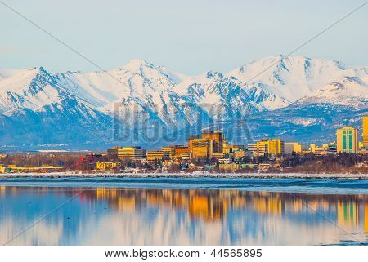
Bigstock Photo ID: 44565895
Downtown Anchorage
Downtown Anchorage at sunset on a clear spring day. ** Note: Slight graininess, best at smaller sizes
Stock Photo 44565895
Copyright: JCB5754

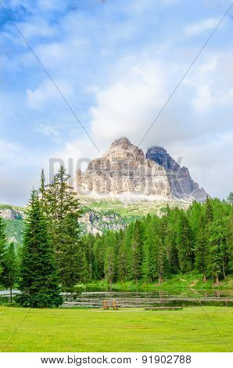
Bigstock Photo ID: 91902788
Editing suggestion: Crop top and bottom of photo to be consistent with the print booklet
Beautiful mountain landscape of Dolomites
Beautiful mountain landscape in Sexten Dolomites, South Tyrol, Italy
Stock Photo ID: 91902788

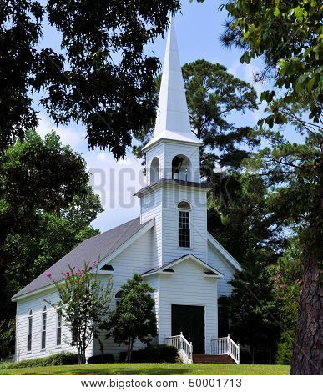
Bigstock Photo ID: 50001713
Editing suggestion: Rotate photo to be consistent with print booklet
Church in the Pines
The Church in the Pines, located at Children's Harbor. Lake Martin at Kowaliga, Alabama:
Stock Photo 50001713
Copyright: doncon402

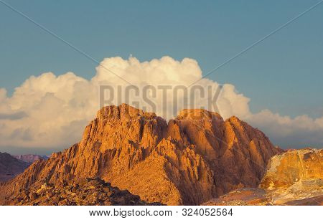
Bigstock Photo ID: 324052564
Amazing Sunrise at Sinai Mountain, Beautiful dawn in Egypt, early morning view of the top of Mount Moses
Stock Photo ID: 324052564
Copyright: AntonMaster

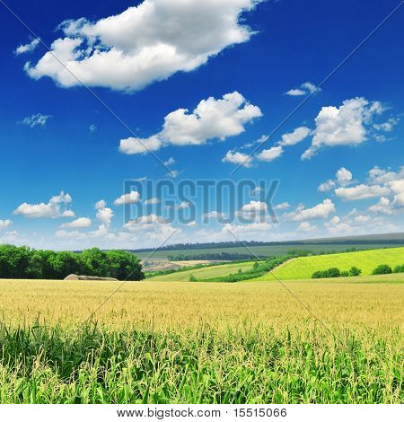
Bigstock Photo ID: 15515066
corn field
Stock Photo 15515066
Copyright: Serg64

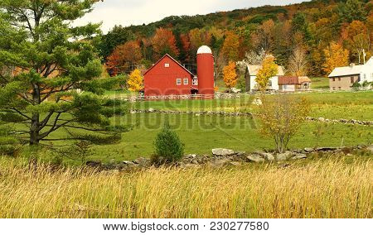
Bigstock Photo ID: 230277580
Editing suggestion: Slightly brighten
Vermont Farm with Red Barn and Fall Foliage
Stock Photo ID: 230277580
Copyright: SusansPhotos

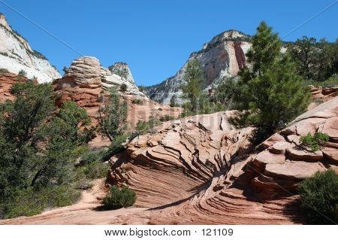
Bigstock Photo ID: Bigstock-121109
By The Mt. Carmel Highway
Crossbedded sandstone layers by the Mt. Carmel Highway
Stock Photo ID: 121109
Copyright: High Country Photos

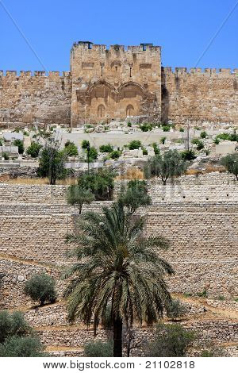
Bigstock Photo ID: 21102818
View of Golden gates in Jerusalem's Old City Walls, garden and ancient cemetery, Israel
by Snake81, Stock Photo 21102818

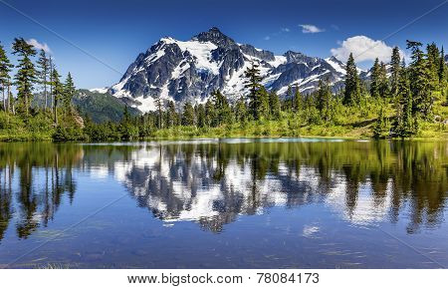

Bigstock Photo ID: 78084173

Editing suggestion: Slightly brighten

Picture Lake Evergreens Mount Shuksan Mount Baker Highway Snow Mountain Trees Washington Pacific Northwest USA
Stock Photo ID: 78084173
Copyright: BILLPERRY


Bigstock Photo ID: 25568384
summer landscape with sea and mountains
by feoris, Stock Photo 25568384

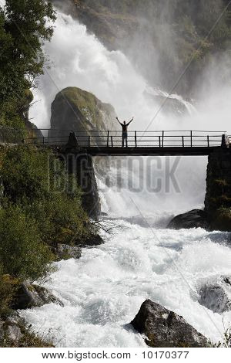
Bigstock Photo ID: 10170377
Editing suggestion: Use the Generative Erase tool to remove person from bridge
Traveler In Norway
Male tourist above an extremely powerful waterfall in Briksdalen valley Jostedalsbreen National Park in Norway.
Stock Photo 10170377
Copyright: Tupungato
Release: Signed model release filed with Bigstock.

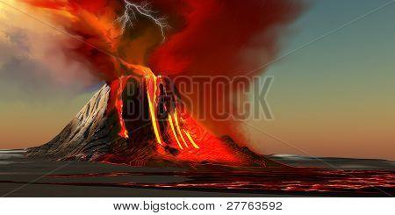
Bigstock Photo ID: 27763592
Hawaii Volcano
The Kilauea volcano erupts on the island of Hawaii with plumes of fire and smoke. Rivers of lava head to the ocean making new land.
Stock Photo 27763592
Copyright: Corey Ford

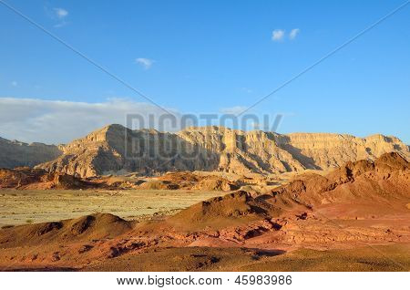
Bigstock Photo ID: 45983986
The Timna Valley - historical area is rich in copper ore the southwestern Arabah Israel.
Stock Photo 45983986
Copyright: AG-PHOTOS


Bigstock Photo ID: 44818732
James Bond island sunset panoramic photography. Famous travel destination, Khao Phing Kan, Ko Tapu, Phang Nga Bay, Andaman Sea, Thailand. Exotic tropical nature landscape background
Stock Photo ID: 44818732
Copyright: SergWSQ
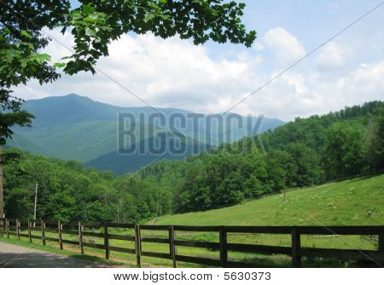
Bigstock Photo ID: 5630373
Moutain Landscape
Beautiful mountain view with a rural landscape
Stock Photo 5630373
Copyright: Lori Worsencroft

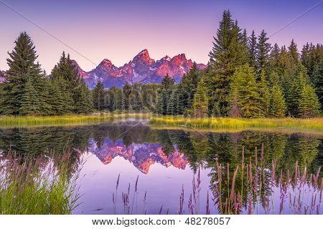
Bigstock Photo ID: 48278057
Editing suggestion: Decrease color warmth and saturation
The Teton range's reflection upon the Snake River. Photographed at dawn at Schwabacher's Landing in Grand Teton National Park WY
Stock Photo ID: 48278057
Copyright: Dean Fikar


Bigstock Photo ID: 11179283
Appalachian Springtime
The yellow-green colors of spring decorate the mountains of West Virginia in June.
Stock Photo 11179283
Copyright: wakr10

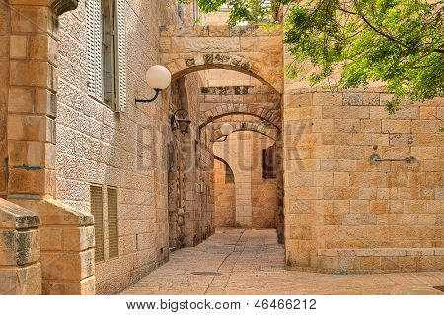
Bigstock Photo ID: 46466212
Narrow cobbled street among traditional stoned houses of jewish quarter at old historic part of jerusalem, Israel.
Stock Photo 46466212
Copyright: rglinsky

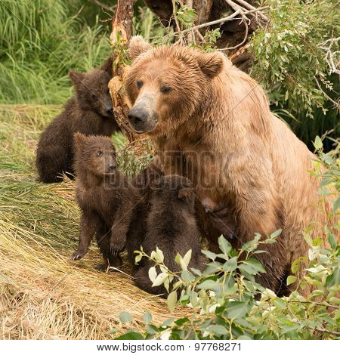

Bigstock Photo ID: 97768271

Four brown bear cubs are sitting with their mother on the bank of Brooks River Alaska. One is looking up at her. ** Note: Soft Focus at 100%, best at smaller sizes
Stock Photo ID: 97768271
Copyright: Nick Dale


Bigstock Photo ID: 7832761
The Northern Light over the marsh landscape with wildflowers in Landmannarlaugar Iceland
Stock Photo ID: 7832761
Copyright: Corepics

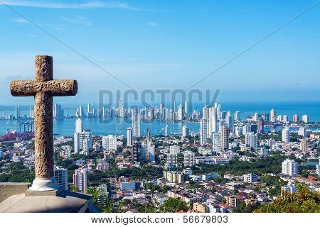
Bigstock Photo ID: 56679803
Cross And Modern City
View of the modern part of Cartagena Colombia with a stone cross in the foreground
Stock Photo ID: 56679803
Copyright: jkraft5

Bigstock Photo ID: 5918559
Editing suggestion: Brighten photo
Pacific sunrise
Pacific sunrise begins the day at Lanikai beach Hawaii
Stock Photo 5918559
Copyright: tomasfoto

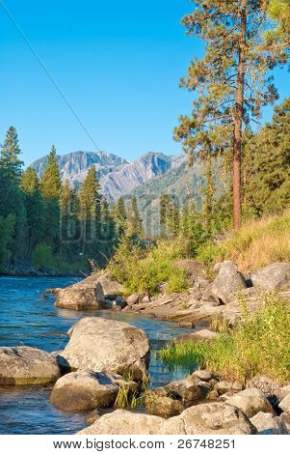
Bigstock Photo ID: 26748251
Beautiful mountain river.
Stock Photo 26748251
Copyright: karamysh

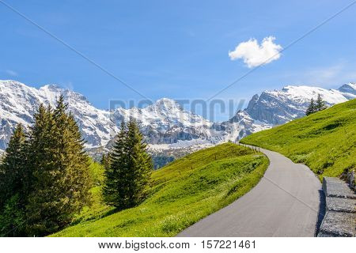
Bigstock Photo ID: 157221461
Crossing the Alps. Hiking trail in the Alps. Murren. Switzerland.
Stock Photo ID: 157221461
Copyright: karamysh


Bigstock Photo ID: 33863027
Mountain scenery, National park Durmitor, Montenegro
Stock Photo 33863027
Copyright: katritch

Booklet Titles in the Series
www.TheWordOfGodSeries.com
Relational and Emotional Health Topics

A Joy-Filled Life

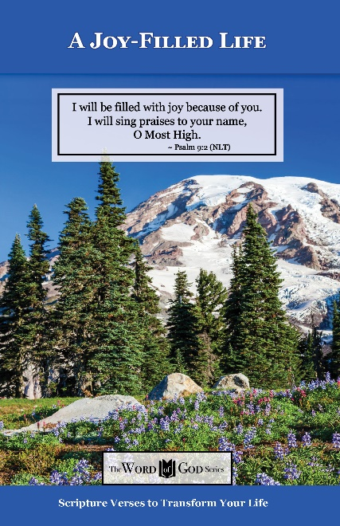
Relational and Emotional Health Topics

Healthy Relationships

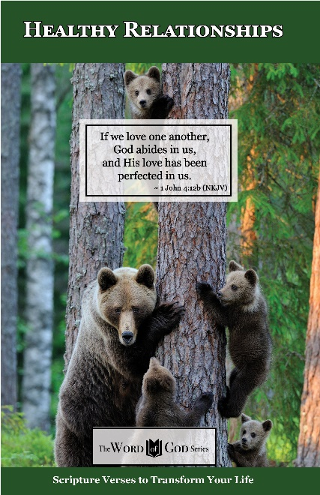
Relational and Emotional Health Topics

Healthy Thoughts

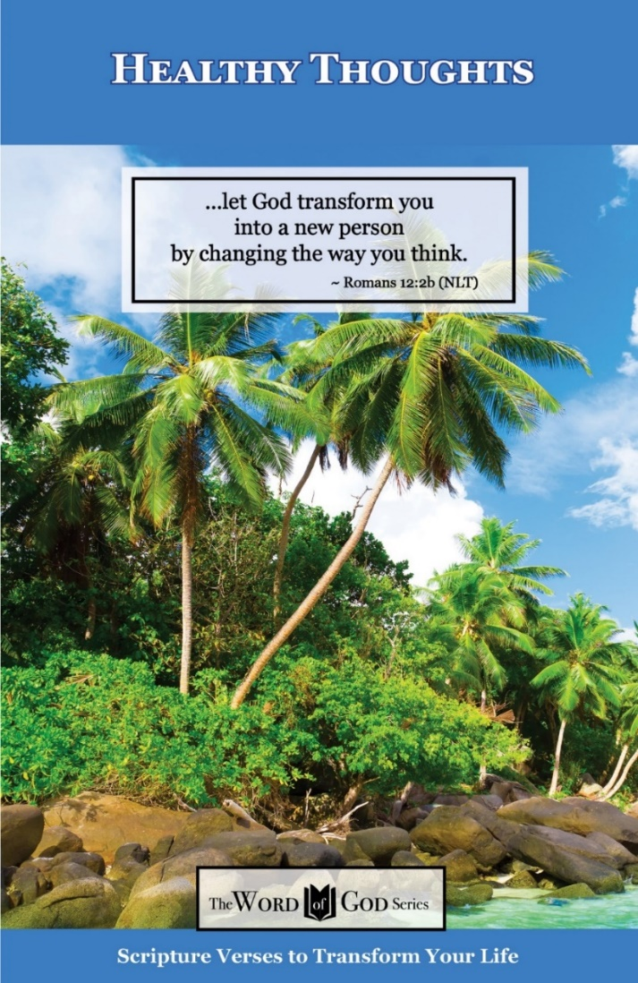
Relational and Emotional Health Topics

Freedom from Depression and Comfort in Grief

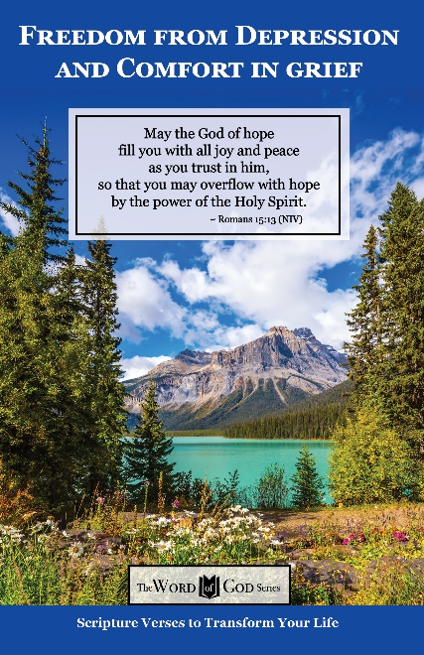
Relational and Emotional Health Topics

Freedom from Fear

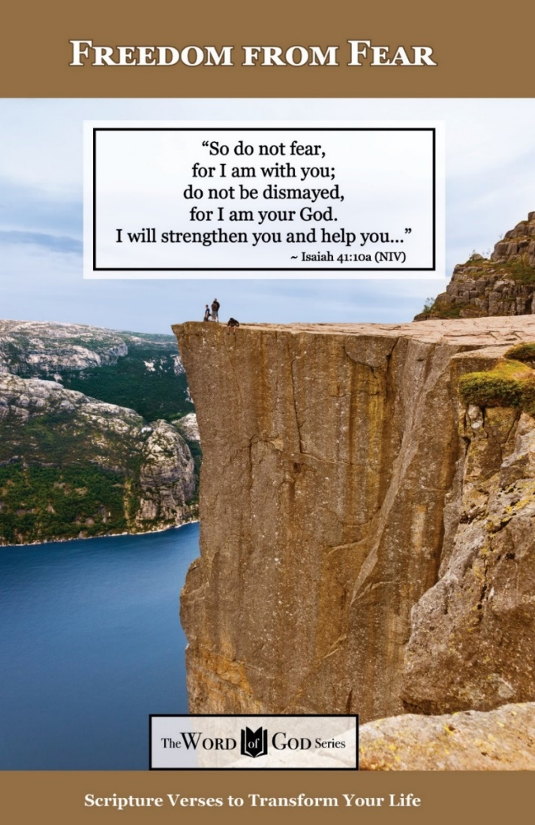
Relational and Emotional Health Topics

Freedom from Addictions

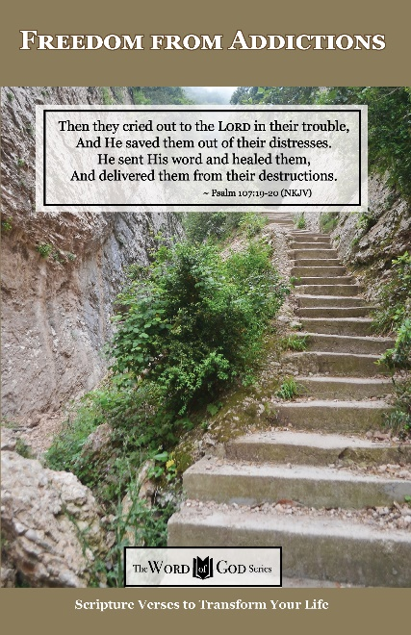
The Life and Ministry of Christ Series

Jesus: His Birth

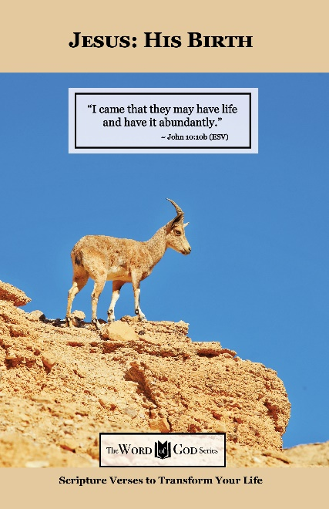
The Life and Ministry of Christ Series

Jesus: His Life Events

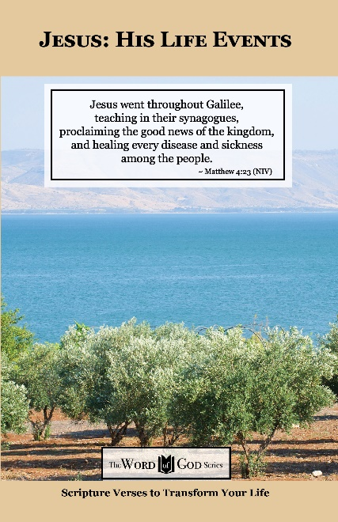
The Life and Ministry of Christ Series

Jesus: His Teachings

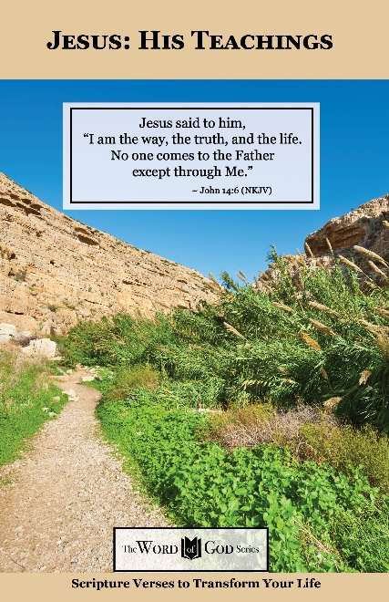
The Life and Ministry of Christ Series

Jesus: His Death, Resurrection and Return

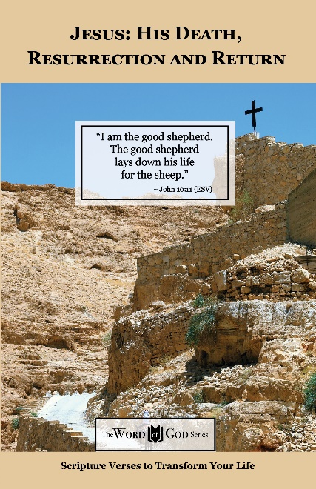
Spiritual Growth Topics

God’s Power and Presence

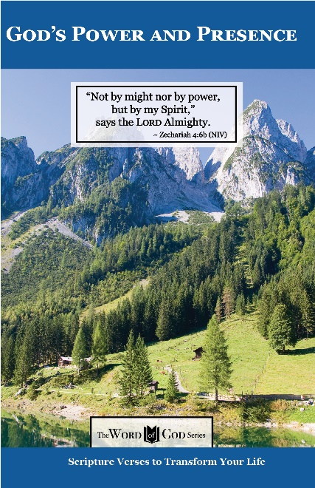
Spiritual Growth Topics

God’s Gift of Eternal Life

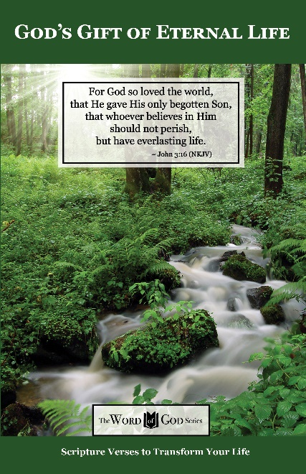
Spiritual Growth Topics

Sharing the Good News

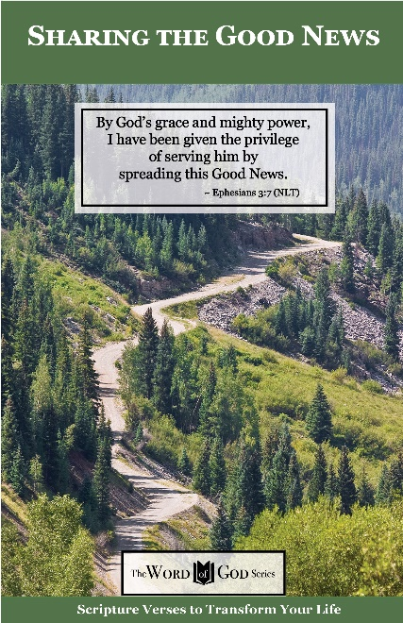
Spiritual Growth Topics

Defeating the Enemy

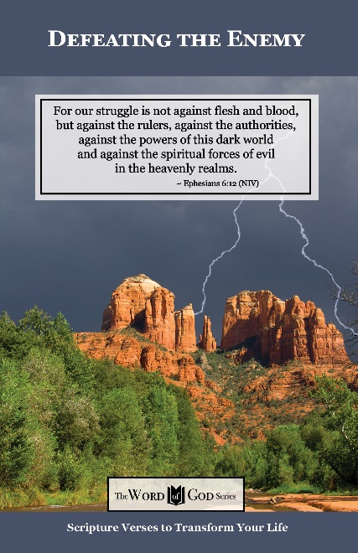
Spiritual Growth Topics

Standing Strong in Persecution

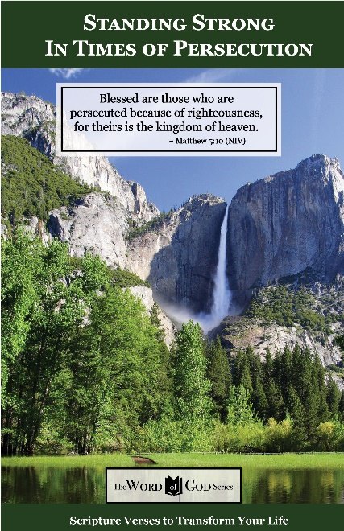
Everyday Life Topics

God’s Healing Power

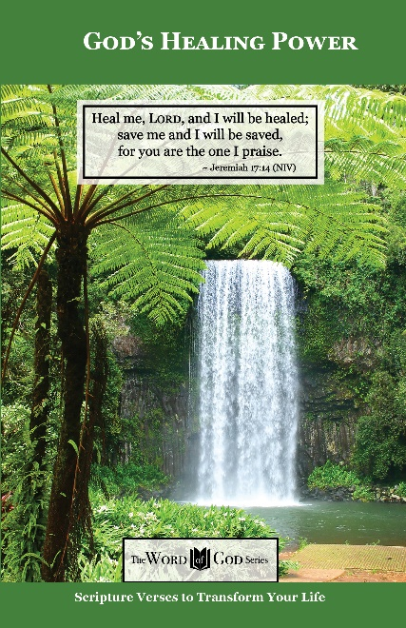
Everyday Life Topics

God is Your Refuge

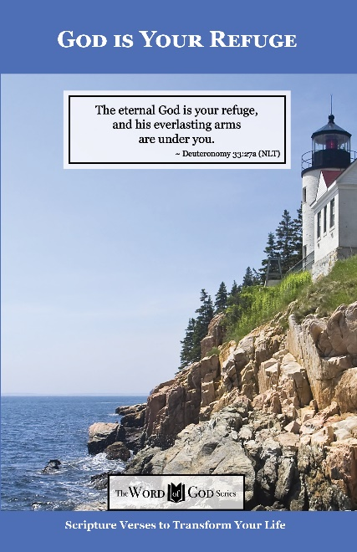
Everyday Life Topics

God’s Guidance for Your Life

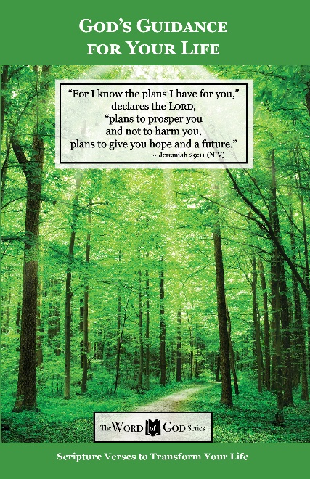
Everyday Life Topics

God’s Word to the Nations

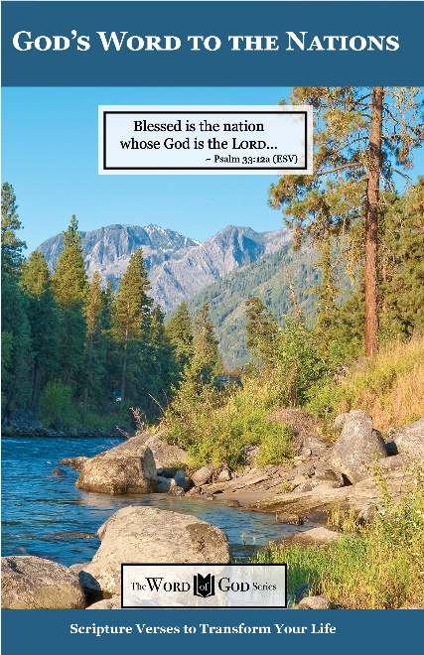
Everyday Life Topics

Praise God at Thanksgiving

