Template for Jesus: His Death, Resurrection and Return in an eBooklet Format

The Word of God Series is a collection of 20 booklets that present Scripture verses in an easy-to-read format, with each booklet focused on a different topic.
Titles include Healthy Relationships, A Joy-Filled Life, Freedom from Depression, and many others. Click here to see other titles.
The booklets are available in both paperback and digital formats at www.TheWordOfGodSeries.com or Amazon.com.
Why This Template?
Because I believe in the power of God’s Word to transform people’s lives, I have dedicated several years of my life to bring this series to fruition.
I am passionate about using these booklets to reach a dark and dying world with the love of Christ and the hope of the Gospel.
Initially, I had expected this series would be a small business. But one day, when I asked God what my next steps should be, He spoke to me through His Word and told me to:
“…complete the ministry God has given you.”
~ 2 Timothy 4:5 (NLT, 1996 version)
So, I shifted the focus from being a business to a ministry.
My vision, also, has evolved over time and I have come to believe that it is possible for millions of these booklets to be distributed (in both print and digital formats) around the world (see the document entitled The Vision at www.TheWordOfGodSeries.com for more info.)
In order to make this a far-reaching ministry, accessing populations that I couldn’t on my own, I decided to invite others to partner with me in producing and distributing these booklets to their own personal networks. To help get it started, I have made templates of each booklet freely available to anyone who would like them.
This way you (whether you are a church, Christian organization or an individual) can easily re-create the booklets in your own ministry’s name, and distribute them to the people you minister to.
I hope that this template will save you:
- Time – so you can benefit from the thousands of hours of development time that has been invested so far
- Money – eliminate layers of profit margin
Whether you simply replicate and reproduce what has already been done, build on it, or take this idea in a different direction, you won’t have to waste time starting with a blank page.
I hope you can easily get these finalized, so you can begin sharing them with the people in your sphere of influence.
On the following pages you will find document formatting tips.
Photo editing tips are also presented, as well as the preview images of each photo (with the Photo ID#), so you to easily find it on either bigstockphoto.com or shutterstock.com. Copyright and general info for each photo can be found here.
Formatting Tips (if making changes to this document)
This document is ready to be exported to an eBook format. The app I used is through Amazon called Kindle Create.
If you make any changes to this document (such as pasting additional verses or entire sections into it), you’ll want follow the steps below.
If you are not making any changes to this document, then just skip these steps.
When converting a document to eBook format, it’s best to remove tabs, indentations and soft returns. While using these formatting tricks in a print format can make the page much more readable (by adding white space to the page), in a digital format, these same tricks can disrupt the flow of the text and make it more difficult to read (since the view can change depending on the type of device, font size selected, etc.)
- Remove all tabs, indentations and soft returns (Note, if a passage is too long, you can always add white space by inserting a
hard return (the Enter key only) after a sentence, with a 6 pt spacing after the line. (Layout / Spacing / After / 6 pt)


- Ensure that the spacing between the lines is consistent throughout the document. When the document is completed, select the entire document (Ctrl + A) and click on Layout / Paragraph / Multiple (under Line Spacing) and change the number to “1”


- Ensure that the spacing between the characters is consistent throughout the document. After completing step 2 above, while the entire document is still selected, click on Home / Font / Advanced and change the Spacing to Normal


Photo Editing Tips
At the end of this document you will find the copyright and descriptive info for each photo in the booklet, as well as editing suggestions for a few of them.
For the digital view, try to keep the photos as large on the page as possible, otherwise they will appear too small on devices. The preview photos in this document are a good size for digital format, so try to keep your photos the same size.
Most of the editing suggestions (especially brightening or increasing color saturation) should be very slight adjustments.
Editing photos within this document
Rotate: Doubleclick the photo, click on the Rotate Object icon.
Note: rotating an image is more important in the print format, so that certain objects in the photo will face the center of the page (such as animal pics). This doesn’t matter in a digital format, but the suggestion to rotate certain photos is included below in order to keep the digital and print formats consistent (in case someone reads both the print and digital booklets.)

Editing photos in the Pictures editing app in MS Word
Navigate to your Pictures folder, doubleclick the photo, and click on the blue Edit button on left
Most of the editing can be accomplished using one of these 3 options:


Crop: Click on the Crop icon and drag edges to desired spot
Brighten a photo: Adjustment icon / Light / Brightness
Increase color saturation: Adjustment icon / Color / Saturation or Warmth
Remove distracting elements from a photo: Click on the Generative Erase icon, select a brush size and click on the part of the photo you want removed.

Photo Searching Tips
Occasionally photographers pull their photos from the sites, so there may be some in this document that are no longer available. You can try using the same key words to search for the photo on other sites. Or, you can search for another photo on Bigstock:
- Under All Images select Photos and search by key word.
- At the next screen, make sure that Safe Search is on.
- In the Category field, select either Landscapes, Nature or Animals.
Forward Page | Copyright Page | Table of Contents

Below are sample Forward and Copyright pages. Feel free to edit to reflect your ministry’s mission and vision.
The Table of Contents in this document contains links to each of the section headings. If you add any new sections to this document, be sure to:
- Assign the Heading Style to the new section heading (in this document, it is referred to as Heading).
Highlight the heading, click on Home, then Heading in the Styles box


- Bookmark the new section heading: Put your cursor after the first letter in the section heading, click on Insert / Bookmark and then give name the bookmark (no spaces in the name!)



- Add the new section heading to the Table of Contents page and add a link to the bookmark you just created: Highlight the text, click on Insert / Link / Place in this Document and select the section heading bookmark.


Kindle Create
Should you decide to use Kindle Create to export this to an eBook format, see the steps below. You can use Kindle Create to export to a Kindle KPF file and/or EPUB file:

Begin at https://kdp.amazon.com/en_US/bookshelf to set up the booklets on Amazon and install the Kindle Create app.
At the first screen, select Create New and Choose

At the next Screen click on Continue. At the next screen click on Choose File, select the document, and click on Open. Then click on Continue and Get Started.
At the next screen you will see a box labeled Suggested Chapter Titles. Click on Reject All.
Next, left-justify the entire document (a quirk with this application is that some portions of the document may be centered, while others portions are left-justified). Highlight the entire document, click on Formatting, and then the left-justify icon.
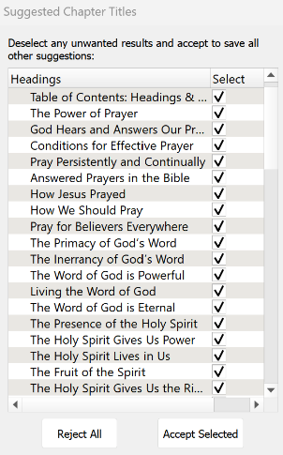

Now you can begin assigning different elements to the Headings and Subheadings in the document so that, when someone is reading the eBook, they can easily jump to another section via the Table of Contents.
I use 2 elements: Chapter Title (for the key headings in the Brittanica Bold font) and Subheading (for the underlined subheadings).
As you begin assigning the elements, be sure to start by assigning the Chapter Title element to the Table of Contents: Headings and Subheadings heading. Then go through the rest of the document and assign either the Chapter Title or Subheading elements.
You can change the formatting from the Kindle Create default, if you want. Below are the formatting options that I use for the eBooklets.
Feel free to customize to suit your preferences.




Finally, go through the document and click on each photo and change it to “Full Size.” (Note, another quirk with this app is that some photos just can’t be changed to full size, so they will appear smaller in the eBooklet).
When complete, first, save the document (File / Save Project). This will automatically put it in a folder. So when you export the document, be sure you export it to that folder.
To export, click on File / Export / KPF (Kindle and print). At the next screen, click on the file name to select it, and then click on Export.
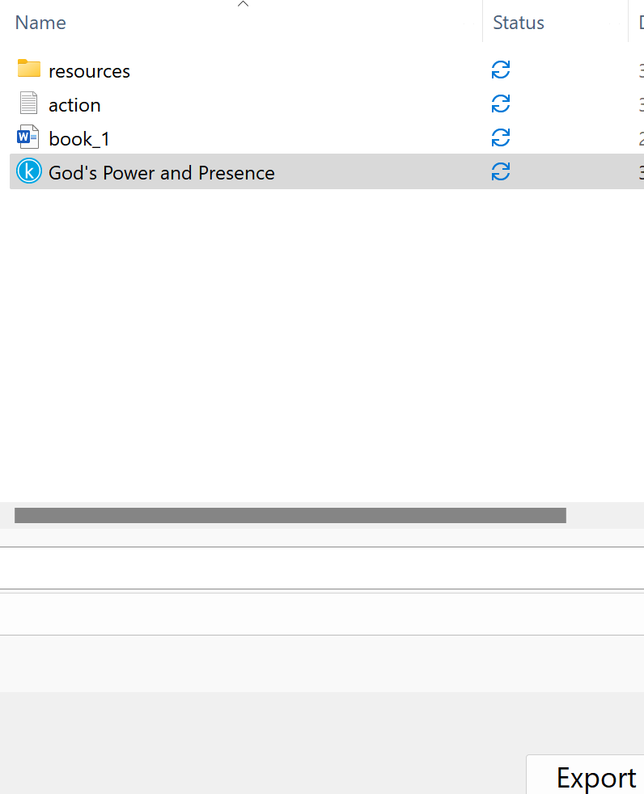

If you want the file in an EPUB format, go through the steps above and select File / Export / EPUB

Stuck on a Step Above and Need Help?
If you want to do this project on your own, but are having tech issues with one of the steps above, feel free to contact me at Susan@TheWordOfGodSeries.com. I may be able to assist you, since I’ve gone through this whole process myself!

Need Help with the Whole Project?
If you want these booklets set up in your own in your own ministry’s name, but don’t have the resources to do the whole project yourself,
I may be able to manage that process for you for a one-time project fee.
This would include the following services:
- Set up an account with Bigstock and Shutterstock in your ministry’s name and purchase the rights for you to use each of the photos
- Download and name the photos
- Edit photos as needed
- Create a cover with your church or ministry logo
- Request the rights to use the various Bible translations from each of the publishers (if applicable)
Feel free to contact me at Susan@TheWordOfGodSeries.com to discuss pricing options.

I hope that this information will help you finalize this document with ease so you can begin distributing it
to the people in your realm of influence.
Thank you for partnering with me in this effort. I wish you the best as you make God’s Word known and
share His love with others!
Warmly in Christ,
Susan

Soli Deo gloria


Feel free to edit this forward page to align to your own ministry’s vision and goals.

The Bible is the best-selling and most transformative book in history. Written over 2,000 years ago, it is still living and powerful today.
Throughout the pages of Scripture you will find inspiration and joy, comfort and peace, healing and hope.
Most importantly, you will learn of God’s abundant love for you, and His plan to give you a glorious, eternal inheritance.
The Word of God Series is a collection of booklets which presents Scripture by topic, so you can focus on verses that are relevant to you at different stages and circumstances throughout your life.
All of the booklets in this series feature Scripture exclusively—just the powerful, undiluted Word of God.
Let God’s Word permeate your mind and transform your life.
This is one of a four-booklet mini-series about Jesus Christ, the most influential and singular person in history. The titles in this series are:
Jesus: His Birth
Jesus: His Life Events
Jesus: His Teachings
Jesus: His Death, Resurrection and Return
The verses in this series are drawn primarily from the gospel accounts (the first four books of the New Testament: Matthew, Mark, Luke and John) which present a narrative on the life and ministry of Jesus.
This series includes many of the life events and teachings of Jesus, but it not comprehensive, so you are encouraged to also read each of the gospel accounts in their entirety.
In this series, text in italics are prophecies about the coming Messiah and “text in quotation marks” are the words of Christ.
Most of the imagery in this mini-series is from the Holy Land.
This booklet, Jesus: His Death, Resurrection and Return, is a Holy Week devotional. It will guide you through that momentous week, from Palm Sunday, to the crucifixion, to the resurrection, to His eventual return.
My prayer for you, as you read this series about Christ, is that you will accept the gift of eternal life that He died to give you and know that you belong to Him. I pray you will spend the remainder of your life seeking to look, live and love more like Jesus.
Let the word of Christ dwell in you richly…

~ Colossians 3:16a (ESV)

A few comments about The Word of God Series:

- The booklets in this series provide you with a sample of what the Bible offers, but it is important that you also read the Bible itself, preferably with a book-by-book focus.

- Passages in quotation marks are the actual words of God, either through His prophets in the Old Testament, or the words of Christ in the New Testament.

- Every booklet includes a section that details God’s plan of salvation (commonly referred to as “The Gospel.”) The booklet entitled God’s Gift of Eternal Life is devoted to the Gospel message.

This series presents verses in the following translations:

NIV: New International Version
Scripture quotations marked NIV are taken from the Holy Bible, New International Version®, NIV®. Copyright © 1973, 1978, 1984, 2011 by Biblica, Inc.™ Used by permission of Zondervan. All rights reserved worldwide. www.zondervan.com. The "NIV" and "New International Version" are trademarks registered in the United States Patent and Trademark Office by Biblica, Inc.™

NLT: New Living Translation
Scripture quotations marked NLT are taken from the Holy Bible, New Living Translation, Copyright© 1996, 2004, 2015 by Tyndale House Foundation. Used by permission of Tyndale House Publishers, Inc., Carol Stream, Illinois 60188. All rights reserved.

ESV: English Standard Version
Scripture quotations marked ESV are taken from the ESV Bible® (The Holy Bible, English Standard Version®), copyright © 2001 by Crossway Bibles, a publishing ministry of Good News Publishers. Used by permission. All rights reserved.

KJV: King James Version
Public Domain

NKJV: New King James Version
Scripture quotations marked NKJV are taken from the New King James Version®. Copyright © 1982 by Thomas Nelson, Inc. Used by permission.

Since this is a template booklet featuring preview photos, it is not copyrighted, so you are free to purchase licenses to use the photos and develop your own booklets. Be sure to determine whether or not you need to request permission (and in some cases pay) for the rights to use the various Bible translations. Scripture verses were sourced from www.BibleGateway.com.

If it would be easier for you to simply purchase this booklet, the copyrighted version is available at www.TheWordOfGodSeries.com or www.amazon.com. ISBN info for the copyrighted booklets is as follows: 978-1-964538-06-8 (print booklet), 978-1-964538-07-5 (eBooklet), 9798356892240 (print booklet on Amazon).

Table of Contents: Headings & Sub-Headings

The Triumphal Entry
The Events of Holy Week
Jesus Clears the Temple
Jesus in the Temple During Holy Week
The Authority of Jesus Challenged
Jesus Anointed
Jesus Predicts His Death
The Plot to Kill Jesus
Judas Agrees to Betray Jesus
The Last Supper
Jesus Predicts Judas’ Betrayal
Jesus Washes His Disciples Feet
Jesus Predicts His Disciples Will Fall Away
Jesus’ Teachings During the Last Supper
Jesus Prays
…to be Glorified
…for His Disciples
…for All Future Believers
…in the Garden of Gethsemane
The Night Jesus was Betrayed, Arrested, Deserted and Denied
Jesus was Betrayed, Arrested and Deserted
Jesus Before the Council
Peter Denies Jesus
Judas Hangs Himself
Jesus Before Pilate
Jesus was Crucified
The Last Words of Jesus
The Death and Burial of Jesus
Jesus is Our Passover Lamb
The Resurrection of Jesus
Jesus Appears to His Disciples
The Road to Emmaus
Jesus Appears to His Disciples
Jesus Challenges Peter
The Great Commission
The Ascension
Why Jesus Gave His Life for Us
The Return of Jesus

Note: The verse references in this document contain links to the BibleGateway.com page that will display the passage in all 5 translations that are used in this series (NIV, NLT, ESV, NKJV, KJV).

Other Booklets in the Series
The Triumphal Entry

Rejoice greatly, Daughter Zion! Shout, Daughter Jerusalem!
See, your king comes to you, righteous and victorious, lowly and riding on a donkey, on a colt, the foal of a donkey.

~ Zechariah 9:9 (NIV)

The next day the great crowd that had come for the festival heard that Jesus was on his way to Jerusalem.
They took palm branches and went out to meet him, shouting,
“Hosanna! Blessed is he who comes in the name of the Lord! Blessed is the king of Israel!”

~ John 12:12-13 (NIV)

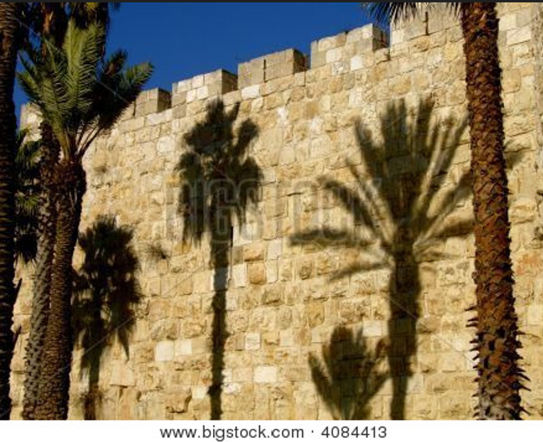

Old wall of Jerusalem

As they approached Jerusalem and came to Bethphage on the Mount of Olives, Jesus sent two disciples, saying to them,
“Go to the village ahead of you, and at once you will find a donkey tied there, with her colt by her. Untie them and bring them to me. If anyone says anything to you, say that the Lord needs them, and he will send them right away.”
This took place to fulfill what was spoken through the prophet: “Say to Daughter Zion,
“See, your king comes to you, gentle and riding on a donkey, and on a colt, the foal of a donkey.”
The disciples went and did as Jesus had instructed them. They brought the donkey and the colt and placed their cloaks on them for Jesus to sit on.
A very large crowd spread their cloaks on the road, while others cut branches from the trees and spread them on the road. The crowds that went ahead of him and those that followed shouted,
“Hosanna to the Son of David! Blessed is he who comes in the name of the Lord! Hosanna in the highest heaven!”

~ Matthew 21:1-9 (NIV)

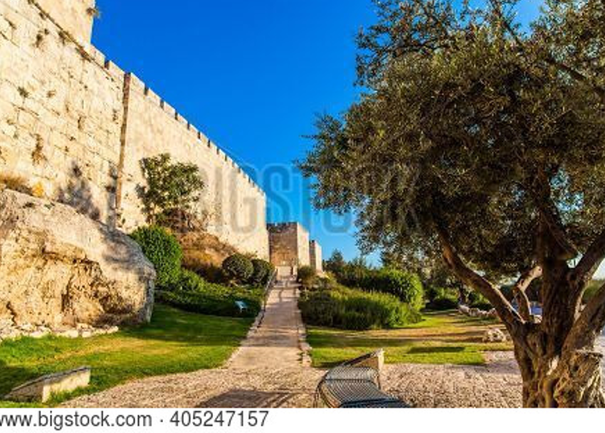

Old wall of Jerusalem

As [Jesus] was drawing near—already on the way down the Mount of Olives—the whole multitude of his disciples began to rejoice and praise God with a loud voice for all the mighty works that they had seen, saying,
“Blessed is the King who comes in the name of the Lord! Peace in heaven and glory in the highest!”
And some of the Pharisees in the crowd said to him, “Teacher, rebuke your disciples.” He answered, “I tell you, if these were silent, the very stones would cry out.”

~ Luke 19:37-40 (ESV)

As he approached Jerusalem and saw the city, he wept over it and said, “If you, even you, had only known on this day what would bring you peace—but now it is hidden from your eyes.
“The days will come upon you when your enemies will build an embankment against you and encircle you and hem you in on every side. They will dash you to the ground, you and the children within your walls.
“They will not leave one stone on another, because you did not recognize the time of God’s coming to you.”

~ Luke 19:41-44 (NIV)

“O Jerusalem, Jerusalem, the one who kills the prophets and stones those who are sent to her!
“How often I wanted to gather your children together, as a hen gathers her chicks under her wings, but you were not willing! See! Your house is left to you desolate; for I say to you, you shall see Me no more till you say, ‘Blessed is He who comes in the name of the Lord!’”

~ Matthew 23:37-39 (NKJV)

His disciples didn’t understand at the time that this was a fulfillment of prophecy.
But after Jesus entered into his glory, they remembered what had happened and realized that these things had been written about him.

~ John 12:16 (NLT)

When Jesus entered Jerusalem, the whole city was stirred and asked, “Who is this?”
The crowds answered, “This is Jesus, the prophet from Nazareth in Galilee.”

~ Matthew 21:10-11 (NIV)

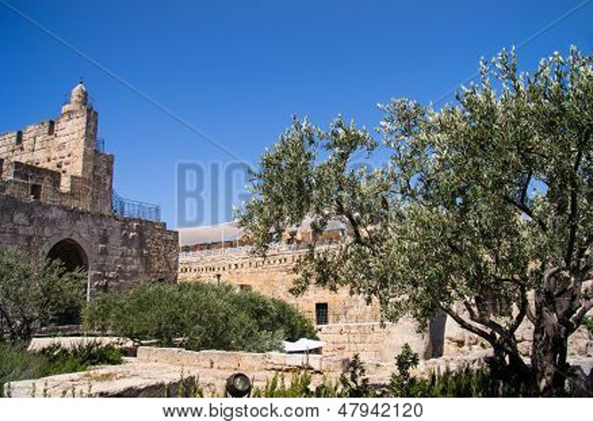
Tower of David, Jerusalem

Many in the crowd had seen Jesus call Lazarus from the tomb, raising him from the dead, and they were telling others about it. That was the reason so many went out to meet him—because they had heard about this miraculous sign.
Then the Pharisees said to each other, “There’s nothing we can do. Look, everyone has gone after him!”

~ John 12:17-19 (NLT)

So the Pharisees said to one another, “See, this is getting us nowhere. Look how the whole world has gone after him!”

~ John 12:19 (NIV)

The Events of Holy Week

Jesus Clears the Temple

“…My house shall be called a house of prayer for all nations.”

~ Isaiah 56:7b (NKJV)

“Has this house, which is called by My name, become a den of thieves in your eyes?”

~ Jeremiah 7:11a (NKJV)

…zeal for your house has consumed me…

~ Psalm 69:9a (ESV)

On reaching Jerusalem, Jesus entered the temple courts and began driving out those who were buying and selling there.
He overturned the tables of the money changers and the benches of those selling doves, and would not allow anyone to carry merchandise through the temple courts.

~ Mark 11:15-16 (NIV)

In the Temple area he saw merchants selling cattle, sheep, and doves for sacrifices; he also saw dealers at tables exchanging foreign money. Jesus made a whip from some ropes and chased them all out of the Temple.
He drove out the sheep and cattle, scattered the money changers’ coins over the floor, and turned over their tables.

~ John 2:14-15 (NLT)

“It is written, ‘My house is a house of prayer,’ but you have made it a ‘den of thieves.’”

~ Luke 19:46b (NKJV)

“Take these things away! Do not make My Father’s house a house of merchandise!”

~ John 2:16b (NKJV)

His disciples remembered that it was written, “Zeal for your house will consume me.”

~ John 2:17 (ESV)

Jesus in the Temple During Holy Week

Through the praise of children and infants you have established a stronghold against your enemies…

~ Psalm 8:2a (NIV)

Every day Jesus went to the Temple to teach…The crowds gathered at the Temple early each morning to hear him.

~ Luke 21:37-38 (NLT)

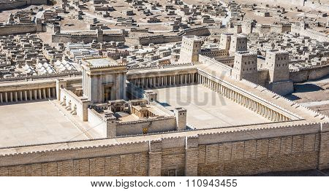

Model of Jerusalem’s ancient Temple, displayed in the Israel Museum

The blind and the lame came to him at the temple, and he healed them.
But when the chief priests and the teachers of the law saw the wonderful things he did and the children shouting in the temple courts, “Hosanna to the Son of David,” they were indignant. “Do you hear what these children are saying?” they asked him.
“Yes,” replied Jesus, “have you never read, ‘from the lips of children and infants you, Lord, have called forth your praise?’”

~ Matthew 21:14-16 (NIV)

…He was teaching daily in the temple. But the chief priests, the scribes, and the leaders of the people sought to destroy Him, and were unable to do anything; for all the people were very attentive to hear Him.

~ Luke 19:47-48 (NKJV)

…all the people hung on his words.

~ Luke 19:48b (NIV)

…all the people were astonished at His teaching.

~ Mark 11:18b (NKJV)

The Authority of Jesus Challenged

The Jews then responded to him, “What sign can you show us to prove your authority to do all this?”
Jesus answered them, “Destroy this temple, and I will raise it again in three days.”
They replied, “It has taken forty-six years to build this temple, and you are going to raise it in three days?”
But the temple he had spoken of was his body.
After he was raised from the dead, his disciples recalled what he had said. Then they believed the scripture and the words that Jesus had spoken.

~ John 2:18-22 (NIV)

Jesus entered the temple courts, and, while he was teaching, the chief priests and the elders of the people came to him. “By what authority are you doing these things?” they asked. “And who gave you this authority?”
Jesus replied, “I will also ask you one question. If you answer me, I will tell you by what authority I am doing these things. John’s baptism—where did it come from? Was it from heaven, or of human origin?”
They discussed it among themselves and said, “If we say, ‘From heaven,’ he will ask, ‘Then why didn’t you believe him?’ But if we say, ‘Of human origin’—we are afraid of the people, for they all hold that John was a prophet.” So they answered Jesus, “We don’t know.”
Then he said, “Neither will I tell you by what authority I am doing these things.”

~ Matthew 21:23-27 (NIV)

Jesus Anointed

While he was in Bethany, reclining at the table in the home of Simon the Leper, a woman came with an alabaster jar of very expensive perfume, made of pure nard.
She broke the jar and poured the perfume on his head. Some of those present were saying indignantly to one another, “Why this waste of perfume? It could have been sold for more than a year’s wages and the money given to the poor.” And they rebuked her harshly.
“Leave her alone,” said Jesus. “Why are you bothering her?
“She has done a beautiful thing to me. The poor you will always have with you, and you can help them any time you want. But you will not always have me.
“She did what she could. She poured perfume on my body beforehand to prepare for my burial.
“Truly I tell you, wherever the gospel is preached throughout the world, what she has done will also be told, in memory of her.”

~ Mark 14:3-9 (NIV)

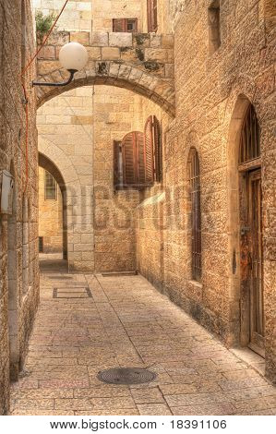

Jesus Predicts His Death

“I have a terrible baptism of suffering ahead of me, and I am under a heavy burden until it is accomplished.”

~ Luke 12:50 (NLT)

Now Jesus was going up to Jerusalem.
On the way, he took the Twelve aside and said to them,
“We are going up to Jerusalem, and the Son of Man will be delivered over to the chief priests and the teachers of the law.
“They will condemn him to death and will hand him over to the Gentiles to be mocked and flogged and crucified.
“On the third day he will be raised to life!”

~ Matthew 20:17-19 (NIV)

“I am the good shepherd. The good shepherd lays down his life for the sheep.
“The hired hand is not the shepherd and does not own the sheep. So when he sees the wolf coming, he abandons the sheep and runs away. Then the wolf attacks the flock and scatters it. The man runs away because he is a hired hand and cares nothing for the sheep.
“I am the good shepherd; I know my sheep and my sheep know me—just as the Father knows me and I know the Father—and I lay down my life for the sheep...
“The reason my Father loves me is that I lay down my life—only to take it up again.
“No one takes it from me, but I lay it down of my own accord.”

~ John 10:11-18a (NIV)

“And I, when I am lifted up from the earth, will draw all people to myself.”
He said this to show by what kind of death he was going to die.

~ John 12:32-33 (ESV)

“I tell you the truth, unless a kernel of wheat is planted in the soil and dies, it remains alone.
“But its death will produce many new kernels—a plentiful harvest of new lives.”

~ John 12:24 (NLT)

The Plot to Kill Jesus

Now the Passover and the Festival of Unleavened Bread were only two days away, and the chief priests and the teachers of the law were scheming to arrest Jesus secretly and kill him. “But not during the festival,” they said, “or the people may riot.”

~ Mark 14:1-2 (NIV)

Then the leading priests and Pharisees called the high council together. “What are we going to do?” they asked each other. “This man certainly performs many miraculous signs. If we allow him to go on like this, soon everyone will believe in him. Then the Roman army will come and destroy both our Temple and our nation.”
Caiaphas, who was high priest at that time, said, “You don’t know what you’re talking about! You don’t realize that it’s better for you that one man should die for the people than for the whole nation to be destroyed.”
He did not say this on his own; as high priest at that time he was led to prophesy that Jesus would die for the entire nation...
So from that time on, the Jewish leaders began to plot Jesus’ death.

~ John 11:47-53 (NLT)

Judas Agrees to Betray Jesus

So they paid me thirty pieces of silver.

~ Zechariah 11:12b (NIV)

Now the Festival of Unleavened Bread, called the Passover, was approaching, and the chief priests and the teachers of the law were looking for some way to get rid of Jesus, for they were afraid of the people.

~ Luke 22:1-2 (NIV)

Then Judas Iscariot, one of the twelve disciples, went to the leading priests and asked, “How much will you pay me to betray Jesus to you?”
And they gave him thirty pieces of silver.

~ Matthew 26:14-15 (NLT)

The Last Supper

It was just before the Passover Festival. Jesus knew that the hour had come for him to leave this world and go to the Father.
Having loved his own who were in the world, he loved them to the end.

~ John 13:1 (NIV)

On the first day of the Festival…when it was customary to sacrifice the Passover lamb, Jesus’ disciples asked him, “Where do you want us to go and make preparations for you to eat the Passover?”
So he sent two of his disciples, telling them, “Go into the city, and a man carrying a jar of water will meet you…
He will show you a large room upstairs, furnished and ready. Make preparations for us there.”

~ Mark 14:12-16 (NIV)

When the hour came, Jesus and his apostles reclined at the table. And he said to them, “I have eagerly desired to eat this Passover with you before I suffer. For I tell you, I will not eat it again until it finds fulfillment in the kingdom of God.”

~ Luke 22:14-16 (NIV)

And he took bread, gave thanks and broke it, and gave it to them, saying,
“This is my body given for you; do this in remembrance of me.”
In the same way, after the supper he took the cup, saying,
“This cup is the new covenant in my blood, which is poured out for you.”

~ Luke 22:19-20 (NIV)



“This is my blood of the covenant, which is poured out for many for the forgiveness of sins.”

~ Matthew 26:28 (NIV)

Jesus Predicts Judas’ Betrayal

Even my close friend, someone I trusted, one who shared my bread, has turned against me.

~ Psalm 41:9 (NIV)

And as they were eating, he said, “Truly, I say to you, one of you will betray me.”

~ Matthew 26:21 (ESV)

Jesus responded, “It is the one to whom I give the bread I dip in the bowl.” And when he had dipped it, he gave it to Judas, son of Simon Iscariot. When Judas had eaten the bread, Satan entered into him.

~ John 13:26-27a (NLT)

“…this is to fulfill this passage of Scripture: ‘He who shared my bread has turned against me.’”

~ John 13:18b (NIV)

Jesus Washes His Disciples Feet

Then they began to argue among themselves about who would be the greatest among them.
Jesus told them, “In this world the kings and great men lord it over their people, yet they are called ‘friends of the people.’
“But among you it will be different. Those who are the greatest among you should take the lowest rank, and the leader should be like a servant.
“Who is more important, the one who sits at the table or the one who serves? The one who sits at the table, of course.
“But not here! For I am among you as one who serves.”

~ Luke 22:24-27 (NLT)

Jesus knew that the hour had come for him to leave this world and go to the Father.
Having loved his own who were in the world, he loved them to the end.
Jesus knew that the Father had put all things under his power, and that he had come from God and was returning to God; so he got up from the meal, took off his outer clothing, and wrapped a towel around his waist.
After that, he poured water into a basin and began to wash his disciples’ feet, drying them with the towel that was wrapped around him.

~ John 13:1b-5 (NIV)

He came to Simon Peter, who said to him, “Lord, are you going to wash my feet?”
Jesus replied, “You do not realize now what I am doing, but later you will understand.”
“No,” said Peter, “you shall never wash my feet.”
Jesus answered, “Unless I wash you, you have no part with me.”

~ John 13:6-8 (NIV)

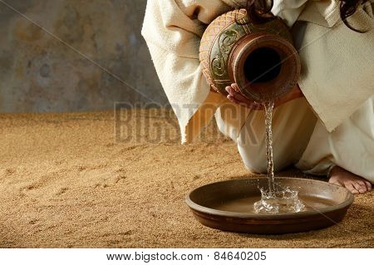

After washing their feet, he put on his robe again and sat down and asked, “Do you understand what I was doing? You call me ‘Teacher’ and ‘Lord,’ and you are right, because that’s what I am.
“And since I, your Lord and Teacher, have washed your feet, you ought to wash each other’s feet.
“I have given you an example to follow. Do as I have done to you.”

~ John 13:12-15 (NLT)

Jesus Predicts His Disciples Will Fall Away

“Strike the shepherd, and the sheep will be scattered…”

~ Zechariah 13:7b (ESV)

And when they had sung a hymn, they went out to the Mount of Olives.
Then Jesus said to them, “You will all fall away because of me this night. For it is written, ‘I will strike the shepherd, and the sheep of the flock will be scattered.’
“But after I am raised up, I will go before you to Galilee.”

~ Matthew 26:30-32 (ESV)

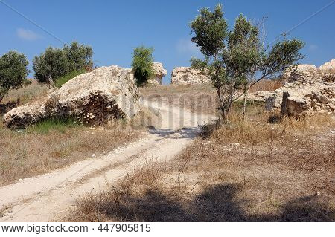

Mount of Olives

Peter answered him, “Though they all fall away because of you, I will never fall away.”
Jesus said to him, “Truly, I tell you, this very night, before the rooster crows, you will deny me three times.”
Peter said to him, “Even if I must die with you, I will not deny you!”
And all the disciples said the same.

~ Matthew 26:33-35 (ESV)

And the Lord said, “Simon, Simon! Indeed, Satan has asked for you, that he may sift you as wheat.
“But I have prayed for you, that your faith should not fail; and when you have returned to Me, strengthen your brethren.”

~ Luke 22:31-32 (NKJV)

“Indeed the hour is coming, yes, has now come, that you will be scattered, each to his own, and will leave Me alone. And yet I am not alone, because the Father is with Me.”

~ John 16:32 (NKJV)

Jesus’ Teachings During the Last Supper

Jesus’ final teachings to His disciples during the Last Supper can be found in John 14-16, and His last prayer for His disciples is recorded in John 17. Excerpts from both are below.

Jesus said to him, “I am the way, the truth, and the life. No one comes to the Father except through Me.”

~ John 14:6 (NKJV)

“Peace I leave with you; my peace I give you. I do not give to you as the world gives.
“Do not let your hearts be troubled and do not be afraid.”

~ John 14:27 (NIV)

“Let not your heart be troubled; you believe in God, believe also in Me.
“In My Father’s house are many mansions; if it were not so, I would have told you.
“I go to prepare a place for you.
“And if I go and prepare a place for you, I will come again and receive you to Myself; that where I am, there you may be also.”

~ John 14:1-3 (NKJV)

“I have said all these things to you to keep you from falling away.”

~ John 16:1 (ESV)

“A new command I give you: Love one another.
“As I have loved you, so you must love one another.
“By this everyone will know that you are my disciples, if you love one another.”

~ John 13:34-35 (NIV)

“Those who are the greatest among you should take the lowest rank, and the leader should be like a servant.”

~ Luke 22:26b (NLT)

“I am the true vine, and my Father is the gardener.
“He cuts off every branch in me that bears no fruit, while every branch that does bear fruit he prunes so that it will be even more fruitful…
“Remain in me, as I also remain in you. No branch can bear fruit by itself; it must remain in the vine. Neither can you bear fruit unless you remain in me.
“I am the vine; you are the branches.
“If you remain in me and I in you, you will bear much fruit; apart from me you can do nothing…
“If you remain in me and my words remain in you, ask whatever you wish, and it will be done for you.
“This is to my Father’s glory, that you bear much fruit, showing yourselves to be my disciples.
“As the Father has loved me, so have I loved you.
“Now remain in my love. If you keep my commands, you will remain in my love, just as I have kept my Father’s commands and remain in his love.
“I have told you this so that my joy may be in you and that your joy may be complete.
“My command is this: Love each other as I have loved you.
“Greater love has no one than this: to lay down one’s life for one’s friends.
“You are my friends if you do what I command. I no longer call you servants, because a servant does not know his master’s business. Instead, I have called you friends, for everything that I learned from my Father I have made known to you.
“You did not choose me, but I chose you and appointed you so that you might go and bear fruit—fruit that will last—and so that whatever you ask in my name the Father will give you.
“This is my command: Love each other.”

~ John 15:1-17 (NIV)



“If you love me, keep my commands.
“And I will ask the Father, and he will give you another advocate to help you and be with you forever—the Spirit of truth.
“The world cannot accept him, because it neither sees him nor knows him.
“But you know him, for he lives with you and will be in you.
“I will not leave you as orphans; I will come to you.”

~ John 14:15-18 (NIV)

“It is to your advantage that I go away; for if I do not go away, the Helper will not come to you; but if I depart, I will send Him to you.”

~ John 16:7b (NKJV)

“When the Spirit of truth comes, he will guide you into all truth.
“He will not speak on his own but will tell you what he has heard.
“He will tell you about the future.”

~ John 16:13 (NLT)

“But the Helper, the Holy Spirit, whom the Father will send in My name, He will teach you all things, and bring to your remembrance all things that I said to you.”

~ John 14:26 (NKJV)

“If the world hates you, keep in mind that it hated me first.
“If you belonged to the world, it would love you as its own.
“As it is, you do not belong to the world, but I have chosen you out of the world. That is why the world hates you.
“Remember what I told you: ‘A servant is not greater than his master.’
“If they persecuted me, they will persecute you also.”

~ John 15:18-20a (NIV)

“Very truly I tell you, you will weep and mourn while the world rejoices. You will grieve, but your grief will turn to joy.
“A woman giving birth to a child has pain because her time has come; but when her baby is born she forgets the anguish because of her joy that a child is born into the world.
“So with you: Now is your time of grief, but I will see you again and you will rejoice, and no one will take away your joy.
“In that day you will no longer ask me anything.
“Very truly I tell you, my Father will give you whatever you ask in my name. Until now you have not asked for anything in my name.
“Ask and you will receive, and your joy will be complete.”

~ John 16:20-24 (NIV)

“Very truly I tell you, whoever believes in me will do the works I have been doing, and they will do even greater things than these, because I am going to the Father.
“And I will do whatever you ask in my name, so that the Father may be glorified in the Son.
“You may ask me for anything in my name, and I will do it.”

~ John 14:12-14 (NIV)

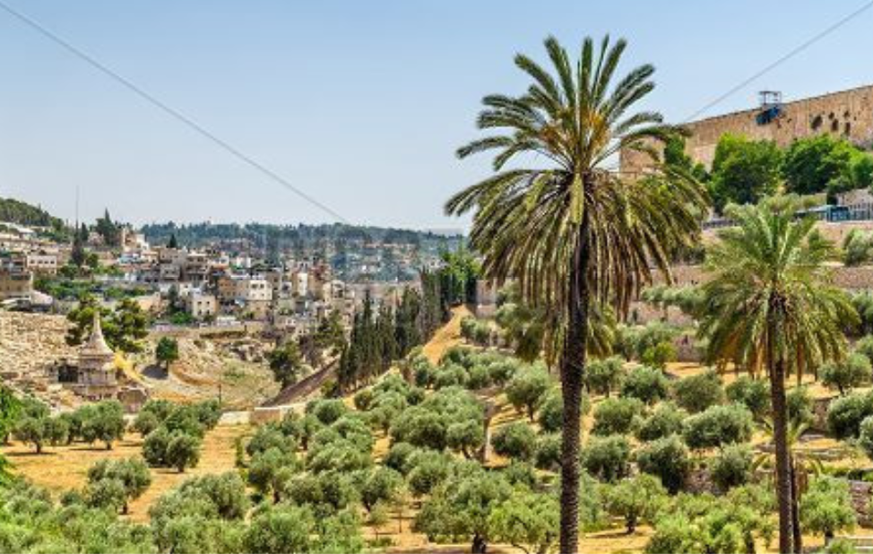

Kidron Valley, Jerusalem

Jesus Prays

…to Be Glorified

After saying all these things, Jesus looked up to heaven and said, “Father, the hour has come. Glorify your Son so he can give glory back to you…He gives eternal life to each one you have given him.
“And this is the way to have eternal life—to know you, the only true God, and Jesus Christ, the one you sent to earth.
“I brought glory to you here on earth by completing the work you gave me to do.
“Now, Father, bring me into the glory we shared before the world began.”

~ John 17:1-5 (NLT)

…for His Disciples

“My prayer is not for the world, but for those you have given me, because they belong to you…
“Now I am departing from the world; they are staying in this world…
“I’m not asking you to take them out of the world, but to keep them safe from the evil one. They do not belong to this world any more than I do.
“Make them holy by your truth; teach them your word, which is truth.
“Just as you sent me into the world, I am sending them into the world.
“And I give myself as a holy sacrifice for them so they can be made holy by your truth.”

~ John 17:9-19 (NLT)

…for All Future Believers

“I am praying not only for these disciples but also for all who will ever believe in me through their message.
“I pray that they will all be one, just as you and I are one…
“May they experience such perfect unity that the world will know that you sent me and that you love them as much as you love me.
“Father, I want these whom you have given me to be with me where I am...”

~ John 17:20-24a (NLT)

…in the Garden of Gethsemane

They went to a place called Gethsemane, and Jesus said to his disciples, “Sit here while I pray.”
He took Peter, James and John along with him, and he began to be deeply distressed and troubled.
“My soul is overwhelmed with sorrow to the point of death,” he said to them. “Stay here and keep watch.”
Going a little farther, he fell to the ground and prayed that if possible the hour might pass from him.
“Abba, Father,” he said, “everything is possible for you.
“Take this cup from me.
“Yet not what I will, but what you will.”

~ Mark 14:32-36 (NIV)

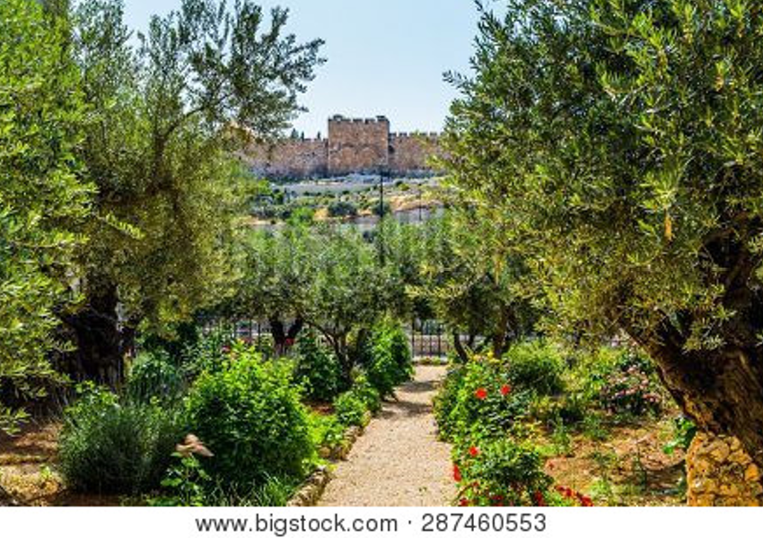

Garden of Gethsemane

…He knelt down and prayed, saying,
“Father, if it is Your will, take this cup away from Me; nevertheless not My will, but Yours, be done.”

~ Luke 22:41b-42 (NKJV)

He went on a little farther and bowed with his face to the ground, praying,
“My Father! If it is possible, let this cup of suffering be taken away from me.
“Yet I want your will to be done, not mine.”

~ Matthew 26:39 (NLT)

Then he returned to the disciples and found them asleep.
He said to Peter, “Couldn’t you watch with me even one hour?
“Keep watch and pray, so that you will not give in to temptation. For the spirit is willing, but the body is weak!”

~ Matthew 26:40-41 (NLT)

Then Jesus left them a second time and prayed,
“My Father! If this cup cannot be taken away unless I drink it, your will be done.”

~ Matthew 26:42 (NLT)

Then an angel appeared to Him from heaven, strengthening Him.
And being in agony, He prayed more earnestly.
Then His sweat became like great drops of blood falling down to the ground.

~ Luke 22:43-44 (NKJV)

Then he returned to his disciples and found them sleeping.
“Simon,” he said to Peter, “are you asleep? Couldn’t you keep watch for one hour?
“Watch and pray so that you will not fall into temptation. The spirit is willing, but the flesh is weak.”
Once more he went away and prayed the same thing.
When he came back, he again found them sleeping, because their eyes were heavy. They did not know what to say to him.
Returning the third time, he said to them, “Are you still sleeping and resting? Enough! The hour has come.
“Look, the Son of Man is delivered into the hands of sinners. Rise! Let us go! Here comes my betrayer!”

~ Mark 14:37-42 (NIV)

The Night Jesus was Betrayed, Arrested, Deserted and Denied

“Strike the shepherd, and the sheep will be scattered…”

~ Zechariah 13:7b (ESV)

Then Jesus said to them, “You will all fall away because of me this night. For it is written, ‘I will strike the shepherd, and the sheep of the flock will be scattered.’”

~ Matthew 26:31 (ESV)

Jesus was Betrayed, Arrested and Deserted

While he was still speaking, Judas came, one of the twelve, and with him a great crowd with swords and clubs, from the chief priests and the elders of the people.
Now the betrayer had given them a sign, saying, “The one I will kiss is the man; seize him.”
And he came up to Jesus at once and said, “Greetings, Rabbi!” And he kissed him.

~ Matthew 26:47-49 (ESV)

But Jesus said to him, “Judas, are you betraying the Son of Man with a kiss?”

~ Luke 22:48 (NKJV)

So Judas came to the garden, guiding a detachment of soldiers and some officials from the chief priests and the Pharisees. They were carrying torches, lanterns and weapons.
Jesus, knowing all that was going to happen to him, went out and asked them, “Who is it you want?”
“Jesus of Nazareth,” they replied.
“I am he,” Jesus said. (And Judas the traitor was standing there with them.)
When Jesus said, “I am he,” they drew back and fell to the ground.
Again he asked them, “Who is it you want?”
“Jesus of Nazareth,” they said.
Jesus answered, “I told you that I am he. If you are looking for me, then let these men go.”

~ John 18:3-8 (NIV)

Then the men stepped forward, seized Jesus and arrested him. With that, one of Jesus’ companions reached for his sword, drew it out and struck the servant of the high priest, cutting off his ear.
“Put your sword back in its place,” Jesus said to him, “for all who draw the sword will die by the sword.”

~ Matthew 26:50b-52 (NIV)

But Jesus said, “No more of this.” And he touched the man’s ear and healed him.

~ Luke 22:51 (NLT)

So Jesus said to Peter, “Put your sword into the sheath. Shall I not drink the cup which My Father has given Me?”

~ John 18:11 (NKJV)

“Don’t you realize that I could ask my Father for thousands of angels to protect us, and he would send them instantly? But if I did, how would the Scriptures be fulfilled that describe what must happen now?”

~ Matthew 26:53-54 (NLT)

…Jesus said to the crowd, “Am I leading a rebellion, that you have come out with swords and clubs to capture me? Every day I sat in the temple courts teaching, and you did not arrest me.
“But this has all taken place that the writings of the prophets might be fulfilled.”

~ Matthew 26:55b-56a (NIV)

“But this is your moment, the time when the power of darkness reigns.”

~ Luke 22:53b (NLT)

Then all the disciples deserted him and fled.

~ Matthew 26:56b (NIV)

Jesus Before the Council

He was oppressed and afflicted, yet he did not open his mouth; he was led like a lamb to the slaughter, and as a sheep before its shearers is silent, so he did not open his mouth.

~ Isaiah 53:7 (NIV)

Those who had arrested Jesus took him to Caiaphas the high priest, where the teachers of the law and the elders had assembled.
But Peter followed him at a distance, right up to the courtyard of the high priest. He entered and sat down with the guards to see the outcome.

~ Matthew 26:57-58 (NIV)

Inside, the leading priests and the entire high council were trying to find evidence against Jesus, so they could put him to death. But they couldn’t find any.
Many false witnesses spoke against him, but they contradicted each other.

~ Mark 14:55-56 (NLT)

Then the high priest stood up before the others and asked Jesus, “Well, aren’t you going to answer these charges? What do you have to say for yourself?”
But Jesus was silent and made no reply. Then the high priest asked him, “Are you the Messiah, the Son of the Blessed One?”
Jesus said, “I Am. And you will see the Son of Man seated in the place of power at God’s right hand and coming on the clouds of heaven.”
Then the high priest tore his clothing to show his horror and said, “Why do we need other witnesses? You have all heard his blasphemy. What is your verdict?”
“Guilty!” they all cried. “He deserves to die!”

~ Mark 14:60-64 (NLT)

Then they began to spit in Jesus’ face and beat him with their fists. And some slapped him, jeering, “Prophesy to us, you Messiah! Who hit you that time?”

~ Matthew 26:67-68 (NLT)

Peter Denies Jesus

Now Peter was sitting outside in the courtyard.
And a servant girl came up to him and said, “You also were with Jesus the Galilean.”
But he denied it before them all, saying, “I do not know what you mean.”
And when he went out to the entrance, another servant girl saw him, and she said to the bystanders, “This man was with Jesus of Nazareth.”
And again he denied it with an oath: “I do not know the man.”
After a little while the bystanders came up and said to Peter, “Certainly you too are one of them, for your accent betrays you.”
Then he began to invoke a curse on himself and to swear, “I do not know the man.”
And immediately the rooster crowed. And Peter remembered the saying of Jesus, “Before the rooster crows, you will deny me three times.”
And he went out and wept bitterly.

~ Matthew 26:69-75 (ESV)

Judas Hangs Himself

And the Lord said to me, “Throw it to the potter”—this magnificent sum at which they valued me! So I took the thirty coins and threw them to the potter in the Temple of the Lord.

~ Zechariah 11:13 (NLT)

When Judas, who had betrayed him, realized that Jesus had been condemned to die, he was filled with remorse.
So he took the thirty pieces of silver back to the leading priests and the elders. “I have sinned,” he declared, “for I have betrayed an innocent man.”
“What do we care?” they retorted. “That’s your problem.”
Then Judas threw the silver coins down in the Temple and went out and hanged himself.
The leading priests picked up the coins. “It wouldn’t be right to put this money in the Temple treasury,” they said, “since it was payment for murder.”
After some discussion they finally decided to buy the potter’s field, and they made it into a cemetery for foreigners.

~ Matthew 27:3-7 (NLT)

Jesus Before Pilate

Very early in the morning the leading priests, the elders, and the teachers of religious law—the entire high council—met to discuss their next step. They bound Jesus, led him away, and took him to Pilate, the Roman governor.
Pilate asked Jesus, “Are you the king of the Jews?” Jesus replied, “You have said it.” Then the leading priests kept accusing him of many crimes, and Pilate asked him, “Aren’t you going to answer them? What about all these charges they are bringing against you?”
But Jesus said nothing, much to Pilate’s surprise.

~ Mark 15:1-5 (NLT)

Then Pilate announced to the chief priests and the crowd, “I find no basis for a charge against this man.”
But they insisted, “He stirs up the people all over Judea by his teaching. He started in Galilee and has come all the way here.”
On hearing this, Pilate asked if the man was a Galilean. When he learned that Jesus was under Herod’s jurisdiction, he sent him to Herod, who was also in Jerusalem at that time.
When Herod saw Jesus, he was greatly pleased, because for a long time he had been wanting to see him…he hoped to see him perform a sign of some sort. He plied him with many questions, but Jesus gave him no answer.
The chief priests and the teachers of the law were standing there, vehemently accusing him.
Then Herod and his soldiers ridiculed and mocked him. Dressing him in an elegant robe, they sent him back to Pilate.

~ Luke 23:4-11 (NIV)

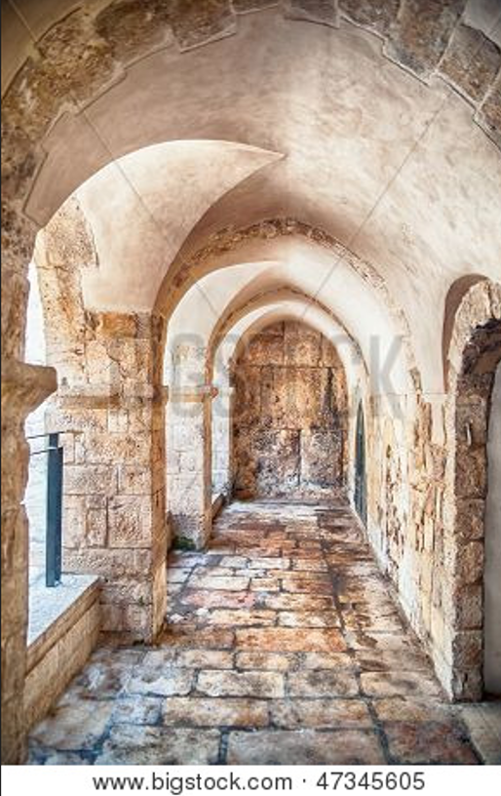

Old City of Jerusalem

Pilate called together the chief priests, the rulers and the people, and said to them, “You brought me this man as one who was inciting the people to rebellion.
“I have examined him in your presence and have found no basis for your charges against him. Neither has Herod, for he sent him back to us; as you can see, he has done nothing to deserve death.”

~ Luke 23:13-15 (NIV)

Pilate said to them, “Take him yourselves and judge him by your own law.” The Jews said to him, “It is not lawful for us to put anyone to death.” This was to fulfill the word that Jesus had spoken to show by what kind of death he was going to die.
So Pilate entered his headquarters again and called Jesus and said to him, “Are you the King of the Jews?”
Jesus answered, “Do you say this of your own accord, or did others say it to you about me?”
Pilate answered, “Am I a Jew? Your own nation and the chief priests have delivered you over to me. What have you done?”
Jesus answered, “My kingdom is not of this world. If my kingdom were of this world, my servants would have been fighting, that I might not be delivered over to the Jews. But my kingdom is not from the world.”
Then Pilate said to him, “So you are a king?”
Jesus answered, “You say that I am a king. For this purpose I was born and for this purpose I have come into the world—to bear witness to the truth. Everyone who is of the truth listens to my voice.”
Pilate said to him, “What is truth?”
After he had said this, he went back outside to the Jews and told them, “I find no guilt in him.”

~ John 18:31-38 (ESV)

From then on Pilate sought to release him, but the Jews cried out, “If you release this man, you are not Caesar’s friend. Everyone who makes himself a king opposes Caesar.”

~ John 19:12 (ESV)

Now it was the governor’s custom each year during the Passover celebration to release one prisoner to the crowd—anyone they wanted. This year there was a notorious prisoner, a man named Barabbas.
As the crowds gathered before Pilate’s house that morning, he asked them, “Which one do you want me to release to you—Barabbas, or Jesus who is called the Messiah?” (He knew very well that the religious leaders had arrested Jesus out of envy.)
Just then, as Pilate was sitting on the judgment seat, his wife sent him this message: “Leave that innocent man alone. I suffered through a terrible nightmare about him last night.”
Meanwhile, the leading priests and the elders persuaded the crowd to ask for Barabbas to be released and for Jesus to be put to death. So the governor asked again, “Which of these two do you want me to release to you?”
The crowd shouted back, “Barabbas!”
Pilate responded, “Then what should I do with Jesus who is called the Messiah?”
They shouted back, “Crucify him!”
“Why?” Pilate demanded. “What crime has he committed?”
But the mob roared even louder, “Crucify him!”

~ Matthew 27:15-23 (NLT)

But they cried out, “Away with Him, away with Him! Crucify Him!”
Pilate said to them, “Shall I crucify your King?”
The chief priests answered, “We have no king but Caesar!”

~ John 19:15 (NKJV)

So to pacify the crowd, Pilate released Barabbas to them.

~ Mark 15:15a (NLT)

Then Pilate had Jesus flogged with a lead-tipped whip. The soldiers wove a crown of thorns and put it on his head, and they put a purple robe on him.
“Hail! King of the Jews!” they mocked, as they slapped him across the face.
Pilate went outside again and said to the people, “I am going to bring him out to you now, but understand clearly that I find him not guilty.”
Then Jesus came out wearing the crown of thorns and the purple robe. And Pilate said, “Look, here is the man!”
When they saw him, the leading priests and Temple guards began shouting, “Crucify him! Crucify him!”
“Take him yourselves and crucify him,” Pilate said. “I find him not guilty.”
The Jewish leaders replied, “By our law he ought to die because he called himself the Son of God.”
When Pilate heard this, he was more frightened than ever. He took Jesus back into the headquarters again and asked him, “Where are you from?” But Jesus gave no answer. “Why don’t you talk to me?” Pilate demanded. “Don’t you realize that I have the power to release you or crucify you?”
Then Jesus said, “You would have no power over me at all unless it were given to you from above.”

~ John 19:1-11a (NLT)

Pilate saw that he wasn’t getting anywhere and that a riot was developing. So he sent for a bowl of water and washed his hands before the crowd, saying, “I am innocent of this man’s blood. The responsibility is yours!”
And all the people yelled back, “We will take responsibility for his death—we and our children!”

~ Matthew 27:24-25 (NLT)

Pilate also wrote an inscription and put it on the cross. It read, “Jesus of Nazareth, the King of the Jews.”
Many of the Jews read this inscription, for the place where Jesus was crucified was near the city, and it was written in Aramaic, in Latin, and in Greek.
So the chief priests of the Jews said to Pilate, “Do not write, ‘The King of the Jews,’ but rather, ‘This man said, I am King of the Jews.’”
Pilate answered, “What I have written I have written.”

~ John 19:19-22 (ESV)

Jesus was Crucified

The stone the builders rejected has become the cornerstone…

~ Psalm 118:22 (NIV)

…there were many who were appalled at him—his appearance was so disfigured beyond that of any human being and his form marred beyond human likeness…

~ Isaiah 52:14 (NIV)

He had no beauty or majesty to attract us to him, nothing in his appearance that we should desire him.
He was despised and rejected by mankind, a man of suffering, and familiar with pain…
Surely he took up our pain and bore our suffering, yet we considered him punished by God, stricken by him, and afflicted.
But he was pierced for our transgressions, he was crushed for our iniquities; the punishment that brought us peace was on him, and by his wounds we are healed.
We all, like sheep, have gone astray, each of us has turned to our own way; and the Lord has laid on him the iniquity of us all.
He was oppressed and afflicted, yet he did not open his mouth; he was led like a lamb to the slaughter, and as a sheep before its shearers is silent, so he did not open his mouth.
By oppression and judgment he was taken away.
Yet who of his generation protested?
For he was cut off from the land of the living; for the transgression of my people he was punished.
He was assigned a grave with the wicked, and with the rich in his death, though he had done no violence, nor was any deceit in his mouth.
Yet it was the Lord’s will to crush him and cause him to suffer, and though the Lord makes his life an offering for sin, he will see his offspring and prolong his days, and the will of the Lord will prosper in his hand…
Therefore I will give him a portion among the great, and he will divide the spoils with the strong, because he poured out his life unto death, and was numbered with the transgressors.
For he bore the sin of many, and made intercession for the transgressors.

~ Excerpts from Isaiah 53 (NIV)

My God, my God, why have you forsaken me?
Why are you so far from saving me, so far from my cries of anguish?...
But I am a worm and not a man, scorned by everyone, despised by the people.
All who see me mock me; they hurl insults, shaking their heads.
“He trusts in the Lord,” they say, let the Lord rescue him…”
I am poured out like water, and all my bones are out of joint…
My mouth is dried up like a potsherd, and my tongue sticks to the roof of my mouth; you lay me in the dust of death.
Dogs surround me, a pack of villains encircles me; they pierce my hands and my feet.
All my bones are on display; people stare and gloat over me.
They divide my clothes among them and cast lots for my garment.

~ Excerpts from Psalm 22 (NIV)

As they led Jesus away, a man named Simon, who was from Cyrene, happened to be coming in from the countryside. The soldiers seized him and put the cross on him and made him carry it behind Jesus.
A large crowd trailed behind, including many grief-stricken women. But Jesus turned and said to them,
“Daughters of Jerusalem, don’t weep for me, but weep for yourselves and for your children. For the days are coming when they will say, ‘Fortunate indeed are the women who are childless, the wombs that have not borne a child and the breasts that have never nursed.’ People will beg the mountains, ‘Fall on us,’ and plead with the hills, ‘Bury us.’ For if these things are done when the tree is green, what will happen when it is dry?”
Two others, both criminals, were led out to be executed with him. When they came to a place called The Skull, they nailed him to the cross. And the criminals were also crucified—one on his right and one on his left.

~ Luke 23:26-33 (NLT)

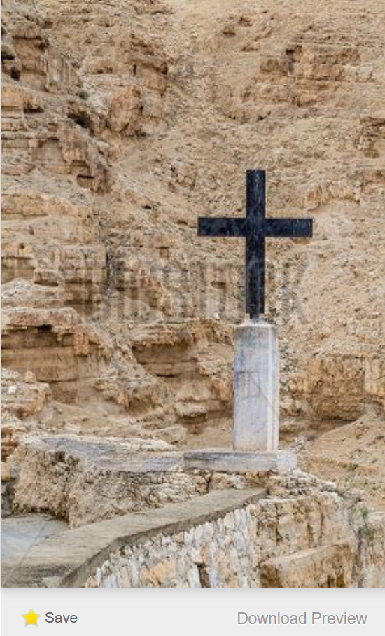
Bigstock Photo ID: 188364250

One of the criminals who hung there hurled insults at him: “Aren’t you the Messiah? Save yourself and us!”
But the other criminal rebuked him. “Don’t you fear God,” he said, “since you are under the same sentence? We are punished justly, for we are getting what our deeds deserve. But this man has done nothing wrong.”

~ Luke 23:39-41 (NIV)

There were also women looking on from a distance, among whom were Mary Magdalene, and Mary the mother of James the younger and of Joses, and Salome. When he was in Galilee, they followed him and ministered to him, and there were also many other women who came up with him to Jerusalem.

~ Mark 15:40-41 (ESV)

And when they came to a place called Golgotha (which means Place of a Skull), they offered him wine to drink, mixed with gall, but when he tasted it, he would not drink it.

~ Matthew 27:33-34 (ESV)

Those who passed by hurled insults at him, shaking their heads and saying, “You who are going to destroy the temple and build it in three days, save yourself! Come down from the cross, if you are the Son of God!” In the same way the chief priests, the teachers of the law and the elders mocked him.
“He saved others,” they said, “but he can’t save himself! He’s the king of Israel! Let him come down now from the cross, and we will believe in him.
“He trusts in God. Let God rescue him now if he wants him, for he said, ‘I am the Son of God.’”

~ Matthew 27:39-43 (NIV)

When the soldiers had crucified Jesus, they took his garments and divided them into four parts, one part for each soldier; also his tunic. But the tunic was seamless, woven in one piece from top to bottom, so they said to one another, “Let us not tear it, but cast lots for it to see whose it shall be.”
This was to fulfill the Scripture which says, “They divided my garments among them, and for my clothing they cast lots.”

~ John 19:23-24a (ESV)

It was nine o’clock in the morning when they crucified him.

~ Mark 15:25 (NLT)

At noon, darkness fell across the whole land until three o’clock.

~ Matthew 27:45 (NLT)

The Last Words of Jesus

My God, my God, why have you forsaken me?

~ Psalm 22:1a (NIV)

Jesus said, “Father, forgive them, for they don’t know what they are doing.”

~ Luke 23:34a (NLT)

One of the criminals who hung there hurled insults at him…But the other criminal rebuked him…
Then he said, “Jesus, remember me when you come into your kingdom.”
Jesus answered him, “Truly I tell you, today you will be with me in paradise.”

~ Luke 23:39-43 (NIV)

Standing near the cross were Jesus’ mother, and his mother’s sister, Mary (the wife of Clopas), and Mary Magdalene.
When Jesus saw his mother standing there beside the disciple he loved, he said to her, “Dear woman, here is your son.”
And he said to this disciple, “Here is your mother.”
And from then on this disciple took her into his home.

~ John 19:25-27 (NLT)

About three in the afternoon Jesus cried out in a loud voice, “Eli, Eli, lema sabachthani?” (which means “My God, my God, why have you forsaken me?”)

~ Matthew 27:46 (NIV)

Later, knowing that everything had now been finished, and so that Scripture would be fulfilled, Jesus said, “I am thirsty.”

~ John 19:28 (NIV)

When he had received the drink, Jesus said, “It is finished.” With that, he bowed his head and gave up his spirit.

~ John 19:30 (NIV)

Then Jesus, calling out with a loud voice, said, “Father, into your hands I commit my spirit!”
And having said this he breathed his last.

~ Luke 23:46 (ESV)

The Death and Burial of Jesus

He was assigned a grave with the wicked, and with the rich in his death…

~ Isaiah 53:9a (NIV)

And when Jesus had cried out again in a loud voice, he gave up his spirit.
At that moment the curtain of the temple was torn in two from top to bottom.

~ Matthew 27:50-51a (NIV)

Later, Joseph of Arimathea asked Pilate for the body of Jesus.
Now Joseph was a disciple of Jesus, but secretly because he feared the Jewish leaders…He was accompanied by Nicodemus...

~ John 19:38-39a (NIV)

And Joseph took the body and wrapped it in a clean linen shroud and laid it in his own new tomb, which he had cut in the rock. And he rolled a great stone to the entrance of the tomb and went away.

~ Matthew 27:59-60 (ESV)

And the women who had come with Him from Galilee followed after, and they observed the tomb and how His body was laid.

~ Luke 23:55 (NKJV)

The next day…the chief priests and the Pharisees gathered before Pilate and said, “Sir, we remember how that impostor said, while he was still alive, ‘After three days I will rise.’
“Therefore order the tomb to be made secure until the third day, lest his disciples go and steal him away and tell the people, ‘He has risen from the dead,’ and the last fraud will be worse than the first.”
Pilate said to them, “You have a guard of soldiers. Go, make it as secure as you can.”
So they went and made the tomb secure by sealing the stone and setting a guard.

~ Matthew 27:62-66 (ESV)

Jesus is Our Passover Lamb

The Lord said to Moses and Aaron in Egypt, “…each man is to take a lamb for his family…Take care of them until the fourteenth day of the month, when all the members of the community of Israel must slaughter them…Then they are to take some of the blood and put it on the sides and tops of the doorframes of the houses where they eat the lambs…
“On that same night I will pass through Egypt and strike down every firstborn of both people and animals…
“The blood will be a sign for you on the houses where you are, and when I see the blood, I will pass over you.”

~ Exodus 12:1-13a (NIV)

He was oppressed and afflicted, yet he did not open his mouth; he was led like a lamb to the slaughter, and as a sheep before its shearers is silent, so he did not open his mouth.

~ Isaiah 53:7 (NIV)

The next day John [the Baptist] saw Jesus coming toward him, and said, “Behold! The Lamb of God who takes away the sin of the world!”

~ John 1:29 (NKJV)

For you know that God paid a ransom to save you from the empty life you inherited from your ancestors.
And it was not paid with mere gold or silver…
It was the precious blood of Christ, the sinless, spotless Lamb of God.

~ 1 Peter 1:18-19 (NLT)

Christ, our Passover Lamb, has been sacrificed for us.

~ 1 Corinthians 5:7b (NLT)

For the Lamb in the midst of the throne will be their shepherd, and he will guide them to springs of living water, and God will wipe away every tear from their eyes.

~ Revelation 7:17a (ESV)

The Resurrection Of Jesus

The resurrection of Jesus is the central tenant of the Christian faith. Without the resurrection, Christianity would be baseless and we would be left without any hope. However, because Jesus rose from the dead, we have eternal hope. Because of its importance, the entire accounts of the resurrection, from all four Gospels, are presented below.

…[the women] saw that the stone, which was very large, had been rolled away.

~ Mark 16:4b (NIV)

The angel said…“I know that you are looking for Jesus, who was crucified. He is not here; he has risen, just as he said.”

~ Matthew 28:5-6a (NIV)

“Why do you seek the living among the dead? He is not here, but has risen.”

~ Luke 24:5b-6a (ESV)

[Jesus said] “…go find my brothers and tell them, ‘I am ascending to my Father and your Father, to my God and your God.’”

~ John 20:17b (NLT)

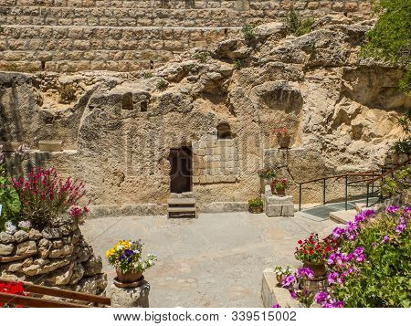

The Garden Tomb in Jerusalem
(considered by some to be the place of Jesus’ burial)

The Resurrection Account in the Gospel of Matthew

After the Sabbath, at dawn on the first day of the week, Mary Magdalene and the other Mary went to look at the tomb.
There was a violent earthquake, for an angel of the Lord came down from heaven and, going to the tomb, rolled back the stone and sat on it.
His appearance was like lightning, and his clothes were white as snow.
The guards were so afraid of him that they shook and became like dead men.
The angel said to the women, “Do not be afraid, for I know that you are looking for Jesus, who was crucified.
“He is not here; he has risen, just as he said. Come and see the place where he lay. Then go quickly and tell his disciples: ‘He has risen from the dead and is going ahead of you into Galilee. There you will see him.’ Now I have told you.”
So the women hurried away from the tomb, afraid yet filled with joy, and ran to tell his disciples
Suddenly Jesus met them. “Greetings,” he said. They came to him, clasped his feet and worshiped him.
Then Jesus said to them, “Do not be afraid. Go and tell my brothers to go to Galilee; there they will see me.”
While the women were on their way, some of the guards went into the city and reported to the chief priests everything that had happened.
When the chief priests had met with the elders and devised a plan, they gave the soldiers a large sum of money, telling them, “You are to say, ‘His disciples came during the night and stole him away while we were asleep.’ If this report gets to the governor, we will satisfy him and keep you out of trouble.” So the soldiers took the money and did as they were instructed.
And this story has been widely circulated among the Jews to this very day.

~ Matthew 28:1-15 (NIV)

The Resurrection Account in the Gospel of Mark

When the Sabbath was over, Mary Magdalene, Mary the mother of James, and Salome bought spices so that they might go to anoint Jesus’ body.
Very early on the first day of the week, just after sunrise, they were on their way to the tomb and they asked each other, “Who will roll the stone away from the entrance of the tomb?”
But when they looked up, they saw that the stone, which was very large, had been rolled away.
As they entered the tomb, they saw a young man dressed in a white robe sitting on the right side, and they were alarmed.
“Don’t be alarmed,” he said. “You are looking for Jesus the Nazarene, who was crucified. He has risen! He is not here. See the place where they laid him. But go, tell his disciples and Peter, ‘He is going ahead of you into Galilee. There you will see him, just as he told you.’”
Trembling and bewildered, the women went out and fled from the tomb. They said nothing to anyone, because they were afraid.
[The earliest manuscripts and some other ancient witnesses do not have verses 9–20.]
When Jesus rose early on the first day of the week, he appeared first to Mary Magdalene, out of whom he had driven seven demons. She went and told those who had been with him and who were mourning and weeping.
When they heard that Jesus was alive and that she had seen him, they did not believe it.
Afterward Jesus appeared in a different form to two of them while they were walking in the country. These returned and reported it to the rest; but they did not believe them either.
Later Jesus appeared to the Eleven as they were eating; he rebuked them for their lack of faith and their stubborn refusal to believe those who had seen him after he had risen.

~ Mark 16:1-14 (NIV)

The Resurrection Account in the Gospel of Luke

But on the first day of the week, at early dawn, they went to the tomb, taking the spices they had prepared.
And they found the stone rolled away from the tomb, but when they went in they did not find the body of the Lord Jesus.
While they were perplexed about this, behold, two men stood by them in dazzling apparel.
And as they were frightened and bowed their faces to the ground, the men said to them, “Why do you seek the living among the dead? He is not here, but has risen. Remember how he told you, while he was still in Galilee, that the Son of Man must be delivered into the hands of sinful men and be crucified and on the third day rise.”
And they remembered his words, and returning from the tomb they told all these things to the eleven and to all the rest.
Now it was Mary Magdalene and Joanna and Mary the mother of James and the other women with them who told these things to the apostles, but these words seemed to them an idle tale, and they did not believe them.
But Peter rose and ran to the tomb; stooping and looking in, he saw the linen cloths by themselves; and he went home marveling at what had happened.

~ Luke 24:1-12 (ESV)

The Resurrection Account in the Gospel of John

Early on Sunday morning, while it was still dark, Mary Magdalene came to the tomb and found that the stone had been rolled away from the entrance.
She ran and found Simon Peter and the other disciple, the one whom Jesus loved. She said, “They have taken the Lord’s body out of the tomb, and we don’t know where they have put him!”
Peter and the other disciple started out for the tomb.
They were both running, but the other disciple outran Peter and reached the tomb first. He stooped and looked in and saw the linen wrappings lying there, but he didn’t go in.
Then Simon Peter arrived and went inside. He also noticed the linen wrappings lying there, while the cloth that had covered Jesus’ head was folded up and lying apart from the other wrappings.
Then the disciple who had reached the tomb first also went in, and he saw and believed—for until then they still hadn’t understood the Scriptures that said Jesus must rise from the dead. Then they went home.
Mary was standing outside the tomb crying, and as she wept, she stooped and looked in. She saw two white-robed angels, one sitting at the head and the other at the foot of the place where the body of Jesus had been lying. “Dear woman, why are you crying?” the angels asked her.
“Because they have taken away my Lord,” she replied, “and I don’t know where they have put him.” She turned to leave and saw someone standing there. It was Jesus, but she didn’t recognize him. “Dear woman, why are you crying?” Jesus asked her. “Who are you looking for?”
She thought he was the gardener. “Sir,” she said, “if you have taken him away, tell me where you have put him, and I will go and get him.”
“Mary!” Jesus said.
She turned to him and cried out, “Rabboni!” (which is Hebrew for “Teacher”).
“Don’t cling to me,” Jesus said, “for I haven’t yet ascended to the Father. But go find my brothers and tell them, ‘I am ascending to my Father and your Father, to my God and your God.’”
Mary Magdalene found the disciples and told them, “I have seen the Lord!” Then she gave them his message.

~ John 20:1-18 (NLT)

Jesus Appears to His Disciples

The Road to Emmaus

Now that same day two of them were going to a village called Emmaus, about seven miles from Jerusalem.
They were talking with each other about everything that had happened. As they talked and discussed these things with each other, Jesus himself came up and walked along with them; but they were kept from recognizing him.
He asked them, “What are you discussing together as you walk along?”

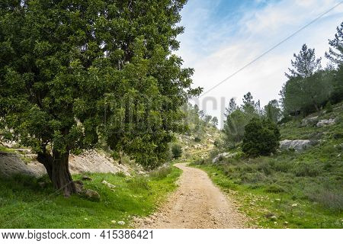

Path near Jerusalem

They stood still, their faces downcast. One of them, named Cleopas, asked him, “Are you the only one visiting Jerusalem who does not know the things that have happened there in these days?”
“What things?” he asked.
“About Jesus of Nazareth,” they replied. “He was a prophet, powerful in word and deed before God and all the people.
“The chief priests and our rulers handed him over to be sentenced to death, and they crucified him; but we had hoped that he was the one who was going to redeem Israel. And what is more, it is the third day since all this took place.
“In addition, some of our women amazed us. They went to the tomb early this morning but didn’t find his body. They came and told us that they had seen a vision of angels, who said he was alive. Then some of our companions went to the tomb and found it just as the women had said, but they did not see Jesus.”
He said to them, “How foolish you are, and how slow to believe all that the prophets have spoken!
“Did not the Messiah have to suffer these things and then enter his glory?”
And beginning with Moses and all the Prophets, he explained to them what was said in all the Scriptures concerning himself. As they approached the village to which they were going, Jesus continued on as if he were going farther.
But they urged him strongly, “Stay with us, for it is nearly evening; the day is almost over.”
So he went in to stay with them. When he was at the table with them, he took bread, gave thanks, broke it and began to give it to them.
Then their eyes were opened and they recognized him, and he disappeared from their sight.
They asked each other, “Were not our hearts burning within us while he talked with us on the road and opened the Scriptures to us?”
They got up and returned at once to Jerusalem. There they found the Eleven and those with them, assembled together and saying,
“It is true! The Lord has risen and has appeared to Simon.”

~ Luke 24:13-34 (NIV)

Jesus Appears to His Disciples

Then the two from Emmaus told their story of how Jesus had appeared to them as they were walking along the road, and how they had recognized him as he was breaking the bread.
And just as they were telling about it, Jesus himself was suddenly standing there among them. “Peace be with you,” he said.
But the whole group was startled and frightened, thinking they were seeing a ghost!
“Why are you frightened?” he asked. “Why are your hearts filled with doubt? Look at my hands. Look at my feet. You can see that it’s really me. Touch me and make sure that I am not a ghost, because ghosts don’t have bodies, as you see that I do.” As he spoke, he showed them his hands and his feet.
Still they stood there in disbelief, filled with joy and wonder.
Then he asked them, “Do you have anything here to eat?” They gave him a piece of broiled fish, and he ate it as they watched.
Then he said, “When I was with you before, I told you that everything written about me in the law of Moses and the prophets and in the Psalms must be fulfilled.”
Then he opened their minds to understand the Scriptures. And he said, “Yes, it was written long ago that the Messiah would suffer and die and rise from the dead on the third day.
“It was also written that this message would be proclaimed in the authority of his name to all the nations, beginning in Jerusalem: ‘There is forgiveness of sins for all who repent.’ You are witnesses of all these things.
“And now I will send the Holy Spirit, just as my Father promised.
“But stay here in the city until the Holy Spirit comes and fills you with power from heaven.”

~ Luke 24:35-49 (NLT)

“But stay in the city until you are clothed with power from on high.”

~ Luke 24:49b (ESV)

On the evening of that first day of the week, when the disciples were together, with the doors locked for fear of the Jewish leaders, Jesus came and stood among them and said, “Peace be with you!” After he said this, he showed them his hands and side.
The disciples were overjoyed when they saw the Lord.
Again Jesus said, “Peace be with you! As the Father has sent me, I am sending you.”
And with that he breathed on them and said,
“Receive the Holy Spirit. If you forgive anyone’s sins, their sins are forgiven; if you do not forgive them, they are not forgiven.”
Now Thomas (also known as Didymus), one of the Twelve, was not with the disciples when Jesus came. So the other disciples told him, “We have seen the Lord!”
But he said to them, “Unless I see the nail marks in his hands and put my finger where the nails were, and put my hand into his side, I will not believe.”
A week later his disciples were in the house again, and Thomas was with them. Though the doors were locked, Jesus came and stood among them and said, “Peace be with you!” Then he said to Thomas, “Put your finger here; see my hands. Reach out your hand and put it into my side. Stop doubting and believe.” Thomas said to him, “My Lord and my God!”
Then Jesus told him, “Because you have seen me, you have believed; blessed are those who have not seen and yet have believed.”

~ John 20:19-29 (NIV)

After this Jesus revealed himself again to the disciples by the Sea of Tiberias, and he revealed himself in this way.
Simon Peter, Thomas (called the Twin), Nathanael of Cana in Galilee, the sons of Zebedee, and two others of his disciples were together. Simon Peter said to them, “I am going fishing.” They said to him, “We will go with you.”

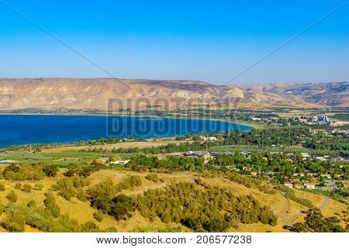

Sea of Galilee (also called the Sea of Tiberias)

They went out and got into the boat, but that night they caught nothing.
Just as day was breaking, Jesus stood on the shore; yet the disciples did not know that it was Jesus.
Jesus said to them, “Children, do you have any fish?”
They answered him, “No.”
He said to them, “Cast the net on the right side of the boat, and you will find some.” So they cast it, and now they were not able to haul it in, because of the quantity of fish.
That disciple whom Jesus loved therefore said to Peter, “It is the Lord!” When Simon Peter heard that it was the Lord, he put on his outer garment, for he was stripped for work, and threw himself into the sea...
When they got out on land, they saw a charcoal fire in place, with fish laid out on it, and bread.
Jesus said to them, “Bring some of the fish that you have just caught.”
So Simon Peter went aboard and hauled the net ashore, full of large fish, 153 of them. And although there were so many, the net was not torn.
Jesus said to them, “Come and have breakfast.”
Now none of the disciples dared ask him, “Who are you?” They knew it was the Lord. Jesus came and took the bread and gave it to them, and so with the fish.
This was now the third time that Jesus was revealed to the disciples after he was raised from the dead.

~ John 21:1-14 (ESV)

Jesus Challenges Peter

When they had finished eating, Jesus said to Simon Peter, “Simon son of John, do you love me more than these?”
“Yes, Lord,” he said, “you know that I love you.”
Jesus said, “Feed my lambs.”
Again Jesus said, “Simon son of John, do you love me?”
He answered, “Yes, Lord, you know that I love you.”
Jesus said, “Take care of my sheep.”
The third time he said to him, “Simon son of John, do you love me?”
Peter was hurt because Jesus asked him the third time, “Do you love me?” He said, “Lord, you know all things; you know that I love you.”
Jesus said, “Feed my sheep. Very truly I tell you, when you were younger you dressed yourself and went where you wanted; but when you are old you will stretch out your hands, and someone else will dress you and lead you where you do not want to go.”
Jesus said this to indicate the kind of death by which Peter would glorify God.
Then he said to him, “Follow me!”
Peter turned and saw that the disciple whom Jesus loved was following them…When Peter saw him, he asked, “Lord, what about him?”
Jesus answered, “If I want him to remain alive until I return, what is that to you? You must follow me.”

~ John 21:15-22 (NIV)

The Great Commission

Then the eleven disciples went to Galilee, to the mountain where Jesus had told them to go. When they saw him, they worshiped him; but some doubted.
Then Jesus came to them and said,
“All authority in heaven and on earth has been given to me. Therefore go and make disciples of all nations, baptizing them in the name of the Father and of the Son and of the Holy Spirit, and teaching them to obey everything I have commanded you.”

~ Matthew 28:16-20a (NIV)

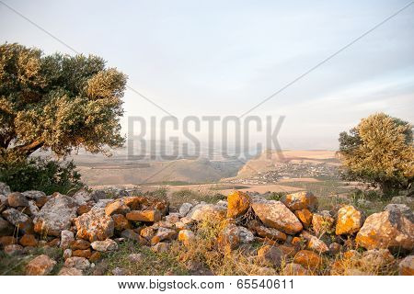

Galilee landscape
He said to them,
“Go into all the world and preach the gospel to all creation.”

~ Mark 16:15 (NIV)

“Go into all the world and preach the Good News to everyone.”

~ Mark 16:15b (NLT)

“And surely I am with you always, to the very end of the age.”

~ Matthew 28:20b (NIV)

The Ascension

Then Jesus led them to Bethany, and lifting his hands to heaven, he blessed them.
While he was blessing them, he left them and was taken up to heaven.
So they worshiped him and then returned to Jerusalem filled with great joy.
And they spent all of their time in the Temple, praising God.

~ Luke 24:50-53 (NLT)

So then, after the Lord had spoken to them, He was received up into heaven, and sat down at the right hand of God.

~ Mark 16:19 (NKJV)

Then they gathered around him and asked him,
“Lord, are you at this time going to restore the kingdom to Israel?”
He said to them: “It is not for you to know the times or dates the Father has set by his own authority.
“But you will receive power when the Holy Spirit comes on you; and you will be my witnesses in Jerusalem, and in all Judea and Samaria, and to the ends of the earth.”
After he said this, he was taken up before their very eyes, and a cloud hid him from their sight.
They were looking intently up into the sky as he was going, when suddenly two men dressed in white stood beside them.
“Men of Galilee,” they said, “why do you stand here looking into the sky?
“This same Jesus, who has been taken from you into heaven, will come back in the same way you have seen him go into heaven.”

~ Acts 1:6-11 (NIV)

Why Jesus Gave His Life for Us

God loves you abundantly, and has made a way for you to live forever in His glorious kingdom. However, first He had to pay an enormous price for you to be forgiven of your sin, in order to receive this eternal glory. This section explains His plan to forgive and save you. In summary:
God loves you, but your sin separates you from Him, and because of it, God’s wrath will come. However, Jesus died as a sacrifice to save you from your sins, from God’s wrath, and from death itself. When you confess your sins, repent and accept the salvation that Christ offers, God will forgive you. By trusting in Christ you become God’s child, and as His child, you will inherit eternal life and heaven will be your home.

God Loves You

“I came that they may have life and have it abundantly.”

~ John 10:10b (ESV)

Know that the Lord is God. It is he who made us, and we are his; we are his people, the sheep of his pasture.

~ Psalm 100:3 (NIV)

The Lord is my shepherd; I shall not want.

~ Psalm 23:1 (NIV)

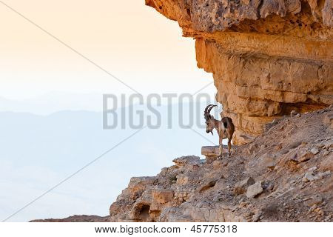

Wild Ibex in the Negev Desert

“I am the good shepherd.
“The good shepherd lays down his life for the sheep.
“The hired hand is not the shepherd and does not own the sheep. So when he sees the wolf coming, he abandons the sheep and runs away...
“I am the good shepherd; I know my sheep and my sheep know me…and I lay down my life for the sheep.
“I have other sheep that are not of this sheep pen. I must bring them also. They too will listen to my voice, and there shall be one flock and one shepherd.
“The reason my Father loves me is that I lay down my life—only to take it up again.
“No one takes it from me, but I lay it down of my own accord.”

~ John 10:11-18a (NIV)

“My sheep listen to my voice; I know them, and they follow me.
“I give them eternal life, and they will never perish.
“No one can snatch them away from me, for my Father has given them to me, and he is more powerful than anyone else.”

~ John 10:27-29a (NLT)

“Suppose one of you has a hundred sheep and loses one of them.
“Doesn’t he leave the ninety-nine in the open country and go after the lost sheep until he finds it?
“And when he finds it, he joyfully puts it on his shoulders and goes home.”

~ Luke 15:4-6a (NIV)

Therefore Jesus said again, “Very truly I tell you, I am the gate for the sheep. All who have come before me are thieves and robbers, but the sheep have not listened to them.
“I am the gate; whoever enters through me will be saved.”

~ John 10:7-9a (NIV)

But Your Sin Separates You from God

But your iniquities have separated you from your God; and your sins have hidden His face from you, so that He will not hear.

~ Isaiah 59:2 (NKJV)

By our very nature we were subject to God’s anger…

~ Ephesians 2:3b (NLT)

The Day of God’s Wrath Will Come

“See, the day of the Lord is coming—a cruel day, with wrath and fierce anger—to make the land desolate and destroy the sinners within it.”

~ Isaiah 13:9 (NIV)

“Woe to the world for temptations to sin! For it is necessary that temptations come, but woe to the one by whom the temptation comes!”

~ Matthew 18:7 (ESV)

“The angels will come and separate the wicked people from the righteous, throwing the wicked into the fiery furnace, where there will be weeping and gnashing of teeth.”

~ Matthew 13:49b-50 (NLT)

They will be punished with everlasting destruction and shut out from the presence of the Lord and from the glory of his might…

~ 2 Thessalonians 1:9 (NIV)

…forever separated from the Lord and from his glorious power.

~ 2 Thessalonians 1:9b (NLT)

For you are not a God who delights in wickedness; evil may not dwell with you.

~ Psalm 5:4 (ESV)

“Not everyone who says to me, ‘Lord, Lord’ will enter the kingdom of heaven, but only the one who does the will of my Father who is in heaven.”

~ Matthew 7:21 (NIV)

Confess Your Sin and Repent

Have mercy on me, O God, according to your unfailing love; according to your great compassion blot out my transgressions.
Wash away all my iniquity and cleanse me from my sin.

~ Psalm 51:1-2 (NIV)

Who is a God like you, who pardons sin…
You do not stay angry forever but delight to show mercy.
You will again have compassion on us; you will tread our sins underfoot and hurl all our iniquities into the depths of the sea.

~ Micah 7:18-19 (NIV)



The Dead Sea

Now this is what the Lord says to the family of Israel: “Come back to me and live!”

~ Amos 5:4 (NLT)

“For I take no pleasure in the death of anyone, declares the Sovereign Lord. Repent and live!”

~ Ezekiel 18:32 (NIV)

Jesus Died to Save You…

…From Your Sin

…God made Christ, who never sinned, to be the offering for our sin, so that we could be made right with God through Christ.

~ 2 Corinthians 5:21b (NLT)

…Christ also suffered once for sins, the righteous for the unrighteous, that he might bring us to God…

~ 1 Peter 3:18a (ESV)

…From God’s Wrath

For there is one God, and there is one mediator between God and men, the man Christ Jesus, who gave himself as a ransom for all…

~ 1 Timothy 2:5-6a (ESV)

…Christ Jesus died for us and was raised to life for us, and he is sitting in the place of honor at God’s right hand, pleading for us.

~ Romans 8:34b (NLT)

…we have an advocate who pleads our case before the Father. He is Jesus Christ, the one who is truly righteous.

~ 1 John 2:1b (NLT)

…because Jesus lives forever, he has a permanent priesthood.
Therefore he is able to save completely those who come to God through him, because he always lives to intercede for them.

~ Hebrews 7:24-25 (NIV)

…From Death

…God raised him from the dead, freeing him from the agony of death, because it was impossible for death to keep its hold on him.

~ Acts 2:24 (NIV)

And because you belong to him, the power of the life-giving Spirit has freed you from the power of sin that leads to death.

~ Romans 8:2 (NLT)

God Bought You at a Price

You are not your own; you were bought at a price.

~ 1 Corinthians 6:19b-20a (NIV)

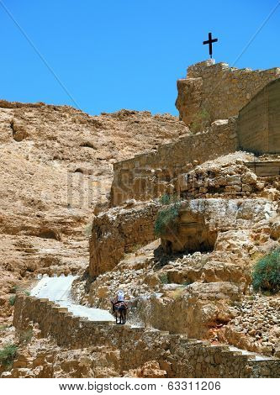

Monastery of St. George

In Christ You Are Forgiven

Therefore, my friends, I want you to know that through Jesus the forgiveness of sins is proclaimed to you.

~ Acts 13:38 (NIV)

For he has rescued us from the dominion of darkness and brought us into the kingdom of the Son he loves, in whom we have redemption, the forgiveness of sins.

~ Colossians 1:13-14 (NIV)

God Demonstrates His Love Through Christ

“For God so loved the world that He gave His only begotten Son, that whoever believes in Him should not perish but have everlasting life.”

~ John 3:16 (NKJV)

But God demonstrates his own love for us in this: While we were still sinners, Christ died for us.

~ Romans 5:8 (NIV)

Imitate God, therefore, in everything you do, because you are his dear children.
Live a life filled with love, following the example of Christ.
He loved us and offered himself as a sacrifice for us…

~ Ephesians 5:1-2a (NLT)

Salvation is Through Christ Alone

Salvation is found in no one else, for there is no other name under heaven given to mankind by which we must be saved.

~ Acts 4:12 (NIV)

We are made right with God by placing our faith in Jesus Christ.

~ Romans 3:22a (NLT)

Salvation is a Gift: Free and Undeserved

But because of his great love for us, God, who is rich in mercy, made us alive with Christ even when we were dead in transgressions—it is by grace you have been saved.

~ Ephesians 2:4-5 (NIV)

For it is by grace you have been saved, through faith—and this not from yourselves, it is the gift of God—not by works, so that no one can boast.

~ Ephesians 2:8-9 (NIV)

Accept This Gift of Salvation

…how shall we escape if we ignore so great a salvation?

~ Hebrews 2:3a (NIV)

You Belong to God Through Faith in Christ and Have Become His Child

See what great love the Father has lavished on us, that we should be called children of God!

~ 1 John 3:1a (NIV)

For you are all children of God through faith in Christ Jesus.

~ Galatians 3:26 (NLT)

Now if we are children, then we are heirs—heirs of God and co-heirs with Christ, if indeed we share in his sufferings in order that we may also share in his glory.

~ Romans 8:17 (NIV)

Eternal Life is Yours Through Christ

…God gave us eternal life, and this life is in his Son.

~ 1 John 5:11b (ESV)

Since he did not spare even his own Son but gave him up for us all, won’t he also give us everything else?

~ Romans 8:32 (NLT)

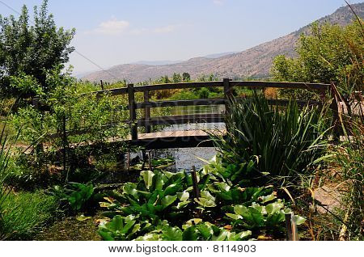

Agamon aHula, Israel

The Lord will rescue me from every evil attack and will bring me safely to his heavenly kingdom.

~ 2 Timothy 4:18a (NIV)

Jesus answered, “My kingdom is not of this world.”

~ John 18:36a (ESV)

“The kingdom of heaven is like treasure hidden in a field.
“When a man found it, he hid it again, and then in his joy went and sold all he had and bought that field.”

~ Matthew 13:44 (NIV)

“If you belonged to the world, it would love you as its own.
“As it is, you do not belong to the world, but I have chosen you out of the world.”

~ John 15:19a (NIV)

“For many are called, but few are chosen.”

~ Matthew 22:14 (ESV)

Jesus answered him, “Truly I tell you, today you will be with me in paradise.”

~ Luke 23:43 (NIV)

Then He who sat on the throne said, “Behold, I make all things new.”

~ Revelation 21:5a (NKJV)

“To the one who is victorious, I will give the right to eat from the tree of life, which is in the paradise of God.”

~ Revelation 2:7b (NIV)

“The one who is victorious will not be hurt at all by the second death.”

~ Revelation 2:11b (NIV)

“All who are victorious will be clothed in white.
“I will never erase their names from the Book of Life, but I will announce before my Father and his angels that they are mine.”

~ Revelation 3:5 (NLT)

“For my Father’s will is that everyone who looks to the Son and believes in him shall have eternal life…”

~ John 6:40a (NIV)

“…rejoice because your names are written in heaven.”

~ Luke 10:20b (NKJV)

Heaven is Your Home

No eye has seen, no ear has heard, and no mind has imagined what God has prepared for those who love him.

~ 1 Corinthians 2:9b (NLT)

Now we live with great expectation, and we have a priceless inheritance—an inheritance that is kept in heaven for you, pure and undefiled, beyond the reach of change and decay.

~ 1 Peter 1:3b-4 (NLT)

His dominion is an everlasting dominion that will not pass away, and his kingdom is one that will never be destroyed.

~ Daniel 7:14b (NIV)

…we are receiving a kingdom that cannot be shaken

~ Hebrews 12:28b (NIV)

Praise God for His Gift of Eternal Life

...thanks be to God, who gives us the victory through our Lord Jesus Christ.

~ 1 Corinthians 15:57 (ESV)
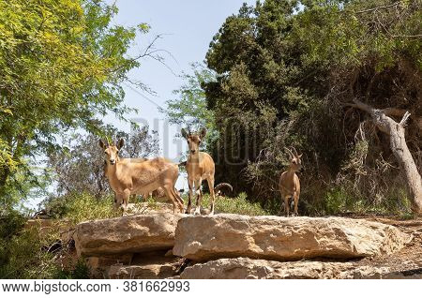

Wild Ibex in the Judean Desert

The Return of Jesus

After he said this, he was taken up before their very eyes, and a cloud hid him from their sight…when suddenly two men dressed in white stood beside them. “Men of Galilee,” they said, “why do you stand here looking into the sky?
“This same Jesus, who has been taken from you into heaven, will come back in the same way you have seen him go into heaven.”

~ Acts 1:9-11 (NIV)

…He is coming with clouds, and every eye will see Him…

~ Revelation 1:7a (NKJV)

“Then everyone will see the Son of Man coming on a cloud with power and great glory.”

~ Luke 21:27 (NLT)

Jesus answered: “Watch out that no one deceives you…
“For many will come in my name, claiming, ‘I am the Messiah,’ and will deceive many…
“So if anyone tells you, ‘There he is, out in the wilderness,’ do not go out; or, ‘Here he is, in the inner rooms,’ do not believe it.
“For as lightning that comes from the east is visible even in the west, so will be the coming of the Son of Man.”

~ Matthew 24:4-5, 23-27 (NIV)

“But about that day or hour no one knows, not even the angels in heaven, nor the Son, but only the Father.”

~ Matthew 24:36 (NIV)

And now, dear children, remain in fellowship with Christ so that when he returns, you will be full of courage and not shrink back from him in shame.

~ 1 John 2:28 (NLT)

May God himself, the God of peace, sanctify you through and through. May your whole spirit, soul and body be kept blameless at the coming of our Lord Jesus Christ.

~ 1 Thessalonians 5:23 (NKJV)

He will keep you strong to the end so that you will be free from all blame on the day when our Lord Jesus Christ returns.

~ 1 Corinthians 1:8 (NLT)

When Christ who is your life appears, then you also will appear with him in glory.

~ Colossians 3:4 (ESV)

…we wait for the blessed hope—the appearing of the glory of our great God and Savior, Jesus Christ...

~ Titus 2:13 (NIV)

It will happen in a moment, in the blink of an eye, when the last trumpet is blown. For when the trumpet sounds, those who have died will be raised to live forever.

~ 1 Corinthians 15:52a (NLT)

For the Lord himself will come down from heaven, with a loud command, with the voice of the archangel and with the trumpet call of God, and the dead in Christ will rise first.
After that, we who are still alive and are left will be caught up together with them in the clouds to meet the Lord in the air.
And so we will be with the Lord forever.
Therefore encourage one another with these words.

~ 1 Thessalonians 4:16-18 (NIV)



Judean Desert

“Surely I am coming soon.”

~ Revelation 22:20b (ESV)

“So don’t be afraid, little flock.”

~ Luke 12:32a (NLT)

“And be sure of this: I am with you always, even to the end of the age.”

~ Matthew 28:20b (NLT)



Sea of Galilee

Now all glory to God, who is able to keep you from falling away and will bring you with great joy into his glorious presence without a single fault.
All glory to him who alone is God, our Savior through Jesus Christ our Lord.
All glory, majesty, power, and authority are his before all time, and in the present, and beyond all time! Amen.

~ Jude 1:24-25 (NLT)
Photo Copyright Info

Note: when purchasing the rights to use the photos, you may want to purchase an Extended License for the cover image.

Bigstock Photo ID: 4084413
A beautiful palm trees and their shadows on the old walls of Jaffa Gates in Jerusalem
Stock Photo ID: 4084413
Copyright: Nancy Habbas

Bigstock Photo ID: 405247157
The fortress wall of old Jerusalem. Stone-paved footpath through green grass lawn. Hot summer sunset. The concept of historical, pilgrim and photo tourism
Stock Photo ID: 405247157
Copyright: kavram

Bigstock Photo ID: 47942120
David Tower .the Old City Jerusalem.
David Tower .Inside the The Old City Jerusalem.Israel
Stock Photo ID: 47942120
Copyright: slavamalai1

Bigstock Photo ID: Bigstock-110943455
Model of Jerusalem Temple from First Century Israel Museum Jerusalem
Stock Photo ID: 110943455
Copyright: Sopotniccy

Bigstock Photo ID: 18391106
Vertical oriented image of old street in historic part of Jerusalem, Israel.
Stock Photo ID: 18391106
Copyright: rglinsky

Bigstock Photo ID: 464476711
Editing suggestion: Crop out bottom right corner of burlap
Concept of Eucharist or holy communion of Christianity. Eucharist is sacrament instituted by Jesus. during last supper with disciples. Bread and wine is body and blood of Jesus Christ of Christians.
Stock Photo ID: 464476711
Copyright: doidam10

Bigstock Photo ID: 84640205
Jesus pouring water from a jar before the feet washing
Stock Photo ID: 84640205
Copyright: carlosphotos
Release: Signed model release filed with Bigstock.

Bigstock Photo ID: 447905815
Jerusalem, view of the old city from the Mount of Olives
Stock Photo ID: 447905815
Copyright: Vladimir_Blinov

Bigstock Photo ID: 51406216
Wine grapes on old vine close-up
Close-up of large bunches of ripe red wine grapes on an old vine, with blurred background.
Stock Photo ID: 51406216
Copyright: AndrewHagen

Bigstock Photo ID: 179058586
Church of All Nations in the Kidron Valley - Jerusalem, Israel
Stock Photo ID: 179058586
Copyright: Leonid Andronov
Bigstock Photo ID: 287460553
Gethsemane Garden on the Mount of Olives in Jerusalem. Magnificent well-kept garden - a symbol of the Christian faith. The concept of historical, religious and ethnographic touris
Stock Photo ID: 287460553
Copyright: kavram

Bigstock Photo ID: 47345605
Passage
Passage in the OLd City of Jerusalem
Stock Photo ID: 47345605
Copyright: naxaso

Bigstock Photo ID: 188364250
The Wadi Qelt or Nahal Prat the Monastery of St. George of Choziba in mountain area Israel
Stock Photo ID: 188364250
Copyright: alefbet

Bigstock Photo ID: 339515002
Editing suggestion: Slightly crop bottom of photo to remove distracting red portion
The Garden Tomb, entrance to the tomb cut into the rock. The Garden Tomb, site of pilgrimage, rock tomb outside the walls of the Old City of Jerusalem, Israel
Stock Photo ID: 339515002
Copyright: Valen Zi

Bigstock Photo ID: 415386421
An old carob tree near a forest path in the Judea mountains near Jerusalem, Israel.
Stock Photo ID: 415386421
Copyright: Moshe Einhorn

Bigstock Photo ID: 206577238
View of the southern part of the Sea of Galilee (the Kinneret lake) and nearby villages in northern Israel
Stock Photo ID: 206577238
Copyright: RnDmS

Bigstock Photo ID: 65540611
Galilee Landscape
Israel landscape a view to Kineret and stones lake during hiking
Stock Photo ID: 65540611
Copyright: javax

Bigstock Photo ID: 45775318
Editing suggestion: Rotate photo so ibex is facing center of page
Wild ibex in the Negev Desert in Israel
Stock Photo ID: 45775318
Copyright: alexeys

Bigstock Photo ID: 53249008
Coast Of The Dead Sea. Israel
Landscape with Dead sea desert coast . Israel ** Note: Shallow depth of field
Stock Photo ID: 53249008
Copyright: Tatiana Belova

Bigstock Photo ID: 63311206
On the road, paved with stone, raised on a donkey woman – a pilgrim dressed in white. Wadi Kelt, the road to the monastery of St. George
Stock Photo ID: 63311206
Copyright: kavram

Bigstock Photo ID: 8114903
Bridge over river.
Bridge on the River. View of the Golan. North Israel, Agmon aHula.
Stock Photo 8114903
Copyright: landscape-painter

Bigstock Photo ID: 381662993
Nubian ibex - Capra Nubiana - graze in an oasis in the Judean Desert in southern Israel
Stock Photo ID: 381662993
Copyright: svarshik

Bigstock Photo ID: 30858836
Judaean Desert in Israel and the West Bank looking towards Jordan over the Dead Sea.
Stock Photo 30858836
Copyright: SeanPavonePhoto

Bigstock Photo ID: 456273283
Sea of Galilee (Kinneret), the largest freshwater lake in Israel
Stock Photo ID: 456273283
Copyright: Vladimir_Blinov

Booklet Titles in the Series
www.TheWordOfGodSeries.com
Relational and Emotional Health Topics

A Joy-Filled Life

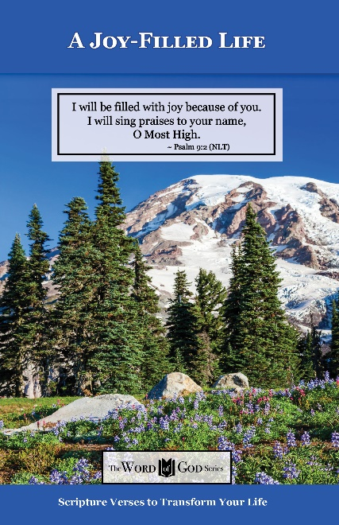
Relational and Emotional Health Topics

Healthy Relationships

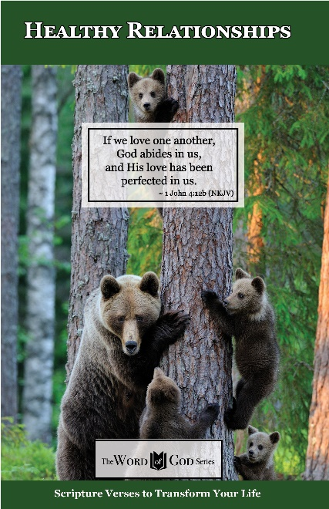
Relational and Emotional Health Topics

Healthy Thoughts

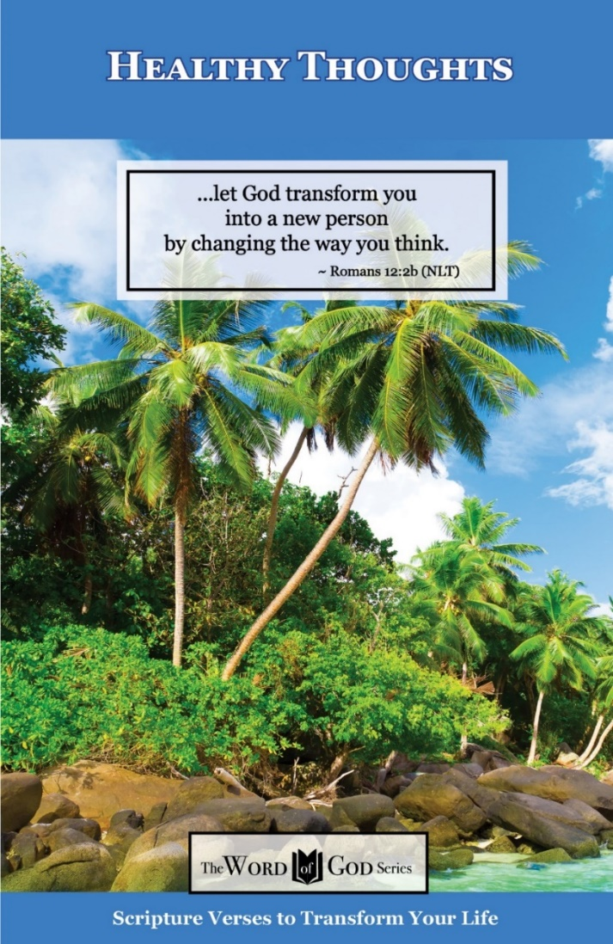
Relational and Emotional Health Topics

Freedom from Depression and Comfort in Grief

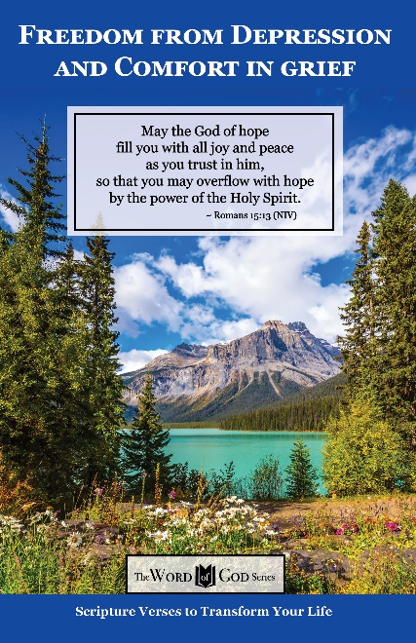
Relational and Emotional Health Topics

Freedom from Fear

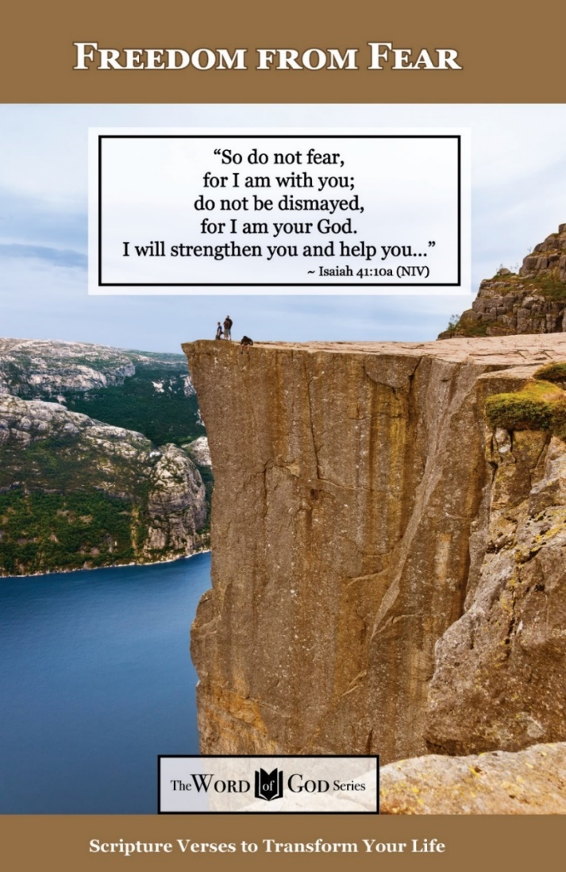
Relational and Emotional Health Topics

Freedom from Addictions

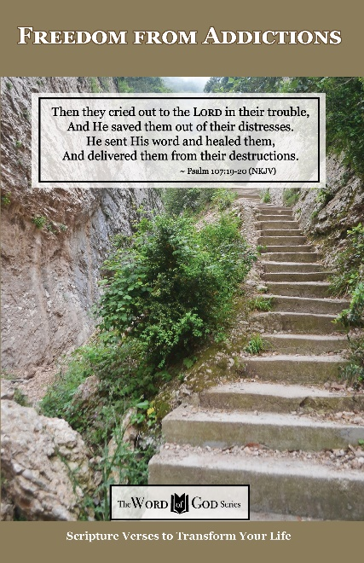
The Life and Ministry of Christ Series

Jesus: His Birth

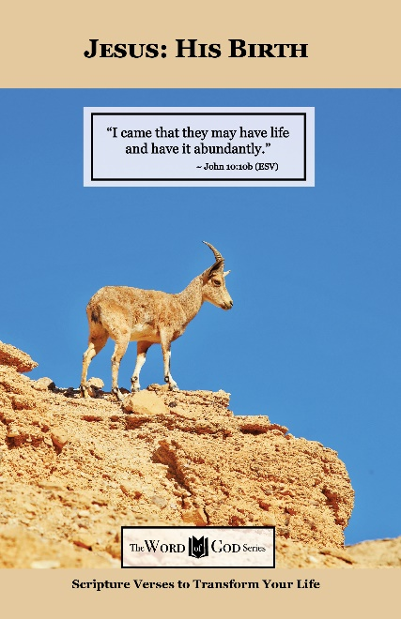
The Life and Ministry of Christ Series

Jesus: His Life Events

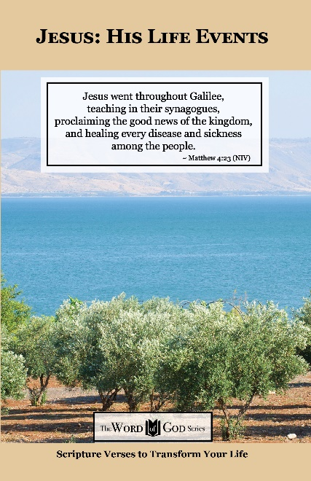
The Life and Ministry of Christ Series

Jesus: His Teachings

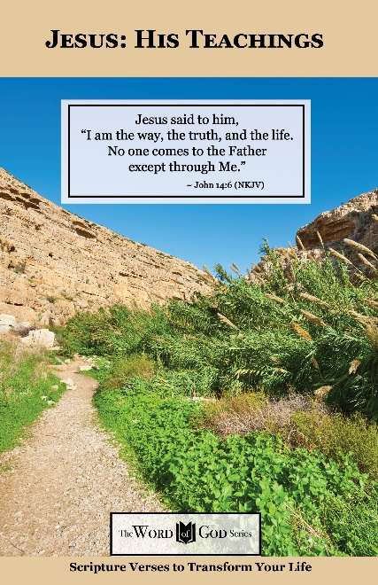
The Life and Ministry of Christ Series

Jesus: His Death, Resurrection and Return

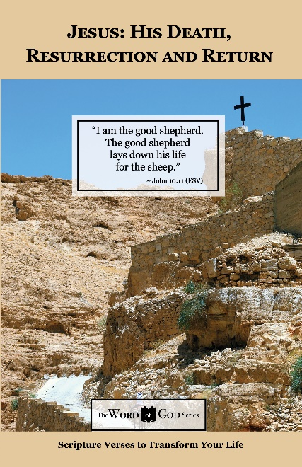
Spiritual Growth Topics

God’s Power and Presence

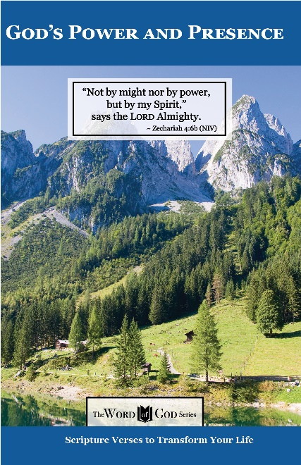
Spiritual Growth Topics

God’s Gift of Eternal Life

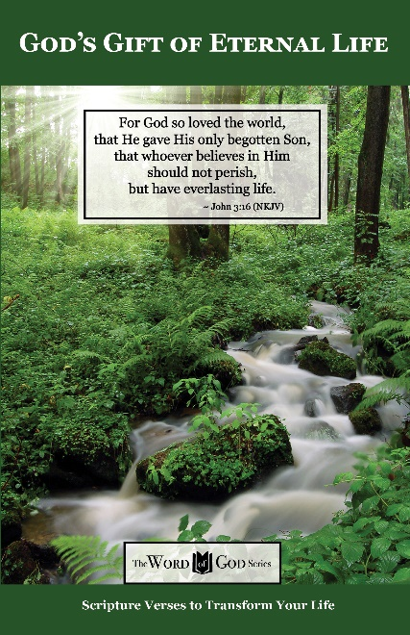
Spiritual Growth Topics

Sharing the Good News

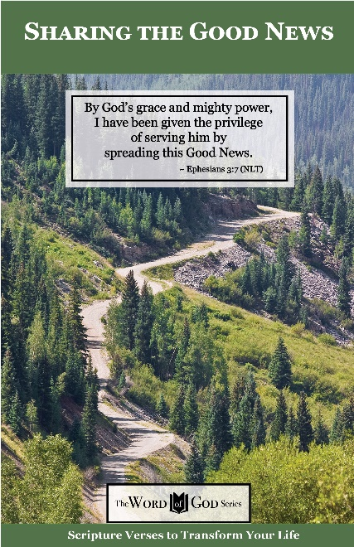
Spiritual Growth Topics

Defeating the Enemy

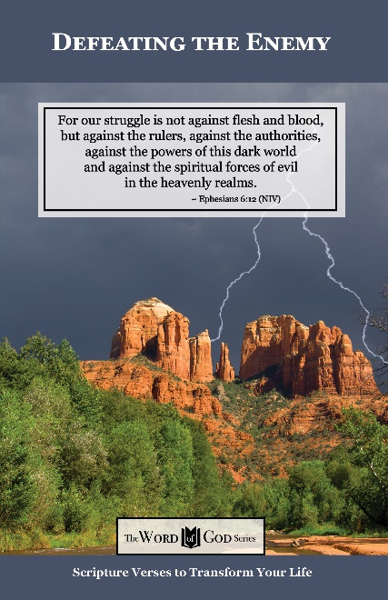
Spiritual Growth Topics

Standing Strong in Persecution

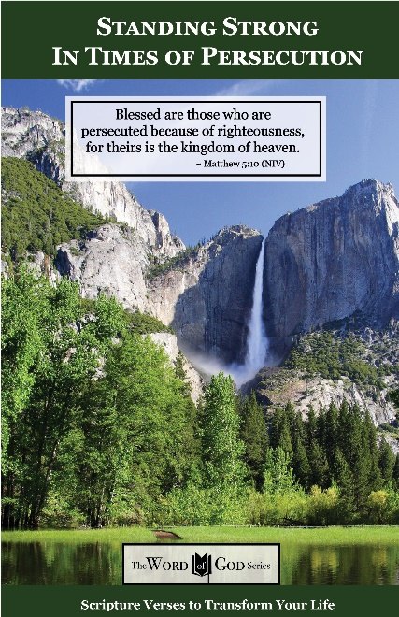
Everyday Life Topics

God’s Healing Power

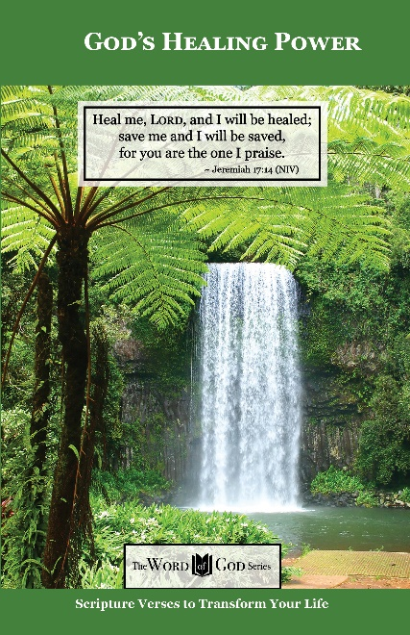
Everyday Life Topics

God is Your Refuge

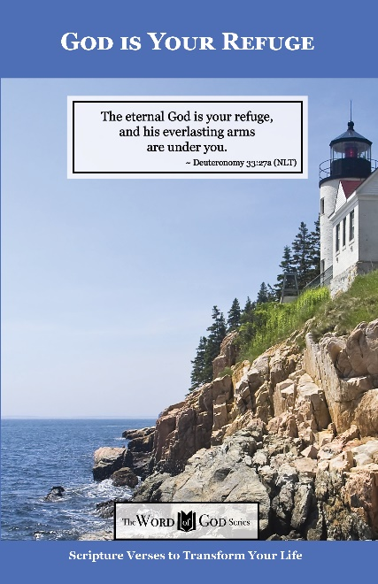
Everyday Life Topics

God’s Guidance for Your Life

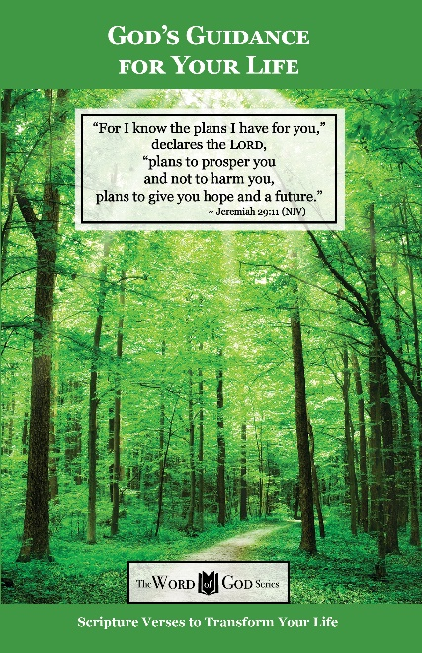
Everyday Life Topics

God’s Word to the Nations

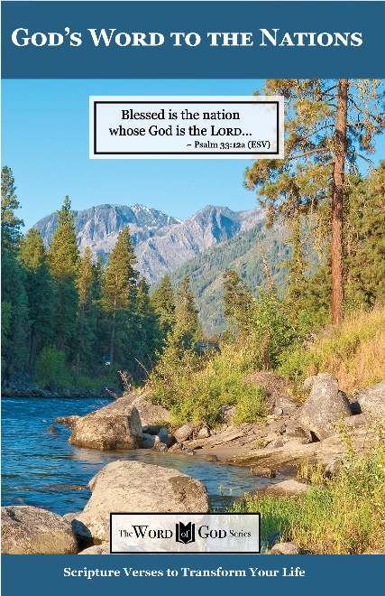
Everyday Life Topics

Praise God at Thanksgiving

