Template for Sharing the Good News in an eBooklet Format

The Word of God Series is a collection of 20 booklets that present Scripture verses in an easy-to-read format, with each booklet focused on a different topic.
Titles include Healthy Relationships, A Joy-Filled Life, Freedom from Depression, and many others. Click here to see other titles.
The booklets are available in both paperback and digital formats at www.TheWordOfGodSeries.com or Amazon.com.
Why This Template?
Because I believe in the power of God’s Word to transform people’s lives, I have dedicated several years of my life to bring this series to fruition.
I am passionate about using these booklets to reach a dark and dying world with the love of Christ and the hope of the Gospel.
Initially, I had expected this series would be a small business. But one day, when I asked God what my next steps should be, He spoke to me through His Word and told me to:
“…complete the ministry God has given you.”
~ 2 Timothy 4:5 (NLT, 1996 version)
So, I shifted the focus from being a business to a ministry.
My vision, also, has evolved over time and I have come to believe that it is possible for millions of these booklets to be distributed (in both print and digital formats) around the world (see the document entitled The Vision at www.TheWordOfGodSeries.com for more info.)
In order to make this a far-reaching ministry, accessing populations that I couldn’t on my own, I decided to invite others to partner with me in producing and distributing these booklets to their own personal networks. To help get it started, I have made templates of each booklet freely available to anyone who would like them.
This way you (whether you are a church, Christian organization or an individual) can easily re-create the booklets in your own ministry’s name, and distribute them to the people you minister to.
I hope that this template will save you:
- Time – so you can benefit from the thousands of hours of development time that has been invested so far
- Money – eliminate layers of profit margin
Whether you simply replicate and reproduce what has already been done, build on it, or take this idea in a different direction, you won’t have to waste time starting with a blank page.
I hope you can easily get these finalized, so you can begin sharing them with the people in your sphere of influence.
On the following pages you will find document formatting tips.
Photo editing tips are also presented, as well as the preview images of each photo (with the Photo ID#), so you to easily find it on either bigstockphoto.com or shutterstock.com. Copyright and general info for each photo can be found here.
Formatting Tips (if making changes to this document)
This document is ready to be exported to an eBook format. The app I used is through Amazon called Kindle Create.
If you make any changes to this document (such as pasting additional verses or entire sections into it), you’ll want follow the steps below.
If you are not making any changes to this document, then just skip these steps.
When converting a document to eBook format, it’s best to remove tabs, indentations and soft returns. While using these formatting tricks in a print format can make the page much more readable (by adding white space to the page), in a digital format, these same tricks can disrupt the flow of the text and make it more difficult to read (since the view can change depending on the type of device, font size selected, etc.)
- Remove all tabs, indentations and soft returns (Note, if a passage is too long, you can always add white space by inserting a
hard return (the Enter key only) after a sentence, with a 6 pt spacing after the line. (Layout / Spacing / After / 6 pt)


- Ensure that the spacing between the lines is consistent throughout the document. When the document is completed, select the entire document (Ctrl + A) and click on Layout / Paragraph / Multiple (under Line Spacing) and change the number to “1”


- Ensure that the spacing between the characters is consistent throughout the document. After completing step 2 above, while the entire document is still selected, click on Home / Font / Advanced and change the Spacing to Normal


Photo Editing Tips
At the end of this document you will find the copyright and descriptive info for each photo in the booklet, as well as editing suggestions for a few of them.
For the digital view, try to keep the photos as large on the page as possible, otherwise they will appear too small on devices. The preview photos in this document are a good size for digital format, so try to keep your photos the same size.
Most of the editing suggestions (especially brightening or increasing color saturation) should be very slight adjustments.
Editing photos within this document
Rotate: Doubleclick the photo, click on the Rotate Object icon.
Note: rotating an image is more important in the print format, so that certain objects in the photo will face the center of the page (such as animal pics). This doesn’t matter in a digital format, but the suggestion to rotate certain photos is included below in order to keep the digital and print formats consistent (in case someone reads both the print and digital booklets.)

Editing photos in the Pictures editing app in MS Word
Navigate to your Pictures folder, doubleclick the photo, and click on the blue Edit button on left
Most of the editing can be accomplished using one of these 3 options:


Crop: Click on the Crop icon and drag edges to desired spot
Brighten a photo: Adjustment icon / Light / Brightness
Increase color saturation: Adjustment icon / Color / Saturation or Warmth
Remove distracting elements from a photo: Click on the Generative Erase icon, select a brush size and click on the part of the photo you want removed.

Photo Searching Tips
Occasionally photographers pull their photos from the sites, so there may be some in this document that are no longer available. You can try using the same key words to search for the photo on other sites. Or, you can search for another photo on Bigstock:
- Under All Images select Photos and search by key word.
- At the next screen, make sure that Safe Search is on.
- In the Category field, select either Landscapes, Nature or Animals.
Forward Page | Copyright Page | Table of Contents

Below are sample Forward and Copyright pages. Feel free to edit to reflect your ministry’s mission and vision.
The Table of Contents in this document contains links to each of the section headings. If you add any new sections to this document, be sure to:
- Assign the Heading Style to the new section heading (in this document, it is referred to as Heading).
Highlight the heading, click on Home, then Heading in the Styles box


- Bookmark the new section heading: Put your cursor after the first letter in the section heading, click on Insert / Bookmark and then give name the bookmark (no spaces in the name!)



- Add the new section heading to the Table of Contents page and add a link to the bookmark you just created: Highlight the text, click on Insert / Link / Place in this Document and select the section heading bookmark.


Kindle Create
Should you decide to use Kindle Create to export this to an eBook format, see the steps below. You can use Kindle Create to export to a Kindle KPF file and/or EPUB file:

Begin at https://kdp.amazon.com/en_US/bookshelf to set up the booklets on Amazon and install the Kindle Create app.
At the first screen, select Create New and Choose

At the next Screen click on Continue. At the next screen click on Choose File, select the document, and click on Open. Then click on Continue and Get Started.
At the next screen you will see a box labeled Suggested Chapter Titles. Click on Reject All.
Next, left-justify the entire document (a quirk with this application is that some portions of the document may be centered, while others portions are left-justified). Highlight the entire document, click on Formatting, and then the left-justify icon.
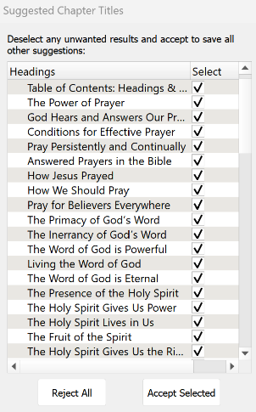

Now you can begin assigning different elements to the Headings and Subheadings in the document so that, when someone is reading the eBook, they can easily jump to another section via the Table of Contents.
I use 2 elements: Chapter Title (for the key headings in the Brittanica Bold font) and Subheading (for the underlined subheadings).
As you begin assigning the elements, be sure to start by assigning the Chapter Title element to the Table of Contents: Headings and Subheadings heading. Then go through the rest of the document and assign either the Chapter Title or Subheading elements.
You can change the formatting from the Kindle Create default, if you want. Below are the formatting options that I use for the eBooklets.
Feel free to customize to suit your preferences.

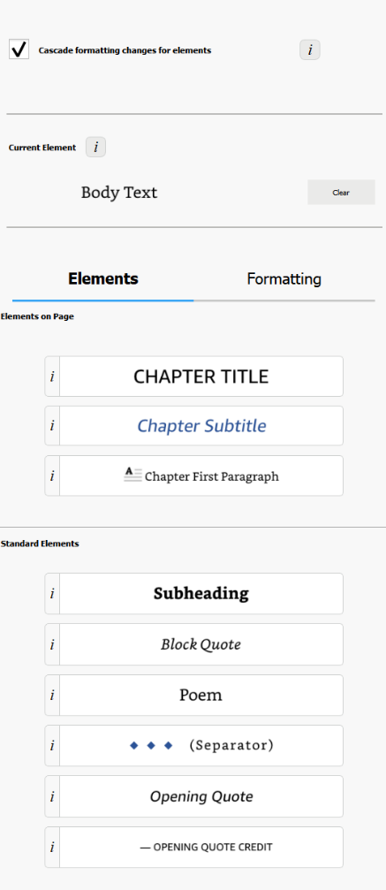


Finally, go through the document and click on each photo and change it to “Full Size.” (Note, another quirk with this app is that some photos just can’t be changed to full size, so they will appear smaller in the eBooklet).
When complete, first, save the document (File / Save Project). This will automatically put it in a folder. So when you export the document, be sure you export it to that folder.
To export, click on File / Export / KPF (Kindle and print). At the next screen, click on the file name to select it, and then click on Export.
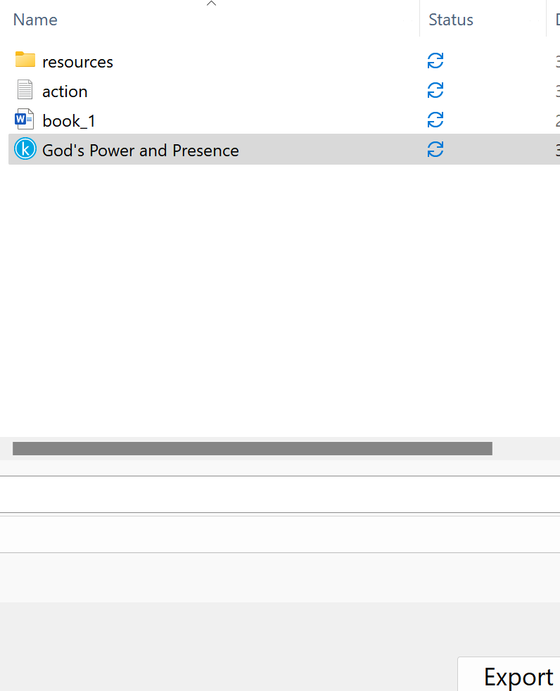

If you want the file in an EPUB format, go through the steps above and select File / Export / EPUB

Stuck on a Step Above and Need Help?
If you want to do this project on your own, but are having tech issues with one of the steps above, feel free to contact me at Susan@TheWordOfGodSeries.com. I may be able to assist you, since I’ve gone through this whole process myself!

Need Help with the Whole Project?
If you want these booklets set up in your own in your own ministry’s name, but don’t have the resources to do the whole project yourself,
I may be able to manage that process for you for a one-time project fee.
This would include the following services:
- Set up an account with Bigstock and Shutterstock in your ministry’s name and purchase the rights for you to use each of the photos
- Download and name the photos
- Edit photos as needed
- Create a cover with your church or ministry logo
- Request the rights to use the various Bible translations from each of the publishers (if applicable)
Feel free to contact me at Susan@TheWordOfGodSeries.com to discuss pricing options.

I hope that this information will help you finalize this document with ease so you can begin distributing it
to the people in your realm of influence.
Thank you for partnering with me in this effort. I wish you the best as you make God’s Word known and
share His love with others!
Warmly in Christ,
Susan

Soli Deo gloria



Feel free to edit this forward page to align to your own ministry’s vision and goals.

The Bible is the best-selling and most transformative book in history. Written over 2,000 years ago, it is still living and powerful today.
Throughout the pages of Scripture you will find inspiration and joy, comfort and peace, healing and hope.
Most importantly, you will learn of God’s abundant love for you, and His plan to give you a glorious, eternal inheritance.
The Word of God Series is a collection of booklets which presents Scripture by topic, so you can focus on verses that are relevant to you at different stages and circumstances throughout your life.
All of the booklets in this series feature Scripture exclusively—just the powerful, undiluted Word of God.
Let God’s Word permeate your mind and transform your life.
Here are a few suggestions to help you fully benefit from Scripture:
Meditate
Pause and reflect on the verses as you read, and even meditate on them throughout the day.
Memorize
A great memorization technique is to repeat the verse several times, each time emphasizing a different word.
“The harvest is plentiful but the workers are few.”
“The harvest is plentiful but the workers are few.”
“The harvest is plentiful but the workers are few.”
~ Matthew 9:37b (NIV)
Pray
Actually pray God’s Word back to Him. For example,
Heavenly Father, since the harvest is plentiful, please use me as a worker into Your harvest field.

Do What It Says
Do not merely listen to the word, and so deceive yourselves. Do what it says.
~ James 1:22 (NIV)

My prayer for you, as you read this booklet, is that you will be empowered by God’s Word to share the Good News with others so that they, too, can someday enter into His glorious Kingdom.
Let the word of Christ dwell in you richly…

~ Colossians 3:16a (ESV)

A few comments about The Word of God Series:

- The booklets in this series provide you with a sample of what the Bible offers, but it is important that you also read the Bible itself, preferably with a book-by-book focus.

- Passages in quotation marks are the actual words of God, either through His prophets in the Old Testament, or the words of Christ in the New Testament.

- Every booklet includes a section that details God’s plan of salvation (commonly referred to as “The Gospel.”) The booklet entitled God’s Gift of Eternal Life is devoted to the Gospel message.

This series presents verses in the following translations:

NIV: New International Version
Scripture quotations marked NIV are taken from the Holy Bible, New International Version®, NIV®. Copyright © 1973, 1978, 1984, 2011 by Biblica, Inc.™ Used by permission of Zondervan. All rights reserved worldwide. www.zondervan.com. The "NIV" and "New International Version" are trademarks registered in the United States Patent and Trademark Office by Biblica, Inc.™

NLT: New Living Translation
Scripture quotations marked NLT are taken from the Holy Bible, New Living Translation, Copyright© 1996, 2004, 2015 by Tyndale House Foundation. Used by permission of Tyndale House Publishers, Inc., Carol Stream, Illinois 60188. All rights reserved.

ESV: English Standard Version
Scripture quotations marked ESV are taken from the ESV Bible® (The Holy Bible, English Standard Version®), copyright © 2001 by Crossway Bibles, a publishing ministry of Good News Publishers. Used by permission. All rights reserved.

KJV: King James Version
Public Domain

NKJV: New King James Version
Scripture quotations marked NKJV are taken from the New King James Version®. Copyright © 1982 by Thomas Nelson, Inc. Used by permission.

Since this is a template booklet featuring preview photos, it is not copyrighted, so you are free to purchase licenses to use the photos and develop your own booklets. Be sure to determine whether or not you need to request permission (and in some cases pay) for the rights to use the various Bible translations. Scripture verses were sourced from www.BibleGateway.com.

If it would be easier for you to simply purchase this booklet, the copyrighted version is available at www.TheWordOfGodSeries.com or www.amazon.com. ISBN info for the copyrighted booklets is as follows: 978-1-964538-24-2 (print booklet), 978-1-964538-25-9 (eBooklet), 9798322919506 (print booklet on Amazon).

Table of Contents: Headings & Sub-Headings

God Chose You to Share the Good News
Prepare for Fruitful Service
Rely on the Power of the Holy Spirit
Know the Gospel Well Enough to Teach It
Praise God for His Gift of Eternal Life
Share the Good News with Others
Make the Most of Every Opportunity
Preach the Gospel
The First Recorded Gospel Message when the Holy Spirit Came at Pentecost
Proclaim God’s Message with Boldness
Proclaim the Gospel Plainly, Not with Eloquence, but with a Demonstration of the Spirit’s Power
Pray for the Ministry of Other Believers
Seek to Please God, Not People
Declare His Glory Among the Nations
Give Yourself Fully to the Work of the Lord
Be Willing to Endure Hardship
Bear Fruit
Reap a Harvest
Finish the Work
Jesus Sends You
Go!

Note: The verse references in this document contain links to the BibleGateway.com page that will display the passage in all 5 translations that are used in this series (NIV, NLT, ESV, NKJV, KJV).

Other Booklets in the Series
God Chose You to Share the Good News

For we know, brothers and sisters loved by God, that he has chosen you…
~ 1 Thessalonians 1:4 (NIV)

…you are a chosen generation, a royal priesthood, a holy nation, His own special people, that you may proclaim the praises of Him who called you out of darkness into His marvelous light...

~ 1 Peter 2:9 (NKJV)



…I urge you to live a life worthy of the calling you have received.

~ Ephesians 4:1b (NIV)

…for you have been called by God.

~ Ephesians 4:1b (NLT)

We are therefore Christ’s ambassadors, as though God were making his appeal through us.

~ 2 Corinthians 5:20a (NIV)

By God’s grace and mighty power, I have been given the privilege of serving him by spreading this Good News.

~ Ephesians 3:7 (NLT)

Though I am the least deserving of all God’s people, he graciously gave me the privilege of telling the Gentiles about the endless treasures available to them in Christ.

~ Ephesians 3:8 (NLT)

The word of the Lord came to me, saying,
“Before I formed you in the womb I knew you,
“before you were born I set you apart…”

~ Jeremiah 1:4-5a (NIV)

I thank Christ Jesus our Lord, who has given me strength, that he considered me trustworthy, appointing me to his service.

~ 1 Timothy 1:12 (NIV)

…because He counted me faithful, putting me into the ministry…

~ 1 Timothy 1:12b (NKJV)

I have been sent to proclaim faith to those God has chosen and to teach them to know the truth that shows them how to live godly lives.
This truth gives them confidence that they have eternal life, which God—who does not lie—promised them before the world began.

~ Titus 1:1b-2 (NLT)

“Everyone who calls on the name of the Lord will be saved.”
But how can they call on him to save them unless they believe in him?
And how can they believe in him if they have never heard about him?
And how can they hear about him unless someone tells them?

~ Romans 10:13-14 (NLT)

Prepare for Fruitful Service

Always be prepared to give an answer to everyone who asks you to give the reason for the hope that you have.
But do this with gentleness and respect, keeping a clear conscience...

~ 1 Peter 3:15b-16a (NIV)

If you keep yourself pure, you will be a special utensil for honorable use.
Your life will be clean, and you will be ready for the Master to use you for every good work.

~ 2 Timothy 2:21 (NLT)



Do everything without grumbling or arguing, so that you may become blameless and pure, “children of God without fault in a warped and crooked generation.”
Then you will shine among them like stars in the sky as you hold firmly to the word of life.

~ Philippians 2:14-16a (NIV)

Do your best to present yourself to God as one approved, a worker who has no need to be ashamed, rightly handling the word of truth.

~ 2 Timothy 2:15 (ESV)

…train yourself for godliness; for while bodily training is of some value, godliness is of value in every way, as it holds promise for the present life and also for the life to come.

~ 1 Timothy 4:7b-8 (ESV)

…make every effort to
add to your faith goodness;
and to goodness, knowledge;
and to knowledge, self-control;
and to self-control, perseverance;
and to perseverance, godliness;
and to godliness, mutual affection;
and to mutual affection, love.
For if you possess these qualities in increasing measure, they will keep you from being ineffective and unproductive in your knowledge of our Lord Jesus Christ…
For if you do these things, you will never stumble, and you will receive a rich welcome into the eternal kingdom of our Lord and Savior Jesus Christ.

~ 2 Peter 1:5b-11 (NIV)



I myself am convinced, my brothers and sisters, that you yourselves are full of goodness, filled with knowledge and competent to instruct one another.

~ Romans 15:14 (NIV)

But now you must also rid yourselves of all such things as these: anger, rage, malice, slander, and filthy language…

~ Colossians 3:8a (NIV)

Therefore this is what the Lord says: “If you repent, I will restore you that you may serve me; if you utter worthy, not worthless, words, you will be my spokesman.”

~ Jeremiah 15:19a (NIV)

All Scripture is God-breathed and is useful for teaching, rebuking, correcting and training in righteousness, so that the servant of God may be thoroughly equipped for every good work.

~ 2 Timothy 3:16-17 (NIV)

For the word of God is alive and powerful.
It is sharper than the sharpest two-edged sword…

~ Hebrews 4:12a (NLT)

Now may the God of peace…equip you with all you need for doing his will.
May he produce in you, through the power of Jesus Christ, every good thing that is pleasing to him.

~ Hebrews 13:20-21a (NLT)

Rely on the Power of the Holy Spirit

“…you will receive power when the Holy Spirit has come upon you, and you will be my witnesses in Jerusalem and in all Judea and Samaria, and to the end of the earth.”

~ Acts 1:8 (ESV)

“And now I will send the Holy Spirit, just as my Father promised.
“But stay here in the city until the Holy Spirit comes and fills you with power from heaven.”

~ Luke 24:49 (NLT)

“…until you are clothed with power from on high.”

~ Luke 24:49b (ESV)



After they prayed, the place where they were meeting was shaken.
And they were all filled with the Holy Spirit and spoke the word of God boldly.
~ Acts 4:31 (NIV)

…as for me, I am filled with power, with the Spirit of the Lord…

~ Micah 3:8a (ESV)

The Spirit of the Lord speaks through me; his words are upon my tongue.

~ 2 Samuel 23:2 (NLT)

The Spirit of the Sovereign Lord is upon me, for the Lord has anointed me to bring good news to the poor.
He has sent me to comfort the brokenhearted and to proclaim that captives will be released and prisoners will be freed.
He has sent me to tell those who mourn that the time of the Lord’s favor has come…

~ Isaiah 61:1-2a (NLT)

“God will give you the right words at the right time.
“For it is not you who will be speaking—it will be the Spirit of your Father speaking through you.”

~ Matthew 10:19b-20 (NLT)

“For the Holy Spirit will teach you in that very hour what you ought to say.”

~ Luke 12:12 (NKJV)

“…do not worry beforehand about what to say.
“Just say whatever is given you at the time, for it is not you speaking, but the Holy Spirit.”

~ Mark 13:11b (NIV)

“But make up your mind not to worry beforehand how you will defend yourselves.
“For I will give you words and wisdom that none of your adversaries will be able to resist or contradict.”

~ Luke 21:14-15 (NIV)

“Settle it therefore in your minds not to meditate beforehand how to answer…”

~ Luke 21:14 (ESV)

“…for I will give you the right words and such wisdom that none of your opponents will be able to reply or refute you!”

~ Luke 21:15 (NLT)

…the fruit of the Spirit is
love,
joy,
peace,
patience,
kindness,
goodness,
faithfulness,
gentleness,
self-control...

~ Galatians 5:22-23a (ESV)



We prove ourselves by
our purity,
our understanding,
our patience,
our kindness,
by the Holy Spirit within us,
and by our sincere love.

~ 2 Corinthians 6:6 (NLT)

For God has not given us a spirit of fear,
but of power
and of love
and of a sound mind.

~ 2 Timothy 1:7 (NKJV)

I pray that out of his glorious riches he may strengthen you with power through his Spirit in your inner being…

~ Ephesians 3:16 (NIV)

For we know, brothers and sisters loved by God, that he has chosen you, because our gospel came to you not simply with words but also with power, with the Holy Spirit and deep conviction…

~ 1 Thessalonians 1:4-5a (NIV)

It is God who enables us, along with you, to stand firm for Christ.
He has commissioned us, and he has identified us as his own by placing the Holy Spirit in our hearts as the first installment that guarantees everything he has promised us.

~ 2 Corinthians 1:21-22 (NLT)

He anointed us, set his seal of ownership on us, and put his Spirit in our hearts as a deposit, guaranteeing what is to come.

~ 2 Corinthians 1:21b-22 (NIV)

It is not that we think we are qualified to do anything on our own.
Our qualification comes from God.

~ 2 Corinthians 3:5 (NLT)

…our competence comes from God.

~ 2 Corinthians 3:5b (NIV)

…our sufficiency is from God…

~ 2 Corinthians 3:5b (NKJV)

Unless the Lord builds the house, the builders labor in vain.
Unless the Lord watches over the city, the guards stand watch in vain.
~ Psalm 127:1 (NIV)

…the Spirit who lives in you is greater than the spirit who lives in the world.

~ 1 John 4:4b (NLT)

…greater is he that is in you, than he that is in the world.

~ 1 John 4:4b (KJV)

May the God of hope fill you with all joy and peace as you trust in him, so that you may overflow with hope by the power of the Holy Spirit.

~ Romans 15:13 (NIV)

For we know how dearly God loves us, because he has given us the Holy Spirit to fill our hearts with his love.

~ Romans 5:5b (NLT)

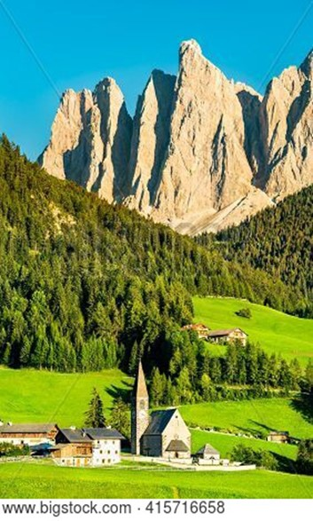

That is what the Scriptures mean when they say,
“No eye has seen, no ear has heard and no mind has imagined what God has prepared for those who love him.”
But it was to us that God revealed these things by his Spirit.

~ 1 Corinthians 2:9-10a (NLT)

Know the Gospel Well Enough to Teach It

God loves you abundantly, and has made a way for you to live forever in His glorious kingdom. However, first He had to pay an enormous price for you to be forgiven of your sin, in order to receive this eternal glory. This section explains His plan to forgive and save you. In summary:
God loves you, but your sin separates you from Him, and because of it, God’s wrath will come. However, Jesus died as a sacrifice to save you from your sins, from God’s wrath, and from death itself. When you confess your sins, repent and accept the salvation that Christ offers, God will forgive you. By trusting in Christ you become God’s child, and as His child, you will inherit eternal life and heaven will be your home.

God Loves You

Even before he made the world, God loved us and chose us in Christ to be holy and without fault in his eyes.
God decided in advance to adopt us into his own family by bringing us to himself through Jesus Christ.
This is what he wanted to do, and it gave him great pleasure.

~ Ephesians 1:4-5 (NLT)

We know how much God loves us, and we have put our trust in his love. God is love…

~ 1 John 4:16a (NLT)

The Lord is compassionate and gracious, slow to anger, abounding in love…
He does not treat us as our sins deserve or repay us according to our iniquities.
For as high as the heavens are above the earth, so great is his love for those who fear him;
As far as the east is from the west, so far has he removed our transgressions from us.
As a father has compassion on his children, so the Lord has compassion on those who fear him…

~ Psalm 103:8-13 (NIV)

But Your Sin Separates You from God

But your iniquities have separated you from your God; and your sins have hidden His face from you, so that He will not hear.

~ Isaiah 59:2 (NKJV)

Don’t you realize that those who do wrong will not inherit the Kingdom of God?
Don’t fool yourselves.

~ 1 Corinthians 6:9a (NLT)

The acts of the flesh are obvious: sexual immorality, impurity and debauchery; idolatry and witchcraft; hatred, discord, jealousy, fits of rage, selfish ambition, dissensions, factions and envy; drunkenness, orgies, and the like.
I warn you, as I did before, that those who live like this will not inherit the kingdom of God.

~ Galatians 5:19-21 (NIV)

For of this you can be sure: No immoral, impure or greedy person—such a person is an idolater—has any inheritance in the kingdom of Christ and of God.
Let no one deceive you with empty words, for because of such things God’s wrath comes on those who are disobedient.

~ Ephesians 5:5-6 (NIV)

The Day of God’s Wrath Will Come

For the great day of His wrath has come, and who is able to stand?

~ Revelation 6:17 (NKJV)

…for those who are self-seeking and who reject the truth and follow evil, there will be wrath and anger.

~ Romans 2:8 (NIV)

…the wicked will be silenced in the place of darkness.

~ 1 Samuel 2:9b (NIV)

They will be punished with everlasting destruction and shut out from the presence of the Lord and from the glory of his might…

~ 2 Thessalonians 1:9 (NIV)

Confess Your Sin and Repent

The Lord is…not willing that any should perish but that all should come to repentance.

~ 2 Peter 3:9 (NKJV)

Seek the Lord while He may be found,
Call upon Him while He is near.
Let the wicked forsake his way, and the unrighteous man his thoughts;
Let him return to the Lord, and He will have mercy on him;
And to our God, for He will abundantly pardon.

~ Isaiah 55:6-7 (NKJV)

For with the Lord there is mercy, and with Him is abundant redemption.

~ Psalm 130:7b (NKJV)

Then Jesus told them this parable: “Suppose one of you has a hundred sheep and loses one of them.
“Doesn’t he leave the ninety-nine in the open country and go after the lost sheep until he finds it?
“And when he finds it, he joyfully puts it on his shoulders and goes home…
“I tell you that in the same way there will be more rejoicing in heaven over one sinner who repents than over ninety-nine righteous persons who do not need to repent.”

~ Luke 15:3-7 (NIV)

So get rid of all the filth and evil in your lives and humbly accept the word God has planted in your hearts, for it has the power to save your souls.

~ James 1:21 (NLT)


Shutterstock Photo ID: 113965084

Jesus Died to Save You

…From Your Sin

Jesus gave his life for our sins, just as God our Father planned, in order to rescue us from this evil world in which we live.

~ Galatians 1:4 (NLT)

He gave his life to free us from every kind of sin, to cleanse us, and to make us his very own people, totally committed to doing good deeds.

~ Titus 2:14 (NLT)

…Christ Jesus came into the world to save sinners…

~ 1 Timothy 1:15b (ESV)

…God made Christ, who never sinned, to be the offering for our sin, so that we could be made right with God through Christ.

~ 2 Corinthians 5:21 (NLT)

…From God’s Wrath

For God did not appoint us to suffer wrath but to receive salvation through our Lord Jesus Christ.

~ 1 Thessalonians 5:9 (NIV)

Jesus, whom God raised from the dead…is the one who has rescued us from the terrors of the coming judgment.

~ 1 Thessalonians 1:10b (NLT)

…because Jesus lives forever…he is able to save completely those who come to God through him, because he always lives to intercede for them.

~ Hebrews 7:24-25 (NIV)

…From Death

Because God’s children are human beings—made of flesh and blood—the Son also became flesh and blood.
For only as a human being could he die, and only by dying could he break the power of the devil, who had the power of death.

~ Hebrews 2:14 (NLT)

God Bought You at a Price

You are not your own; you were bought at a price.

~ 1 Corinthians 6:19b-20a (NIV)



God paid a high price for you, so don’t be enslaved by the world.

~ 1 Corinthians 7:23 (NLT)

For you know that God paid a ransom to save you…
And it was not paid with mere gold or silver…
It was the precious blood of Christ…

~ 1 Peter 1:18-19a (NLT)

…without the shedding of blood there is no forgiveness of sins.

~ Hebrews 9:22b (ESV)

…without holiness no one will see the Lord.

~ Hebrews 12:14b (NIV)

And so Jesus also suffered outside the city gate to make the people holy through his own blood.

~ Hebrews 13:12 (NIV)

…he was pierced for our transgressions,
he was crushed for our iniquities;
the punishment that brought us peace was on him,
and by his wounds we are healed.

~ Isaiah 53:5 (NIV)

In Christ You Are Forgiven

We are made right with God by placing our faith in Jesus Christ…
For everyone has sinned; we all fall short of God’s glorious standard.
Yet God, in his grace, freely makes us right in his sight.
He did this through Christ Jesus when he freed us from the penalty for our sins.

~ Romans 3:22-24 (NLT)

Therefore, since we have been made right in God’s sight by faith, we have peace with God because of what Jesus Christ our Lord has done for us.
Because of our faith, Christ has brought us into this place of undeserved privilege where we now stand, and we confidently and joyfully look forward to sharing God’s glory.

~ Romans 5:1-2 (NLT)



Therefore, my friends, I want you to know that through Jesus the forgiveness of sins is proclaimed to you.

~ Acts 13:38 (NIV)

For with the Lord there is mercy, and with Him is abundant redemption.

~ Psalm 130:7b (NKJV)

God Demonstrates His Love Through Christ

“For God so loved the world that He gave His only begotten Son, that whoever believes in Him should not perish but have everlasting life.”

~ John 3:16 (NKJV)

Salvation is Through Christ Alone

Salvation is found in no one else, for there is no other name under heaven given to mankind by which we must be saved.

~ Acts 4:12 (NIV)

Jesus said to him, “I am the way, the truth, and the life. No one comes to the Father except through Me.”

~ John 14:6 (NKJV)

“I have come as a light to shine in this dark world, so that all who put their trust in me will no longer remain in the dark.”

~ John 12:46 (NLT)

“Most assuredly, I say to you, he who believes in Me has everlasting life.”

~ John 6:47 (NKJV)

“No one can come to Me unless the Father who sent Me draws him...”

~ John 6:44a (NKJV)

“…whoever comes to me I will never drive away.”

~ John 6:37b (NIV)

“Enter through the narrow gate.
“For wide is the gate and broad is the road that leads to destruction, and many enter through it.
“But small is the gate and narrow the road that leads to life, and only a few find it.”

~ Matthew 7:13-14 (NIV)

“I am the gate; whoever enters through me will be saved.”

~ John 10:9a (NIV)

“My sheep listen to my voice; I know them, and they follow me.
“I give them eternal life, and they will never perish.”

~ John 10:27-28a (NLT)

“For the Son of Man came to seek and to save the lost.”

~ Luke 19:10 (ESV)

“For God did not send His Son into the world to condemn the world, but that the world through Him might be saved.”

~ John 3:17 (NKJV)

Salvation is a Gift: Free and Undeserved

For it is by grace you have been saved, through faith—and this not from yourselves, it is the gift of God—not by works, so that no one can boast.

~ Ephesians 2:8-9 (NIV)

Salvation is not a reward for the good things we have done, so none of us can boast about it.

~ Ephesians 2:9 (NLT)

…God saved us and called us to live a holy life.
He did this, not because we deserved it, but because that was his plan from before the beginning of time…

~ 2 Timothy 1:9a (NLT)

And since it is through God’s kindness, then it is not by their good works.
For in that case, God’s grace would not be what it really is—free and undeserved.

~ Romans 11:6 (NLT)

Accept This Gift of Salvation

If you declare with your mouth, “Jesus is Lord,” and believe in your heart that God raised him from the dead, you will be saved.

~ Romans 10:9 (NIV)

This is all the more urgent, for you know how late it is; time is running out…
The night is almost gone; the day of salvation will soon be here.

~ Romans 13:11-12a (NLT)

…how shall we escape if we ignore so great a salvation?

~ Hebrews 2:3a (NIV)

But you must continue to believe this truth and stand firmly in it.

Don’t drift away from the assurance you received when you heard the Good News.

~ Colossians 1:23a (NLT)

For if we are faithful to the end, trusting God just as firmly as when we first believed, we will share in all that belongs to Christ.

~ Hebrews 3:14 (NLT)

You Belong to God Through Faith in Christ and Have Become His Child

See what great love the Father has lavished on us, that we should be called children of God!

~ 1 John 3:1a (NIV)

Everyone who believes that Jesus is the Christ has become a child of God.

~ 1 John 5:1a (NLT)

And since you are his child, God has made you his heir.

~ Galatians 4:7b (NLT)

Now if we are children, then we are heirs—heirs of God and co-heirs with Christ, if indeed we share in his sufferings in order that we may also share in his glory.

Romans 8:17 (NIV)



Now all of us can come to the Father through the same Holy Spirit because of what Christ has done for us.

~ Ephesians 2:18 (NLT)

“If you belonged to the world, it would love you as its own.
“As it is, you do not belong to the world, but I have chosen you out of the world.”

~ John 15:19a (NIV)

Eternal Life is Yours Through Christ

God has given us eternal life, and this life is in his Son.

~ 1 John 5:11b (NIV)

Since he did not spare even his own Son but gave him up for us all, won’t he also give us everything else?

~ Romans 8:32 (NLT)

I pray that your hearts will be flooded with light so that you can understand the confident hope he has given to those he called—his holy people who are his rich and glorious inheritance.
I also pray that you will understand the incredible greatness of God’s power for us who believe him.

~ Ephesians 1:18-19a (NLT)

May you be filled with joy, always thanking the Father.
He has enabled you to share in the inheritance that belongs to his people, who live in the light.

~ Colossians 1:11b-12 (NLT)

For you have been born again, but not to a life that will quickly end.
Your new life will last forever because it comes from the eternal, living word of God.

~ 1 Peter 1:23 (NLT)

Those who have been ransomed by the Lord will return.
They will enter Jerusalem singing, crowned with everlasting joy.
Sorrow and mourning will disappear, and they will be filled with joy and gladness.

~ Isaiah 51:11 (NLT)

If only for this life we have hope in Christ, we are of all people most to be pitied.

~ 1 Corinthians 15:19 (NIV)

For our light and momentary troubles are achieving for us an eternal glory that far outweighs them all.
So we fix our eyes not on what is seen, but on what is unseen,
since what is seen is temporary, but what is unseen is eternal.

~ 2 Corinthians 4:17-18 (NIV)

Jesus traveled through all the towns and villages of that area, teaching in the synagogues and announcing the Good News about the Kingdom.

~ Matthew 9:35a (NLT)

Jesus answered, “My kingdom is not of this world.”

~ John 18:36 (ESV)

“The kingdom of heaven is like treasure hidden in a field.
“When a man found it, he hid it again, and then in his joy went and sold all he had and bought that field.”

~ Matthew 13:44 (NIV)

He told them another parable: “The kingdom of heaven is like a mustard seed, which a man took and planted in his field.
“Though it is the smallest of all seeds, yet when it grows, it is the largest of garden plants...”

~ Matthew 13:31-32a (NIV)

“Truly I tell you, anyone who will not receive the kingdom of God like a little child will never enter it.”

~ Mark 10:15 (NIV)

“So don’t be afraid, little flock. For it gives your Father great happiness to give you the Kingdom.”

~ Luke 12:32 (NLT)



Heaven is Your Home

All your works praise you, Lord; your faithful people extol you.
They tell of the glory of your kingdom and speak of your might, so that all people may know of your mighty acts and the glorious splendor of your kingdom.
Your kingdom is an everlasting kingdom, and your dominion endures through all generations.

~ Psalm 145:10-13a (NIV)

“Blessed are those who are persecuted for righteousness’ sake, for theirs is the kingdom of heaven.
“Blessed are you when they revile and persecute you, and say all kinds of evil against you falsely for My sake.
“Rejoice and be exceedingly glad, for great is your reward in heaven…”

~ Matthew 5:10-12a (NKJV)

“And people will come from all over the world—from east and west, north and south—to take their places in the Kingdom of God.
“And note this: Some who seem least important now will be the greatest then, and some who are the greatest now will be least important then.”

~ Luke 13:29-30 (NLT)

In Jerusalem, the Lord of Heaven’s Armies will spread a wonderful feast for all the people of the world.
It will be a delicious banquet with clear, well-aged wine and choice meat.
There he will remove the cloud of gloom, the shadow of death that hangs over the earth.
He will swallow up death forever!
The Sovereign Lord will wipe away all tears.

~ Isaiah 25:6-8a (NLT)

He will wipe away every tear from their eyes, and death shall be no more, neither shall there be mourning, nor crying, nor pain anymore, for the former things have passed away.

~ Revelation 21:4 (ESV)

…the creation looks forward to the day when it will join God’s children in glorious freedom from death and decay.

~ Romans 8:21 (NLT)

“In that day the wolf and the lamb will live together; the leopard will lie down with the baby goat…
“The cow will graze near the bear…
“Nothing will hurt or destroy in all my holy mountain…”

~ Isaiah 11:6-9a (NIV)



His dominion is an everlasting dominion that will not pass away, and his kingdom is one that will never be destroyed.

~ Daniel 7:14b (NIV)

“To the one who is victorious, I will give the right to eat from the tree of life, which is in the paradise of God.”

~ Revelation 2:7b (NIV)

Jesus answered him, “Truly I tell you, today you will be with me in paradise.”

~ Luke 23:43 (NIV)

“In My Father’s house are many mansions; if it were not so, I would have told you.
“I go to prepare a place for you.
“And if I go and prepare a place for you, I will come again and receive you to Myself; that where I am, there you may be also.”

~ John 14:2-3 (NKJV)

“And be sure of this: I am with you always, even to the end of the age.”

~ Matthew 28:20b (NLT)

Then He who sat on the throne said, “Behold, I make all things new.”

~ Revelation 21:5a (NKJV)

“See, I will create new heavens and a new earth.
“The former things will not be remembered, nor will they come to mind.
“But be glad and rejoice forever in what I will create, for I will create Jerusalem to be a delight and its people a joy.
“I will rejoice over Jerusalem and take delight in my people; the sound of weeping and of crying will be heard in it no more.”

~ Isaiah 65:17-19 (NIV)

Then I saw “a new heaven and a new earth,” for the first heaven and the first earth had passed away…
Nothing impure will ever enter it…but only those whose names are written in the Lamb’s book of life.

~ Revelation 21:1a, 27 (NIV)

Because of God’s tender mercy, the morning light from heaven is about to break upon us, to give light to those who sit in darkness and in the shadow of death, and to guide us to the path of peace.

~ Luke 1:78-79 (NLT)

Point out anything in me that offends you,
and lead me along the path of everlasting life.

~ Psalm 139:24 (NLT)

Yet I still belong to you; you hold my right hand.
You guide me with your counsel, leading me to a glorious destiny.

~ Psalm 73:23-24 (NLT)

You make known to me the path of life;
you will fill me with joy in your presence,
with eternal pleasures at your right hand.

~ Psalm 16:11 (NIV)



Further Reading

See the booklet titled God’s Gift of Eternal Life for more verses on the subject of salvation. It more fully presents the Gospel message, and is designed to be a resource for people who are exploring Christianity.

Praise God for His Gift of Eternal Life

“…rejoice because your names are written in heaven.”

~ Luke 10:20b (NKJV)

Thanks be to God for His indescribable gift!

~ 2 Corinthians 9:15 (NKJV)

Thank God for this gift too wonderful for words!

~ 2 Corinthians 9:15 (NLT)

Praise be to the God and Father of our Lord Jesus Christ, who has blessed us in the heavenly realms with every spiritual blessing in Christ.

~ Ephesians 1:3 (NIV)

Since we are receiving a Kingdom that is unshakable, let us be thankful and please God by worshiping him with holy fear and awe.

~ Hebrews 12:28 (NLT)

The Spirit is God’s guarantee that he will give us the inheritance he promised and that he has purchased us to be his own people.
He did this so we would praise and glorify him.

~ Ephesians 1:14 (NLT)

So we praise God for the glorious grace he has poured out on us who belong to his dear Son.

~ Ephesians 1:6 (NLT)

Praise be to the Lord, the God of Israel, because he has come to his people and redeemed them.

~ Luke 1:68 (NIV)

Praise God for the privilege of being called by his name!

~ 1 Peter 4:16b (NLT)

…at the name of Jesus every knee should bow, in heaven and on earth and under the earth, and every tongue acknowledge that Jesus Christ is Lord…

~ Philippians 2:10-11a (NIV)

Let the peace of Christ rule in your hearts...
And be thankful.
Let the message of Christ dwell among you richly as you teach and admonish one another with all wisdom through psalms, hymns, and songs from the Spirit, singing to God with gratitude in your hearts.

~ Colossians 3:15-16 (NIV)

...be filled with the Spirit, speaking to one another with psalms, hymns, and songs from the Spirit.
Sing and make music from your heart to the Lord, always giving thanks to God the Father for everything, in the name of our Lord Jesus Christ.

~ Ephesians 5:18b-21 (NIV)



So then, just as you received Christ Jesus as Lord, continue to live your lives in him, rooted and built up in him, strengthened in the faith as you were taught, and overflowing with thankfulness.

~ Colossians 2:6-7 (NIV)

Share the Good News with Others

Make the Most of Every Opportunity

Be wise in the way you act toward outsiders;
Make the most of every opportunity.
Let your conversation be always full of grace, seasoned with salt, so that you may know how to answer everyone.

~ Colossians 4:5-6 (NIV)

Be very careful, then, how you live—not as unwise but as wise, making the most of every opportunity, because the days are evil.

~ Ephesians 5:15-16 (NIV)

…God has given us this task of reconciling people to him.

~ 2 Corinthians 5:18b (NLT)

Rescue those who are being taken away to death; hold back those who are stumbling to the slaughter.

~ Proverbs 24:11 (ESV)

And you must show mercy to those whose faith is wavering.
Rescue others by snatching them from the flames of judgment.
Show mercy to still others, but do so with great caution, hating the sins that contaminate their lives.

~ Jude 1:22-23 (NLT)

“When I say to a wicked person, ‘You will surely die,’ and you do not warn them or speak out to dissuade them from their evil ways in order to save their life, that wicked person will die for their sin, and I will hold you accountable for their blood.”
~ Ezekiel 3:18 (NIV)

Because we understand our fearful responsibility to the Lord, we work hard to persuade others.

~ 2 Corinthians 5:11a (NLT)

We live in such a way that no one will stumble because of us, and no one will find fault with our ministry.

~ 2 Corinthians 6:3 (NLT)

…so that our ministry will not be discredited.

~ 2 Corinthians 6:3b (NIV)

A servant of the Lord must not quarrel but must be kind to everyone, be able to teach, and be patient with difficult people.
Gently instruct those who oppose the truth.
Perhaps God will change those people’s hearts, and they will learn the truth.

~ 2 Timothy 2:24-25 (NLT)



And you yourself must be an example to them by doing good works of every kind.
Let everything you do reflect the integrity and seriousness of your teaching.

~ Titus 2:7 (NLT)

…make it your ambition to lead a quiet life:
You should mind your own business and work with your hands, just as we told you, so that your daily life may win the respect of outsiders and so that you will not be dependent on anybody.
~ 1 Thessalonians 4:11-12 (NIV)

Be an example to all believers in what you say, in the way you live, in your love, your faith, and your purity.
~ 1 Timothy 4:12b (NLT)

Because we loved you so much, we were delighted to share with you not only the gospel of God but our lives as well.
Surely you remember, brothers and sisters, our toil and hardship; we worked night and day in order not to be a burden to anyone while we preached the gospel of God…
For you know that we dealt with each of you as a father deals with his own children, encouraging, comforting and urging you to live lives worthy of God, who calls you into his kingdom and glory.
~ 1 Thessalonians 2:8b-12 (NIV)

…I am not seeking my own good but the good of many, so that they may be saved.

~ 1 Corinthians 10:33b (NIV)

Though I am free and belong to no one, I have made myself a slave to everyone, to win as many as possible…
To the weak I became weak, to win the weak.
I have become all things to all people so that by all possible means I might save some.
I do all this for the sake of the gospel, that I may share in its blessings.

~ 1 Corinthians 9:19-23 (NIV)

[The new believers in Jerusalem] devoted themselves to the apostles’ teaching and to fellowship, to the breaking of bread and to prayer.
Everyone was filled with awe at the many wonders and signs performed by the apostles.
All the believers were together and had everything in common.
They sold property and possessions to give to anyone who had need.
Every day they continued to meet together in the temple courts.
They broke bread in their homes and ate together with glad and sincere hearts, praising God and enjoying the favor of all the people.
And the Lord added to their number daily those who were being saved.

~ Acts 2:42-47 (NIV)

Preach the Gospel

In the presence of God and of Christ Jesus, who will judge the living and the dead, and in view of his appearing and his kingdom, I give you this charge:
Preach the word; be prepared in season and out of season; correct, rebuke and encourage—with great patience and careful instruction.

~ 2 Timothy 4:1-2 (NIV)

It has always been my ambition to preach the gospel where Christ was not known, so that I would not be building on someone else’s foundation.

~ Romans 15:20 (NIV)



I want you to know, brothers and sisters, that the gospel I preached is not of human origin.

~ Galatians 1:11 (NIV)

…I did not shrink from declaring to you the whole counsel of God.

~ Acts 20:27 (ESV)

But the Lord said to me, “Do not say, ‘I am too young.’ You must go to everyone I send you to and say whatever I command you.”

~ Jeremiah 1:7 (NIV)

“You must influence them; do not let them influence you!
“They will fight against you like an attacking army, but I will make you as secure as a fortified wall of bronze…
“I, the Lord, have spoken!”

~ Jeremiah 15:19b-20 (NLT)

But thanks be to God, who in Christ always leads us in triumphal procession, and through us spreads the fragrance of the knowledge of him everywhere.

~ 2 Corinthians 2:14 (ESV)

How beautiful upon the mountains are the feet of him who brings good news…

~ Isaiah 52:7a (ESV)



Whatever happens, conduct yourselves in a manner worthy of the gospel of Christ…stand firm in the one Spirit, striving together as one for the faith of the gospel…

~ Philippians 1:27 (NIV)

Watch your life and doctrine closely. Persevere in them, because if you do, you will save both yourself and your hearers.

~ 1 Timothy 4:16 (NIV)

Do you not know that in a race all the runners run, but only one gets the prize?
Run in such a way as to get the prize.
Everyone who competes in the games goes into strict training. They do it to get a crown that will not last, but we do it to get a crown that will last forever.
Therefore I do not run like someone running aimlessly; I do not fight like a boxer beating the air. No, I strike a blow to my body and make it my slave so that after I have preached to others, I myself will not be disqualified for the prize.

~ 1 Corinthians 9:24-27 (NIV)

Has the Lord redeemed you? Then speak out!

~ Psalm 107:2a (NLT)

But if I say, “I will not mention his word or speak anymore in his name,” his word is in my heart like a fire, a fire shut up in my bones.
I am weary of holding it in; indeed, I cannot.

~ Jeremiah 20:9 (NIV)

For when I preach the gospel, I cannot boast, since I am compelled to preach. Woe to me if I do not preach the gospel!

~ 1 Corinthians 9:16 (NIV)

“You are the light of the world.
“A town built on a hill cannot be hidden.
“Neither do people light a lamp and put it under a bowl.
“Instead they put it on its stand, and it gives light to everyone in the house.
“In the same way, let your light shine before others, that they may see your good deeds and glorify your Father in heaven.”

~ Matthew 5:14-16 (NIV)



“And this gospel of the kingdom will be preached in the whole world as a testimony to all nations, and then the end will come.”

~ Matthew 24:14 (NIV)

Now to him who is able to do immeasurably more than all we ask or imagine, according to his power that is at work within us, to him be glory in the church and in Christ Jesus throughout all generations, for ever and ever! Amen.

~ Ephesians 3:20-21 (NIV)

The First Recorded Gospel Message when The Holy Spirit Came at Pentecost

Then Peter stood up…and addressed the crowd…
“Fellow Israelites, listen to this:
“Jesus of Nazareth was a man accredited by God to you by miracles, wonders and signs, which God did among you through him, as you yourselves know.
“This man was handed over to you by God’s deliberate plan and foreknowledge; and you, with the help of wicked men, put him to death by nailing him to the cross.
“But God raised him from the dead, freeing him from the agony of death, because it was impossible for death to keep its hold on him…
“God has raised this Jesus to life, and we are all witnesses of it.
“Exalted to the right hand of God, he has received from the Father the promised Holy Spirit and has poured out what you now see and hear…
“Therefore let all Israel be assured of this:
“God has made this Jesus, whom you crucified, both Lord and Messiah.”
When the people heard this, they were cut to the heart and said to Peter and the other apostles, “Brothers, what shall we do?”
Peter replied, “Repent and be baptized, every one of you, in the name of Jesus Christ for the forgiveness of your sins.
“And you will receive the gift of the Holy Spirit.”

~ Acts 2:14-38 (NIV)

Further Reading About Gospel Proclamation

See the book of Acts to read the first gospel sermons preached in the history of the Christian church, especially the following passages:

Acts 2:14-41
Acts 10:34-47
Acts 13:16-41
Acts 17:22-34
Acts 20:17-38
Acts 26:6-23

Proclaim God’s Message with Boldness

The lion has roared—so who isn’t frightened?
The Sovereign Lord has spoken—so who can refuse to proclaim his message?

~ Amos 3:8 (NLT)

…the righteous are bold as a lion.

~ Proverbs 28:1b (NKJV)



…enable your servants to speak your word with great boldness.

~ Acts 4:29b (NIV)

When [the Jewish religious leaders] saw the courage of Peter and John and realized that they were unschooled, ordinary men, they were astonished and they took note that these men had been with Jesus.

~ Acts 4:13 (NIV)

They also recognized them as men who had been with Jesus.

~ Acts 4:13b (NLT)

Proclaim the Gospel Plainly, Not with Eloquence, but with a Demonstration of the Spirit’s Power

…I did not come with eloquence or human wisdom as I proclaimed to you the testimony about God.
For I resolved to know nothing while I was with you except Jesus Christ and him crucified.
I came to you in weakness with great fear and trembling.
My message and my preaching were not with wise and persuasive words, but with a demonstration of the Spirit’s power, so that your faith might not rest on human wisdom, but on God’s power.

~ 1 Corinthians 2:1b-5 (NIV)

…I didn’t use lofty words and impressive wisdom to tell you God’s secret plan…
And my message and my preaching were very plain.
Rather than using clever and persuasive speeches, I relied only on the power of the Holy Spirit.
I did this so you would trust not in human wisdom but in the power of God.

~ 1 Corinthians 2:1b-5 (NLT)

…I, brethren, when I came to you, came not with excellency of speech or of wisdom…
And my speech and my preaching was not with enticing words of man’s wisdom, but in demonstration of the Spirit and of power:
That your faith should not stand in the wisdom of men, but in the power of God.

~ 1 Corinthians 2:1b-5 (KJV)

Since God in his wisdom saw to it that the world would never know him through human wisdom, he has used our foolish preaching to save those who believe.

~ 1 Corinthians 1:21 (NLT)

…Christ did not send me to baptize but to preach the gospel, and not with words of eloquent wisdom, lest the cross of Christ be emptied of its power.

~ 1 Corinthians 1:17 (ESV)

Pray for the Ministry of Other Believers

…we constantly pray for you, that our God may make you worthy of his calling, and that by his power he may bring to fruition your every desire for goodness and your every deed prompted by faith.

~ 2 Thessalonians 1:11b (NIV)

May he give you the power to accomplish all the good things your faith prompts you to do.

~ 2 Thessalonians 1:11b (NLT)

Pray for us, too, that God will give us many opportunities to speak about his mysterious plan concerning Christ.

~ Colossians 4:3a (NLT)

…that God may open a door for our message…

~ Colossians 4:3a (NIV)

Ask God to give me the right words so I can boldly explain God’s mysterious plan that the Good News is for Jews and Gentiles alike…
So pray that I will keep on speaking boldly for him, as I should.

~ Ephesians 6:19b-20 (NLT)

…so that I will fearlessly make known the mystery of the gospel…

~ Ephesians 6:19b (NIV)

…we ask you to pray for us.
Pray that the Lord’s message will spread rapidly and be honored wherever it goes, just as when it came to you.
Pray, too, that we will be rescued from wicked and evil people…

~ 2 Thessalonians 3:1b-2a (NLT)

Stay alert and be persistent in your prayers for all believers everywhere.

~ Ephesians 6:18b (NLT)

Remember those who are in prison, as though in prison with them...

~ Hebrews 13:3a (ESV)

But while Peter was in prison, the church prayed very earnestly for him.

~ Acts 12:5 (NLT)

So we have not stopped praying for you since we first heard about you.
We ask God to give you complete knowledge of his will and to give you spiritual wisdom and understanding.
Then the way you live will always honor and please the Lord, and your lives will produce every kind of good fruit.

~ Colossians 1:9-10a (NLT)

In all my prayers for all of you, I always pray with joy because of your partnership in the gospel from the first day until now, being confident of this, that he who began a good work in you will carry it on to completion until the day of Christ Jesus.

~ Philippians 1:4-6 (NIV)



We always thank God, the Father of our Lord Jesus Christ, when we pray for you, because we have heard of your faith in Christ Jesus and of the love you have for all God’s people...

~ Colossians 1:3-4 (NIV)

Seek to Please God, Not People

Our purpose is to please God, not people.
He alone examines the motives of our hearts.

~ 1 Thessalonians 2:4b (NLT)

As for human praise, we have never sought it from you or anyone else.

~ 1 Thessalonians 2:6 (NLT)

Nor did we seek glory from men…

~ 1 Thessalonians 2:6a (NKJV)

Am I now trying to win the approval of human beings, or of God? …
If I were still trying to please people, I would not be a servant of Christ.

~ Galatians 1:10 (NIV)

For I am not ashamed of the gospel, because it is the power of God that brings salvation to everyone who believes: first to the Jew, then to the Gentile.

~ Romans 1:16 (NIV)

Declare His Glory Among the Nations

Give thanks to the Lord and proclaim his greatness.
Let the whole world know what he has done.

~ 1 Chronicles 16:8 (NLT)

Declare his glory among the nations…

~ Psalm 96:3a (NIV)

Tell all the nations, “The Lord reigns!”

~ Psalm 96:10a (NLT)

Let all the earth fear the Lord;
let all the inhabitants of the world stand in awe of him!

~ Psalm 33:8 (ESV)

Sing to the Lord, for he has done glorious things; let this be known to all the world.

~ Isaiah 12:5 (NIV)

Sing to the Lord, all the earth; proclaim the good news of His salvation from day to day.

~ 1 Chronicles 16:23 (NKJV)

I will perpetuate your memory through all generations; therefore the nations will praise you for ever and ever.

~ Psalm 45:17 (NIV)

For the earth will be filled with the knowledge of the glory of the Lord as the waters cover the sea.

~ Habakkuk 2:14 (ESV)



Further Reading About Sharing the Good News
Matthew 10
Mark 14:3-9
1 Corinthians 9
Philippians 1
1 Thessalonians 2
2 Timothy 2

Give Yourself Fully to the Work of the Lord

Therefore, my dear brothers and sisters, stand firm.
Let nothing move you.
Always give yourselves fully to the work of the Lord, because you know that your labor in the Lord is not in vain.

~ 1 Corinthians 15:58 (NIV)

…be steadfast, immovable, always abounding in the work of the Lord…

~ 1 Corinthians 15:58b (ESV)

…be strong and immovable. Always work enthusiastically for the Lord…

~ 1 Corinthians 15:58b (NLT)

Whatever you do, work at it with all your heart, as working for the Lord, not for human masters, since you know that you will receive an inheritance from the Lord as a reward.
It is the Lord Christ you are serving.

~ Colossians 3:23-24 (NIV)

And whatsoever ye do, do it heartily…

~ Colossians 3:23a (KJV)

…whatever you do, do all to the glory of God.

~ 1 Corinthians 10:31b (ESV)

Never be lacking in zeal, but keep your spiritual fervor, serving the Lord.

~ Romans 12:11 (NIV)

…on the judgment day, fire will reveal what kind of work each builder has done.
The fire will show if a person’s work has any value.
If the work survives, that builder will receive a reward.

~ 1 Corinthians 3:13-14 (NLT)

Be Willing to Endure Hardship

So I am willing to endure anything if it will bring salvation and eternal glory in Christ Jesus to those God has chosen.

~ 2 Timothy 2:10 (NLT)

Endure suffering along with me, as a good soldier of Christ Jesus.
Soldiers don’t get tied up in the affairs of civilian life, for then they cannot please the officer who enlisted them.

~ 2 Timothy 2:3-4 (NLT)

No one engaged in warfare entangles himself with the affairs of this life…

~ 2 Timothy 2:4a (NKJV)

For it has been granted to you that for the sake of Christ you should not only believe in him but also suffer for his sake…

~ Philippians 1:29 (ESV)

If we endure hardship, we will reign with him.

~ 2 Timothy 2:12a (NLT)



Be on guard.
Stand firm in the faith.
Be courageous.
Be strong.
And do everything with love.

~ 1 Corinthians 16:13-14 (NLT)

But you should keep a clear mind in every situation.
Don’t be afraid of suffering for the Lord.
Work at telling others the Good News, and fully carry out the ministry God has given you.

~ 2 Timothy 4:5 (NLT)

As for you, always be sober-minded, endure suffering, do the work of an evangelist, fulfill your ministry.

~ 2 Timothy 4:5 (ESV)

And I trust that my life will bring honor to Christ, whether I live or die.
For to me, living means living for Christ, and dying is even better.
But if I live, I can do more fruitful work for Christ…
I’m torn between two desires: I long to go and be with Christ, which would be far better for me.
But for your sakes, it is better that I continue to live.

~ Philippians 1:20b-24 (NLT)

So we tell others about Christ, warning everyone and teaching everyone with all the wisdom God has given us...
That’s why I work and struggle so hard, depending on Christ’s mighty power that works within me.

~ Colossians 1:28-29 (NLT)

But the Lord stood with me and gave me strength, that I might preach the Good News in all its fullness for all the Gentiles to hear.

~ 2 Timothy 4:17a (NLT)

…so that through me the message might be fully proclaimed...

~ 2 Timothy 4:17b (ESV)

“Don’t be afraid of what you are about to suffer…if you remain faithful even when facing death, I will give you the crown of life.”

~ Revelation 2:10 (NLT)

“Truly I tell you,” Jesus replied, “no one who has left home or brothers or sisters or mother or father or children or fields for me and the gospel will fail to receive a hundred times as much in this present age: homes, brothers, sisters, mothers, children and fields—along with persecutions—and in the age to come eternal life.”

~ Mark 10:29-30 (NIV)

“If you cling to your life, you will lose it; but if you give up your life for me, you will find it.”

~ Matthew 10:39 (NLT)

“Whoever loves father or mother more than me is not worthy of me, and whoever loves son or daughter more than me is not worthy of me.
“And whoever does not take his cross and follow me is not worthy of me.”

~ Matthew 10:37-38 (ESV)

“Whoever desires to come after Me, let him deny himself, and take up his cross, and follow Me.
“For whoever desires to save his life will lose it, but whoever loses his life for My sake and the gospel’s will save it.”

~ Mark 8:34b-35 (NKJV)

Because of that cross, my interest in this world has been crucified, and the world’s interest in me has also died.

~ Galatians 6:14b (NLT)



We live in such a way that no one will stumble because of us, and no one will find fault with our ministry.
In everything we do, we show that we are true ministers of God.
We patiently endure troubles and hardships and calamities of every kind.
We have been beaten, been put in prison, faced angry mobs, worked to exhaustion, endured sleepless nights, and gone without food.
We prove ourselves by our purity, our understanding, our patience, our kindness, by the Holy Spirit within us, and by our sincere love.
We faithfully preach the truth. God’s power is working in us.
We use the weapons of righteousness in the right hand for attack and the left hand for defense.
We serve God whether people honor us or despise us, whether they slander us or praise us.
We are honest, but they call us impostors.
We are ignored, even though we are well known.
We live close to death, but we are still alive.
We have been beaten, but we have not been killed.
Our hearts ache, but we always have joy.
We are poor, but we give spiritual riches to others.
We own nothing, and yet we have everything.

~ 2 Corinthians 6:3-10 (NLT)

…we put up with anything rather than hinder the gospel of Christ.

~ 1 Corinthians 9:12b (NIV)

…the more we suffer for Christ, the more God will shower us with his comfort through Christ.

~ 2 Corinthians 1:5 (NLT)

“Blessed are those who are persecuted because of righteousness, for theirs is the kingdom of heaven.”

~ Matthew 5:10 (NIV)

“Blessed are you when people insult you, persecute you and falsely say all kinds of evil against you because of me.
“Rejoice and be glad, because great is your reward in heaven…”

~ Matthew 5:11-12a (NIV)

“Blessed are you when people hate you, when they exclude you and insult you and reject your name as evil, because of the Son of Man.
“Rejoice in that day and leap for joy, because great is your reward in heaven.”

~ Luke 6:22-23a (NIV)



Blessed is the man who remains steadfast under trial, for when he has stood the test he will receive the crown of life, which God has promised to those who love him.

~ James 1:12 (ESV)

Finally, be strong in the Lord and in his mighty power.
Put on the full armor of God, so that you can take your stand against the devil’s schemes.
Finally, be strong in the Lord and in his mighty power.
Put on the full armor of God, so that you can take your stand against the devil’s schemes.
For our struggle is not against flesh and blood, but against the rulers, against the authorities, against the powers of this dark world and against the spiritual forces of evil in the heavenly realms.
Therefore put on the full armor of God, so that when the day of evil comes, you may be able to stand your ground, and after you have done everything, to stand.
Stand firm then,
with the belt of truth buckled around your waist,
with the breastplate of righteousness in place, and
with your feet fitted with the readiness that comes from the gospel of peace.
In addition to all this, take up the shield of faith, with which you can extinguish all the flaming arrows of the evil one.
Take the helmet of salvation
and the sword of the Spirit, which is the word of God.

~ Ephesians 6:10-17 (NIV)

The Spirit himself testifies with our spirit that we are God’s children.
Now if we are children, then we are heirs—heirs of God and co-heirs with Christ, if indeed we share in his sufferings in order that we may also share in his glory.

~ Romans 8:16-17 (NIV)

For if we are faithful to the end, trusting God just as firmly as when we first believed, we will share in all that belongs to Christ.

~ Hebrews 3:14 (NLT)

He will keep you strong to the end so that you will be free from all blame on the day when our Lord Jesus Christ returns.

~ 1 Corinthians 1:8 (NLT)

Bear Fruit

“You did not choose me, but I chose you and appointed you so that you might go and bear fruit—fruit that will last—and so that whatever you ask in my name the Father will give you.
“This is my command: Love each other.”

~ John 15:16-17 (NIV)

“I am the true vine, and my Father is the gardener.
“He cuts off every branch in me that bears no fruit, while every branch that does bear fruit he prunes so that it will be even more fruitful.”

~ John 15:1-2 (NIV)

“Remain in me, as I also remain in you.
“No branch can bear fruit by itself; it must remain in the vine.
“Neither can you bear fruit unless you remain in me.
“I am the vine; you are the branches.
“If you remain in me and I in you, you will bear much fruit; apart from me you can do nothing.”

~ John 15:4-5 (NIV)



Reap a Harvest

Then he said to his disciples, “The harvest is plentiful but the workers are few.
“Ask the Lord of the harvest, therefore, to send out workers into his harvest field.”

~ Matthew 9:37-38 (NIV)

“But I say, wake up and look around. The fields are already ripe for harvest. The harvesters are paid good wages, and the fruit they harvest is people brought to eternal life.
“What joy awaits both the planter and the harvester alike...
“I sent you to harvest where you didn’t plant; others had already done the work, and now you will get to gather the harvest.”

~ John 4:35b-38 (NLT)

I planted the seed in your hearts, and Apollos watered it, but it was God who made it grow…
The one who plants and the one who waters work together with the same purpose.
And both will be rewarded for their own hard work.
For we are both God’s workers.

~ 1 Corinthians 3:6-9a (NLT)



Let us not become weary in doing good, for at the proper time we will reap a harvest if we do not give up.

~ Galatians 6:9 (NIV)

“A farmer went out to plant his seed.
“As he scattered it across his field, some seed fell on a footpath, where it was stepped on, and the birds ate it.
“Other seed fell among rocks. It began to grow, but the plant soon wilted and died for lack of moisture.
“Other seed fell among thorns that grew up with it and choked out the tender plants.
“Still other seed fell on fertile soil. This seed grew and produced a crop that was a hundred times as much as had been planted…
“This is the meaning of the parable:
“The seed is God’s word.
“The seeds that fell on the footpath represent those who hear the message, only to have the devil come and take it away from their hearts and prevent them from believing and being saved.
“The seeds on the rocky soil represent those who hear the message and receive it with joy. But since they don’t have deep roots, they believe for a while, then they fall away when they face temptation.
“The seeds that fell among the thorns represent those who hear the message, but all too quickly the message is crowded out by the cares and riches and pleasures of this life. And so they never grow into maturity.
“And the seeds that fell on the good soil represent honest, good-hearted people who hear God’s word, cling to it, and patiently produce a huge harvest.”

~ Luke 8:5-8a, 11-15 (NLT)

“Most assuredly, I say to you, unless a grain of wheat falls into the ground and dies, it remains alone; but if it dies, it produces much grain.”

~ John 12:24 (NKJV)

Then another angel came out of the temple and called in a loud voice to him who was sitting on the cloud,
“Take your sickle and reap, because the time to reap has come, for the harvest of the earth is ripe.”

~ Revelation 14:15 (NIV)

Finish the Work

See to it that you complete the ministry you have received in the Lord.
~ Colossians 4:17b (NIV)

Work at telling others the Good News, and fully carry out the ministry God has given you.

~ 2 Timothy 4:5b (NLT)

…do the work of an evangelist, fulfill your ministry.

~ 2 Timothy 4:5b (ESV)

But my life is worth nothing to me unless I use it for finishing the work assigned me by the Lord Jesus—the work of telling others the Good News about the wonderful grace of God.

~ Acts 20:24 (NLT)

…let us throw off everything that hinders and the sin that so easily entangles.
And let us run with perseverance the race marked out for us, fixing our eyes on Jesus…

~ Hebrews 12:1b-2a (NIV)

…let us lay aside every weight, and the sin which so easily ensnares us,
and let us run with endurance the race that is set before us, looking unto Jesus…

~ Hebrews 12:1b-2a (NLT)

…I press on toward the goal to win the prize for which God has called me heavenward in Christ Jesus.

~ Philippians 3:14 (NIV)

This is what the Lord of Heaven’s Armies says: Be strong and finish the task!
~ Zechariah 8:9a (NLT)

[Jesus prayed] “I have brought you glory on earth by finishing the work you gave me to do.”

~ John 17:4 (NIV)

“We must quickly carry out the tasks assigned us by the one who sent us. The night is coming, and then no one can work.”

~ John 9:4 (NLT)

I have fought the good fight,
I have finished the race,
I have kept the faith.
Now there is in store for me the crown of righteousness, which the Lord, the righteous Judge, will award to me on that day—and not only to me, but also to all who have longed for his appearing.

~ 2 Timothy 4:7-8 (NIV)



Jesus Sends You

And I heard the voice of the Lord saying, “Whom shall I send, and who will go for us?”
Then I said, “Here I am! Send me.”

~ Isaiah 6:8 (ESV)



Desert Path in Israel

And Jesus, walking by the Sea of Galilee, saw two brothers, Simon called Peter, and Andrew his brother, casting a net into the sea; for they were fishermen.
Then He said to them, “Follow Me, and I will make you fishers of men.”
They immediately left their nets and followed Him.

~ Matthew 4:18-20 (NKJV)

Then He said to another, “Follow Me.”
But he said, “Lord, let me first go and bury my father.”
Jesus said to him, “Let the dead bury their own dead, but you go and preach the kingdom of God.”
And another also said, “Lord, I will follow You, but let me first go and bid them farewell who are at my house.”
But Jesus said to him, “No one, having put his hand to the plow, and looking back, is fit for the kingdom of God.”

~ Luke 9:59-62 (NKJV)

“Very truly I tell you, whoever believes in me will do the works I have been doing, and they will do even greater things than these, because I am going to the Father.
“And I will do whatever you ask in my name, so that the Father may be glorified in the Son.
“You may ask me for anything in my name, and I will do it.”

~ John 14:12-14 (NIV)

“Yes, I am sending you to the Gentiles to open their eyes, so they may turn from darkness to light and from the power of Satan to God.
“Then they will receive forgiveness for their sins and be given a place among God’s people, who are set apart by faith in me.”

~ Acts 26:17b-18 (NLT)

“I am sending you out like sheep among wolves.
“Therefore be as shrewd as snakes and as innocent as doves.”

~ Matthew 10:16 (NIV)

“A man prepared a great feast and sent out many invitations. When the banquet was ready, he sent his servant to tell the guests, ‘Come, the banquet is ready.’
“But they all began making excuses.
“One said, ‘I have just bought a field and must inspect it. Please excuse me.’ Another said, ‘I have just bought five pairs of oxen, and I want to try them out. Please excuse me.’ Another said, ‘I now have a wife, so I can’t come.’
“The servant returned and told his master what they had said. His master was furious and said,
“‘Go quickly into the streets and alleys of the town and invite the poor, the crippled, the blind, and the lame…
“‘Go out into the country lanes and behind the hedges and urge anyone you find to come, so that the house will be full.’”

~ Luke 14:16b-23 (NLT)

…He called His twelve disciples together and gave them power and authority over all demons, and to cure diseases.
He sent them to preach the kingdom of God and to heal the sick.
And He said to them, “Take nothing for the journey, neither staffs nor bag nor bread nor money; and do not have two tunics apiece.
“Whatever house you enter, stay there, and from there depart. And whoever will not receive you, when you go out of that city, shake off the very dust from your feet as a testimony against them.”
So they departed and went through the towns, preaching the gospel and healing everywhere.

~ Luke 9:1-6 (NKJV)

After this the Lord appointed seventy-two others and sent them two by two ahead of him to every town and place where he was about to go.
He told them, “The harvest is plentiful, but the workers are few.
“Ask the Lord of the harvest, therefore, to send out workers into his harvest field.”

~ Luke 10:1-2 (NIV)

“And as you go, preach, saying, ‘The kingdom of heaven is at hand.’
“Heal the sick, cleanse the lepers, raise the dead, cast out demons.
“Freely you have received, freely give.”

~ Matthew 10:7-8 (NKJV)

Then Jesus asked them, “When I sent you without purse, bag or sandals, did you lack anything?”
“Nothing,” they answered.

~ Luke 22:35 (NIV)



So Jesus said to them again, “Peace to you! As the Father has sent Me, I also send you.”

~ John 20:21 (NKJV)

And [Jesus] said to them,
“Go into all the world and proclaim the gospel to the whole creation.
“Whoever believes and is baptized will be saved, but whoever does not believe will be condemned.
“And these signs will accompany those who believe: in my name they will cast out demons; they will speak in new tongues; they will pick up serpents with their hands; and if they drink any deadly poison, it will not hurt them; they will lay their hands on the sick, and they will recover.”

~ Mark 16:15-18 (ESV)

Go!

“Go into all the world and proclaim the gospel to the whole creation.”

~ Mark 16:15b (ESV)

“…and preach the Good News to everyone.”

~ Mark 16:15b (NLT)

“Go! I am sending you out like lambs among wolves.”

~ Luke 10:3 (NIV)

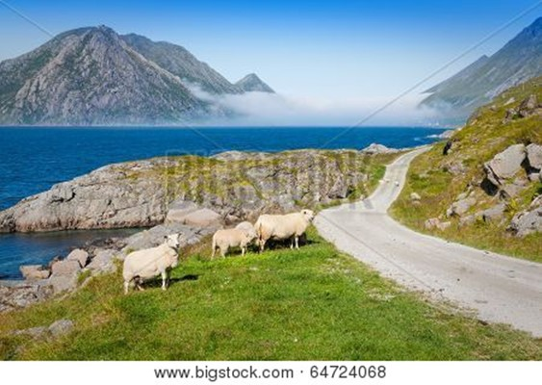

Then Jesus came to them and said,
“All authority in heaven and on earth has been given to me.
“Therefore go and make disciples of all nations, baptizing them in the name of the Father and of the Son and of the Holy Spirit, and teaching them to obey everything I have commanded you.
“And surely I am with you always, to the very end of the age.”

~ Matthew 28:18-20 (NIV)

Photo Copyright Info

Note: when purchasing the rights to use the photos, you may want to purchase an Extended License for the cover image.


Bigstock Photo ID: 383446451
misty foggy Nature background. forest sunrise and rain forest river, Green forest stream. Natural environment. branches and trees. Travel in nature.
Stock Photo ID: 383446451
Copyright: Quotes Designer


Bigstock Photo ID: 1355190
Editing suggestion: Crop out dark portion on right
Jungle waterfall in national park in Thailand
Stock Photo ID: 1355190
Copyright: ingus


Bigstock Photo ID: 441287537
Panoramic aerial view of the stunning Plitvice Lakes National Park
Stock Photo ID: 441287537
Copyright: Try Media


Bigstock Photo ID: 216236161
Stream in the tropical forest. Environment sunny landscape
Stock Photo ID: 216236161
Copyright: Pavlo Vakhrushev


Bigstock Photo ID: 41508493
Ripe Oranges On Tree
Orange tree with ripe fruits in sunlight. Horizontal shot
Stock Photo ID: 41508493
Copyright: dvoevnore

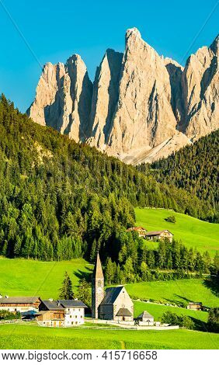
Bigstock Photo ID: 415716658
Chruch at Santa Maddalena - the Dolomites, Italy
Stock Photo ID: 415716658
Copyright: Leonid Andronov


Shutterstock Photo ID: 113965084
Mountain peak at winter - Roszutec - Slovakia mountain Fatra
Photo Contributor
TTstudio


Bigstock Photo ID: 48889046
Editing suggestion: Crop roof out of bottom of photo, crop out some of the top portion
Cross on a church rooftop on the top of Mount San Salvatore with mountain panorama landscape view in Lugano Lake Como district at Italian and Swiss border
Stock Photo ID: 48889046
Copyright: Anna-Mari West


Bigstock Photo ID: 38096296
Plitvice Lakes National Park, Croatia
Plitvice Lakes National Park is the oldest national park in Southeast Europe and the largest national park in Croatia. In 1979, It was was added to the UNESCO World Heritage register among the first natural sites worldwide.
Stock Photo ID: 38096296
Copyright: Scirocco340


Bigstock Photo ID: 133675775
Veliki Medjed mountain and river Zabljak Montenegro
Stock Photo ID: 133675775
Copyright: saiko3p


Bigstock Photo ID: 63626344
Editing suggestion: Rotate photo to be consistent with print booklet
tropical beach with palm and turquoise sea
Stock Photo ID: 63626344
Copyright: kubais


Bigstock Photo ID: 58273739
Herd cows on blossoming glade and Mont Blanc mountain massif (Chamonix valley France view from Plaine Joux outskirts).
Stock Photo ID: 58273739
Copyright: j-wildman


Bigstock Photo ID: 4528137
Old Stone Staircase
footpath in beautiful park with violet flowers around
Stock Photo ID: 4528137
Copyright: valerian


Bigstock Photo ID: 477449545
Colorful Autumn in Mount Fuji, Japan - Lake Kawaguchiko is one of the best places in Japan to enjoy Mount Fuji scenery of maple leaves changing color giving image of those leaves framing Mount Fuji.
Copyright: Freshpixel

Bigstock Photo ID: 451149447
View of the wooden walkway to The Neitikoski Rapids, part of Ruunaa Rapids, Lieksa, Finland
Stock Photo ID: 451149447
Copyright: Hivaka

Bigstock Photo ID: 20488712
Great Wall of China at Mutianyu (Beijing)
Stock Photo ID: 20488712
Copyright: wusuowei


Bigstock Photo ID: 3476526
Mountain Road
Scenic view of a winding mountain road near Silverton Colorado.
Stock Photo 3476526
Copyright: kenhurst


Bigstock Photo ID: 42742771
Santorini View - Greece
Santorini View (Fira Greece) - vacation background
Stock Photo 42742771
Copyright: Nik_Sorokin

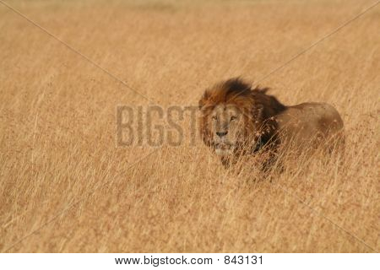
Bigstock Photo ID: 843131
Editing suggestion: Rotate photo to be consistent with print booklet
Male Lion In Serengeti
male lion stalking prey in serengeti ** Note: Slight blurriness, best at smaller sizes
Stock Photo ID: 843131
Copyright: mwf208


Bigstock Photo ID: 232356286
Idyllic Gazebo in Park Setting with Lush Green Trees and Green Grass
Stock Photo ID: 232356286
Copyright: SusansPhotos


Bigstock Photo ID: 12688361
Sunrise
Stock Photo ID: 12688361
Copyright: VibrantImage


Bigstock Photo ID: 309325528
Spitzkoppe, unique rock formation in Damaraland, Namibia
Stock Photo ID: 309325528
Copyright: javarman


Bigstock Photo ID: 6713672
Llanddwyn Island on a cold winter morning with ice and snow
Stock Photo 6713672
Copyright: GailJohnson


Bigstock Photo ID: 58739750
Editing suggestion: Crop dark edges of left and right of photo
Yosemite Reflection
Yosemite valley reflected on the river at sunset. California USA .
Stock Photo ID: 58739750
Copyright: fotoferrarini


Bigstock Photo ID: 6277965

Agriculture wine red grapefruit field in Spain
Stock Photo ID: 6277965
Copyright: holbox


Bigstock Photo ID: 44595667
Cotton Field
A southern field of rows of early cotton plants.
Stock Photo ID: 44595667
Copyright: Denton Rumsey

Bigstock Photo ID: 25863362
Water bungalows and sunset - abstract vacation background
Stock Photo ID: 25863362
Copyright: Nik_Sorokin


Bigstock Photo ID: 429464195
Warm winter on the Red Sea. Eilat mountains. Picturesque multi-colored landscape formations. Eilat is major international year-round resort. Israel
Stock Photo ID: 429464195
Copyright: kavram


Bigstock Photo ID: 13687697
Cottonwood Canyon Road
Colorful rock formations along BLM Road 400, Cottonwood Canyon Road, between US Highway 89 and Utah State Route 12, Utah, USA
Stock Photo 13687697
Copyright: mddfiles

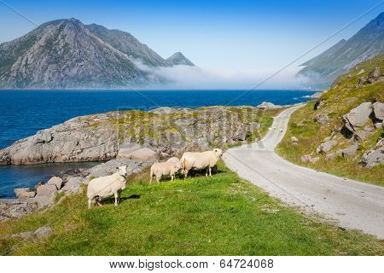
Bigstock Photo ID: 64724068
Sheep Walking Along Road. Norway Landscape
Sheep walking along road. Norway landscape of the Lofoten, Scandinavia,
Stock Photo 64724068
Copyright: perszing1982

Booklet Titles in the Series
www.TheWordOfGodSeries.com
Relational and Emotional Health Topics

A Joy-Filled Life

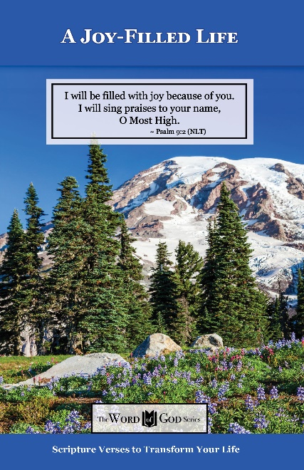
Relational and Emotional Health Topics

Healthy Relationships

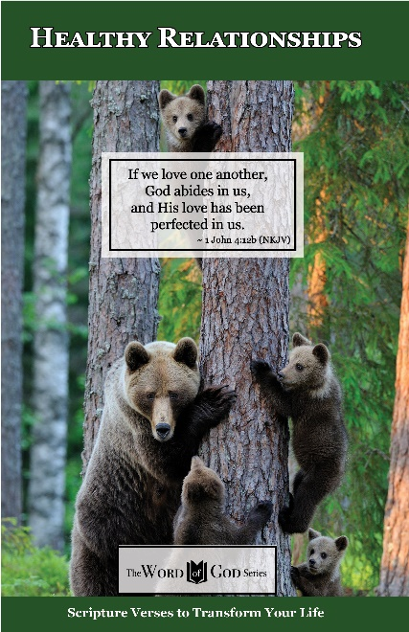
Relational and Emotional Health Topics

Healthy Thoughts

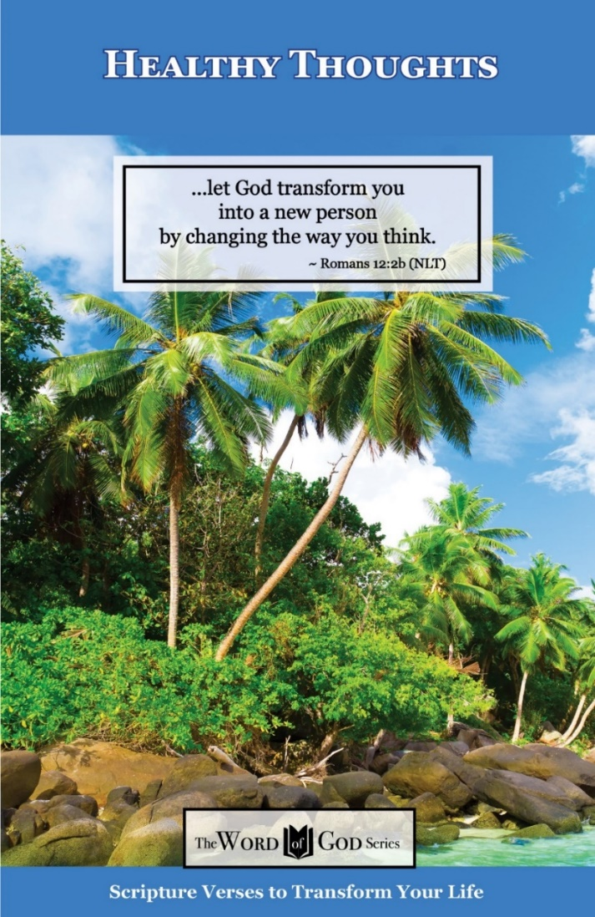
Relational and Emotional Health Topics

Freedom from Depression and Comfort in Grief

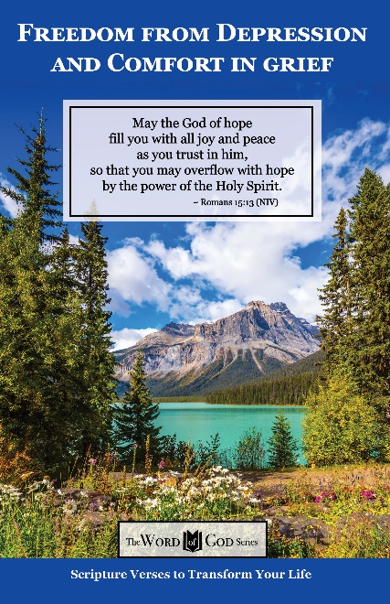
Relational and Emotional Health Topics

Freedom from Fear

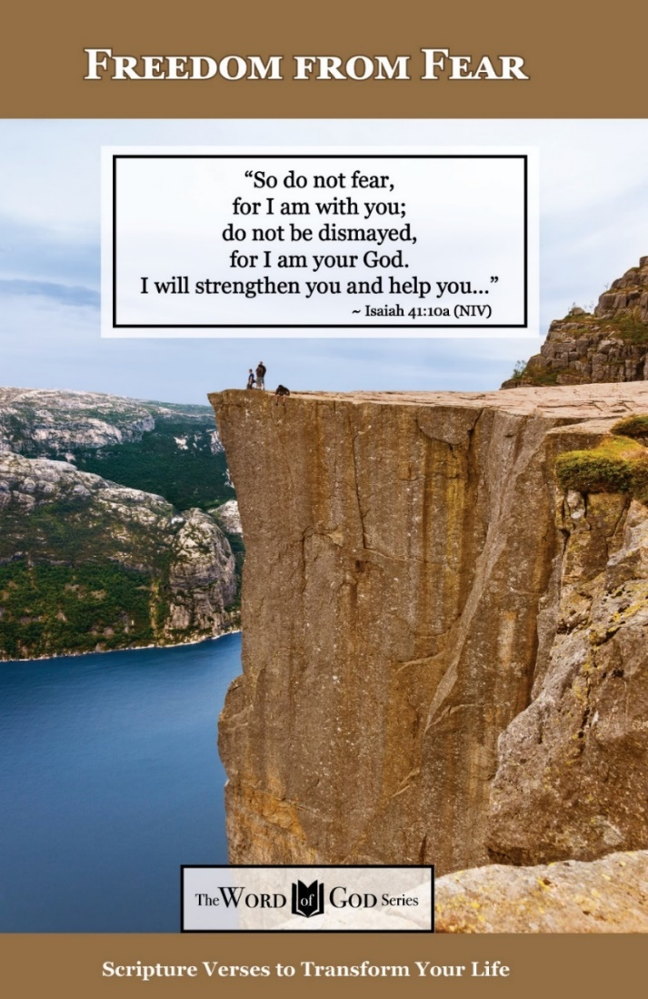
Relational and Emotional Health Topics

Freedom from Addictions

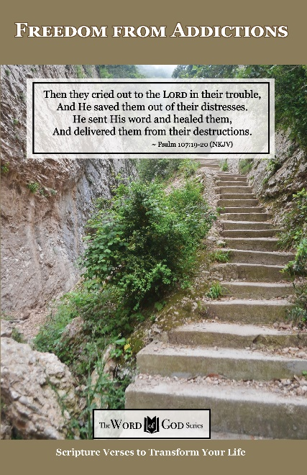
The Life and Ministry of Christ Series

Jesus: His Birth

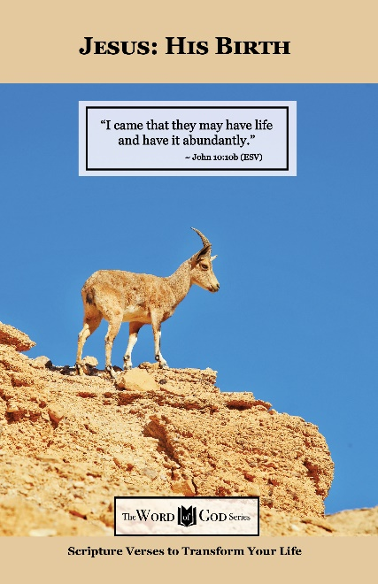
The Life and Ministry of Christ Series

Jesus: His Life Events

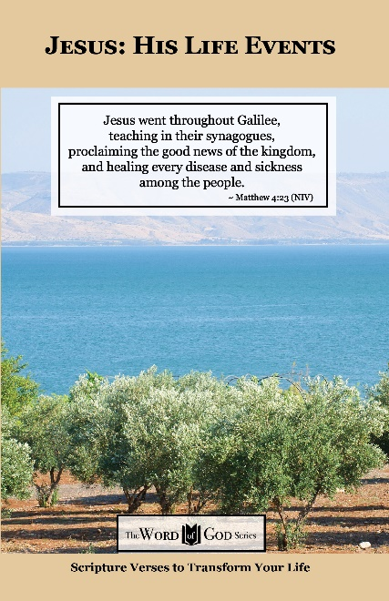
The Life and Ministry of Christ Series

Jesus: His Teachings

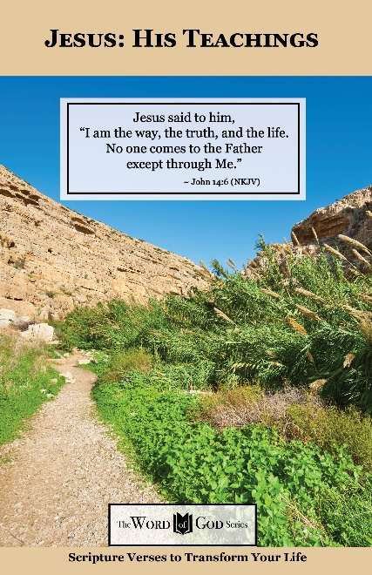
The Life and Ministry of Christ Series

Jesus: His Death, Resurrection and Return

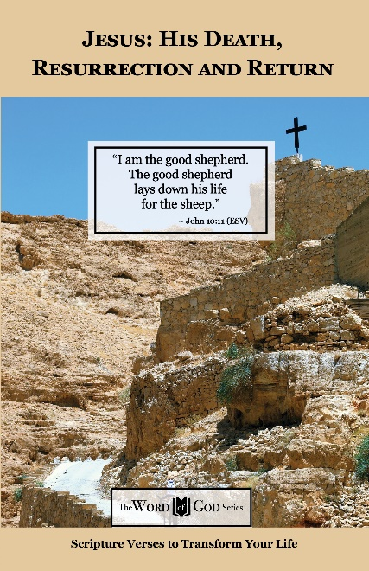
Spiritual Growth Topics

God’s Power and Presence

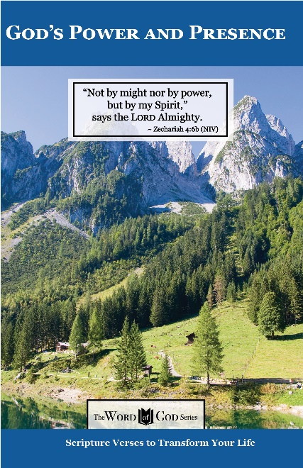
Spiritual Growth Topics

God’s Gift of Eternal Life

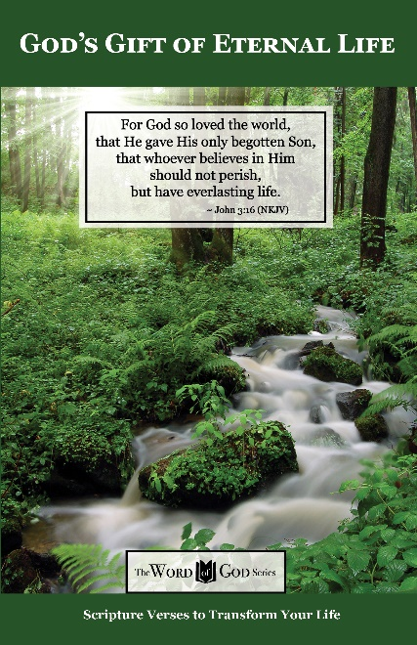
Spiritual Growth Topics

Sharing the Good News

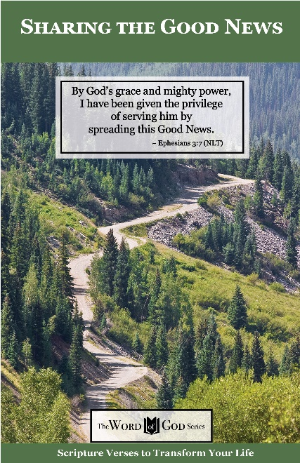
Spiritual Growth Topics

Defeating the Enemy

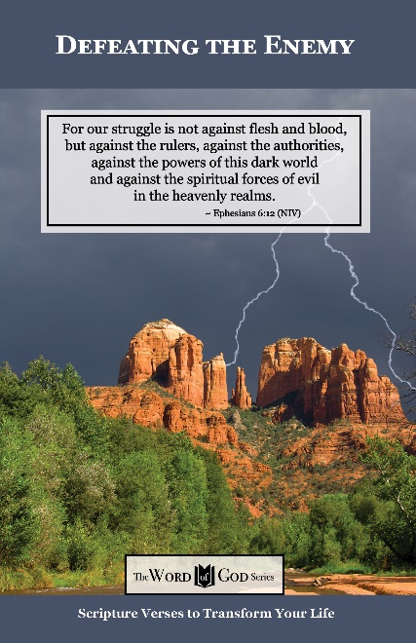
Spiritual Growth Topics

Standing Strong in Persecution

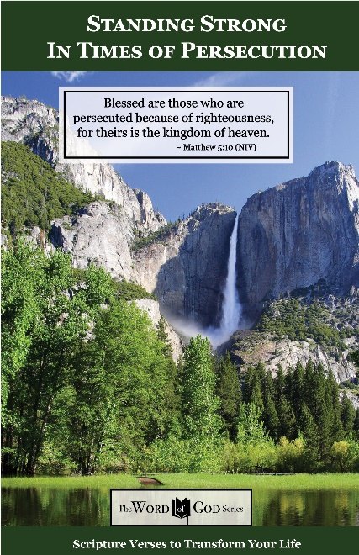
Everyday Life Topics

God’s Healing Power

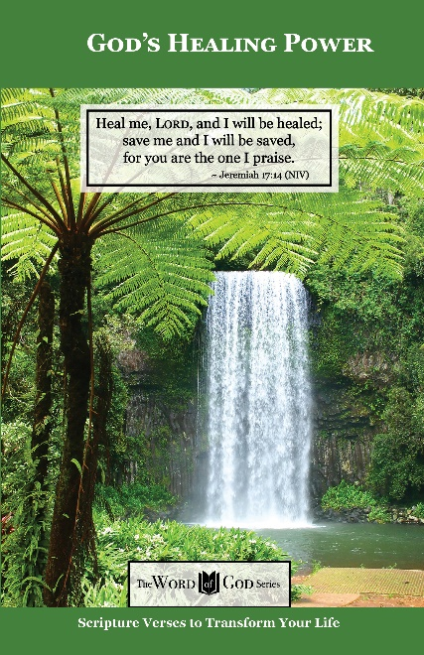
Everyday Life Topics

God is Your Refuge

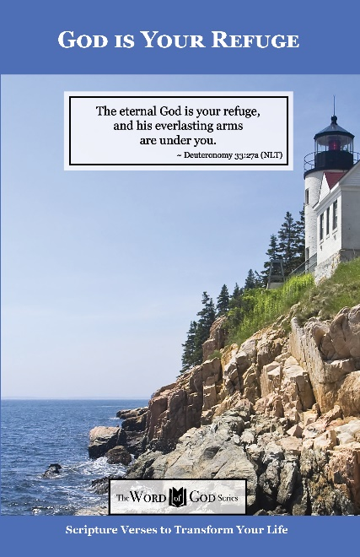
Everyday Life Topics

God’s Guidance for Your Life

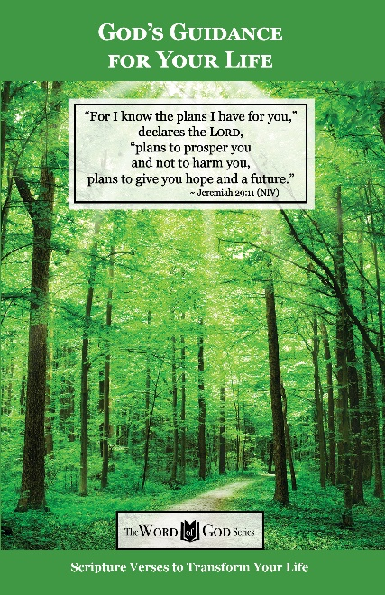
Everyday Life Topics

God’s Word to the Nations

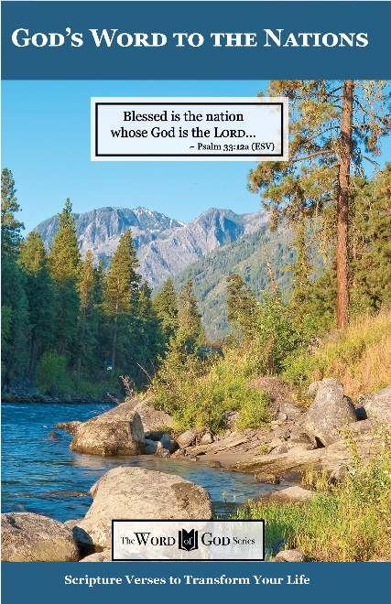
Everyday Life Topics

Praise God at Thanksgiving

