Template for Standing Strong in Persecution in an eBooklet Format

The Word of God Series is a collection of 20 booklets that present Scripture verses in an easy-to-read format, with each booklet focused on a different topic.
Titles include Healthy Relationships, A Joy-Filled Life, Freedom from Depression, and many others. Click here to see other titles.
The booklets are available in both paperback and digital formats at www.TheWordOfGodSeries.com or Amazon.com.
Why This Template?
Because I believe in the power of God’s Word to transform people’s lives, I have dedicated several years of my life to bring this series to fruition.
I am passionate about using these booklets to reach a dark and dying world with the love of Christ and the hope of the Gospel.
Initially, I had expected this series would be a small business. But one day, when I asked God what my next steps should be, He spoke to me through His Word and told me to:
“…complete the ministry God has given you.”
~ 2 Timothy 4:5 (NLT, 1996 version)
So, I shifted the focus from being a business to a ministry.
My vision, also, has evolved over time and I have come to believe that it is possible for millions of these booklets to be distributed (in both print and digital formats) around the world (see the document entitled The Vision at www.TheWordOfGodSeries.com for more info.)
In order to make this a far-reaching ministry, accessing populations that I couldn’t on my own, I decided to invite others to partner with me in producing and distributing these booklets to their own personal networks. To help get it started, I have made templates of each booklet freely available to anyone who would like them.
This way you (whether you are a church, Christian organization or an individual) can easily re-create the booklets in your own ministry’s name, and distribute them to the people you minister to.
I hope that this template will save you:
- Time – so you can benefit from the thousands of hours of development time that has been invested so far
- Money – eliminate layers of profit margin
Whether you simply replicate and reproduce what has already been done, build on it, or take this idea in a different direction, you won’t have to waste time starting with a blank page.
I hope you can easily get these finalized, so you can begin sharing them with the people in your sphere of influence.
On the following pages you will find document formatting tips.
Photo editing tips are also presented, as well as the preview images of each photo (with the Photo ID#), so you to easily find it on either bigstockphoto.com or shutterstock.com. Copyright and general info for each photo can be found here.
Formatting Tips (if making changes to this document)
This document is ready to be exported to an eBook format. The app I used is through Amazon called Kindle Create.
If you make any changes to this document (such as pasting additional verses or entire sections into it), you’ll want follow the steps below.
If you are not making any changes to this document, then just skip these steps.
When converting a document to eBook format, it’s best to remove tabs, indentations and soft returns. While using these formatting tricks in a print format can make the page much more readable (by adding white space to the page), in a digital format, these same tricks can disrupt the flow of the text and make it more difficult to read (since the view can change depending on the type of device, font size selected, etc.)
- Remove all tabs, indentations and soft returns (Note, if a passage is too long, you can always add white space by inserting a
hard return (the Enter key only) after a sentence, with a 6 pt spacing after the line. (Layout / Spacing / After / 6 pt)


- Ensure that the spacing between the lines is consistent throughout the document. When the document is completed, select the entire document (Ctrl + A) and click on Layout / Paragraph / Multiple (under Line Spacing) and change the number to “1”


- Ensure that the spacing between the characters is consistent throughout the document. After completing step 2 above, while the entire document is still selected, click on Home / Font / Advanced and change the Spacing to Normal


Photo Editing Tips
At the end of this document you will find the copyright and descriptive info for each photo in the booklet, as well as editing suggestions for a few of them.
For the digital view, try to keep the photos as large on the page as possible, otherwise they will appear too small on devices. The preview photos in this document are a good size for digital format, so try to keep your photos the same size.
Most of the editing suggestions (especially brightening or increasing color saturation) should be very slight adjustments.
Editing photos within this document
Rotate: Doubleclick the photo, click on the Rotate Object icon.
Note: rotating an image is more important in the print format, so that certain objects in the photo will face the center of the page (such as animal pics). This doesn’t matter in a digital format, but the suggestion to rotate certain photos is included below in order to keep the digital and print formats consistent (in case someone reads both the print and digital booklets.)

Editing photos in the Pictures editing app in MS Word
Navigate to your Pictures folder, doubleclick the photo, and click on the blue Edit button on left
Most of the editing can be accomplished using one of these 3 options:


Crop: Click on the Crop icon and drag edges to desired spot
Brighten a photo: Adjustment icon / Light / Brightness
Increase color saturation: Adjustment icon / Color / Saturation or Warmth
Remove distracting elements from a photo: Click on the Generative Erase icon, select a brush size and click on the part of the photo you want removed.

Photo Searching Tips
Occasionally photographers pull their photos from the sites, so there may be some in this document that are no longer available. You can try using the same key words to search for the photo on other sites. Or, you can search for another photo on Bigstock:
- Under All Images select Photos and search by key word.
- At the next screen, make sure that Safe Search is on.
- In the Category field, select either Landscapes, Nature or Animals.
Forward Page | Copyright Page | Table of Contents

Below are sample Forward and Copyright pages. Feel free to edit to reflect your ministry’s mission and vision.
The Table of Contents in this document contains links to each of the section headings. If you add any new sections to this document, be sure to:
- Assign the Heading Style to the new section heading (in this document, it is referred to as Heading).
Highlight the heading, click on Home, then Heading in the Styles box


- Bookmark the new section heading: Put your cursor after the first letter in the section heading, click on Insert / Bookmark and then give name the bookmark (no spaces in the name!)



- Add the new section heading to the Table of Contents page and add a link to the bookmark you just created: Highlight the text, click on Insert / Link / Place in this Document and select the section heading bookmark.


Kindle Create
Should you decide to use Kindle Create to export this to an eBook format, see the steps below. You can use Kindle Create to export to a Kindle KPF file and/or EPUB file:

Begin at https://kdp.amazon.com/en_US/bookshelf to set up the booklets on Amazon and install the Kindle Create app.
At the first screen, select Create New and Choose

At the next Screen click on Continue. At the next screen click on Choose File, select the document, and click on Open. Then click on Continue and Get Started.
At the next screen you will see a box labeled Suggested Chapter Titles. Click on Reject All.
Next, left-justify the entire document (a quirk with this application is that some portions of the document may be centered, while others portions are left-justified). Highlight the entire document, click on Formatting, and then the left-justify icon.
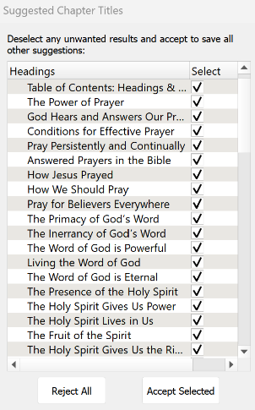

Now you can begin assigning different elements to the Headings and Subheadings in the document so that, when someone is reading the eBook, they can easily jump to another section via the Table of Contents.
I use 2 elements: Chapter Title (for the key headings in the Brittanica Bold font) and Subheading (for the underlined subheadings).
As you begin assigning the elements, be sure to start by assigning the Chapter Title element to the Table of Contents: Headings and Subheadings heading. Then go through the rest of the document and assign either the Chapter Title or Subheading elements.
You can change the formatting from the Kindle Create default, if you want. Below are the formatting options that I use for the eBooklets.
Feel free to customize to suit your preferences.




Finally, go through the document and click on each photo and change it to “Full Size.” (Note, another quirk with this app is that some photos just can’t be changed to full size, so they will appear smaller in the eBooklet).
When complete, first, save the document (File / Save Project). This will automatically put it in a folder. So when you export the document, be sure you export it to that folder.
To export, click on File / Export / KPF (Kindle and print). At the next screen, click on the file name to select it, and then click on Export.
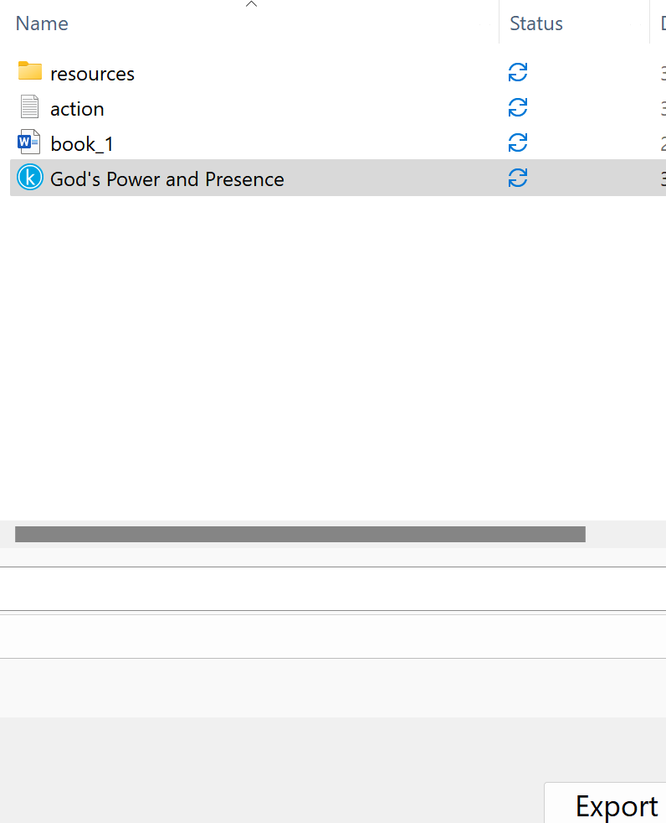

If you want the file in an EPUB format, go through the steps above and select File / Export / EPUB

Stuck on a Step Above and Need Help?
If you want to do this project on your own, but are having tech issues with one of the steps above, feel free to contact me at Susan@TheWordOfGodSeries.com. I may be able to assist you, since I’ve gone through this whole process myself!

Need Help with the Whole Project?
If you want these booklets set up in your own in your own ministry’s name, but don’t have the resources to do the whole project yourself,
I may be able to manage that process for you for a one-time project fee.
This would include the following services:
- Set up an account with Bigstock and Shutterstock in your ministry’s name and purchase the rights for you to use each of the photos
- Download and name the photos
- Edit photos as needed
- Create a cover with your church or ministry logo
- Request the rights to use the various Bible translations from each of the publishers (if applicable)
Feel free to contact me at Susan@TheWordOfGodSeries.com to discuss pricing options.

I hope that this information will help you finalize this document with ease so you can begin distributing it
to the people in your realm of influence.
Thank you for partnering with me in this effort. I wish you the best as you make God’s Word known and
share His love with others!
Warmly in Christ,
Susan

Soli Deo gloria


Feel free to edit this forward page to align to your own ministry’s vision and goals.

The Bible is the best-selling and most transformative book in history. Written over 2,000 years ago, it is still living and powerful today.
Throughout the pages of Scripture you will find inspiration and joy, comfort and peace, healing and hope.
Most importantly, you will learn of God’s abundant love for you, and His plan to give you a glorious, eternal inheritance.
The Word of God Series is a collection of booklets which presents Scripture by topic, so you can focus on verses that are relevant to you at different stages and circumstances throughout your life.
All of the booklets in this series feature Scripture exclusively—just the powerful, undiluted Word of God.
Let God’s Word permeate your mind and transform your life.
Here are a few suggestions to help you fully benefit from Scripture:
Meditate
Pause and reflect on the verses as you read, and even meditate on them throughout the day.
Memorize
A great memorization technique is to repeat the verse several times, each time emphasizing a different word.
Be joyful in hope, patient in affliction, faithful in prayer.
Be joyful in hope, patient in affliction, faithful in prayer.
Be joyful in hope, patient in affliction, faithful in prayer.

~ Romans 12:12 (NIV)
Pray
Pray God’s Word back to Him. For example,
Dear Father, I pray that, whatever happens, I will remain joyful in hope, patient in affliction and faithful in prayer.

Do What It Says
Do not merely listen to the word, and so deceive yourselves. Do what it says.

~ James 1:22 (NIV)

My prayer for you, as you read this booklet, is that, in times of persecution, God will strengthen you with all of His glorious power so you will have all the endurance and patience you need.
Let the word of Christ dwell in you richly…

~ Colossians 3:16a (ESV)

A few comments about The Word of God Series:

- The booklets in this series provide you with a sample of what the Bible offers, but it is important that you also read the Bible itself, preferably with a book-by-book focus.

- Passages in quotation marks are the actual words of God, either through His prophets in the Old Testament, or the words of Christ in the New Testament.

- Every booklet includes a section that details God’s plan of salvation (commonly referred to as “The Gospel.”) The booklet entitled God’s Gift of Eternal Life is devoted to the Gospel message.

This series presents verses in the following translations:

NIV: New International Version
Scripture quotations marked NIV are taken from the Holy Bible, New International Version®, NIV®. Copyright © 1973, 1978, 1984, 2011 by Biblica, Inc.™ Used by permission of Zondervan. All rights reserved worldwide. www.zondervan.com. The "NIV" and "New International Version" are trademarks registered in the United States Patent and Trademark Office by Biblica, Inc.™

NLT: New Living Translation
Scripture quotations marked NLT are taken from the Holy Bible, New Living Translation, Copyright© 1996, 2004, 2015 by Tyndale House Foundation. Used by permission of Tyndale House Publishers, Inc., Carol Stream, Illinois 60188. All rights reserved.

ESV: English Standard Version
Scripture quotations marked ESV are taken from the ESV Bible® (The Holy Bible, English Standard Version®), copyright © 2001 by Crossway Bibles, a publishing ministry of Good News Publishers. Used by permission. All rights reserved.

KJV: King James Version
Public Domain

NKJV: New King James Version
Scripture quotations marked NKJV are taken from the New King James Version®. Copyright © 1982 by Thomas Nelson, Inc. Used by permission.

Since this is a template booklet featuring preview photos, it is not copyrighted, so you are free to purchase licenses to use the photos and develop your own booklets. Be sure to determine whether or not you need to request permission (and in some cases pay) for the rights to use the various Bible translations. Scripture verses were sourced from www.BibleGateway.com.

If it would be easier for you to simply purchase this booklet, the copyrighted version is available at www.TheWordOfGodSeries.com or www.amazon.com. ISBN info for the copyrighted booklets is as follows: 978-1-964538-28-0 (print booklet), 978-1-964538-29-7 (eBooklet), 9798360280361 (print booklet on Amazon).

Table of Contents: Headings & Sub-Headings

Be Strong and Courageous
Fear the Lord
Seek God for Refuge and Deliverance
Hope in the Lord
Stay in Perfect Peace
Trust in the Lord Forever
Remember Christ’s Words to His Disciples
In Times of Persecution
Share in Christ’s Sufferings
Endure Suffering for Christ
Be Patient in Affliction
Rejoice in Times of Suffering
Offer to God a Sacrifice of Thanksgiving
Praise the Lord
Rely on the Holy Spirit
Love Your Enemies
Boldly Proclaim the Gospel in Times of Persecution
Remember that You are Blessed
When Persecuted in One Town, Flee to the Next
Be Inspired by the Faith and Perseverance of Biblical Heroes
Be Faithful Unto Death
Stand With Believers Who are Being Persecuted
Pray for Them
Share with Them
Be Encouraged by Their Faith
Remember God’s Promises
He Will Deliver the Righteous
He Will Keep You Strong to the End

Note: The verse references in this document contain links to the BibleGateway.com page that will display the passage in all 5 translations that are used in this series (NIV, NLT, ESV, NKJV, KJV).

Other Booklets in the Series

Be Strong and Courageous

Be strong and courageous…for it is the Lord your God who goes with you.

~ Deuteronomy 31:6a (ESV)

“Have I not commanded you? Be strong and courageous.
“Do not be afraid; do not be discouraged, for the Lord your God will be with you wherever you go.”

~ Joshua 1:9 (NIV)

For the eyes of the Lord run to and fro throughout the whole earth, to show Himself strong on behalf of those whose heart is loyal to Him.

~ 2 Chronicles 16:9a (NKJV)



Be strong and courageous. Do not be afraid or discouraged because of the king of Assyria and the vast army with him, for there is a greater power with us than with him.

~ 2 Chronicles 32:7 (NIV)

Be on guard.
Stand firm in the faith.
Be courageous.
Be strong.
And do everything with love.

~ 1 Corinthians 16:13-14 (NLT)

The Lord himself goes before you and will be with you; he will never leave you nor forsake you.
Do not be afraid; do not be discouraged.

~ Deuteronomy 31:8 (NIV)

The Lord will guide you continually, giving you water when you are dry and restoring your strength.
You will be like a well-watered garden, like an ever-flowing spring.

~ Isaiah 58:11 (NLT)

But as for you, be strong and do not give up, for your work will be rewarded.

~ 2 Chronicles 15:7 (NIV)

Therefore, my dear brothers and sisters, stand firm.
Let nothing move you.
Always give yourselves fully to the work of the Lord, because you know that your labor in the Lord is not in vain.

~ 1 Corinthians 15:58 (NIV)

Therefore, my beloved brothers, be steadfast, immovable, always abounding in the work of the Lord…

~ 1 Corinthians 15:58a (ESV)

Seek the Lord and his strength; seek his presence continually!

~ 1 Chronicles 16:11 (ESV)

…the joy of the Lord is your strength.

~ Nehemiah 8:10b (ESV)

I also pray that you will understand the incredible greatness of God’s power for us who believe him.
This is the same mighty power that raised Christ from the dead and seated him in the place of honor at God’s right hand in the heavenly realms.

~ Ephesians 1:19-20 (NLT)

But we have this treasure in jars of clay, to show that the surpassing power belongs to God and not to us.

~ 2 Corinthians 4:7 (ESV)

“Do not fear, for I have redeemed you; I have summoned you by name; you are mine.
“When you pass through the waters, I will be with you; and when you pass through the rivers, they will not sweep over you.
“When you walk through the fire, you will not be burned; the flames will not set you ablaze.
“For I am the Lord your God, the Holy One of Israel, your Savior…”

~ Isaiah 43:1b-3a (NIV)

“Call upon Me in the day of trouble; I will deliver you, and you shall glorify Me.”

~ Psalm 50:15 (NLKV)

“Though the mountains be shaken and the hills be removed, yet my unfailing love for you will not be shaken nor my covenant of peace be removed,” says the Lord, who has compassion on you.

~ Isaiah 54:10 (NIV)


Bigstock Photo ID: 140920199

“So do not fear, for I am with you;
“do not be dismayed, for I am your God.
“I will strengthen you and help you;
“I will uphold you with my righteous right hand.”

~ Isaiah 41:10 (NIV)

Power and might are in your hand, and at your discretion people are made great and given strength.

~ 1 Chronicles 29:12b (NLT)

Powerful is your arm! Strong is your hand!
Your right hand is lifted high in glorious strength.

~ Psalm 89:13 (NLT)

Summon your might, O God.
Display your power, O God, as you have in the past.

~ Psalm 68:28 (NLT)

You formed the mountains by your power and armed yourself with mighty strength.

~ Psalm 65:6 (NLT)



I write to you, young men,
because you are strong,
and the word of God abides in you,
and you have overcome the evil one.

~ 1 John 2:14b (ESV)

Finally, be strong in the Lord and in his mighty power.
Put on the full armor of God so that you can take your stand against the devil’s schemes.
For our struggle is not against flesh and blood, but against the rulers, against the authorities, against the powers of this dark world and against the spiritual forces of evil in the heavenly realms.
Therefore put on the full armor of God, so that when the day of evil comes, you may be able to stand your ground, and after you have done everything, to stand.
Stand firm then, with the belt of truth buckled around your waist, with the breastplate of righteousness in place, and with your feet fitted with the readiness that comes from the gospel of peace.
In addition to all this, take up the shield of faith, with which you can extinguish all the flaming arrows of the evil one.
Take the helmet of salvation and the sword of the Spirit, which is the word of God.
And pray in the Spirit on all occasions with all kinds of prayers and requests.
With this in mind, be alert and always keep on praying for all the Lord’s people.
Pray also for me, that whenever I speak, words may be given me so that I will fearlessly make known the mystery of the gospel, for which I am an ambassador in chains.
Pray that I may declare it fearlessly, as I should.

~ Ephesians 6:10-20 (NIV)

The Lord is my strength and shield.
I trust him with all my heart.
He helps me, and my heart is filled with joy.
I burst out in songs of thanksgiving.

~ Psalm 28:7 (NLT)

I can do all things through Christ who strengthens me.

~ Philippians 4:13 (NKJV)

I keep my eyes always on the Lord.
With him at my right hand, I will not be shaken.

~ Psalm 16:8 (NIV)

It is God who arms me with strength and keeps my way secure.

~ Psalm 18:32 (NIV)

He gives strength to the weary and increases the power of the weak.

~ Isaiah 40:29 (NIV)

But he said to me, “My grace is sufficient for you, for my power is made perfect in weakness.”
Therefore I will boast all the more gladly about my weaknesses, so that Christ’s power may rest on me.
That is why, for Christ’s sake, I delight in weaknesses, in insults, in hardships, in persecutions, in difficulties.
For when I am weak, then I am strong.

~ 2 Corinthians 12:9-10 (NIV)

Lord, there is no one like you to help the powerless against the mighty.
Help us, Lord our God, for we rely on you, and in your name we have come against this vast army.
Lord, you are our God; do not let mere mortals prevail against you.

~ 2 Chronicles 14:11b (NIV)

I cling to you; your strong right hand holds me securely.

~ Psalm 63:8 (NLT)

I love you, Lord; you are my strength.

~ Psalm 18:1 (NLT)

Fear the Lord

Fear the Lord, you his holy people, for those who fear him lack nothing.

~ Psalm 34:9 (NIV)

…the Lord of hosts, him you shall honor as holy.
Let him be your fear, and let him be your dread.

~ Isaiah 8:13 (ESV)

…the eyes of the Lord are on those who fear him, on those whose hope is in his unfailing love...

~ Psalm 33:18 (NIV)

The fear of the Lord leads to life; then one rests content, untouched by trouble.

~ Proverbs 19:23 (NIV)

Those who fear the Lord are secure; he will be a refuge for their children.

~ Proverbs 14:26 (NLT)


Bigstock Photo ID: 138466088

“And do not fear those who kill the body but cannot kill the soul.
“But rather fear Him who is able to destroy both soul and body in hell.”

~ Matthew 10:28 (NKJV)

“But for you who fear my name, the Sun of Righteousness will rise with healing in his wings.
“And you will go free, leaping with joy like calves let out to pasture.”

~ Malachi 4:2 (NLT)

Seek God for Refuge and Deliverance

But you, O Lord, are a shield around me…

~ Psalm 3:3a (NLT)



Be my rock of refuge, to which I can always go...

~ Psalm 71:3a (NIV)

Keep me safe, my God, for in you I take refuge.

~ Psalm 16:1 (NIV)

For thou art my rock and my fortress; therefore for thy name’s sake lead me, and guide me.

~ Psalm 31:3 (KJV)

Be merciful to me, O God, be merciful to me, for in you my soul takes refuge; in the shadow of your wings I will take refuge, till the storms of destruction pass by.

~ Psalm 57:1 (ESV)

God is our refuge and strength, an ever-present help in trouble.

~ Psalm 46:1 (NIV)

The eternal God is your refuge, and his everlasting arms are under you.

~ Deuteronomy 33:27a (NLT)

Be still before the Lord and wait patiently for him;
do not fret when people succeed in their ways, when they carry out their wicked schemes.
Refrain from anger and turn from wrath; do not fret—it leads only to evil.

~ Psalm 37:7-8 (NIV)

Don’t be intimidated in any way by your enemies.
This will be a sign to them that they are going to be destroyed, but that you are going to be saved, even by God himself.

~ Philippians 1:28 (NLT)

Fear of man will prove to be a snare, but whoever trusts in the Lord is kept safe.

~ Proverbs 29:25 (NIV)

You need not be afraid of sudden disaster or the destruction that comes upon the wicked, for the Lord is your security.
He will keep your foot from being caught in a trap.

~ Proverbs 3:25-26 (NLT)

Moses answered the people, “Do not be afraid. Stand firm and you will see the deliverance the Lord will bring you today. The Egyptians you see today you will never see again.
“The Lord will fight for you; you need only to be still.”

~ Exodus 14:13-14 (NIV)

...for the Lord your God, who is among you, is a great and awesome God.

~ Deuteronomy 7:21b (NIV)

The Lord reigns, he is robed in majesty;
the Lord is robed in majesty and armed with strength;
Indeed, the world is established, firm and secure.

~ Psalm 93:1 (NIV)

So we will not fear when earthquakes come and the mountains crumble into the sea.

~ Psalm 46:2 (NLT)

Those who live in the shelter of the Most High will find rest in the shadow of the Almighty.
This I declare about the Lord:
He alone is my refuge, my place of safety; he is my God, and I trust him.
For he will rescue you from every trap and protect you from deadly disease.
He will cover you with his feathers.
He will shelter you with his wings.
His faithful promises are your armor and protection.
Do not be afraid of the terrors of the night, nor the arrow that flies in the day.
Do not dread the disease that stalks in darkness, nor the disaster that strikes at midday. Though a thousand fall at your side, though ten thousand are dying around you, these evils will not touch you. Just open your eyes, and see how the wicked are punished.
If you make the Lord your refuge, if you make the Most High your shelter, no evil will conquer you; no plague will come near your home.
For he will order his angels to protect you wherever you go. They will hold you up with their hands so you won’t even hurt your foot on a stone.
You will trample upon lions and cobras; you will crush fierce lions and serpents under your feet!
The Lord says,
“I will rescue those who love me.
“I will protect those who trust in my name.
“When they call on me, I will answer;
“I will be with them in trouble.
“I will rescue and honor them.
“I will reward them with a long life and give them my salvation.”

~ Psalm 91 (NLT)

This is what the Lord says:
“Cursed are those who put their trust in mere humans, who rely on human strength and turn their hearts away from the Lord.
“They are like stunted shrubs in the desert, with no hope for the future. They will live in the barren wilderness, in an uninhabited salty land.
“But blessed are those who trust in the Lord and have made the Lord their hope and confidence.
“They are like trees planted along a riverbank, with roots that reach deep into the water. Such trees are not bothered by the heat or worried by long months of drought. Their leaves stay green, and they never stop producing fruit.”

~ Jeremiah 17:5-8 (NLT)



This is what the Lord says to you:
“Do not be afraid or discouraged because of this vast army. For the battle is not yours, but God’s…
“You will not have to fight this battle. Take up your positions; stand firm and see the deliverance the Lord will give you…
“Do not be afraid; do not be discouraged. Go out to face them tomorrow, and the Lord will be with you.”

~ 2 Chronicles 20:15b-17 (NIV)

The Lord is my shepherd; I shall not want.
He makes me to lie down in green pastures;
He leads me beside the still waters.
He restores my soul;
He leads me in the paths of righteousness for His name’s sake.
Yea, though I walk through the valley of the shadow of death, I will fear no evil; for You are with me; Your rod and Your staff, they comfort me.
You prepare a table before me in the presence of my enemies;
You anoint my head with oil.
My cup runs over.
Surely goodness and mercy shall follow me all the days of my life;
And I will dwell in the house of the Lord forever.

~ Psalm 23 (NKJV)



Every word of God proves true; he is a shield to those who take refuge in him.

~ Proverbs 30:5 (ESV)

How great is the goodness you have stored up for those who fear you.
You lavish it on those who come to you for protection, blessing them before the watching world.

~ Psalm 31:19 (NLT)

…let all who take refuge in you rejoice…that all who love your name may be filled with joy.

~ Psalm 5:11 (NLT)

…my eyes are fixed on you, Sovereign Lord; in you I take refuge…

~ Psalm 141:8a (NIV)

You have been a refuge for the poor,
a refuge for the needy in his distress,
a shelter from the storm
and a shade from the heat.

~ Isaiah 25:4a (NIV)

You have allowed me to suffer much hardship, but you will restore me to life again and lift me up from the depths of the earth.

~ Psalm 71:20 (NLT)

You are my hiding place; you will protect me from trouble and surround me with songs of deliverance. Selah.

~ Psalm 32:7 (NIV)

Whenever I am afraid, I will trust in You.

~ Psalm 56:3 (NKJV)

Rescue me from those who are deceitful and wicked.

~ Psalm 43:1b (NIV)

Deliver me, O Lord, from evil men; preserve me from violent men...

~ Psalm 140:1 (ESV)

You have delivered me from all my troubles, and my eyes have looked in triumph on my foes.

~ Psalm 54:7 (NIV)

For thou hast been a shelter for me, and a strong tower from the enemy.

~ Psalm 61:3 (KJV)

How precious is your unfailing love, O God!
All humanity finds shelter in the shadow of your wings.

~ Psalm 36:7 (NLT)

This I declare about the Lord: He alone is my refuge, my place of safety; he is my God, and I trust him.

~ Psalm 91:2 (NLT)

He alone is my rock and my salvation, my fortress where I will not be shaken.

~ Psalm 62:6 (NLT)

I sought the Lord, and he answered me and delivered me from all my fears.

~ Psalm 34:4 (ESV)

He rescued me from my powerful enemy, from my foes, who were too strong for me.
They confronted me in the day of my disaster, but the Lord was my support.

~ Psalm 18:17-18 (NIV)

Then they cried out to the Lord in their trouble and He saved them out of their distresses.
He sent His word and healed them, and delivered them from their destructions.

~ Psalm 107:19-20 (NKJV)

Taste and see that the Lord is good; blessed is the one who takes refuge in him.

~ Psalm 34:8 (NIV)

Cast your burden on the Lord, and he will sustain you; he will never permit the righteous to be moved.

~ Psalm 55:22 (ESV)

Cast all your anxiety on him because he cares for you.

~ 1 Peter 5:7 (NIV)

The Lord is faithful. He will establish you and guard you against the evil one.

~ 2 Thessalonians 3:3 (ESV)

The Lord will rescue me from every evil attack and will bring me safely to his heavenly kingdom.
To him be glory for ever and ever. Amen.

~ 2 Timothy 4:18 (NIV)

Hope in the Lord

“For I know the plans I have for you,” declares the Lord,
“plans to prosper you and not to harm you,
“plans to give you hope and a future.”

~ Jeremiah 29:11 (NIV)

…those who hope in the Lord will renew their strength.
They will soar on wings like eagles;
they will run and not grow weary,
they will walk and not be faint.

~ Isaiah 40:31 (NIV)

I pray that your hearts will be flooded with light so that you can understand the confident hope he has given to those he called—his holy people who are his rich and glorious inheritance.

~ Ephesians 1:18 (NLT)



Let us hold unswervingly to the hope we profess, for he who promised is faithful.

~ Hebrews 10:23 (NIV)

Therefore, since we have such a hope, we are very bold.

~ 2 Corinthians 3:12 (NIV)

Let your unfailing love surround us, Lord, for our hope is in you alone.

~ Psalm 33:22 (NLT)

Stay in Perfect Peace

You will keep in perfect peace
all who trust in you,
all whose thoughts are fixed on you!

~ Isaiah 26:3 (NLT)

In peace I will lie down and sleep, for you alone, O Lord, will keep me safe.

~ Psalm 4:8 (NLT)

“Peace I leave with you; my peace I give you.
“I do not give to you as the world gives.
“Do not let your hearts be troubled and do not be afraid.”

~ John 14:27 (NIV)

“I will heal my people and will let them enjoy abundant peace and security.”

~ Jeremiah 33:6b (NIV)

“You will go out in joy and be led forth in peace…”

~ Isaiah 55:12a (NIV)

Do not be anxious about anything, but in everything, by prayer and petition, with thanksgiving, present your requests to God.
And the peace of God, which transcends all understanding, will guard your hearts and your minds in Christ Jesus.

~ Philippians 4:6-7 (NIV)

May the God of hope fill you with all joy and peace as you trust in him, so that you may overflow with hope by the power of the Holy Spirit.

~ Romans 15:13 (NIV)

The Lord bless you and keep you;
the Lord make his face shine on you and be gracious to you;
the Lord turn his face toward you and give you peace.

~ Numbers 6:24-26 (NIV)

Trust in the Lord Forever

Trust in the Lord forever, for the Lord, the Lord himself, is the Rock eternal.

~ Isaiah 26:4 (NIV)

Trust in the Lord with all your heart and lean not on your own understanding…

~ Proverbs 3:5 (NIV)

Trust in the Lord and do good; dwell in the land and enjoy safe pasture.

~ Psalm 37:3 (NIV)



O Lord of hosts, blessed is the one who trusts in you!

~ Psalm 84:12 (ESV)

For You, Lord, have not forsaken those who seek You.

~ Psalm 9:10 (NKJV)

But I am trusting you, O Lord, saying, “You are my God!” My future is in your hands.

~ Psalm 31:14-15a (NLT)

Remember Christ’s Words to His Disciples

His Warnings

“Remember the word that I said to you, ‘A servant is not greater than his master.’
“If they persecuted Me, they will also persecute you.”

~ John 15:20a (NKJV)

“If the world hates you, keep in mind that it hated me first.
“If you belonged to the world, it would love you as its own.
“As it is, you do not belong to the world, but I have chosen you out of the world. That is why the world hates you.”

~ John 15:18-19 (NIV)

“There will be famines and earthquakes in various places. All these are the beginning of birth pains.
“Then you will be handed over to be persecuted and put to death, and you will be hated by all nations because of me.
“At that time many will turn away from the faith and will betray and hate each other, and many false prophets will appear and deceive many people.
“Because of the increase of wickedness, the love of most will grow cold, but the one who stands firm to the end will be saved.”

~ Matthew 24:7b-13 (NIV)

“Brother will betray brother to death, and a father his child…”

~ Matthew 10:21a (NIV)

“You will be hated by everyone because of me, but the one who stands firm to the end will be saved.”

~ Matthew 10:22 (NIV)

“I have said all these things to you to keep you from falling away…that when their hour comes you may remember that I told them to you.”

~ John 16:1-4a (ESV)

Then Jesus said to His disciples, “If anyone desires to come after Me, let him deny himself, and take up his cross, and follow Me.
“For whoever desires to save his life will lose it, but whoever loses his life for My sake will find it.”

~ Matthew 16:24-25 (NKJV)

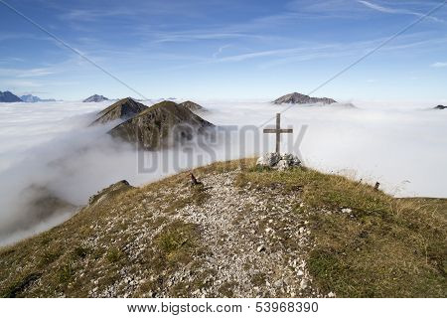

“...but whoever loses their life for me and for the gospel will save it.”

~ Mark 8:35b (NIV)

“If anyone desires to come after Me, let him deny himself, and take up his cross daily, and follow Me.”

~ Luke 9:23b (NKJV)

“Whoever does not bear his own cross and come after me cannot be my disciple.”

~ Luke 14:27 (ESV)

“And he who does not take his cross and follow after Me is not worthy of Me.”

~ Matthew 10:38 (NKJV)

“Truly I tell you,” Jesus replied, “no one who has left home or brothers or sisters or mother or father or children or fields for me and the gospel will fail to receive a hundred times as much in this present age: homes, brothers, sisters, mothers, children and fields—along with persecutions—and in the age to come eternal life.”

~ Mark 10:29-30 (NIV)

Jesus left that part of the country and returned with his disciples to Nazareth, his hometown. The next Sabbath he began teaching in the synagogue, and many who heard him were amazed.
They asked, “Where did he get all this wisdom and the power to perform such miracles?”
Then they scoffed, “He’s just a carpenter, the son of Mary and the brother of James, Joseph, Judas, and Simon. And his sisters live right here among us.”
They were deeply offended and refused to believe in him.
Then Jesus told them, “A prophet is honored everywhere except in his own hometown and among his relatives and his own family.”

~ Mark 6:1-4 (NLT)

“We must quickly carry out the tasks assigned us by the one who sent us.
“The night is coming, and then no one can work.”

~ John 9:4 (NLT)

“I am sending you out like sheep among wolves. Therefore be as shrewd as snakes and as innocent as doves.”

~ Matthew 10:16 (NIV)

His Encouragement

“…I will build my church,
and all the powers of hell will not conquer it.”

~ Matthew 16:18b (NLT)

“…I will build my church,
and the gates of hell shall not prevail against it.”

~ Matthew 16:18b (ESV)

“I have told you these things, so that in me you may have peace.
“In this world you will have trouble. But take heart! I have overcome the world.”

~ John 16:33 (NIV)

“If you remain in me and my words remain in you, ask whatever you wish, and it will be done for you.”

~ John 15:7 (NIV)

“Therefore I tell you, do not worry about your life, what you will eat or drink; or about your body, what you will wear.
“Is not life more than food, and the body more than clothes?
“Look at the birds of the air; they do not sow or reap or store away in barns, and yet your heavenly Father feeds them. Are you not much more valuable than they?...
“So do not worry, saying, ‘What shall we eat?’ or ‘What shall we drink?’ or ‘What shall we wear?’
“For the pagans run after all these things, and your heavenly Father knows that you need them.”

~ Matthew 6:25-32 (NIV)

“But seek first the kingdom of God and His righteousness, and all these things shall be added to you.”

~ Matthew 6:33 (NKJV)

“Are not two sparrows sold for a penny? Yet not one of them will fall to the ground outside your Father’s care.
“And even the very hairs of your head are all numbered.
“So don’t be afraid; you are worth more than many sparrows.”

~ Matthew 10:29-31 (NIV)

“Who of you by worrying can add a single hour to your life?”

~ Luke 12:25 (NIV)

“I tell you the truth, everyone who acknowledges me publicly here on earth, the Son of Man will also acknowledge in the presence of God’s angels.
“But anyone who denies me here on earth will be denied before God’s angels.”

~ Luke 12:8-9 (NLT)

“You have stayed with me in my time of trial. And just as my Father has granted me a Kingdom, I now grant you the right to eat and drink at my table in my Kingdom.”

~ Luke 22:28-30a (NLT)

“And I bestow upon you a kingdom…”

~ Luke 22:29a (NKJV)

“So don’t be afraid, little flock. For it gives your Father great happiness to give you the Kingdom.”

~ Luke 12:32 (NLT)

In Times of Persecution

Yes, and everyone who wants to live a godly life in Christ Jesus will suffer persecution.

~ 2 Timothy 3:12 (NLT)

Share in Christ’s Sufferings

For as we share abundantly in Christ’s sufferings, so through Christ we share abundantly in comfort too.

~ 2 Corinthians 1:5 (ESV)

He comforts us in all our troubles so that we can comfort others.
When they are troubled, we will be able to give them the same comfort God has given us.

~ 2 Corinthians 1:4 (NLT)

They went to a place called Gethsemane, and Jesus said to his disciples, “Sit here while I pray.”
He took Peter, James and John along with him, and he began to be deeply distressed and troubled.
“My soul is overwhelmed with sorrow to the point of death,” he said to them. “Stay here and keep watch.”
Going a little farther, he fell to the ground and prayed that if possible the hour might pass from him.
“Abba, Father,” he said, “everything is possible for you. Take this cup from me. Yet not what I will, but what you will.”

~ Mark 14:32-36 (NIV)

“…nevertheless not My will, but Yours, be done.”

~ Luke 22:42 (NKJV)

Since therefore Christ suffered in the flesh, arm yourselves with the same way of thinking, for whoever has suffered in the flesh has ceased from sin...

~ 1 Peter 4:1 (ESV)

For God is pleased when, conscious of his will, you patiently endure unjust treatment…if you suffer for doing good and endure it patiently, God is pleased with you.
For God called you to do good, even if it means suffering, just as Christ suffered for you.
He is your example, and you must follow in his steps.
He never sinned, nor ever deceived anyone.
He did not retaliate when he was insulted, nor threaten revenge when he suffered.
He left his case in the hands of God, who always judges fairly.

~ 1 Peter 2:19-23 (NLT)

So we will not be afraid on the day of judgment, but we can face him with confidence because we live like Jesus here in this world.

~ 1 John 4:17b (NLT)



But rejoice inasmuch as you participate in the sufferings of Christ, so that you may be overjoyed when his glory is revealed.

~ 1 Peter 4:13 (NIV)

Endure Suffering for Christ

Endure suffering along with me, as a good soldier of Christ Jesus.
Soldiers don’t get tied up in the affairs of civilian life, for then they cannot please the officer who enlisted them.

~ 2 Timothy 2:3-4 (NLT)

For you have been given not only the privilege of trusting in Christ but also the privilege of suffering for him.

~ Philippians 1:29 (NLT)

…we put up with anything rather than hinder the gospel of Christ.

~ 1 Corinthians 9:12b (NIV)

And because I preach this Good News, I am suffering and have been chained like a criminal.
But the word of God cannot be chained.
So I am willing to endure anything if it will bring salvation and eternal glory in Christ Jesus to those God has chosen.

~ 2 Timothy 2:9-10 (NLT)

I want you to know, brothers, that what has happened to me has really served to advance the gospel, so that it has become known throughout the whole imperial guard and to all the rest that my imprisonment is for Christ.
And most of the brothers, having become confident in the Lord by my imprisonment, are much more bold to speak the word without fear.

~ Philippians 1:12-14 (ESV)

So do not be ashamed of the testimony about our Lord or of me his prisoner.
Rather, join with me in suffering for the gospel, by the power of God.

~ 2 Timothy 1:8 (NIV)

...be ready to suffer with me for the sake of the Good News…

~ 2 Timothy 1:8b (NLT)

If only for this life we have hope in Christ, we are of all people most to be pitied.

~ 1 Corinthians 15:19 (NIV)

If we endure hardship, we will reign with him.

~ 2 Timothy 2:12a (NLT)

Remember those earlier days after you had received the light, when you endured in a great conflict full of suffering.
Sometimes you were publicly exposed to insult and persecution; at other times you stood side by side with those who were so treated.
You suffered along with those in prison and joyfully accepted the confiscation of your property, because you knew that you yourselves had better and lasting possessions.

~ Hebrews 10:32-34 (NIV)

You became imitators of us and of the Lord, for you welcomed the message in the midst of severe suffering with the joy given by the Holy Spirit.

~ 1 Thessalonians 1:6 (NIV)

I now rejoice in my sufferings for you, and fill up in my flesh what is lacking in the afflictions of Christ, for the sake of His body, which is the church...

~ Colossians 1:24 (NKJV)

…I bear on my body the scars that show I belong to Jesus.

~ Galatians 6:17b (NLT)

I want to know Christ—yes, to know the power of his resurrection and participation in his sufferings, becoming like him in his death, and so, somehow, attaining to the resurrection from the dead.

~ Philippians 3:10-11 (NIV)

We always carry around in our body the death of Jesus, so that the life of Jesus may also be revealed in our body.

~ 2 Corinthians 4:10 (NIV)

Because of that cross, my interest in this world has been crucified, and the world’s interest in me has also died.

~ Galatians 6:14b (NLT)

Do not be surprised, brothers, that the world hates you.

~ 1 John 3:13 (ESV)

For it seems to me that God has put us apostles on display at the end of the procession, like those condemned to die in the arena. We have been made a spectacle to the whole universe, to angels as well as to human beings…
To this very hour we go hungry and thirsty, we are in rags, we are brutally treated, we are homeless. We work hard with our own hands.
When we are cursed, we bless;
when we are persecuted, we endure it;
when we are slandered, we answer kindly.
We have become the scum of the earth, the garbage of the world—right up to this moment.

~ 1 Corinthians 4:9-13 (NIV)

But God chose the foolish things of the world to shame the wise;
God chose the weak things of the world to shame the strong.

~ 1 Corinthians 1:27 (NIV)



We are hard pressed on every side, but not crushed; perplexed, but not in despair; persecuted, but not abandoned; struck down, but not destroyed.

~ 2 Corinthians 4:8-9 (NIV)

We live in such a way that no one will stumble because of us, and no one will find fault with our ministry.
In everything we do, we show that we are true ministers of God.
We patiently endure troubles and hardships and calamities of every kind.
We have been beaten, been put in prison, faced angry mobs, worked to exhaustion, endured sleepless nights, and gone without food.
We prove ourselves by our purity, our understanding, our patience, our kindness, by the Holy Spirit within us, and by our sincere love.
We faithfully preach the truth. God’s power is working in us.
We use the weapons of righteousness in the right hand for attack and the left hand for defense.
We serve God whether people honor us or despise us, whether they slander us or praise us.
We are honest, but they call us impostors.
We are ignored, even though we are well known.
We live close to death, but we are still alive.
We have been beaten, but we have not been killed.
Our hearts ache, but we always have joy.
We are poor, but we give spiritual riches to others.
We own nothing, and yet we have everything.

~ 2 Corinthians 6:3-10 (NLT)

Five times I received at the hands of the Jews the forty lashes less one. Three times I was beaten with rods. Once I was stoned.
Three times I was shipwrecked; a night and a day I was adrift at sea; on frequent journeys, in danger from rivers, danger from robbers, danger from my own people, danger from Gentiles, danger in the city, danger in the wilderness, danger at sea, danger from false brothers; in toil and hardship, through many a sleepless night, in hunger and thirst, often without food, in cold and exposure.

~ 2 Corinthians 11:24-27 (ESV)

Be Patient in Affliction

Be joyful in hope, patient in affliction, faithful in prayer.

~ Romans 12:12 (NIV)

Let us not become weary in doing good, for at the proper time we will reap a harvest if we do not give up.

~ Galatians 6:9 (NIV)

Patient endurance is what you need now, so that you will continue to do God’s will.
Then you will receive all that he has promised.

~ Hebrews 10:36 (NLT)

And the God of all grace, who called you to his eternal glory in Christ, after you have suffered a little while, will himself restore you and make you strong, firm and steadfast.

~ 1 Peter 5:10 (NIV)

Be alert and of sober mind.
Your enemy the devil prowls around like a roaring lion looking for someone to devour.
Resist him, standing firm in the faith, because you know that the family of believers throughout the world is undergoing the same kind of sufferings.

~ 1 Peter 5:8-9 (NIV)

...let us throw off everything that hinders and the sin that so easily entangles.
And let us run with perseverance the race marked out for us, fixing our eyes on Jesus…

~ Hebrews 12:1b-2a (NIV)

...I have learned to be content whatever the circumstances.
I know what it is to be in need, and I know what it is to have plenty.
I have learned the secret of being content in any and every situation, whether well fed or hungry, whether living in plenty or in want.

~ Philippians 4:11b-12 (NIV)

“I know your deeds. See, I have placed before you an open door that no one can shut.
“I know that you have little strength, yet you have kept my word and have not denied my name…
“Since you have kept my command to endure patiently, I will also keep you from the hour of trial that is going to come on the whole world to test the inhabitants of the earth.”

~ Revelation 3:8-10 (NIV)

Fight the good fight of the faith.
Take hold of the eternal life to which you were called…
I charge you to keep this command without spot or blame until the appearing of our Lord Jesus Christ, which God will bring about in his own time—God, the blessed and only Ruler, the King of kings and Lord of lords, who alone is immortal and who lives in unapproachable light…

~ 1 Timothy 6:12-16a (NIV)



Who shall separate us from the love of Christ?
Shall trouble or hardship or persecution or famine or nakedness or danger or sword?
As it is written: “For your sake we face death all day long; we are considered as sheep to be slaughtered.”
No, in all these things we are more than conquerors through him who loved us.
For I am convinced that
neither death nor life,
neither angels nor demons,
neither the present nor the future,
nor any powers,
neither height nor depth,
nor anything else in all creation,
will be able to separate us from the love of God that is in Christ Jesus our Lord.

~ Romans 8:35-39 (NIV)

Rejoice in Times of Suffering

…I consider that the sufferings of this present time are not worth comparing with the glory that is to be revealed to us.

~ Romans 8:18 (ESV)

For our light and momentary troubles are achieving for us an eternal glory that far outweighs them all.
So we fix our eyes not on what is seen, but on what is unseen,
since what is seen is temporary, but what is unseen is eternal.

~ 2 Corinthians 4:17-18 (NIV)



Rejoice in the Lord always. I will say it again: Rejoice!

~ Philippians 4:4 (NIV)

...we rejoice in our sufferings, knowing that suffering produces endurance, and endurance produces character, and character produces hope…

~ Romans 5:3b-4 (ESV)

…we know that for those who love God all things work together for good, for those who are called according to his purpose.

~ Romans 8:28 (ESV)

So if you are suffering in a manner that pleases God, keep on doing what is right, and trust your lives to the God who created you, for he will never fail you.

~ 1 Peter 4:19 (NLT)

Consider it pure joy, my brothers and sisters, whenever you face trials of many kinds, because you know that the testing of your faith produces perseverance.
Let perseverance finish its work so that you may be mature and complete, not lacking anything.

~ James 1:2-4 (NIV)

Beloved, do not think it strange concerning the fiery trial which is to try you, as though some strange thing happened to you; but rejoice to the extent that you partake of Christ’s sufferings, that when His glory is revealed, you may also be glad with exceeding joy.

~ 1 Peter 4:12-13 (NKJV)

So be truly glad.
There is wonderful joy ahead, even though you have to endure many trials for a little while.
These trials will show that your faith is genuine…
So when your faith remains strong through many trials, it will bring you much praise and glory and honor on the day when Jesus Christ is revealed to the whole world.

~ 1 Peter 1:6-7 (NLT)

Offer to God a Sacrifice of Thanksgiving

...give thanks in all circumstances; for this is God’s will for you in Christ Jesus.

~ 1 Thessalonians 5:18 (NIV)

“The one who offers thanksgiving as his sacrifice glorifies me…”

~ Psalm 50:23a (ESV)

I will offer to You the sacrifice of thanksgiving…

~ Psalm 116:17a (NKJV)

Though the fig tree does not bud and there are no grapes on the vines,
though the olive crop fails and the fields produce no food…
Yet I will rejoice in the Lord, I will be joyful in God my Savior.

~ Habakkuk 3:17-18 (NIV)

Praise the Lord

So then, just as you received Christ Jesus as Lord, continue to live your lives in him, rooted and built up in him, strengthened in the faith as you were taught, and overflowing with thankfulness.

~ Colossians 2:6-7 (NIV)

Praise the Lord. Give thanks to the Lord, for he is good; his love endures forever.

~ Psalm 106:1 (NIV)

Praise be to the Lord, to God our Savior, who daily bears our burdens.

~ Psalm 68:19 (NIV)

...thanks be to God, who gives us the victory through our Lord Jesus Christ.

~ 1 Corinthians 15:57 (ESV)

May the praise of God be in their mouths and a double-edged sword in their hands…

~ Psalm 149:6 (NIV)

After consulting the people, Jehoshaphat appointed men to sing to the Lord and to praise him for the splendor of his holiness as they went out at the head of the army, saying:
“Give thanks to the Lord, for his love endures forever.”
As they began to sing and praise, the Lord set ambushes against the men…who were invading Judah, and they were defeated.

~ 2 Chronicles 20:21-22 (NIV)

Around midnight Paul and Silas were praying and singing hymns to God, and the other prisoners were listening.
Suddenly, there was a massive earthquake, and the prison was shaken to its foundations.
All the doors immediately flew open, and the chains of every prisoner fell off!

~ Acts 16:25-26 (NLT)

Set me free from my prison, that I may praise your name.

~ Psalm 142:7a (NIV)

All your works praise you, Lord; your faithful people extol you.
They tell of the glory of your kingdom and speak of your might, so that all people may know of your mighty acts and the glorious splendor of your kingdom.
Your kingdom is an everlasting kingdom, and your dominion endures through all generations.

~ Psalm 145:1o-13a (NIV)

Yours, O Lord, is the greatness, the power, the glory, the victory, and the majesty.
Everything in the heavens and on earth is yours, O Lord, and this is your kingdom.
We adore you as the one who is over all things.

~ 1 Chronicles 29:11 (NLT)

How great is the goodness you have stored up for those who fear you.
You lavish it on those who come to you for protection, blessing them before the watching world.

~ Psalm 31:19 (NLT)



Through the praise of children and infants you have established a stronghold against your enemies…

~ Psalm 8:2a (NIV)

Rely on the Holy Spirit

…as for me, I am filled with power, with the Spirit of the Lord…

~ Micah 3:8a (ESV)

…God has not given us a spirit of fear,
but of power
and of love
and of a sound mind.

~ 2 Timothy 1:7 (NKJV)

The Spirit of the Sovereign Lord is upon me, for the Lord has anointed me to bring good news to the poor.
He has sent me to comfort the brokenhearted and to proclaim that captives will be released and prisoners will be freed.
He has sent me to tell those who mourn that the time of the Lord’s favor has come…

~ Isaiah 61:1-2a (NLT)

The Spirit of the Lord speaks through me; his words are upon my tongue.

~ 2 Samuel 23:2 (NLT)



“Not by might nor by power, but by my Spirit,” says the Lord Almighty.

~ Zechariah 4:6b (NIV)

“…you will receive power when the Holy Spirit has come upon you, and you will be my witnesses in Jerusalem and in all Judea and Samaria, and to the end of the earth.”

~ Acts 1:8 (ESV)

“God will give you the right words at the right time.
“For it is not you who will be speaking—it will be the Spirit of your Father speaking through you.”

~ Matthew 10:19b-20 (NLT)

“...they will seize you and persecute you. They will hand you over to synagogues and put you in prison...
“But make up your mind not to worry beforehand how you will defend yourselves.
“For I will give you words and wisdom that none of your adversaries will be able to resist or contradict.”

~ Luke 21:12b-15 (NIV)

“…do not worry beforehand about what to say.
“Just say whatever is given you at the time, for it is not you speaking, but the Holy Spirit.”

~ Mark 13:11b (NIV)

“… do not worry about what to say or how to say it.
“At that time you will be given what to say, for it will not be you speaking, but the Spirit of your Father speaking through you.”

~ Matthew 10:19b-20 (NIV)

“For the Holy Spirit will teach you in that very hour what you ought to say.”

~ Luke 12:12 (NKJV)

“…the Helper, the Holy Spirit, whom the Father will send in My name, He will teach you all things, and bring to your remembrance all things that I said to you.”

~ John 14:26 (NKJV)

“When the Spirit of truth comes, he will guide you into all truth…”

~ John 16:13a (NLT)

Love Your Enemies

“A new command I give you: Love one another.
“As I have loved you, so you must love one another.
“By this everyone will know that you are my disciples, if you love one another.”

~ John 13:34-35 (NIV)

“But I say, love your enemies!
“Pray for those who persecute you!
“In that way, you will be acting as true children of your Father in heaven.”

~ Matthew 5:44-45a (NLT)

“But love your enemies, do good to them, and lend to them without expecting to get anything back.
“Then your reward will be great, and you will be children of the Most High, because he is kind to the ungrateful and wicked.
“Be merciful, just as your Father is merciful.”

~ Luke 6:35-36 (NIV)

“But to you who are listening I say:
“Love your enemies,
“do good to those who hate you,
“bless those who curse you
“pray for those who mistreat you.
“If someone slaps you on one cheek, turn to them the other also. If someone takes your coat, do not withhold your shirt from them.
“Give to everyone who asks you, and if anyone takes what belongs to you, do not demand it back.
“Do to others as you would have them do to you.”

~ Luke 6:27-31 (NIV)

“If you love those who love you, what reward will you get?...
“Be perfect, therefore, as your heavenly Father is perfect.”

~ Matthew 5:46-48 (NIV)

Then Jesus said, “Father, forgive them, for they do not know what they do.”

~ Luke 23:34a (NKJV)

Do not be overcome by evil, but overcome evil with good.

~ Romans 12:21 (ESV)

Do not repay anyone evil for evil.
Be careful to do what is right in the eyes of everyone.
If it is possible, as far as it depends on you, live at peace with everyone.

~ Romans 12:17-18 (NIV)

Bear with each other and forgive one another if any of you has a grievance against someone.
Forgive as the Lord forgave you.

~ Colossians 3:13 (NIV)

Beloved, never avenge yourselves, but leave it to the wrath of God, for it is written, “Vengeance is mine, I will repay, says the Lord.”
To the contrary, “if your enemy is hungry, feed him; if he is thirsty, give him something to drink…”

~ Romans 12:19-20a (ESV)



Bless those who persecute you; bless and do not curse.

~ Romans 12:14 (NKJV)

God is just: He will pay back trouble to those who trouble you and give relief to you who are troubled, and to us as well.
This will happen when the Lord Jesus is revealed from heaven in blazing fire with his powerful angels.

~ 2 Thessalonians 1:6-7 (NIV)

Boldly Proclaim the Gospel in Times of Persecution

Be wise in the way you act toward outsiders; make the most of every opportunity.
Let your conversation be always full of grace, seasoned with salt, so that you may know how to answer everyone.

~ Colossians 4:5-6 (NIV)

Always be prepared to give an answer to everyone who asks you to give the reason for the hope that you have.
But do this with gentleness and respect, keeping a clear conscience…

~ 1 Peter 3:15b-16a (NIV)

A servant of the Lord must not quarrel but must be kind to everyone, be able to teach, and be patient with difficult people.
Gently instruct those who oppose the truth.

~ 2 Timothy 2:24-25a (NLT)

Do your best to present yourself to God as one approved, a worker who has no need to be ashamed, rightly handling the word of truth.

~ 2 Timothy 2:15 (ESV)

Preach the word; be prepared in season and out of season; correct, rebuke and encourage—with great patience and careful instruction.

~ 2 Timothy 4:2 (NIV)

…you should keep a clear mind in every situation.
Don’t be afraid of suffering for the Lord.
Work at telling others the Good News, and fully carry out the ministry God has given you.

~ 2 Timothy 4:5 (NLT)

Be very careful, then, how you live—not as unwise but as wise, making the most of every opportunity…

~ Ephesians 5:15-16a (NIV)

…you are a chosen generation, a royal priesthood, a holy nation, His own special people, that you may proclaim the praises of Him who called you out of darkness into His marvelous light...

~ 1 Peter 2:9 (NKJV)

By God’s grace and mighty power, I have been given the privilege of serving him by spreading this Good News.

~ Ephesians 3:7 (NLT)

I thank Christ Jesus our Lord, who has given me strength, that he considered me trustworthy, appointing me to his service.

~ 1 Timothy 1:12 (NIV)

…my life is worth nothing to me unless I use it for finishing the work assigned me by the Lord Jesus—the work of telling others the Good News about the wonderful grace of God.

~ Acts 20:24 (NLT)

…thanks be to God, who in Christ always leads us in triumphal procession, and through us spreads the fragrance of the knowledge of him everywhere.

~ 2 Corinthians 2:14 (ESV)


Bigstock Photo ID: 138205925

…live a life worthy of the calling you have received.

~ Ephesians 4:1b (NIV)

Now may the God of peace…equip you with all you need for doing his will.
May he produce in you, through the power of Jesus Christ, every good thing that is pleasing to him.

~ Hebrews 13:20-21a (NLT)

“Arise, shine, for your light has come, and the glory of the Lord rises upon you.
“See, darkness covers the earth and thick darkness is over the peoples, but the Lord rises upon you and his glory appears over you.”

~ Isaiah 60:1-2 (NIV)

“Let this people turn to you, but you must not turn to them.”

~ Jeremiah 15:19b (NIV)

“They will fight against you like an attacking army, but I will make you as secure as a fortified wall of bronze.
“They will not conquer you, for I am with you to protect and rescue you.
“I, the Lord, have spoken!”

~ Jeremiah 15:20 (NLT)

“Do not be afraid of them, for I am with you and will rescue you,” declares the Lord.

~ Jeremiah 1:8 (NIV)

One night the Lord spoke to Paul in a vision and told him, “Don’t be afraid! Speak out! Don’t be silent! For I am with you, and no one will attack and harm you, for many people in this city belong to me.”

~ Acts 18:9-10 (NLT)

[Jesus] said to them, “Go into all the world and proclaim the gospel to the whole creation.”

~ Mark 16:15 (ESV)

“Go! I am sending you out like lambs among wolves.”

~ Luke 10:3 (NIV)

“You are the light of the world. A town built on a hill cannot be hidden.”

~ Matthew 5:14 (NIV)

“You did not choose me, but I chose you and appointed you so that you might go and bear fruit—fruit that will last...”

~ John 15:16a (NIV)

“And surely I am with you always, to the very end of the age.”

~ Matthew 28:20b (NIV)

Remember that You are Blessed

“Blessed are those who are persecuted because of righteousness, for theirs is the kingdom of heaven.”

~ Matthew 5:10 (NIV)

“Blessed are you when people insult you, persecute you and falsely say all kinds of evil against you because of me.
“Rejoice and be glad, because great is your reward in heaven…”

~ Matthew 5:11-12a (NIV)

“Blessed are you when people hate you, when they exclude you and insult you and reject your name as evil, because of the Son of Man.
“Rejoice in that day and leap for joy, because great is your reward in heaven.”

~ Luke 6:22-23a (NIV)

Blessed is the man who remains steadfast under trial, for when he has stood the test he will receive the crown of life, which God has promised to those who love him.

~ James 1:12 (ESV)



When Persecuted in One Town, Flee to the Next

“When they persecute you in one town, flee to the next…”

~ Matthew 10:23a (ESV)

On that day a great persecution broke out against the church in Jerusalem, and all except the apostles were scattered throughout Judea and Samaria...
Those who had been scattered preached the word wherever they went.

~ Acts 8:1b-4 (NIV)

Be Inspired by the Faith and Perseverance of Biblical Heroes

Now faith is the assurance of things hoped for, the conviction of things not seen.
For by it the people of old received their commendation...
By faith Noah, being warned by God concerning events as yet unseen, in reverent fear constructed an ark...
By faith Abraham obeyed when he was called to go out to a place that he was to receive as an inheritance. And he went out, not knowing where he was going...
By faith Moses, when he was grown up, refused to be called the son of Pharaoh’s daughter, choosing rather to be mistreated with the people of God than to enjoy the fleeting pleasures of sin. He considered the reproach of Christ greater wealth than the treasures of Egypt, for he was looking to the reward.

~ Hebrews 11:1-26 (ESV)

It would take too long to recount the stories of the faith of Gideon, Barak, Samson, Jephthah, David, Samuel, and all the prophets.
By faith these people overthrew kingdoms, ruled with justice, and received what God had promised them.
They shut the mouths of lions, quenched the flames of fire, and escaped death by the edge of the sword.
Their weakness was turned to strength.

~ Hebrews 11:32b-34a (NLT)

Some were tortured, refusing to accept release, so that they might rise again to a better life.
Others suffered mocking and flogging, and even chains and imprisonment.
They were stoned, they were sawn in two, they were killed with the sword.
They went about in skins of sheep and goats, destitute, afflicted, mistreated—of whom the world was not worthy—wandering about in deserts and mountains, and in dens and caves of the earth.

~ Hebrews 11:35b-38 (ESV)

All these people were still living by faith when they died.
They did not receive the things promised; they only saw them and welcomed them from a distance, admitting that they were foreigners and strangers on earth.

~ Hebrews 11:13 (NIV)

Therefore, since we are surrounded by such a great cloud of witnesses, let us throw off everything that hinders and the sin that so easily entangles.
And let us run with perseverance the race marked out for us, fixing our eyes on Jesus, the pioneer and perfecter of faith.
For the joy set before him he endured the cross, scorning its shame, and sat down at the right hand of the throne of God.
Consider him who endured such opposition from sinners, so that you will not grow weary and lose heart.

~ Hebrews 12:1-3 (NIV)

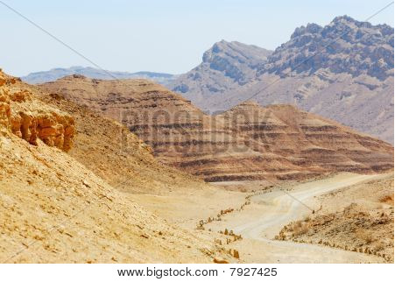

The Faith and Perseverance of Peter and John
The priests and the captain of the temple guard and the Sadducees came up to Peter and John while they were speaking to the people. They were greatly disturbed because the apostles were teaching the people, proclaiming in Jesus the resurrection of the dead. They seized Peter and John…
But many who heard the message believed; so the number of men who believed grew to about five thousand.
The next day the rulers, the elders and the teachers of the law met in Jerusalem...They had Peter and John brought before them and began to question them: “By what power or what name did you do this?”
Then Peter, filled with the Holy Spirit, said to them: “Rulers and elders of the people! If we are being called to account today for an act of kindness shown to a man who was lame and are being asked how he was healed, then know this, you and all the people of Israel:
“It is by the name of Jesus Christ of Nazareth, whom you crucified but whom God raised from the dead, that this man stands before you healed. Jesus is ‘the stone you builders rejected, which has become the cornerstone.’ Salvation is found in no one else, for there is no other name under heaven given to mankind by which we must be saved.”
When they saw the courage of Peter and John and realized that they were unschooled, ordinary men, they were astonished and they took note that these men had been with Jesus…
Then they called them in again and commanded them not to speak or teach at all in the name of Jesus. But Peter and John replied, “Which is right in God’s eyes: to listen to you, or to him? You be the judges! As for us, we cannot help speaking about what we have seen and heard.”

~ Acts 4:1-20 (NIV)

Then the high priest and all his associates, who were members of the party of the Sadducees, were filled with jealousy.
They arrested the apostles and put them in the public jail.
But during the night an angel of the Lord opened the doors of the jail and brought them out. “Go, stand in the temple courts,” he said, “and tell the people all about this new life.”
At daybreak they entered the temple courts, as they had been told, and began to teach the people…
Then someone came and said, “Look! The men you put in jail are standing in the temple courts teaching the people...”
The apostles were brought in and made to appear before the Sanhedrin to be questioned by the high priest. “We gave you strict orders not to teach in this name,” he said. “Yet you have filled Jerusalem with your teaching and are determined to make us guilty of this man’s blood.”
Peter and the other apostles replied: “We must obey God rather than human beings...”
They called the apostles in and had them flogged.
Then they ordered them not to speak in the name of Jesus, and let them go.
The apostles left the Sanhedrin, rejoicing because they had been counted worthy of suffering disgrace for the Name.
Day after day, in the temple courts and from house to house, they never stopped teaching and proclaiming the good news that Jesus is the Messiah.

~ Acts 5:17-42 (NIV)

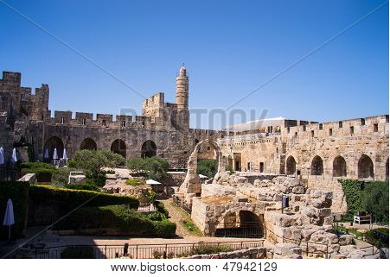

Tower of David, Old City area of Jerusalem

The Faith and Perseverance of Stephen, the First Christian Martyr

[Stephen said to the Sanhedrin] “You are just like your ancestors: You always resist the Holy Spirit! Was there ever a prophet your ancestors did not persecute?
“They even killed those who predicted the coming of the Righteous One. And now you have betrayed and murdered him—you who have received the law that was given through angels but have not obeyed it.”
When the members of the Sanhedrin heard this, they were furious and gnashed their teeth at him.
But Stephen, full of the Holy Spirit, looked up to heaven and saw the glory of God, and Jesus standing at the right hand of God.
“Look,” he said, “I see heaven open and the Son of Man standing at the right hand of God.”
At this they covered their ears and, yelling at the top of their voices, they all rushed at him, dragged him out of the city and began to stone him.
Meanwhile, the witnesses laid their coats at the feet of a young man named Saul.
While they were stoning him, Stephen prayed, “Lord Jesus, receive my spirit.”
Then he fell on his knees and cried out, “Lord, do not hold this sin against them.”
When he had said this, he fell asleep.
And Saul approved of their killing him.

~ Acts 7:51b-8:1a (NIV)

On that day a great persecution broke out against the church in Jerusalem, and all except the apostles were scattered throughout Judea and Samaria. Godly men buried Stephen and mourned deeply for him.
But Saul began to destroy the church.
Going from house to house, he dragged off both men and women and put them in prison.

~ Acts 8:1b-3 (NIV)

The Conversion of Saul on the Road to Damascus

Meanwhile, Saul was still breathing out murderous threats against the Lord’s disciples.
He went to the high priest and asked him for letters to the synagogues in Damascus, so that if he found any there who belonged to the Way, whether men or women, he might take them as prisoners to Jerusalem.
As he neared Damascus on his journey, suddenly a light from heaven flashed around him.
He fell to the ground and heard a voice say to him,
“Saul, Saul, why do you persecute me?”
“Who are you, Lord?” Saul asked.
“I am Jesus, whom you are persecuting,” he replied.
“Now get up and go into the city, and you will be told what you must do.”
The men traveling with Saul stood there speechless; they heard the sound but did not see anyone. Saul got up from the ground, but when he opened his eyes he could see nothing. So they led him by the hand into Damascus. For three days he was blind, and did not eat or drink anything.
In Damascus there was a disciple named Ananias.
The Lord called to him in a vision, “Ananias!”
“Yes, Lord,” he answered.
The Lord told him, “Go to the house of Judas on Straight Street and ask for a man from Tarsus named Saul, for he is praying. In a vision he has seen a man named Ananias come and place his hands on him to restore his sight.”
“Lord,” Ananias answered, “I have heard many reports about this man and all the harm he has done to your holy people in Jerusalem. And he has come here with authority from the chief priests to arrest all who call on your name.”
But the Lord said to Ananias, “Go! This man is my chosen instrument to proclaim my name to the Gentiles and their kings and to the people of Israel. I will show him how much he must suffer for my name.”
Then Ananias went to the house and entered it. Placing his hands on Saul, he said, “Brother Saul, the Lord—Jesus, who appeared to you on the road as you were coming here—has sent me so that you may see again and be filled with the Holy Spirit.”
Immediately, something like scales fell from Saul’s eyes, and he could see again. He got up and was baptized, and after taking some food, he regained his strength.
Saul spent several days with the disciples in Damascus.
At once he began to preach in the synagogues that Jesus is the Son of God.
All those who heard him were astonished and asked, “Isn’t he the man who raised havoc in Jerusalem among those who call on this name? And hasn’t he come here to take them as prisoners to the chief priests?”
Yet Saul grew more and more powerful and baffled the Jews living in Damascus by proving that Jesus is the Messiah.

~ Acts 9:1-22 (NIV)

The Faith and Perseverance of Paul (formerly Saul)

We do not want you to be uninformed, brothers and sisters, about the troubles we experienced in the province of Asia.
We were under great pressure, far beyond our ability to endure, so that we despaired of life itself.
Indeed, we felt we had received the sentence of death.
But this happened that we might not rely on ourselves but on God, who raises the dead.
He has delivered us from such a deadly peril, and he will deliver us again.
On him we have set our hope that he will continue to deliver us, as you help us by your prayers.

~ 2 Corinthians 1:8-11a (NIV)

But you, Timothy, certainly know what I teach, and how I live, and what my purpose in life is.
You know my faith, my patience, my love, and my endurance.
You know how much persecution and suffering I have endured…
but the Lord rescued me from all of it.

~ 2 Timothy 3:10-11 (NLT)

For I am already being poured out like a drink offering, and the time for my departure is near.
I have fought the good fight,
I have finished the race,
I have kept the faith.
Now there is in store for me the crown of righteousness, which the Lord, the righteous Judge, will award to me on that day—and not only to me, but also to all who have longed for his appearing.

~ 2 Timothy 4:6-8 (NIV)



Be Faithful Unto Death

“Be faithful unto death, and I will give you the crown of life.”

~ Revelation 2:10b (ESV)

“I tell you the truth, unless a kernel of wheat is planted in the soil and dies, it remains alone.
“But its death will produce many new kernels—a plentiful harvest of new lives.”

~ John 12:24 (NLT)

“If you cling to your life, you will lose it; but if you give up your life for me, you will find it.”

~ Matthew 10:39 (NLT)

For you died to this life, and your real life is hidden with Christ in God.

~ Colossians 3:3 (NLT)

And I trust that my life will bring honor to Christ, whether I live or die.
For to me, living means living for Christ, and dying is even better.
But if I live, I can do more fruitful work for Christ…
I’m torn between two desires: I long to go and be with Christ, which would be far better for me.
But for your sakes, it is better that I continue to live.

~ Philippians 1:20b-24 (NLT)

For to me, to live is Christ, and to die is gain.

~ Philippians 1:21 (NKJV)

I have been crucified with Christ and I no longer live, but Christ lives in me.

~ Galatians 2:20a (NIV)

…I saw under the altar the souls of all who had been martyred for the word of God and for being faithful in their testimony.
They shouted to the Lord and said, “O Sovereign Lord, holy and true, how long before you judge the people who belong to this world and avenge our blood for what they have done to us?”…
And they were told to rest a little longer until the full number of their brothers and sisters—their fellow servants of Jesus who were to be martyred—had joined them.

~ Revelation 6:9b-11 (NLT)

He will wipe away every tear from their eyes, and death shall be no more, neither shall there be mourning, nor crying, nor pain anymore, for the former things have passed away.

~ Revelation 21:4 (ESV)

Then I heard a loud voice in heaven say:
“Now have come the salvation and the power and the kingdom of our God, and the authority of his Messiah.
“For the accuser of our brothers and sisters, who accuses them before our God day and night, has been hurled down.
“They triumphed over him by the blood of the Lamb and by the word of their testimony;
“they did not love their lives so much as to shrink from death.”

~ Revelation 12:10-11 (NIV)

And I heard a voice from heaven saying,
“Write this: Blessed are the dead who die in the Lord from now on. Blessed indeed,” says the Spirit, “that they may rest from their labors, for their deeds follow them!”

~ Revelation 14:13 (ESV)

But those who die in the Lord will live; their bodies will rise again!
Those who sleep in the earth will rise up and sing for joy!
For your life-giving light will fall like dew on your people in the place of the dead!

~ Isaiah 26:19 (NLT)



Stand With Believers Who are Being Persecuted

Pray for Them

Stay alert and be persistent in your prayers for all believers everywhere.

~ Ephesians 6:18b (NLT)

The prayer of a righteous person is powerful and effective.

~ James 5:16b (NIV)

Pray also for me, that whenever I speak, words may be given me so that I will fearlessly make known the mystery of the gospel, for which I am an ambassador in chains.
Pray that I may declare it fearlessly, as I should.

~ Ephesians 6:19-20 (NIV)

Pray for us, too, that God will give us many opportunities to speak about his mysterious plan concerning Christ. That is why I am here in chains.
Pray that I will proclaim this message as clearly as I should.

~ Colossians 4:3-4 (NLT)

Pray, too, that we will be rescued from wicked and evil people…

~ 2 Thessalonians 3:2a (NLT)

…we ask you to pray for us.
Pray that the Lord’s message will spread rapidly and be honored wherever it goes...

~ 2 Thessalonians 3:1b (NLT)

…pray for us, too, that God may open a door for our message…

~ Colossians 4:3a (NIV)

…join in my struggle by praying to God for me...

~ Romans 15:30b (NLT)

…for I know that through your prayers and the help of the Spirit of Jesus Christ this will turn out for my deliverance…

~ Philippians 1:19 (ESV)

I pray that out of his glorious riches he may strengthen you with power through his Spirit in your inner being...

~ Ephesians 3:16 (NIV)

We also pray that you will be strengthened with all his glorious power so you will have all the endurance and patience you need.
May you be filled with joy, always thanking the Father.

~ Colossians 1:11-12a (NLT)

…we constantly pray for you, that our God may make you worthy of his calling, and that by his power he may bring to fruition your every desire for goodness and your every deed prompted by faith.

~ 2 Thessalonians 1:11b (NIV)

So we have not stopped praying for you since we first heard about you.
We ask God to give you complete knowledge of his will and to give you spiritual wisdom and understanding.
Then the way you live will always honor and please the Lord, and your lives will produce every kind of good fruit.

~ Colossians 1:9-10a (NLT)


Shutterstock Photo ID: 2521590345

In all my prayers for all of you, I always pray with joy because of your partnership in the gospel from the first day until now, being confident of this, that he who began a good work in you will carry it on to completion until the day of Christ Jesus.

~ Philippians 1:4-6 (NIV)

“…if two of you agree on earth concerning anything that they ask, it will be done for them by My Father in heaven.
“For where two or three are gathered together in My name, I am there in the midst of them.”

~ Matthew 18:19-20 (NKJV)

Remember those who are in prison, as though in prison with them, and those who are mistreated, since you also are in the body.

~ Hebrews 13:3 (ESV)

But while Peter was in prison, the church prayed very earnestly for him.

~ Acts 12:5 (NLT)

Share with Them

Share with the Lord’s people who are in need.
Practice hospitality…
Rejoice with those who rejoice; mourn with those who mourn.

~ Romans 12:13-15 (NIV)

Just as a body, though one, has many parts, but all its many parts form one body, so it is with Christ.
For we were all baptized by one Spirit so as to form one body…
Even so the body is not made up of one part but of many.
Now if the foot should say, “Because I am not a hand, I do not belong to the body,” it would not for that reason stop being part of the body...
If the whole body were an eye, where would the sense of hearing be?
If the whole body were an ear, where would the sense of smell be?
But in fact God has placed the parts in the body, every one of them, just as he wanted them to be...that its parts should have equal concern for each other.
If one part suffers, every part suffers with it; if one part is honored, every part rejoices with it.
Now you are the body of Christ, and each one of you is a part of it.

~ 1 Corinthians 12:12-27 (NIV)

All the believers were one in heart and mind. No one claimed that any of their possessions was their own, but they shared everything they had.

~ Acts 4:32 (NIV)

May the Lord grant mercy to the household of Onesiphorus, for he often refreshed me and was not ashamed of my chains...

~ 2 Timothy 1:16 (ESV)

And now, brothers and sisters, we want you to know about the grace that God has given the Macedonian churches.
In the midst of a very severe trial, their overflowing joy and their extreme poverty welled up in rich generosity.
For I testify that they gave as much as they were able, and even beyond their ability. Entirely on their own, they urgently pleaded with us for the privilege of sharing in this service to the Lord’s people.

~ 2 Corinthians 8:1-4 (NIV)

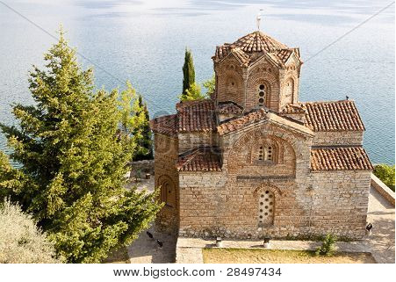

A church in Macedonia

Whatever happens, conduct yourselves in a manner worthy of the gospel of Christ…stand firm in the one Spirit, striving together as one for the faith of the gospel…

~ Philippians 1:27 (NIV)

Be Encouraged by Their Faith

So we have been greatly encouraged in the midst of our troubles and suffering, dear brothers and sisters, because you have remained strong in your faith.

~ 1 Thessalonians 3:7 (NLT)

And when they had preached the gospel to that city and made many disciples, they returned…strengthening the souls of the disciples, exhorting them to continue in the faith, and saying, “We must through many tribulations enter the kingdom of God.”

~ Acts 14:21-22 (NKJV)

Dear brothers and sisters, we can’t help but thank God for you, because your faith is flourishing and your love for one another is growing.
We proudly tell God’s other churches about your endurance and faithfulness in all the persecutions and hardships you are suffering.
And God will use this persecution to show his justice and to make you worthy of his Kingdom, for which you are suffering.

~ 2 Thessalonians 1:3-5 (NLT)



Remember God’s Promises

He Will Deliver the Righteous

“Because he loves me,” says the Lord, “I will rescue him; I will protect him, for he acknowledges my name.”

~ Psalm 91:14 (NIV)

The name of the Lord is a fortified tower; the righteous run to it and are safe.

~ Proverbs 18:10 (NIV)

When the righteous cry for help, the Lord hears and delivers them out of all their troubles.

~ Psalm 34:17 (ESV)

The angel of the Lord encamps around those who fear him, and delivers them.

~ Psalm 34:7 (ESV)

Many are the afflictions of the righteous,
but the Lord delivers him out of them all.

~ Psalm 34:19 (ESV)

He brought me out into a spacious place;
he rescued me because he delighted in me.

~ 2 Samuel 22:20 (NIV)

The Lord preserves all who love Him, but all the wicked He will destroy.

~ Psalm 145:20 (NKJV)

The wicked plot against the righteous and gnash their teeth at them;
but the Lord laughs at the wicked, for he knows their day is coming.

~ Psalm 37:12-13 (NIV)

The wicked are crushed by disaster, but the godly have a refuge when they die.

~ Proverbs 14:32 (NLT)

He Will Keep You Strong to the End

He will keep you strong to the end so that you will be free from all blame on the day when our Lord Jesus Christ returns.

~ 1 Corinthians 1:8 (NLT)



May he strengthen your hearts so that you will be blameless and holy in the presence of our God and Father when our Lord Jesus comes with all his holy ones.

~ 1 Thessalonians 3:13 (NIV)

I know the one in whom I trust, and I am sure that he is able to guard what I have entrusted to him until the day of his return.

~ 2 Timothy 1:12b (NLT)

Now all glory to God, who is able to keep you from falling away and will bring you with great joy into his glorious presence without a single fault.

~ Jude 1:24 (NLT)

The Lord will rescue me from every evil attack and will bring me safely to his heavenly kingdom.

~ 2 Timothy 4:18a (NIV)

Photo Copyright Info

Note: when purchasing the rights to use the photos, you may want to purchase an Extended License for the cover image.


Bigstock Photo ID: 2759336
A portion of the Barr Trail up Pikes Peak Colorado. The trail switchbacks sharply here around huge rocks showing a wide mountain view in the distance.
Stock Photo ID: 2759336
Copyright: BonnyHeather


Bigstock Photo ID: 140920199
the scenic landscape of cathedral rock near Sedona Arizona
Stock Photo ID: 140920199
Copyright: twildlife


Bigstock Photo ID: 4383563
Yosemite Falls
Yosemite falls. Yosemite national park. California. USA
Stock Photo 4383563
Copyright: Maridav

Bigstock Photo ID: 138466088
Beautiful summer landscape panorama of the lake, pine trees and mountains on the background Stock Photo ID: 138466088
Copyright: Kisa_Markiza


Bigstock Photo ID: 4289419
Lake Still As Glass
This picture was taken in Prescott Arizona. It is a still body of water that prefects the rocks.
Stock Photo 4289419
Copyright: OnTheStreetPhoto


Bigstock Photo ID: 8519791
Lake Eleanor lily pads and forest reflections, Trinity Alps, Northern California
Stock Photo ID: 8519791
Copyright: caminor


Bigstock Photo ID: 231501268
Lush Green Summer Landscape with Lake and Trees
Stock Photo ID: 231501268
Copyright: SusansPhotos


Bigstock Photo ID: 42090586
Editing suggestion: Crop top and bottom of photo to make island more prominent
Water Paradise Summer
by VibrantImage, Stock Photo 42090586


Bigstock Photo ID: 47073601
Fence and hills
Fence and hills in the English countryside in summertime.
Stock Photo ID: 47073601
Copyright: Catherine Ames

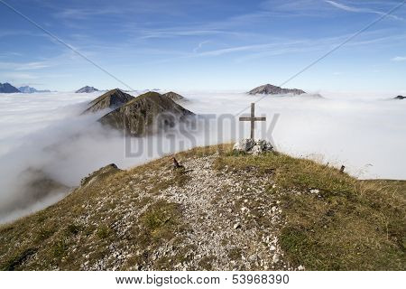
Bigstock Photo ID: 53968390
Editing suggestion: Crop all edges of photo in order to make the cross more prominent
clouds and mountain
some mountain peaks on top of clouds
Stock Photo ID: 53968390
Copyright: Trbilder


Bigstock Photo ID: 37507240
Dead Sea, Israel. Magnificent ancient mountains in the early winter morning.
Stock Photo ID: 37507240
Copyright: kavram


Bigstock Photo ID: 26904263
summer storm beginning with lightning
Stock Photo ID: 26904263
Copyright: Leonid Tit


Bigstock Photo ID: 14013431
Sunset on sea
Stock Photo ID: 14013431
Copyright: Dudarev Mikhail


Bigstock Photo ID: 112451033
Rainbow Forms By The Piton
Pool palm trees and rainbow over the bay by the Pitons in the Caribbean tropical island of Saint Lucia
Stock Photo ID: 112451033
Copyright: LivetImages


Bigstock Photo ID: 1502277
a colorful flower garden in spring background
Stock Photo ID: 1502277
Copyright: EnjoyLife


Bigstock Photo ID: 383309456
forest background. rain, river, green forest stream. Natural environment. Nature stream, branches and trees. Travel in nature.
Stock Photo ID: 383309456
Copyright: Quotes Designer


Bigstock Photo ID: 404215214
Editing suggestion: Rotate photo to be consistent with the print booklet
Beatiful beach Anse Source d'Argent with big granite rocks in sunny day. La Digue Island, Seychelles.
Stock Photo ID: 404215214
Copyright: volrab vaclav


Bigstock Photo ID: 66849562
Rushing waterfalls at High Falls State Park near Macon GA
Stock Photo ID: 66849562
Copyright: Rob Hainer

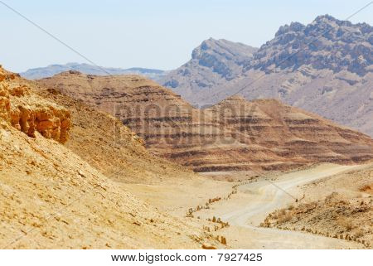
Bigstock Photo ID: 7927425
Stones Of Makhtesh Ramon
Stones of Makhtesh Ramon unique crater in Israel
Stock Photo ID: 7927425
Copyright: Vladimir_Blinov
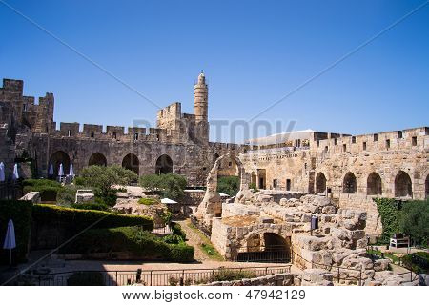
Bigstock Photo ID: 47942129
David Tower .Inside the The Old City Jerusalem.Israel
Stock Photo ID: 47942129
Copyright: slavamalai1


Bigstock Photo ID: 49025789
Panoramic view of Zakynthos island, Greece with a shipwreck on the sandy beach, at sunset, shot with a tilt and shift lens
Stock Photo ID: 49025789
Copyright: buso23

Bigstock Photo ID: 138205925
Standing Strong in Persecution-22-Bigstock-138205925
Double arch stone bridge at Ponte dei Salti with waterfall Lavertezzo Verzascatal Canton Tessin.
Stock Photo ID: 138205925
Copyright: gevision


Bigstock Photo ID: 64424557
Editing suggestion: Crop out top and bottom of photo
sea sunset
Stock Photo ID: 64424557
Copyright: Andrushko Galyna

Shutterstock Photo ID: 2521590345
A nature path through a field of bright yellow wildflowers, with evergreen trees and a blue sky
Susan's Nature Photos

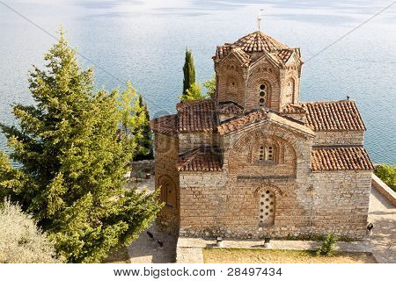
Bigstock Photo ID: 28497434
Church Of St. John At Kaneo.
Church of St. John at Kaneo in Ohrid Macedonia Balkans.
Stock Photo ID: 28497434
Copyright: Tomasz Parys


Bigstock Photo ID: 90688220
Azure mountain lake on the background of the high peaks of the Alps, Zillertal, Austria
Stock Photo ID: 90688220
Copyright: ankamonika


Bigstock Photo ID: 28027214
An arch in a huge natural stone wall through which other arches are visible, in National park in the USA
Stock Photo ID: 28027214
Copyright: kavram

Booklet Titles in the Series
www.TheWordOfGodSeries.com
Relational and Emotional Health Topics

A Joy-Filled Life

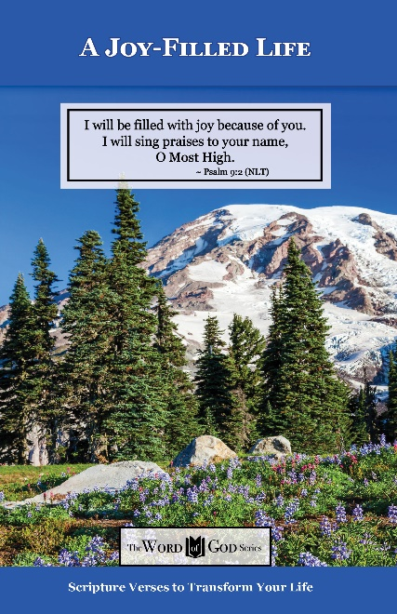
Relational and Emotional Health Topics

Healthy Relationships

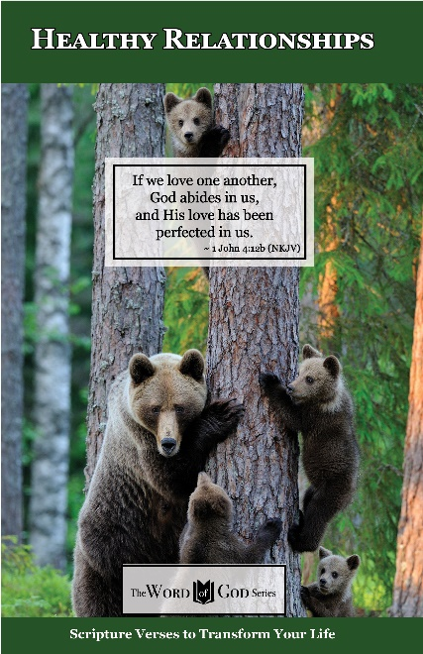
Relational and Emotional Health Topics

Healthy Thoughts

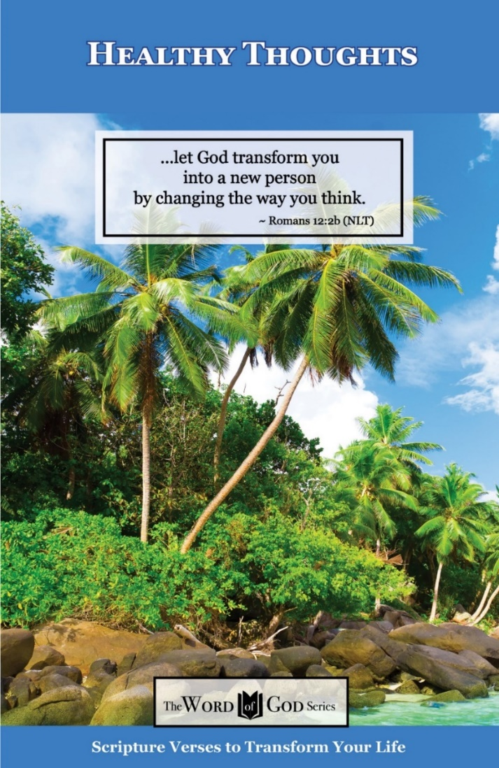
Relational and Emotional Health Topics

Freedom from Depression and Comfort in Grief

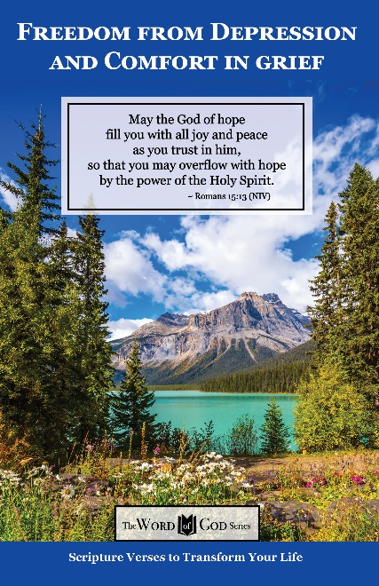
Relational and Emotional Health Topics

Freedom from Fear

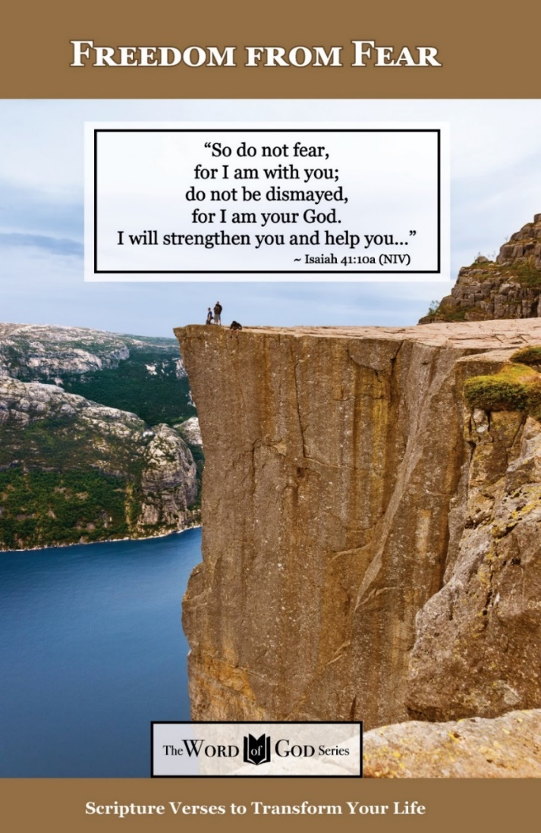
Relational and Emotional Health Topics

Freedom from Addictions

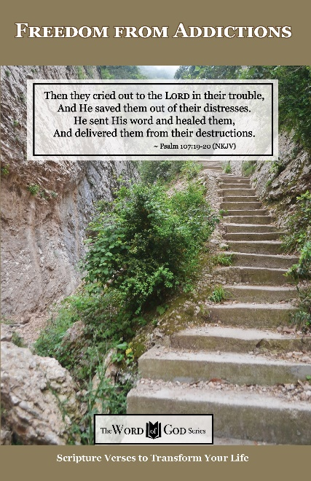
The Life and Ministry of Christ Series

Jesus: His Birth

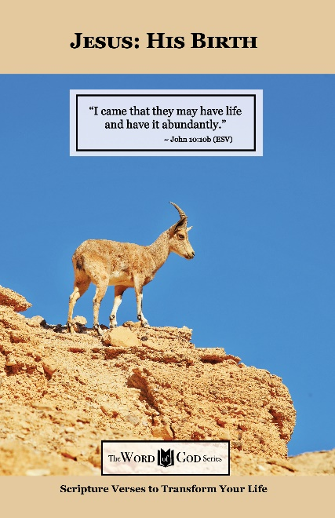
The Life and Ministry of Christ Series

Jesus: His Life Events

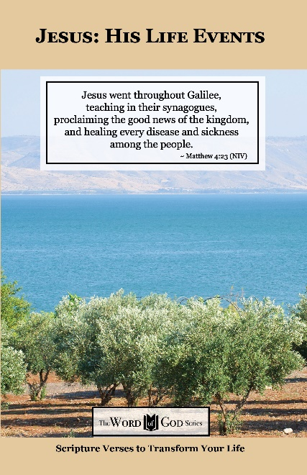
The Life and Ministry of Christ Series

Jesus: His Teachings

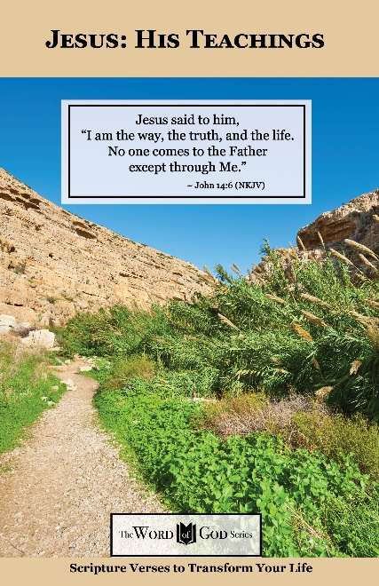
The Life and Ministry of Christ Series

Jesus: His Death, Resurrection and Return

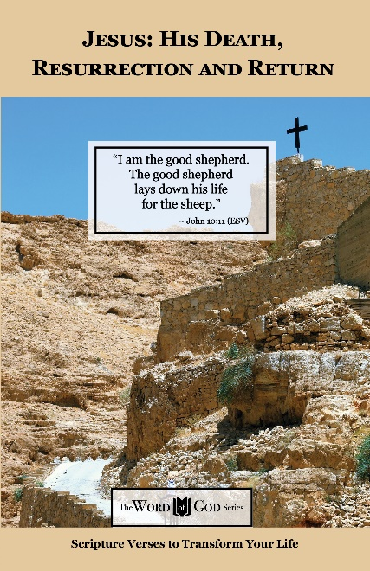
Spiritual Growth Topics

God’s Power and Presence

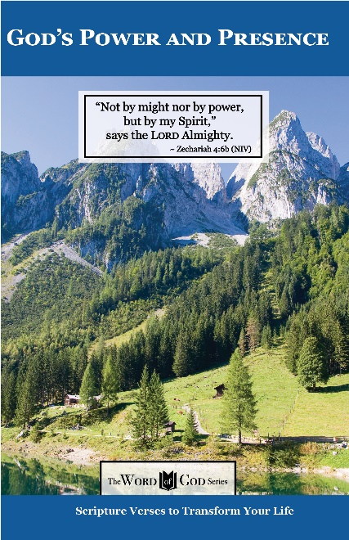
Spiritual Growth Topics

God’s Gift of Eternal Life

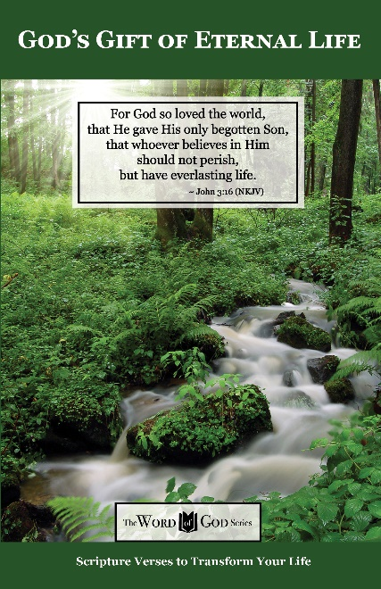
Spiritual Growth Topics

Sharing the Good News

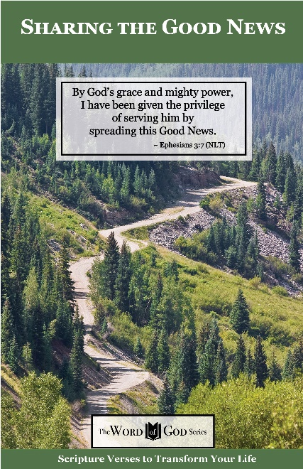
Spiritual Growth Topics

Defeating the Enemy

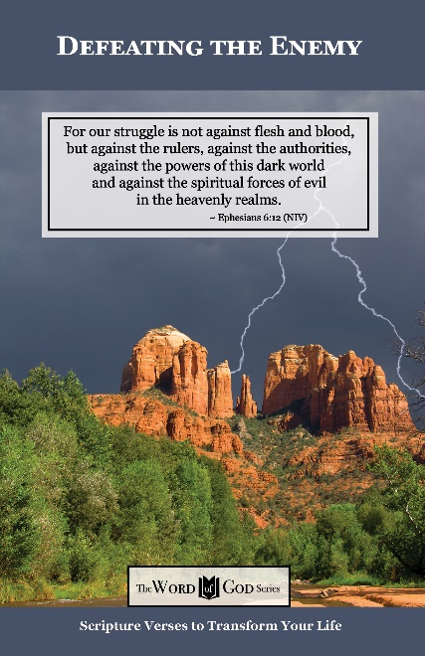
Spiritual Growth Topics

Standing Strong in Persecution

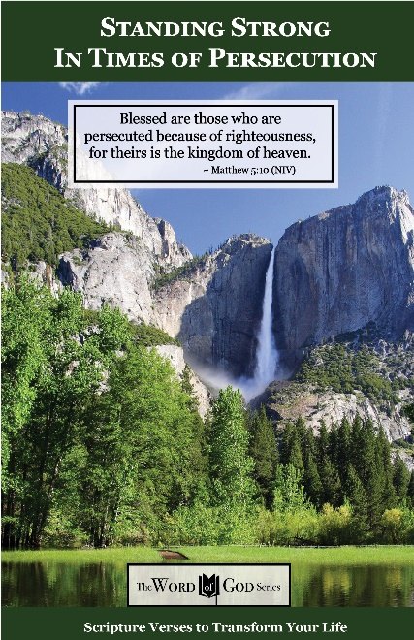
Everyday Life Topics

God’s Healing Power

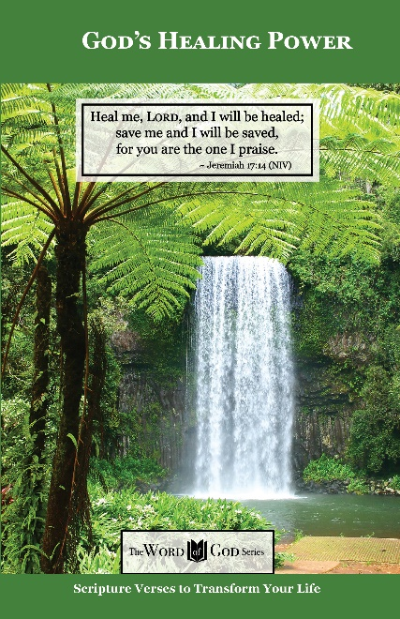
Everyday Life Topics

God is Your Refuge

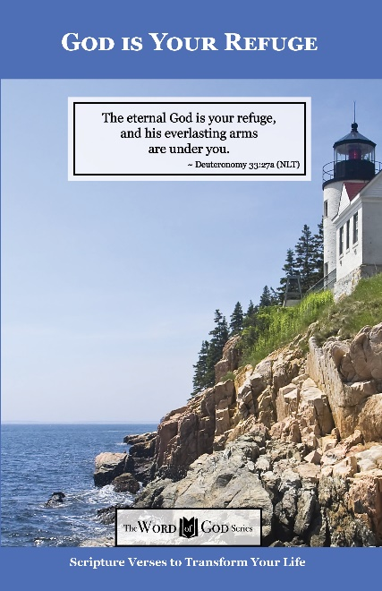
Everyday Life Topics

God’s Guidance for Your Life

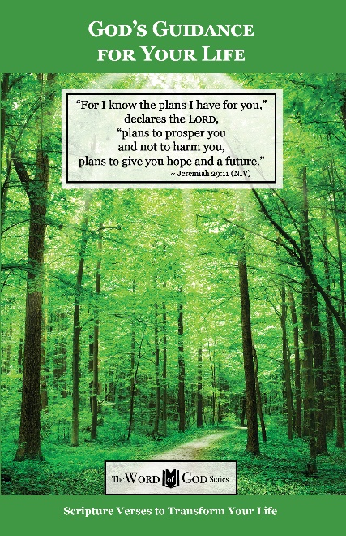
Everyday Life Topics

God’s Word to the Nations

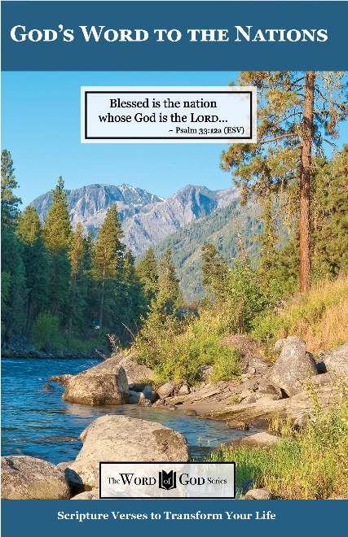
Everyday Life Topics

Praise God at Thanksgiving

